Terrain Texture by Height Tool
Short guide to get your started

How to setup the Terrain Texture by Height Tool
- Add the TTHTS script to a object does not matter which object
- Drag the terrain to the current Terrain variable you want to paint
- Make Terrain layers you want
  - A guide on how to make unity terrain layers
https://learn.unity.com/tutorial/texturize-terrains-with-materials#5fbd5bafedbc2a100385fb18
- Height Types list is where you put terrain layers that you want the tool to paint onto your terrain
- Set the heights that each layer should be on the set texture Height
- Setup is completed

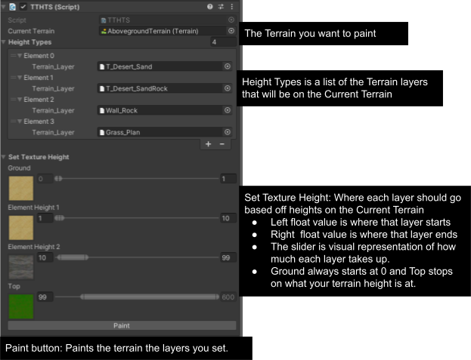

How to use the TTHT in the editor
Once you correctly set up the TTHTS script just click the paint button and you should now see your terrain is painted.
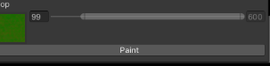

How to use the TTHT at runtime
Made it where it does not save the paint changes that were made to the terrain at runtime.
I provided a script called ModifyTerrain that you can check out on how you can use the tool at runtime.

Script Reference
Using TTHT

TTHTS
Variables | Description
currentTerrain: Terrain | Stores the terrain that will be modified
HeightTypes : List<THTT.HeightType> | Stores data need to know how the terrain should be painted
Methods | Descriptions
Void PaintNow() | Starts the StartPaint Coroutine
IEnumerator StartPaint() | Paint the current terrain based on the height at given grid cell size of 1 by 1 units of the terrain.
IEnumerator PaintDuringPlayMode() | Optimize to be able to run during playmode to save all the height spots of the terrain during the first paint, so it won't have to during the next paint jobs

HeightTypes
Variables | Description
Terrain_Layer: TerrainLayer | Stores the texture that you want at that height
StartHeight: float | Set the height on where you want it to start from  Never want to set the HeightTypes[0] because it should always be zero

Contact Info:
Email:

