Abstract— This paper is devoted to develop an efficient method for speaker dependent keyword spotting. To this end, we have defined a new set of feature coefficients called formant-based frequency cepstral coefficients (FFCCs) for considering voiced and voiceless sound features. FFCCs can eliminate the shortcomings caused by traditional Mel frequency cepstral coefficients (MFCCs), which emphasize voiced features and underrate voiceless features. In keyword spotting, underrating the voiceless features often causes misjudgment of keywords. Unlike previous literatures that used a single filter bank to capture speech features, we have proposed a formant-based filter bank (FFB) to enhance speech characteristics according to the formant distribution of each frame. We have evaluated the performance of the keyword spotting system based on FFCC using the database of RSR2015 and similarly pronounced words. The experimental results show that the proposed system has significantly better recognition rate than other existing methods.
Kuang-Yow Lian and Yong-Jie Hong
A New Efficient Feature Extraction Technique Based on Voiceless Sound Features for Speaker Dependent Keyword Spotting

Index Terms—Keyword spotting, formant-based frequency cepstral coefficients, Mel frequency cepstral coefficients.

INTRODUCTION
T HE development of speech recognition technology has a long history. With the advent of the smart living technologies, speaker dependent keyword spotting has received unprecedented attention in various applications [1] [2]. In keyword spotting, the features extracted from keywords has significant role in determining the recognition rate. Hence, the need of an efficient feature extraction technique in keyword spotting systems is inevitable. The existing advanced feature extraction techniques are mainly based on feature coefficients extracted from human auditory system characteristics. For instance, MFCC [3], gammatone frequency cepstral coefficient (GFCC) [4], modified Mel-frequency cepstral coefficient (MMFCC) and power-normalized cepstral coefficient (PNCC) [5-8], belong to it. The aforementioned feature extraction techniques are similar in the fact that filter banks used in these algorithms are more emphasized on the voiced features of the speech signal. The voiced features comprise a large number of speaker voiceprints, which are more distinguishable than the
This work was supported by the MOST, Taiwan, under Grant No. 107-2221-E-027-114-. The authors are with the Department of Electrical Engineering, National Taipei University of Technology, Taipei 10608 Taiwan. (e-mail of corresponding author: kylian@mail.ntut.edu.tw).
voiceless features. However, the lack of voiceless features can easily lead to misjudgment of keywords. For instance, in the keywords “stop” and “top”, the voiced features between them are very similar and only the voiceless features have a significant distinction. In the previous literatures, in order to reduce the false positive rate, keywords containing voiceless features were avoided as far as possible. To relieve this restriction, this paper proposes a new audio feature extraction technique called FFCC that emphasizes the voiceless features of the speaker keywords.
Among the existing feature extraction methods, MFCC is the most commonly used method for keyword spotting applications [9]. In order to eliminate the shortcomings of MFCC caused by underrating the voiceless features, researchers have proposed various solutions. For instance, the voice characteristics in the high frequency domain are efficiently extracted in linear frequency cepstral coefficient (LFCC) technique, which indeed helps in attaining better accuracy for keyword spotting applications [10]. The experiment results on whispered speech [10-12] showed that LFCC improved the accuracy of the speaker recognition compared with MFCC. Moreover, in [13] [14], LFCC gave better performance in nasal and non-nasal consonants. However, we have noticed that when most of the keywords are voiced sound, the recognition rate of MFCC is better than LFCC.
In addition, some literatures used inverse MFB to extract audio features and named it as inverse Mel filter bank (IMFB). The resulting frequency cepstral coefficients (IMFCCs) outperform the traditional MFCCs by considering high-frequency features and form a complementary relationship with the original MFCCs. Based on such complementary relationship, the classification algorithm was performed separately by using MFCC and IMFCC as features. Then, the classification results were finally determined by weighted fusion [9, 15, 16]. Here, we have noticed that IMFCC method has two drawbacks:
- Defects in the IMFB structure: The IMFB focuses on features ranging from 7000 to 8000 Hz. However, the main feature of the voiceless sound is not fixed in this range. It often distributes between 4000 and 8000 Hz according to different speakers and different keywords. In other words, IMFB cannot accurately reinforce the main features of the voiceless sound.
- Cannot be used as independent sound feature to perform classification: It is aforementioned that the voiced features contain more distinguishing voice prints. IMFCC itself focuses on voiceless sounds and disregards voiced features. Therefore, the usage of IMFCC alone as a feature to perform keyword spotting will result in a poor recognition rate.
In the study of speech recognition or speaker recognition, the formant frequencies are found to be very important which is revealed from past researches [17-19]. 在共振峰頻率的分佈中，the first two formants often being important [20]. Therefore, we have proposed a FFCC to enhance speech characteristics according to the formant distribution of each frame. The experimental results show that the proposed system has significantly better recognition rate than other existing methods.

Structure of FFCC
In this section, we describe and discuss briefly the main components of the FFCC feature extraction technique. The sampling frequency Fs of FFCC is currently set as 16 kHz in this work, but the sampling frequency of FFCC is easy to modify and adapt to other sampling frequencies. We have compared the structural difference of the proposed FFCC with other three traditional feature extraction techniques namely, MFCC, IMFCC, and LFCC in Fig. 1. The main difference is the use of different enhanced feature filter banks.
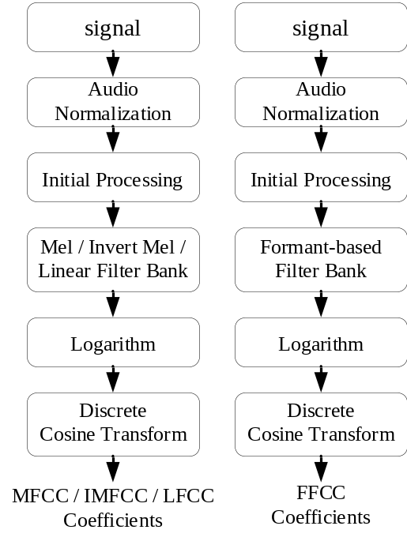
Fig. 1. Comparison of MFCC, IMFCC, LFCC, and FFCC in terms of structure.

Audio Normalization

Usually even if the same person speaks the same keyword, the volume level will not be the same each time. This difference in volume level adversely affects the accuracy of the speaker dependent keyword spotting. Therefore, in order to reduce the difference in volume between the speech signals, we perform audio normalization, which primarily evaluates the histogram of the signal amplitude and regards the position of 70% accumulation as the reference value of the signal amplitude. Then, the amplitude scaling is set as the ratio of expected value and reference value. Based on the experience, we have considered the expected value as 0.2 for audio normalization.

Initial Processing
In the initial processing step, we have filtered out the ultra-low frequency noise caused by microphone. The pre-emphasis filter is [21]. Moreover, a short-time Fourier transformation (STFT) was performed using a 32ms Hamming window, with frames overlap of 16ms [22, 23].

Formant-based Filter Bank
This paper studies a voiced and voiceless sound feature extraction approach where the filter placement is determined by distribution of energy in the short-term spectrum. More precisely, in each time frame, this is achieved by estimation of formant information using linear prediction. 以下將會詳細介紹擷取formant的方法 and categories of formant frequency distribution in Sec III-A. The composition of FFB will be discussed in detail in Sec III-B, whereas the pseudo code of HFB fusion strategy will be given in Sec. III-C.

Formant Extraction through LPC
This paper is based on the linear predictive coding (LPC) method to extract the formants of the speech signal [24]. Fig. 2 depicts the flow chart of using LPC to extract the formants. In this method, we used to compute the linear predictive coefficients using the LPC method. Then these coefficients are used to find the LP smoothed spectrum which has spectral peak amplitude and frequency. Formants are extracted by detecting the peaks from the LP smoothed spectrum.
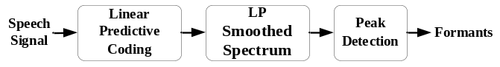
Fig. 2. Flow chart of extracting formants.
where G is the gain factor, P is the order of linear prediction, and is set of LPC coefficients. The short-time transfer function of the vocal tract filter obtained using the All-pole model is given by
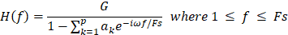 | ()
Each frame is processed by LPC to obtain the formant frequency distribution for , where and M is the total number of formants. Through experimental results, it is found that the frequency distribution of the formants can be roughly divided into three categories:
- The first category has formants below 4000 Hz. This means that the audio signal of the current frame contains only voiced features, as shown in Fig. 3 (a).
- The second category has formants above 4000 Hz. This means that the audio signal of the current frame contains only voiceless features, as shown in Fig. 3 (b).
- The third category has formants above and below 4000 Hz. This case represents that the audio signal of the current frame contains both voiced and voiceless features, as shown in Fig. 3 (c).
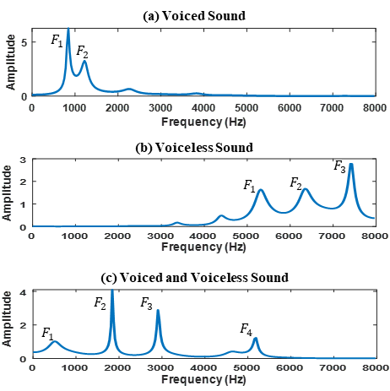
Fig. 3. Three types of formant frequency distribution.
Formant-based filter bank is based on the concept that same speaker and the same keyword will have similar formant frequencies. To validate this concept, we used histogram to count the formant distribution of speakers. As shown in Fig. 4 and Fig. 5, each histogram represents the result of a sound file, where the abscissa is the frequency of the formant and the vertical axis is the cumulative number. As shown in Fig. 6, each histogram represents the result of ten sound file. These histograms show that the formant frequency distribution is very
similar for the same keyword spoken by the same person. However, different people saying the same keyword results in different formant frequency distribution.
Formant-based filter bank is based on the concept that same speaker and the same keyword will have similar formant frequencies. Nolan and Grigoras [25] once remarked that the best information for speaker identification is formant-based. Other researchers [26] [27] also used the characteristics of formants to successfully identify the speaker. All of the above evidences confirm the fact that formant frequency distribution is similar for the keyword spoken by the same speaker.
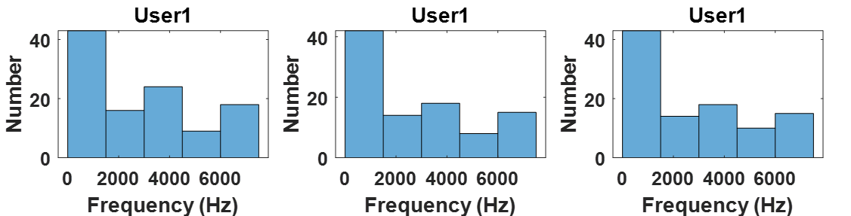
Fig. 4 formant distribution of the keyword “Stop” spoken three times by user 1.
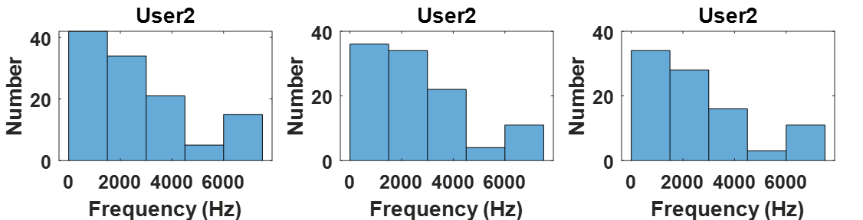
Fig. 5 formant distribution of the keyword “Stop” spoken three times by user 2.

 | Speaker A | Speaker B | Speaker C
Glee | 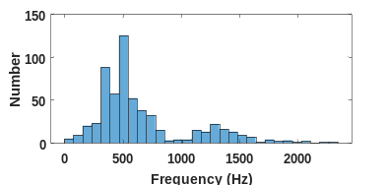 | 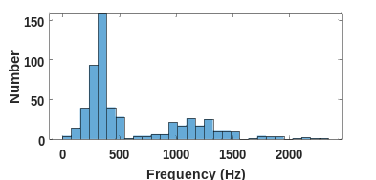 | 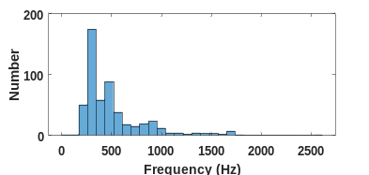
Rave | 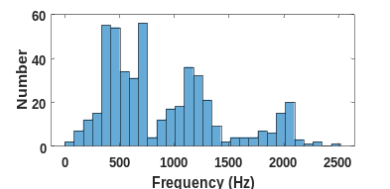 | 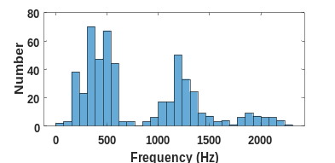 | 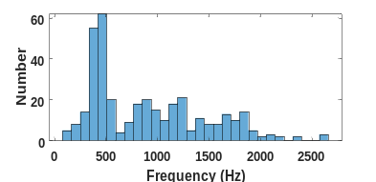
Stop | 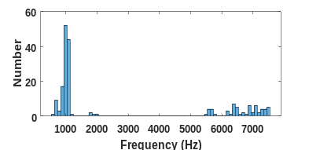 | 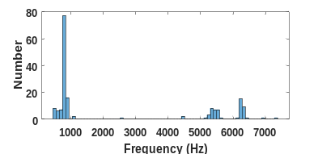 | 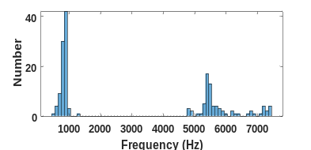
Fig. 6 LTF distribution of three keywords spoken ten times by three speakers.

Composition of FFB

This subsection describes in-detail the structure of FFB and the selection procedure of the appropriate filter bank by FFB for the three formant distributions depicted in Fig. 3. In addition, according to the experimental results of Xing, Loizou et al., MFCC and LFCC using 80 filters have the best results [14]. In order to fairly compare the performance of the filter banks, the proposed FFB also uses 80 filters. 我們使用Eq. ()至Eq. ()建立FFB的frequency response. 在曲線的設計上，我們Define the bell curve according to the following Gaussian function:
()
Where is the frequency of the second formant; describes the width of the bell shape, which is fixed at 2 kHz in this work; are the center frequencies. 上述所說的 and 都能根據讀者所需要的應用場景隨時調整。Establish the center frequencies () for each filter according to the following equation:
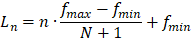 | ()
where and are respectively the minimum and maximum frequencies of the filter bank, 為1 Hz, 為8000 Hz; and with the total number of filters N = 80.
Finally, use Eq. () to modulate the triangular band pass
filters’ amplitudes. 其方程式如Eq. () 所示。 and create the FFB with bell-shaped envelope shown in Fig. 4:
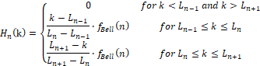 | ()
Where k is the frequency. 將Fig. 3 Three types of formant frequency distribution經過FFB處理，其frequency response 如Fig. 7所示。
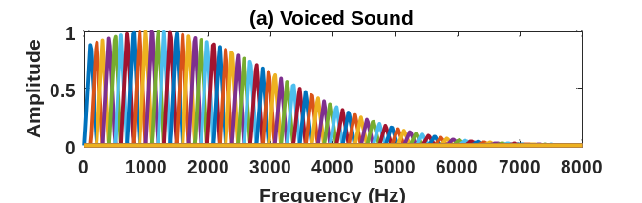
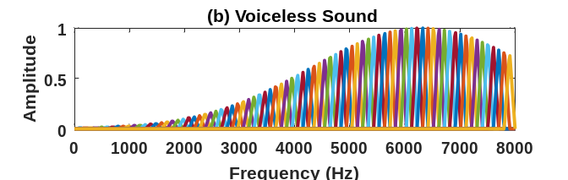
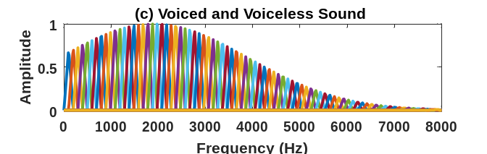
Fig. 7. The frequency response of the FFB.

Fusion Strategy
The spectrum of each frame needs to be enhanced by HFB to obtain its HFB spectrum, and then the HFB spectrum can be used to find FFCCs via discrete cosine transform (DCT). Fig. 8 is the pseudocode of obtaining FFCCs.
1 | FFCC Pseudocode
: | S is power spectrum, n is frame number
1: | FFCC(S)
2:
3:
4:
5:
6:
7:
8:
9:
Fig. 8. FFCC pseudocode

Experimental Results

Feature Extraction and Classifier Description
In this study, we have used the dynamic time warping (DTW) algorithm to perform the speaker dependent keyword spotting based on MFCC, LFCC, IMFCC, and FFCC respectively, to compare the performance of these four feature extraction methods. When an unknown voice signal is to be identified, its feature coefficients are first extracted and then followed by feature matching with the voice templates in the database based on DTW technique. Assuming that the shortest matching distance is lower than the threshold we have set, the corresponding template is treated as the final target. On the contrary, if it is greater than the threshold, the voice signal is regarded as unknown. It is to be noted that the filter banks for the four feature extraction methods are composed of 80 filters, resulting in the first 13 cepstral coefficients per frame. 另外，本論文主要是在比較四種特徵的性能，為了避免過多的因素(Factor)造成結果的差異，故我們未使用DTW的local path constraints. The sampling frequency is 16KHz.
We use a frame length of 512 samples with sampling frequency 16 kHz. No zero padding is used in the discrete Fourier transform (DFT). The frame shift is 256 samples. The DET curve graphically illustrates the relationship between false rejects and false accepts when varying a decision threshold across a genuine and an imposter match score distributions. 我們透過DET curve找出equal error rate (EER). The EER is the rate at which the false accept rate and the false reject rate are identical. 因此，我們將EER指標的decision threshold，當做DTW最佳的decision threshold.

Speech Corpus
The performance comparison of MFCC, LFCC, IMFCC, and FFCC was carried out based on similarly pronounced words (SPW) and RSR2015 database [28] in this work. The SPW database has the voice samples of 20 speakers (6 females and 14 males) uttering 6 keywords, and each keyword having 10 voice samples of the particular speaker. The time length of the keywords is maximum 1 second, and the sampling rate is 16 kHz. The six keywords are “glee”, “sleep”, “rave”, “serve”, “stock”, and “top”, among which the voiced features of paired keywords (glee, sleep) and (rave, serve) are very similar. In this case, only the unvoiced features are different. When we consider the paired keywords (stock, stop), we can find that both unvoiced and voiced features are very similar. We have used the high similarity between those paired keywords in the SPW database to verify the performance of feature extraction methods. This study uses 30 keywords of RSR2015 database group II [22], which are used to control smart home appliances. Table I depicts the details of the training sets and testing sets of RSR2015 and SPW. 上面所說的training sets是用於建立模板(creating templates). For instance, in dataset (a) in Table I, we have used half of the 24 female and 24 male voices as training set, and the other half of the voices as testing set B. In addition, the voices of remaining 2 speakers who are not included in the speaker template are treated as interference voices, named testing set A.
TABLE I
Details of the training sets and testing sets of RSR2015 and SPW
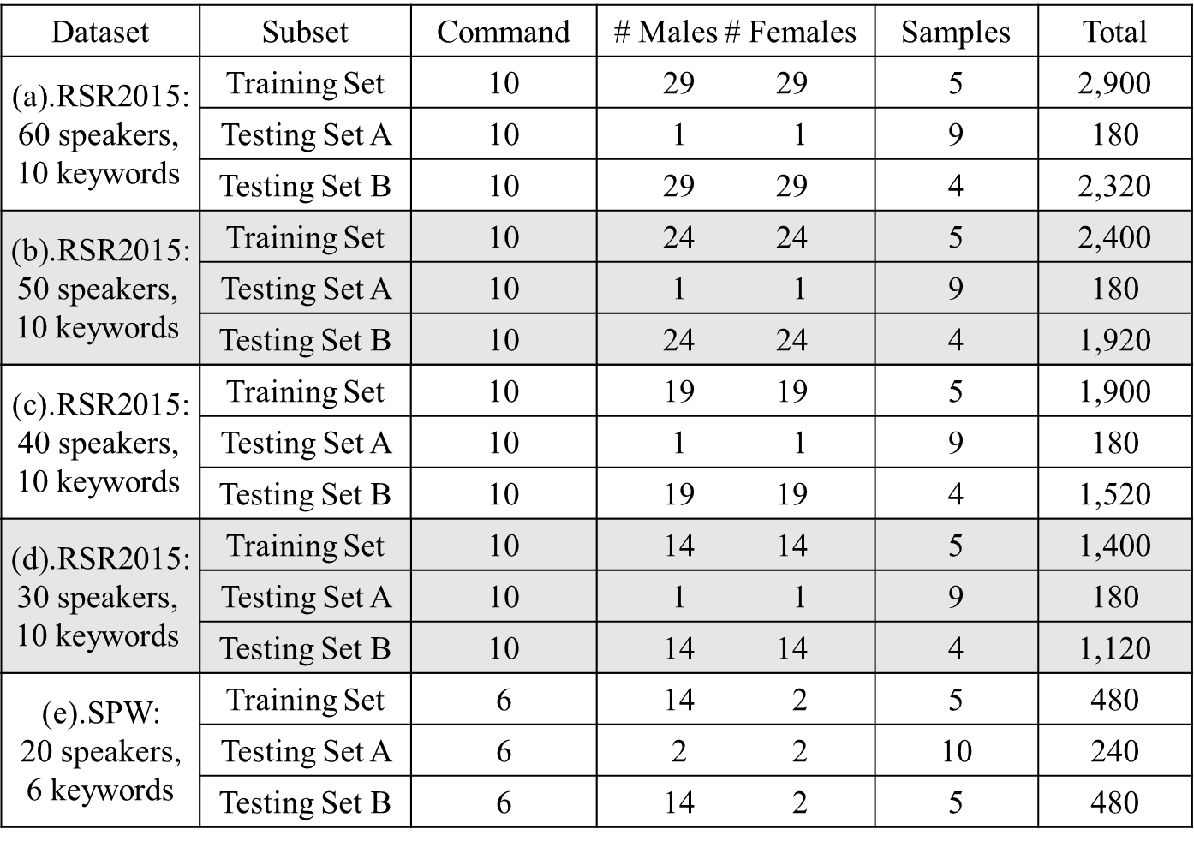
    - SPW Database
Primarily, we have compared the recognition rates of keyword spotting based on MFCC, LFCC, IMFCC, and FFCC for the keywords with very similar features. Fig. 9 shows the detection error tradeoff (DET) curves of the four aforementioned feature extraction methods. From the DET curves, it can be found that the equal error rate (EER) of FFCC is significantly better than other feature extraction methods, which is also evident from the fact that the EER of second-best method LFCC is 3.8% higher than FFCC.
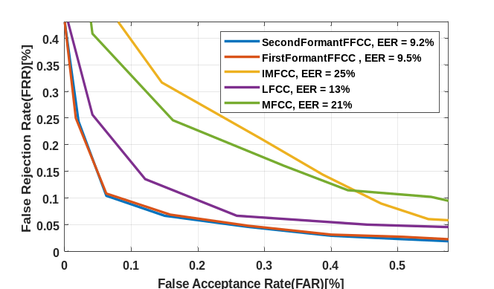
Fig. 9. DET curve
In Sec. Ⅳ-B, we have mentioned that the voiced features of the SPW keywords are very similar, and they only differ in the voiceless features. Therefore, compared with MFCC having emphasis on voiced features, LFCC method that focuses on unvoiced and voiced features equally, exhibits better overall recognition rate. Furthermore, we can find that although IMFCC focuses on unvoiced features, the most important voiced features are ignored, resulting in comparatively low accuracy than other methods.
從Fig. 9 我們可以看到FFCC的bell curve , 使用first and second formants的EER差異。雖然，使用second formant 的FFCC優於使用first formant的FFCC，但EER的差異並不太大，FFCC(first formant) is 0.3% higher than FFCC(second formant). 或許是formant frequencies的first formant and second formant，對於speech recognition or speaker recognition都是非常重要。 但當音框內的語音訊號含有voiced and voiceless features ，bell curve 會偏向於1000 Hz 以下。因此，有可能造成voiceless features所強化的權重會過低，導致second formant EER優於first formant EER的原因。
Finally, we analyze the false positive errors and false negative errors for FFCC. The testing set of SPW dataset contains 120 speech samples for each keyword, as shown in Table I. The confusion matrix shown in TABLE II is the experimental result of recognizing keywords using FFCC. It can be seen from this table that FFCC has good discrimination for keywords with similar features. For example, “glee” and “sleep”, and “rave” and “serve” were not misclassified. Only the keywords “stock” and “stop” are misclassified in few instances. The reason behind this is that some speakers did not pronounce the sound of “k” in stock and “p” in stop clearly.
TABLE II
Confusion matrix of recognizing keywords using FFCC
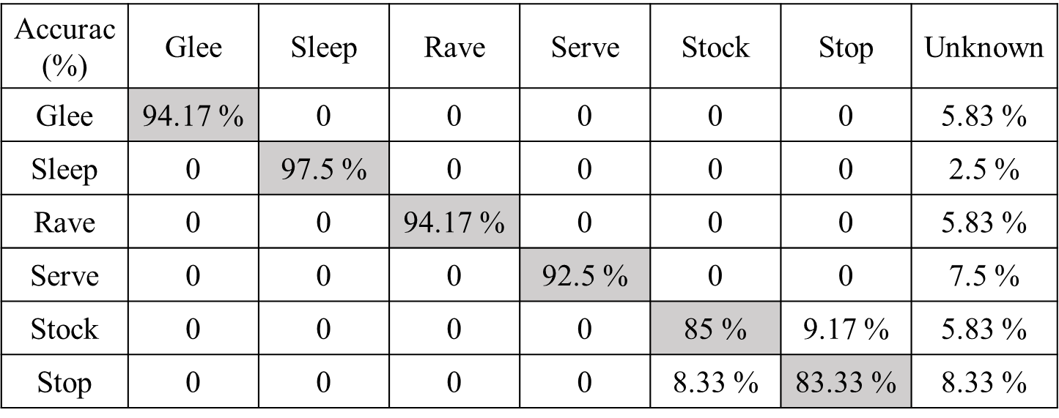

RSR2015 Database
In this subsection, the results of testing with RSR2015 database group II are presented. TABLE III shows the EER of the four feature extraction methods considered in this work. When we analyze the table, we can find that as the number of testers increases, EER gradually increases. Furthermore, from the results of this experiment depicted in TABLE III, it is evident that that FFCC method with significantly lower EER is better than other feature extraction methods.
TABLE III
EER for four feature extraction methods
EER (%) | MFCC | LFCC | IMFCC | FFCC  First  Formant | FFCC  Second  Formant
30 speakers,  10 keywords | 22.14 | 24.61 | 39.41 | 19.87 | 18.78
40 speakers,  10 keywords | 22.77 | 25.5 | 40.29 | 20.11 | 18.81
50 speakers,  10 keywords | 24.54 | 26.83 | 41.4 | 21.26 | 19.84
60 speakers,  10 keywords | 25.72 | 28.49 | 43.47 | 21.91 | 20.57
The keywords used in RSR2015 have almost no similar features, and most of them are voiced. Therefore, the experimental results show that MFCC focusing on voiced features is better than LFCC, whereas the recognition rate of IMFCC focusing on unvoiced is the lowest.
From the results obtained from keyword spotting experiments conducted using SPW and RSR2015 datasets as part of this work, it can be found that the selection of keywords will greatly affect the recognition rate. However, the FFCC method proposed in this paper has strong robustness and hence it can be successfully applied to keyword spotting experiments having even keywords with similar features to achieve good recognition rate.

Audio normalization
In this subsection, the effect of the recognition rate before and after using audio normalization is presented. This technique has been described in Sec. II-A. In the experiments of Sec. IV-B. and Sec. IV-C., each feature coefficient method used the technique of audio normalization to improve the recognition rate. The Table VI is a comparison table before and after using normalization. It can be found that the four methods improve the overall EER by 0.59 to 0.7% after using audio normalization.
TABLE IV
Comparison before and after using audio normalization
EER (%) | MFCC | LFCC | IMFCC | FFCC  First  Formant | FFCC  Second  Formant
Normalized  30 speakers, 10 keywords | 22.14 | 24.61 | 39.41 | 19.87 | 18.78
Unnormalized  30 speakers, 10 keywords | 22.84 | 25.22 | 40 | 20.57 | 19.45

Conclusion

This study presents a new efficient feature extraction algorithm called FFCC, which combines the advantages of MFB and FFB. Experiments carried out in this work based on SPW and RSR2015 database have verified that FFCC has more comprehensive ability to deal with speaker dependent keyword spotting than MFCC, IMFCC and LFCC. Keyword spotting based on FFCC exhibited excellent recognition rate even when keywords with similar voiced features are used. Moreover, the experimental results show that keyword spotting based on FFCC has comparatively very low false positive error when keywords with similar voiced and voiceless features are used. This indeed verifies the robustness of the proposed FFCC technique in keyword spotting applications.

References
[1] B. Lecouteux, M. Vacher, and F. Portet, “Distant speech recognition for home automation: Preliminary experimental results in a smart home,” SpeD, 2011. pp. 1-10.
[2] Y. Han, J. Hyun, T. Jeong, J.-H. Yoo, and J. W.-K. Hong, “A smart home control system based on context and human speech,” ICACT, 2016. pp. 165-169.
[3] S. Davis, and P. Mermelstein, “Comparison of parametric representations for monosyllabic word recognition in continuously spoken sentences,” IEEE transactions on acoustics, speech, and signal processing, vol. 28, no. 4, pp. 357-366, 1980.
[4] Y. Shao, S. Srinivasan, and D. Wang, “Incorporating auditory feature uncertainties in robust speaker identification,” ICASSP'07, 2007. pp. IV-277-IV-280.
[5] M. A. Islam, “Modified mel-frequency cepstral coefficients (MMFCC) in robust text-dependent speaker identification,” ICAEE, 2017. pp. 505-509.
[6] C. Kim, and R. M. Stern, “Power-normalized cepstral coefficients (PNCC) for robust speech recognition,” IEEE/ACM Transactions on Audio, Speech and Language Processing (TASLP), vol. 24, no. 7, pp. 1315-1329, 2016.
[7] M. Sahidullah, and G. Saha, “A novel windowing technique for efficient computation of MFCC for speaker recognition,” IEEE signal processing letters, vol. 20, no. 2, pp. 149-152, 2012.
[8] K. S. R. Murty, and B. Yegnanarayana, “Combining evidence from residual phase and MFCC features for speaker recognition,” IEEE signal processing letters, vol. 13, no. 1, pp. 52-55, 2005.
[9] S. Chakroborty, A. Roy, and G. Saha, “Improved closed set text-independent speaker identification by combining MFCC with evidence from flipped filter banks,” International Journal of Signal Processing, vol. 4, no. 2, pp. 114-122, 2007.
[10] J. Xu, and H. Zhao, “Speaker identification with whispered speech using unvoiced-consonant phonemes,” Int, 2012. pp. 1-4.
[11] X. Zhou, D. Garcia-Romero, R. Duraiswami, C. Espy-Wilson, and S. Shamma, “Linear versus mel frequency cepstral coefficients for speaker recognition,” ASRU, 2011. pp. 559-564.
[12] X. Fan, and J. H. Hansen, “Speaker identification with whispered speech based on modified LFCC parameters and feature mapping,” ICASSP, 2009. pp. 4553-4556.
[13] H. Lei, and E. Lopez, “Mel, linear, and antimel frequency cepstral coefficients in broad phonetic regions for telephone speaker recognition,” INTERSPEECH, 2009.
[14] H. Xing, and P. C. Loizou, “Frequency shift detection of speech with GMMs and SVMs,” SIPS, 2012. pp. 215-219.
[15] S. Chakroborty, and G. Saha, “Improved text-independent speaker identification using fused MFCC & IMFCC feature sets based on Gaussian filter,” International Journal of Signal Processing, vol. 5, no. 1, pp. 11-19, 2009.
[16] S. Chakroborty, A. Roy, S. Majumdar, and G. Saha, “Capturing complementary information via reversed filter bank and parallel implementation with MFCC for improved text-independent speaker identification,” ICCTA, 2007. pp. 463-467.
[17] M. J. J. P. R. L. Hunt, “Delayed decisions in speech recognition—the case of formants,” vol. 6, no. 2, pp. 121-137, 1987.
[18] P. Schmid, and E. Barnard, “Robust, n-best formant tracking,” 1995.
[19] L. Welling, and H. Ney, “A model for efficient formant estimation,” 1996. pp. 797-800.
[20] R. D. J. P. d. M. Kent, research, implications, “The biology of phonological development,” pp. 65-90, 1992.
[21] W. Han, C.-F. Chan, C.-S. Choy, and K.-P. Pun, “An efficient MFCC extraction method in speech recognition,” ISCAS, 2006. p. 4 pp.
[22] M. N. Aulia, M. S. Mubarok, W. U. Novia, and F. Nhita, “A comparative study of MFCC-KNN and LPC-KNN for hijaiyyah letters pronounciation classification system,” 2017. pp. 1-5.
[23] N. A. J. N. U. o. S. Meseguer, D. o. E. Technology, and Telecommunications, “Speech analysis for automatic speech recognition,” pp. 14-19, 2009.
[24] D. O'Shaughnessy, “Linear predictive coding,” IEEE potentials, vol. 7, no. 1, pp. 29-32, 1988.
[25] F. Nolan, and C. Grigoras, “A case for formant analysis in forensic speaker identification,” International Journal of Speech Language and the Law, vol. 12, no. 2, pp. 143-173, 2007.
[26] X. Yixue, and K. Jiangping, “Vocal tract characteristic on long-term formant distribution,” Int, 2012. pp. 207-211.
[27] M. Chougala, and S. Kuntoji, “Novel text independent speaker recognition using LPC based formants,” ICEEOT, 2016. pp. 510-513.
[28] A. Larcher, K. A. Lee, B. Ma, and H. Li, “Text-dependent speaker verification: Classifiers, databases and RSR2015,” Speech Communication, vol. 60, pp. 56-77, 2014.

