1. Logo on index redirecting to a 404 error page

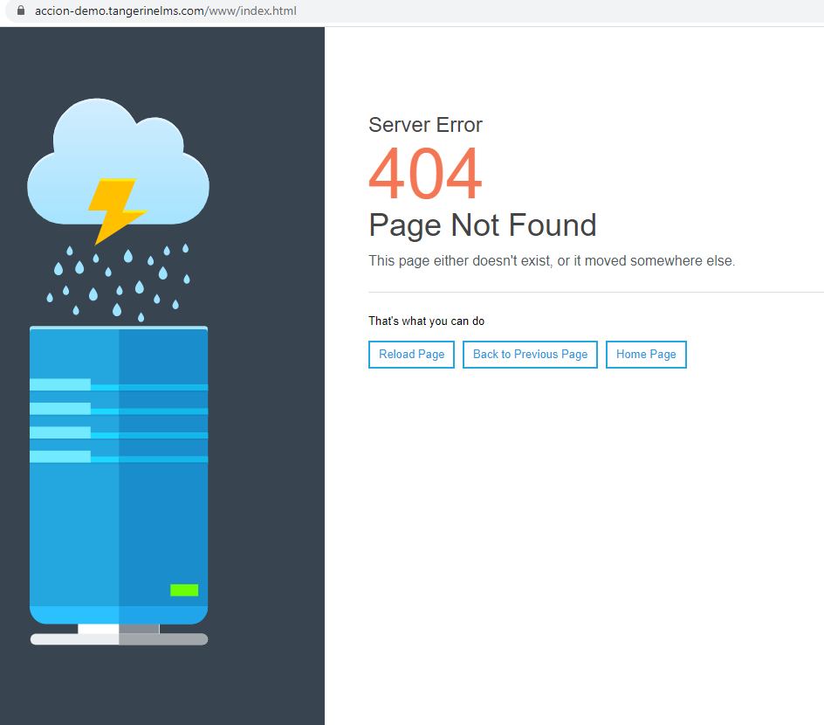

1. “These fields are required” should be in brighter colors

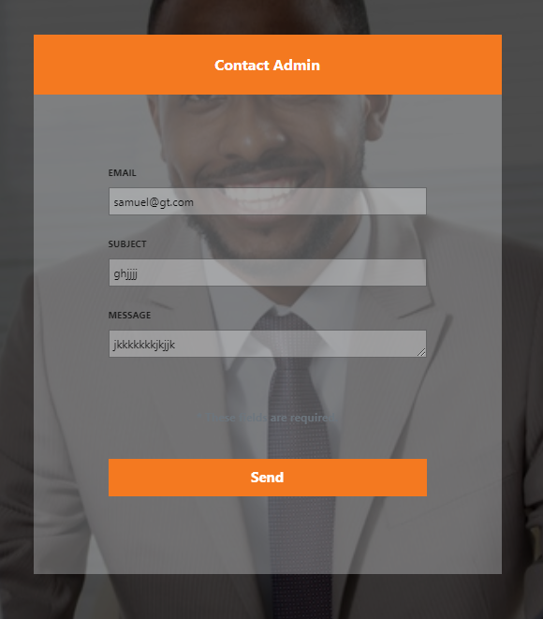

1. The Email placeholder should be in brighter colors

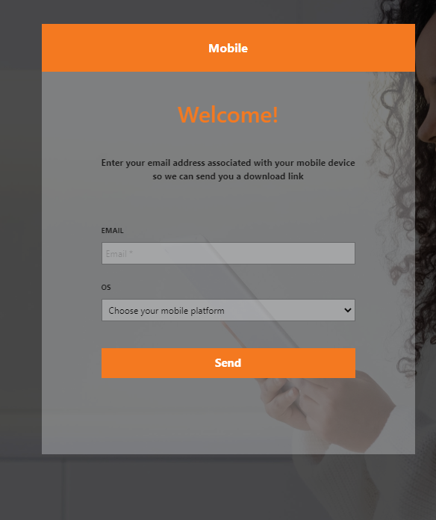

1. The hover effect on the components should be orange in color

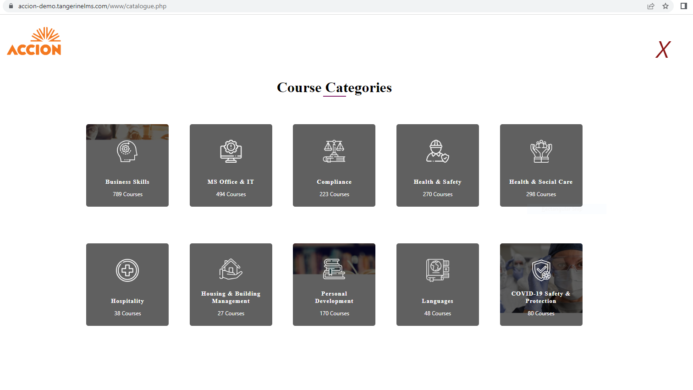

1. I want this course button redirecting to a page displaying “file not found”

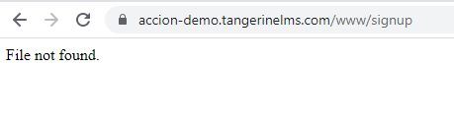

1. There should be a close button to exist the modal

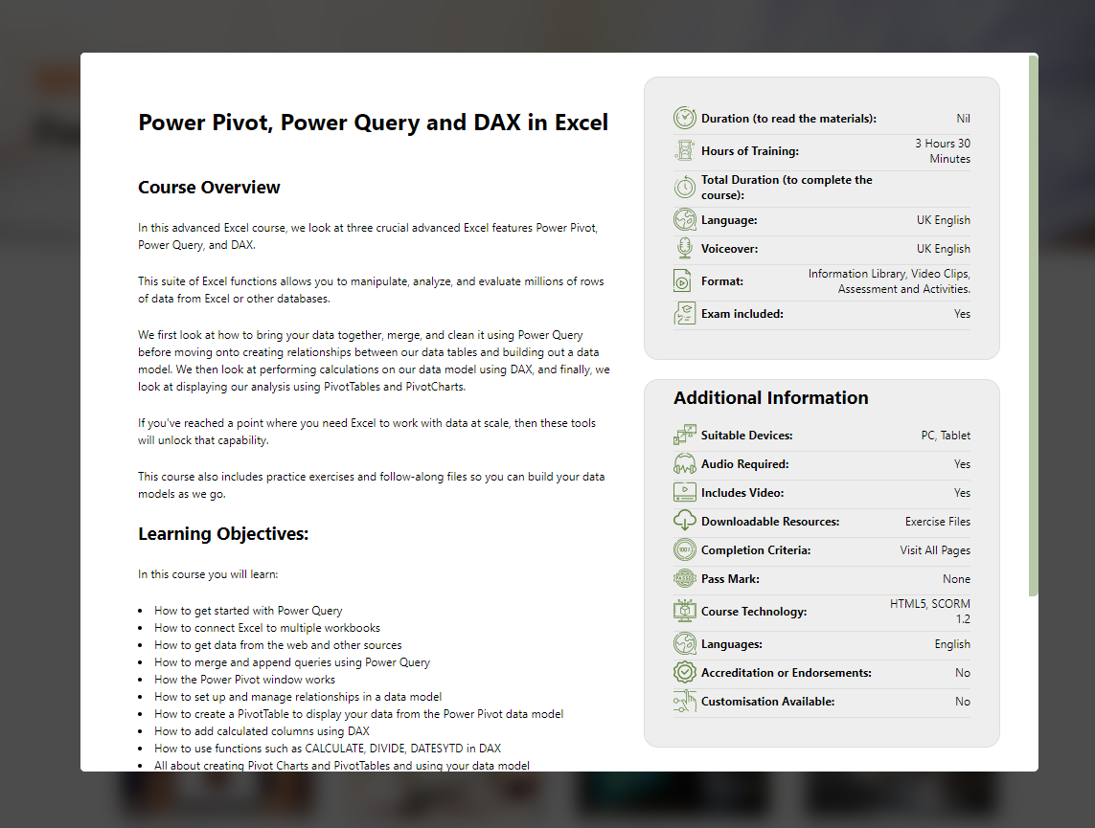

1. Hospitality button is redirecting to a page displaying “page not found”

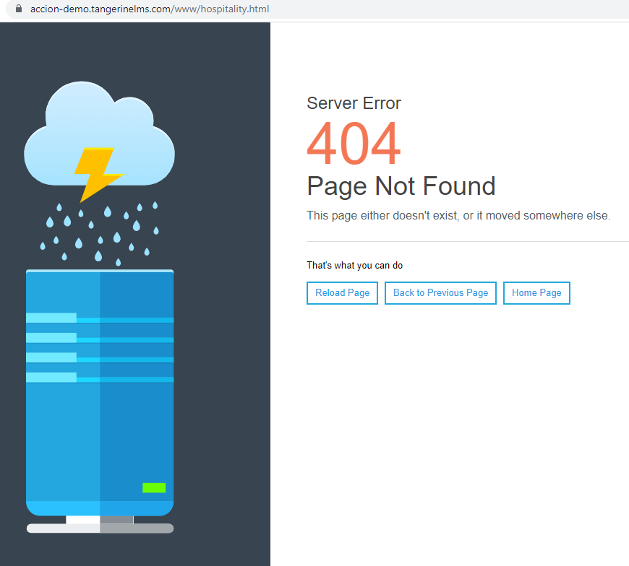

1. Colors need to be replaced with orange.

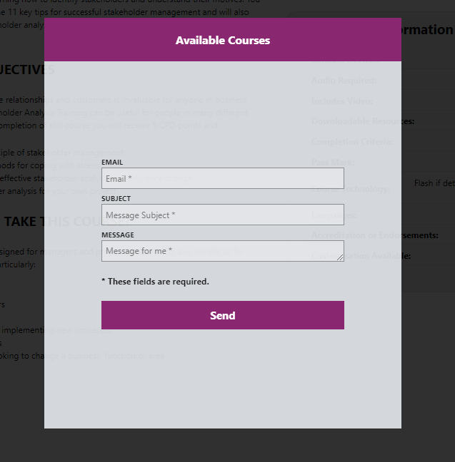

1. Hover effect on those fields should be color orange.

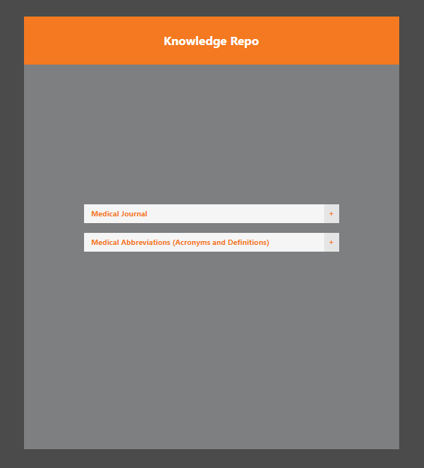

10). “Purple Academy should be replaced with LMS Tangerine”



11) The components needs to be aligned properly.

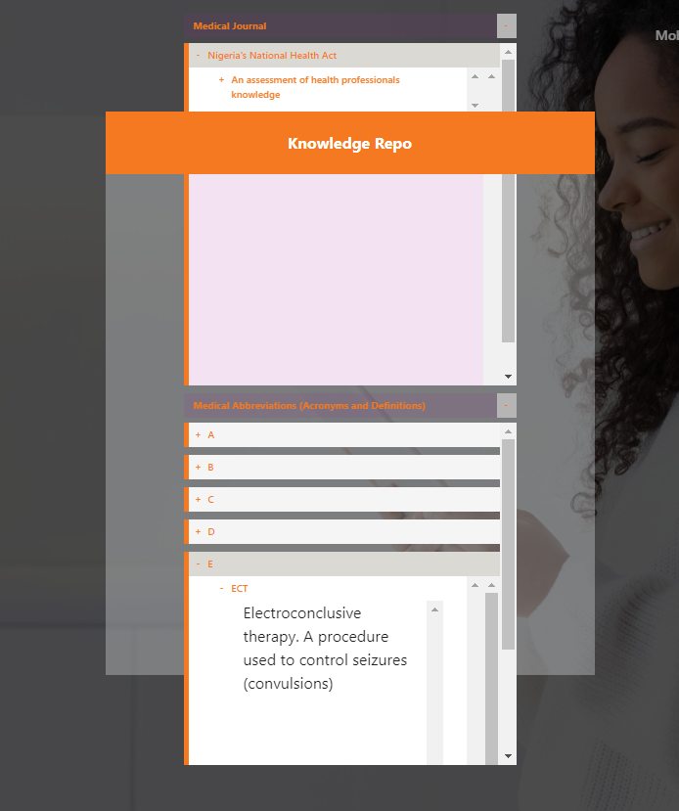

12). Knowledge repo is not populating after being added

