# 积分兑换优惠券

大致步骤：积分兑换后，减少用户积分，生成一个优惠券，用户获取该优惠券

一、**相关的表和字段**

**会员表(es_member)**：会员消费积分mp

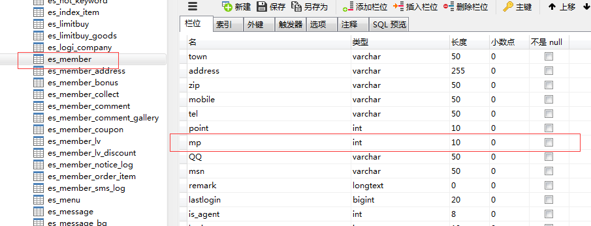

**会员红包(优惠券)表(es_member_bonus)**

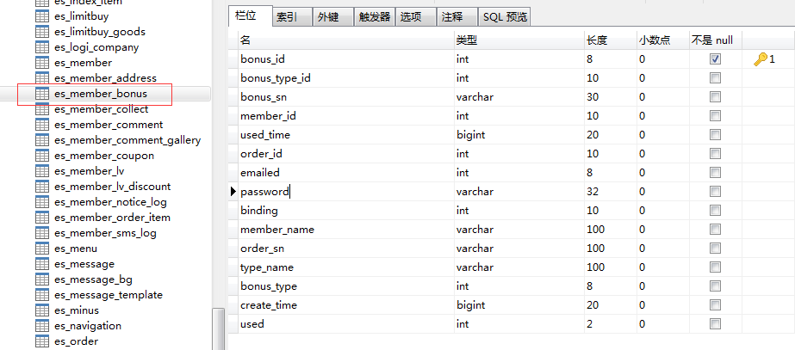

**红包(优惠券)类型表(es_bonus_type)**

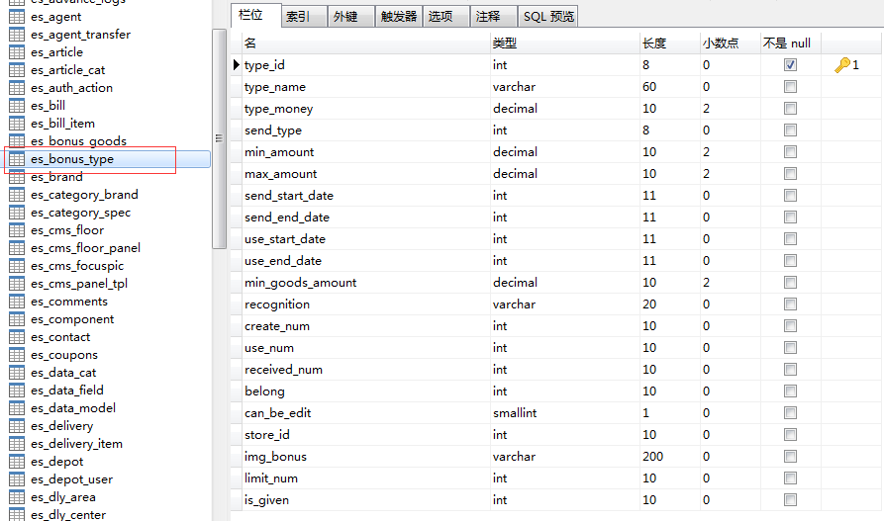

**会员积分日志表(es_point_history)**

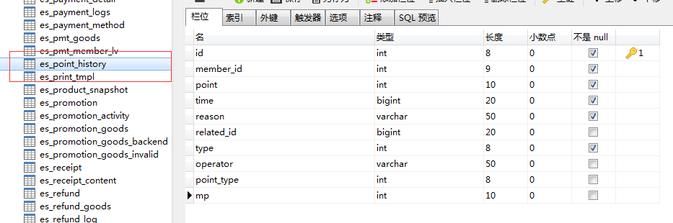

**店铺表(es_shop)**

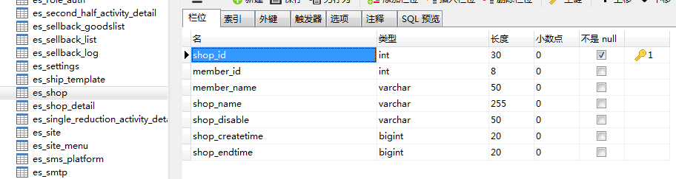

**二、功能实现相关类和代码**

**1、相关的页面：**

Wap端页面：（注意：checkout.html有两个类，一个是PC端的，一个是wap端的）

/javashop-web/src/main/webapp/themes/wap/checkout/checkout.html

/javashop-web/src/main/webapp/themes/wap/js/page/checkout.js

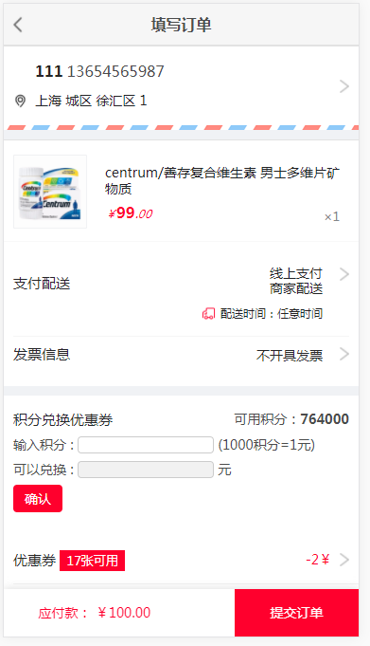

/javashop-web/src/main/webapp/themes/wap/checkout/checkout-bonus.html

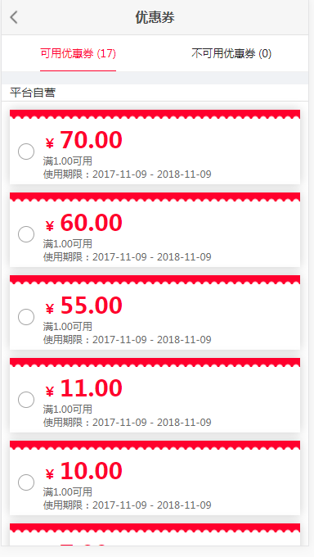

PC端页面：

/javashop-web/src/main/webapp/themes/b2b2cv4/member/point.html

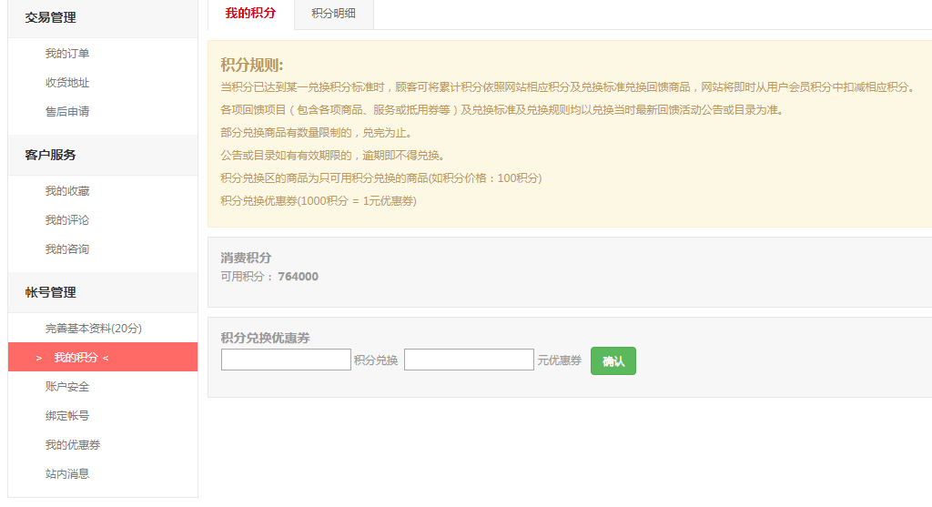

/javashop-web/src/main/webapp/themes/b2b2cv4/member/point_list.html

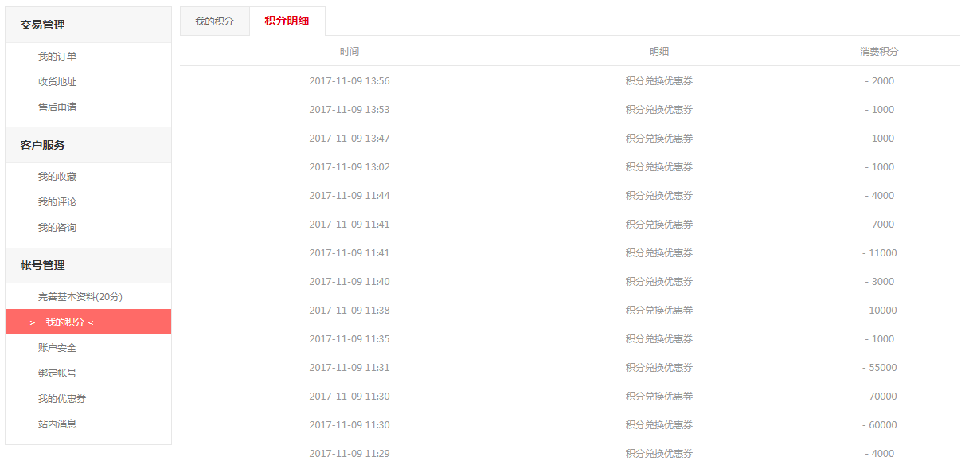

/javashop-web/src/main/webapp/themes/b2b2cv4/member/bonus.html

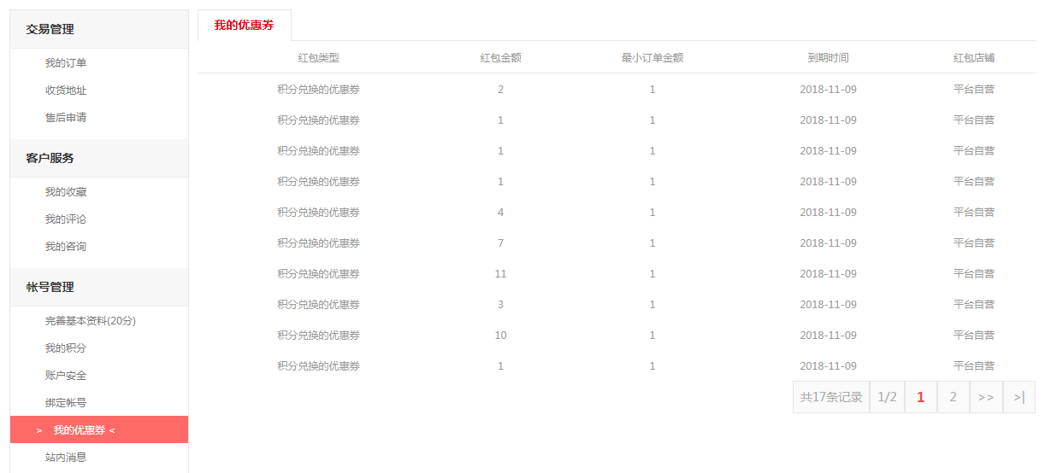

**2、相关类和代码：**

/javashop-web/src/main/webapp/themes/wap/js/page/checkout.js

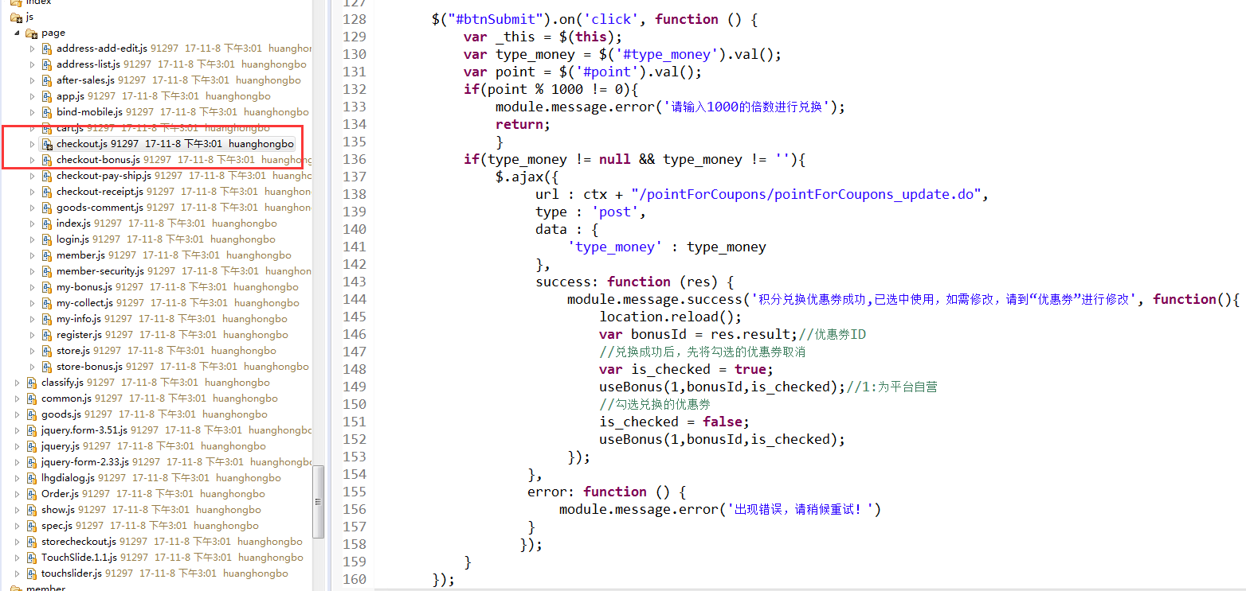

/shop-core/src/main/java/com/enation/app/shop/member/controller/front/PointForCouponsController.java

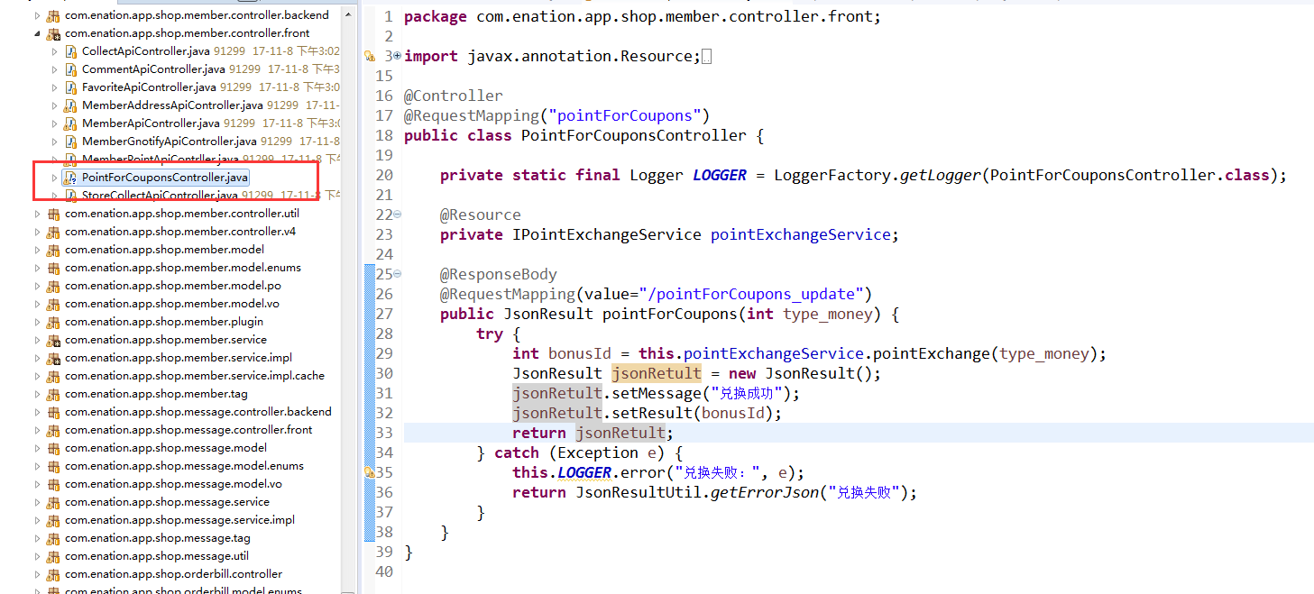

/shop-core/src/main/java/com/enation/app/shop/member/service/impl/PointExchangeServiceImpl.java

