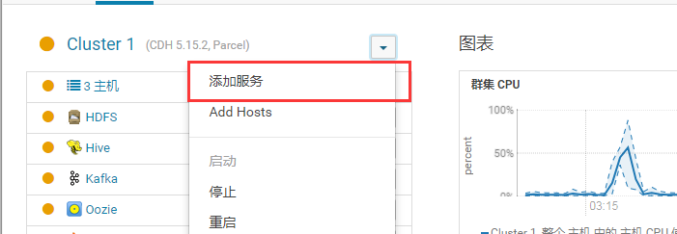

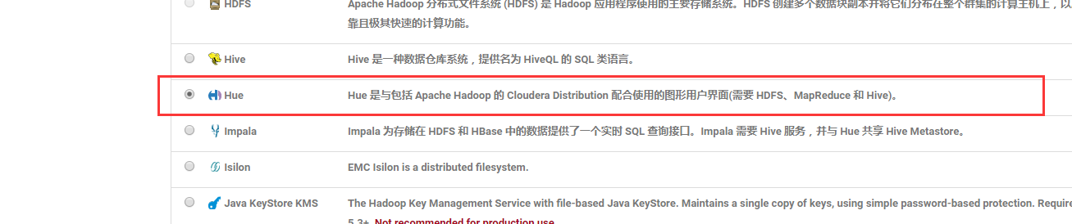

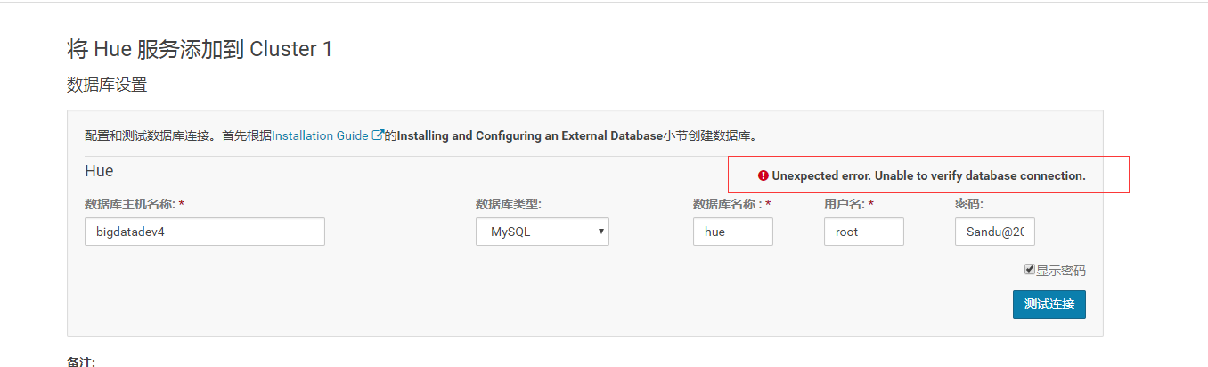

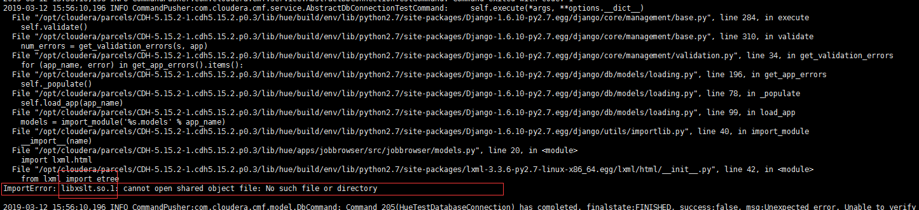

安装libxslt包

yum install libxslt

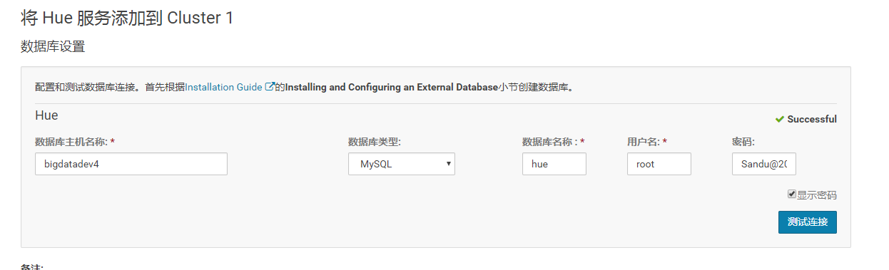

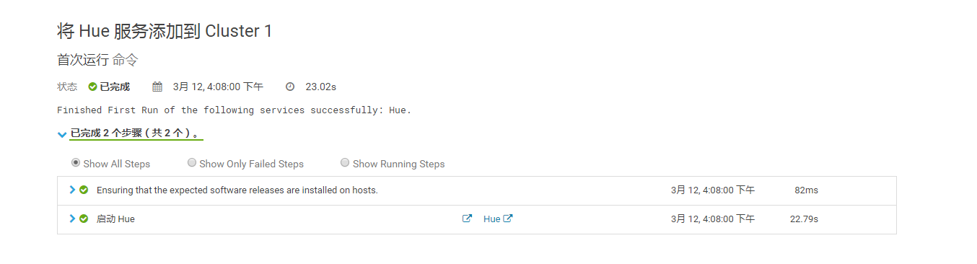

//如果启动失败,看日志,发现httpd没安装

//是否安装httpd

rpm    -qa    httpd

//安装

yum  install  httpd   -y

//启动

**service httpd start**

**service httpd status**

**//重启hue**

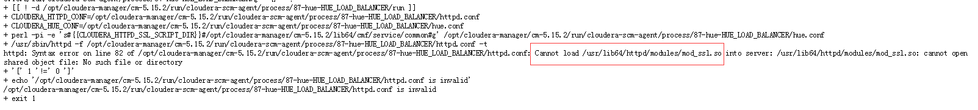

yum install mod_ssl

**//重启hue**



hdfs

[Sandu@2019](mailto:Sandu@2019)

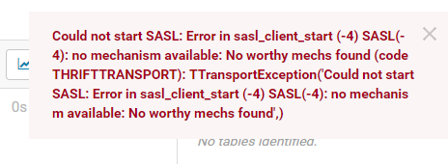

yum install cyrus-sasl-plain  cyrus-sasl-devel  cyrus-sasl-gssapi

**//重启hue**