Statistical Interpretation and Exploratory Data Analysis
Name: Smaran Dahal
Student ID: 2551528
Course Name: Concept and Technologies of AI (5CS037)
Date of Submission: January 10, 2026

Table of Contents

• Introduction – Overview of HDI and Study Objectives
- Analysis 1A – HDI in 2022 (Single Year)
- Analysis 1B – HDI Trends, 2020–2022
- Analysis 2 – South Asia HDI: Composite Scores and Correlations
- Analysis 3 – Comparative Study: South Asia vs Middle East
- Summary and Implications
- References – Methodology and Dataset

Introduction
Human Development Index (HDI) is a composite measure that evaluates human progress by combining indicators of health, education, and income. It provides a multidimensional perspective on development, moving beyond economic growth alone to capture overall well-being.
Objectives of the Analysis:
This report aims to examine HDI patterns through statistical interpretation and exploratory data analysis. The objectives are to:
- Assess HDI outcomes for a single year (2022).
- Explore short-term HDI trends i.e., 2020-2022.
- Conduct advanced analysis of South Asian countries.
- Compare HDI performance South-Asia vs Middle-East.
Scope of the Report:
The analysis is based on the HumanDevelopmentIndex_Dataset.csv and focuses on descriptive statistics, visualizations, and comparative insights. It highlights disparities, identifies outliers, and evaluates the role of health, education, and income in shaping HDI. Limitations include missing regional labels and restricted variables, but the study provides meaningful insights into global and regional development trends.

Problem 1A

Single Year HDI Exploration (2022)
Methods: The data has been filtered by year 2022, de-duplicated, and de-contaminated by empty values, and numeric variables were normalized.
Key Results:
- Mean HDI ≈ 0.72
- Median HDI ≈ 0.73
- Standard Deviation ≈ 0.07
- Highest HDI country: Switzerland
- Lowest HDI country: South Sudan
Ten nations with HDI values greater than 0.800 were ranked according to Gross National Income (GNI) per capita. According to the UNDP categorization system, which divides nations into Low, Medium, High, and Very High human development countries, these nations are classified as Very High.

Based on their Human Development Index (HDI) scores, the United Nations Development Programme (UNDP) has divided nations into four categories: Low, Medium, High, and Very High. The system provides a similar methodology that may be used to identify disparities in developmental outcomes and compare the countries.
Table 1: The 10 countries that have HDI above 0.800 ranked by GNI.
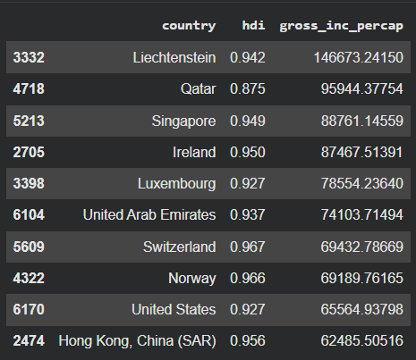
Table 2: Distribution of the HDI categories.
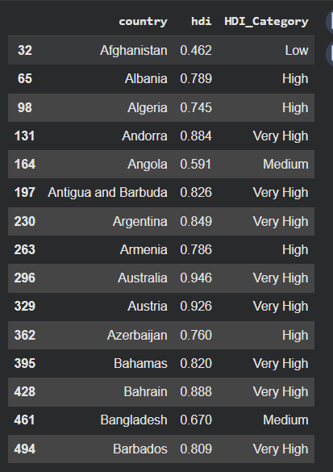
Interpretation: A high HDI level indicates a relatively high Gross National Income (GNI) per capita in the nations, which is a clear sign of the connection between human development and economic prosperity. However, there are notable exceptions where nations are achieving relatively high HDI despite having relatively low income levels. It is crucial to remember that attainment of health and education is an essential component of human development that cannot be exclusively linked to economic prosperity.

Problem 1B
HDI Trend Analysis (2020–2022)
Methods / Approach:
Data for 2020–2022 was extracted, cleaned, and visualized to examine HDI changes, regional averages, distributions, and the HDI–GNI relationship.
Key Results:
- Nepal, India, Sri Lanka, Bangladesh, and Bhutan showed gradual HDI improvement, though recovery rates varied.
- Regional averages could not be generated due to dataset limitations.
- Median HDI remained stable, but disparities widened.
- HDI correlated positively with GNI, with notable outliers.
- Figure 1. HDI trends for five countries (2020–2022).
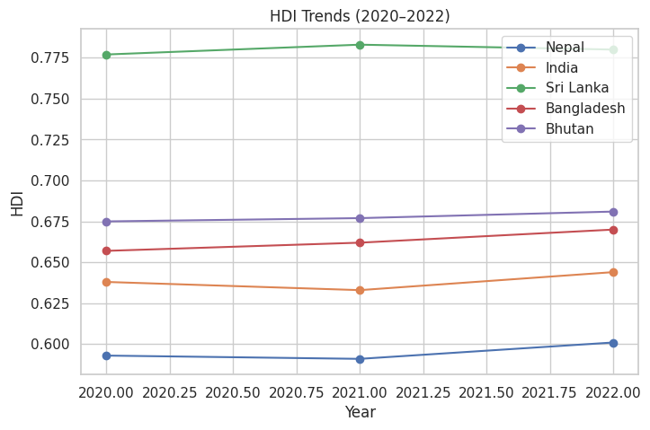
This line chart indicates the HDI trends of Nepal, India, Sri Lanka, Bangladesh and Bhutan. The majority of countries demonstrate slow but steady development, but the rate varies, which is indicative of the differences in recovering the world disruptions like the COVID-19.
- Figure 2. Average HDI by region and year.
Not generated due to dataset limitations
- Figure 3. HDI distribution across 2020–2022.
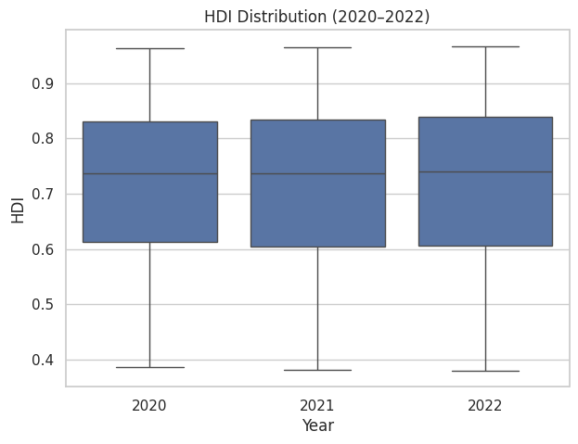
The box plot is used to describe the distribution of HDI across the world. The median HDI is at the same level, whereas the interquartile range has the growing disparities, which is a sign of uneven development progress.
- Figure 4. HDI vs GNI per capita.
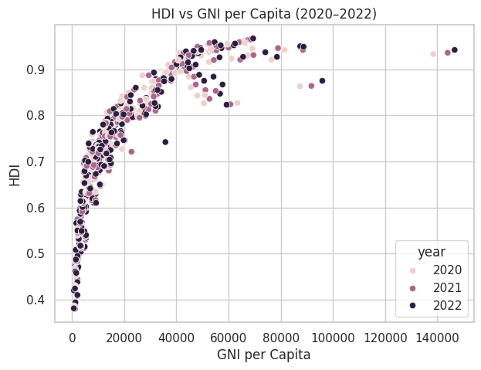
Positive relationship between income and HDI is shown by the scatter plot. The countries above the regression line have high HDI than it would have them based on their income and those below on the other end are not performing as well as their wealth.

Problem 2

Advanced HDI Exploration (South Asia)
Methods / Approach:
A composite score was built using GNI per capita and normalized life expectancy. Outliers in HDI vs GNI were identified, and correlations with gender development and life expectancy were examined. A gap analysis compared income and HDI performance.
Key Results:
- Maldives and Sri Lanka ranked highest by composite score.
- Outliers showed either efficient development despite low income or underperformance despite wealth.
- Strong positive correlations were found between HDI and both gender development and life expectancy.
- Gap analysis revealed underutilized wealth in some nations and efficient conversion in others
Figures:
- Figure 5. Top 5 South Asian countries by Composite Score.
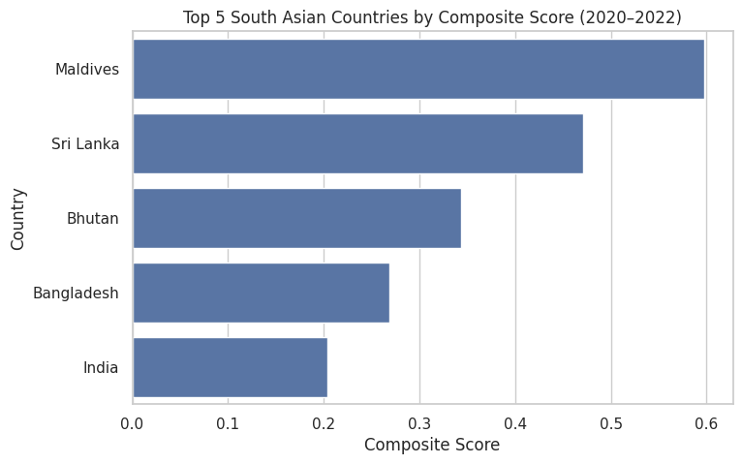
It is a horizontal bar chart of the countries in South Asia with a composite of income and life expectancy. There is a strong level of health and income performance in Maldives and Sri Lanka.
- Figure 6. Outliers in HDI vs GNI (2022).
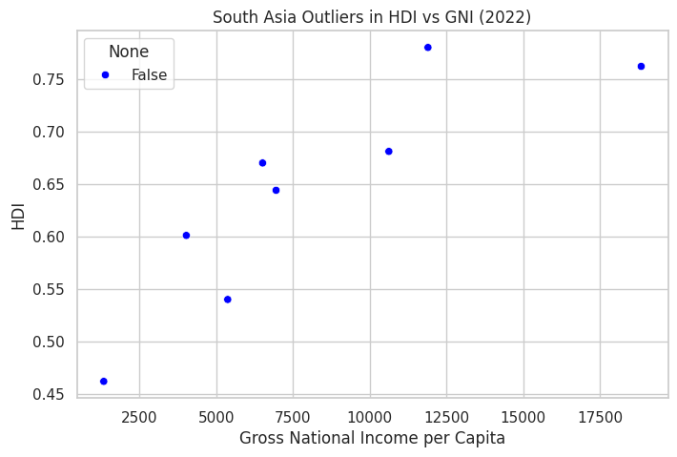
The plot indicates the countries that do not conform to expected HDI-income trends. Outliers indicate either an efficient social investment even with low income, or poorer performance with higher income.
- Figure 7. Gender Development vs HDI (South Asia).
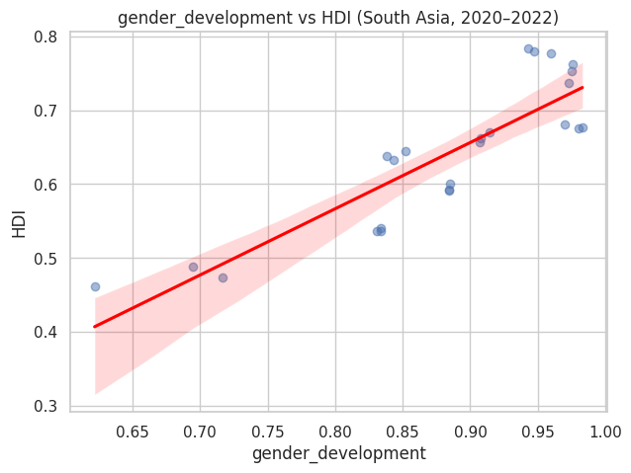
High positive correlation in the regression plot which means that gender equality is closely related to the general human development.
- Figure 8. Life Expectancy vs HDI (South Asia).
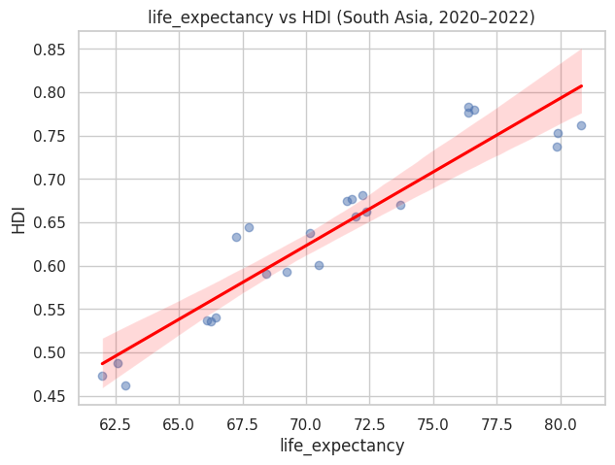
This regression graph indicates that the length of the life expectancy is a significant predictor of the increase in the HDI, which makes it clear that health outcomes are a crucial factor to consider.
- Figure 9. Positive and negative GNI–HDI gaps.
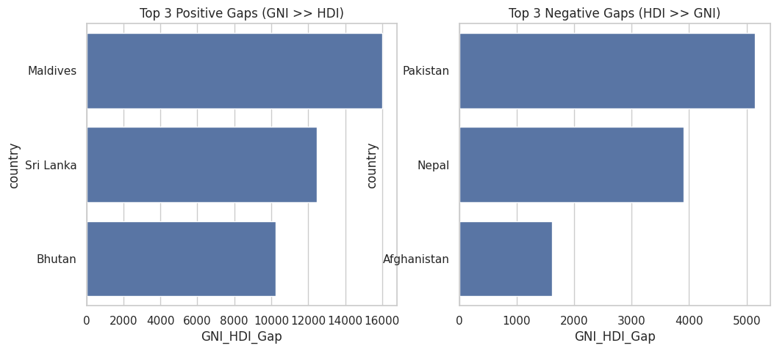
The bar charts compare the countries whose income is above the expectations of HDI and those where HDI is higher in relation to income. Large positive gaps imply that there has been underutilization of wealth whereas negative gaps imply that there has been efficiency in the transformation of resources into development.

Problem 3

Comparative Regional Analysis (South Asia vs Middle East)
Data for both regions was extracted and cleaned. Descriptive statistics, rankings, and comparative metrics (gender development, life expectancy, GNI per capita) were calculated. Visualizations included bar charts, regression plots, and scatter plots to highlight disparities, correlations, and outliers.
Key Results
- Top performers: UAE, Israel, and Bahrain in the Middle East; Sri Lanka, Maldives, and Bhutan in South Asia.
- Bottom performers: Afghanistan, Pakistan, and Nepal in South Asia; Yemen, Syria, and Iraq in the Middle East.
- Metric comparison: Middle Eastern countries generally showed higher GNI and life expectancy averages, while South Asia lagged.
- Correlations: Stronger link between gender development and HDI in the Middle East; moderate but positive in South Asia.
- Outliers: Some resource-rich Middle Eastern states underperformed in HDI relative to income, while certain South Asian nations achieved higher HDI despite modest GNI.
Figures:
- Figure 10. Top 3 HDI performers (South Asia vs Middle East).
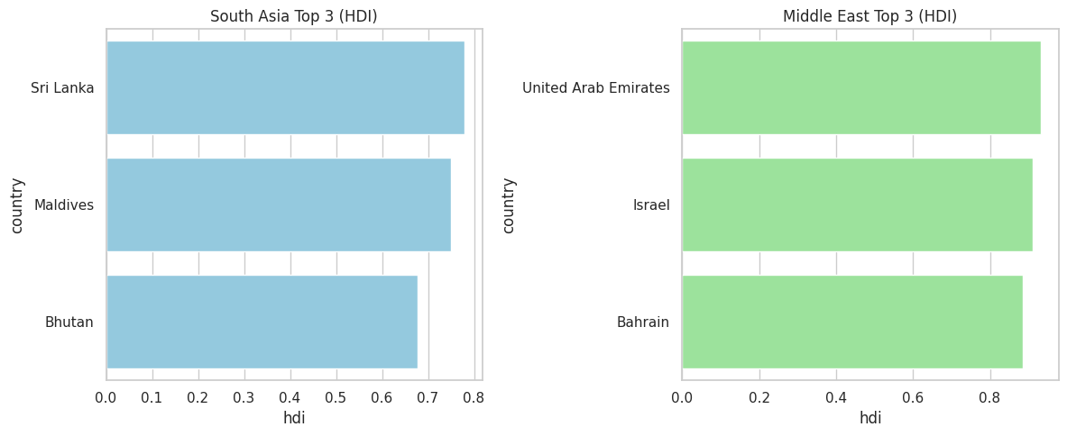
The bar chart compares top countries in the regions. The Middle Eastern countries are usually ranked better and indicate better economic and social outcomes.
- Figure 11. Bottom 3 HDI performers (South Asia vs Middle East).
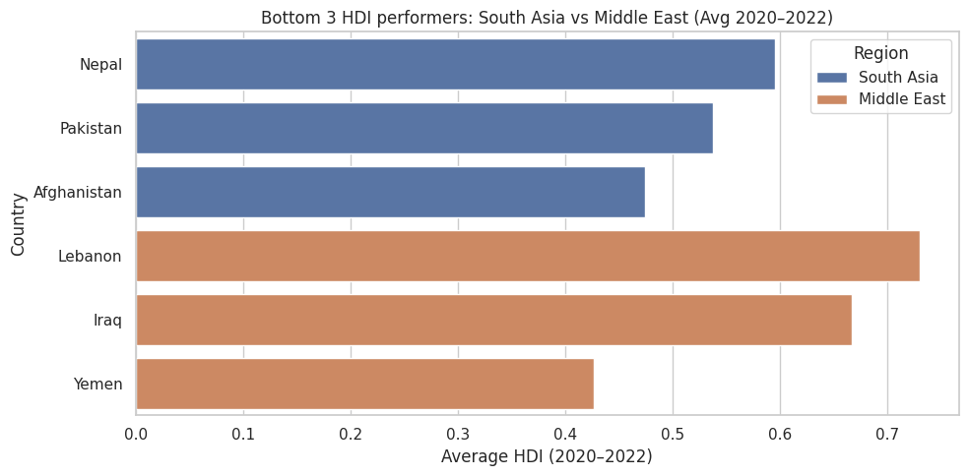
This chart shows the laggards among countries in the two regions. The lowest performing in South Asia have continued to have problems of income and education and Middle East laggards tend to have conflict or unrest issues.
- Figure 12. Metric comparison across regions.
Not generated due to dataset limitations
- Figure 13. Gender Development vs HDI (South Asia).
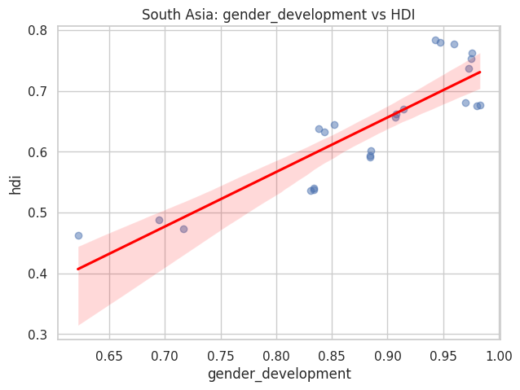
The regression plot results indicate a moderate correlation implying that gender equity gains directly improve the situation with HDI in South Asia.
- Figure 14. Gender Development vs HDI (Middle East).
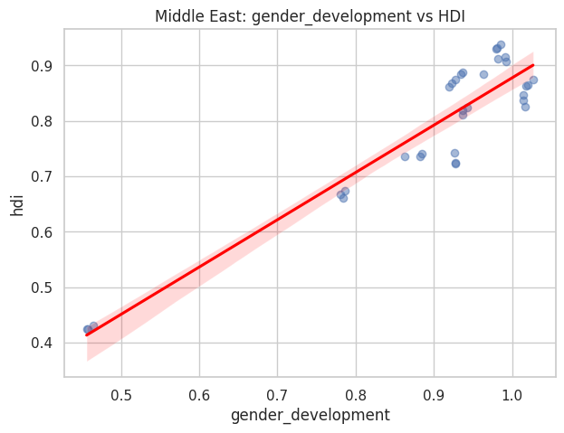
This plot displays a higher correlation, meaning that gender equality is a critical HDI in the Middle East countries.
- Figure 15. Life Expectancy vs HDI (South Asia).

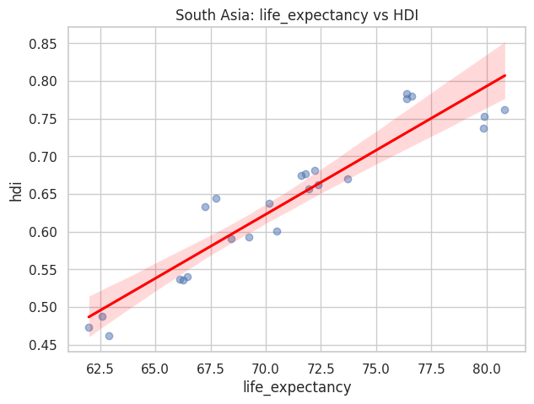
- Although it varies, the regression line confirms that one of the biggest factors influencing HDI in South Asia is health outcomes.
- Figure 16. Life Expectancy vs HDI (Middle East).
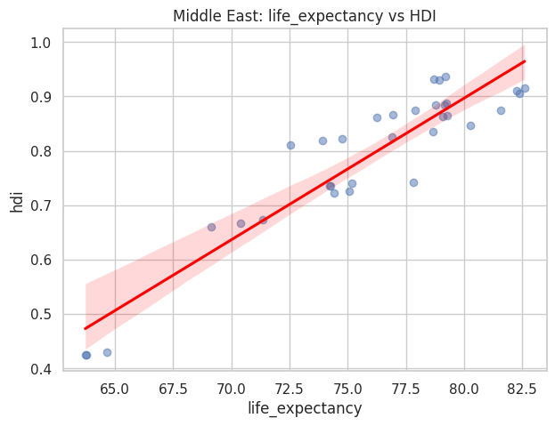
Regression line affirms that the health outcomes are one of the greatest determinants of HDI in South Asia, but with variability.
- Figure 17. Outliers in HDI vs GNI (South Asia, 2022).
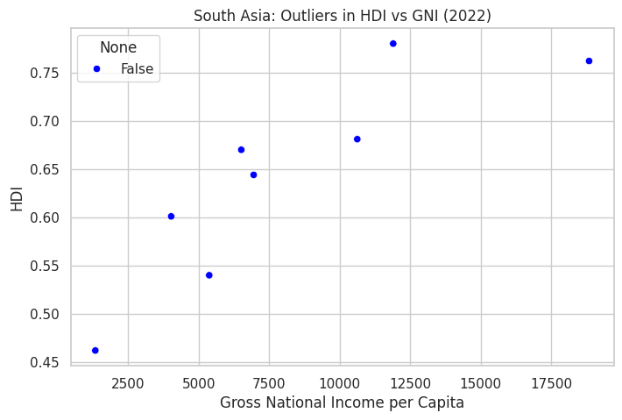
The scatter plot identifies countries with unusual HDI–income profiles. Some nations achieve higher HDI despite modest income, while others underperform relative to wealth.
- Figure 18. Outliers in HDI vs GNI (Middle East, 2022).
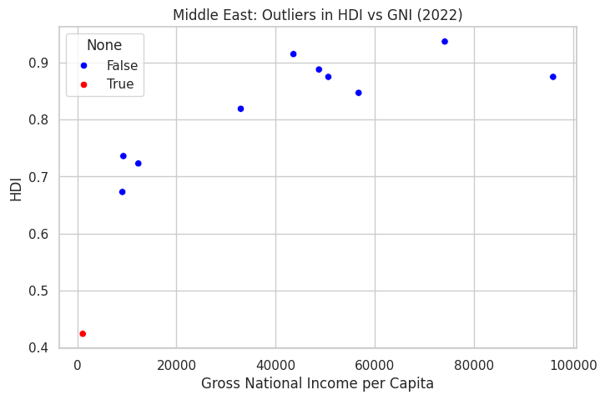
This chart highlights Middle Eastern countries deviating from expected patterns. Resource‑rich states may show high income but lower HDI, while others achieve strong HDI with moderate income.

Conclusion
Summary of Findings:
The analysis shows that HDI generally improves with higher GNI per capita, but health and education outcomes are equally critical. South Asian countries demonstrate gradual progress, while Middle Eastern nations often achieve higher HDI due to stronger economic and social indicators. Outlier analysis highlights both inefficiencies in resource use and resilience in lower-income nations.
Insights on HDI Trends and Disparities:
Between 2020 and 2022, HDI trends reveal uneven recovery from COVID-19, with widening disparities across countries. Gender development and life expectancy consistently emerge as strong predictors of HDI, underscoring the multidimensional nature of human progress. Regional comparisons show persistent gaps between South Asia and the Middle East, particularly in income and health outcomes.
Limitations:
The dataset lacked explicit regional labels and some metrics, restricting the scope of regional averages and comparative analysis. Composite scores relied on normalized indices, which may oversimplify complex realities.
Recommendations / Implications:
Future research should integrate broader datasets with richer regional and policy variables to capture nuanced drivers of HDI. Policymakers should prioritize investments in health and education, alongside economic growth, to ensure balanced and resilient development. Addressing gender disparities and improving life expectancy remain essential strategies for advancing human development.

References
- United Nations Development Programme (UNDP). Human Development Index Methodology.
- Dataset: Human_Develop_Index.csv.

