NATIONAL UNIVERSITY OF SCIENCE AND TECHNOLOGY POLITEHNICA BUCHAREST
Faculty of Electronics, Telecommunications and Information Technology
MES Project
Volume control using an ultrasonic sensor
Author: Andronic Smaranda
Master’s Program: ACES

2025-2026

Contents
1. Project description 2
2. Hardware description 2
3. Software description 2
4. Problems and solutions (optional) 2
5. Conclusions 2
6. Source code 2

Project description
Using an ultrasonic sensor, I am modifying the volume of a buzzer according to the distance to an object (my hand). If the distance between the sensor and the hand is smaller than a certain threshold, the sound will be turned on and off (the alarm will be triggered). If the buzzer is on, I can modify the buzzer volume by moving the hand closer or farther the sensor in a continuous motion.

Hardware description
Components used:
- Microcontroller: STM32L476 Nucleo development board : ARM Cortex-M4 based microcontroller
- HC-SR04 ultrasonic distance sensor
- Buzzer : Active Buzzer

The system measures the distance of an object using ultrasonic echo timing and triggers an audible alarm whose behaviour depends on the measured distance. The STM32 microcontroller handles sensor triggering, echo time measurement using hardware timers, distance computation, and buzzer control.

The HC-SR04 ultrasonic sensor measures distance by emitting an ultrasonic pulse and returning an echo signal. It is powered from 5 V supplied by the Nucleo board.
The TRIG pin is connected to PA10, where the microcontroller generates a 10 µs trigger pulse. The ECHO pin is connected to PA8, configured as TIM1 input capture, allowing accurate measurement of the echo pulse width.
An active buzzer is used as the alarm indicator. It is connected to PA6, which supports TIM3_CH1 PWM output. Although the buzzer is active, PWM is used to control the alarm behaviour.
The buzzer, sensor, and microcontroller share a common ground.
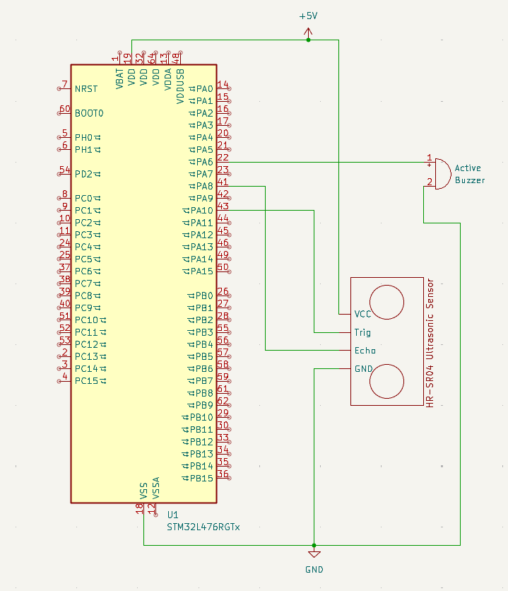

Software description
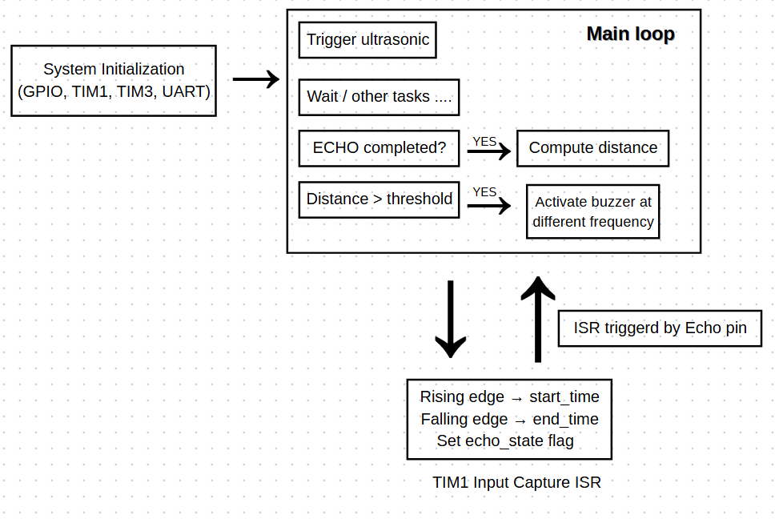

Software Implementation Description
The software is structured around a non-blocking main loop combined with interrupt-driven timing measurements. The main loop periodically triggers the ultrasonic sensor by generating a 10 µs pulse on the trigger pin. After triggering, the program continues running while waiting for the echo signal to be captured by the timer hardware.
The echo pin is connected to TIM1 in input capture mode, which generates interrupts on both the rising and falling edges of the echo signal. When the rising edge interrupt occurs, the current timer value is stored as the start time. When the falling edge interrupt occurs, the end time is recorded. This interrupt-based approach allows precise time measurement without polling or delaying the CPU.
Once both edges have been captured, the main loop computes the distance from the measured pulse width and adjusts the buzzer output accordingly. The buzzer is driven using TIM3 PWM output, where the PWM frequency is changed based on the measured distance. This design separates time-critical operations (handled in interrupts) from higher-level processing (handled in the main loop), resulting in accurate measurements and responsive system behaviour.

Problems and solutions
System clock configuration:
Problem:
The system clock was unintentionally divided by 16
(RCC_ClkInitStruct.AHBCLKDivider = RCC_SYSCLK_DIV16), resulting in a core frequency of 1 MHz instead of 16 MHz. All timing-dependent operations (timers, delays, and sensor measurements) ran 16 x slower than expected, causing incorrect ultrasonic distance measurements and unstable system behavior.
Solution:
The AHB prescaler was changed to RCC_SYSCLK_DIV1, restoring the full 16 MHz system clock and correct timing operation.
UART Debugging Interference
Problem:
Extensive UART debug messages were used during development, including transmissions from inside interrupt service routines.
UART transmissions are blocking operations and introduced significant delays, preventing time-critical interrupts from completing in time and causing missed ultrasonic echo pulses.
Solution:
All UART transmissions were removed from interrupt handlers. Debug messages were kept only in the main loop, ensuring reliable interrupt timing and correct sensor operation.

Conclusions
This project successfully implemented an ultrasonic distance measurement system using the STM32L476RG microcontroller. Accurate timing was achieved by using hardware timers and input capture interrupts, allowing precise measurement of the echo pulse width without blocking the main program flow. The final system operates reliably, triggers alarms based on measured distance, and demonstrates effective use of low-level timer configuration, interrupt-driven design, and structured software state management.

Source code

/* Includes ------------------------------------------------------------------*/
#include "main.h"

/* Private includes ----------------------------------------------------------*/
/* USER CODE BEGIN Includes */
#include <stdio.h>
#include <string.h>
/* USER CODE END Includes */

/* Private define ------------------------------------------------------------*/
/* USER CODE BEGIN PD */
#define BUZZER_PIN GPIO_PIN_6

#define TRIGGER_PIN GPIO_PIN_10
#define TRIG_PORT GPIOA
#define TRIG_DELAY_TIME 10 //10 us

#define ECHO_PORT GPIOA
#define ECHO_PIN GPIO_PIN_8

#define MIN_SENSOR_THRESHOLD 25
#define MIN_ALARM_TRIGGER_TIME 1000
#define MIN_SENSOR_DISTANCE 2

#define ECHO_TIMEOUT_US 25000 // ~4 meters

#define TONES_ARRAY_SIZE 7
#define NEXT_TONE_OFFSET 3

#define BUZZER_BASE_FREQ 3000

uint16_t tones[TONES_ARRAY_SIZE] = {
2, // 2 cm
5, // 5cm
7,
15,
20,
25,
30 //24
};

/* USER CODE END PD */

/* Private macro -------------------------------------------------------------*/
/* USER CODE BEGIN PM */
volatile uint32_t start_time = 0;
volatile uint32_t end_time = 0;
typedef enum
{
ECHO_IDLE = 0,
ECHO_WAIT_RISING,
ECHO_WAIT_FALLING,
ECHO_DONE
} EchoState_t;
volatile EchoState_t echo_state = ECHO_IDLE;

float distance = 0;
/* USER CODE END PM */

/* Private variables ---------------------------------------------------------*/
TIM_HandleTypeDef htim1;
TIM_HandleTypeDef htim3;
UART_HandleTypeDef huart2;

/* Private function prototypes -----------------------------------------------*/
void SystemClock_Config(void);
static void MX_GPIO_Init(void);
static void MX_USART2_UART_Init(void);
static void MX_TIM3_Init(void);

/* Private user code ---------------------------------------------------------*/
/* USER CODE BEGIN 0 */

void TIM1_InputCapture_Init(void)
{
RCC->APB2ENR |= RCC_APB2ENR_TIM1EN;

TIM1->PSC = 15;
TIM1->ARR = 0xFFFF;

// CH1 input, mapped to TI1
TIM1->CCMR1 &= ~TIM_CCMR1_CC1S;
TIM1->CCMR1 |= TIM_CCMR1_CC1S_0;

// both edges
TIM1->CCER &= ~(TIM_CCER_CC1P | TIM_CCER_CC1NP);
TIM1->CCER |= (TIM_CCER_CC1P | TIM_CCER_CC1NP);

// enable capture on channel 1
TIM1->CCER |= TIM_CCER_CC1E;

// Enable capture interrupt
TIM1->DIER |= TIM_DIER_CC1IE;

// NVIC
NVIC_SetPriority(TIM1_CC_IRQn, 0);
NVIC_EnableIRQ(TIM1_CC_IRQn);

TIM1->CR1 |= TIM_CR1_CEN;
}

void TIM1_CC_IRQHandler(void)
{
if (TIM1->SR & TIM_SR_CC1IF)
{
uint32_t captured = TIM1->CCR1;

if (echo_state == ECHO_WAIT_RISING)
{
start_time = captured;
echo_state = ECHO_WAIT_FALLING;
}
else if (echo_state == ECHO_WAIT_FALLING)
{
end_time = captured;
echo_state = ECHO_DONE;
}

TIM1->SR &= ~TIM_SR_CC1IF;
}
}

void Sensor_Trigger(void)
{
TIM1->CNT = 0;

GPIOA->BSRR = (1 << 10); // TRIG HIGH
while(TIM1->CNT < TRIG_DELAY_TIME); // Wait 10µs
GPIOA->BSRR = (1 << (10 + 16)); // TRIG LOW

// Wait a bit for the trigger pulse to settle before starting capture
while(TIM1->CNT < 20); // Wait 20µs total

echo_state = ECHO_WAIT_RISING; // start waiting for echo
}

void Buzzer_Init(void)
{
// Enable TIM3 clock
RCC->APB1ENR1 |= RCC_APB1ENR1_TIM3EN;
TIM3->PSC = 15;

// PWM mode 1 on Channel 1
TIM3->CCMR1 &= ~(7 << 4);
TIM3->CCMR1 |= (6 << 4); // PWM mode 1

// Enable preload for CCR1
TIM3->CCMR1 |= TIM_CCMR1_OC1PE;

// Enable CH1 output
TIM3->CCER |= TIM_CCER_CC1E;

// Enable auto-reload preload
TIM3->CR1 |= TIM_CR1_ARPE;

// Start timer
TIM3->CR1 |= TIM_CR1_CEN;
}

void Buzzer_SetFrequency(uint32_t freq)
{
if (freq == 0) {
TIM3->CCR1 = 0; // silence
return;
}

uint32_t arr = (1000000 / freq) - 1;

TIM3->ARR = arr;
TIM3->CCR1 = arr / 2; // 50% duty cycle

TIM3->EGR |= TIM_EGR_UG; // force update
}

void Trigger_Alarm(uint16_t distance){

if(distance < MIN_SENSOR_THRESHOLD){ //we will trigger the alarm
uint16_t rest = (distance - MIN_SENSOR_DISTANCE) / NEXT_TONE_OFFSET;
uint16_t pwm_ratio = tones[rest];
Buzzer_SetFrequency(pwm_ratio);
}
else{
Buzzer_SetFrequency(0);
}
}

float Compute_Distance (uint32_t start_time, uint32_t end_time)
{
if (end_time <= start_time) {
return -1.0f; // Invalid measurement
}

float duration = (float)(end_time - start_time);

// HC-SR04 should take at least 150µs for ~2.5cm
if (duration < 100) {
return -1.0f; // too short. likely noise
}

float distance = duration * 0.034f / 2.0f;
return distance;
}

/* USER CODE END 0 */

/**
* @brief The application entry point.
* @retval int
*/

int main(void)
{

/* Reset of all peripherals, Initializes the Flash interface and the Systick. */
HAL_Init();

/* Configure the system clock */
SystemClock_Config();

/* Initialize all configured peripherals */
MX_GPIO_Init();
TIM1_InputCapture_Init(); //my version of MX_TIM
MX_USART2_UART_Init();
Buzzer_Init(); // TIM3 init
/* USER CODE BEGIN 2 */

char msg[40];
int len = sprintf(msg, "System started!\r\n");
HAL_UART_Transmit(&huart2, (uint8_t*)msg, len, HAL_MAX_DELAY);

static uint32_t last_trigger = 0;
/* USER CODE END 2 */

/* Infinite loop */
/* USER CODE BEGIN WHILE */
while (1)
{
if (HAL_GetTick() - last_trigger >= 100) { // Trigger every 100ms
Sensor_Trigger();
last_trigger = HAL_GetTick();
}

if (echo_state == ECHO_DONE)
{
distance = Compute_Distance(start_time, end_time);
echo_state = ECHO_IDLE;

if (distance > 0) {
char msg[50];
int len = sprintf(msg, "Distance: %.2f cm\r\n", distance);
HAL_UART_Transmit(&huart2,(uint8_t*)msg, len, HAL_MAX_DELAY);
Trigger_Alarm(distance);
}
}
}
/* USER CODE END 3 */
}

/**
* @brief System Clock Configuration
* @retval None
*/
void SystemClock_Config(void)
{
RCC_OscInitTypeDef RCC_OscInitStruct = {0};
RCC_ClkInitTypeDef RCC_ClkInitStruct = {0};

/** Configure the main internal regulator output voltage
*/
if (HAL_PWREx_ControlVoltageScaling(PWR_REGULATOR_VOLTAGE_SCALE1) != HAL_OK)
{
Error_Handler();
}

/** Initializes the RCC Oscillators according to the specified parameters
* in the RCC_OscInitTypeDef structure.
*/
RCC_OscInitStruct.OscillatorType = RCC_OSCILLATORTYPE_HSI;
RCC_OscInitStruct.HSIState = RCC_HSI_ON;
RCC_OscInitStruct.HSICalibrationValue = RCC_HSICALIBRATION_DEFAULT;
RCC_OscInitStruct.PLL.PLLState = RCC_PLL_NONE;
if (HAL_RCC_OscConfig(&RCC_OscInitStruct) != HAL_OK)
{
Error_Handler();
}

/** Initializes the CPU, AHB and APB buses clocks
*/
RCC_ClkInitStruct.ClockType = RCC_CLOCKTYPE_HCLK|RCC_CLOCKTYPE_SYSCLK
|RCC_CLOCKTYPE_PCLK1|RCC_CLOCKTYPE_PCLK2;
RCC_ClkInitStruct.SYSCLKSource = RCC_SYSCLKSOURCE_HSI;
RCC_ClkInitStruct.AHBCLKDivider = RCC_SYSCLK_DIV1;
RCC_ClkInitStruct.APB1CLKDivider = RCC_HCLK_DIV1;
RCC_ClkInitStruct.APB2CLKDivider = RCC_HCLK_DIV1;

if (HAL_RCC_ClockConfig(&RCC_ClkInitStruct, FLASH_LATENCY_0) != HAL_OK)
{
Error_Handler();
}
}

/**
* @brief TIM3 Initialization Function
* @param None
* @retval None
*/
static void MX_TIM3_Init(void)
{

/* USER CODE BEGIN TIM3_Init 0 */
//
/* USER CODE END TIM3_Init 0 */

TIM_ClockConfigTypeDef sClockSourceConfig = {0};
TIM_MasterConfigTypeDef sMasterConfig = {0};
TIM_OC_InitTypeDef sConfigOC = {0};

/* USER CODE BEGIN TIM3_Init 1 */
//
/* USER CODE END TIM3_Init 1 */
htim3.Instance = TIM3;
htim3.Init.Prescaler = 0;
htim3.Init.CounterMode = TIM_COUNTERMODE_UP;
htim3.Init.Period = 65535;
htim3.Init.ClockDivision = TIM_CLOCKDIVISION_DIV1;
htim3.Init.AutoReloadPreload = TIM_AUTORELOAD_PRELOAD_DISABLE;
if (HAL_TIM_Base_Init(&htim3) != HAL_OK)
{
Error_Handler();
}
sClockSourceConfig.ClockSource = TIM_CLOCKSOURCE_INTERNAL;
if (HAL_TIM_ConfigClockSource(&htim3, &sClockSourceConfig) != HAL_OK)
{
Error_Handler();
}
if (HAL_TIM_PWM_Init(&htim3) != HAL_OK)
{
Error_Handler();
}
sMasterConfig.MasterOutputTrigger = TIM_TRGO_RESET;
sMasterConfig.MasterSlaveMode = TIM_MASTERSLAVEMODE_DISABLE;
if (HAL_TIMEx_MasterConfigSynchronization(&htim3, &sMasterConfig) != HAL_OK)
{
Error_Handler();
}
sConfigOC.OCMode = TIM_OCMODE_PWM1;
sConfigOC.Pulse = 0;
sConfigOC.OCPolarity = TIM_OCPOLARITY_HIGH;
sConfigOC.OCFastMode = TIM_OCFAST_DISABLE;
if (HAL_TIM_PWM_ConfigChannel(&htim3, &sConfigOC, TIM_CHANNEL_1) != HAL_OK)
{
Error_Handler();
}
/* USER CODE BEGIN TIM3_Init 2 */
//
/* USER CODE END TIM3_Init 2 */
HAL_TIM_MspPostInit(&htim3);

}

/**
* @brief USART2 Initialization Function
* @param None
* @retval None
*/
static void MX_USART2_UART_Init(void)
{

/* USER CODE BEGIN USART2_Init 0 */

/* USER CODE END USART2_Init 0 */

/* USER CODE BEGIN USART2_Init 1 */

/* USER CODE END USART2_Init 1 */
huart2.Instance = USART2;
huart2.Init.BaudRate = 9600;
huart2.Init.WordLength = UART_WORDLENGTH_8B;
huart2.Init.StopBits = UART_STOPBITS_1;
huart2.Init.Parity = UART_PARITY_NONE;
huart2.Init.Mode = UART_MODE_TX_RX;
huart2.Init.HwFlowCtl = UART_HWCONTROL_NONE;
huart2.Init.OverSampling = UART_OVERSAMPLING_16;
huart2.Init.OneBitSampling = UART_ONE_BIT_SAMPLE_DISABLE;
huart2.AdvancedInit.AdvFeatureInit = UART_ADVFEATURE_NO_INIT;
if (HAL_UART_Init(&huart2) != HAL_OK)
{
Error_Handler();
}
/* USER CODE BEGIN USART2_Init 2 */

/* USER CODE END USART2_Init 2 */

}

/**
* @brief GPIO Initialization Function
* @param None
* @retval None
*/
static void MX_GPIO_Init(void)
{
GPIO_InitTypeDef GPIO_InitStruct = {0};
/* USER CODE BEGIN MX_GPIO_Init_1 */

/* USER CODE END MX_GPIO_Init_1 */

/* GPIO Ports Clock Enable */
__HAL_RCC_GPIOA_CLK_ENABLE();

/*Configure GPIO pin Output Level */
HAL_GPIO_WritePin(GPIOA, GPIO_PIN_10, GPIO_PIN_RESET);

/*Configure GPIO pin : PA8 */
GPIO_InitStruct.Pin = GPIO_PIN_8;
GPIO_InitStruct.Mode = GPIO_MODE_AF_PP; // alternate function push-pull
GPIO_InitStruct.Pull = GPIO_NOPULL;
GPIO_InitStruct.Speed = GPIO_SPEED_FREQ_HIGH;
GPIO_InitStruct.Alternate = GPIO_AF1_TIM1; // TIM1_CH1
HAL_GPIO_Init(GPIOA, &GPIO_InitStruct);

/*Configure GPIO pins : PA10 */
GPIO_InitStruct.Pin = GPIO_PIN_10;
GPIO_InitStruct.Mode = GPIO_MODE_OUTPUT_PP;
GPIO_InitStruct.Pull = GPIO_NOPULL;
GPIO_InitStruct.Speed = GPIO_SPEED_FREQ_LOW;
HAL_GPIO_Init(GPIOA, &GPIO_InitStruct);

/* USER CODE BEGIN MX_GPIO_Init_2 */
/* Configure PA6 as TIM3_CH1 (PWM output for buzzer) */
GPIO_InitStruct.Pin = GPIO_PIN_6;
GPIO_InitStruct.Mode = GPIO_MODE_AF_PP;
GPIO_InitStruct.Pull = GPIO_NOPULL;
GPIO_InitStruct.Speed = GPIO_SPEED_FREQ_HIGH;
GPIO_InitStruct.Alternate = GPIO_AF2_TIM3;
HAL_GPIO_Init(GPIOA, &GPIO_InitStruct);
/* USER CODE END MX_GPIO_Init_2 */
}

/**
* @brief This function is executed in case of error occurrence.
* @retval None
*/
void Error_Handler(void)
{
/* USER CODE BEGIN Error_Handler_Debug */
/* User can add his own implementation to report the HAL error return state */
__disable_irq();
while (1)
{
}
/* USER CODE END Error_Handler_Debug */
}
#ifdef USE_FULL_ASSERT
/**
* @brief Reports the name of the source file and the source line number
* where the assert_param error has occurred.
* @param file: pointer to the source file name
* @param line: assert_param error line source number
* @retval None
*/
void assert_failed(uint8_t *file, uint32_t line)
{
/* USER CODE BEGIN 6 */
/* User can add his own implementation to report the file name and line number,
ex: printf("Wrong parameters value: file %s on line %d\r\n", file, line) */
/* USER CODE END 6 */
}
#endif /* USE_FULL_ASSERT */

