

**Faculty of Engineering, Design and Technology**

**Department of Computing and Technology**

**INDUSTRIAL PLACEMENT PROGRAMME**

**PRACTICAL TRAINING REPORT**

**July 2024**

**NAME : BALIGEYA DEOGRATIAUS**

**Reg. No. : S23B13/096**

**COURSE : BSIT**

**COMPANY NAME : UNIVERSITY ICT SERVICES**

**COMPANY SUPERVISOR: MUSASIZI KENNETH**

**FACULTY SUPERVISOR : MR. KUBANJA MARTIN**

**DATE OF SUBMISSION : 26TH JULY 2024**

#### PREFACE

This report covers the operations of University ICT Services (UCU) and details the experiences during training in the Information Technology department. It encompasses the historical background of the institution, the structure and functions of the Information Technology (IT) department, the tasks assigned to the intern, the objectives of the training, the recommendations made, the challenges faced, and the conclusion.

#### DECLARATION

I, Baligeya Deogratiaus, hereby declare that this report is my own original work and has not been submitted to any other institution. The content of this document has been compiled and prepared following the completion of my industrial training at University ICT Services. This report has not been published or presented to any other university for the pursuit of a higher degree.

Sign: ____________________

Date: ____________________

#### DEDICATION

This report is dedicated to all students who have a fervent love for ICT and computer technology. May your passion drive you to explore new horizons, innovate with creativity, and contribute positively to the technological landscape.

Your commitment to mastering technology and embracing its challenges inspires a future where innovation thrives and solutions abound. Remember, perseverance and a thirst for knowledge are key to achieving greatness in this dynamic field.

May your journey in ICT be filled with learning, growth, and exciting opportunities.

#### ACKNOLGEDEMENT

I am sincerely thankful for the invaluable internship experience I had with University ICT Services. This period has been instrumental in my professional and personal development. I would like to express my deepest gratitude to my field supervisors: Mr. Musasizi Kenneth, Systems Developer; Mr. Mbogo Aggrey, Network Administrator; Mr. Edward Musitwa, Network Assistant; Mr. Twongirwe Son, Web Developer; Mrs. Salome Sanyu, Web Developer; Mr.Nuwhasima Amos, System Administrator; Madam Dorcus Kogaya, System Administrator Assistant; and Mr. Kakama Daniel, System Support. Their willingness to share their expertise and provide guidance, despite their demanding schedules, has been greatly appreciated. Their mentorship has been a cornerstone of my learning during this internship.

I also extend my heartfelt thanks to my parents for their unwavering support, particularly given that the company did not provide any allowance. Their encouragement and assistance have been indispensable.

Thank you to everyone who contributed to making this internship a profoundly enriching experience.

#### ABSTRACT

This internship report offers an in-depth account of my field attachment experience at University ICT Services. It outlines the objectives and background of the internship while providing a detailed look into the organizational culture, structure, and core activities at UIS. The report also examines the IT infrastructure at UIS, highlighting aspects such as networking devices, hardware repair and maintenance, local area

network (LAN) configurations, and IT security measures.

The report emphasizes my participation in a range of activities during the field attachment, including hardware repair and maintenance, operating system installations, and the configuration of LAN and wireless networks. It also explores the deployment and management of virtualization technologies and outlines the duties of a system administrator, addressing potential network threats and their corresponding solutions.

A key focus of the report is the process of interacting with virtual containers and servers, specifically during the installation of MariaDB and WordPress. This section details the creation of a development environment for website projects, outlining the advantages, challenges, and operational aspects of managing these virtualized resources.

Throughout the internship, practical experience and valuable insights were gained into the IT operations at University ICT Services, contributing to professional growth and a deeper understanding of real-world challenges in the field. The report concludes with reflections on the overall internship experience and its impact on personal and professional development.

#### ABBREVIATIONS AND ACRONYMS

API………………………………………………Application Programming Interface  
BIOS……………………………………………..Basic Input/Output System  
CPU………………………………………………Central Processing Unit  
CSS……………………………………………….Cascading Style Sheets  
DNS…………………………………………….…Domain Name System  
FTP…………………………………………………File Transfer Protocol  
GPU…………………………………………………Graphics Processing Unit  
GUI……………………………………………….…Graphical User Interface  
HDD…………………………………………………Hard Disk Drive  
HTML………………………………………………Hypertext Markup Language  
IDE……………………………………………Integrated Development Environment  
IP………………………………………………Internet Protocol  
RAM……………………………………………Random Access Memory  
SSH……………………………………………Secure Shell  
TCP………………………………………………Transmission Control Protocol  
UEFI……………………………………… Unified Extensible Firmware Interface  
USB……………………………………………Universal Serial Bus  
VM…………………………………………………Virtual Machine  
WIFI………………………………………………………Wireless Fidelity  
JS……………………………………………………JavaScript

**Cp…………………………………………………….c**opy

**Scp……………………………………………………**Secure Copy Protocol

**mv**……………………………………………………………Move

**rm**…………………………………………………………………Remove

**ls**………………………………………………………………………List

**cd**……………………………………………………………………Change Directory

**chmod**………………………………………………………………Change Mode

**chown**……………………………………………………………Change Owner

**grep**………………………………………………Global Regular Expression Print

**find**………………………………………………………………………Find

**tar**……………………………………………………………………Tape Archive

**gzip**……………………………………………………………………………GNU Zip

**sudo**……………………………………………………………………Super User Do

**ps**……………………………………………………………………Process Status

**top**…………………………………………………………………Table of Processes

**df**……………………………………………………………………………Disk Free **du**………………………………………………………………………Disk Usage

**ifconfig**………………………………………………………Interface Configuration **route**………………………………………………………………Routing Ta

**apt**…………………………………………………………Advanced Package Tool

**ssh**…………………………………………………………………………Secure Shell

**ftp**………………………………………………………………File Transfer Protocol

**wget**……………………………………………………………………………Web Get

**curl**…………………………………………………………………Client for URLs

Table Of Contents

CHAPTER ONE 1

CHAPTER TWO - COMPUTER NETWORKS AND SYSTEMS ADMINISTRATION 5

2.3.1 STATIC IP ADDRESS 7

2.3.2. ASSIGNING A DYNAMIC IP ADDRESS TO A COMPUTER: 8

CHAPTER THREE - WEB PROGRAMMING 22

**C:\Users\ISRAEL UG\Desktop\deo.tar.gz,** 28

**1. Install osTicket Dependencies** 31

**2. Create a Directory for osTicket** 32

**3. Create a Virtual Host File** 34

CHAPTER FOUR - SOFTWARE DEVELOPMENT 39

4.2.1. DEVELOPING THE ENTITY RELATION DIAGRAM FOR INSTANCE MANAGEMENT SYSTEM 42

Detailed Analysis: 42

System Development Steps 43

Flow chart 46

Entity-Relationship Diagram (ERD) Analysis: 47

Comparison: 47

4.2.2. AN ILLUSTRATION OF A FLOW CHART FOR INSTANCE MANAGEMENT SYSTEM 50

CHAPTER FIVE - CONCLUSION, LIMITATION, AND RECOMMENDATION. 57

REFERENCES 60

APPENDIX 62

# CHAPTER ONE

## 1.1.INTRODUCTION

This chapter outlines the company’s background, aims and objectives, organizational structure, key business operations, vision, mission, and motto.

## 1.2. BACKGROUND OF THE ORANIZATION.

Since its inception in 1997, Uganda Christian University (UCU) has been a beacon of academic excellence, evolving from the historic Bishop Tucker Theological College into a premier university. Today, UCU boasts a vibrant community of over 14,000 students as of 2020 record on Google, and has expanded its reach across the country through its various colleges. At CU, we challenge our students with rigorous courses, expecting high levels of commitment, ability, and motivation. In return, students experience profound intellectual satisfaction, a well-rounded education, and enhanced employability in both industry and academia.

University ICT Services (UIS) is a pivotal department at UCU, responsible for coordinating the provision of Information and Communications Technology (ICT) services across the university's diverse functional units. Recognizing ICT as a crucial enabler for achieving its strategic goals, UCU has structured UIS into three main units: Directorate, Systems, and Infrastructure. UIS delivers a comprehensive range of ICT services, including email, internet, and telephone services, computer labs, library commons, and technical support, thereby empowering students and staff to leverage and comprehend ICT effectively.

## 1.3. VISION OF THE ORGANIZATION

To fully utilize ICT to provide enhanced support for teaching, learning, research and administration.

## 1.4. MOTTO OF THE ORGANIZATION

"Inspire, Innovate, Connect."

## 1.5. THE AIMS OF THE ORGANIZATION ARE AS FOLLOWS:

1. Develop ICT as an essential resource to support UCU’s vision and mission
2. Support and promote ICT proliferation throughout the university
3. Harness e-Learning to support teaching and learning and research
4. Support collaboration with other higher education institutions for learning and research
5. Ensure sustainable use of ICT resources
6. Ensure business continuity of digitize University services.

## 1.6. ORGANIZATION STRUCTURE OF UNIVERSITY ICT SERVIVES

University ICT Services (UIS) is led by a Director, who is supported by a Technical Manager (TM) and an Administrative Assistant. This leadership team is responsible for setting the strategic direction and policies for the department. The department is organized into two primary sections: Systems and Infrastructure.

The Systems section is overseen by the Head Systems Administrator, who manages the overall administration of IT systems. This section includes roles such as the Network Administrator, who handles the maintenance and performance of network systems, and the Network Specialist, who addresses advanced network issues and specialized tasks. Additionally, the User Support Specialist within this section provides technical support to end-users and resolves system-related issues.

In the Infrastructure section, the Head of Infrastructure is responsible for the strategic planning and implementation of IT infrastructure. The team in this section includes Network Technicians, who are tasked with the installation, maintenance, and repair of network equipment, and Lab Technicians, who manage and support computer labs to ensure hardware and software functionality. Lab Attendants assist users in the labs and provide basic technical support.

#### Justification of Organizational Structure:

An effective organizational structure is crucial as it provides clarity and efficiency by defining clear roles and responsibilities, which helps prevent confusion and overlap of duties. This clarity ensures that tasks are executed efficiently and effectively. Additionally, a well-defined structure enhances coordination and communication within the department, establishing reporting lines and information flow channels that are essential for decision-making and problem-solving.

Furthermore, an organized structure supports strategic management by aligning resources and personnel with the department’s goals and objectives. This alignment aids in achieving desired outcomes and adapting to changes in the organizational environment. It also sets up a system of accountability by clearly identifying responsibilities, which helps to monitoring performance and evaluating results.

## 1.7. AN ILLUSTARTION OF THE UIS ORGANISTATION STRUCTURE

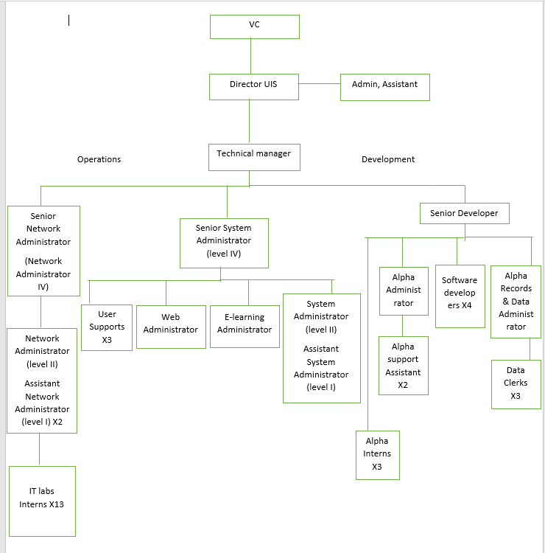

**Figure 1.1: UIS Organizational Structure**

## 1.8. MAIN ACTIVITIES / BUSSINESS OPERATIONS

The main activities carried out in the university ICT services are under the aspects of system administration, networks, and system support & maintenance, and they assist the university in the following ways.

1. Responsible for the deployment and maintenance of all aspects of ICT infrastructure and office equipment.
2. Registering and authorizing end users (students and staff) on the UCU network.
3. Providing technical and logistical support to any faculty-led initiative to implement e-learning programs.

# CHAPTER TWO - COMPUTER NETWORKS AND SYSTEMS ADMINISTRATION

## 2.1 INRODUCTION

This chapter explores hands-on training in network and system administration. The training covered various practical tasks, including terminating Ethernet cables, assigning static IP addresses, and configuring network switches. Additional skills developed included setting up cable paths, replacing access points, and installing servers such as Nginx, Proxmox, Nagios, and DNS.

## 2.2 CLASSES AND ASSIGNING IP ADDRESSES TO A COMPUTER

An IP address, or Internet Protocol address, is a series of numbers that uniquely identifies any device on a network. IP addresses facilitate communication between devices on the Internet and other networks.

**CLASS A**:Class A IP addresses are designated for networks with a large number of hosts. The network ID is 8 bits long, while the host ID is 24 bits long. The first bit of the first octet is always set to 0, with the remaining 7 bits used for the network ID. The 24 bits of the host ID identify the host within the network. The default subnet mask for Class A is 255.0.0.0, supporting a range of IP addresses from 1.0.0.0 to 127.0.0.0. This class allows for 127 networks and 16,777,214 hosts per network.

**CLASS B:** Class B IP addresses cater to medium to large-sized networks. The network ID and host ID are each 16 bits long. The first two bits of the first octet are set to 10, with the remaining 14 bits used for the network ID. The 16 bits of the host ID identify the host within the network. The default subnet mask for Class B is 255.255.0.0, covering IP addresses from 128.0.0.0 to 191.255.0.0. This class supports 16,384 networks and 65,534 hosts per network.

**CLASS C:** Class C IP addresses are assigned to small-sized networks. The network ID is 24 bits long, and the host ID is 8 bits long. The first three bits of the first octet are set to 110, with the remaining 21 bits used for the network ID. The 8 bits of the host ID identify the host within the network. The default subnet mask for Class C is 255.255.255.0, supporting a range of IP addresses from 192.0.0.0 to 223.255.255.0. This class allows for 2,097,152 networks and 254 hosts per network.

**CLASS D**:Class D IP addresses are used for multicast groups rather than traditional network addressing. The first four bits of the first octet are set to 1111, and the remaining bits are used to identify multicast groups. Class D addresses range from 224.0.0.0 to 239.255.255.255. This class does not support host addressing and is intended for the distribution of data to multiple hosts simultaneously.

## 2.3: PROCEDURE FOR ASSIGNING A STATIC IP ADDRESS TO A COMPUTER:

During the training, static IP addresses were assigned to computers to facilitate networked printer sharing within the organization. The following steps were followed:

### 2.3.1 STATIC IP ADDRESS

1. open the Control Panel by pressing Windows + R, typing "ncpa.cpl", and pressing Enter.
2. select the network adapter you want to assign the static IP address to.

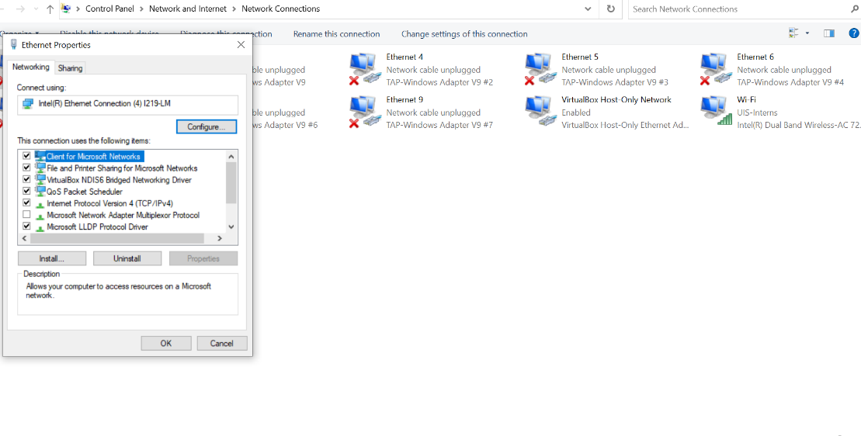

**Figure 2.1: Select the network adapter.**

1. right-click the network adapter and select "Properties".
2. double-click on "Internet Protocol Version 4 (TCP/IPv4)".
3. manually enter the IP address and subnet mask (e.g., IP address: 192.168.56.20, subnet mask: 255.255.255.0).

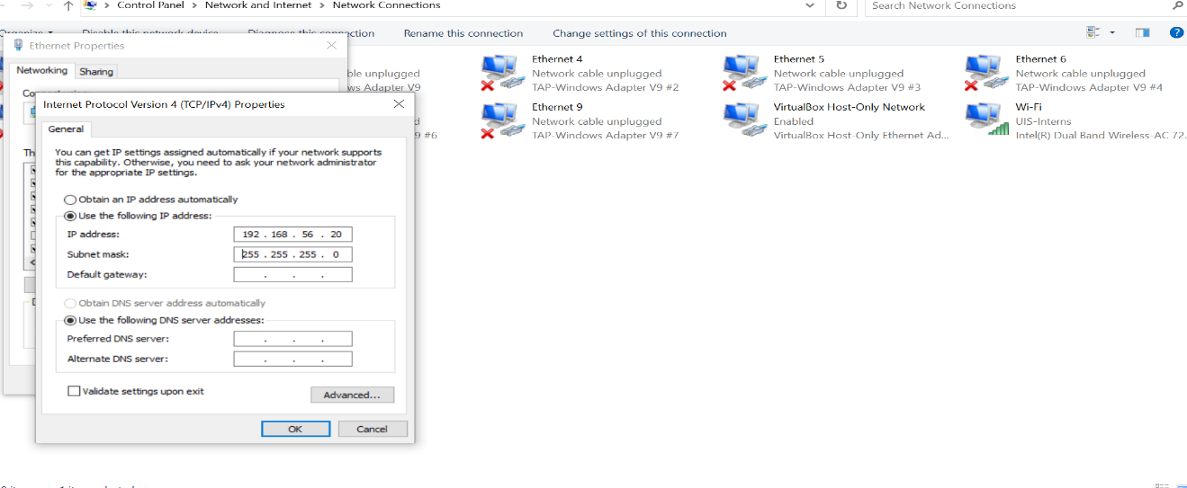

**Figure 2.2: Assigning a static IP address.**

1. click "OK" to save the settings.

### 2.3.2. ASSIGNING A DYNAMIC IP ADDRESS TO A COMPUTER:

Dynamic IP address assignment was also necessary for networked printer sharing. The steps I followed were:

1. open the Control Panel.
2. click on "Network and Internet".
3. click on "Network and Sharing Center".
4. click on "Change adapter settings" in the left pane.

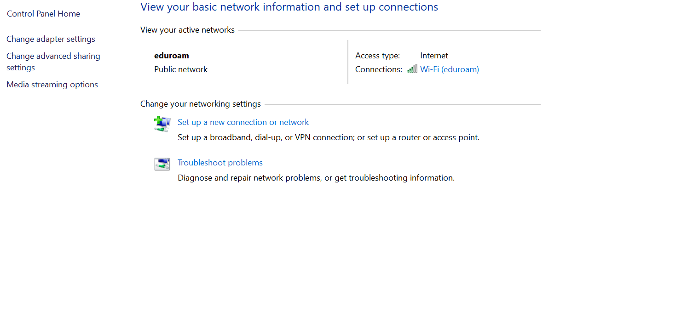

**Figure 2.3: changing adapter setting.**

1. right-click the network adapter and select "Properties".
2. select "Internet Protocol Version 4 (TCP/IPv4)" and click "Properties".
3. select "Obtain an IP address automatically" and "Obtain DNS server address automatically".

#### About the DHCP

Select **Obtain an IP address automatically** and **Obtain DNS server address automatically**. By choosing these options, the computer will use DHCP (Dynamic Host Configuration Protocol), allowing it to automatically request and receive an IP address and DNS server information from the DHCP server on the network. The DHCP server dynamically allocates IP addresses and other network configuration details to devices. When a device connects to the network, it requests an IP address from the server, which then assigns an available IP address from a predefined pool and provides the necessary DNS server details. This automatic assignment simplifies network management by ensuring devices receive appropriate configurations without manual intervention, helps prevent IP address conflicts, and reduces the administrative burden of managing IP addresses manually.

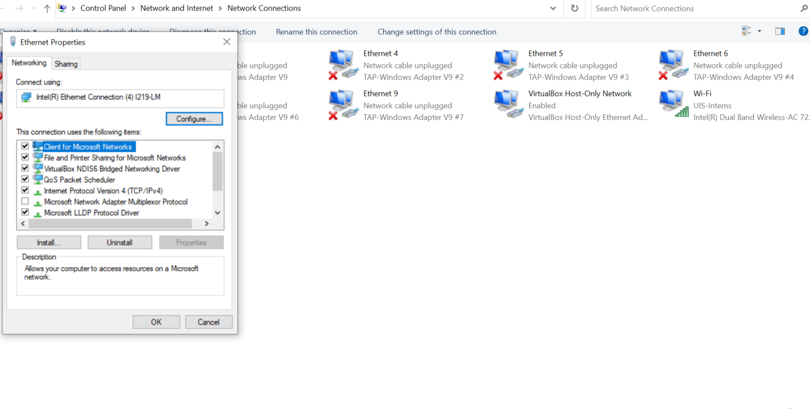

**Figure 2.4: selecting internet protocol version IPV4**

1. click "OK" to save the settings.

## 2.3 TERMINATING NETWORK ETHERNET CAT-6 CABLES

A network failure due to a faulty Ethernet cable was resolved by terminating the cable at both ends. The steps taken to restore connectivity were as follows:

1. gather materials: wire strippers, wire cutters, RJ45 crimping tool, RJ45 modular data plug, bulk CAT-6 network cable.
2. measure the cable, allowing an extra 2 inches on either end.
3. strip the cable, leaving 1.5 inches of exposed wires.
4. separate and organize the twisted pairs into the correct order (T568B standard or T568A).

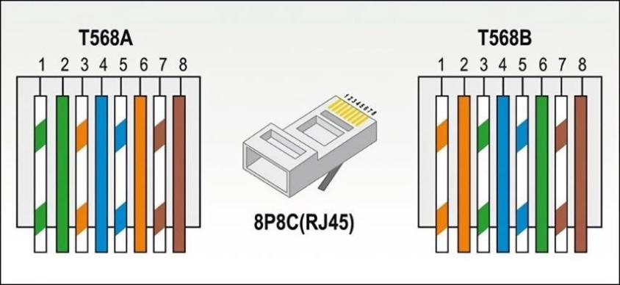  **Figure 2.5: separated Ethernet cat-6 cable wires**

1. flatten and straighten the wires, trim the tips evenly, and insert them into the RJ45 plug.

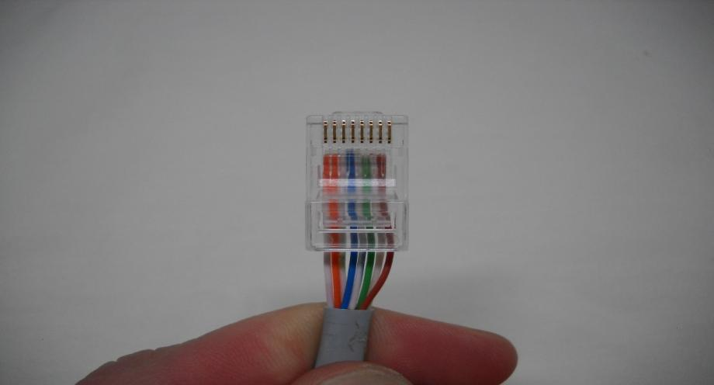

**Figure 2.6: wires inserted into data plug or RJ45**

1. use the crimping tool to secure the plug onto the wires.

## 2.4 CONFIGURING A CISCO SWITCH FOR BASIC NETWORK CONNECTIVITY AND MANAGEMENT

During the training, practical experience was gained in configuring Cisco switches and routers, essential components for managing and optimizing network performance. Below are the detailed steps and procedures followed:

#### Accessing the Switch:

connect your computer to the switch using a console cable.

open a terminal emulator (like PuTTY) and connect to the switch using the appropriate COM port settings (typically 9600 baud rate, 8 data bits, no parity, 1 stop bit, and no flow control).

press Enter to access the switch's command line interface (CLI).

#### Entering Privileged EXEC Mode:

at the Switch> prompt, type enable and press Enter to enter privileged EXEC mode. The prompt changes to Switch#

#### Entering Global Configuration Mode:

type configure terminal and press Enter to enter global configuration mode. The prompt changes to Switch(config)#.

#### Setting the Hostname:

type hostname [desired_hostname] (e.g., hostname Switch1) and press Enter to set the switch's hostname.

#### Configuring Interface VLAN:

to assign an IP address to the switch, enter the interface configuration mode for VLAN 1 (or another VLAN, if needed) by typing interface vlan 1 and pressing Enter.

type ip address [IP_address] [subnet_mask] (e.g., ip address 192.168.1.2 255.255.255.0) and press Enter.

type no shutdown and press Enter to activate the interface.

#### Configuring Default Gateway:

type ip default-gateway [gateway_IP_address] (e.g., ip default-gateway 192.168.1.1) and press Enter to set the default gateway.

#### Saving the Configuration:

type exit to return to privileged EXEC mode.

type write memory or copy running-config startup-config to save the configuration.

## 2.5 CONFIGURING A CISCO ROUTER FOR BASIC NETWORK CONNECTIVITY.

#### Accessing the Router:

connect your computer to the router using a console cable.

open a terminal emulator (like PuTTY) and connect to the router using the appropriate COM port settings (typically 9600 baud rate, 8 data bits, no parity, 1 stop bit, and no flow control).

press Enter to access the router's command line interface (CLI).

#### Entering Privileged EXEC Mode:

at the Router> prompt, type enable and press Enter to enter privileged EXEC mode. The prompt changes to Router#.

#### Entering Global Configuration Mode:

Type configure terminal and press Enter to enter global configuration mode. The prompt changes to Router(config)#.

#### Setting the Hostname:

type hostname [desired_hostname] (e.g., hostname Router1) and press Enter to set the router's hostname.

#### Configuring Interfaces:

enter the interface configuration mode for the desired interface (e.g., interface GigabitEthernet0/0) by typing interface [interface_name] and pressing Enter.

type ip address [IP_address] [subnet_mask] (e.g., ip address 192.168.1.1 255.255.255.0) and press Enter.

type no shutdown and press Enter to activate the interface.

repeat the process for other interfaces as needed.

#### Configuring Routing Protocols:

to enable a routing protocol like OSPF, enter router configuration mode by typing router ospf [process_id] (e.g., router ospf 1) and pressing Enter.

type network [network_address] [wildcard_mask] area [area_id] (e.g., network 192.168.1.0 0.0.0.255 area 0) and press Enter to configure the network.

#### Configuring Default Route:

to set a default route, type ip route 0.0.0.0 0.0.0.0 [next_hop_IP_address] (e.g., ip route 0.0.0.0 0.0.0.0 192.168.1.2) and press Enter.

#### Saving the Configuration:

type exit to return to privileged EXEC mode.

type write memory or copy running-config startup-config to save the configuration.

## 2.6 INTERNET ACCESS POINTS MANAGEMENT

Management of the Internet access points ensured seamless and robust connectivity for all attendees, exhibitors, and event staff. This task required meticulous planning, setup, configuration, and real-time management to handle the high demand for Internet access.

Steps for Managing Internet Access Points

#### Pre-Event Planning and Design:

* 1. conduct a site survey of the event venue to determine optimal locations for AP placement, considering coverage areas, signal strength, and potential interference.
  2. estimate the number of devices expected to connect to the network and ensure sufficient APs are available to handle the load.
  3. develop a network topology plan, including the placement of APs, switches, and any necessary cabling.

## 2.7 CONFIGURING CISCO ACCESS POINTS FOR EVENT CONNECTIVITY.

* 1. deploy APs at strategic locations throughout the event venue, ensuring coverage in high-traffic areas such as exhibit halls, presentation rooms, and common areas.
  2. connect APs to the network using Ethernet cables and ensure they are powered, either through Power over Ethernet (PoE) switches or power adapters.

#### Configuring Access Points:

* 1. access each AP's web interface using its default IP address, and log in using the default credentials provided by the manufacturer.
  2. change the default login credentials to enhance security.
  3. configure the SSID (Service Set Identifier) for the event network, which will be visible to attendees. Create separate SSIDs if needed for different user groups (e.g., attendees, exhibitors, staff).
  4. set up security protocols such as WPA2 or WPA3 to protect the network. Use a strong passphrase for access and consider enabling guest network features with restricted access.
  5. configure IP settings, either by assigning static IP addresses or using DHCP reservations, to ensure APs are easily identifiable and manageable.

#### Channel and Frequency Management:

* 1. select appropriate channels to minimize interference with other APs and devices. For 2.4 GHz networks, use channels 1, 6, or 11 to avoid overlap. For 5 GHz networks, choose non-overlapping channels.
  2. adjust the transmit power settings to ensure adequate coverage without causing interference.

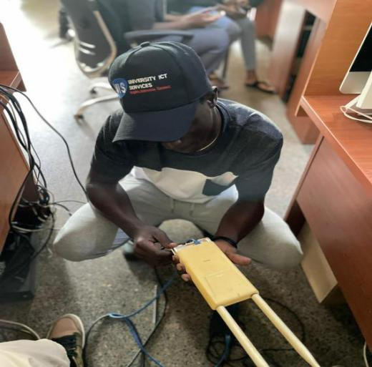

**Figure 2.7: configuring the an access point**

## 2.8 CAMERA SYSTEMS MAINTENANCE AND TROUBLESHOOTING

Maintenance and troubleshooting of camera systems involved ensuring the surveillance cameras were fully operational, diagnosing and resolving issues, and performing routine maintenance to prevent future problems. A specific challenge encountered was a camera with a faulty Ethernet cable at the switch, which required immediate attention. The issue was resolved by terminating the RJ45 cable using the T568B wiring standard.

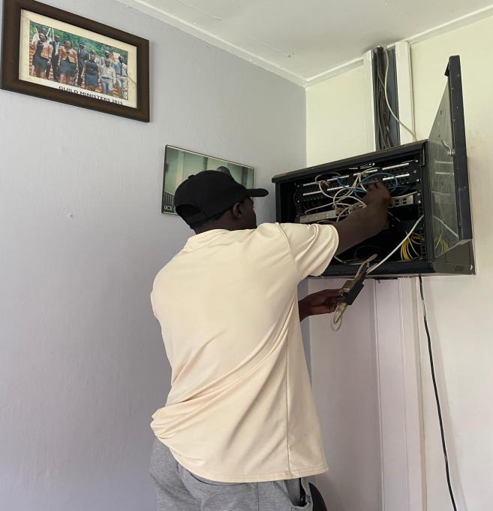

**Figure 2.8: installing a camera**

## 2.9 INSTALLING AND CONFIGURING NAGIOS NETWORK MONITORING SYSTEM.

The installation and configuration of the Nagios Network Monitoring System were completed on a server with the IP address 196.43.140.34. This report details the step-by-step process followed to set up Nagios, a crucial tool for monitoring IT infrastructure.

#### Prerequisites

before proceeding with the installation, ensured the following prerequisites were met:

**Server Access:**

administrative access to the server with the IP address 196.43.140.34.

Linux Environment: A server running a Linux-based operating system, such as Ubuntu.

**Network Connectivity:**

stable network connection to download necessary packages.

Step-by-Step Installation

**Step 1: Updating the Server**

begin by updating the server to ensure all packages were currently installed.

With the following command.

sudo apt update

**Step 2: Installing Required Packages**

next, install essential packages required for Nagios and its dependencies:

sudo apt install -y apache2 libapache2-mod-php php php-gd libgd-dev unzip wget build-essential libssl-dev daemon

**Step 3: Creating Nagios User and Group**

to maintain security and proper permissions, create a dedicated user and group for Nagios:

sudo useradd nagios

sudo groupadd nag admin

**Step 4: Downloading and Installing Nagios Core**

download Nagios Core from the official repository and proceeded with installation:

cd /tmp wget https://assets.nagios.com/downloads/nagioscore/releases/nagios-4.5.2.tar.gz tar -zxvf nagios-4.5.2.tar.gz cd nagios-4.5.2 sudo ./configure --with-command-group=nagcmd sudo make all sudo make install sudo make install-commandmode sudo make install-init sudo make install-config sudo make install-webconf

**Step 5: Setting Up Nagios Web Interface**

configure the Nagios web interface for administration, including creating an administrative user:

sudo htpasswd -c /usr/local/nagios/etc/htpasswd.users nagiosadmin

**Step 7: Starting and Enabling Nagios**

start Nagios and configure it to start automatically on server boot:

sudo systemctl start nagios

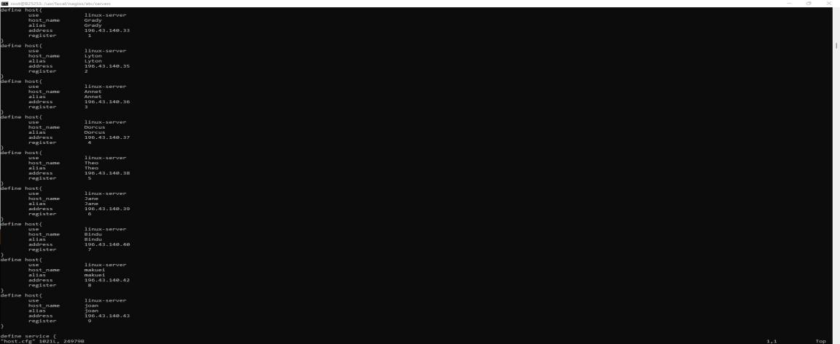

**Figure 2.9: showing host.cfg configured to be on website page**

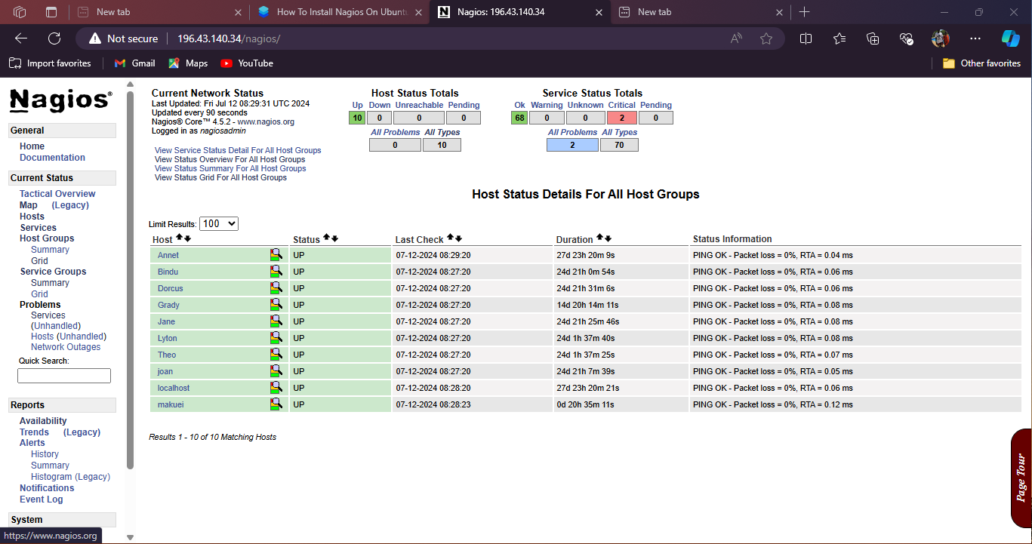**Figure 2.9.1 : showing a complete monitoring tool configured**

#### Conclusion

With Nagios successfully installed and configured on the server assigned the IP address 196.43.140.34, our network monitoring capabilities are now enhanced. This setup ensures proactive monitoring of critical services and systems, contributing to improved reliability and performance across our IT infrastructure.

# CHAPTER THREE - **WEB PROGRAMMING**

This section details the process of installing and configuring MariaDB and WordPress on a server. This setup enables the hosting of a dynamic and content-rich website using WordPress, with MariaDB as the database backend.

## 3.1. INSTALLING AND CONFIGURING MARIADB AND WORDPRESS ON A SERVER.

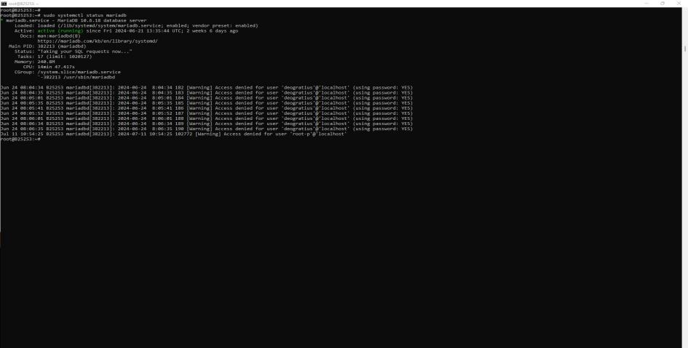

**Figure 3.1: showing successful installation of mariadb on server**

Step-by-Step Installation

**Step 1: Install MariaDB**

mariaDB is a popular open-source relational database management system.

update package List:

sudo apt update

install MariaDB Server:

sudo apt install -y mariadb-server

secure MariaDB Installation:

run the security script to secure your installation:

sudo mysql_secure_installation

create WordPress Database and User:

log in to MariaDB as the root user:

sudo mysql -u root -p

Enter the root password when prompted.

Inside the MariaDB shell, create a new database for WordPress

CREATE DATABASE wordpress;

CEATE USER ‘deogratius'@’localhost’IDENTIFIED BY ‘12345’;

GRANT ALL PRIVILEGES ON wordpress.* TO 'deogratius'@'localhost’;

FLUSH PRIVILEGES;

EXIT;

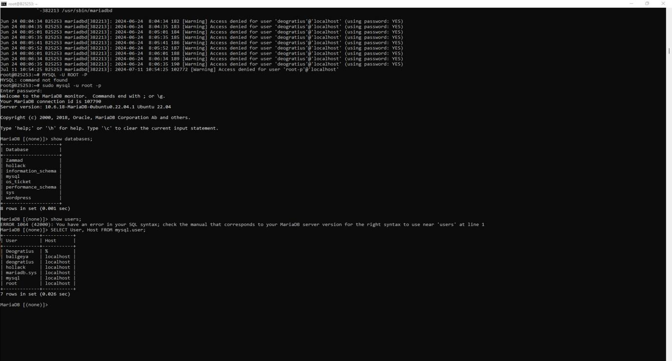

**Figure 3.2: showing my database created and the user**

**Step 2: Install Apache and PHP**

wordPress requires a web server (Apache) and PHP for server-side scripting.

**install Apache and PHP:**

**sudo apt install -y apache2 php libapache2-mod-php php-mysql**

adjust Apache Configuration:

by default, Apache should be started automatically. Ensure it is running:

**sudo systemctl status apache2**

**Step 3: Download and Configure WordPress**

**download WordPress:**

**cd /tmp**

**wget https://wordpress.org/latest.tar.gz**

**tar -zxvf latest.tar.gz**

**move WordPress Files:**

sudo mv wordpress/* /var/www/html/

**set Permissions:** Set appropriate permissions for WordPress files:

sudo chown -R www-data:www-data /var/www/html/

sudo chmod -R 755 /var/www/html/

**Configure WordPress:** create wp-config.php file:

cd /var/www/html/

sudo mv wp-config-sample.php wp-config.php

sudo nano wp-config.php

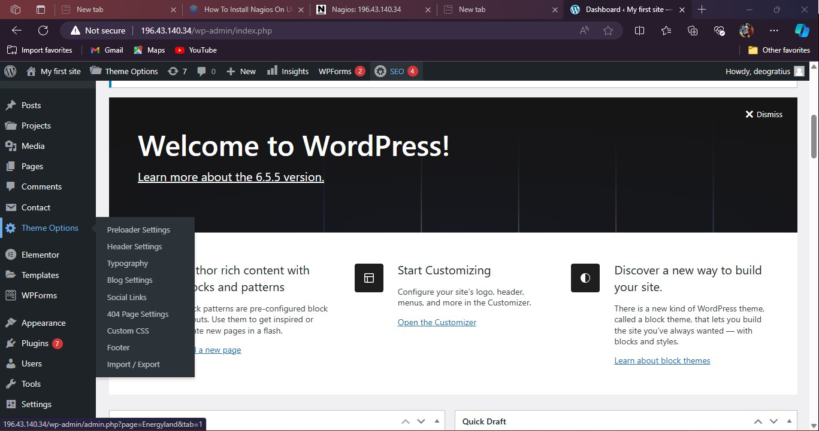**Figure 3.3 : showing successfully installed wordpress.**

## 3.2 IMPORTING THEM FOLDER FROM MY LOCAL THE LOCAL MACHINE TO THE SEREVR.

The task was to install the themeforest-mhESY3CN-energyland-solar-renewable-energy-wordpress-theme on WordPress using the SCP protocol.

SCP stands for Secure Copy Protocol. It is a secure file transfer protocol that allows you to securely transfer files between a local host and a remote host or between two remote hosts over an SSH (Secure Shell) connection. SCP encrypts both the file and any passwords exchanged during the transfer, providing a secure way to copy file

The command in this installation used is to copy the path of the folder on the local machine for example

**C:\Users\ISRAEL UG\Desktop\deo.tar.gz,**

open command prompt through pressing wind+x command and use the scp command to be able transfer the file to the server.

Steps to follow

**Step-1**

**open cm**d

specify the command to direct the file from your local folder path to the destination on the server. In this case, the file is being sent to the home directory of the server.

**scp "C:\Users\ISRAEL UG\Desktop\deo.tar.gz"** [**B25253@196.43.140.34:**](mailto:B25253@196.43.140.34:)

then log into the server to confirm the installation if it is complete

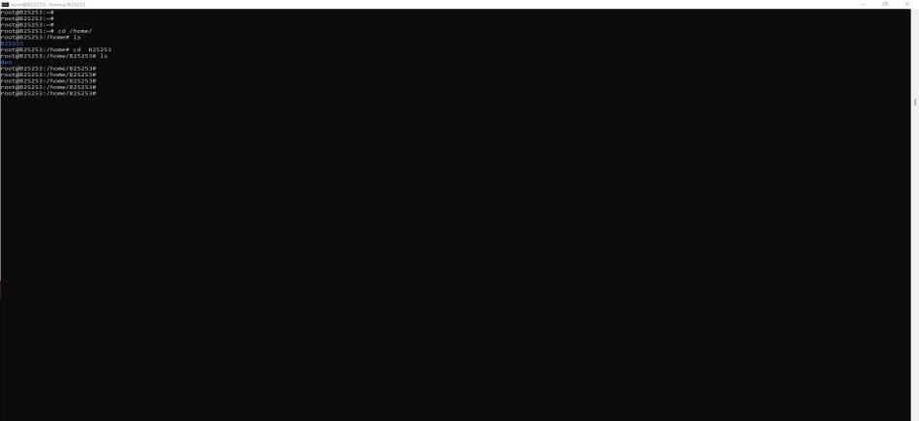

**Figure 3.4 : showing the folder was successfully sent to the server**

Step-2

next, move the folder from the server's home directory to the WordPress wp-content folder.Command

**cp -r themeforest-mhESY3CN-energyland-solar-renewable-energy-wordpress-theme /var/www/wordpress/wp-content/themes**

confirm by navigating to wordpress folder to check for the uploaded file.

command

**root@B25253:/home/B25253# cd /var/www/wordpress/**

**root@B25253:/var/www/wordpress# vi wp-content/themes/**

**Illustration**

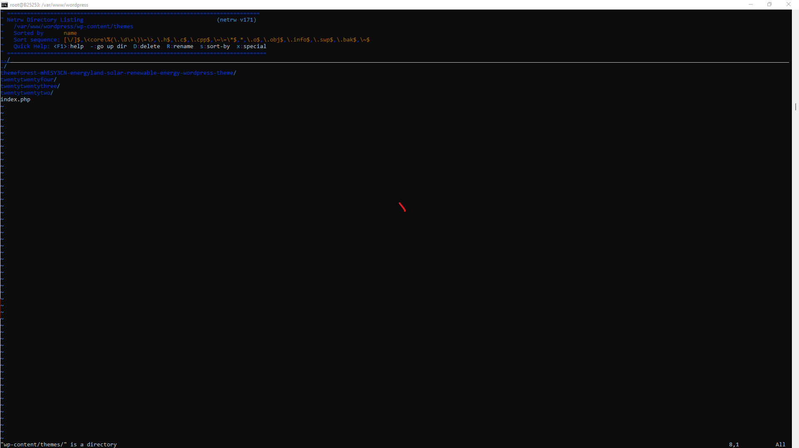Figure 3.5: showing them folder successfully installed

navigated with the ip address on the web browser to check for the installation of the them folder in wordpress.

Them is called energyland

#### Illustration of the them folder loaded to wordpress

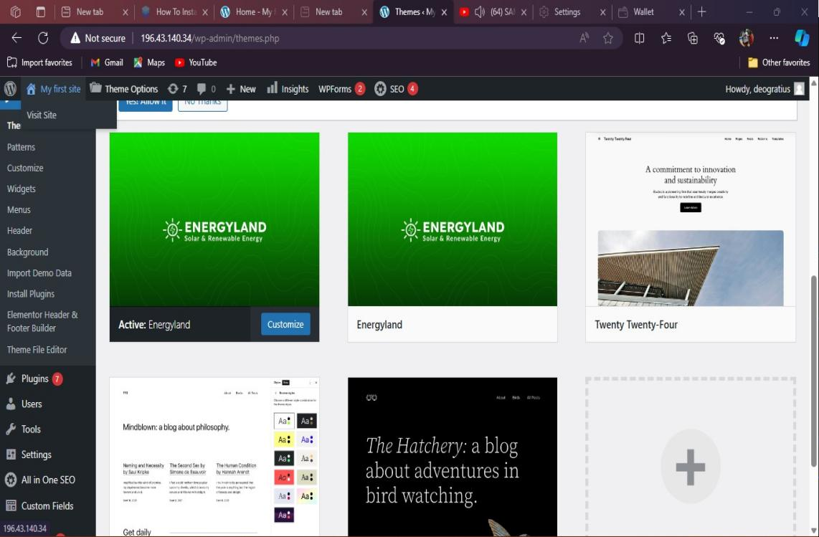

Figure 3.6 showing them folder successfully installed onto wordpress

## 3.3 INSTALLING OF OSTICKET SYSTEM FOR UIS.

osTicket is a help-desk solution suitable for organizations of all sizes. It is excellent for managing your customer inquiries created either from emails, phone calls, or your website. In this guide, you'll install osTicket on your Ubuntu 20.04 server with Apache and your choice of MySQL or MariaDB server.

#### Procedure of installing osTicket on a server

#### Prerequisites

1. **Server Access**: Ensure administrative access to the server.
2. **Web Server**: Apache or Nginx should be installed.
3. **Database**: MariaDB or MySQL should be installed.
4. **PHP**: Ensure PHP is installed along with required extensions (e.g., php-mysql, php-xml, php-mbstring).
5. **Install osTicket Dependencies**

connect to your server and update the package information index.

$ sudo apt update

next, install the following PHP extensions required by the osTicket application.

$ sudo apt install -y php-common php-gd php-imap php-intl php-apcu php-cli php-mbstring php-curl php-mysql php-json php-xml

restart the Apache server.

$ sudo systemctl restart apache2

then, install the unzip tool. You'll need it later to unpack the osTicket installation archive.

$ sudo apt install -y unzip

once you've installed all the dependencies required by osTicket, create a database in the next step.

**2. Create a Database for osTicket**

osTicket requires a database to work. Connect to your MySQL server as root.

$ sudo mysql -u root -p

key in your MySQL root password and press ENTER to proceed. Then, create an os_ticket database.

mysql> CREATE DATABASE os_ticket;

next, set up a user named os_ticket_user for connecting to the os_ticket database and exit from the database server command-line interface.

mysql> CREATE USER 'os_ticket_user'@'localhost' IDENTIFIED WITH mysql_native_password BY 'EXAMPLE_PASSWORD';

GRANT ALL PRIVILEGES ON os_ticket.* TO 'os_ticket_user'@'localhost';

FLUSH PRIVILEGES;

EXIT;

if you're using the MariaDB server, use the command below to create the os_ticket_user.

MariaDB> GRANT ALL PRIVILEGES on os_ticket.* TO 'os_ticket_user'@'localhost' identified by 'EXAMPLE_PASSWORD';

EXIT;

your database and user account are ready. Next, you will initialize a directory structure for the osTicket.

1. **Create a Directory for osTicket**

create a directory for the osTicket website under the root of your web server.

$ sudo mkdir -p /var/www/os_ticket

then, change the directory ownership to your current Linux user so that you can make modifications easily without permission issues.

$ sudo chown -R $USER:$USER /var/www/os_ticket

navigate to the /var/www/os_ticket directory using the Linux cd command.

$ cd /var/www/os_ticket

next, use the Linux wget command to pull the latest osTicket installation archive from GitHub.

$ wget [https://github.com/osTicket/osTicket/releases/download/v1.18.1/osTicket-v1.15.2.zip](https://github.com/osTicket/osTicket/releases/download/v1.15.2/osTicket-v1.15.2.zip)

extract the archive file you've just downloaded to your current directory.

$ unzip osTicket-v1.15.2.zip

once all the osTicket files have been unpacked, delete the zip file.

$ rm osTicket-v1.15.2.zip

by default, osTicket ships with a sample configuration file in upload/include/ost-sampleconfig.php. Copy it in the same directory and change its name to ost-config.php

$ sudo cp upload/include/ost-sampleconfig.php upload/include/ost-config.php

use the Linux chown command to assign the ownership of the /var/www/os_ticket directory to the Apache webserver user - www-data. Then, make sure the files have appropriate permissions.

$ sudo chown -R www-data:www-data /var/www/os_ticket

$ sudo chmod -R 755 /var/www/os_ticket

your osTicket website files are now in place. Create a virtual host in the next step.

1. **Create a Virtual Host File**

to run your osTicket with Apache, you'll need to create a configuration file under the /etc/apache2/sites-available directory. First, use the a2dissite command to disable the default Apache configuration file 000-default.conf.

$ sudo a2dissite 000-default.conf

then, using nano, open a new /etc/apache2/sites-available/os_ticket.conf configuration file for editing.

$ sudo nano /etc/apache2/sites-available/os_ticket.conf

enter the information below and replace example.com with your server's correct domain name or public IP address.

<VirtualHost *:80>

ServerName example.com

ServerAlias example.com

DocumentRoot "/var/www/os_ticket/upload"

<Directory "/var/www/os_ticket/upload">

Require all granted

Options Indexes FollowSymLinks

AllowOverride All

Order allow,deny

Allow from all

</Directory>

ErrorLog ${APACHE_LOG_DIR}/error.log

CustomLog ${APACHE_LOG_DIR}/access.log combined

</VirtualHost>

once you finish editing /etc/apache2/sites-available/os_ticket.conf press CTRL + X, then Y and ENTER to close and save the file. then, run the a2ensite command against the os_ticket.conf file to enable it.

$ sudo a2ensite os_ticket.conf

restart Apache to load the new configuration settings.

$ sudo systemctl restart apache2

with the osTicket virtual host configuration file enabled, you'll test the installation in the next step.

5**. Test the osTicket Installation**

visit your osTicket site URL to complete the setup process. Replace example.com with the correct domain name or public IP address of your server.

196.43.140.34

you'll see a web page similar to the screenshot below.

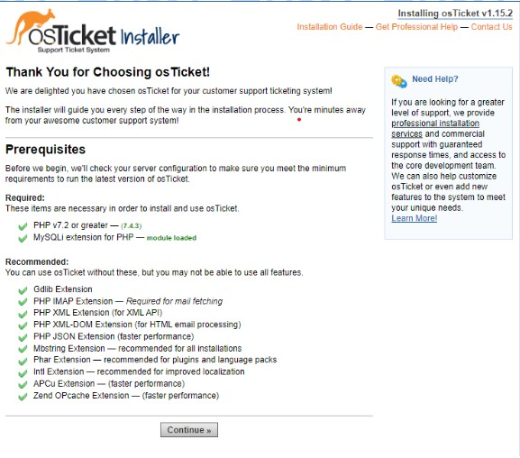

**Figure 3.7: a web page showing successfully installation for osTicket**

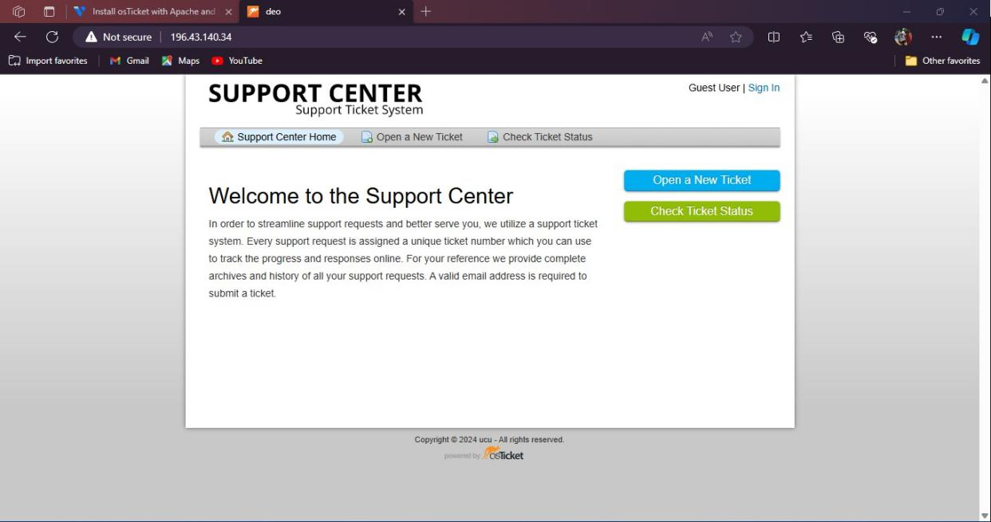

**Figure 3.8: shows a sign page of uis osTicket system**

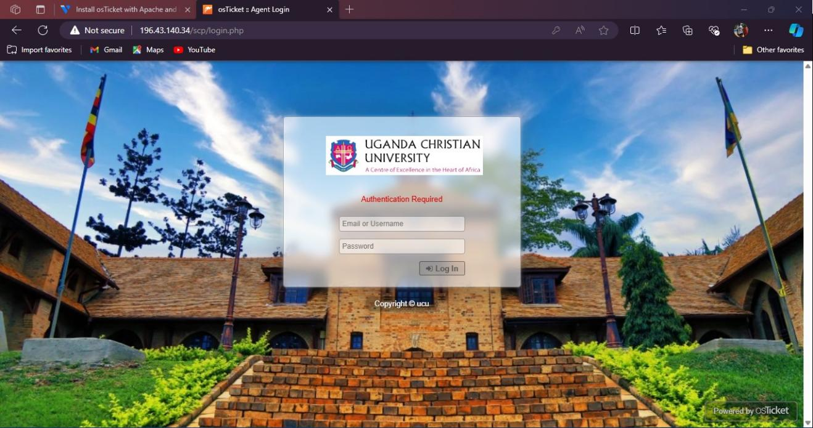

**Figure 3.9: Shows the login as an administrator**

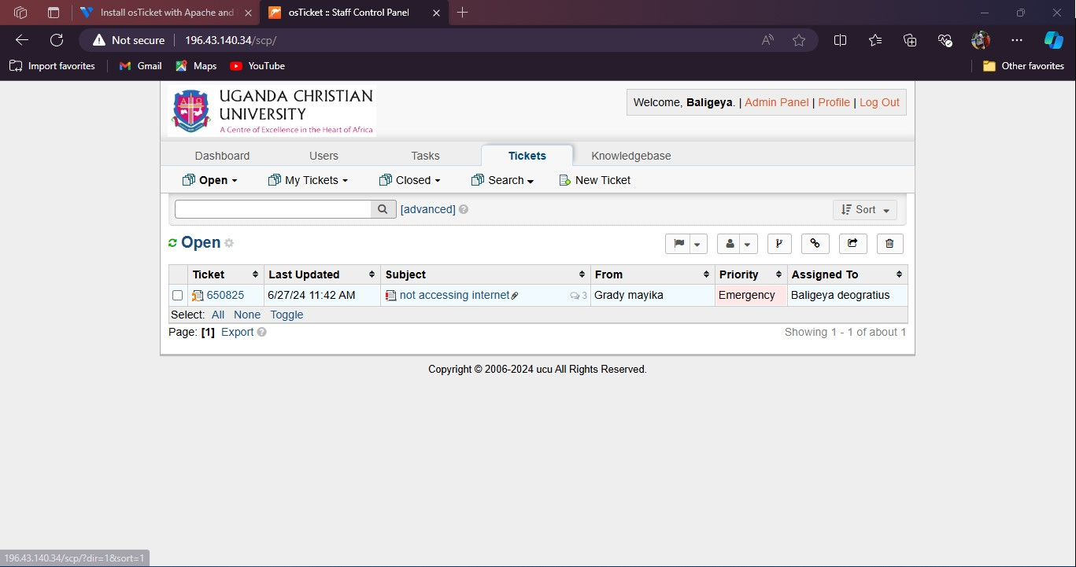

**Figure 3.9.1: shows an open osTicket system for uis**

# CHAPTER FOUR - SOFTWARE DEVELOPMENT

## 4.1. INTRODUCTION:

The purpose of this project was to develop a system to efficiently manage incidents within University ICT Services. The system includes features for both administrators and users, providing a comprehensive solution for incident tracking and management.

## 4.2. BUILDING AN INSTANCE MANAGEMENT SYSTEM

#### System Development Steps:

#### Requirement Analysis:

Identify and gather requirements for the incident management system.

Determine the roles and permissions for different users (admin and regular users).

#### System Design:

Design the system architecture, including the database schema and user interface layout.

Create wire frames and mock ups for the admin and user dashboards.

#### Technology Stack:

Frontend: REACT.JS for building interactive user interfaces.

Backend: EXPRESS.JS for handling server-side logic and API endpoints.

Database: MySQL for storing and managing data.

Programming Language: JAVASCRIPT for both frontend and backend development.

Database Design:

Design the MySQL database schema to store incident data, user information, and role-based access control.

Create tables for incidents, users, roles, and related entities.

#### Frontend Development:

Develop the user dashboard using REACT.JS, providing users with the ability to report incidents and view the status of their reported incidents.

Develop the admin dashboard using REACT.JS, allowing administrators to view all incidents, update incident statuses, and manage user roles.

#### Backend Development:

Set up the EXPRESS.JS server to handle API requests from the frontend.

Implement API endpoints for user authentication, incident reporting, incident management, and role management.

Integrate the backend with the MySQL database to store and retrieve data.

#### User Authentication and Authorization:

Implement user authentication using JWT (JSON Web Tokens) for secure login and session management.

Implement role-based access control to restrict access to admin functionalities.

#### Testing and Debugging:

Conduct thorough testing of both the admin and user dashboards to ensure all functionalities work as expected.

Debug any issues and optimize performance.

#### Deployment:

Deploy the system on a server, ensuring it is accessible to all users within the University ICT Services.

Set up necessary security measures, including HTTPS and secure database connections.

#### Documentation and Training:

Create comprehensive documentation for system usage, including user guides for both administrators and regular users.

Conduct training sessions for staff to ensure they are familiar with the system and its functionalities.

### 4.2.1. DEVELOPING THE ENTITY RELATION DIAGRAM FOR INSTANCE MANAGEMENT SYSTEM

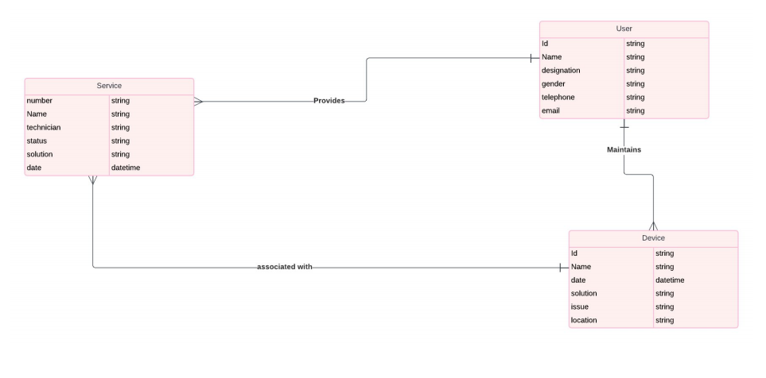

**Figure 4.1: showing an entity relationship diagram**

#### INTRODUCTION:

This report provides an analysis of the Entity-Relationship Diagram (ERD) for a Device Inventory and Management System. The system is designed to manage devices, services, and users, ensuring efficient tracking and maintenance of devices within an organization.

## Detailed Analysis:

#### Service:

* **number** (string): Unique identifier for each service.
* **name** (string): Name of the service.
* **technician** (string): Technician assigned to the service.
* **status** (string): Status of the service.
* **location** (string): Location where the service is provided.
* **date** (date-time): Date of the service.

#### User:

* **id** (string): Unique identifier for each user.
* **name** (string): Name of the user.
* **designation** (string): Designation of the user.
* **gender** (string): Gender of the user.
* **telephone** (string): Telephone number of the user.
* **email** (string): Email address of the user.

#### Device:

* **id** (string): Unique identifier for each device.
* **name** (string): Name of the device.
* **date** (datetime): Date associated with the device (e.g., purchase date).
* **solution** (string): Solution applied to the device issue.
* **issue** (string): Issue with the device.
* **location** (string): Location of the device.

#### Relationships:

* **Service** provides services to **Device**. This implies that each service entry is associated with a specific device that receives the service.
* **User** maintains **Device**. This indicates that each user entry is associated with the maintenance activities of specific devices.
* **Device** is associated with **Service**. This denotes a bidirectional relationship where devices are linked to the services provided to them.

## System Development Steps

#### Requirement Analysis:

Identify and gather requirements for the device inventory and management system.

Determine the roles and permissions for different users (e.g., technicians, administrators).

#### System Design:

Design the system architecture, including the database schema and user interface layout.

Create wire frames and mock ups for the service, user, and device management interfaces.

#### Technology Stack:

Frontend: REACT.JS for building interactive user interfaces.

Backend: EXPRESS.JS for handling server-side logic and API endpoints.

Database: MySQL for storing and managing data.

Programming Language: JAVASCRIPT for both frontend and backend development.

#### Database Design:

Design the MySQL database schema to store device, service, and user data.

Create tables for services, users, devices, and related entities as shown in the ERD.

#### Frontend Development:

Develop the user interface for managing devices, services, and users using REACT.JS.

Implement forms and views for adding, updating, and viewing device, service, and user data.

#### Backend Development:

Set up the EXPRESS.JS server to handle API requests from the frontend.

Implement API endpoints for user authentication, device management, service management, and user management.

Integrate the backend with the MySQL database to store and retrieve data.

#### User Authentication and Authorization:

Implement user authentication using JWT (JSON Web Tokens) for secure login and session management.

Implement role-based access control to restrict access to certain functionalities based on user roles.

#### Testing and Debugging:

Conduct thorough testing of the system to ensure all functionalities work as expected.

**Debug any issues and optimize performance.**

#### Deployment:

Deploy the system on a server, ensuring it is accessible to all users within the organization.

Set up necessary security measures, including HTTPS and secure database connections.

#### Documentation and Training:

Create comprehensive documentation for system usage, including user guides for managing devices, services, and users.

Conduct training sessions for staff to ensure they are familiar with the system and its functionalities.

## Flow chart

#### Flow Chart Analysis:

The flow chart depicts the process of logging into the system, navigating to the landing page, and the subsequent actions based on user roles (Technician or Admin). The primary steps in the flow chart include:

#### Login:

The user initiates the process by logging into the system.

#### Landing Page:

Upon successful login, the user is directed to the landing page.

Here, a distinction is made between two user roles: Technician and Admin.

#### Submit Credentials:

Both Technician and Admin users submit their credentials.

#### Verification:

The system checks the submitted credentials.

If credentials are incorrect, an error is displayed.

If credentials are correct, the system proceeds to display the respective dashboard.

#### Display Dashboard:

The dashboard displays information and functionalities relevant to the user role (Technician or Admin).

## Entity-Relationship Diagram (ERD) Analysis:

The ERD provides a detailed view of the data structure for the Device Inventory and Management System. Key entities include:

**Service:**

Attributes: number, name, technician, status, location, date

Relationship: Provides services to devices.

**User:**

Attributes: id, name, designation, gender, telephone, email

Relationship: Maintains devices.

**Device:**

Attributes: id, name, date, solution, issue, location

Relationship: Associated with services and maintained by users.

## Comparison:

#### User Authentication and Roles:

**Flow Chart:** Focuses on the user authentication process and role differentiation between Technician and Admin.

**ERD:** Includes the user entity but does not explicitly define roles; roles are implied by user actions (e.g., maintaining devices).

#### Service Management:

**Flow Chart:** Indicates that users (Technicians/Admins) interact with the system to manage devices.

**ERD:** Defines a structured way to manage services through the Service entity, showing how services relate to devices and users.

#### Error Handling:

**Flow Chart:** Includes error handling for incorrect credentials.

**ERD:** Does not explicitly cover error handling but provides a data structure to support validation processes.

#### Dashboard Display:

**Flow Chart:** Concludes with displaying dashboards tailored to the user role.

**ERD:** Supports this by structuring data (devices, services, users) in a way that can be queried and displayed on the dashboards.

#### Integration of Flow Chart and ERD:

To create a cohesive system, the flow chart's process should be mapped to the ERD's data structure as follows:

* **Login Process:** User credentials are verified against the User table in the database.
* **Role-Based Navigation:** After login, user roles are determined, which can be an attribute in the User entity or managed through a separate role management system.
* **Submit Credentials:** Additional credentials or actions taken by users (Technician or Admin) are recorded in the Service and Device tables.
* **Error Handling:** Implement error handling using the database to validate credentials and other user actions.
* **Dashboard Display:** Data from Service, Device, and User tables are used to populate dashboards tailored to the specific needs of Technicians and Admins.

### 4.2.2. AN ILLUSTRATION OF A FLOW CHART FOR INSTANCE MANAGEMENT SYSTEM

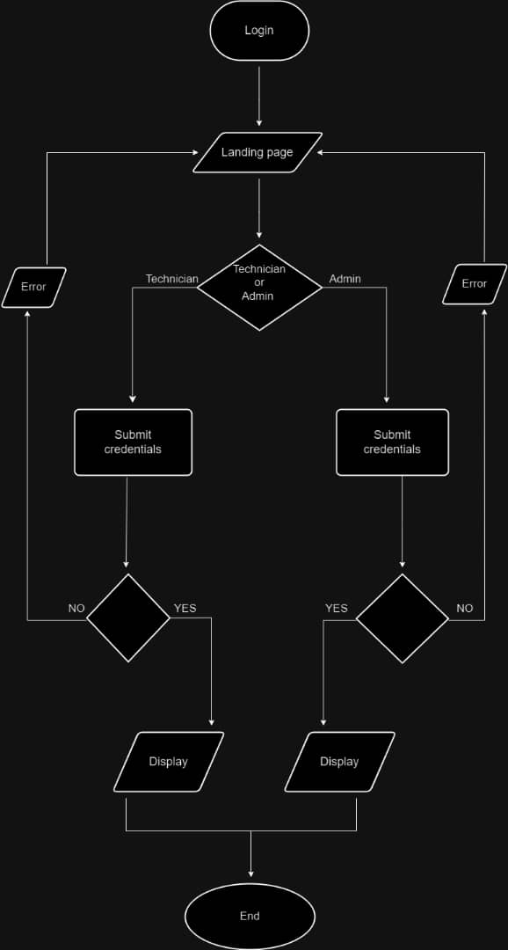

**Figure 4.2: showing a flow chart of the IMS**

1. Creating a mysql database table.

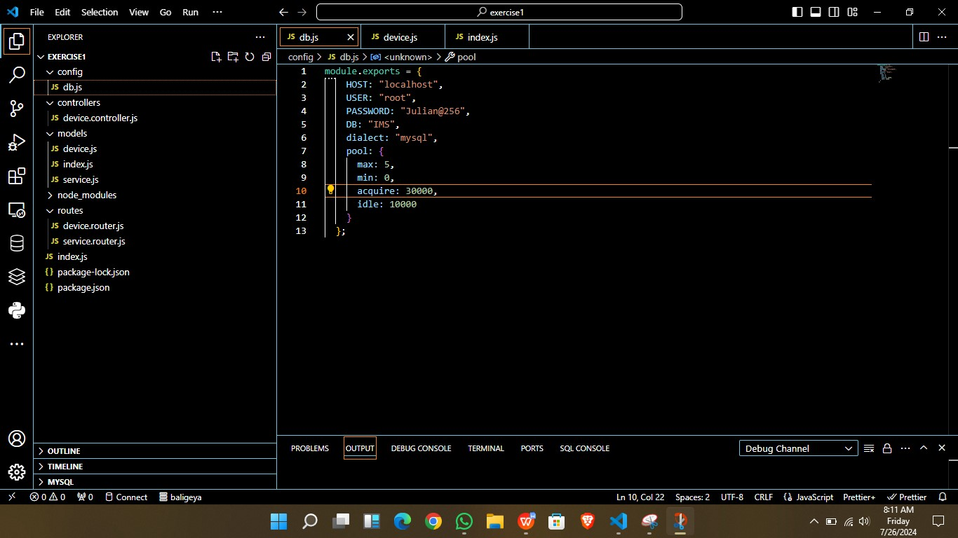

**Figure 4.3: showing the backend of the mysql database table**

1. Creating user registration and login

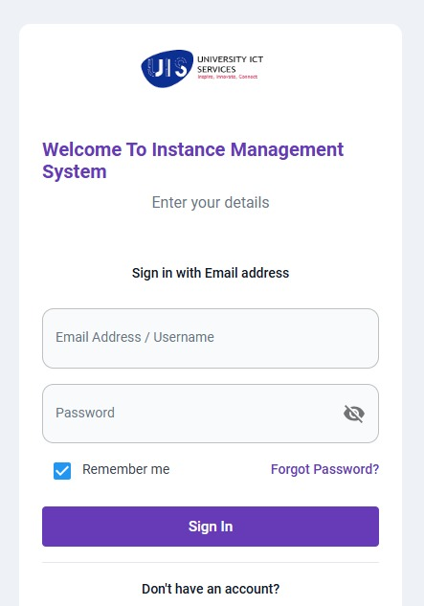

**Figure 4.4: showing user registration and login**

1. Connecting to the database
2. Managing admin dashboard with functionalities such as adding create, update, edit and delete and search options.

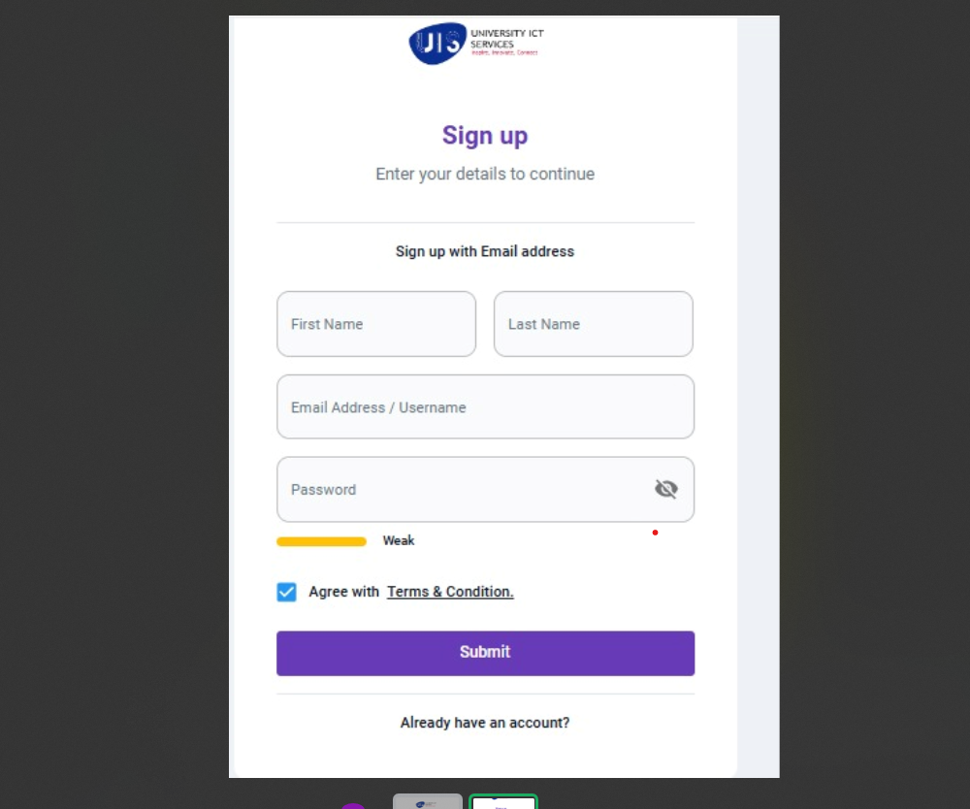

**Figure 4.6: showing**

1. Managing user dashboard such as user can be able to search and sort list of incidents.

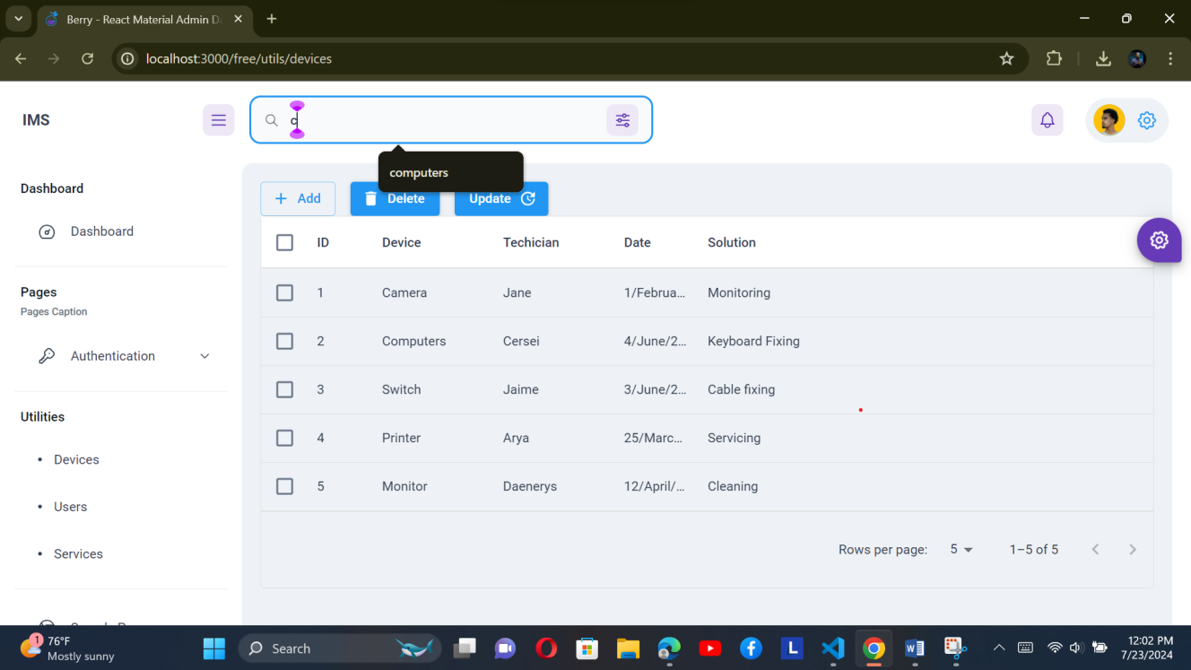

**Figure 4.7: incident page**

Vi. when user wants to record and new incident.

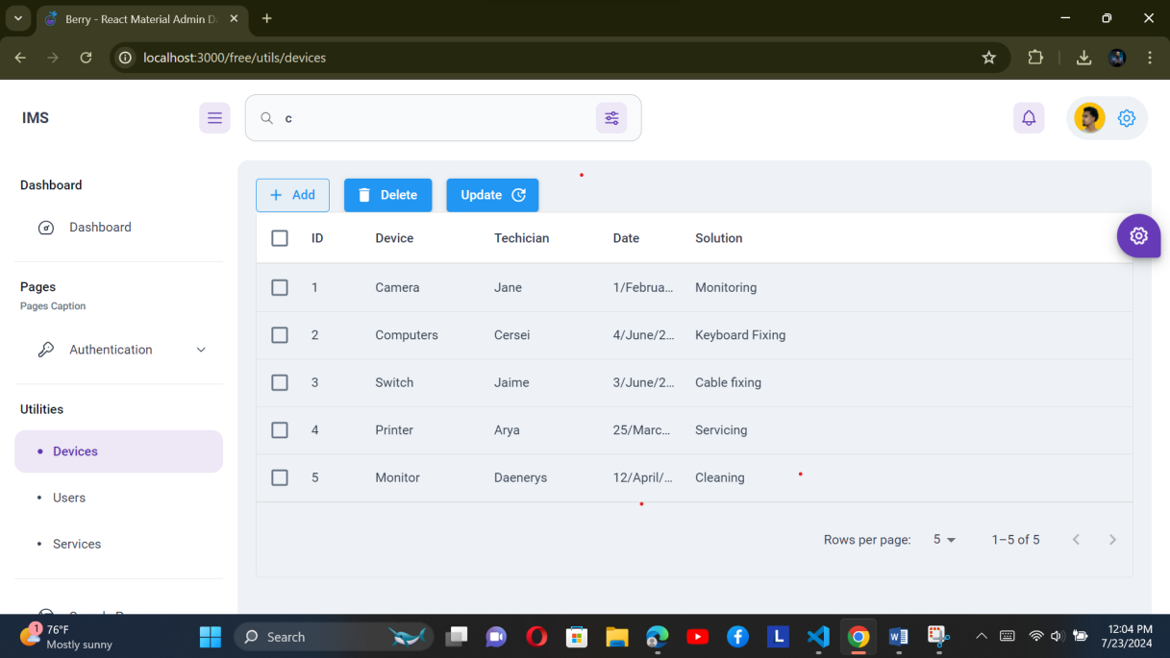

**Figure 4.8: incident log.**

## 

## 4.3. UPDATING AND MAINTAINING A WEBSITE

Getting your websites hosted and running online is amazing. However, that is not enough due to so many insecurities in the internet and properly maintaining your website is mandatory. An old, outdated website with incorrect information, broken links, or irrelevant content can turn visitors away, particularly if you have an online store as part of your website., a developer needs to know how to update and maintain an organization or company websites at all time to ensure security. I managed to witness and participate in how to do this during my industrial training in the following ways

1. Check that all of your pages are loading without errors
2. Run a backup and make sure a previous version of your site is stored
3. Make updates to website software and plugins
4. Check that all of your forms are running properly
5. Remove any spam comments from pages and posts
6. Check your pages to see if there are any broken links that are not working
7. Search for 404 errors and fix or redirect
8. Check the load speed of your website and ensure that nothing is slowing it down
9. Review your security scans and make sure nothing is out of place
10. Analyze website statistics from all visitors in the website

## 4.4. HOSTING A WEBSITE

Web hosting is the business of housing, serving, and maintaining files for one or more Web sites. It’s always important for a web developer to learn how to host a website after he or she has finished developing it. Therefore, during my industrial training, I was taken through a few steps on how to host a website and this includes the following below

1. Select which type of website you want to host either dynamic or static
2. Choose your hosting server which can either Linux or Windows hosting
3. Select your web hosting plan either shared virtual private server, dedicated, or cloud hosting
4. Change your DNS address after u have purchased your web hosting plan
5. Upload your website to your account by connecting to the server using either cPanel file manager or an FTP client like FileZilla
6. The launch your site and your website will be up and running (HostGator, 2022)

# CHAPTER FIVE - CONCLUSION, LIMITATION, AND RECOMMENDATION.

## 5.1 CONCLUSION

The internship experience at University ICT Services (UIS) has been transformative, providing hands-on exposure to cutting-edge technologies and methodologies in software development, networking, and project management. The successful development and deployment of the Management Information System (MIS) underscores UIS's commitment to leveraging technology for social and economic empowerment. Moving forward, the MIS is expected to support and empower women entrepreneurs, contributing to gender equality and sustainable economic growth.

This internship has not only provided technical skills but also instilled a deeper understanding of the impact of technology in driving social change. The opportunity to contribute to UIS's mission is highly valued, with a continued focus on innovation and excellence in software development and networking.

## 5.2 LIMITATIONS

During this training period, numerous challenges were encountered, testing resilience and problem-solving skills:

**Financial Strain on Transportation Costs:** Commuting to the internship site often posed a financial burden. Navigating through heavy traffic further compounded this issue, frequently delaying punctuality and impacting the early arrival crucial for maximizing internship hours.

**Access to Expert Guidance:** Accessing guidance and support from experts in specialized fields like networking proved challenging. Many professionals had demanding schedules and institutional commitments, hindering timely assistance and rapid comprehension of complex topics. The expectation to possess prior knowledge before seeking guidance added to the difficulty, making starting from scratch not an option despite having a solid academic foundation.

**Stringent Project Deadlines:** Delivering projects under stringent deadlines required swift learning and adaptation to unfamiliar tasks and technologies. Although the academic foundation was solid, the rapid pace and high expectations necessitated effective time management and quick learning to meet project objectives within tight timelines.

## 5.3 RECOMMENDATIONS

Based on the experiences and challenges faced, the following recommendations are offered to both UIS and the Faculty regarding industrial training:

**Enhanced Support Structures:** Establishing enhanced support structures for interns, particularly in fields requiring specialized knowledge like networking, would be beneficial. Allocating dedicated time or resources for mentors to assist interns can greatly enhance the learning experience and proficiency in practical skills.

**Flexible Learning Opportunities:** Providing flexible learning opportunities that cater to interns' diverse schedules and commitments would be advantageous. This could include flexible working hours, remote learning options, or asynchronous training modules that allow interns to learn at their own pace and convenience.

**Clear Expectations and Guidance:** Setting clear expectations from the outset and providing comprehensive guidance throughout the internship period can alleviate uncertainties and ensure interns understand their roles and responsibilities. Regular feedback sessions and checkpoints can also help interns track their progress and address any challenges promptly.

**Integration of Real-World Projects:** Incorporating more real-world projects and assignments during the internship can bridge the gap between theoretical knowledge and practical application. This hands-on experience not only enhances skills but also prepares interns for the complexities of professional environments.

**Professional Development Opportunities:** Offering professional development opportunities such as workshops, seminars, or certifications can further enrich interns' learning experiences and enhance their career readiness. These opportunities should align with industry trends and skills in demand to ensure relevance and competitiveness in the job market.

**Encouraging Collaboration and Networking:** Encouraging interns to collaborate with peers and professionals within the organization fosters a conducive learning environment. Facilitating networking opportunities with industry experts and alumni can broaden interns' professional networks and open doors to future career prospects.

**Continuous Improvement Feedback Loop:** Establishing a continuous improvement feedback loop where interns can provide constructive feedback about their experiences can help refine the internship program over time. This feedback should be valued and used to make necessary adjustments to enhance the overall quality and effectiveness of the training program.

# REFERENCES

Chacko, C. P., & Subramanian, C. R. (2014). Network Security Essentials: Applications and Standards. Prentice Hall.

Castells, M. (2001). The Internet Galaxy: Reflections on the Internet, Business, and Society. Oxford University Press.

Evans, D. S., & Schmalensee, R. (2016). Matchmakers: The New Economics of Multisided Platforms. Harvard Business Review Press.

Fitzgerald, J. (2017). Cybersecurity and Cyberwar: What Everyone Needs to Know. Oxford University Press.

Gans, J. S. (2016). The Disruption Dilemma. MIT Press.

Kumar, S., & West, R. (2020). Digital Entrepreneurship: Impact on Business and Society. Springer.

Mowery, D. C., & Simcoe, T. S. (2002). "Is the Internet a US Invention? - An Economic and Technological History of Computer Networking". Research Policy, 31(8-9), 1369-1387.

Spinellis, D. (2003). Code Reading: The Open Source Perspective. Addison-Wesley Professional.

Sullivan, B., & Kaminsky, D. (2012). Security Risk Management: Building an Information Security Risk Management Program from the Ground Up. Syngress.

Williams, B. (2019). Big Data in Practice: How 45 Successful Companies Used Big Data Analytics to Deliver Extraordinary Results. Wiley.

Carter, B. (2019). The DigitalOcean Cookbook: Over 90 Recipes to Effectively Deploy, Manage, and Scale Cloud Applications on DigitalOcean. Packt Publishing.

# APPENDIX

Appendix A**: Internship Tasks and Projects**

**1. Management Information System (MIS) Development**

Objective: Develop and deploy a MIS to support and empower women entrepreneurs.

Technologies Used: JavaScript, Node.js, MySQL,React.

**Key Features Implemented:**

User Authentication and Authorization

Database Management

Reporting and Analytics

User Interface Design

**2. Network router Configuration**

Objective: Facilitate networked switches sharing within the organization.

Tasks Completed:

Assigned static IP addresses to computers

Configured printers for network access

Troubleshot connectivity issues

**3. osTicket Installation**

Objective: Install and configure the osTicket support ticket system on the server.

Steps Involved:

Downloaded and installed osTicket

Configured system settings and user roles

Tested ticket submission and management functionalities

Appendix B**: Tools and Technologies Used**

**1. Development Tools:**

Integrated Development Environments (IDEs): Visual Studio Code.

Version Control: Git, GitHub

Database Management: MySQL, MongoDB

2. Networking Tools:

Network Configuration: [e.g., DHCP, static IP assignment]

Monitoring software: Wire-shark, Nagios.

3. Project Management Tools:

Task Management:JIRA, Trello

Documentation: Confluence, Microsoft Word

Appendix C**: Sample Code and Screenshots**

Login Function (JavaScript):



function loginUser(username, password) {

// Code for user authentication

}

**Database Schema (SQL):**

CREATE TABLE Users (

id INT AUTO_INCREMENT PRIMARY KEY,

username VARCHAR(50) NOT NULL,

password VARCHAR(255) NOT NULL

);

**2. Screenshots:**

MIS Dashboard:



osTicket Configuration Page:



Appendix D: Feedback and Evaluations

#### 1. Intern Feedback:

#### Strengths:

* **Hands-On Experience:** The internship provided extensive practical experience in developing and deploying the Management Information System (MIS). Working on real-world projects allowed for the application of theoretical knowledge and enhanced technical skills.
* **Supportive Team:** The team at University ICT Services (UIS) was highly supportive, offering valuable guidance and feedback throughout the internship. This collaborative environment fostered learning and professional growth.
* **Exposure to New Technologies:** The opportunity to work with various technologies, such as [specific tools/technologies used], was invaluable. This exposure broadened understanding and proficiency in modern software development and networking practices.
* **Practical Problem-Solving:** The internship involved tackling complex problems and finding practical solutions, which significantly improved problem-solving abilities and adaptability in a dynamic work environment.

#### Areas for Improvement:

* **Structured Guidance:** More structured guidance and formal on boarding processes would have been beneficial. Providing a clearer road map and initial training could help interns quickly acclimate and understand their roles and responsibilities.
* **Resource Availability:** Access to resources, such as comprehensive documentation or dedicated support for specialized areas like networking, could be improved. Enhanced availability of these resources would facilitate faster learning and problem resolution.
* **Regular Feedback:** Increasing the frequency of feedback sessions and progress reviews would help interns better track their performance and address any issues in a timely manner. Regular feedback can also assist in setting clear expectations and goals.
* **Project Management Support:** Additional support in project management, including clearer deadlines and milestones, would aid in better time management and task prioritization. This could help interns manage their workload more effectively and meet project objectives within given timelines.