

**Faculty of Engineering, Design and Technology**

**Department of Computing and Technology**

# INDUSTRIAL PLACEMENT PROGRAMME CARRIED OUT AT UGANDA CHRISTIAN UNIVERSITY UNDER THE DEPARTMENT OF UIS

**PRACTICAL TRAINING REPORT**

**June 2023**

|  |
| --- |
| **NAME : MIIRO LUUTU JOSEPH**    **Reg. No. : J22B13/009**    **COURSE : BSIT**  **COMPANY NAME : UGANDA CHRISTIAN UNIVERSITY MUKONO**    **COMPANY SUPERVISOR: MR. MUSASIZI KENNETH**  **FACULTY SUPERVISOR: MADAM MUWANGUZI SARAH**  **DATE OF SUBMISSION:** |

# 

# DECLARATION

I **Miiro Luutu Joseph** hereby declare that the industrial training report represented was prepared solely by me and that this report is original and has never been produced, published or submitted to any other University or institution for any academic award before to the best of my knowledge.

Signature ………………………………………… Date

**NAME: Miiro Luutu Joseph**

**J22B13/009**

# APPROVAL

**It has been approved by** the following supervisors.

**Academic Supervisor**

……………….. …………………………….

Signature Date

**Madam Muwanguzi Sarah**

Contact

Uganda Christian University

**Field supervisor**

………………………….. …………………………………….

Signature Date

**Mr. Musasizi Kenneth**

Contact

Uganda Christian University

# ACKNOWLEDGEMENT

I would like to express my sincere gratitude to Uganda Christian University and the Department of Computing and Technology providing me with the opportunity to undertake my industrial placement in their esteemed institution. This internship experience has been a pivotal moment in my academic and professional journey, and I am truly grateful for the knowledge and skills I have acquired during this period. I extend my heartfelt appreciation to all the faculty members, mentors, and staff at the Department of Computing and Technology for their unwavering support, guidance, and encouragement throughout my internship. Their expertise and willingness to share their knowledge have been instrumental in shaping my understanding of computer networks, systems administration, website development, and software development.

I would like to extend special thanks to Mr. Musasizi Kenneth, my mentor during the industrial training, for their continuous guidance, patience, and mentorship. Their valuable insights and constructive feedback have been invaluable in enhancing my learning experience and skill development.

Lastly, I am grateful to all the individuals who have contributed directly or indirectly to the successful completion of this industrial training report. Your contributions have been invaluable, and I am honored to have been a part of such a nurturing and enriching learning environment. Thank you all for making this internship a memorable and transformative experience. I am confident that the knowledge and skills I have gained during this period will serve as a strong foundation for my future endeavors in the field of computing and technology.

Sincerely,

MiiroLuutu Joseph,

Uganda Christian University.

# TABLE OF CONTENTS

Table of Contents

DECLARATION i

APPROVAL ii

ACKNOWLEDGEMENT iii

TABLE OF CONTENTS iv

ABSTRACT vi

CHAPTER ONE 1

1.1 Introduction 1

1.2 Background of the Company 1

1.3 Vision of the Company 2

1.4 Aims and objectives 2

1.5 UIS Leadership structure 3

1.6 Organizational structure 3

Figure 1.1: Organizational structure 4

1.7 Main activities / business operation. 4

CHAPTER TWO 6

COMPUTER NETWORKS AND SYSTEMS ADMINISTRATION 6

2.0 Computer Networks 6

2.1 Introduction 6

2.2 Classes and assigning IP addresses to a computer 6

2.3 Terminating network cables 8

2.4 Setting up a LAN 9

2.4.1 Configuring and Installing Access Points 9

UCU Missionary homes 9

2.4.2 Configuring and Installing a Camera 10

*2.4.*3 Trouble shooting and resolving network connectivity 13

2.4.4 Rebuilding a new network 14

2.4.5 Extending Internet Connectivity 14

2.6 The Mbarara project Ntale school (robotics) 15

CHAPTER THREE 17

3.1 Software development 17

3.1.1 MIS Alpha Incident management system 17

3.1.2 Repository Setup 17

3.1.3 API Development with Express.js and MongoDB 18

3.1.4 Authentication Implementation 19

3.1.5 CRUD Operations with Protected Endpoints 19

3.1.5 Github 20

3.2 System and Database Designing 23

3.3 Teaching BSIT condition statements and Functions 25

3.4 The UIS week 26

CHAPTER FOUR 30

CONCLUSION, LIMITATIONS AND RECOMMENDATION. 30

4.1 Conclusion 30

4.2 Limitations 30

4.3 Recommendations: 30

# ABSTRACT

This industrial training report documents the experiences and learning acquired during an internship at Uganda Christian University in the Department of Computing and Technology. The internship provided a unique opportunity to bridge the gap between theoretical knowledge and practical application in the field of computing and technology. The report covers various aspects, including computer networks and systems administration, website development and maintenance, software development, and troubleshooting network connectivity issues.

In the section on computer networks and systems administration, topics such as IP address classes, cable termination, LAN setup, and troubleshooting network connectivity are explored. The website development and maintenance section discusses the types of websites (static and dynamic) and building websites using platforms like Word Press and Joomla. The software development section focuses on the development of the Alpha Incident Management System and an introduction to using GitHub in Visual Code. The report concludes with a summary of the internship experience, acknowledging its transformative impact, and provides recommendations for future improvement, such as extending the duration of the internship and implementing mentorship programs. Overall, the industrial training at Uganda Christian University proved to be a valuable and enriching experience, providing essential skills and knowledge in the computing and technology domain**.**

# CHAPTER ONE

# 1.1 Introduction

The journey of my industrial placement at Uganda Christian University (UCU) and the Department of Computing and Technology has been a significant milestone in my academic and professional development.

This introduction provides a brief overview of my internship experience, the objectives, and the opportunities that have shaped my understanding of the computing and technology domain.

Undertaking this industrial placement was an exceptional opportunity to bridge the gap between theoretical knowledge and practical application. The placement at UCU allowed me to immerse myself in a dynamic and thriving environment, working alongside experienced professionals in various areas of computing and technology.

As an authentic Christian institution, Uganda Christian University holds a strong commitment to providing high quality education infused with Christian values. During my internship, I had the privilege of contributing to the university's vision by engaging in projects that align with its mission to deliver reliable voice and data communications services to the institution and its regional colleges.

# 1.2 Background of the Company Uganda Christian University (UCU)

Uganda Christian University (UCU) is a private, Christian university located in Mukono, Uganda. Founded in 1997, it is one of the top-ranked universities in Uganda, and is accredited by the Uganda National Council for Higher Education. The university offers a wide range of undergraduate and graduate programs across various disciplines, including business, computer science, education, law, medicine, and theology. Uganda Christian University

Plot 67-173, Mukono Hill,

Bishop Tucker Road,

P.O. Box 4, Mukono, Uganda

Telephone:+256 312 350 800 /880

Fax: +256 414 290 800

Email Us: info@ucu.ac.ug

Web: [www.ucu.ac.ug](http://www.ucu.ac.ug)

**Background of UNIVERSITY ICT SERVICES (UIS)**

University ICT Services (UIS) is a department at Uganda Christian University (UCU), which coordinates the delivery of Information and Communications Technology (ICT) services…

The entire internship period was quite challenging. The internship background was University ICT Services (UIS), a department at Uganda Christian University (UCU). This department coordinates the delivery of Information and Communications Technology (ICT) services to the university's various functional units based on their needs. UCU recognizes the role of ICT as an enabler for the attainment of its goals and strategic objectives. The department is currently organized into three functional units: Directorate, Systems, and Infrastructure. It provides the UCU community with a broad range of ICT services, including email, internet, and telephone services, campus computer labs, library commons, and technical support. The department also assists students in acquiring skills to use and understand ICT.

# 1.3 Vision of the Company and the department

A Centre of Excellence in the Heart of Africa

**Vision of (UIS)**

University ICT Services (UIS), is to provide reliable voice and data communications services for UCU, its regional colleges and beyond with a target of 95% annual availability.

MISSION

To equip students for productive, holistic lives of Christian faith and service.

THEME

A Complete Education for A Complete Person

CORE VALUES

CHRIST-CENTREDNESS

We acknowledge the Lordship of Christ, seeking to know and obey God’s will, challenging ingrained secular thinking in education.

DILIGENCE

We are careful in whatever we do, conscientious at work and persistent in the face of difficulty because our work is a service to Lord Jesus Christ.

INTEGRITY

We hold to sound moral character, as defined by biblical principles of upholding honesty and transparency, truthfulness, faithfulness and exercising humility.

SERVANTHOOD

We are convinced that all people bear the image of God, therefore we commit to love them as we love ourselves, using our positions of influence to build up others.

STEWARDSHIP

We faithfully manage ourselves, our relationship and tangible resources knowing that these are given to us in trust, for God’s glory.

# 1.4 Aims and objectives

The aims and objectives of the ICT Department at Uganda Christian University (UCU) are designed to facilitate the integration and utilization of information and communication technology across various facets of the university's operations. These aims and objectives guide the department's efforts in enhancing the overall learning experience, promoting research, fostering collaboration, and ensuring efficient resource management.

1. To Ensure Appropriate ICT Facilities for UCU Community

Objective:

Provide students, academic staff, and administrative personnel with well-equipped and up-to-date ICT facilities to support their learning, research, communication, and administrative tasks effectively.

1. To Support and Promote ICT Proliferation:

Objective:

Foster an environment that encourages the widespread adoption and integration of ICT tools and technologies throughout the UCU community, contributing to digital literacy and technological competence.

1. To Facilitate Collaboration and Research:

Objective:

1. Collaborate with other higher education institutions to promote research collaboration and knowledge exchange. Use ICT resources to facilitate research initiatives and the dissemination of research findings within and beyond UCU.
2. To Ensure Optimal Utilization of ICT Resources:

Objective:

Efficiently manage and optimize the usage of ICT resources, including hardware, software, network infrastructure, and digital services, to ensure smooth operations and minimize resource wastage.

1. To Develop ICT as an Essential Resource:

Objective:

Position ICT as a crucial resource aligned with UCU's strategic goals. Showcase how ICT can enhance learning outcomes, streamline administrative processes, and contribute to the overall success of the university.

**1.5 UIS Leadership structure**

The University ICT Services (UIS) is led by a Director and is assisted by a Technical Manager (TM) and an Administrative Assistant. These individuals form the policymaking body that provides policy and strategic direction for the service department within the University.

Under this leadership structure, there is the Network and Systems Administrator who heads the Systems section and the Infrastructure section. In the Infrastructure section, there are roles such as Network Administrator, Network Specialist, User Support Specialist, Network Technicians, Lab Technicians, and Lab Attendants.

**1.6 Organizational structure**

## Endeavour to blow out this organizational structure to indicate the particular department you were involved in. Then on this organizational structure the interns have personnel they report too.

# Figure 1.1: Organizational structure

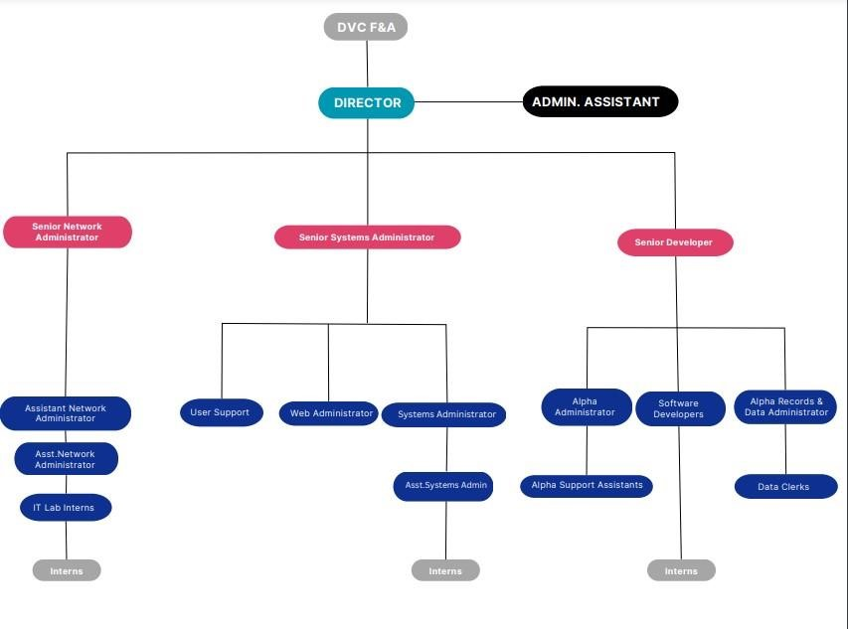

# 1.7 Main activities / business operation.

Infrastructure Management: To efficiently install, manage, and maintain the university's physical and digital infrastructure, ensuring seamless and reliable ICT services to support teaching, learning, research, and collaboration.

User Support Services: To deliver prompt and effective ICT technical support to students and staff, resolving hardware and software issues, troubleshooting problems, and addressing IT-related queries, thereby enhancing the university community's productivity and user experience. System Management: To expertly implement, maintain, and support essential corporate systems, such as mailing systems, financial ERPs, and student management information systems, with the aim of streamlining processes, digitizing operations, and maximizing operational efficiency university-wide.

Data Security and Privacy: To ensure the highest level of data security and privacy by implementing and adhering to robust cyber security policies and procedures, safeguarding sensitive information from unauthorized access, and minimizing the risk of data breaches.

System Integrations: To facilitate seamless interactions between different software systems by fostering effective collaboration with service vendors and integrating services into the university's systems, promoting efficient data flow and enhancing overall operational effectiveness.

System Development: To create tailor-made software solutions that address the specific needs of the university, promoting innovation, optimizing workflows, and enhancing the university's capabilities through the development of user-centric and purpose-driven applications.

Network Connectivity: To ensure reliable and high-speed internet connectivity across all university campuses, enabling uninterrupted access to online resources, promoting efficient communication, and supporting a conducive digital learning and research environment.

# CHAPTER TWO

# COMPUTER NETWORKS AND SYSTEMS ADMINISTRATION

# 2.0 Computer Networks

# 2.1 Introduction

## The field of Computer Networks and Systems Administration is a critical component of modern organizations, facilitating seamless communication, data sharing, and resource management. During my industrial training at Uganda Christian University (UCU) in the Department of Computing and Technology, I had the privilege of delving into this dynamic domain and gaining valuable insights and skills. As an intern, I was exposed to various aspects of network management, starting from the basics of terminating network cables to more complex tasks such as setting up local area networks (LANs) and administering network servers. Troubleshooting network connectivity issues and configuring network switches were essential skills that I gained during my training, ensuring the smooth functioning of the entire network system.

# 2.2 Classes and assigning IP addresses to a computer

## IP addresses are essential components of computer networks that uniquely identify devices and enable data communication over the Internet and local networks. IP addresses are classified into three classes: Class A, Class B, and Class C.

Class A IP Addresses:

* Class A IP addresses have the first bit set to 0, and they can range from 0.0.0.0 to 127.255.255.255.
* The first octet of a Class A address represents the network part, and the last three octets represent the host part.
* Class A addresses are suitable for large networks because they can support over 16 million host addresses.
* The range from 1.0.0.0 to 126.0.0.0 is reserved, with 127.0.0.0 used for loopback testing.

2. Class B IP Addresses:

* Class B IP addresses has the first two bits set to 10, and they can range from 128.0.0.0 to 191.255.255.255.
* The first two octets represent the network part, and the last two octets represent the host part.
* Class B addresses can support around 65,000 host addresses per network, making them suitable for medium-sized networks.

3. Class C IP Addresses:

* Class C IP addresses has the first three bits set to 110, and they can range from 192.0.0.0 to 223.255.255.255.
* The first three octets represent the network part, and the last octet represents the host part.
* Class C addresses provide approximately 254 host addresses per network, making them ideal for small networks.

IP Address Assignment: IP addresses can be assigned to computers either statically or dynamically.

1. Static IP Address Assignment:

* In a static IP address assignment, a network administrator manually configures the IP address settings for each device on the network.
* To assign a static IP address, the administrator needs to choose an appropriate IP address from the network's IP address range and ensure it is not already in use by another device.
* Once the IP address is selected, it is configured directly on the device's network settings, including the IP address, subnet mask, default gateway, and DNS server addresses.
* Static IP addresses are typically used for servers, printers, network devices, and devices requiring fixed, predictable addresses.

2. Dynamic IP Address Assignment (DHCP - Dynamic Host

Configuration

Protocol):

* DHCP is a network protocol that automatically assigns IP addresses to devices on a network.
* A DHCP server is responsible for managing a pool of available IP addresses.
* When a device joins the network, it sends a DHCP request to the DHCP server, requesting an IP address.
* The DHCP server then assigns an available IP address from its pool to the requesting device along with other configuration details like subnet mask, default gateway, and DNS server addresses.
* DHCP is commonly used for client devices like computers, smartphones, and tablets, as it simplifies network administration and ensures efficient utilization of IP addresses.

# 2.3 Terminating network cables

In UCU we use standard A for cable termination in networking and here are some of the steps that we use for cable termination

* Using a Crimping Tool, trim the end of the cable you're terminating, to ensure that the ends of the conducting wires are even.
* Separate the 4 twisted wire pairs from each other, and then unwind each pair, so that you end up with 8 individual wires. Flatten the wires out as much as possible, since they'll need to be very straight for proper insertion into the connector.
* Holding the cable with the wire ends facing away from you. Moving from left to right, arrange the wires in a flat, side-by-side ribbon formation, placing them in the following order: white/green, solid green, white/orange, solid blue, white/blue, solid orange, white/brown, solid brown.
* Holding the RJ45 connector so that its pins are facing away from you and the plug-clip side is facing down, carefully insert the flattened, arranged wires into the connector, pushing through until the wire ends emerge from the pins.
* Check to make sure that the wire ends coming out of the connector's pin side are in the correct order; if not, remove them from the connector, rearrange into proper formation, and re-insert.
* Insert the prepared connector/cable assembly into the RJ45 slot in your crimping tool.

# 2.4 Setting up a LAN

# 2.4.1 Configuring and Installing Access Points

# UCU Missionary homes

We set up a LAN in the residents of UCU, but we started by removing the AP archives because it had a wider bandwidth and was capable of transferring internet to other APs. It was relocated to the Honors College, where we were able to run cables through the ceiling, terminate cables, and fully configure the AP. This AP, transferred to the Honors College, was intended to deliver internet to the new APs that were configured to achieve a point-to-point network. One of the residents hardly received internet, so we had to set up a new network for him. At the end of the activity, we were able to set up a point to point network and the residents were able to receive interment

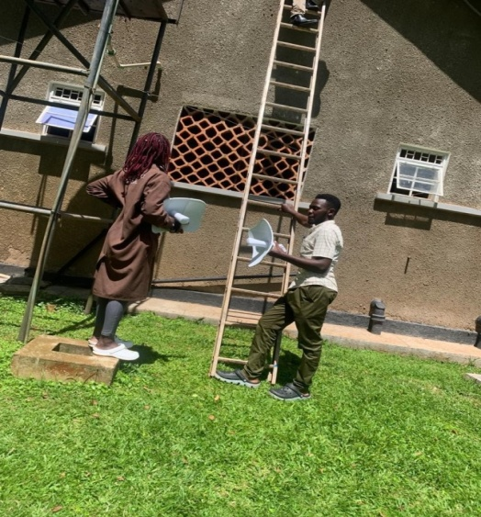

*Fig 1. Access point installation*

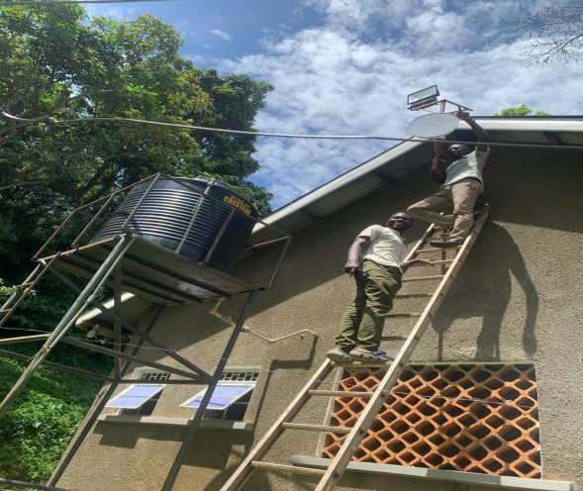

*Fig.2 Access Point Installation Missionary Houses*

# MIS

In MIS were able to install and configure a new access point so that people that work from there receive internet various steps were taken as explained below

* Access Point Selection**:** In the Management Information Systems (MIS) department, a suitable access point was chosen based on factors such as coverage area, bandwidth etc.
* Physical Installation: The selected access point was physically installed in a strategic location within the MIS department which involved mounting the AP on to the wall
* Network Configuration: The access point was then configured with the appropriate settings for example assigning the address.
* Testing: After the installation and configuration, testing was conducted to verify the functionality of the new access point. This ensured that people working in the MIS department received a stable internet connection.

**2.4.2 Configuring and Installing a Camera**

# N12 block

At N12 block, we had to install and configure a new camera for security purposes various steps were taken during the installation and they include the following

* We carried out a Site Survey and Planning at N12 block to determine the location for the new security camera.
* Installed the camera in the place that was served on which involved mounting it on the ceiling
* Power supply and network connectivity were provided to the

camera.

* The camera was then configured with the appropriate settings so that it could be detected at the monitoring system.
* We tested the camera after installation and configuration to ensure that the camera operated as intended security system, providing effective surveillance for security purposes. Any issues identified during testing were addressed to ensure optimal

functionality.

Dining hall

In the DH we installed new camera for security purposes and various steps were taken below

* We carried out a Site Survey and Planning in the DH to determine the location for the new security camera.
* Installed the camera in the place that was served on which involved mounting it on the ceiling
* Power supply and network connectivity were provided to the camera.
* The camera was then configured with the appropriate settings so that it could be detected at the monitoring system

We tested the camera after installation and configuration to ensure that the camera operated as intended security system, providing effective

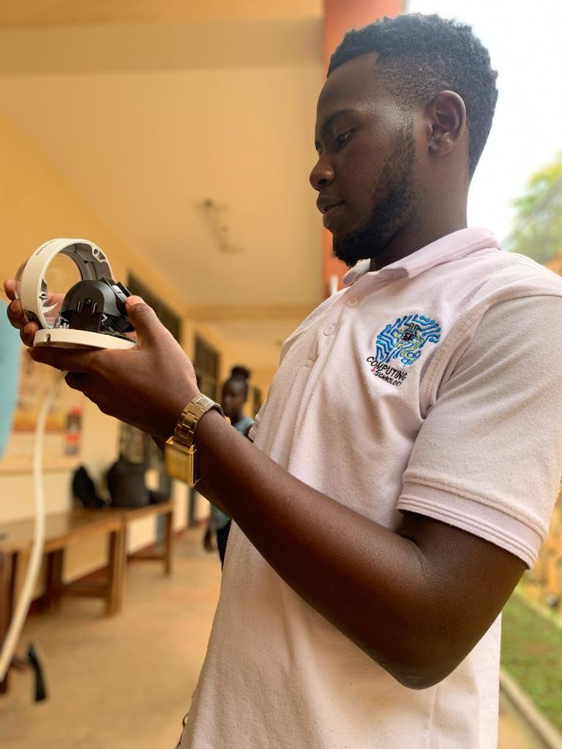

*Fig.3 Camera installation N13*

# *2.4.*3 Trouble shooting and resolving network connectivity

Chief Officers office

There was no internet access at the office internet at the Chief Security Officers office where I found out that the problem was a physical issue at the Ethernet ports of the Cisco phone. I managed to reconnect the Ethernet and the phone regained internet access. We changed cables the UTP and replaced them with the STP and blow are the to achieve the internet connectivity on the Cisco phone.

* Initial observation: Identified that there is no internet access at the Chief Security Officer's (CSO) office.
* Investigation: Determined that the problem is a physical issue at the Ethernet ports of the Cisco phone. Inspect the ports for any visible issues or loose connections.
* Reconnect Ethernet: Disconnected the Ethernet cable from the Cisco phone and reestablished the connection securely, ensuring proper insertion into the Ethernet port.
* Restore internet access: After reconnecting the Ethernet cable, verified that the Cisco phone has regained internet access, indicating that the physical issue has been resolved.

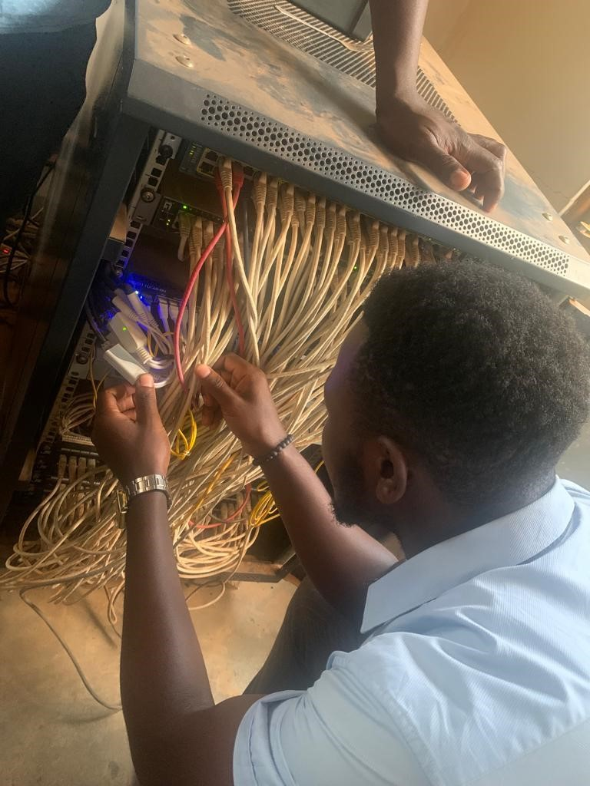

*Fig.4 Physical connection Troubleshooting*

# 2.4.4 Rebuilding a new network

# Communications Block

In the communications block we rebuilder a new network because the cables were very old and we hard to replace the to a new cables in order to improve on the network connectivity this included a lot of activities that we carried out like terminating the modules putting new trunks and also testing the cables that we had terminated.

**2.4.5 Extending Internet Connectivity**

**UCU school of Business-Ankara.**

At UCU the school of business the offices could not receive internet because of low power supply to the switch and we hard to extend the network from the lower building to the business. This undertaking involved several activities to ensure successful network extension. We carefully terminated the necessary network modules to facilitate the connection. Then, we laid the cables from the lower building to the business offices, ensuring they were securely positioned along walls and ceilings. Proper saddles were used to support the cables effectively. While conducting these activities, we made sure to maintain the highest standards of cable management and organization to avoid any future issues. Attention to detail was crucial, and we performed thorough testing to verify the stability and reliability of the extended network.

Upgraded the network from level one to level two at Ankra, running cables through building ceilings and installing an access point for efficient internet supply at the HOD of the business school's office.

2.5 Assistance at N11

During my internship at N11A, I took on the role of a dedicated lab assistant, where I was responsible for providing valuable assistance to students facing Ubuntu-related issues. This involved addressing a diverse range of technical challenges and ensuring that students could effectively navigate and utilize the Ubuntu operating system for their academic pursuits.

Furthermore, I played a pivotal role in enhancing the academic experience of statistics students by installing SPSS, a powerful statistical analysis tool. This installation aimed to empower students with the necessary tools to conduct in-depth statistical analyses, thereby fostering a more comprehensive understanding of their coursework and research projects.

In addition to my software-related responsibilities, I showcased my problem-solving abilities by successfully troubleshooting a persistent issue with the N1 projector. By diagnosing the problem, which was rooted in a loose power supply connection, I was able to restore the projector's functionality. This effort contributed to the seamless delivery of presentations and lectures, enhancing the overall learning environment within the lab.

While fulfilling these crucial tasks, I remained committed to advancing my ongoing development project. This project demonstrated my ability to manage multiple responsibilities simultaneously and showcased my dedication to both personal growth and contributing positively to the lab's operations.

# 2.6 The Mbarara project Ntale School (robotics)

During the course of my internship, I was entrusted with a significant task: to develop the code necessary for the successful operation of a robotic project focused on monitoring oxygen levels. This endeavor required a combination of C++ and C# programming languages, guided by the expert directives of Marvin. Through meticulous coding and problem-solving, I successfully achieved the functionality sought, enabling the accurate tracking and reporting of oxygen counts within the robotic system.

Upon the completion of the robotic project, I transitioned to the pivotal stage of presenting our accomplishment to Dr. Innocent, the Head of the Department. This presentation was facilitated through a Zoom meeting, thoughtfully organized by Mr. Kasole and Mr. Ken. During this session, I had the opportunity to articulate the technical aspects of our work, the innovation embedded within the robotic system, and its potential applications. This presentation not only showcased our achievement but also demonstrated my ability to communicate complex technical concepts effectively to stakeholders.

Additionally, I had the privilege of representing our university in Mbarara. Alongside Mr. Ken, I participated in the dissemination and demonstration of the sickle cell tracker system. This venture showcased our university's commitment to addressing pressing healthcare challenges and utilizing technology to make a positive impact experience allowed me to engage directly with real-world applications of our work and provided invaluable insights into the practical implementation of technological solutions in the medical field.

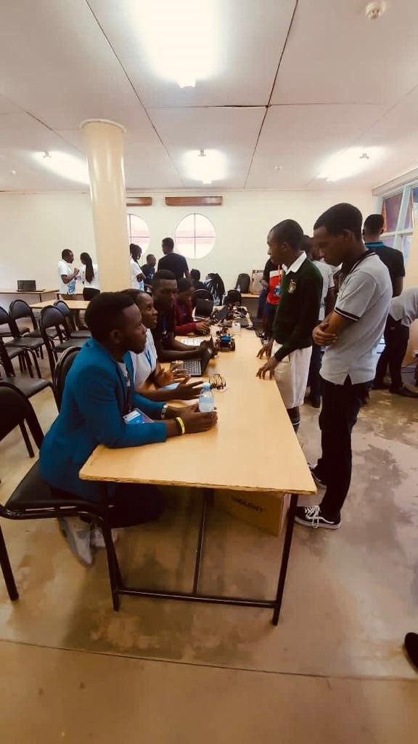

*Fig 6 Mbarara Robotics training and exhibition*

# 

# CHAPTER THREE

# 3.1 Software development

# 3.1.1 MIS Alpha Incident management system

### During the course of our project, we embarked on the development of the Alpha Incident Management System (A.I.M.S) - a comprehensive solution to streamline incident management processes. To efficiently manage this ambitious task, we decided to divide the workload into distinct parts, with junior developers and senior developers each playing crucial roles. My focus as a junior developer centered around implementing the authentication component of the system, which was a fundamental step in ensuring the security and access control of the incident management system.

Here's a breakdown of the steps we undertook

# 3.1.2 Repository Setup

We began by creating dedicated repositories for the A.I.M.S API. This organized approach allowed us to work collaboratively and maintain a clear version history of our codebase.

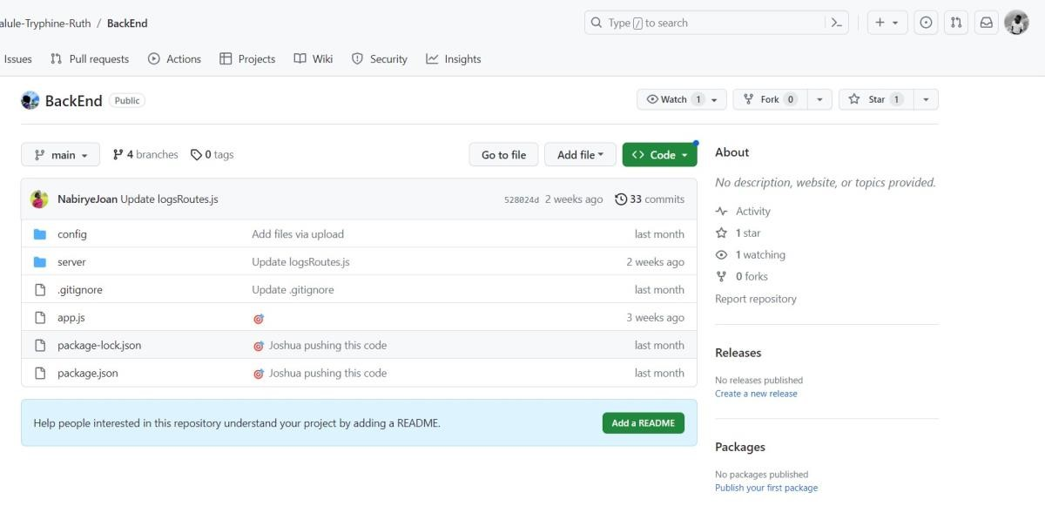

*Fig.7 GitHub Repository creation*

# 3.1.3 API Development with Express.js and MongoDB

## Our development stack comprised Express.js and MongoDB, with the assistance of Mongoose for efficient database operations. This choice of technologies empowered us to build a robust and scalable API foundation.

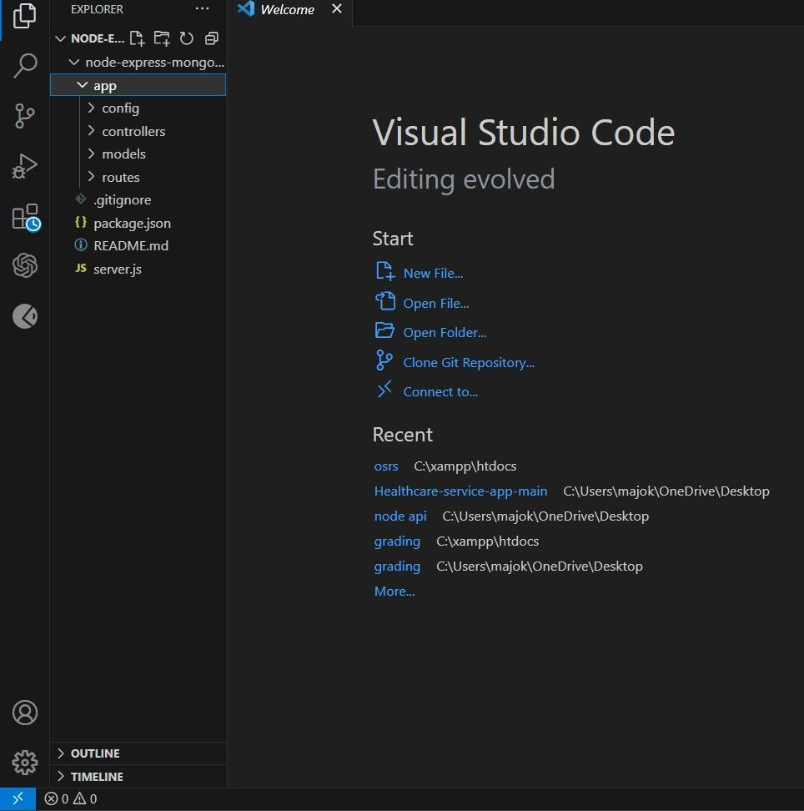

*Fig.8 Visual studio code working space set up for project*

# 3.1.4 Authentication Implementation

## A pivotal aspect of the system's functionality was its authentication mechanism. As junior developers, we took on the challenge of learning and implementing user authentication and authorization. We chose to integrate JSON Web Tokens (JWT) to securely manage user sessions and ensure data integrity.

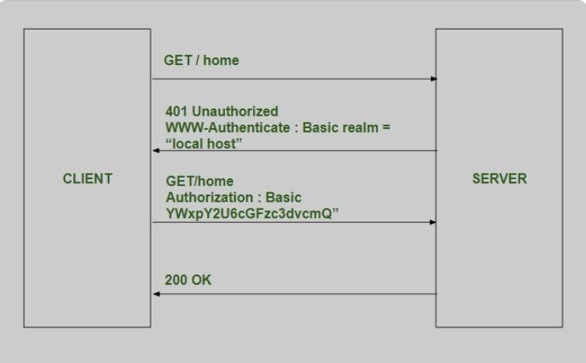

*Fig.9 illustration of the authentication fetch and post*

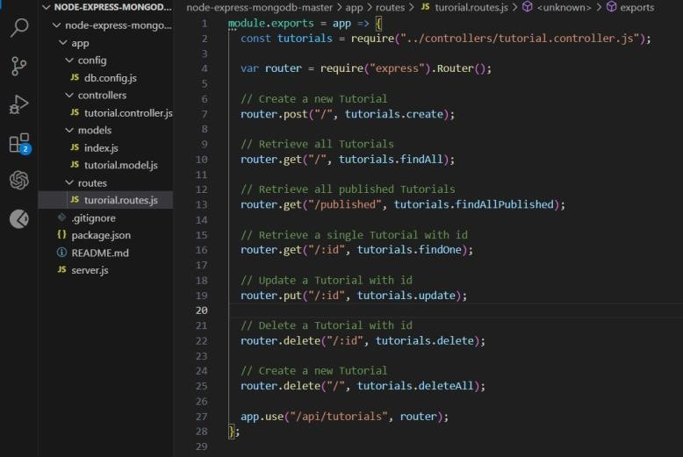

*Fig.10 Authentication API code*

# 3.1.5 CRUD Operations with Protected Endpoints

## With authentication in place, we moved on to implementing the core functionalities of the system. This involved designing and creating the necessary CRUD (Create, Read, Update, Delete) operations to manage incidents effectively. We ensured that these endpoints were protected, meaning only authenticated users with the appropriate permissions could access and modify data.

**Testing and Validation**

Thorough testing was essential to ensure the reliability and accuracy of our API. We utilized tools like POSTMAN to rigorously test the endpoints, validating that they responded correctly to various inputs and scenarios.

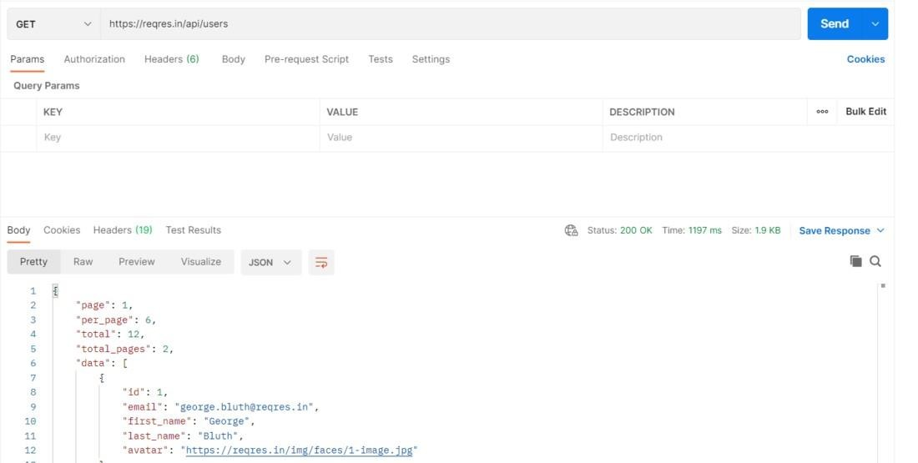

*Fig.11 Postman API testing.*

As junior developers, our contribution focused on laying the foundation for secure access to the incident management system. By learning and implementing JWT based authentication, as well as enabling CRUD operations with protected endpoints, we fortified the system's security and data management capabilities.

Our dedication to this task not only enhanced our technical skills but also contributed to the overall success of the project. It was an invaluable learning experience to work collaboratively within a team, aligning our efforts towards a common goal. We are confident that the groundwork we laid will set the stage for the senior developers to build upon and deliver a comprehensive and efficient

Alpha Incident Management System.

# 3.1.5 Github

During the course of my internship, I had the privilege of engaging in an enlightening interaction with Mr. Joshua, who provided valuable insights into the utilization of GitHub and its integration within Visual Studio Code (VS Code) alongside Git Bash. This interaction expanded my understanding of version control, collaborative coding, and efficient development practices.

Mr. Joshua's guidance covered several key areas:

1. GitHub Fundamentals:

Mr. Joshua introduced me to the fundamental concepts of GitHub, emphasizing its significance in facilitating collaborative software development. He explained how GitHub serves as a centralized platform for version control, allowing developers to manage code changes, collaborate seamlessly, and track project history.

1. Visual Studio Code Integration:

Through hands-on demonstrations, Mr. Joshua illustrated how to seamlessly integrate GitHub within Visual Studio Code. This integration streamlines the coding process by enabling direct interaction with repositories, branches, and commits without needing to switch between applications.

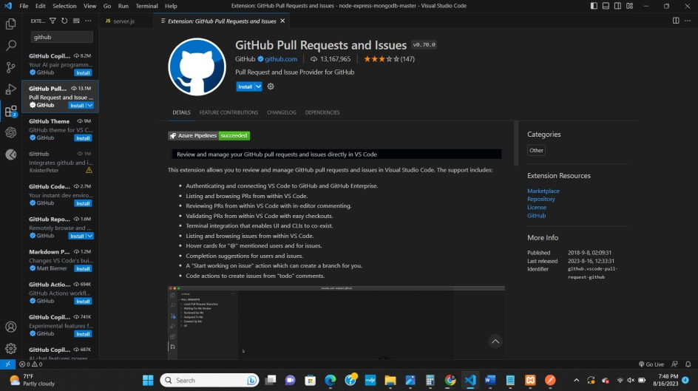

*Fig.12 Creating of GitHub branch in Visual Studio Code*

1. Git desktop for Command-Line Interaction:

Mr. Joshua highlighted the importance of Git desktop, a command-line tool that provides a powerful interface for interacting with Git and GitHub repositories. He demonstrated essential Git commands, such as cloning repositories, creating branches, committing changes, and pushing code to remote repositories.

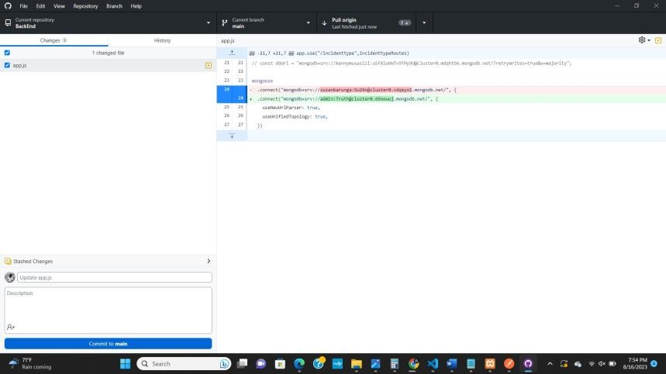

*Fig.13 GitHub desktop pull and push cycle*

1. **Cloning a Repository:**

As a practical exercise, Mr. Joshua guided me through the process of cloning a repository from GitHub using Git Bash. He explained how this operation creates a local copy of the repository on my development environment, allowing for code modifications and collaboration.

1. Extensions for Enhanced Functionality:

To enhance the development experience further, Mr. Joshua introduced me to a range of extensions available within Visual Studio Code. These extensions provide added functionality, such as syntax highlighting, code linting, and seamless integration with Git.

He highlighted how these extensions contribute to efficient and error-free coding.

This interaction with Mr. Joshua not only broadened my technical skills but also underscored the importance of effective version control and collaboration in modern software development. Through his guidance, I gained a deeper appreciation for the tools and practices that foster efficient coding, facilitate teamwork, and enhance the overall quality of software projects.

I am excited to apply the knowledge gained from this interaction to my ongoing and future projects, confident that the insights shared by Mr. Joshua will contribute to my growth as a proficient and collaborative developer.

# 3.2 System and Database Designing

# During the course of our project, we achieved significant milestones in the development process. Collaborating with Mr. Senyondo Jordan, we successfully completed the design phase of our database, laying the foundation for our program's structure. Subsequently, we embarked on the construction of flowcharts that intricately correlated with our program's functionalities, ensuring a comprehensive and organized approach to development.

1. Database Design:

With careful consideration of the project's requirements and objectives, we meticulously designed the database architecture. This encompassed defining the relationships between different data entities, establishing data types, and creating an efficient structure to store and manage information. The database design phase was critical in shaping the data management aspect of our program, setting the stage for seamless integration and retrieval of information.

1. Flowchart Construction:

Working closely with Mr. Senyondo Jordan, we translated our program's functionalities into visual representations through the construction of detailed flowcharts. These flowcharts provided a step-by-step visual guide to the logic and sequence of operations within the program. This approach allowed us to comprehensively plan and foresee potential challenges in the development process, enhancing our overall project strategy.

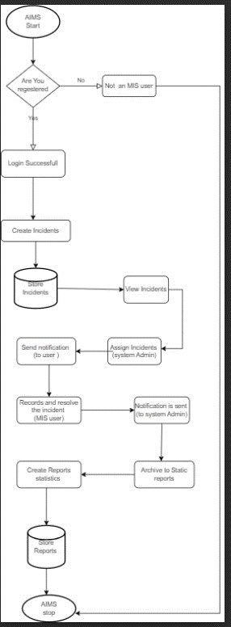

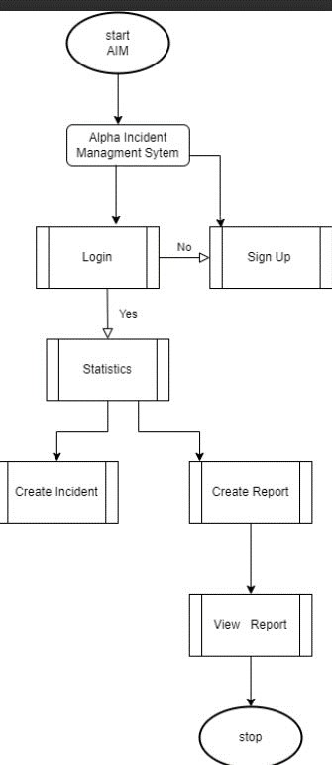

*Fig.14Fowcharts used in system designs*

Collaborating with Mr. Senyondo Jordan enriched our development approach by infusing expert insights and leveraging collective expertise. The completion of the database design and construction of flowcharts marked essential milestones that enabled us to transition seamlessly into the development phase of the project. These preparatory steps not only laid a solid foundation for efficient coding but also demonstrated our commitment to a structured and organized approach to software development.

As we move forward in the development process, we are poised to capitalize on the groundwork we have laid, ensuring that our program aligns seamlessly with its intended functionalities and objectives. The collaborative efforts and meticulous planning undertaken with Mr. Senyondo Jordan will undoubtedly contribute to the successful realization of our project's goals.

# 3.3 Teaching BSIT condition statements and Functions

In response to Mr. Ken's request, the student had a privilege of collaborating with him to teach a class on fundamental programming concepts to his first-year class of BSIT students. The focus of the tutorial was on functions and conditional statements within the context of C programming. Embracing this opportunity, I actively engaged in the teaching process, facilitating an informative and interactive session that provided students with a solid understanding of these essential programming concepts.

Key highlights of the collaboration include:

1. Collaborative Teaching:

The student worked closely with Mr. Ken to co-teach the class, leveraging our combined knowledge and expertise to deliver comprehensive instruction. Our shared dedication to providing students with a rich learning experience ensured that the content was effectively communicated.

1. Fundamental Concepts:

The tutorial centered on functions and condition statements, which are foundational to programming. The student employed clear explanations, real-world examples, and interactive exercises to help students grasp the concepts' significance and practical application.

1. Interactive Engagement:

Recognizing the importance of engagement, the student encouraged active participation from students through questions, discussions, and hands-on coding exercises. This approach fostered a dynamic learning environment and allowed students to apply theoretical knowledge to practical scenarios.

1. Practical Implementation:

Demonstrating the concepts in action, the internee guided students through coding exercises that showcased the usage of functions and conditional statements. By providing tangible examples, students gained hands-on experience and confidence in their coding abilities.

1. Comprehensive Understanding:

The tutorial aimed not only to introduce concepts but also to ensure that students comprehended the underlying principles. I used analogies and visual aids to simplify complex ideas, enabling students to connect theoretical concepts to real-world applications.

Collaborating with Mr. Ken to deliver this tutorial was both fulfilling and rewarding. It provided me with the opportunity to share my knowledge, foster a positive learning environment, and contributes to the growth of aspiring IT professionals. The successful completion of the tutorial underscored the significance of effective teamwork and the power of practical teaching methodologies in nurturing students' understanding of programming concepts.

As I reflect on this experience, I am reminded of the impact educators can have on shaping future professionals' skills and perspectives. I am grateful for the chance to have contributed positively to the learning journey of Mr. Ken's class and look forward to continued opportunities to engage in similar educational endeavors.

# 3.4 The UIS week

During the UIS (University ICT Services) week, the student actively participated in a diverse range of services and activities, contributing to the successful execution of various tasks. This engaging experience allowed me to contribute my skills and energy to different aspects of the event, creating a positive impact on both the university community and the overall event itself.

My involvement encompassed:

1. Software Installation:

The student played a key role in assisting with software installation on various machines. This involved ensuring that the required software applications were correctly installed and configured to meet the specific needs of different departments and users such as windows and libre office.

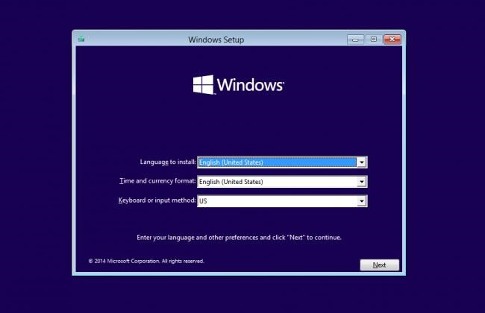

*Fig .15 Windows installation UIS week*

2. Machine Maintenance

Contributing to the maintenance of machines, the student helped to ensure that the computer systems were functioning optimally. This involved tasks such as system updates, hardware checks, and addressing any technical issues that arose during the event.

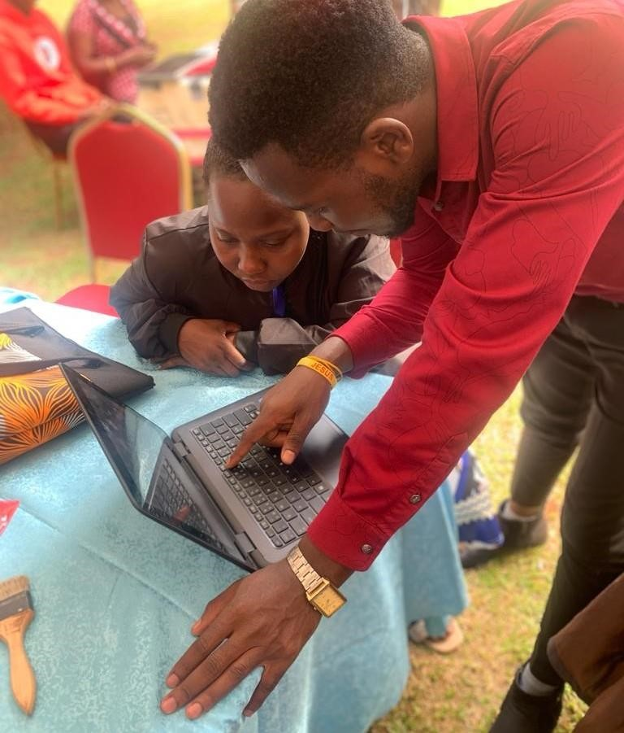

*Fig.16 UIS week Machine Maintenance*

1. Food Serving at Dining Hall (DH):

As part of the UIS week, I also participated in food serving activities at the dining hall. This involved helping with meal preparation, serving, and maintaining a pleasant dining environment for attendees.

1. Computer Guidance:

Utilizing my technical knowledge, the student provided computer guidance to attendees who required assistance. This included helping individuals navigate software applications, troubleshoot minor technical issues, and answer general technology-related queries.

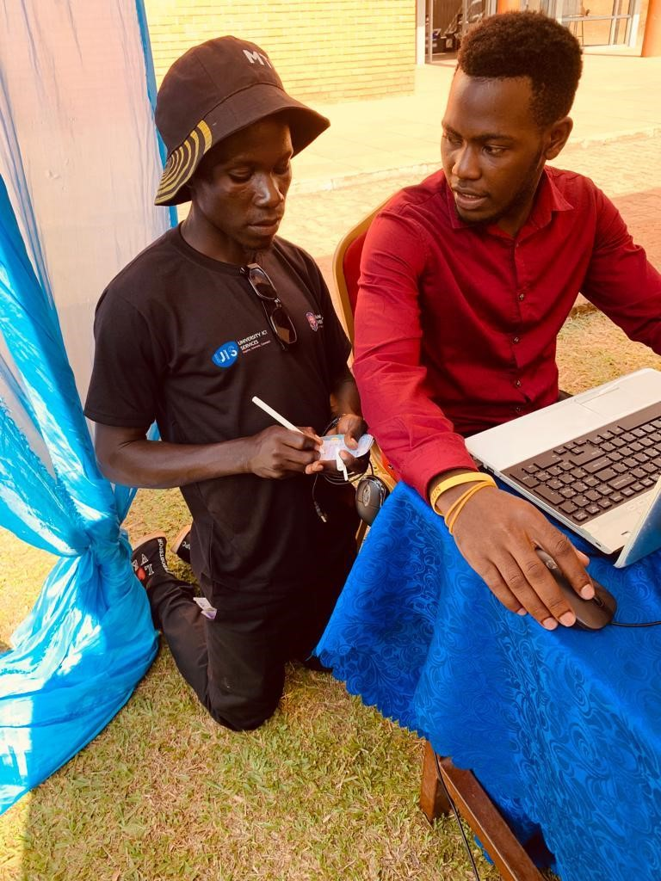

*Fig.17 UIS week Computer Guidance*

1. Other Activities:

The student actively engaged in various other activities that contributed to the overall success of the UIS week. This could include setting up equipment, assisting with event logistics, providing information to participants, and ensuring the smooth flow of the event.

My participation in these diverse activities not only showcased my versatility but also demonstrated my commitment to supporting the UIS week's objectives. Collaborating with fellow participants, event organizers, and attendees allowed me to contribute positively to the university's vibrant community and create a memorable experience for everyone involved.

**The Identified problem/ task at hand** poorly developed ICT infrastructure

As it adopts ICT in education, Uganda Christian University faces the same challenges as most developing universities that is poorly developed ICT infrastructure, high bandwidth costs, an unreliable supply of electricity, and a general lack of resources to meet a broad spectrum of needs.

However, with the rapid emergence of wireless network capacity and the ubiquitous growth of mobile phones, the context of the infrastructure is changing. A national ICT policy is in place and an education sector ICT policy is before Cabinet. The Ministry of Education and Sports is taking steps to co-ordinate ICT development and has allocated resources to support implementation of its ICT strategy

Procedures to overcome the stated problem /task above

1. Guidelines on the use of ICTs should be developed.
2. An agreement with Microsoft should be been signed to subsidize software licenses and training of teachers. In addition, the Microsoft Partners in Learning Program has endorsed a number of activities for implementation.
3. An ICT budget for all learning institutions is now required.
4. Subsidized rates from ICT service providers have to been negotiated.
5. Training teachers in ICT skills has to begin.
6. Ordinary level curriculum on ICT should be operational and examinable by the examinations Board.
7. Operational funds to support ICT in learning institutions has to be been provided.
8. Some ICT infrastructure should be provided to schools.

# CHAPTER FOUR

# CONCLUSION, LIMITATIONS AND RECOMMENDATION.

# 4.1 Conclusion

In conclusion, my industrial training experience at Uganda Christian University (UCU) within the Department of Computing and Technology has been a remarkable journey of growth and learning. This opportunity has bridged the gap between theoretical knowledge and practical application, providing me with a transformative experience in the field of computing and technology. Working alongside seasoned professionals in a dynamic environment has not only expanded my technical skills but also deepened my understanding of the industry's demands and the significance of hands-on experiences in shaping the future workforce.

Throughout this internship, I had the privilege of applying classroom concepts to real world projects, gaining insights that textbooks alone could not offer. Collaborating with industry experts allowed me to witness the practical implications of my work and the tangible impact of technology on society. This experience has ignited a passion within me to contribute meaningfully to the ever-evolving field of computing.

# 4.2 Limitations

While the industrial training experience was undeniably valuable, it's essential to acknowledge a few limitations that surfaced. The constrained duration of the internship posed a challenge in terms of fully delving into certain projects. As technology advancements demand increasing complexity, some tasks would have benefitted from a more extended period to explore thoroughly. Moreover, the nature of some projects demanded resources and expertise that could not be fully harnessed within the limited timeframe of the internship.

# 4.3 Recommendations:

Drawing from the enriching experience of my industrial training, I offer recommendations that could enhance the program's impact on future interns and the

Department of Computing and Technology at UCU:

1. Extension of Duration: To provide interns with a more comprehensive learning experience, consider extending the duration of the industrial training program.

This extension would allow interns to immerse themselves deeply in projects, address complex challenges, and engage in a more in-depth exploration of their chosen field.

1. Diversified Training Opportunities: Introducing a broader spectrum of training opportunities would expose interns to cutting-edge technologies and emerging industry trends. Incorporating workshops, seminars, and practical sessions on new tools and methodologies would ensure that interns remain well-versed in the fast-paced world of computing and technology.
2. Mentorship Programs: Implementing mentorship programs would greatly enrich the intern experience. Pairing interns with experienced professionals for guidance, feedback, and mentorship could accelerate their learning curve and empower them to make more substantial contributions to projects. This personal connection could also foster a sense of belonging and encouragement within the intern community.

References

Eremu, J. “ICT Connectivity in Schools in Uganda.” 2005. I-Connect Online. www.iconnectonline.

org/Articles/iconnectarticles.2005-05-3

Aguti, J.N. and W.J. Fraser. “Integration of Information Communication Technologies (ICTs) in The Distance Education Bachelor of Education Programme, Makerere University, Uganda.” July 2006.*Turkish Online Journal of Distance.*

Obot, D., F. Kintu, and L. Elder. “The Uganda Knowledge and Information Society: Early Lessons

from ICT Projects,” in *At The Crossroads: ICT Policymaking in East Africa*. 2005. IDRC.

http://www.idrc.ca/en/ev-93065-201-1-DO_TOPIC.html

Farrell, G.M. and C. Wachholz, eds. 2003. *ICT in Education: Meta-Survey on the Use of Technologies in Asia and the Pacific.* UNESCO. www.unescobkk.org/index.php?id=1225

Etta, F.E. and L. Elder, eds. 2005. *At The Crossroads: ICT Policy Making In East Africa.* IDRC.

www.idrc.ca/openebooks/219-8/

Nyaki Adeya, C. and B. Oyelaran-Oyeyinka. 2002. *The Internet in African Universities: Case Studies from Kenya and Nigeria.* United Nations University, Institute for New Technologies

Murray, Lize. “AVU Gap Analysis Report: August 2005.” 2005. Prepared for the Hewlett Foundation

OdeL Initiative. <http://www.avu.org/acep.asp>

Appendix

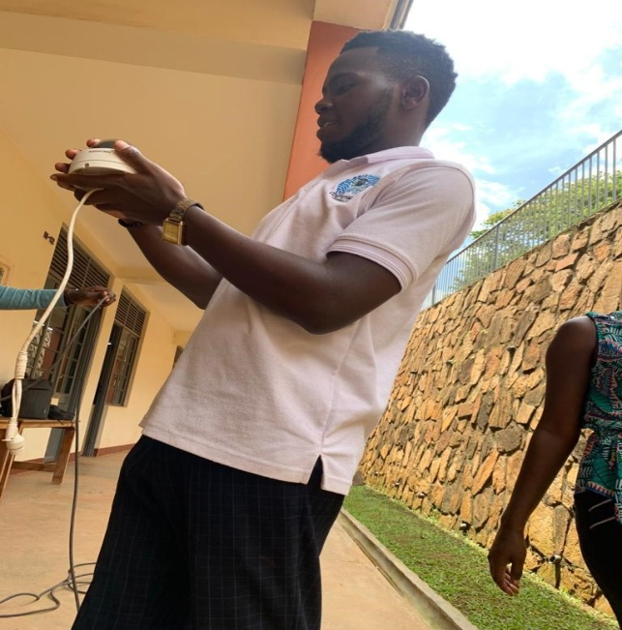 **

Camera installation at N13 *Spss software setup*

 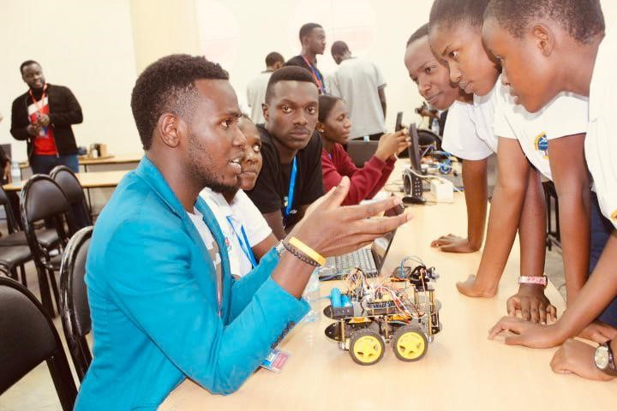

*Camera Inspecting N-block Mbarara Robotics session*

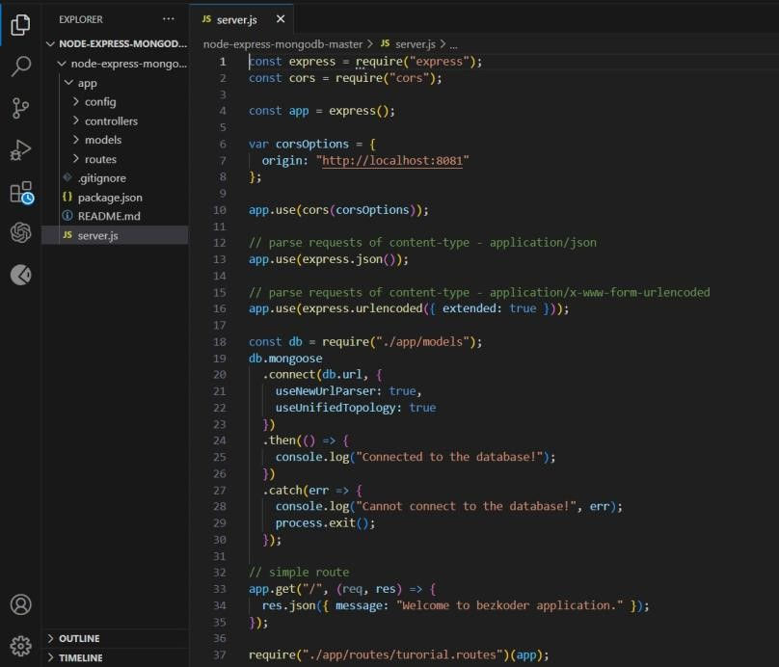 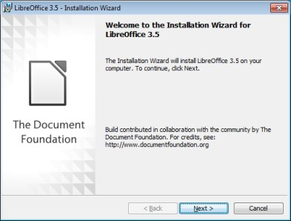

*API setup libre office installation UIS week*