A WEB BASED PLATFORM TO PROVIDE STUDENTS WITH REAL-TIME FEEDBACK ON THEIR ACADEMIC PROGRESS. THE CASE OF UGANDA CHRISTIAN UNIVERSITY

By

SENGENDO MARK

M22B13/013

DEPARTMENT OF COMPUTING AND TECHNOLOGY

FACULTY OF ENGINEERING, DESIGN AND TECHNOLOGY

Email Address: sengendomark16@gmail.com ; Phone Number +256 759079867

A Project Proposal Submitted to the Faculty of Engineering, Design and Technology for the Study Leading to a Project in Partial Fulfillment of the Requirements for the Award of the UITA of Uganda Christian University.

May, 2024.

Contents

CHAPTER ONE 3

1.Introduction 3

1.1. Background To The Study 3

1.2. Statement Of The Problem 4

1.3. Purpose Of The Study (General Objective) 5

1.3.1. Specific Objectives 5

1.4. Scope Of The Study 6

1.5. Justification Of The Study 7

CHAPTER TWO 8

2. Introduction To The Literature Review 8

2.1. Literature Review Of Objectives 9

**CHAPTER THREE** 10

3. Introduction To Methodology 10

3.1. Research Design 10

3.1.1. System Development LifeCycle (SDLC) 11

3.2. Population Of Study 16

3.3. Sample Size and Selection 18

3.3.1. Sample Size 18

**3.3.2. Selection Criteria:** 19

3.4. Data Collection methods and Instruments 19

3.4.1. Data Collection Methods: 19

**3.4.2. Data Analysis Tools:** 20

3.5. Reliability and Validity 20

3.5.1. Reliability: 20

3.5.2. Validity: 21

**REFERENCES** 22

APPENDICES 24

# 

# CHAPTER ONE

## 1.Introduction

In today's fast-paced educational environment, the need for immediate and actionable feedback has never been more critical. Traditional methods of academic assessment and feedback often fall short, leaving students to navigate their educational journey with delayed insights into their performance. This gap in timely feedback can hinder their ability to address weaknesses promptly and capitalize on strengths effectively. To bridge this gap, we propose the development of a platform designed to provide students with real-time feedback on their academic progress. This innovative solution aims to transform the educational landscape by equipping students with the tools they need to succeed, fostering a more responsive and supportive learning environment, and ultimately enhancing academic outcomes. Our platform will leverage advanced technologies to deliver instant, personalized feedback, empowering students to take control of their learning and achieve their full potential.

## 1.1. Background To The Study

The contemporary educational system is increasingly recognizing the importance of timely and relevant feedback in the learning process. Research consistently shows that prompt feedback significantly enhances student performance by allowing learners to understand their mistakes and grasp key concepts more quickly. Despite this, many educational institutions still rely on traditional methods of assessment and feedback, which are often slow and inefficient.

Traditional feedback mechanisms, such as periodic exams and written evaluations, typically involve a significant delay between the time a student completes an assignment and when they receive feedback. This delay can be detrimental to the learning process, as it prevents students from promptly addressing their misunderstandings and refining their skills. Consequently, students may continue to make the same errors, leading to a cycle of frustration and stagnation in their academic progress.

The advent of digital technology in education has opened new avenues for enhancing the feedback process. With the proliferation of online learning platforms and educational apps, there is a growing opportunity to provide students with real-time feedback. Such platforms can offer immediate insights into a student's performance, helping them identify areas of improvement and adjust their learning strategies on the fly. This approach not only supports continuous learning but also fosters a more engaged and motivated student body.

Several studies have highlighted the benefits of real-time feedback in education. For instance, research indicates that students who receive immediate feedback demonstrate improved retention of information and higher overall achievement levels. Moreover, real-time feedback can cater to diverse learning styles and paces, making education more inclusive and personalized.

Despite these advantages, the integration of real-time feedback systems in educational settings remains limited. Challenges such as technological infrastructure, scalability, and the need for tailored feedback mechanisms pose significant hurdles. Therefore, there is a pressing need for innovative solutions that can effectively deliver real-time feedback, accommodate the diverse needs of students, and seamlessly integrate into existing educational frameworks.

This proposal aims to address these challenges by developing a platform specifically designed to provide students with real-time feedback on their academic progress. By leveraging cutting-edge technology and pedagogical insights, this platform seeks to enhance the learning experience, promote academic excellence, and prepare students for the demands of a rapidly evolving world.

## 1.2. Statement Of The Problem

In the current educational landscape, students often face significant delays in receiving feedback on their academic performance. Traditional feedback mechanisms, such as periodic exams and written assessments, do not provide the timely insights necessary for students to promptly address their weaknesses and build on their strengths. This lag in feedback hinders students' ability to make real-time adjustments to their learning strategies, resulting in prolonged periods of misunderstanding and suboptimal academic progress.

The lack of immediate feedback creates a critical gap in the learning process. Students are unable to correct mistakes or reinforce knowledge when it is most relevant, leading to a cycle of repeated errors and missed opportunities for improvement. This issue is particularly pronounced in diverse educational settings where students have varying learning paces and styles, requiring more personalized and immediate feedback to support their unique needs effectively.

Furthermore, educators are often burdened with the task of providing detailed, individualized feedback within tight timeframes, which can be challenging and inefficient. This strain on resources and time impacts the overall quality of education and limits the ability of teachers to engage in more meaningful instructional activities.

To address these challenges, there is a pressing need for a platform that can deliver real-time feedback on academic progress. Such a platform would enable students to receive instant, actionable insights, empowering them to take proactive steps in their learning journey. It would also alleviate the pressure on educators by streamlining the feedback process and enhancing the overall efficiency of academic assessments.

This proposal seeks to develop a solution that bridges the gap between student needs and current feedback mechanisms, fostering a more dynamic and responsive educational environment. By implementing a real-time feedback platform, we aim to enhance student engagement, improve academic outcomes, and support educators in delivering high-quality, personalized instruction.

## 1.3. Purpose Of The Study (General Objective)

The purpose of this study is to develop and implement a platform that provides students with real-time feedback on their academic progress.

### 1.3.1. Specific Objectives

To Investigate the current challenges and limitations of traditional feedback mechanisms in educational settings, including their impact on student learning outcomes and engagement.

To Design a user-friendly platform architecture that leverages advanced technologies to provide real-time, personalized feedback to students based on their academic performance.

To Develop the proposed platform, incorporating features such as automated assessment tools, performance tracking, and personalized feedback generation.

To Test and Validate the platform in various educational environments to ensure its functionality, usability, and effectiveness in delivering real-time feedback to students, and to assess its impact on student learning outcomes and engagement through comprehensive analysis and feedback from both students and educators.

## 1.4. Scope Of The Study

The study will focus on the development and implementation of a platform designed to provide real-time feedback on students' academic progress. Key components will include automated assessment tools, performance tracking systems, and personalized feedback mechanisms. The platform will be evaluated for its effectiveness in enhancing student learning outcomes and engagement, as well as its usability and integration within existing educational frameworks.

The project will initially be implemented and tested in a select number of educational institutions within a specific region, ideally where there is a diverse student population to ensure a comprehensive analysis. The pilot phase will focus on schools and colleges within a metropolitan area to facilitate close monitoring and support. Depending on the results, future phases may extend to additional regions and potentially international contexts to validate the platform's broader applicability and effectiveness.

The duration of this project will be determined based on the complexity of the research objectives and the development of the platform. A timeline of approximately 18 months is envisioned for completing the entire project, including the investigation, design, development, testing, and validation phases.

The study will be guided by educational theories and models that emphasize the importance of timely feedback in the learning process. Key theoretical frameworks include:

**Constructivist Learning Theory**: Emphasizing the role of feedback in helping students construct their own understanding and knowledge through experiences.

**Formative Assessment Theory**: Highlighting the role of continuous assessment and feedback in enhancing student learning and informing instructional strategies.

**Motivational Theories**: Exploring how immediate feedback can impact student motivation, engagement, and self-regulated learning.

## 1.5. Justification Of The Study

The current educational landscape is undergoing rapid transformation due to technological advancements and the increasing need for personalized learning experiences. Traditional feedback mechanisms are no longer sufficient to meet the demands of modern education, where students and educators require immediate, actionable insights to enhance learning outcomes. The COVID-19 pandemic has further accelerated the shift towards digital learning environments, highlighting the urgent need for effective online tools that support student engagement and academic success. Implementing a real-time feedback platform now will address these pressing needs, ensuring that students receive timely support and guidance in their educational journey.

The primary beneficiaries of this study will be students and educators. Students will benefit from receiving immediate, personalized feedback that allows them to identify and address their weaknesses promptly, enhancing their learning outcomes and academic performance. Educators will benefit by having access to streamlined feedback tools that reduce their workload, enabling them to focus more on instructional activities and provide targeted support to their students. Additionally, educational institutions will benefit from improved student performance and satisfaction, leading to better academic reputations and outcomes.

If the study is not conducted now, educational institutions will continue to rely on outdated feedback mechanisms that fail to meet the needs of today's learners. This delay in innovation will result in prolonged periods of student disengagement, decreased academic performance, and missed opportunities for timely interventions. The gap between the capabilities of traditional feedback systems and the needs of modern education will widen, potentially leading to higher dropout rates and lower overall educational standards.

The study is feasible given the availability of technological resources, expertise in educational technology, and institutional support. Advances in data analytics, machine learning, and user experience design provide a strong foundation for developing an effective real-time feedback platform. Collaborations with educational institutions for pilot testing and feedback will ensure that the platform is practical and tailored to real-world educational settings. Funding opportunities and grants dedicated to educational innovation also enhance the feasibility of the project.

The urgency and relevance of this study are underscored by the rapid evolution of educational needs and the critical role of timely feedback in student success. As education continues to adapt to digital and hybrid models, the need for immediate, actionable feedback becomes increasingly important. By addressing this need, the study will contribute to the development of a more responsive and effective educational system, fostering a generation of learners who are better equipped to meet the challenges of the future. The relevance of the study is further highlighted by its potential to bridge existing gaps in educational practices, ensuring that students receive the support they need to thrive academically.

# CHAPTER TWO

## 2. Introduction To The Literature Review

The literature review delves into the pivotal role of feedback in education, exploring theories such as formative assessment and constructivist learning. It examines how traditional feedback methods fall short in providing timely insights into student progress, prompting the need for innovative solutions like real-time feedback platforms. Advancements in educational technology have fueled the emergence of these platforms, offering immediate, personalized feedback to enhance student engagement and academic success. By synthesizing existing research, the review aims to inform the development of a novel real-time feedback system tailored to meet the evolving needs of modern education.

## 2.1. Literature Review Of Objectives

**Objective 1: To Investigate the current challenges and limitations of traditional feedback mechanisms**

The investigation into feedback mechanisms in education reveals a rich tapestry of theories and empirical studies emphasizing its crucial role in shaping student learning experiences. Constructivist learning theory posits that feedback aids students in constructing their own understanding through active engagement and reflection (Vygotsky, 1978). Similarly, formative assessment theory underscores the importance of continuous feedback in informing instructional strategies and promoting student progress (Black & Wiliam, 1998). However, traditional feedback methods often exhibit limitations in providing timely insights, necessitating exploration into innovative solutions.

**Objective 2: To Design a user-friendly platform architecture that leverages advanced technologies**

The design of real-time feedback platforms draws inspiration from contemporary frameworks grounded in educational technology and cognitive psychology. These platforms leverage advances in information technology to deliver immediate, personalized feedback to students (Shute & Zapata-Rivera, 2012). By incorporating features such as automated assessment tools and performance tracking systems, these platforms aim to create dynamic learning environments that cater to individual student needs (D'Mello & Graesser, 2012).

**Objective 3: To Develop the proposed platform, incorporating features such as automated assessment tools**

The development of real-time feedback platforms requires a synthesis of theoretical insights and practical considerations. Research in human-computer interaction informs the user interface design, ensuring that feedback delivery is intuitive and engaging for students (Norman, 2013). Additionally, advances in data analytics and machine learning facilitate the integration of adaptive feedback mechanisms, allowing the platform to respond dynamically to student progress and performance (Baker & Siemens, 2014).

**Objective 4: To Test and Validate the platform in various educational environments to ensure its functionality**

Testing and validation of real-time feedback platforms involve rigorous empirical evaluation to assess their effectiveness and impact on student learning outcomes. Studies employing methodologies such as randomized controlled trials and quasi-experimental designs provide valuable insights into the efficacy of these platforms in diverse educational settings (Hattie & Timperley, 2007). Moreover, qualitative research methods, including interviews and focus groups, offer nuanced perspectives on student and educator experiences with the platform, informing iterative improvements (Creswell & Creswell, 2017).

# **CHAPTER THREE**

## 3. Introduction To Methodology

The methodology section serves as a blueprint for the systematic execution of the proposed study, delineating the research design, data collection procedures, and analytical techniques employed to achieve the study objectives. In the context of developing and implementing a real-time feedback platform for enhancing student learning outcomes, a robust methodology is essential to ensure the validity, reliability, and generalizability of the findings. This section outlines the methodological approach adopted in the study, drawing upon established research methodologies in education, technology, and data analytics. By providing a clear roadmap for data collection, analysis, and interpretation, the methodology seeks to facilitate transparency, rigor, and reproducibility in the research process.

## 3.1. Research Design

The research design for this study is structured to systematically investigate, design, develop, test, and validate a real-time feedback platform tailored for educational settings. The design integrates both qualitative and quantitative approaches to provide a comprehensive understanding of the platform's effectiveness and usability. The study will employ the Systems Development Life Cycle (SDLC) methodology, a widely-recognized framework in software engineering, to guide the development process. This methodology ensures a structured and iterative approach to system development, encompassing several key phases: Planning, Analysis, Design, Implementation, Testing, and Maintenance.

### 3.1.1. System Development LifeCycle (SDLC)

This is a structured and systematic process used in software engineering to design, develop, test, deploy, and maintain software systems. The SDLC framework provides a series of phases and activities that guide the development process from inception to completion, ensuring that software projects are completed efficiently, effectively, and in a predictable manner.

**Prototype Of The SDLC**

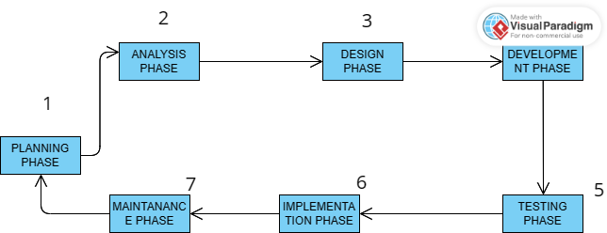

The Typical phases of The SDLC include:

**Planning Phase:**

The planning phase is essential for establishing the foundation of the real-time feedback platform project. It involves defining the project scope, objectives, and feasibility, and developing a comprehensive project plan. The scope includes key features such as automated assessment tools and performance tracking systems, with a pilot focus on selected educational institutions. Objectives encompass investigating current feedback challenges, designing a user-friendly platform, developing technological components, and testing and validating the platform. Feasibility analysis covers technical, operational, and economic aspects, ensuring the project's viability. Stakeholder engagement involves identifying and communicating with students, educators, and technical experts to gather insights and requirements. The project plan outlines timelines, milestones, resource allocation, and risk management strategies. Finally, documentation and approval processes ensure alignment with institutional goals and secure necessary permissions and support for successful execution.

**Analysis Phase:**

The analysis phase is crucial for understanding the limitations of current feedback mechanisms and gathering detailed requirements for the real-time feedback platform. Key activities include conducting a literature review, engaging with stakeholders through surveys and interviews, and performing a needs assessment to identify desired functionalities. A technical analysis evaluates the necessary infrastructure and technological components, while user and system requirements are specified based on stakeholder feedback. A feasibility study assesses the project's practicality in terms of cost, time, and resources, and a risk analysis identifies potential challenges and mitigation strategies. The outcomes include a detailed requirements document, a feasibility report, and stakeholder buy-in, all of which lay the foundation for the platform's design and development.

**Design Phase:**

The design phase translates the requirements from the analysis phase into a detailed blueprint for the real-time feedback platform. Key activities include creating the system architecture, developing sophisticated Entity-Relationship Diagrams (ERDs) with constraints to manage data efficiently, and designing intuitive user interfaces through wireframes and mockups. User experience design focuses on seamless interaction flows and personalized feedback mechanisms. Technical specifications cover APIs, integrations, and security measures to ensure robust and secure platform operation. A functional prototype is built and subjected to usability testing with educators and students to gather feedback for refinement. Comprehensive design documentation, including system diagrams, UI/UX designs, and user manuals, guides the development team in creating a user-friendly and effective platform. This phase ensures the platform is well-structured, secure, and aligned with user needs, paving the way for successful development and implementation**.**

**ERD Diagram**

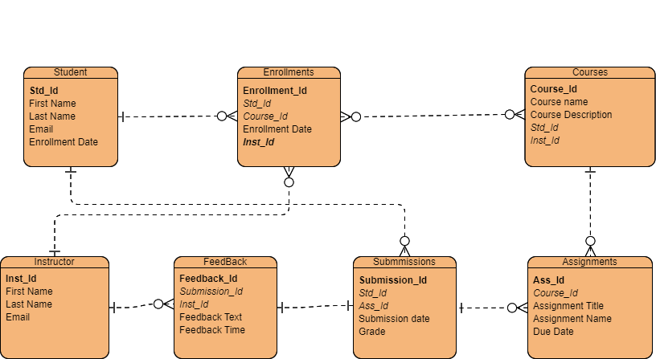

**Development Phase:**

During the development phase, adhering to the structured Systems Development Life Cycle (SDLC) methodology, the focus is on transforming design specifications into a functional real-time feedback platform. PostgreSQL serves as the backbone for database management, ensuring robust data storage and management capabilities. Django, a high-level Python web framework, accelerates backend development, with Django Channels and WebSockets facilitating real-time communication. Utilizing React for frontend development streamlines interface creation, enabling dynamic and interactive user experiences.

Integration of notification APIs enhances user engagement, delivering real-time alerts and notifications. Moreover, the platform implements RESTful APIs for seamless communication between frontend and backend, ensuring flexibility and scalability. Token-based authentication mechanisms bolster security, granting secure access to authenticated users.

Throughout development, agile principles enable iterative cycles and continuous improvement. Comprehensive testing methodologies, including unit, integration, performance, and security testing, guarantee the platform's reliability and security. User acceptance testing (UAT) collects feedback from pilot users, guiding iterative refinements to align with user needs effectively.

Comprehensive technical documentation, encompassing database schemas, API specifications, and deployment guides, supports future maintenance and scalability. By the culmination of this phase, the real-time feedback platform emerges as a fully functional, thoroughly tested, and user-friendly solution, poised for deployment in educational environments.

**Testing Phase:**

The testing phase is a critical stage in the development process, ensuring the real-time feedback platform's functionality, reliability, and security. Various testing methodologies, including unit testing, integration testing, performance testing, security testing, and user acceptance testing (UAT), are employed to identify and address any issues before deployment.

Unit testing verifies individual components' correctness and functionality, while integration testing ensures seamless communication between different parts of the platform. Performance testing evaluates the platform's performance under various load conditions, and security testing assesses its security measures to mitigate vulnerabilities.

User acceptance testing (UAT) involves pilot users evaluating the platform's usability and functionality, providing feedback for iterative refinements. Through comprehensive testing and validation, defects are identified, usability is enhanced, and security vulnerabilities are mitigated, ensuring a robust and reliable solution for educators and students.

**Diagram Of The Flow Chat**

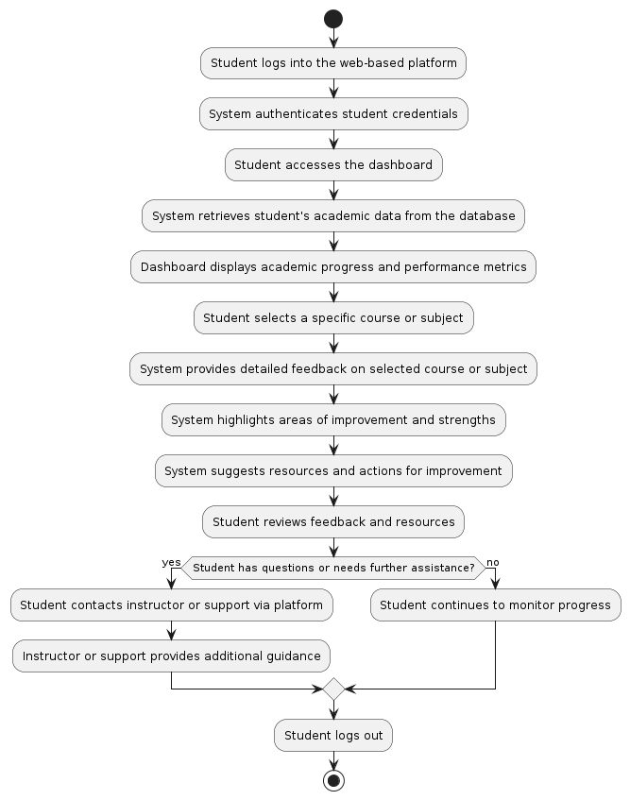

**Implementation Phase:**

The implementation phase involves deploying the real-time feedback platform, ensuring it operates smoothly and securely within the educational environment. Key activities include setting up the production environment, integrating code, and configuring APIs and WebSockets for real-time updates. Security measures such as token-based authentication and SSL/TLS encryption are implemented to protect user data. Performance is optimized using Redis for caching and load balancing for scalability. Data migration ensures existing records are accurately imported. The platform undergoes final testing, including smoke testing and user acceptance testing, to verify its readiness. User training sessions and comprehensive manuals support a smooth transition. Ongoing monitoring and a support system are established to maintain platform reliability and address any issues. By the end of this phase, the platform is fully operational, secure, and ready for use by students and educators.

**Maintenence Phase:**

The maintenance phase ensures the ongoing functionality, security, and adaptability of the real-time feedback platform. Continuous system monitoring and performance tracking are implemented to maintain responsiveness and efficiency. Regular security audits, timely application of patches, and management of authentication tokens keep the platform secure. Bug fixes and issue resolution are promptly addressed using an issue tracking system. Robust helpdesk services and feedback mechanisms support users and guide future improvements. Regular updates and feature enhancements, along with routine database maintenance, ensure the platform remains current and effective. Up-to-date technical documentation and training materials support both users and maintenance staff. This phase ensures the platform remains stable, secure, and capable of evolving with user needs and technological advancements**.**

## 3.2. Population Of Study

The population of the study refers to the group of individuals or entities from which data will be collected to evaluate the real-time feedback platform. This population is crucial as it directly impacts the validity and generalizability of the study's findings.

**Key Aspects of the Population of Study:**

**Target Audience:**

**Students:** Primary users of the platform, ranging from different educational levels (e.g., high school, undergraduate, graduate). Students will use the platform to receive real-time feedback on their academic progress.

**Educators:** Teachers and professors who will provide feedback through the platform. Their insights are vital for assessing the platform’s effectiveness in facilitating timely and constructive feedback.

**Demographic and Educational Diversity:**

**Demographic Diversity:** Ensuring a diverse sample in terms of age, gender, socioeconomic background, and geographic location to understand the platform's impact across different student demographics.

**Educational Diversity:** Including students and educators from various disciplines (e.g., sciences, humanities, arts) to evaluate the platform's versatility and effectiveness across different subjects.

**Institutional Types:**

**Public and Private Institutions:** Including both public and private schools and universities to ensure the platform is applicable and beneficial across different types of educational institutions.

**Urban and Rural Institutions:** Involving institutions from both urban and rural areas to assess the platform’s accessibility and functionality in different settings.

Sample Size:

**Representative Sample:** Ensuring a sample size that is large enough to be representative of the broader population of students and educators. This helps in obtaining statistically significant results that can be generalized to a larger population.

**Random Sampling:** Using random sampling methods to avoid bias and ensure that the sample accurately reflects the diversity of the population.

## 3.3. Sample Size and Selection

### 3.3.1. Sample Size

Determining the sample size is crucial to ensure that the study’s findings are statistically significant and generalizable to the broader population. The sample size should be large enough to provide reliable and valid results, while also being manageable within the scope and resources of the study.

**Determination of Sample Size:**

**Statistical Power Analysis:** Conducting a power analysis to determine the minimum sample size required to detect a meaningful effect. This involves considering the expected effect size, desired statistical power , and the significance level .

**Margin of Error:** Setting an acceptable margin of error, which affects the required sample size. A smaller margin of error requires a larger sample size to ensure precision.

**Sample Selection**

Selecting the sample involves choosing participants in a way that minimizes bias and ensures representativeness. The selection process must be methodical and transparent to enhance the study’s validity.

**Sampling Method:**

**Random Sampling:** Utilizing random sampling techniques to ensure each member of the population has an equal chance of being selected. This helps in reducing selection bias and enhancing the representativeness of the sample.

**Stratified Sampling:** If the population is heterogeneous, stratified sampling can be used to ensure representation from various subgroups (e.g., different educational levels, disciplines, or geographic locations). This involves dividing the population into strata and randomly sampling from each stratum.

### **3.3.2. Selection Criteria:**

**Inclusion Criteria:** Clearly defining criteria for participant inclusion to ensure relevance and consistency. Typical inclusion criteria might be: Current enrollment as a student or employment as an educator in the participating institutions. Regular access to the internet and familiarity with basic digital tools. Willingness to participate in the study and provide feedback on the platform.

**Exclusion Criteria:** Defining criteria to exclude certain participants, such as:

Lack of consent to participate in the study. Insufficient technological proficiency to use the platform. Irregular participation in the educational system (e.g., part-time students or visiting lecturers).

## 3.4. Data Collection methods and Instruments

The data collection methods and instruments chosen for the study play a pivotal role in gathering comprehensive and reliable data to evaluate the real-time feedback platform's effectiveness and user experience. It is essential to select methods that align with the research objectives, provide rich insights, and ensure data validity and reliability.

### 3.4.1. Data Collection Methods:

**Surveys:**

**Online Surveys:** Utilizing web-based survey platforms (e.g., Google Forms, SurveyMonkey) to collect quantitative data from a large number of participants efficiently.

**Questionnaires:** Designing structured questionnaires with closed-ended and Likert scale questions to gather quantitative feedback on user satisfaction, usability, and perceived effectiveness of the platform.

**Interviews:**

**Structured Interviews:** Conducting structured interviews with selected participants to gather in-depth qualitative insights into their experiences, challenges, and suggestions regarding the platform.

**Semi-Structured Interviews:** Allowing for flexibility in questioning while maintaining a predetermined set of topics to explore participants' perceptions in more detail.

### **3.4.2. Data Analysis Tools:**

**Statistical Software:** Utilizing statistical software packages (e.g., SPSS, R) to analyze quantitative survey data, conduct inferential statistics, and identify significant patterns or correlations.

**Qualitative Analysis Software:** Using qualitative analysis tools (e.g., NVivo, Dedoose) to analyze interview transcripts, focus group recordings, and open-ended survey responses, employing techniques such as thematic analysis or content analysis

## 3.5. Reliability and Validity

Ensuring the reliability and validity of data collected is crucial to maintaining the integrity and credibility of the study's findings. Reliability refers to the consistency and stability of measurements, while validity pertains to the accuracy and appropriateness of the data in relation to the research objectives.

### 3.5.1. Reliability:

**Internal Consistency:**

**Cronbach's Alpha:** Utilizing Cronbach's alpha coefficient to assess the internal consistency of survey items measuring the same construct. A high alpha value indicates strong reliability, suggesting that items are measuring the same underlying concept consistently.

**Test-Retest Reliability:**

**Test-Retest Method:** Conducting a test-retest reliability analysis by administering the same survey or instrument to a sample of participants at two different time points. Consistency in responses across time indicates the stability of measurements.

**Inter-Rater Reliability:**

**Inter-Rater Agreement:** Assessing inter-rater reliability for qualitative data collected through interviews or observations by comparing coding or rating scores assigned by different raters. Consistency in ratings indicates reliability in data interpretation.

**Data Collection Procedures:**

**Standardized Procedures:** Implementing standardized data collection procedures and protocols to minimize measurement errors and ensure consistency in data collection across different settings and researchers.

**Training and Calibration:** Providing training and calibration sessions for data collectors to ensure uniformity in administering surveys, conducting interviews, and recording observations.

### 3.5.2. Validity:

**Content Validity:**

**Expert Review:** Conducting expert reviews of survey instruments, interview guides, and observation checklists to ensure that items accurately represent the intended constructs and cover relevant content areas.

**Pilot Testing:** Pilot testing the data collection instruments with a small sample of participants to assess clarity, comprehensibility, and relevance of items.

**Criterion Validity:**

**Comparison with Established Criteria:** Establishing criterion validity by comparing the results of the new instrument with those of established measures or criteria known to assess the same construct. Consistency between the two indicates criterion validity.

**Construct Validity:**

**Factor Analysis**: Conducting factor analysis to explore the underlying structure of survey items and confirm whether they measure the intended constructs.

**Convergent and Discriminant Validity:** Assessing convergent validity by examining the correlation between the new instrument and other measures of the same construct. Discriminant validity is demonstrated by low correlations with measures of unrelated constructs.

## **REFERENCES**

P. Baepler and C. J. Murdoch. Academic Analytics and Data Mining in Higher Education. International Journal for the Scholarship of Teaching and Learning, 4(2), 2010.

S. Bull and J. Kay. Student Models that Invite the Learner In: The SMILI:() Open Learner Modelling Framework. International Journal of Artificial Intelligence in Education, 17(2):89--120, 2007.

J. Campbell, P. DeBlois, and D. Oblinger. Academic Analytics. Technical report, EDUCAUSE White Paper, 2007.

S. Dawson, A. Bakharia, and E. Heathcote. SNAPP: Realising the affordances of real-time SNA within networked learning environments. In L. Dirckinck-Holmfeld, V. Hodgson, C. Jones, M. D. Laat, D. McConnell, and T. Ryberg, editors, International Conference on Networked Learning, pages 125--133, 2010.

E. Duval. Attention please!: learning analytics for visualization and recommendation. In International Conference on Learning Analytics, pages 9--17. ACM Press, 2011.

R. M. Felder and R. Brent. Active Learning: An Introduction. ASQ Higher Education, 2(August), 2009.

R. Ferguson. The State of Learning Analytics in 2012: A Review and Future Challenges a review and future challenges. Technical report, The Open University UK, 2012.

S. Freeman, S. L. Eddy, M. McDonough, M. K. Smith, N. Okoroafor, H. Jordt, and M. P. Wenderoth. Active learning increases student performance in science, engineering, and mathematics. Proceedings of the National Academy of Sciences of the United States of America, pages 1--6, May 2014.

J. Fritz. Classroom walls that talk: Using online course activity data of successful students to raise self-awareness of underperforming peers. The Internet and Higher Education, 14(2):89--97, Mar. 2011.

S. P. Goggins, K. Galyen, and J. Laffey. Network Analysis of Trace Data for the Support of Group Work: Activity Patterns in a Completely Online Course. ACM Press, 2010.

P. Goldstein and R. Katz. Academic analytics: The uses of management information and technology in higher education, volume 8. Educause Center for Applied Research, 2005.

J. Grann and D. Bushway. Competency Map: Visualizing Student Learning to Promote Student Success. In Proceedings of the Fourth International Conference on Learning Analytics And Knowledge, LAK '14, pages 168--172, New York, NY, USA, 2014. ACM.

J. Hattie and H. Timperley. The Power of Feedback. Review of Educational Research, 77(1):81--112, Mar. 2007.

J. A. C. Hattie. Visible learning: A synthesis of over 800 meta-analyses related to achievement. Routledge, New York, 2008.

V. Kovanovi, D. Gašević, S. Dawson, S. Joksimović, R. S. Baker, and M. Hatala. Penetrating the Black Box of Time-on-task Estimation Categories and Subject Descriptors. In Proceedings of the International Conference on Learning Analytics and Knowledge. ACM Press, 2015.

A. E. Krumm, R. J. Waddington, S. D. Teasley, and S. Lonn. A Learning Management Sytem-Based Early Warning Sytem for Academic Advising in Undergraduate Engineering. In Learning Analytics. From Research to Practice, pages 103--119. Springer New York, 2014.

S. Lonn, A. E. Krumm, R. J. Waddington, and S. D. Teasley. Bridging the Gap from Knowledge to Action: Putting Analytics in the Hands of Academic Advisors. In International Conference on Learning Analytics and Knowledge, pages 184--187. ACM Press, 2012.

L. P. Macfadyen and S. Dawson. Mining LMS data to develop an "early warning system" for educators: A proof of concept. Computers & Education, 54(2):588--599, Feb. 2010.

## APPENDICES

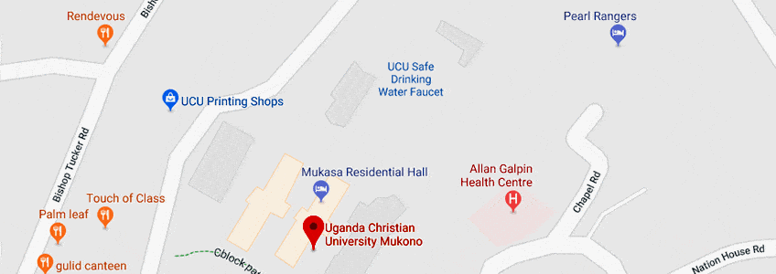

Figure showing the map of UCU the case study