- Name of Use Case
Name of the Use Case | Smart Greenhouse
Version No. | v0.1
Submission Date | 10/12/2022
Team Members (with student ids) | Ravera Stefano (271156), Redi Alessandro (310471), Scardi Alessia (317628), Volponi Federico (309709)
- Scope and Objectives of Function
Scope and Objectives of Use Case
Scope | The proposed IoT platform aims at providing services for a smart greenhouse management.
Objective(s) | The objective is to fully automate a greenhouse and release essential information to the owner thanks to the placement of sensors and user-awareness applications.
Domain(s) | Agriculture 4.0
Stakeholder(s) | Farmers
Short description | The proposed IoT platform aims at automating the main functions of a greenhouse. Through the integration of IoT devices it is possible to monitor the humidity, temperature, and CO2 levels of the greenhouse. Moreover, to monitor humidity, sensors are inserted in the topsoil to check if irrigation is needed and if so, it is provided thanks to an actuator. Finally, humidity and temperature are controlled by vaporizers and fans.  The farmer has easily access to the data thanks to a third-party application (Freeboard), and can have real time informations about the plants status through a telegram bot.  The key features of the IoT platform are:  - Humidity and temperature monitoring (both for each plant and for the whole greenhouse)  - Air monitoring and fans control  - Irrigation control  - Plants datasheet  - Applications for user-awareness
- Diagram of Use Case
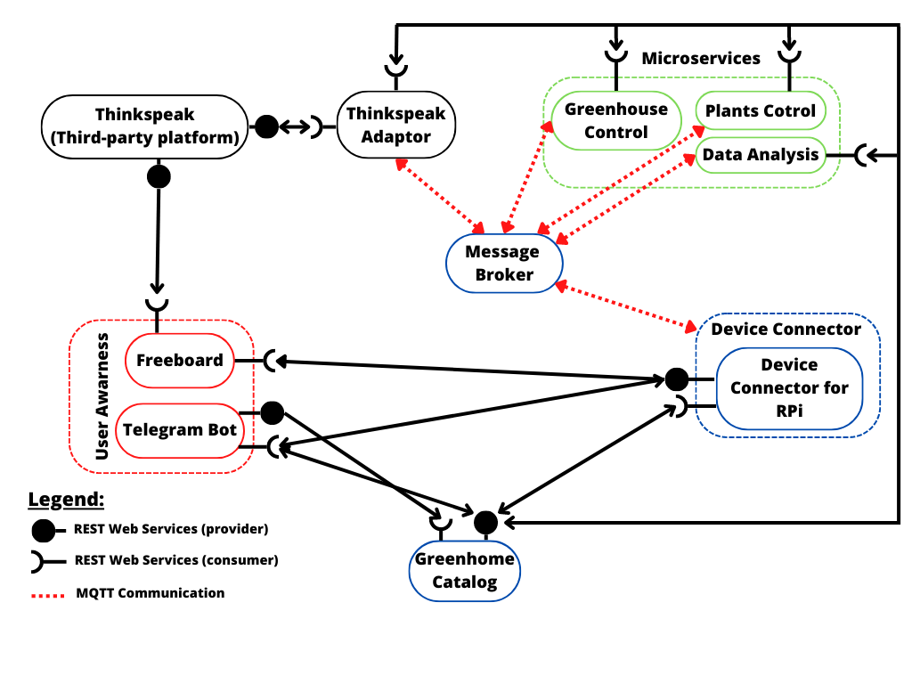
- Complete description of the system

The Smart Greenhouse platform is designed using a micorservices approach. The communication

between actors occurs through two communication paradigms:
- publish/subscribe based on MQTT protocol.
- request/response based on REST Web Services.

The actors involved in the IoT platform are:
- The Message broker is a software module that provides an asynchronous communication among applications. It exploits the MQTT protocol based on the publish/subcriber approach.
- The Greenhouse Catalog works as a registry system both for devices and services, that operates as an entry point for all the actors in the system. For the proposed IoT platform it contains: configuration of the Greenhouse Control as, humidity and temperature thresholds, and of the Plants Control as, humidity levels needed for each variety of plants. It also provides a registry of the IoT devices. It is implemented as JSON-based RESTful API.
- The Raspberry Pi Connector is a Device Connector that introduces the Raspberry Pi boards into the system. The Greenhouse is equipped with temperature, humidity and CO2 sensors in order to monitor the Greenhouse's climate conditions and with humidity sensors for each batch of plants. They are all controlled by the Raspberry Pi. It exploits the REST Web Services in order to provide to the users the information they need, when asked, and it also works as an MQTT publisher to send sensor data and as a MQTT subscriber to collect actuation commands from the Control Strategy.
- Thingspeak is a third-party software (https://thingspeak.com/) that provides REST Web Services. It is an IoT analytics platform service that allows you to aggregate, visualize, and analyze data in the cloud.
- The Thingspeak adaptor behaves as an MQTT subscriber that links the microservices’ outputs to the cloud platform using REST web Services.
- The Greenhouse Control is a control strategy that manages temperature, humidity and CO2 inside the Greenhouse. Based on the comparison between the measurements received from the Device connector and the thresholds stored in the Greenhouse Catalog, it turn on the activation system. In the first case, when receiving data, it works as an MQTT subscriber and in the second case, when sending actuation commands, it works as an MQTT publisher. It is also a REST Client getting information from the Greenhouse Catalog.
- The Plants Control is a control strategy that manages irrigation of each batch of pots of the Greenhouse independently. It receives the data from the Device Connector about the humidity of a batch of pots. Then the Plants Control decides whether to irrigate the specific batch of pots by comparing the current wetness of its soil with the threshold related to the water needed by each plant variety. It works as an MQTT subscriber to read the data and as an MQTT publisher to send actuation commands. It communicates with the Greenhouse Catalog to get the information about the thresholds of the plant varieties by using the REST Web Services.
- Data Analysis is a long term analysis that summarizes the data related to the plants grown in the last weeks/months. Moreover it reports a statistic of the future growth of the plants and the mean harvest time for each plant variety.
- Freeboad is an open source dashboard creation tool that simplifies tracking feeds from multiple devices in the IoT environment. It helps visualize them exploiting the REST and the Thinkspeak Web Services to import plots about environmental measurements.
- The Telegram Bot is the user-side service needed for creating a fast communication system between the final user and the proposed infrastructure. It can retrieve measurements from IoT devices exploiting the REST Web Services provided by the Device Connector. It uses the REST protocol also to communicate with the Greenhouse Catalog by associating every pot with the plant it has to store. Moreover it sends information to the Greenhouse Catalog about the plant varieties that have to be added or modified.

- Desired Hardware components (only among those we can provide)

Device Name | Quantity | Needed for…

