- Name of Use Case
Name of the Use Case | Smart Greenhouse
Version No. | v0.1
Submission Date | 10/12/2022
Team Members (with student ids) | Ravera Stefano (271156), Redi Alessandro (310471), Scardi Alessia (317628), Volponi Federico (309709)
- Scope and Objectives of Function
Scope and Objectives of Use Case
Scope | The proposed IoT platform aims at providing services for a smart greenhouse management.
Objective(s) | The objective is to fully automate a greenhouse and release essential information to the owner thanks to the placement of sensors and user-awareness applications.
Domain(s) | Agriculture 4.0
Stakeholder(s) | Farmers
Short description | The proposed IoT platform aims at automating the main functions of a greenhouse. Through the integration of IoT devices it is possible to monitor the humidity, temperature, and CO2 levels of the greenhouse. Moreover, to monitor humidity, sensors are inserted in the topsoil to check if irrigation is needed and if so, it is provided thanks to an actuator. Finally, humidity and temperature are controlled by vaporizers and fans.  The farmer has easily access to the data thanks to a third-party application (Freeboard), and can have real time informations about the plants status through a telegram bot.  The key features of the IoT platform are:  - Humidity and temperature monitoring (both for each plant and for the whole greenhouse)  - Air monitoring and fans control  - Irrigation control  - Plants datasheet  - Applications for user-awareness
- Diagram of Use Case
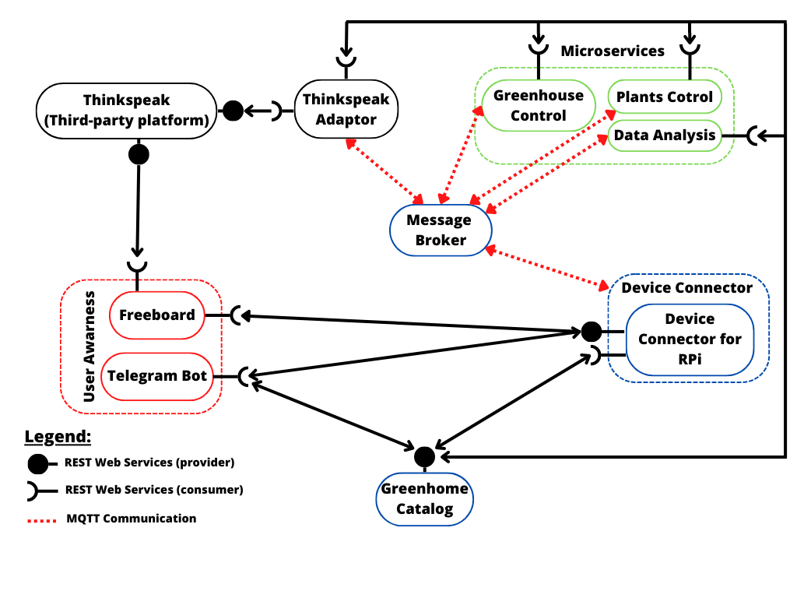
- Complete description of the system

The Smart Greenhouse platform is designed using a micorservices approach. The communication

between actors occurs through two communication paradigms:
- publish/subscribe based on MQTT protocol.
- request/response based on REST Web Services.

The actors involved in the IoT platform are:
- The Message broker is a software module that provides an asynchronous communication among applications. It exploits the MQTT protocol based on the publish/subcriber approach.
- The Raspberry Pi Connector is a Device Connector that integrates into the platform raspberry Pi boards. There is a raspberry per greenhouse that is equipped with humidity sensors for every lot of plants, and temperature, humidity and CO2 sensors monitor the air status of the greenhouse. It exploits the Rest Web Services to provide information to the users when needed. It also works as an MQTT publisher and subscriber, obtaining information from the sensors and sending information to the cloud.
- Thingspeak is a third-party software (https://thingspeak.com/) that provides REST Web Services. It is an IoT analytics platform service that allows you to aggregate, visualize, and analyze data in the cloud.
- The Greenhouse Control is a control strategy that manages the Greenhouse system using temperature, umidity and CO2 sensors.
- The Plant control is a control strategy that manages the plant system, dividing each part of the greenhouse into blocks of plants, managed by an instance of this strategy.
- Freeboad is an open source dashboard creation tool that simplifies tracking feeds from multiple devices in the IoT environment. It helps visualize them exploiting the REST and the Thinkspeak Web Services to import plots about environmental measurements.
- Desired Hardware components (only among those we can provide)

Device Name | Quantity | Needed for…

