DSLL-Net: A Dual-Stage Leaf–Lesion Segmentation Framework for Automated Plant Disease Severity Quantification
Changqing Yanª, Shuyang Liª, Zhe Liuª, Ling Yin ^{b}, Shumei Wei ^{b}, Xin Linª, Xin Liª, Jindong Liuª, Zhenpeng Huangª, Danni Zhengª, Zeyun Liangª, Qi Tian^{c}, Linjia Yao^{c}, Bin Chen ^{d}, Chenliang Wang^{e}, Junjie Qu^{b}*, Gang Zhao ^{d*}
ªCollege of Intelligent Equipment, Shandong University of Science and Technology, Taian 271019, China
^{b}Guangxi Crop Genetic Improvement and Biotechnology Key Lab, Guangxi Academy of Agricultural Sciences, Nanning 530007, China
^{c}College of Natural Resources and Environment, Northwest A & F University, Yangling 712100, China
^{d}State Key Laboratory of Soil and Water Conservation and Desertification Control, College of Soil and Water Conservation Science and Engineering, Northwest A&F University, Yangling 712100, China
^{e}School of Data Science and Artificial Intelligence, Wenzhou University of Technology, Wenzhou 325000, China
*Corresponding author: Gang Zhao, E-mail address: gang.zhao@nwafu.edu.cn; Junjie Qu, Email address: qujunjie@gxaas.net

Abstract
Quantitative assessment of plant disease severity is essential for fungicide efficacy evaluation, host resistance screening, and evidence-based disease management in modern crop protection systems. However, accurate and scalable severity estimation from field imagery remains challenging due to complex backgrounds, variable illumination, occlusion, and the coexistence of leaf and lesion features at different spatial scales. To address these challenges, we propose DSLL-Net, a lightweight dual-stage leaf–lesion segmentation framework for robust and quantitative disease severity assessment. The framework explicitly decouples leaf segmentation and lesion segmentation into two successive stages to reduce feature interference and improve lesion delineation. In the first stage, DeepLabV3+ with a SimAM-enhanced MobileNetV3 backbone is employed for reliable leaf segmentation under heterogeneous field conditions. In the second stage, lesion segmentation is performed using an improved U-Net architecture integrating a SimAM-augmented EfficientNet-B0 encoder and a RepConv-based decoder to enhance boundary precision and fine-grained lesion representation. Experimental results on field datasets demonstrate that DSLL-Net achieves superior accuracy–efficiency trade-offs compared with existing methods, attaining a lesion IoU(Intersection over Union) of 74.3% with only 12.56 M parameters. Disease severity estimation based on the segmented results yields a high agreement with reference values (R² = 0.976). Application-level deployment further confirms the practicality of the proposed framework for field-oriented disease monitoring and decision support.
- Introduction
Crop diseases pose a major threat to global agricultural production, leading to substantial yield losses and increased management costs [1-4]. The accurate evaluation of their severity provides quantitative insight into disease progression, enabling precise management decisions, fungicide development, yield loss estimation, and the assessment of cultivar resistance [5].
Traditionally, plant disease severity has been assessed through visual evaluation by technicians, relying largely on personal experience. Such assessments lack quantitative precision and are inherently subjective, leading to observer bias and limited reproducibility [6-8]. In the early adoption of deep learning for plant disease assessment, disease severity estimation was predominantly formulated as an image-level classification task, where samples were assigned to predefined severity categories [9]. trained shallow CNNs from scratch and fine-tune deep models on apple black-rot images labeled with four severity levels, with VGG16 combined by transfer learning achieving the best performance at 90.4% accuracy. proposed the first deep learning network PD2SE-Net for plant disease diagnosis and severity estimation by combining ResNet50 and ShuffleNet-V2 on the dataset with three severity categories, achieving 91% accuracy on severity estimation. compared six models on an augmented HLB-infected citrus leaf dataset with three severity levels, with Inception_v3 achieving the highest accuracy of 92.60%. Despite their performance, classification-based methods are inherently constrained by fixed severity categories and are sensitive to errors introduced during manual severity labeling.
To achieve more quantitative severity estimation, subsequent studies formulated the task as a semantic segmentation problem, assigning pixel-wise labels to diseased and healthy regions and deriving severity from lesion coverage [10]. Segmentation-based approaches have been applied to multiple crops and diseases, including coffee leaf diseases, cucumber powdery mildew, and grapevine downy mildew [11, 14-15]. More recent studies focused on improving segmentation accuracy and efficiency through lightweight architectures and attention mechanisms, such as WEDeepLabV3+ and PDSNets, enabling improved lesion detection and real-time field deployment [16-17]. Hernández et al. [16] further applied a U-Net with a MobileViT-S encoder to grapevine downy mildew, achieving accurate symptom classification and lesion count estimation. Most existing segmentation-based approaches adopt single-stage architectures that simultaneously segment leaves and lesions within a single network. However, because disease severity is computed as the ratio between lesion area and leaf area, accurate severity estimation requires both reliable leaf segmentation and precise lesion delineation. Under complex field conditions, joint segmentation often suffers from feature interference between leaf boundaries and small lesions, leading to compounded errors in severity estimation and reduced robustness.
To mitigate this issue, dual-stage segmentation frameworks have been proposed to explicitly decouple leaf segmentation and lesion segmentation into two successive models. Wang et al. [17] proposed DUNet, a dual-stage model designed to estimate cucumber leaf disease severity in complex environments. By combining DeepLabV3+ and U-Net for effective leaves and spots segmentation, DUNet demonstrates higher robustness, segmentation precision, and severity classification accuracy over other models. Xu et al. [18] proposed LD-DeepLabv3+ for extracting apple leaves and disease spots in complex scenes. By introducing adaptive loss and tailored modules for leaf edges and disease features, it achieved 98.70% IoU for leaves and 86.56% for spots, outperforming DUNet with significantly lower computational cost and better suitability for mobile deployment. Similarly, Liu et al. [19] proposes StripeRustNet for wheat stripe rust severity assessment. By employing MobileNetV2-DeepLabV3+ for leaf segmentation on the first stage, and ResNet50-DeepLabV3+ for lesion segmentation on the second stage, StripeRustNet achieves a mIoU of 98.65% for leaf segmentation, and 86.08% for lesion segmentation, respectively. Based on an improved DeepLabV3+ architecture, Xu et al. [18] developed CL-VW-DeepLabV3+ to address the efficiency challenges in field detection of cotton Verticillium wilt. The first stage integrates a Shallow Advanced Feature Fusion (SAFF) module and a compound Focal-Dice (F&D) loss function, achieving 87.66% IoU for leaf segmentation, while the second stage employs parameter-free attention mechanisms, achieving 85.15% IoU for lesion segmentation. By dividing the segmentation task into two successive stages, these methods further enhance the accuracy and efficiency of disease severity estimation. However, accurate and scalable disease severity estimation from field imagery remains challenging under complex conditions characterized by variable illumination, background interference, occlusion, and the need for deployment on resource-constrained devices. Existing dual-stage frameworks often prioritize segmentation accuracy while offering limited consideration of model compactness, inference efficiency, and practical usability in real-world crop protection scenarios.
In this study, we propose DSLL-Net, a lightweight dual-stage leaf–lesion segmentation framework for robust and quantitative disease severity assessment from field images. The framework is designed for general foliar disease analysis and is evaluated in this work using grapevine downy mildew (Plasmopara viticola) as a representative application scenario. DSLL-Net explicitly decouples leaf segmentation and lesion segmentation into two successive stages to reduce feature interference and improve severity estimation accuracy. In the first stage, a DeepLabV3+ model [20] equipped with a SimAM-augmented MobileNetV3 backbone [21] is employed to achieve reliable leaf segmentation under heterogeneous field conditions. In the second stage, an improved U-Net architecture integrating a SimAM-enhanced EfficientNet-B0 encoder [22] with a RepConv-based decoder [23] is used to perform high-precision lesion segmentation and refine lesion boundaries. The resulting leaf and lesion segmentation outputs are combined to quantitatively estimate disease severity, and the framework is further integrated into an application to support efficient and practical field deployment.
- Materials and Methods
  - Overview of the workflow
Fig. 1 illustrates the overall workflow of the proposed disease severity evaluation framework, consisting of data preparation of leaf and lesion segmentation datasets, dual-stage segmentation model development, and the application of the dual-stage model. First, field-acquired images are annotated to construct the two task-specific datasets. Then, a dual-stage segmentation strategy is adopted to decouple leaf extraction from lesion delineation into two sequential stages. In the first stage, a leaf segmentation model is developed by improving DeepLabV3+ model with a SimAM-augmented MobileNetV3 backbone (SimV3-DL3+) to robustly segment leaf regions from complex backgrounds, while in the second stage, a lesion segmentation model is developed by integrating U-Net–based architecture with a SimAM-enhanced EfficientNet-B0 encoder and a RepConv-based decoder (SimEffB0-RepUNet) for fine-grained lesion segmentation. Finally, an application pipeline is developed based on the trained dual-stage model, where efficient and automated disease severity assessment is enabled by quantitatively computing the ratio of lesion area to total leaf area segmented by the model from field images.
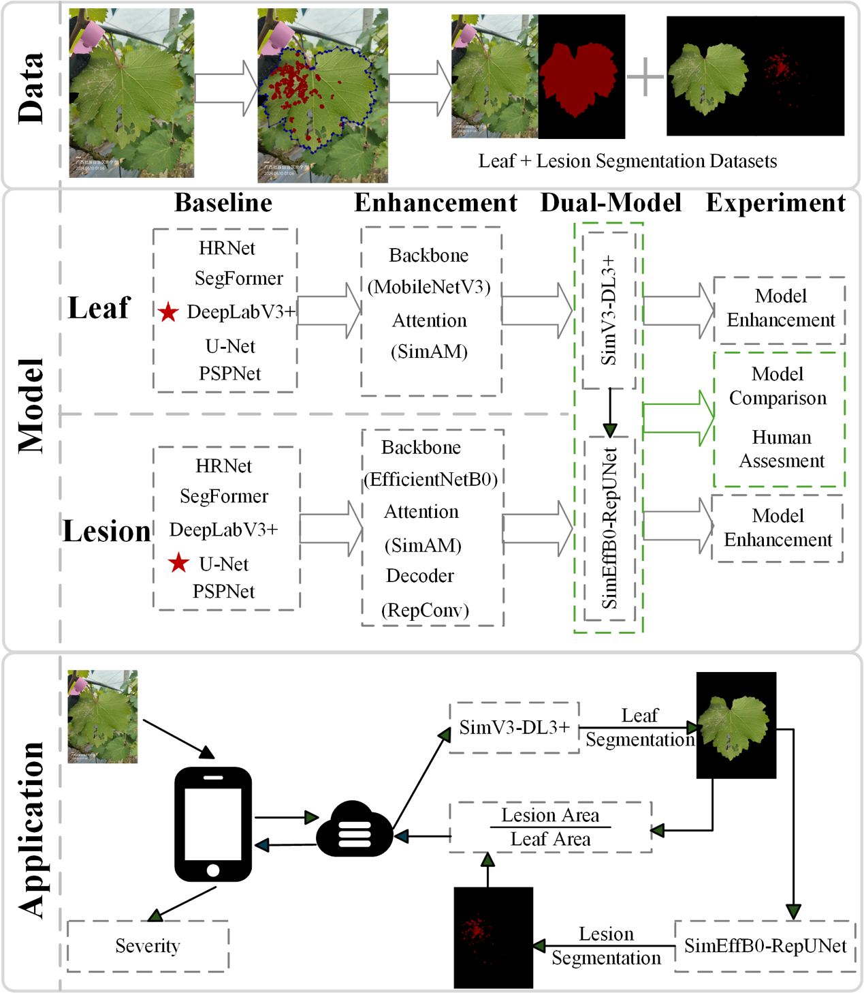
Fig. 1. The overall research workflow involving data, model and application. The upper section illustrates the complete pipeline for data preprocessing and dataset construction. The middle section highlights the architectural design and enhancements of the leaf and lesion segmentation model in the dual-stage model, with a star (★) marking the selected baseline models after rigorous comparative evaluation. The lower section presents the workflow of a mobile application based on our dual-stage model, which clearly demonstrates how the severity can be obtained by the model enabled mobile application system in practical use.
  - Data Preparation
A total of 696 field images were collected between April and August 2024 at two sites (Mingyang and Du’an) in Guangxi, China. Images were captured using a Huawei P70 and an iPhone 15 at a camera-to-subject distance of 15–20 cm, with each image focused on a single leaf. To ensure data quality and consistency, images were selected under controlled illumination conditions (excluding strong direct sunlight), with naturally oriented leaves, appropriate viewing angles, and clearly visible, intact leaf structures free from occlusion.
Manual annotations were conducted using LabelMe (v3.16.7) to precisely delineate leaf regions and disease lesions (https://github.com/wkentaro/labelme.git). From these annotations, two binary masks were generated for each image: a leaf mask (leaf vs. background) and a lesion mask (lesion vs. non-lesion). These labeled data were further used to construct three task-specific datasets for different modeling strategies, as summarized in Table. 1
Table. 1 An overview of the constructed datasets and their corresponding modeling tasks.
Dataset | Input to model | Label(s) | Construction | Task | Models using it
Leaf segmentation | Original full RGB field image | Leaf mask (binary) | Manual annotation on original image | Leaf extraction from background | Stage-1 models: DeepLabV3+ (baseline comparisons), SimV3-DL3+
Lesion segmentation | Cropped leaf ROI | Lesion mask (binary, cropped consistently) | Crop leaf regions using leaf masks; pair with cropped lesion masks | Fine-grained lesion segmentation within leaf | Stage-2 models: U-Net family, SimEffB0-RepUNet
Single-stage segmentation | Original full RGB field image | Lesion mask (binary) | Original images + lesion masks | Single-stage lesion segmentation | Single-stage baselines: U-Net, DeepLabV3+, PSPNet, HRNet, SegFormer
To guarantee experimental consistency, a fixed train–test partition (567 training and 129 testing images; 80%/20%) was enforced across all dataset variants. To simulate practical deployment conditions, the lesion model in the second stage was conditioned on predicted leaf masks produced by the first-stage segmentation model, rather than relying on ground-truth annotations.
  - Dual-Stage Segmentation Model
    - Leaf Segmentation Model SimV3-DL3+
Leaf regions, characterized by larger spatial extent and clearer structural boundaries, are inherently easier to segment than lesions, typically leading to higher segmentation accuracy. Accordingly, the first-stage model prioritizes a balance between accuracy and a lightweight design to enable efficient deployment on mobile devices in field environments. To establish a suitable baseline, five representative semantic segmentation models—DeepLabV3+ [20], U-Net[24], PSPNet [25], SegFormer [26], and HRNet [27]—were comparatively evaluated. As shown in Fig. 4, DeepLabV3+ achieved the best overall performance, offering the highest accuracy with a moderate model size, and was therefore selected as the baseline.
In its lightweight configuration, DeepLabV3+ is typically coupled with a MobileNet backbone to achieve a favorable balance between accuracy and efficiency. Owing to their efficiency–accuracy trade-off, MobileNet architectures are widely adopted in mobile vision applications [28-29]. MobileNetV2 employs inverted residual blocks with linear bottlenecks to reduce computational cost [28], yet its representational capacity is often insufficient for capturing fine-grained boundaries in heterogeneous field conditions. MobileNetV3 addresses this limitation by integrating squeeze-and-excitation (SE) modules and hard-swish activations, enhancing feature representation while preserving efficiency. More recent variants such as MobileNetV4, designed via neural architecture search with compound scaling, offer further accuracy gains but introduce increased structural complexity and training overhead [29]. In view of practical deployment constraints, MobileNetV3 was selected as the backbone of the proposed model.
While the SE attention mechanism in MobileNetV3 improves feature representation with relatively low computational cost, it introduces additional parameters and inadequately captures spatial structures essential for pixel-level segmentation, as its design focuses on inter-channel dependencies via global pooling and lightweight fully connected layers [30]. In contrast, the Simple, Parameter-Free Attention Module (SimAM) adopts a parameter-free formulation that directly modulates neuron responses based on spatial significance, enabling more effective modeling of fine-grained structural patterns [31]. This characteristic is particularly beneficial for leaf–lesion scenarios, where subtle spatial variations and boundary details play a critical role. By integrating SimAM, the network is able to better capture discriminative regions within grape leaves while suppressing irrelevant background interference. Importantly, the absence of additional learnable parameters allows SimAM to preserve the computational efficiency of the MobileNetV3 backbone, making it well-suited for real-time and resource-constrained deployment. Based on these considerations, SimAM is employed to replace the SE module in the final leaf segmentation model.
Guided by the above design considerations, a leaf segmentation model is constructed, with its overall architecture presented in Fig. 2.
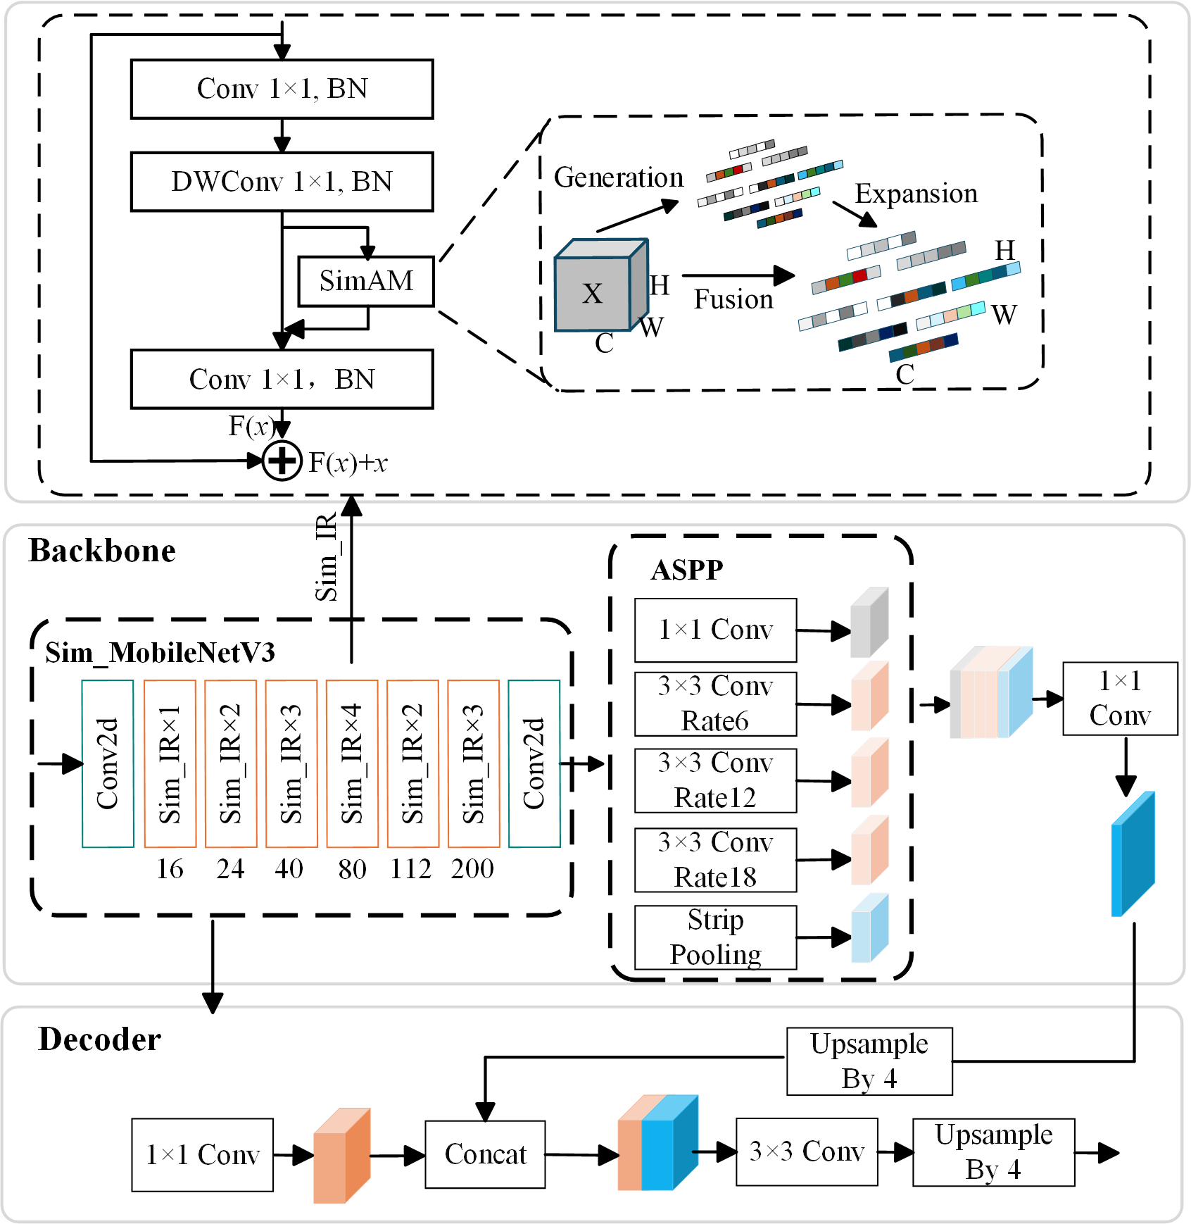
Fig. 2. Architecture of the SimV3-DL3+ Model. The backbone and decoder present the overall architecture of SimV3-DL3+. Sim_IR denotes the module obtained by enhancing the original InvertedResidual block with the SimAM attention. The upper part shows the detailed structure of the SimIR module and the computational flow of the SimAM attention.
    - Lesion Segmentation Model (SimEffB0-RepUNet)
Given the inherent difficulty of lesion segmentation, achieving high accuracy is prioritized in the model design. Accordingly, the model is first optimized for segmentation performance, after which efficiency and parameter reduction are further considered.
To construct a reliable lesion segmentation model for the second stage, five representative architectures—DeepLabV3+, U-Net, PSPNet, SegFormer, and HRNet—were systematically evaluated on the lesion dataset. Among these candidates, U-Net exhibited the highest segmentation accuracy, despite its relatively high parameter cost, and was selected as the baseline for subsequent model development. In standard practice, U-Net is commonly implemented with a VGG16 encoder.
Although this configuration ensures stable performance, the associated parameter overhead limits its efficiency in deployment scenarios with constrained computational resources. To address this limitation, the encoder was reconfigured using EfficientNet-B0, which adopts a compound scaling strategy across network dimensions to achieve more efficient feature representation with reduced complexity. This design is particularly effective for capturing the subtle texture and structural variations characteristic of small and irregular lesion regions.
The encoder adopts EfficientNet-B0, whose architecture is composed of stacked MBConv blocks with integrated squeeze-and-excitation (SE) attention in its original design. Following the design in the leaf segmentation stage, the SE module is replaced with the Simple Attention Module (SimAM) to improve spatial feature representation without increasing model complexity[31]. This adjustment enhances the modeling of fine-grained lesion patterns and reduces background interference, while maintaining the lightweight and efficient characteristics of the encoder.
In the decoder, although multi-scale features are progressively reconstructed through upsampling and skip connections, the fusion process can still result in boundary ambiguity and limited structural coherence, especially for small and irregular lesions. To mitigate this issue, RepConv blocks based on structural re-parameterization [23] are incorporated into the upsampling pathway to strengthen feature integration. RepConv leverages a multi-branch convolutional structure during training to enhance representational capacity, which is subsequently re-parameterized into a single convolutional operation for inference. This design facilitates more accurate reconstruction of lesion boundaries without introducing additional computational overhead at deployment. Based on these considerations, RepConv is incorporated into the decoder.
In summary, the proposed lesion segmentation model, termed SimEffB0-RepUNet, integrates a SimAM-enhanced EfficientNet-B0 encoder with a RepConv-based decoder within the U-Net framework. This design is intended to improve the segmentation of small and irregular lesions while maintaining computational efficiency suitable for practical field deployment. The overall architecture of SimEffB0-RepUNet is shown in Fig. 3.
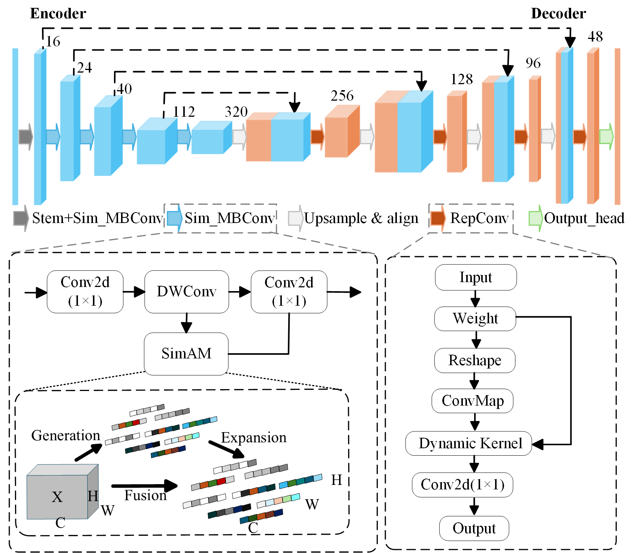
Fig. 3. Architecture of the proposed SimEffB0-RepUNet model. The upper part shows the overall structure of SimEffB0-RepUNet, which is built upon the U-Net framework, using EfficientNetB0 with embedded SimAM attention as the encoder and RepConv modules in the decoder. The lower left illustrates the structure of the Sim_MBConv enhanced by the SimAM mechanism, while the lower right presents the architecture of the RepConv module. Sim_MBConv refers to an EfficientNetB0 block enhanced by SimAM.
  - Experimental design
    - Leaf segmentation
To identify a suitable baseline model that best balances leaf segmentation accuracy and computational efficiency, five representative semantic segmentation architectures—U-Net, DeepLabV3+, PSPNet, HRNet, and SegFormer—were comparatively evaluated on the leaf segmentation task. Performance was assessed using six key metrics, including Mean Pixel Accuracy (mPA), Intersection over Union for the background and leaf regions (IoU-Background, IoU-Leaf), Mean Intersection over Union (mIoU), the number of model parameters (Params), and the inference time. Here, IoU-Background corresponds to the overlap over non-leaf regions, i.e., areas outside the leaf mask. Among these metrics, IoU-Leaf is treated as the primary evaluation criterion, as it directly reflects the accuracy of leaf region delineation.
To examine the effect of backbone selection, five lightweight networks—MobileNetV2 (baseline), MobileNetV3, MobileNetV4 [29], StarNetS1 [32], and EfficientNetB0—were incorporated into the baseline architecture for comparative evaluation. All MobileNet variants were implemented in their large configurations. The evaluation followed the same metric setting as the baseline analysis, ensuring a consistent comparison of efficiency–accuracy trade-offs across different backbones.
To examine the contribution of SimAM to spatial feature representation, a comparative study was performed within the DeepLabV3+ framework by replacing the original squeeze-and-excitation (SE) attention with SimAM in the MobileNetV3 backbone. The resulting variants—SimAM-enhanced MobileNetV3 (Sim-MobileNetV3) and the original MobileNetV3 with SE [30]—were evaluated under an identical metric setting to ensure a fair assessment of their impact on leaf segmentation performance.
    - Lesion segmentation
A series of experiments were designed to systematically evaluate lesion segmentation performance. As an initial step, four representative models—U-Net, DeepLabV3+, PSPNet, and HRNet—were comparatively evaluated under the same protocol as used in the leaf segmentation task to establish a suitable baseline architecture. Performance was measured using five metrics, including mean pixel accuracy (mPA), intersection over union for background and lesion regions (IoU-Background and IoU-Disease), mean intersection over union (mIoU), model parameters, and inference time. Among these, IoU-Disease is treated as the primary evaluation criterion due to its direct relevance to lesion delineation accuracy, while IoU-Background corresponds to the overlap over non-lesion regions.
Subsequently, to examine the effect of backbone enhancement, six commonly used architectures——VGG16, ResNet50 [27] , ResNetRS50 [33], MobileNetV2, MobileNetV3, and EfficientNetB0—were incorporated into the baseline model for comparative evaluation.
Following this, the role of attention mechanisms was further investigated by comparing SimAM with three widely used modules— SE, ECA [34], and CBAM [35]. The comparison focuses on their capability to enhance both spatial and channel-wise feature representations and their impact on lesion segmentation performance.
Finally, the contribution of the RepConv-based decoder was assessed by replacing the original double-convolution module with several representative alternatives, including standard convolution, RepConv, ODConv [36], PConv [37], and CondConv2D [38] modules. The comparison focuses on their ability to preserve spatial details during feature reconstruction, evaluated using mPA, IoU-disease, parameter count, and inference time.
    - Model Comparison Experiments
To further investigate the effectiveness of the proposed dual-stage strategy for lesion extraction, three segmentation paradigms—single-stage, conventional dual-stage, and the proposed dual-stage approach—were comparatively analyzed. For the single-stage setting, five representative architectures—U-Net, DeepLabV3+, PSPNet, HRNet, and SegFormer—were trained and evaluated on the corresponding dataset, where lesion segmentation is performed directly without an explicit prior leaf segmentation step.
For the dual-stage setting, a conventional configuration was constructed using DeepLabV3+ (MobileNetV2) for leaf segmentation followed by U-Net (VGG16) for lesion segmentation, serving as a representative baseline. This configuration was further compared with the proposed dual-stage framework, SimV3-DL3+ + SimEffB0-RepUNet, in which leaf and lesion segmentation are explicitly decoupled and optimized through dedicated models at each stage.
Model performance was assessed using four metrics: inference time, parameter count, intersection over union for leaf regions (IoU-Leaf), and intersection over union for lesion regions (IoU-Disease). Inference time here is defined as the average processing time per image, computed by dividing the total inference time over the test set by the number of test samples. For dual-stage models, this measure additionally accounts for the sequential execution of both stages, including leaf and lesion prediction, intermediate processing (e.g., pixel counting), and data transfer between stages. This evaluation enables a comprehensive comparison of segmentation accuracy and computational efficiency across different modeling strategies.
    - Expert Visual Evaluation and Model Prediction
To compare model-based severity estimation with human expert judgment, a visual evaluation experiment was conducted involving trained technicians. A total of 15 technicians with formal training and practical experience in crop disease diagnosis were included, all of whom were familiar with symptom recognition and field-based severity assessment.
Each technician independently evaluated the leaf images and estimated disease severity based on visual inspection, without the aid of quantitative tools. In parallel, the proposed model generated automated severity predictions for the same image set. The resulting expert assessments and model outputs were subsequently compared to examine their consistency and to assess the potential of the model to provide more objective, reproducible, and scalable severity estimation.
  - Experimental setup
All experiments were performed on a workstation equipped with an NVIDIA GeForce RTX 4060 Ti GPU (16 GB memory) and an Intel® Core™ i5-13490F CPU (2.50 GHz), with 32 GB RAM, running Python 3.8 on a 64-bit Windows 10 operating system with CUDA 11.8. The models were trained using the Adam optimizer with a batch size of 2. The initial learning rate was set to 1×10⁻⁵ and adjusted using a cosine annealing schedule, with a minimum value of 1×10⁻⁶ to ensure stable convergence in later training stages. All input images were resized to 512 × 512 pixels prior to training, and the models were trained for 500 epochs. Dice loss function was adopted as the objective function, formulated as $\left(1\right)$
$$\begin{aligned}L_{Dice}=1-\frac{2|X∩Y|}{\left|X\right|+|Y|}\#\left( SEQ equation 1\right)\end{aligned}$$
where $X$ and $Y$denote the predicted and ground truth masks. It measures the overlap between the two sets, encouraging higher similarity and effectively addressing class imbalance in segmentation tasks.
  - Evaluation metrics
To quantitative evaluate the segmentation performance, several standard metrics are employ. Pixel Accuracy (PA) provides a global perspective by calculating the fraction of correctly identified pixels::
$$\begin{aligned}PA=\frac{\sum_{i=0}^{k}{P_{ii}}}{\sum_{i=0}^{k}{\sum_{j=0}^{k}{P_{ij}}}}\#\left(2\right)\end{aligned}$$
where $P_{ii}$ is the number of pixels correctly classified as class $i$, and $P_{ij}$ is the number of pixels whose ground-truth class is $i$ but predicted as class $j$ ($i≠j$).
Beyond global accuracy, Mean Pixel Accuracy (mPA) offers a more class-aware evaluation by averaging the individual accuracies across all categories:
$$\begin{aligned}\text{mPA}=\frac{1}{K+1}\sum_{i=0}^{K}{ } \frac{P_{ii}}{\sum_{j=0}^{K}{ } P_{ij}}\#\left(3\right)\end{aligned}$$
Here, K denotes the number of foreground classes in the segmentation task, and K+1 represents the total number of classes including the background.
The Intersection over Union (IoU), or the Jaccard Index, further characterizes the spatial overlap between the prediction and ground truth, which is formulated:
$$\begin{aligned}{\text{IoU}}_{i}=\frac{TP_{i}}{TP_{i}+FP_{i}+FN_{i}}\#\left(4\right)\end{aligned}$$
where $TP_{i}$, $FP_{i}$, and $FN_{i}$ denote the numbers of true-positive, false-positive, and false-negative pixels for class $i$, respectively.
To provide a consolidated performance metric across the entire dataset, the Mean Intersection over Union (mIoU) is synthesized by aggregating the IoU values across all semantic categories:
$$\begin{aligned}\text{mIoU}=\frac{1}{K+1}\sum_{i=0}^{K}{ } {IoU}_{i}=\frac{1}{K+1}\sum_{i=0}^{K}{ } \frac{TP_{i}}{TP_{i}+FP_{i}+FN_{i}}\#\#（5）\end{aligned}$$
To quantify the regression performance and the degree of linear correlation between the observations and predictions, the coefficient of determination ($R^{2}$) is employed. It encapsulates the proportion of total response variance that is captured by the proposed model. A $R^{2}$ value approaching unity signifies a superior goodness-of-fit, reflecting that the model effectively accounts for the underlying data variability The mathematical representation is given as Equation ($6$).
$$\begin{aligned}R^{2}=1-\frac{\sum_{i=1}^{n}{ } {\left(y_{i}-{\overset{˜}{y}}_{i}\right)}^{2}}{\sum_{i=1}^{n}{ } {\left(y_{i}-\overset{ˉ}{y} \right)}^{2}}\#\#（6）\end{aligned}$$
where $n$ is the number of samples, $y_{i}$ and ${\overset{˜}{y}}_{i}$are the actual and predicted values, respectively, and $\overset{ˉ}{y}$ is the mean of all actual values.
To evaluate the average prediction discrepancy in the same units as the target variable, the Mean Absolute Error (MAE) is utilized. Unlike metrics that square the deviations, MAE provides a linear representation of the error magnitude, offering a resilient measure against outliers that does not account for the direction of the residuals, as shown in Equation ($7$).
$$\begin{aligned}MAE=\frac{1}{n}\sum_{i=1}^{n}{|y_{i}-{\overset{˜}{y}}_{i}|}\#\#（7）\end{aligned}$$
The Root Mean Squared Error (RMSE) serves as a quadratic loss metric that quantifies the standard deviation of the prediction residuals. By taking the square root of the average squared discrepancies, RMSE inherently assigns a disproportionate weight to larger errors, thereby offering heightened sensitivity to outliers compared to MAE. RMSE is especially useful when large deviations are particularly undesirable, as shown in Equation $1$.
$$\begin{aligned}RMSE=\sqrt{\frac{1}{n}\sum_{i=1}^{n}{{(y_{i}-{\overset{˜}{y}}_{i})}^{2}}}\#\#（8）\end{aligned}$$
- Results
  - Leaf segmentation
The comparative results of baseline model evaluation for leaf segmentation are shown in Fig. 4. Among the five evaluated models, DeepLabV3+ achieved the best overall segmentation performance, outperforming the other architectures across all accuracy-related metrics. Specifically, DeepLabV3+ reached an mPA of 99.11%, IoU values of 98.70% for background and 97.49% for leaf regions, and an mIoU of 98.09%. In addition to its high accuracy, DeepLabV3+ exhibited a moderate model size and an inference time that was second only to PSPNet, indicating a favorable balance between accuracy and efficiency.
HRNet achieved the second-highest segmentation accuracy across most metrics; however, this improvement came at the cost of a substantially larger model size and longer inference time, which limits its suitability for efficient field deployment. U-Net ranked third in segmentation accuracy but exhibited the largest parameter count and the longest inference time among the five models. PSPNet achieved relatively lower accuracy—only outperforming SegFormer—while offering the smallest model size and the fastest inference speed. SegFormer showed the lowest segmentation accuracy overall, despite maintaining a compact architecture and moderate inference time.
Considering both segmentation accuracy and computational efficiency, DeepLabV3+ demonstrated the most favorable overall performance among the evaluated models and was therefore selected as the baseline architecture for subsequent experiments.
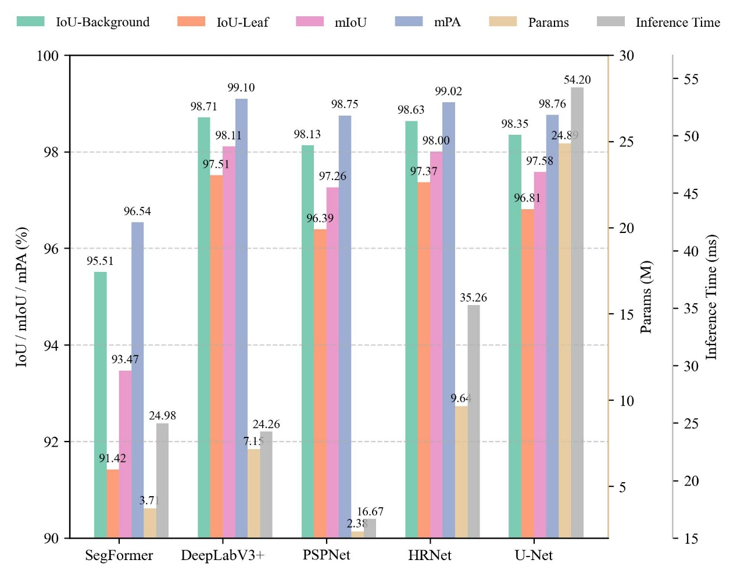
Fig. 4. Performance comparison of five semantic segmentation models for leaf segmentation—SegFormer, DeepLabV3+, PSPNet, HRNet, and U-Net—evaluated using segmentation accuracy metrics, parameter count, and inference time.
Fig. 5 shows the performance of DeepLabV3+ with different backbones for leaf segmentation. Using MobileNetV2, the baseline model achieved an mPA of 99.10% and an mIoU of 98.11%, with 7.15 M parameters and 20.43 ms(millisecond) inference time. MobileNetV3 slightly improved accuracy with fewer parameters but longer inference time (25.65 ms), while MobileNetV4 resulted in reduced accuracy with increased model size and latency. StarNet-S1 exhibited the lowest accuracy but maintained relatively fast inference. EfficientNet-B0 achieved accuracy comparable to the baseline but incurred the largest parameter count and the second-longest inference time. In contrast, Sim_MobileNetV3 achieved the best overall performance, reaching the highest mPA (99.19%) and mIoU (98.30%) with the smallest model size (4.83 M) and a fast inference time (20.62 ms). 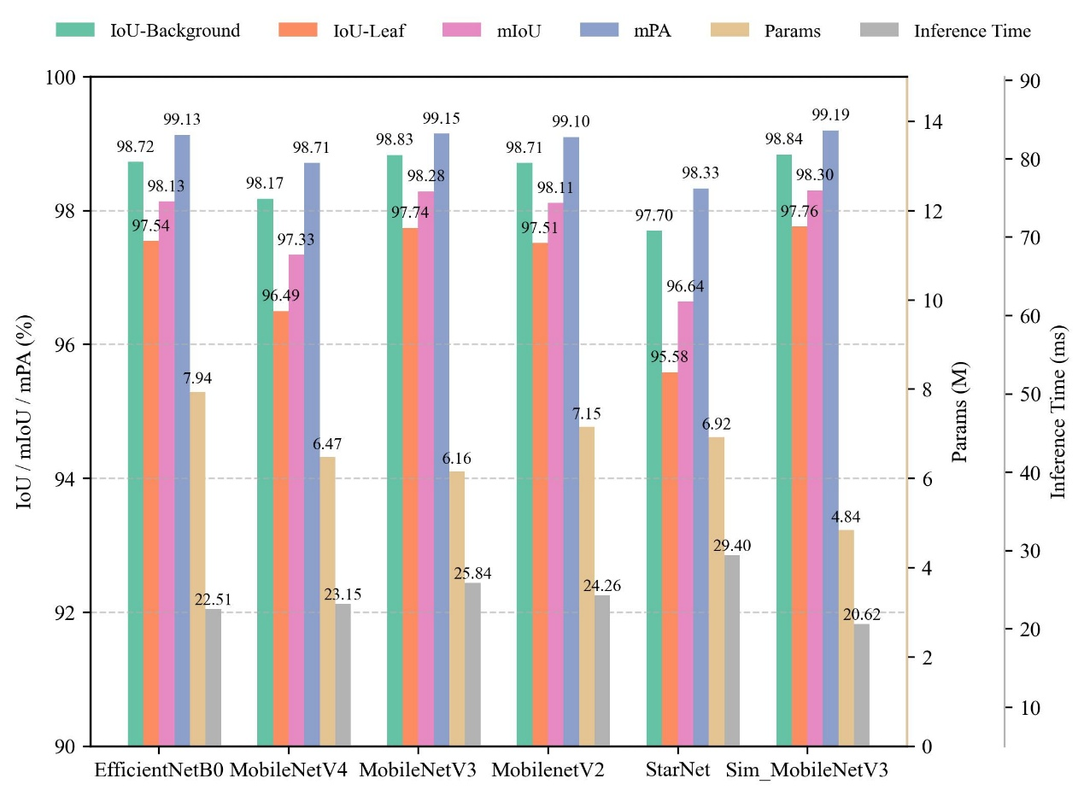
Fig. 5. Leaf segmentation performance of DeepLabV3+ models with different backbone networks, including EfficientNet-B0, MobileNetV4, MobileNetV3, MobileNetV2 (baseline), StarNet, and Sim_MobileNetV3. Models are evaluated using segmentation accuracy metrics, parameter count, and inference time.
  - Lesion segmentation
Fig. 6 compares the lesion segmentation performance of five semantic segmentation models: U-Net, HRNet, PSPNet, DeepLabV3+, and SegFormer. U-Net achieved the highest segmentation accuracy, with an mIoU of 84.97%, IoU-Disease of 73.07%, IoU-Background of 96.87%, and mPA of 91.38%, but also exhibited the largest parameter count (24.89 M) and the longest inference time (51.53 ms). HRNet achieved slightly lower accuracy (mIoU 84.86%, IoU-Disease 72.86%) with fewer parameters (9.64 M) and moderate inference time (35.26 ms). DeepLabV3+ showed competitive accuracy (mIoU 84.09%, IoU-Disease 71.42%) with a smaller model size (7.15 M) and faster inference (22.26 ms). SegFormer achieved moderate performance (mIoU 80.79%, IoU-Disease 65.46%) with 13.68 M parameters, while PSPNet exhibited the lowest accuracy (mIoU 71.72%, IoU-Disease 51.35%) but the smallest model size (2.38 M) and fastest inference (17.10 ms). Overall, U-Net provided the best lesion segmentation accuracy and was therefore selected as the baseline model for subsequent experiments.
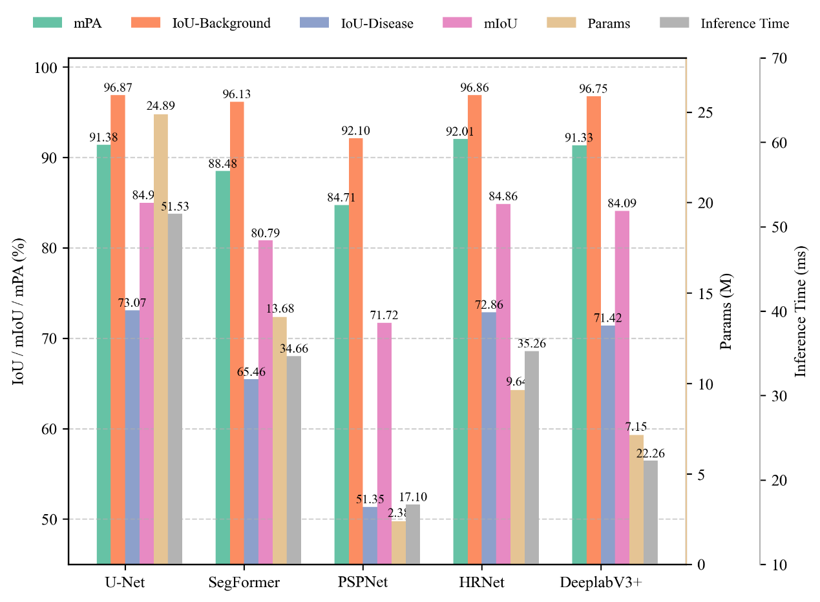
Fig. 6. Lesion segmentation performance of five semantic segmentation models—U-Net, SegFormer, PSPNet, HRNet, and DeepLabV3+,—evaluated using mPA, IoU-Background, IoU-Disease, mIoU, parameter count, and inference time.
Fig. 7 presents the lesion segmentation performance of the U-Net model with different backbone networks, including VGG16, ResNet50, ResNetRS50, EfficientNet-B0, and the MobileNet series. Using VGG16 as the backbone, U-Net achieved an mIoU of 85.94%, IoU-Disease of 73.07%, and mPA of 91.28%, but exhibited a relatively large parameter count (24.89 M) and the slowest inference speed (50.31 ms). ResNet50 and ResNetRS50 achieved comparable accuracy to VGG16 but required substantially more parameters (43.93 M) while offering shorter inference times (34.90 ms and 34.34 ms, respectively). EfficientNet-B0 achieved the highest mIoU and IoU-Disease, while reducing the parameter count by more than 82% compared with ResNet50 and achieving the fastest inference time (25.01 ms). MobileNetV2 and MobileNetV3 resulted in slightly lower accuracy and higher parameter counts than EfficientNet-B0, although they remained more efficient than heavier backbones. Overall, EfficientNet-B0 provided the most favorable balance between segmentation accuracy and computational efficiency and was therefore selected as the backbone for subsequent lesion segmentation experiments.
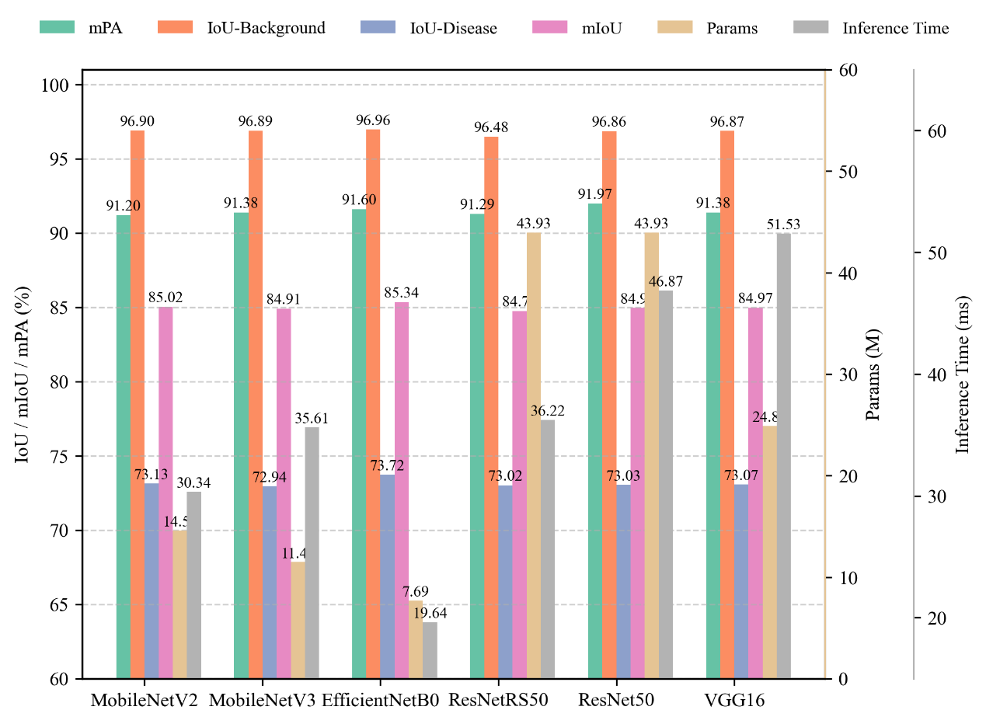
Fig. 7. Performance comparison of U-Net–based lesion segmentation models using different backbone networks, including VGG16, ResNet50, ResNetRS50, MobileNetV2, MobileNetV3, and EfficientNet-B0. Models are evaluated in terms of segmentation accuracy (mPA, IoU-Background, IoU-Disease, mIoU), parameter count, and inference time.
Fig. 8 compares the performance of the U-Net model with an EfficientNet-B0 backbone using four attention mechanisms: SE (baseline), SimAM, ECA, and CBAM. The SE-based model achieved an mPA of 91.60%, mIoU of 85.34%, IoU-Disease of 73.72%, with 7.69 M parameters and an inference time of 19.64 ms. Compared with SE, SimAM improved mIoU (85.46%) and IoU-Disease (73.94%) while reducing the parameter count to 7.05 M, and maintained a competitive inference time (20.55 ms). ECA achieved the highest mPA (91.94%) and comparable mIoU (85.22%), but required the longest inference time (25.08 ms). CBAM provided marginal accuracy gains over the baseline but incurred the largest parameter count (7.99 M) and increased latency (24.07 ms). Overall, SimAM delivered the most favorable balance between lesion segmentation accuracy and computational efficiency, and was therefore selected for subsequent experiments.
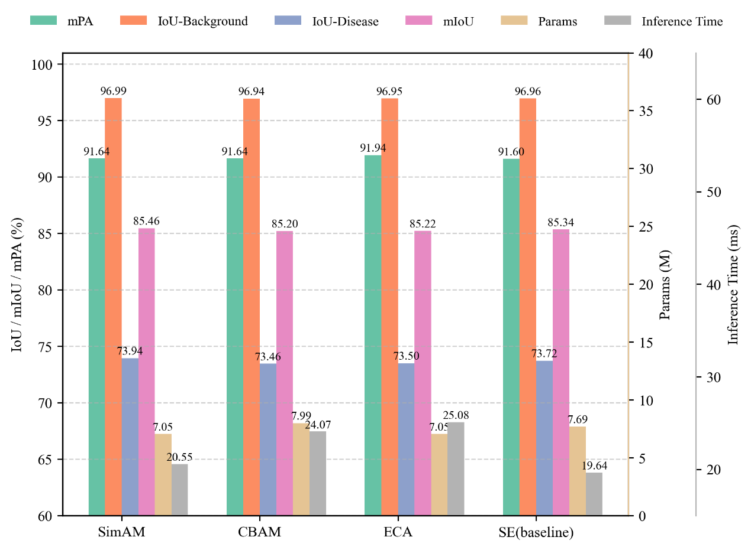
Fig. 8. Performance comparison of U-Net with an EfficientNet-B0 backbone using different attention mechanisms, including SimAM, CBAM, ECA, and SE (baseline), evaluated in terms of segmentation accuracy, parameter count, and inference time.
Fig. 9 compares the lesion segmentation performance of U-Net with an EfficientNet-B0 backbone using different decoder convolution variants. RepConv achieved the best overall performance, obtaining the highest IoU-Disease (74.30%) and mIoU (85.64%), with a moderate parameter count (7.73 M) and the shortest inference time (17.33 ms). CondConv2D showed competitive accuracy but required more parameters (9.25 M), while ODConv exhibited the lowest accuracy and the highest computational cost. The baseline Conv×2 and standard Conv decoders achieved moderate performance, and PConv, although lightweight, did not provide competitive accuracy. Overall, RepConv offers the most favorable trade-off between segmentation accuracy and efficiency and was therefore adopted in the final model.
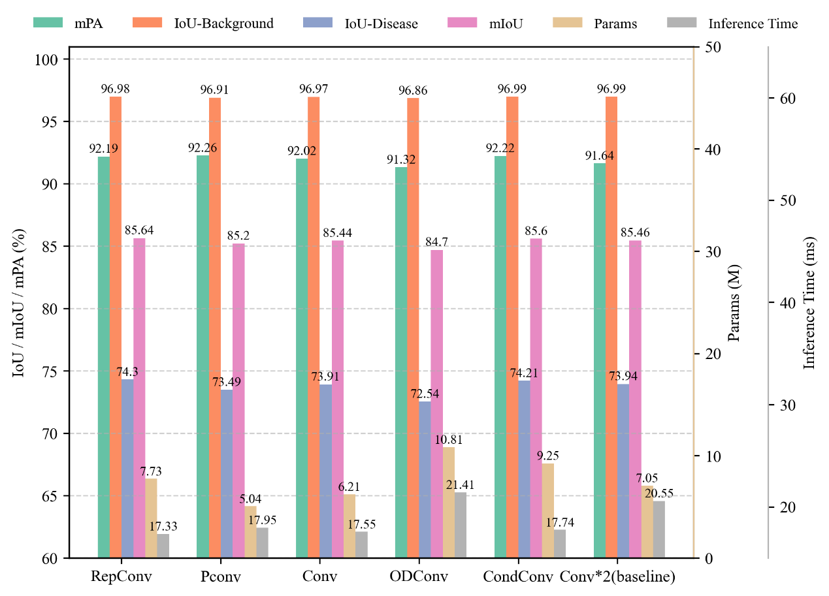
Fig. 9. Lesion segmentation performance of U-Net with a SimAM-enhanced EfficientNet-B0 backbone using different decoder convolution variants, including RepConv, PConv, Conv, ODConv, CondConv2D, and Conv×2 (baseline), evaluated in terms of segmentation accuracy, parameter count, and inference time.
Fig.S1 illustrates the relationship between the SimEffB0-RepUNet predicted disease severity and the ground truth, in terms of the R² results and error metrics (MAE and RMSE). The model achieved an evaluation performance of R² = 0.976, MAE = 0.012, and RMSE = 0.019 on the test set, demonstrating strong predictive accuracy and robustness in both disease segmentation and severity quantification tasks.
  - Model comparison
The performance of five single-stage models and two dual-stage models, including our proposed model, is summarized in Fig. 10. Among the single-stage models, DeepLabV3+ and U-Net (VGG backbone) ranked the top two position in both IoU-Leaf (94.44, 92.62) and IoU-Disease (70.9, 70.84) while sharing a much lower inference speed (1138 ms, 1131 ms), with the former achieving slightly better accuracy and substantially smaller parameter count than the latter. HRNet performed moderately across all the metrics. PSPNet achieved a higher accuracy (89.69% leaf IoU and 58.88% disease IoU) only than SegFormer with the smallest parameter count (2.38 M) and the fastest inference time (392 ms). SegFormer achieved the lowest leaf IoU (88.59%) and disease IoU (55.19%), with a lightweight architecture (3.71 M) and an inference time of 361 ms. Compared with the single-stage models, the dual-stage model achieved substantially higher accuracy while having a relatively large parameter count and inference time. Among the two dual-stage models, DeepLabV3+ + U-Net achieved 97.49% leaf IoU and 72.71% disease IoU, with a larger parameter size (32.04 M) and an inference time of 2303 ms. In contrast, the proposed SimV3-DL3+ + SimEffB0-RepUNet model delivered the best overall performance, attaining 97.76% leaf IoU and 74.3% disease IoU while maintaining a moderate parameter size (12.56 M) and an inference time of 2261 ms.
As observed in Fig.S2, most single-stage models and the DeepLabV3+ + U-Net pipeline exhibit over-segmentation in leaf extraction, frequently including background regions and producing boundary inaccuracies along fine leaf structures. The proposed dual-stage model effectively mitigates these issues, yielding cleaner leaf masks and more accurate boundary delineation, which directly contributes to improved lesion segmentation and disease severity estimation.
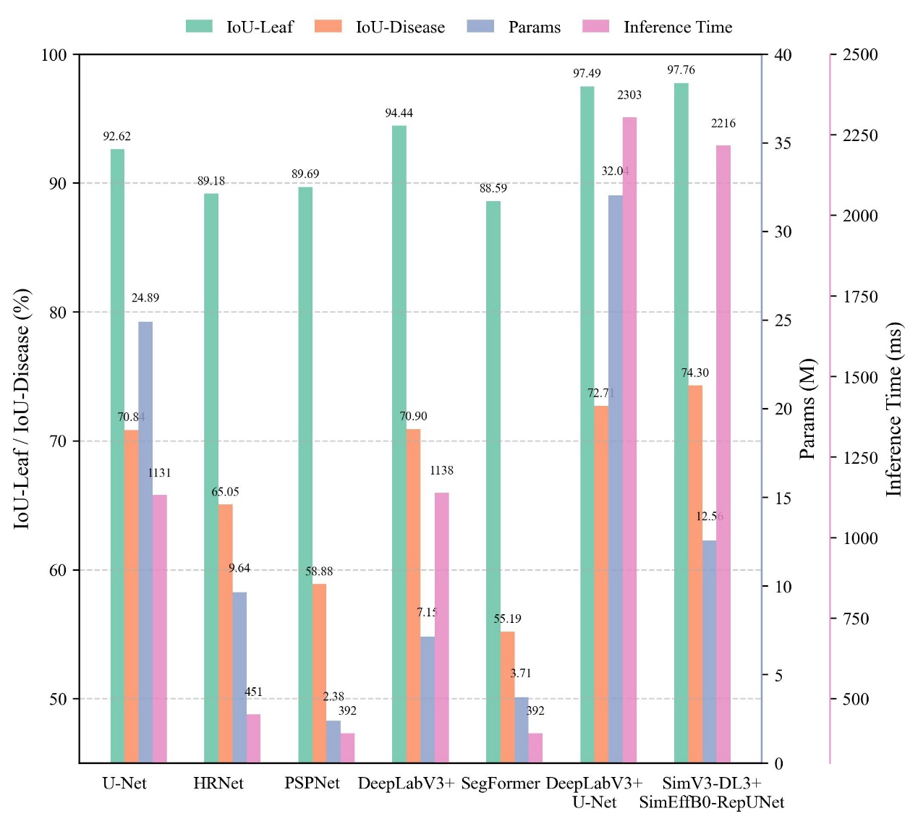
Fig. 10. Performance comparison of segmentation models, including U-Net, HRNet, PSPNet, DeepLabV3+, SegFormer, DeepLabV3+ + U-Net, and the proposed SimV3-DL3+ + SimEffB0-RepUNet, evaluated in terms of IoU-Leaf, IoU-Disease, parameter count, and inference time.

  - Expert Visual Evaluation and Model Prediction
Fig.S3 compares disease severity estimates provided by 15 trained technicians. Two representative images with contrasting disease severity levels were evaluated. For the first image, which exhibited mild disease symptoms, expert estimates showed noticeable variability and were consistently higher than the model prediction. The average expert-estimated severity was 4.56%, whereas the model predicted a lower severity of 2.32%. For the second image, characterized by more extensive disease symptoms, expert assessments were more concentrated, with an average estimated severity of 20.01%, closely aligning with the model prediction of 19.32%, despite a few higher individual estimates.
Overall, the comparison indicates that expert visual evaluation tends to overestimate severity under mild disease conditions, while showing stronger agreement with model predictions under moderate-to-severe disease levels. These results highlight the inherent subjectivity and inter-observer variability in visual severity assessment and demonstrate the potential of the proposed model to provide more consistent and objective severity quantification.
- Discussion
Accurate and quantitative assessment of foliar disease severity is a core requirement for evaluating yield impacts, screening host resistance, assessing fungicide efficacy, and supporting evidence-based disease management across a wide range of crop protection systems. However, severity estimation from field imagery remains challenging due to heterogeneous backgrounds, variable illumination, occlusion, and the coexistence of leaf- and lesion-scale visual patterns. In this study, we propose a general dual-stage segmentation framework for disease severity quantification, and demonstrate its effectiveness using grapevine downy mildew as a representative application scenario. By explicitly decoupling leaf segmentation and lesion segmentation, the proposed framework achieves improved boundary delineation, enhanced robustness, and favorable accuracy–efficiency trade-offs compared with conventional single-stage approaches.
  - Attention-guided lightweight leaf segmentation for robust field conditions
Experimental results demonstrate that the proposed leaf segmentation model—DeepLabV3+ equipped with a SimAM-enhanced MobileNetV3 backbone—achieves superior segmentation accuracy while simultaneously reducing model complexity under field conditions (Fig. 4 and Fig. 5). These improvements can be attributed to the complementary effects of the lightweight backbone and the parameter-free SimAM attention mechanism combined with the multiscale context aggregation capability of DeepLabV3+. Specifically, SimAM enhances spatial sensitivity, enabling the network to better emphasize salient structural features of leaves while suppressing background interference, which leads to more accurate boundary delineation and reduced over-segmentation, as qualitatively illustrated in Fig.S2. Similar benefits of spatial attention for leaf segmentation have been reported by Dong et al. [39]. On the other hand, owing to the lightweight nature of both MobileNetV3 and SimAM, incorporating the SimAM attention module into the MobileNetV3 backbone maintains computational efficiency while enhancing feature representation. Similarly, Wen et al. [40] also confirmed the benefits from the combination of lightweight architecture and attention mechanism for leaf segmentation. These advantages are critical not only for improving accuracy in downstream tasks, including lesion detection and severity estimation, where segmentation accuracy directly impacts diagnostic reliability, but also for enabling practical deployment in agricultural settings with limited computational resources.
Overall, the high performance of our model for leaf segmentation highlights the dual benefits of employing attention-guided lightweight backbones: improved robustness under diverse illumination and background conditions, and reduced computational resources consumption that is essential for practical deployment [37-38].
  - Lesion segmentation model performance enhancement
For lesion segmentation, our U‑Net variant employing a SimAM‑enhanced EfficientNet‑B0 encoder and a RepConv decoder achieved the highest IoU‑Disease and mIoU (Fig. 6-Fig. 9). Compared with the baseline U-Net, this model demonstrates a clear improvement in both segmentation accuracy and computational efficiency. These gains can be primarily attributed to the combined effects of (i) a lightweight yet expressive backbone (EfficientNet-B0), (ii) spatial attention via SimAM, and (iii) structural re-parameterization through RepConv in the decoder.
EfficientNet-B0, designed using compound scaling of depth, width, and resolution, provides a strong balance between representational capacity and efficiency [22]. When integrated into the U-Net encoder, EfficientNet-B0 enhances multi-scale feature extraction and fusion for lesion regions without increasing model size. However, its original squeeze-and-excitation (SE) attention focuses mainly on channel dependencies and offers limited spatial sensitivity, which can be suboptimal for segmenting small, irregular, and spatially heterogeneous disease lesions [43]. By replacing SE with SimAM, a parameter-free spatial attention mechanism, the backbone gains enhanced sensitivity to lesion morphology and spatial distribution, improving lesion localization while maintaining a lightweight structure [15]. This is consistent with the attention comparison results in Fig. 8, where SimAM provides the most favorable accuracy–efficiency trade-off among evaluated attention mechanisms.
In the decoder stage, RepConv further strengthens lesion segmentation performance. During training, RepConv employs a multi-branch structure that improves feature fusion and boundary refinement, while being re-parameterized into a single convolutional layer at inference time [23] . This design enhances the model’s ability to capture fine-grained lesion boundaries and small lesion regions without increasing inference complexity. As shown in Fig. 9, the RepConv-based decoder achieves the highest IoU-Disease and mIoU with the shortest inference time among all tested convolution variants, highlighting its suitability for accurate yet efficient lesion segmentation.
Together, the combination of EfficientNet-B0, SimAM, and RepConv allows the model to focus more effectively on lesion regions while suppressing irrelevant background signals, leading to substantially higher segmentation accuracy compared with the baseline U-Net. At the same time, the use of lightweight attention and structural optimization reduces the overall parameter count, ensuring that computational efficiency is maintained without sacrificing predictive power.
Related studies have also demonstrated the effectiveness of enhanced feature extraction and attention mechanisms in U-Net–based architectures. For example, Zhang et al. [44] proposed a U-Net variant for real-world pest segmentation by incorporating multiscale feature extraction and attention-based feature fusion, achieving high segmentation accuracy. However, their work did not explicitly address lightweight architectural design or efficiency optimization. Similarly, Gu and Liu [45] developed a high-performance U-Net for crop disease segmentation, but computational efficiency and inference time were not reported. In contrast, the proposed lesion segmentation model explicitly balances accuracy, efficiency, and deploy ability, making it more suitable for large-scale and field-oriented applications.
Overall, the lesion segmentation stage of the proposed framework demonstrates strong adaptability to the complex visual variability of disease symptoms in real-world vineyard environments, while also providing a practical foundation for scalable deployment in precision viticulture and, more broadly, quantitative foliar disease severity assessment.
  - Performance of the dual-stage model
Our comparative experiments confirm that dual‑stage models outperform single‑stage models both in leaf and lesion segmentation accuracy (Fig. 10). This can be attributed to the fact that dual-stage architectures leverage task decomposition, allowing independent optimization of leaf and lesion segmentation[17]. In our dual-stage framework, the DeepLabV3+ model—optimized for leaf segmentation—exhibited stronger performance on large and medium-scale targets, effectively delineating complex leaf boundaries. Meanwhile, the lesion segmentation model achieved superior accuracy in identifying small lesions and demonstrated high performance in grape downy mildew segmentation, showing a clear advantage in capturing subtle and irregular lesion regions. This architectural decoupling allows each model to specialize in learning scale- and texture-specific representations, thereby mitigating interference between structurally distinct targets. These findings further confirm the effectiveness and suitability of the proposed dual-stage architecture for complex agricultural scenarios, consistent with observations reported in recent studies [16, 22]. In contrast, single-stage models, while generally more efficient and suitable for real-time applications, often exhibit divergent performance across leaf and lesion segmentation tasks. They struggle to achieve optimal results for both simultaneously, particularly in complex field environments where occlusion, variable illumination, and background clutter impede reliable disease detection [49-50]. Between the two dual-stage models, our approach strengthens feature extraction and fusion while maintaining a lightweight architecture, thereby achieving improved overall performance. This improvement leads to more accurate disease severity estimation, which is critical for guiding timely and effective disease management strategies in vineyards. Nevertheless, it should be noted that the overall performance of dual-stage models is inherently constrained by the first-stage model, even when the second-stage model achieves excellent performance. In this regard, the strong performance of our first-stage model plays a key role in enabling our method to outperform competing approaches.
  - Practical deployment and applications
To facilitate field deployment and highlight the real-world applicability of the proposed dual-stage model, a Flutter-based Android application was developed (https://github.com/husnxjsjsb/Grape-Downy ). The application integrates the model into a portable, user-friendly platform, enabling efficient, real-time operation in agricultural environments and substantially reducing manual labor requirements. This practical implementation bridges the gap between advanced deep learning algorithms and on-site agricultural decision-making, aligning with recent progress in intelligent agriculture [21-22]. Fig.S4 illustrates the application’s intuitive interface and user interaction. Field deployment and evaluation verify the model’s feasibility under practical conditions, confirming its robustness, reliability, and scalability. The demonstration further highlights how lightweight yet accurate models can provide real-time disease severity assessment, supporting timely interventions and data-driven crop management. Overall, these findings demonstrate the model’s readiness for broad agricultural deployment and future system integration.
  - Limitations
Despite its advantages, DSLL‑Net still involves two networks and therefore incurs longer inference times than some single‑stage models. Model compression or neural architecture search could further reduce latency. Our evaluation is limited to a single disease and crop; broader validation across multiple crops, diseases and environments is necessary. Moreover, pixel‑level annotations remain labor-intensive; semi‑supervised, weakly supervised or synthetic data approaches could alleviate this burden. Finally, severity estimation is based solely on the ratio of lesion to leaf area; integrating temporal progression models or multispectral data may provide more robust severity assessments. Addressing these limitations will enhance the scalability and applicability of quantitative disease severity assessment in precision agriculture.
- Conclusion
This study proposes a robust and efficient dual-stage architecture for assessing the severity of grape downy mildew, built upon two segmentation models: SimV3-DL3+ and SimEffB0-RepUNet. SimV3-DL3+ adopts a SimAM attention enhanced MobileNetV3 as backbone of DeepLabV3 to balance segmentation accuracy and computational efficiency for leaf segmentation, while SimEffB0-RepUNet is a U-Net with a SimAM enhanced_EfficientNetB0 as backbone, and a RepConv modules enhanced decoder. The proposed dual-stage model achieved an IoU-Disease of 74.3% in lesion segmentation, demonstrating high accuracy in delineating diseased regions on grape leaves. With only 12.56 million parameters, it remains lightweight and well-suited for deployment on mobile or edge devices. The model also achieved an R² of 0.976 in disease severity regression, confirming its reliability in quantifying infection levels. Overall, it provides a compact and high-precision solution for intelligent assessment of grape downy mildew severity and supports practical applications in smart agriculture. Future work will expand the dataset to include grape leaves at various growth stages and under diverse environmental conditions to further improve the model’s generalization ability. Additionally, we plan to explore approaches for simultaneous multi-leaf assessment and rapid evaluation to enhance efficiency in field applications.

Data and code availability
The data and code used in this study are available on GitHub ( https://github.com/SmartAG-NWAFU/Grape-Downy).

Author contribution statement
Changqing Yan, Gang Zhao: Writing – review & editing, Validation, Supervision, Resources, Project administration, Methodology, Funding acquisition, Conceptualization. Shuyang Li: Writing – original draft, Visualization, Validation, Methodology, Data curation, Conceptualization. Ling Yin: Supervision, project administration, funding acquisition. Zhe Liu, Shumei Wei, Xin Lin, Xin Li, Jindong Liu, Zhenpeng Huang, Danni Zheng, Zeyun Liang, Linjia Yao, Bin Chen, Qi Tian: Data curation, Investigation, Validation, Writing – review & editing. Chenliang Wang, Junjie Qu: Writing – review & editing, Visualization, Validation, Data curation.

Declaration of competing interest
The authors declare that they have no known competing financial interests or personal relationships that could have appeared to influence the work reported in this paper.

Acknowledgments
The authors gratefully acknowledge financial support from the Key Research and Development Program of Shaanxi (Grant No. 2023-ZDLNY-64), Guangxi Key R&D Program Project (Grant No. Gui Ke AB24010121).

Supplementary Materials
Figs.S1-Figs.S4: Fig.S1 Fig.S2 Fig.S3 Fig.S4.

References
[1] L. Guo et al., “Super pangenome of Vitis empowers identification of downy mildew resistance genes for grapevine improvement,” Nature Genetics, vol. 57, no. 3, pp. 741–753, Mar. 2025, doi: 10.1038/s41588-025-02111-7.
[2] L. Bin, Z. Ding, L. Tian, D. He, S. Li, and H. Wang, “Grape Leaf Disease Identification Using Improved Deep Convolutional Neural Networks,” Frontiers in Plant Science, vol. 11, p. 1082, Jul. 2020, doi: 10.3389/fpls.2020.01082.
[3] W. Hui et al., “Adoption of Sobol’s analysis method improved the application of a coupled primary and secondary infection grape downy mildew model in northern China,” Computers and Electronics in Agriculture, vol. 199, p. 107154, 2022, doi: https://doi.org/10.1016/j.compag.2022.107154.
[4] S. Savary, A. Ficke, J.-N. Aubertot, and C. Hollier, “Crop losses due to diseases and their implications for global food production losses and food security,” Food security, vol. 4, no. 4, pp. 519–537, 2012.
[5] Y. Wang et al., “High-efficiency fungicide screening and field control efficacy of maize southern corn rust,” Crop Protection, vol. 187, p. 106997, 2025.
[6] M. Ji, L. Zhang, and Q. Wu, “Automatic grape leaf diseases identification via UnitedModel based on multiple convolutional neural networks,” Information Processing in Agriculture, vol. 7, no. 3, pp. 418–426, 2020, doi: https://doi.org/10.1016/j.inpa.2019.10.003.
[7] N. R. Kolhalkar and V. L. Krishnan, “Mechatronics system for diagnosis and treatment of major diseases in grape vineyards based on image processing,” Materials Today: Proceedings, vol. 23, pp. 549–556, 2020, doi: https://doi.org/10.1016/j.matpr.2019.05.407.
[8] L. I. Cazón, J. A. Paredes, N. R. González, E. C. Conforto, L. Suarez, and E. M. Del Ponte, “Optimizing visual estimation of peanut late leaf spot severity with online training sessions and standard area diagrams,” European Journal of Plant Pathology, pp. 1–15, 2025.
[9] T. Shi et al., “Recent advances in plant disease severity assessment using convolutional neural networks,” Scientific Reports, vol. 13, no. 1, p. 2336, Feb. 2023, doi: 10.1038/s41598-023-29230-7.
[10] K. Li, L. Zhang, B. Li, S. Li, and J. Ma, “Attention-optimized DeepLab V3 + for automatic estimation of cucumber disease severity,” Plant Methods, vol. 18, no. 1, p. 109, Sep. 2022, doi: 10.1186/s13007-022-00941-8.
[11] J. G. M. Esgario, R. A. Krohling, and J. A. Ventura, “Deep learning for classification and severity estimation of coffee leaf biotic stress,” Computers and Electronics in Agriculture, vol. 169, p. 105162, 2020, doi: https://doi.org/10.1016/j.compag.2019.105162.
[12] I. Hernández et al., “Assessment of downy mildew in grapevine using computer vision and fuzzy logic. Development and validation of a new method,” OENO One, vol. 56, no. 3, pp. 41–53, Jul. 2022, doi: 10.20870/oeno-one.2022.56.3.5359.
[13] Q. Liang, S. Xiang, Y. Hu, G. Coppola, D. Zhang, and W. Sun, “PD2SE-Net: Computer-assisted plant disease diagnosis and severity estimation network,” Computers and Electronics in Agriculture, vol. 157, pp. 518–529, 2019, doi: https://doi.org/10.1016/j.compag.2019.01.034.
[14] Z. Wang, L. Yang, R. Wang, L. Lei, H. Ding, and Q. Yang, “WE-DeepLabV3+: A lightweight segmentation model for Panax notoginseng leaf diseases,” Computers and Electronics in Agriculture, vol. 227, p. 109612, 2024, doi: https://doi.org/10.1016/j.compag.2024.109612.
[15] C. Zhao et al., “Plant Disease Segmentation Networks for Fast Automatic Severity Estimation Under Natural Field Scenarios,” Agriculture, vol. 15, no. 6, 2025, doi: 10.3390/agriculture15060583.
[16] I. Hernández, R. Silva, P. Melo-Pinto, S. Gutiérrez, and J. Tardaguila, “Early detection of downy mildew in vineyards using deep neural networks for semantic segmentation,” Biosystems Engineering, vol. 252, pp. 15–31, 2025, doi: https://doi.org/10.1016/j.biosystemseng.2025.02.007.
[17] C. Wang, P. Du, H. Wu, J. Li, C. Zhao, and H. Zhu, “A cucumber leaf disease severity classification method based on the fusion of DeepLabV3+ and U-Net,” Computers and Electronics in Agriculture, vol. 189, p. 106373, 2021, doi: https://doi.org/10.1016/j.compag.2021.106373.
[18] Y. Xu et al., “Accurate cotton verticillium wilt segmentation in field background based on the two-stage lightweight DeepLabV3+ model,” Computers and Electronics in Agriculture, vol. 229, p. 109814, 2025, doi: https://doi.org/10.1016/j.compag.2024.109814.
[19] W. Liu et al., “StripeRust-Pocket: A Mobile-Based Deep Learning Application for Efficient Disease Severity Assessment of Wheat Stripe Rust,” Plant Phenomics, vol. 6, p. 0201, 2024, doi: 10.34133/plantphenomics.0201.
[20] L.-C. Chen, Y. Zhu, G. Papandreou, F. Schroff, and H. Adam, “Encoder-Decoder with Atrous Separable Convolution for Semantic Image Segmentation,” Aug. 22, 2018, arXiv: arXiv:1802.02611. doi: 10.48550/arXiv.1802.02611.
[21] A. Howard et al., “Searching for MobileNetV3,” in 2019 IEEE/CVF International Conference on Computer Vision (ICCV), 2019, pp. 1314–1324. doi: 10.1109/ICCV.2019.00140.
[22] C. Lin, P. Yang, Q. Wang, Z. Qiu, W. Lv, and Z. Wang, “Efficient and accurate compound scaling for convolutional neural networks,” Neural Networks, vol. 167, pp. 787–797, 2023.
[23] X. Ding, X. Zhang, N. Ma, J. Han, G. Ding, and J. Sun, “RepVGG: Making VGG-style ConvNets Great Again,” in 2021 IEEE/CVF Conference on Computer Vision and Pattern Recognition (CVPR), 2021, pp. 13728–13737. doi: 10.1109/CVPR46437.2021.01352.
[24] V. Iglovikov and A. Shvets, “TernausNet: U-Net with VGG11 Encoder Pre-Trained on ImageNet for Image Segmentation,” 2018, arXiv: arXiv:1801.05746. doi: 10.48550/arXiv.1801.05746.
[25] H. Zhao, J. Shi, X. Qi, X. Wang, and J. Jia, “Pyramid Scene Parsing Network,” in 2017 IEEE Conference on Computer Vision and Pattern Recognition (CVPR), 2017, pp. 6230–6239. doi: 10.1109/CVPR.2017.660.
[26] E. Xie, W. Wang, Z. Yu, A. Anandkumar, J. M. Alvarez, and P. Luo, “SegFormer: simple and efficient design for semantic segmentation with transformers,” in Proceedings of the 35th International Conference on Neural Information Processing Systems, in NIPS ’21. Red Hook, NY, USA: Curran Associates Inc., 2021.
[27] J. Wang et al., “Deep High-Resolution Representation Learning for Visual Recognition,” IEEE Transactions on Pattern Analysis and Machine Intelligence, vol. 43, no. 10, pp. 3349–3364, 2021, doi: 10.1109/TPAMI.2020.2983686.
[28] M. Sandler, A. Howard, M. Zhu, A. Zhmoginov, and L.-C. Chen, “MobileNetV2: Inverted Residuals and Linear Bottlenecks,” in 2018 IEEE/CVF Conference on Computer Vision and Pattern Recognition, 2018, pp. 4510–4520. doi: 10.1109/CVPR.2018.00474.
[29] D. Qin et al., “MobileNetV4: Universal Models for Mobile Ecosystem,” in Computer Vision – ECCV 2024: 18th European Conference, Milan, Italy, September 29–October 4, 2024, Proceedings, Part XL, Berlin, Heidelberg: Springer-Verlag, 2024, pp. 78–96. doi: 10.1007/978-3-031-73661-2_5.
[30] J. Hu, L. Shen, and G. Sun, “Squeeze-and-Excitation Networks,” in 2018 IEEE/CVF Conference on Computer Vision and Pattern Recognition, 2018, pp. 7132–7141. doi: 10.1109/CVPR.2018.00745.
[31] L. Yang, R.-Y. Zhang, L. Li, and X. Xie, “SimAM: A Simple, Parameter-Free Attention Module for Convolutional Neural Networks,” in International Conference on Machine Learning, 2021. [Online]. Available: https://api.semanticscholar.org/CorpusID:235825945
[32] X. Ma, X. Dai, Y. Bai, Y. Wang, and Y. Fu, “Rewrite the Stars,” in 2024 IEEE/CVF Conference on Computer Vision and Pattern Recognition (CVPR), 2024, pp. 5694–5703. doi: 10.1109/CVPR52733.2024.00544.
[33] K. He, X. Zhang, S. Ren, and J. Sun, “Deep Residual Learning for Image Recognition,” in 2016 IEEE Conference on Computer Vision and Pattern Recognition (CVPR), 2016, pp. 770–778. doi: 10.1109/CVPR.2016.90.
[34] Q. Wang, B. Wu, P. Zhu, P. Li, W. Zuo, and Q. Hu, “ECA-Net: Efficient Channel Attention for Deep Convolutional Neural Networks,” in 2020 IEEE/CVF Conference on Computer Vision and Pattern Recognition (CVPR), 2020, pp. 11531–11539. doi: 10.1109/CVPR42600.2020.01155.
[35] S. Woo, J. Park, J.-Y. Lee, and I. S. Kweon, “CBAM: Convolutional Block Attention Module,” in Computer Vision – ECCV 2018: 15th European Conference, Munich, Germany, September 8–14, 2018, Proceedings, Part VII, Berlin, Heidelberg: Springer-Verlag, 2018, pp. 3–19. doi: 10.1007/978-3-030-01234-2_1.
[36] L. Bai and Z. J. Song, “Omni-dimensional dynamic convolution with coordinate attention detection scheme,” Science Progress, vol. 108, no. 2, p. 00368504251336695, 2025, doi: 10.1177/00368504251336695.
[37] J. Chen et al., “Run, Don’t Walk: Chasing Higher FLOPS for Faster Neural Networks,” in 2023 IEEE/CVF Conference on Computer Vision and Pattern Recognition (CVPR), 2023, pp. 12021–12031. doi: 10.1109/CVPR52729.2023.01157.
[38] B. Yang, G. Bender, Q. V. Le, and J. Ngiam, “CondConv: conditionally parameterized convolutions for efficient inference,” in Proceedings of the 33rd International Conference on Neural Information Processing Systems, Red Hook, NY, USA: Curran Associates Inc., 2019.
[39] X. Dong et al., “Detection of pine wilt disease infected pine trees using YOLOv5 optimized by attention mechanisms and loss functions,” Ecological Indicators, vol. 168, p. 112764, Nov. 2024, doi: 10.1016/j.ecolind.2024.112764.
[40] F. Wen et al., “Accurate recognition and segmentation of northern corn leaf blight in drone RGB Images: A CycleGAN-augmented YOLOv5-Mobile-Seg lightweight network approach,” Computers and Electronics in Agriculture, vol. 236, p. 110433, Sep. 2025, doi: 10.1016/j.compag.2025.110433.
[41] J. Zi, W. Hu, G. Fan, F. Chen, and Y. Chen, “SFL-MobileNetV3: A lightweight network for weed recognition in tropical cassava fields in China,” Expert Systems with Applications, vol. 277, p. 127196, 2025, doi: https://doi.org/10.1016/j.eswa.2025.127196.
[42] M. Parajuli, M. Shaban, and T. L. Phung, “Automated differentiation of skin melanocytes from keratinocytes in high-resolution histopathology images using a weakly-supervised deep-learning framework,” Int. J. Imaging Syst. Technol., vol. 33, pp. 262--275, 2023, doi: 10.1002/IMA.22810.
[43] B. Zhang et al., “Multi-scale segmentation squeeze-and-excitation UNet with conditional random field for segmenting lung tumor from CT images,” Computer Methods and Programs in Biomedicine, vol. 222, p. 106946, 2022.
[44] C. Zhang, Y. Zhang, and X. Xu, “Dilated inception U-Net with attention for crop pest image segmentation in real-field environment,” Smart Agricultural Technology, vol. 11, p. 100917, Aug. 2025, doi: 10.1016/j.atech.2025.100917.
[45] R. Gu and L. Liu, “An agricultural leaf disease segmentation model applying multi-scale coordinate attention mechanism,” Applied Soft Computing, vol. 172, p. 112904, Mar. 2025, doi: 10.1016/j.asoc.2025.112904.
[46] L. G. Divyanth, A. Ahmad, and D. Saraswat, “A two-stage deep-learning based segmentation model for crop disease quantification based on corn field imagery,” Smart Agricultural Technology, vol. 3, p. 100108, 2023, doi: https://doi.org/10.1016/j.atech.2022.100108.
[47] B.-Y. Liu, K.-J. Fan, W.-H. Su, and Y. Peng, “Two-Stage Convolutional Neural Networks for Diagnosing the Severity of Alternaria Leaf Blotch Disease of the Apple Tree,” Remote Sensing, vol. 14, no. 11, 2022, doi: 10.3390/rs14112519.

