DSLL-Net: A Dual-Stage Leaf–Lesion Segmentation Framework for Automated Plant Disease Severity Quantification
Changqing Yanª, Shuyang Liª, Zhe Liuª, Ling Yin ^{b}, Shumei Wei ^{b}, Xin Linª, Xin Liª, Jindong Liuª, Zhenpeng Huangª, Danni Zhengª, Zeyun Liangª, Qi Tian^{c}, Linjia Yao^{c}, Bin Chen ^{d}, Chenliang Wang^{e}, Junjie Qu^{b}*, Gang Zhao ^{d*}
ªCollege of Intelligent Equipment, Shandong University of Science and Technology, Taian 271019, China
^{b}Guangxi Crop Genetic Improvement and Biotechnology Key Lab, Guangxi Academy of Agricultural Sciences, Nanning 530007, China
^{c}College of Natural Resources and Environment, Northwest A & F University, Yangling 712100, China
^{d}State Key Laboratory of Soil and Water Conservation and Desertification Control, College of Soil and Water Conservation Science and Engineering, Northwest A&F University, Yangling 712100, China
^{e}School of Data Science and Artificial Intelligence, Wenzhou University of Technology, Wenzhou 325000, China
*Corresponding author: Gang Zhao, E-mail address: gang.zhao@nwafu.edu.cn; Junjie Qu, Email address: qujunjie@gxaas.net

Abstract
Quantitative disease severity assessment from field images requires accurate estimation of both leaf and lesion areas, yet complex backgrounds, illumination variation, occlusion, and small lesion patterns remain challenging. This study proposes DSLL-Net, a lightweight dual-stage leaf–lesion segmentation framework for grapevine downy mildew severity quantification. DSLL-Net first segments leaves using DeepLabV3+ with a SimAM-enhanced MobileNetV3 backbone, and then delineates lesions with an improved U-Net integrating a SimAM-EfficientNet-B0 encoder and a RepConv decoder. This task decomposition reduces feature interference between leaf boundaries and disease symptoms while maintaining computational efficiency. Experiments on field datasets show that DSLL-Net achieves a favorable accuracy–efficiency trade-off, with a lesion IoU of 74.3% using 12.56 M parameters. Severity estimates derived from segmented leaf and lesion areas strongly agree with reference values ($R^{2}=0.976$). The framework was further integrated into an Android application, demonstrating its potential for field-oriented disease monitoring and decision support.

1 Introduction
Crop diseases threaten agricultural production and require accurate severity assessment for disease management, fungicide development, yield loss estimation, and resistance screening [1-4]. Accurate severity evaluation provides quantitative support for disease progression analysis and management decisions [5]. Conventional visual assessment is subjective and difficult to reproduce [6-8]. Although image-level classification methods can assign disease samples to predefined severity grades [9], they provide coarse estimates and depend heavily on manually defined categories.
Pixel-wise semantic segmentation enables more quantitative severity estimation by calculating lesion coverage on leaf regions [10]. Related computer-vision and deep-learning studies have extended disease severity estimation from coffee and grapevine to broader crop disease scenarios [11-13]. Recent segmentation methods have further improved disease detection through lightweight architectures and attention mechanisms [14-16]. However, many approaches segment leaves and lesions in a single network. Because severity is calculated as the ratio of lesion area to leaf area, errors in either component directly affect the final estimate. In complex field images, single-stage segmentation can suffer from feature interference between large leaf boundaries and small, irregular lesions, leading to unstable severity quantification.
This problem is particularly evident for grapevine downy mildew, where symptoms often appear as small, scattered, and weakly contrasted lesion regions on leaves with variable orientation and illumination. A model that performs well for complete leaf extraction may not be sufficiently sensitive to early lesions, whereas a model optimized for lesion discrimination may overfit local texture and ignore the global leaf boundary. Therefore, disease severity estimation benefits from a design that treats leaf area estimation and lesion area estimation as related but distinct segmentation tasks.
Dual-stage frameworks reduce this interference by separating leaf extraction from lesion delineation. Existing methods such as DUNet [17], two-stage DeepLabV3+-based models [18], and mobile crop disease assessment frameworks [19] have demonstrated the benefit of task decomposition for disease severity estimation. However, field deployment still requires models that balance segmentation accuracy, compactness, inference efficiency, and usability on resource-constrained devices.
Most existing dual-stage studies emphasize segmentation accuracy, while less attention is given to how each stage should be redesigned for deployment-oriented severity estimation. In practical field use, the first stage should be compact and robust to background interference, whereas the second stage should preserve fine lesion boundaries without excessive parameter cost. These requirements motivated the stage-specific architecture design in DSLL-Net.
In this study, we propose DSLL-Net, a lightweight dual-stage framework for quantitative grapevine downy mildew severity assessment from field images. The main contributions are: (1) a task-decoupled leaf–lesion segmentation pipeline that reduces interference between leaf boundaries and small lesions; (2) a compact leaf segmentation model based on DeepLabV3+ [20] and SimAM-MobileNetV3 [21] and an efficient lesion segmentation model based on SimAM-EfficientNet-B0 [22] and RepConv U-Net [23]; and (3) a severity estimation and mobile deployment workflow validated under field conditions.

2 Materials and Methods

2.1 Overview of the workflow
Fig. 1 summarizes the proposed workflow. Field images were annotated to construct task-specific datasets for leaf segmentation, lesion segmentation, and single-stage comparison. DSLL-Net then performs severity estimation in two stages: SimV3-DL3+ first extracts leaf regions from complex backgrounds, and SimEffB0-RepUNet subsequently segments lesions within the leaf region. Disease severity is calculated as the ratio of lesion area to total leaf area and is integrated into a mobile application workflow.
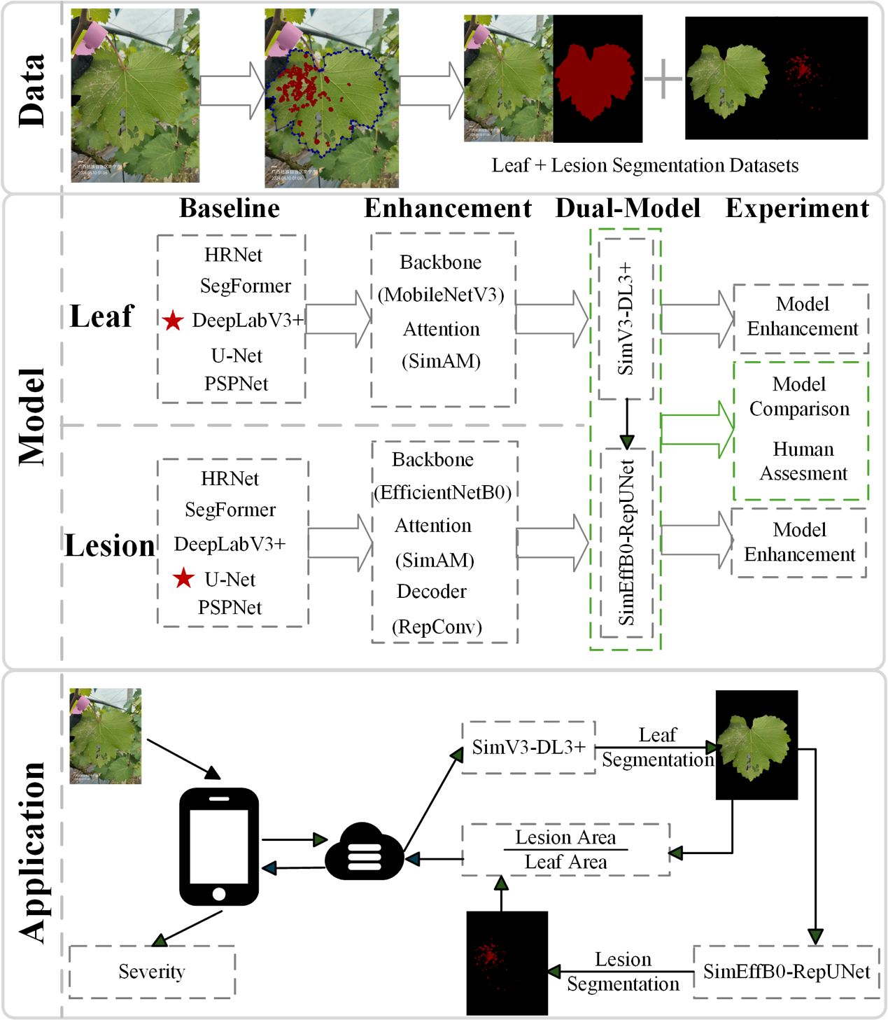
Fig. 1. Overall workflow of data preparation, dual-stage model development, and mobile application deployment.

2.2 Data Preparation
A total of 696 field images were collected between April and August 2024 at Mingyang and Du’an in Guangxi, China. Images were captured using a Huawei P70 and an iPhone 15 at a distance of 15–20 cm, with each image focused on a single leaf. Images with clear leaf structures, appropriate viewing angles, and no severe occlusion were retained.
The collection period covered different stages of disease occurrence in field conditions, allowing the dataset to include leaves with mild, moderate, and relatively severe symptoms. Images affected by strong direct sunlight, severe blur, or incomplete leaf visibility were excluded to reduce annotation ambiguity. This filtering was intended to maintain reliable pixel-level labels while still preserving typical background variation encountered in vineyard scenes.
Leaf and lesion regions were manually annotated using LabelMe (v3.16.7), generating binary masks for leaf/background and lesion/non-lesion classes. These annotations were used to construct three datasets for leaf segmentation, lesion segmentation, and single-stage lesion segmentation, as summarized in Table 1.
Table. 1 An overview of the constructed datasets and their corresponding modeling tasks.
Dataset | Input to model | Label(s) | Construction | Task | Models using it
Leaf segmentation | Original full RGB field image | Leaf mask (binary) | Manual annotation on original image | Leaf extraction from background | Stage-1 models: DeepLabV3+ baseline comparisons and SimV3-DL3+
Lesion segmentation | Cropped leaf ROI | Lesion mask (binary, cropped consistently) | Crop leaf regions using leaf masks; pair with cropped lesion masks | Fine-grained lesion segmentation within leaf | Stage-2 models: U-Net family and SimEffB0-RepUNet
Single-stage segmentation | Original full RGB field image | Lesion mask (binary) | Original images + lesion masks | Single-stage lesion segmentation | Single-stage baselines: U-Net, DeepLabV3+, PSPNet, HRNet, and SegFormer
All datasets used the same train–test split: 567 images for training and 129 for testing. To match deployment conditions, the second-stage lesion model used leaf regions predicted by the first-stage model rather than ground-truth leaf masks.
This setting is important because the lesion stage receives imperfect leaf regions during real use. Evaluating the full pipeline with predicted leaf masks therefore provides a more realistic estimate of deployment performance than testing lesion segmentation only on manually cropped ground-truth leaf regions. The single-stage dataset was retained as a direct comparison to quantify the benefit of explicitly separating leaf and lesion segmentation.

2.3 Dual-Stage Segmentation Model

2.4 Leaf Segmentation Model SimV3-DL3+
The first stage aims to segment leaf regions accurately while keeping the model compact for mobile deployment. Five representative segmentation models (DeepLabV3+ [20], U-Net [24], PSPNet [25], SegFormer [26], and HRNet [27]) were evaluated, and DeepLabV3+ was selected as the baseline because it provided the best accuracy with moderate complexity. To improve efficiency, MobileNetV3 [21] was used as the backbone. Its original SE module was replaced with SimAM, which enhances spatial responses without adding learnable parameters. The resulting SimV3-DL3+ model is shown in Fig. 2.
The choice of DeepLabV3+ is based on its atrous spatial pyramid pooling, which captures multi-scale context useful for separating complete leaf regions from heterogeneous backgrounds. MobileNetV3 was selected because it offers a stronger accuracy–efficiency balance than MobileNetV2 [28] and a more compact alternative than MobileNetV4 [29] in this task. Replacing SE [30] with SimAM [31] was intended to strengthen spatial attention for boundary pixels and reduce the parameter cost introduced by channel attention.
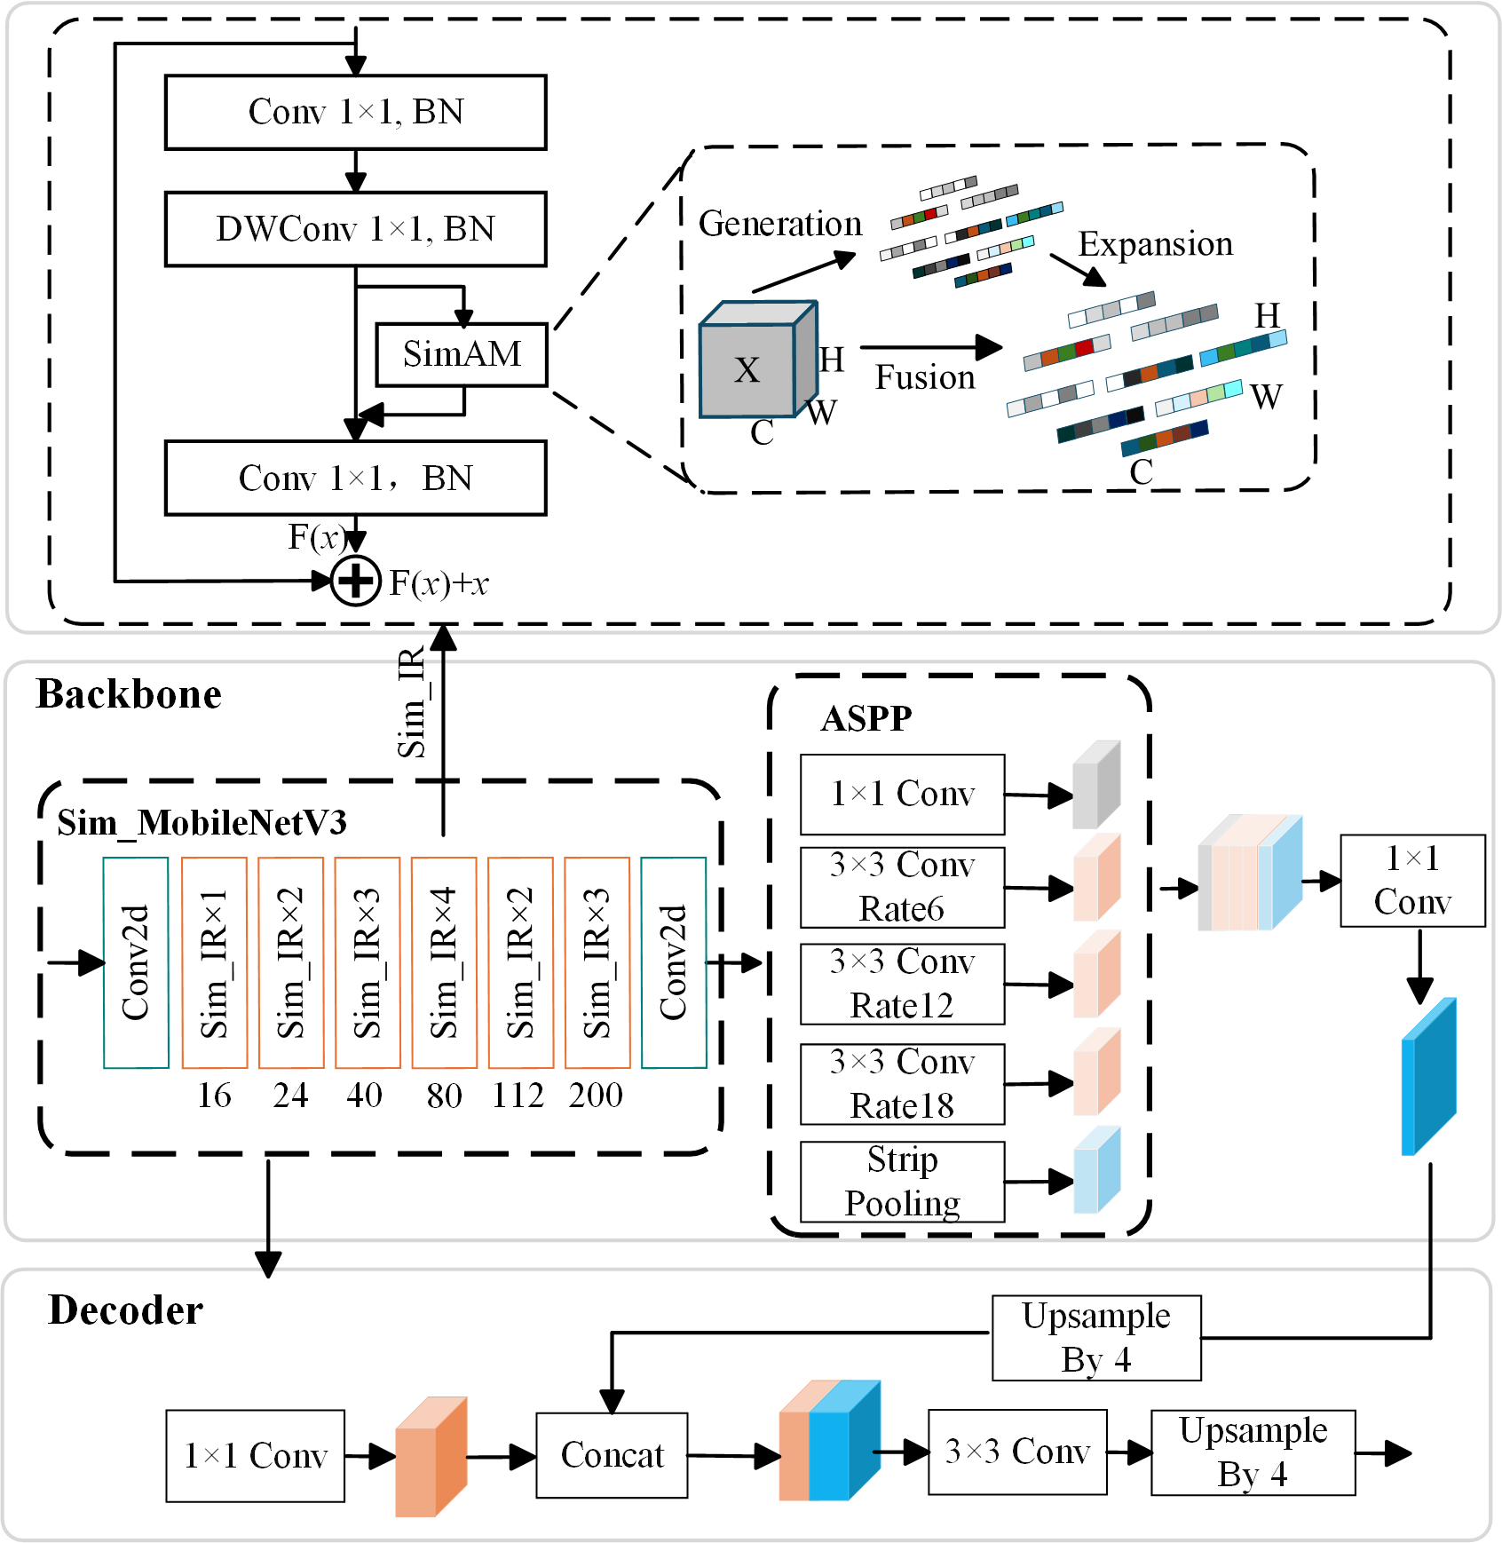
Fig. 2. Architecture of the SimV3-DL3+ model. Sim_IR denotes the InvertedResidual block enhanced with SimAM attention.

2.5 Lesion Segmentation Model (SimEffB0-RepUNet)
The second stage focuses on small and irregular lesion regions, where boundary precision is more difficult than leaf extraction. U-Net was selected as the baseline after comparison with DeepLabV3+, PSPNet, SegFormer, and HRNet. To reduce the parameter cost of the conventional VGG16 encoder, EfficientNet-B0 was adopted as the encoder. Its SE module was replaced with SimAM to improve spatial lesion representation without increasing model complexity. RepConv blocks were further introduced in the decoder to strengthen feature fusion and boundary reconstruction during training while preserving efficient inference after re-parameterization [23]. The final model, SimEffB0-RepUNet, is shown in Fig. 3.
This design follows the different requirements of lesion segmentation. EfficientNet-B0 provides compact multi-scale feature extraction for fine-grained lesion patterns, SimAM increases sensitivity to spatially sparse symptoms, and RepConv improves decoder representation during training through multi-branch convolution. After re-parameterization, RepConv is converted into a single convolutional structure, so the decoder gains training-time representation capacity without increasing inference complexity.
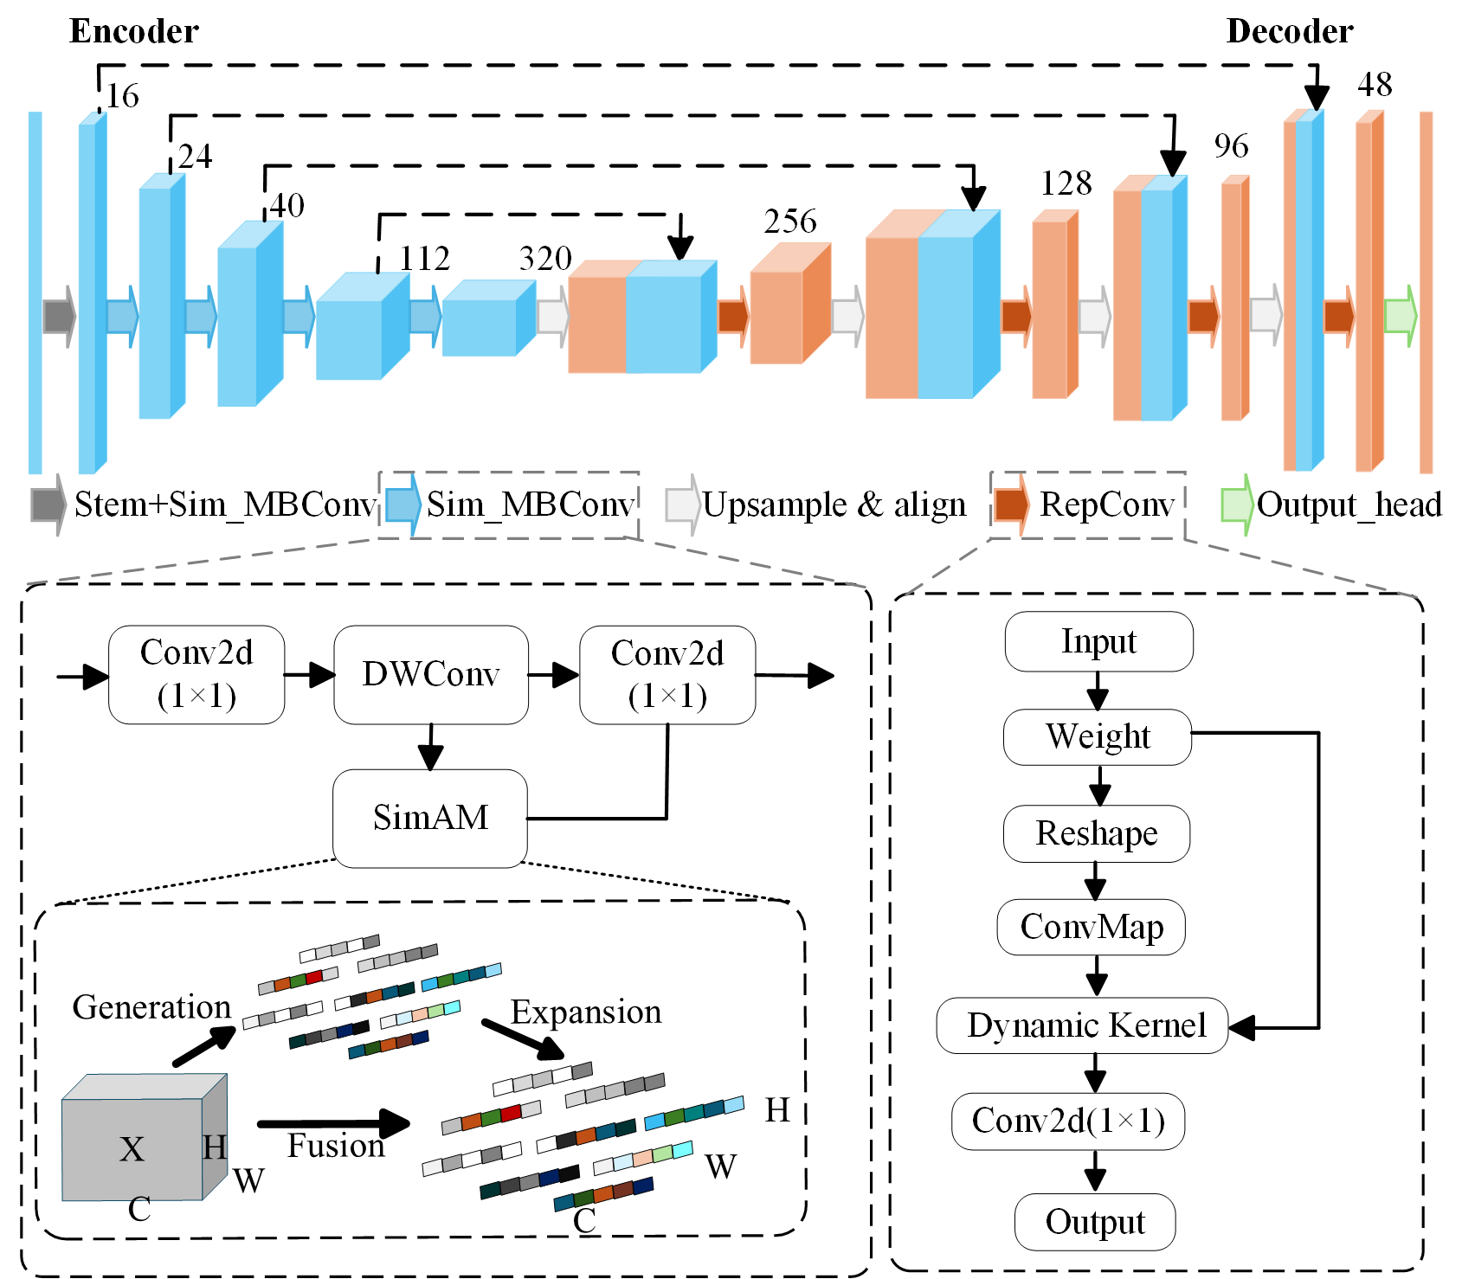
Fig. 3. Architecture of SimEffB0-RepUNet, which uses a SimAM-enhanced EfficientNet-B0 encoder and RepConv modules in the decoder.

2.6 Experimental design

2.7 Leaf segmentation
For leaf segmentation, U-Net, DeepLabV3+, PSPNet, HRNet, and SegFormer were compared using mPA, IoU-Background, IoU-Leaf, mIoU, parameter count, and inference time. IoU-Leaf was treated as the primary metric. Backbone selection was then evaluated within DeepLabV3+ using MobileNetV2, MobileNetV3, MobileNetV4 [29], StarNetS1 [32], and EfficientNet-B0. Finally, MobileNetV3 with SE attention was compared with the SimAM-enhanced variant to assess the contribution of parameter-free spatial attention [30], [31].
The experimental sequence was designed to avoid changing multiple factors simultaneously. First, the baseline segmentation architecture was selected. Then, lightweight backbones were compared under the same DeepLabV3+ framework. Finally, the attention module was changed while keeping the selected architecture fixed, allowing the contribution of SimAM to be isolated.

2.8 Lesion segmentation
For lesion segmentation, candidate architectures were first compared to select the baseline, followed by ablation experiments on backbone, attention module, and decoder convolution. The evaluated backbones included VGG16, ResNet50 [27], ResNetRS50 [33], MobileNetV2, MobileNetV3, and EfficientNet-B0. The attention comparison included SE, ECA, CBAM, and SimAM, and the decoder comparison included Conv, Conv×2, RepConv, ODConv, PConv, and CondConv2D [34-38]. IoU-Disease was the primary metric, together with mPA, IoU-Background, mIoU, parameter count, and inference time.
Because lesion pixels occupy a smaller proportion of the image than leaf pixels, IoU-Disease was emphasized over global accuracy. Parameter count and inference time were reported together with segmentation metrics to ensure that improvements were not obtained solely by increasing model size. This is particularly relevant for mobile or edge deployment, where small increases in latency can affect usability in field surveys.

2.9 Model Comparison Experiments
To evaluate the dual-stage strategy, five single-stage models were compared with a conventional DeepLabV3+ + U-Net pipeline and the proposed SimV3-DL3+ + SimEffB0-RepUNet pipeline. Performance was measured by IoU-Leaf, IoU-Disease, parameter count, and average inference time per image. For dual-stage models, inference time included both segmentation stages and intermediate processing.
The comparison was intended to answer two questions. First, it tested whether lesion segmentation from full field images can match a pipeline that explicitly extracts the leaf region before lesion detection. Second, it evaluated whether the proposed lightweight modifications can improve the conventional dual-stage configuration without increasing model size. This setting directly reflects the severity estimation task, because the final value depends on both the numerator (lesion area) and the denominator (leaf area).

2.10 Expert Visual Evaluation and Model Prediction
To compare automated severity estimation with human judgment, 15 trained technicians visually estimated disease severity on representative leaf images. Their assessments were compared with model predictions for the same images.

2.11 Experimental setup
Experiments were conducted on an NVIDIA GeForce RTX 4060 Ti GPU with an Intel Core i5-13490F CPU and 32 GB RAM. Models were trained in Python 3.8 with CUDA 11.8 using Adam, a batch size of 2, an initial learning rate of $1×{10}^{−5}$, cosine annealing to $1×{10}^{−6}$, and 500 epochs. All images were resized to $512×512$. Dice loss was used:
All models in the same comparison group were trained under the same input resolution, optimization settings, and train–test split. This ensured that differences in performance mainly reflected architectural design rather than data partitioning or training protocol. Inference time was measured on the test set and averaged per image. For the proposed pipeline, the reported time includes leaf prediction, cropping or intermediate processing, lesion prediction, and pixel counting for severity calculation.
$$L_{D\text{ice}}=1−\frac{2|X∩Y|}{\left|X\right|+|Y|}$$ (1)
where $X$ and $Y$ denote the predicted and ground-truth masks.

2.12 Evaluation metrics
Segmentation performance was evaluated using PA, mPA, IoU, and mIoU:
$$PA=\frac{\sum_{i=0}^{k}{P_{\text{ii}}}}{\sum_{i=0}^{k}{\sum_{j=0}^{k}{P_{\text{ij}}}}}$$ (2)
where $P_{\text{ii}}$ denotes correctly classified pixels of class $i$, and $P_{\text{ij}}$ denotes pixels whose ground-truth class is $i$ but are predicted as class $j$.
$$\text{mPA}=\frac{1}{K+1}\sum_{i=0}^{K}{\frac{P_{\text{ii}}}{\sum_{j=0}^{K}{P_{\text{ij}}}}}$$ (3)
Here, $K+1$ is the number of classes including background.
$${\text{IoU}}_{i}=\frac{TP_{i}}{TP_{i}+FP_{i}+FN_{i}}$$ (4)
where $TP_{i}$, $FP_{i}$, and $FN_{i}$ are true-positive, false-positive, and false-negative pixels for class $i$.
$$\text{mIoU}=\frac{1}{K+1}\sum_{i=0}^{K}{{\text{IoU}}_{i}}=\frac{1}{K+1}\sum_{i=0}^{K}{\frac{TP_{i}}{TP_{i}+FP_{i}+FN_{i}}}$$ (5)
Severity estimation was evaluated using $R^{2}$, MAE, and RMSE:
After segmentation, disease severity was computed as:
$$S=\frac{A_{\text{lesion}}}{A_{\text{leaf}}}$$ (9)
where $A_{\text{lesion}}$ and $A_{\text{leaf}}$ are the pixel areas of the predicted lesion and leaf masks, respectively. This formulation directly links segmentation performance to the final agronomic severity indicator.
$$R^{2}=1−\frac{\sum_{i=1}^{n}{{\left(y_{i}−{\tilde{y}}_{i}\right)}^{2}}}{\sum_{i=1}^{n}{{\left(y_{i}−\overset{‾}{y}\right)}^{2}}}$$ (6)
where $n$ is the number of samples, $y_{i}$ and ${\tilde{y}}_{i}$ are the actual and predicted values, and $\overset{‾}{y}$ is the mean of all actual values.
$$\text{MAE}=\frac{1}{n}\sum_{i=1}^{n}{|y_{i}−{\tilde{y}}_{i}|}$$ (7)
$$\text{RMSE}=\sqrt{\frac{1}{n}\sum_{i=1}^{n}{{(y_{i}−{\tilde{y}}_{i})}^{2}}}$$ (8)

3 Results

3.1 Leaf segmentation
Among the five leaf segmentation models (Fig. 4), DeepLabV3+ achieved the best overall accuracy, with an mPA of 99.11%, IoU-Background of 98.70%, IoU-Leaf of 97.49%, and mIoU of 98.09%. It also maintained moderate model size and inference time, and was therefore selected as the baseline for leaf segmentation.
Although HRNet also produced competitive accuracy, its larger model size and longer inference time were less suitable for the intended deployment scenario. U-Net ranked behind DeepLabV3+ in accuracy and required more parameters, whereas PSPNet and SegFormer provided lower segmentation accuracy despite their compactness. These results indicate that DeepLabV3+ provides the best starting point for stage-1 leaf extraction.
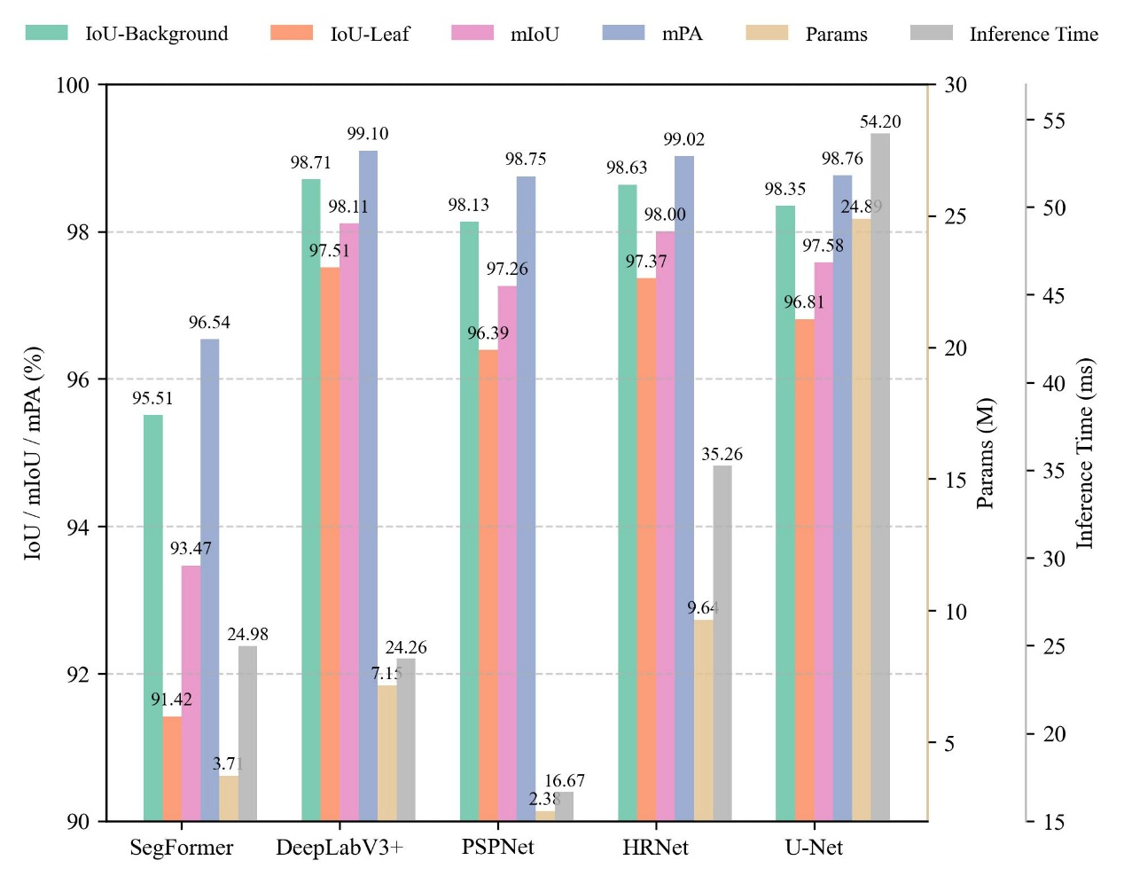
Fig. 4. Leaf segmentation comparison of SegFormer, DeepLabV3+, PSPNet, HRNet, and U-Net.
Backbone comparison further showed that Sim_MobileNetV3 provided the best accuracy–efficiency balance (Fig. 5), reaching the highest mPA (99.19%) and mIoU (98.30%) with only 4.83 M parameters and 20.62 ms inference time.
Compared with the MobileNetV2 baseline, Sim_MobileNetV3 improved accuracy while reducing parameter count. EfficientNet-B0 achieved comparable accuracy but required more parameters and longer inference, and MobileNetV4 did not provide a favorable trade-off in this dataset. The improvement obtained by Sim_MobileNetV3 supports the use of parameter-free spatial attention for leaf boundary extraction. 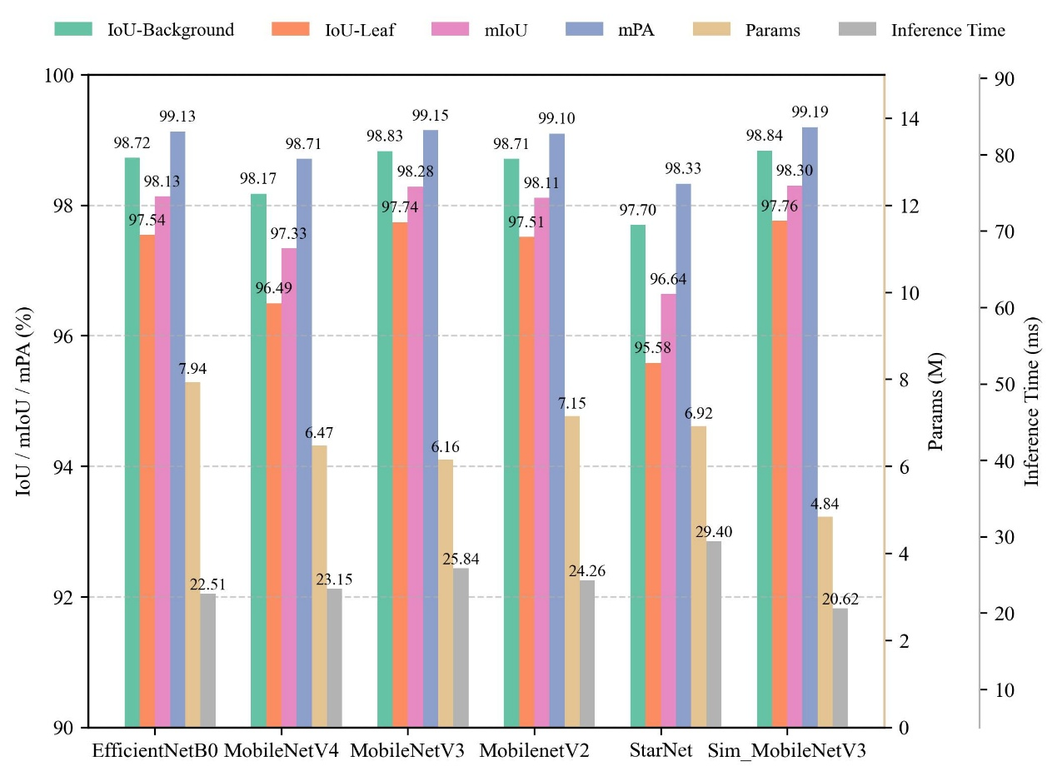
Fig. 5. Leaf segmentation performance of DeepLabV3+ with different backbones.

3.2 Lesion segmentation
For lesion segmentation, U-Net achieved the highest accuracy among the candidate architectures (Fig. 6), with an mIoU of 84.97% and IoU-Disease of 73.07%. Although it had the largest parameter count (24.89 M) and longest inference time (51.53 ms), its accuracy made it the baseline for subsequent optimization.
HRNet and DeepLabV3+ showed competitive lesion segmentation performance, but neither exceeded U-Net in IoU-Disease. PSPNet was the most efficient but had substantially lower lesion accuracy, indicating that speed alone is insufficient for reliable severity estimation. The strong performance of U-Net confirmed the value of encoder–decoder feature fusion for small lesion delineation.
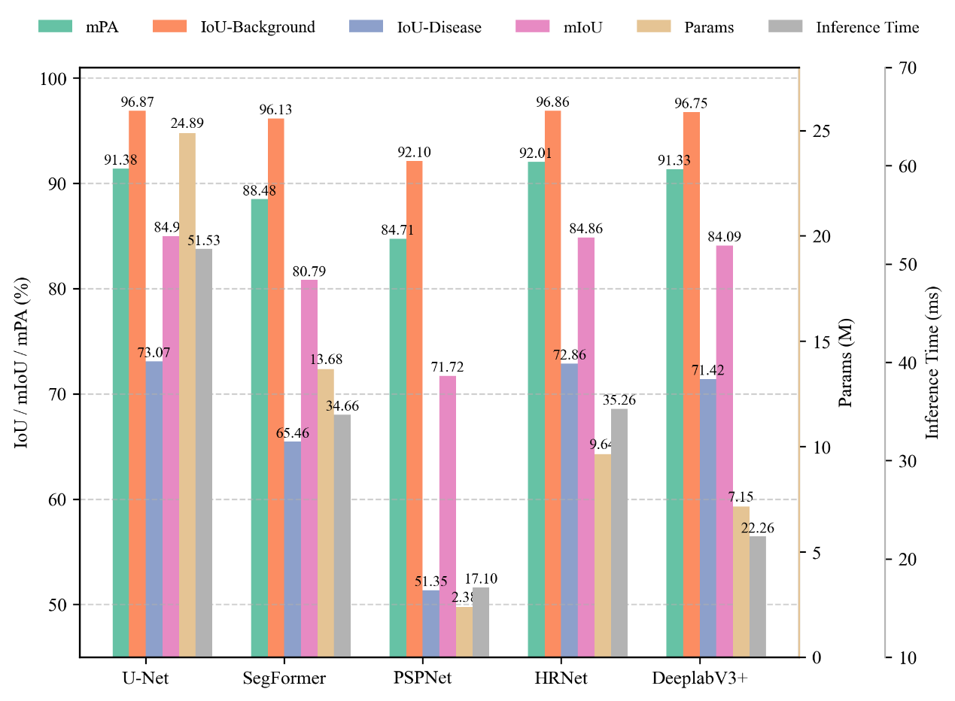
Fig. 6. Lesion segmentation comparison of U-Net, SegFormer, PSPNet, HRNet, and DeepLabV3+.
Backbone evaluation showed that EfficientNet-B0 achieved the best balance for lesion segmentation (Fig. 7), providing the highest mIoU and IoU-Disease while reducing parameters by more than 82% compared with ResNet50 and achieving the fastest inference time (25.01 ms).
This result suggests that EfficientNet-B0 is better suited to the lesion stage than heavier residual backbones. ResNet50 and ResNetRS50 produced similar accuracy but with much larger parameter counts, while the MobileNet variants were efficient but less accurate. EfficientNet-B0 was therefore adopted as the encoder for the final lesion model.
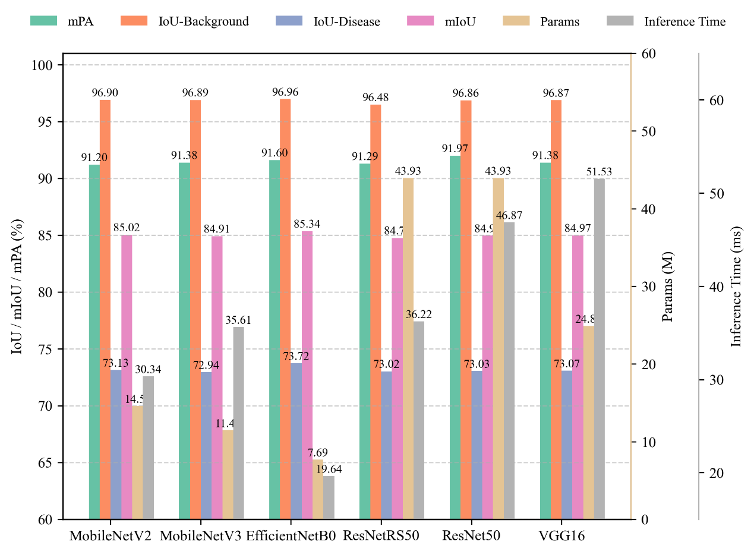
Fig. 7. Lesion segmentation performance of U-Net with different backbones.
Attention comparison indicated that SimAM improved mIoU (85.46%) and IoU-Disease (73.94%) over SE while reducing the parameter count to 7.05 M (Fig. 8). It therefore provided the most favorable trade-off among the evaluated attention modules.
ECA and CBAM provided limited or inconsistent gains and increased latency. The advantage of SimAM is that it improves spatial sensitivity without introducing additional learnable parameters, which is beneficial for small and irregular disease lesions.
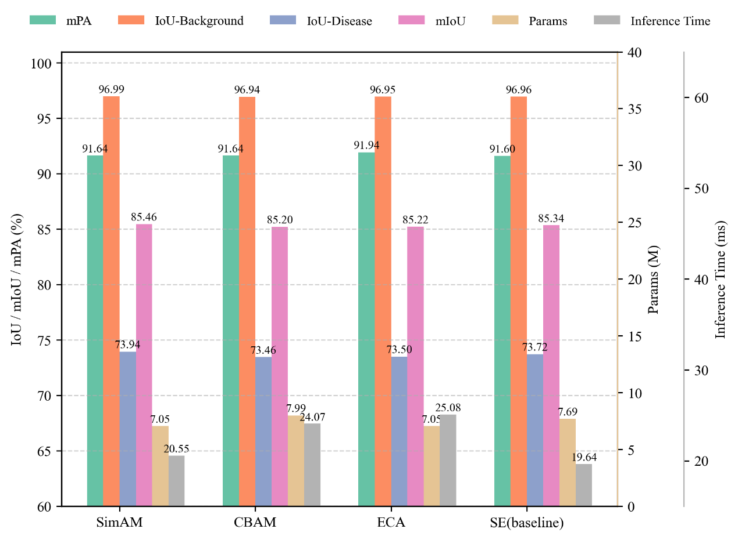
Fig. 8. Lesion segmentation performance with different attention modules.
Among decoder variants, RepConv achieved the best overall performance (Fig. 9), with the highest IoU-Disease (74.30%) and mIoU (85.64%), a moderate parameter count (7.73 M), and the shortest inference time (17.33 ms). RepConv was therefore adopted in the final lesion model.
The comparison indicates that the decoder plays a critical role in recovering fine lesion boundaries. CondConv2D achieved competitive accuracy but required more parameters, whereas ODConv increased computational cost without improving accuracy. RepConv provided the best combination of boundary accuracy and inference efficiency.
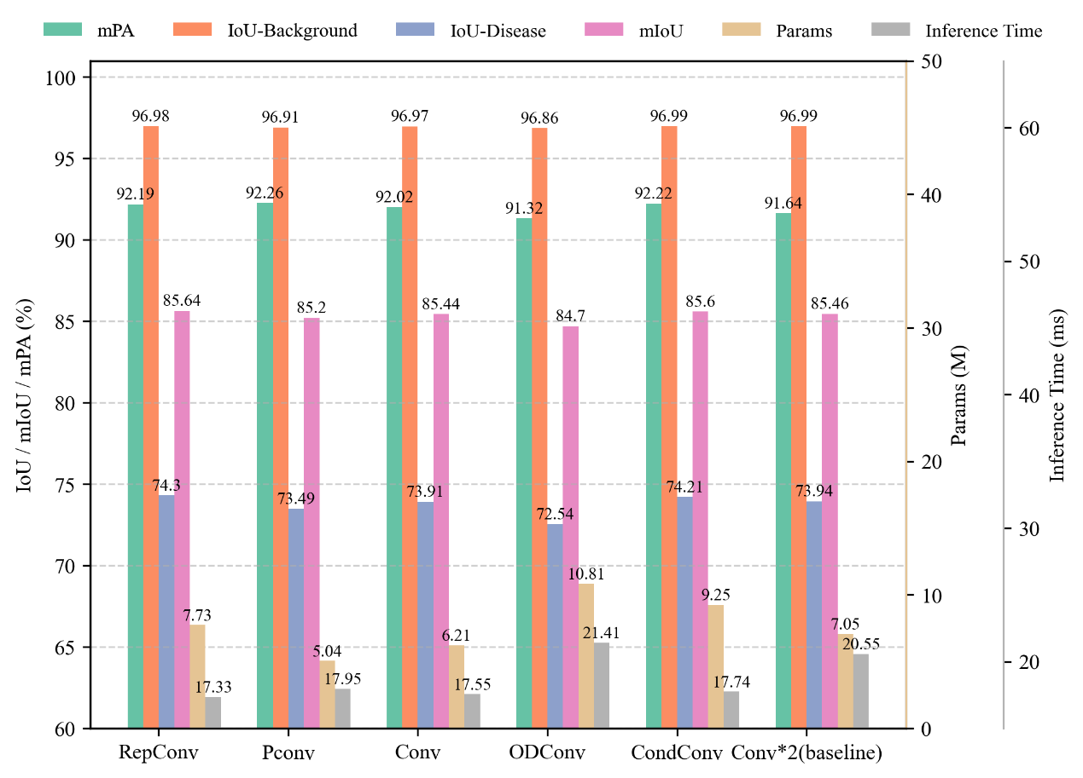
Fig. 9. Lesion segmentation performance with different decoder convolution variants.
Severity estimation based on SimEffB0-RepUNet outputs strongly agreed with ground truth (Fig. S1), achieving $R^{2}=0.976$, MAE = 0.012, and RMSE = 0.019 on the test set.
The low MAE and RMSE indicate that the proposed method not only ranks samples consistently with the reference values but also produces numerically close severity estimates. This is important for practical applications such as fungicide evaluation and disease progression monitoring, where small differences in lesion coverage may influence management decisions. The high $R^{2}$ further suggests that the segmentation-derived severity values capture most of the variation in the reference measurements.

3.3 Model comparison
The proposed dual-stage model outperformed both single-stage models and the conventional dual-stage baseline (Fig. 10). It achieved 97.76% IoU-Leaf and 74.30% IoU-Disease with 12.56 M parameters and 2261 ms inference time. In comparison, DeepLabV3+ + U-Net reached 97.49% IoU-Leaf and 72.71% IoU-Disease with 32.04 M parameters and 2303 ms inference time. Qualitative results (Fig. S2) further showed that the proposed model reduced leaf over-segmentation and improved lesion boundary delineation.
Among single-stage models, DeepLabV3+ and U-Net achieved the strongest lesion results, but both were less accurate than the dual-stage pipelines. This confirms that direct lesion segmentation from full field images is affected by background and leaf boundary interference. The proposed model improves both accuracy and compactness relative to the conventional dual-stage baseline, showing that task decomposition should be paired with stage-specific lightweight design.
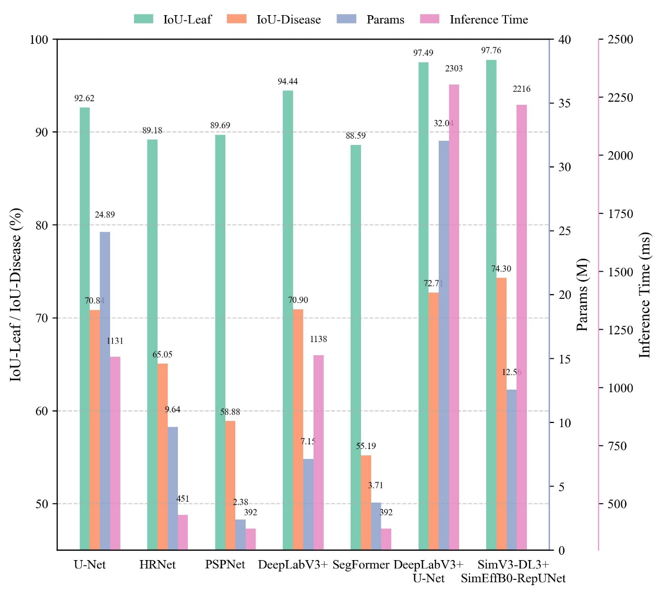
Fig. 10. Performance comparison of single-stage and dual-stage segmentation models.

3.4 Expert Visual Evaluation and Model Prediction
Expert visual estimates showed clear inter-observer variability (Fig. S3). For a mildly diseased leaf, the mean expert estimate was 4.56%, whereas the model predicted 2.32%. For a more severely diseased leaf, the mean expert estimate (20.01%) was close to the model prediction (19.32%). These results indicate that automated estimation can reduce subjectivity, particularly under mild disease conditions.
The difference between expert and model estimates was more pronounced for mild symptoms, where small lesions are easily overestimated by visual inspection. Under higher severity, the symptomatic area is more apparent and expert estimates became more concentrated. This pattern supports the value of pixel-level quantification for early-stage disease monitoring, where visual scoring is often less stable.

4 Discussion
The results demonstrate that separating leaf and lesion segmentation is effective for disease severity quantification under field conditions. The first stage provides a reliable leaf area for severity calculation, while the second stage focuses on small and irregular symptomatic regions. Compared with single-stage models, this task decomposition reduces feature interference and improves the stability of lesion delineation and severity estimation.

4.1 Attention-guided lightweight leaf segmentation for robust field conditions
The leaf segmentation results show that DeepLabV3+ with a SimAM-enhanced MobileNetV3 backbone improves boundary extraction while keeping the model compact. Attention-guided segmentation studies [39], [40] also show that spatially focused feature enhancement helps suppress background interference and reduce over-segmentation. This is important because errors in leaf area directly propagate to severity estimation.
The high IoU-Leaf obtained by SimV3-DL3+ indicates that the first stage can provide a stable denominator for severity calculation. In visual results, inaccurate leaf masks often include background pixels or miss leaf margins, which changes the estimated total leaf area and biases the final severity ratio. Therefore, a compact but accurate first-stage model is not only an auxiliary preprocessing step but a key component of the severity estimation pipeline. This requirement is consistent with recent resource-constrained recognition and weakly supervised segmentation workflows [41], [42].

4.2 Lesion segmentation model performance enhancement
For lesion segmentation, the performance gains arise from the combined use of EfficientNet-B0 [22], SimAM, and RepConv [23]. EfficientNet-B0 provides a compact encoder for multi-scale lesion features, SimAM improves spatial localization of small symptoms, and RepConv strengthens boundary reconstruction during training while preserving inference efficiency. Together, these components improve IoU-Disease and mIoU without the large parameter cost of heavier U-Net variants.
The ablation results also show that the lesion stage cannot be optimized by simply selecting the most compact model. Disease lesions occupy a small and irregular portion of the image, so excessive compression can reduce sensitivity to weak symptoms. The proposed SimEffB0-RepUNet therefore keeps the U-Net encoder–decoder structure but replaces its heavier components with more efficient alternatives, preserving lesion detail while reducing parameter count. This design also aligns with U-Net-based segmentation work using squeeze-and-excitation enhancement [43], dilated attention modules [44], and multi-scale coordinate attention [45] for agricultural target delineation.

4.3 Performance of the dual-stage model
The comparison with single-stage and conventional dual-stage models confirms that independent optimization of leaf and lesion segmentation is beneficial. The proposed framework improves both leaf and lesion IoU while using fewer parameters than the DeepLabV3+ + U-Net baseline. Similar dual-stage disease severity studies based on leaf–lesion decomposition [17-19] and crop disease quantification [46], [47] also support this design logic. This also explains the strong agreement between predicted and reference severity values.
This result highlights the main advantage of DSLL-Net: the two stages solve different visual problems. Leaf segmentation emphasizes global shape and background separation, whereas lesion segmentation emphasizes local texture and boundary refinement. Prior segmentation and dual-stage severity-estimation studies [16-19] show similar benefits from separating symptom delineation from whole-leaf context. By allowing each model to focus on one task, DSLL-Net reduces conflicting feature requirements and improves the reliability of downstream severity estimates.

4.4 Practical deployment and applications
To support field use, the model was integrated into a Flutter-based Android application (https://github.com/SmartAG-NWAFU/Grape-Downy). This implementation demonstrates the feasibility of deploying the proposed framework for portable disease monitoring and decision support. Related mobile disease assessment [19] and lightweight field-recognition systems [41], [42] indicate that compact segmentation models can be embedded into practical field tools.
The application workflow follows the same logic as the experimental pipeline: users acquire or select a leaf image, the system predicts the leaf mask and lesion mask, and the severity value is calculated from the two predicted areas. Although further acceleration is required for large-scale real-time scouting, this prototype shows that the proposed model can be embedded into an operational tool rather than remaining only an offline algorithm.

4.5 Limitations
Several limitations remain. DSLL-Net uses two networks and is therefore slower than some single-stage alternatives. The current evaluation focuses on one crop-disease system, so broader validation across crops, diseases, sensors, and field environments is needed. Pixel-level annotation is also labor-intensive; semi-supervised or weakly supervised learning may reduce this cost. Finally, severity is estimated from lesion area alone, and future work may incorporate temporal or multispectral information.
Additional implementation details, complete ablation settings, and qualitative examples can be provided in the Supplementary Materials to keep the main text concise while preserving reproducibility.
In future work, the framework should be evaluated on images collected under broader illumination conditions, growth stages, and disease pressures. Multi-leaf image processing and temporal severity tracking would also increase its value for field-scale disease monitoring. Combining RGB imagery with additional sensing modalities may further improve severity estimation when symptoms are weak or partially occluded.

5 Conclusion
This study proposes DSLL-Net, a lightweight dual-stage framework for grapevine downy mildew severity assessment. SimV3-DL3+ extracts leaf regions from field backgrounds, while SimEffB0-RepUNet segments small and irregular lesions using a SimAM-EfficientNet-B0 encoder and RepConv decoder. The final model achieved 74.3% IoU-Disease with 12.56 M parameters and produced severity estimates highly consistent with reference values ($R^{2}=0.976$). These results indicate that DSLL-Net provides an efficient and deployable solution for quantitative disease monitoring. Future work will expand validation across more crops, diseases, and field conditions and further optimize edge-device deployment.

Data and code availability
The data and code used in this study are available on GitHub (https://github.com/SmartAG-NWAFU/Grape-Downy).

Author contribution statement
Changqing Yan, Gang Zhao: Writing – review & editing, Validation, Supervision, Resources, Project administration, Methodology, Funding acquisition, Conceptualization. Shuyang Li: Writing – original draft, Visualization, Validation, Methodology, Data curation, Conceptualization. Ling Yin: Supervision, project administration, funding acquisition. Zhe Liu, Shumei Wei, Xin Lin, Xin Li, Jindong Liu, Zhenpeng Huang, Danni Zheng, Zeyun Liang, Linjia Yao, Bin Chen, Qi Tian: Data curation, Investigation, Validation, Writing – review & editing. Chenliang Wang, Junjie Qu: Writing – review & editing, Visualization, Validation, Data curation.

Declaration of competing interest
The authors declare that they have no known competing financial interests or personal relationships that could have appeared to influence the work reported in this paper.

Acknowledgments
The authors gratefully acknowledge financial support from the Key Research and Development Program of Shaanxi (Grant No. 2023-ZDLNY-64), Guangxi Key R&D Program Project (Grant No. Gui Ke AB24010121).

Supplementary Materials
Figs.S1-Figs.S4: Fig.S1 Fig.S2 Fig.S3 Fig.S4.

References
[1] L. Guo et al., “Super pangenome of Vitis empowers identification of downy mildew resistance genes for grapevine improvement,” Nature Genetics, vol. 57, no. 3, pp. 741–753, Mar. 2025, doi: 10.1038/s41588-025-02111-7.
[2] L. Bin, Z. Ding, L. Tian, D. He, S. Li, and H. Wang, “Grape Leaf Disease Identification Using Improved Deep Convolutional Neural Networks,” Frontiers in Plant Science, vol. 11, p. 1082, Jul. 2020, doi: 10.3389/fpls.2020.01082.
[3] W. Hui et al., “Adoption of Sobol’s analysis method improved the application of a coupled primary and secondary infection grape downy mildew model in northern China,” Computers and Electronics in Agriculture, vol. 199, p. 107154, 2022, doi: https://doi.org/10.1016/j.compag.2022.107154.
[4] S. Savary, A. Ficke, J.-N. Aubertot, and C. Hollier, “Crop losses due to diseases and their implications for global food production losses and food security,” Food security, vol. 4, no. 4, pp. 519–537, 2012.
[5] Y. Wang et al., “High-efficiency fungicide screening and field control efficacy of maize southern corn rust,” Crop Protection, vol. 187, p. 106997, 2025.
[6] M. Ji, L. Zhang, and Q. Wu, “Automatic grape leaf diseases identification via UnitedModel based on multiple convolutional neural networks,” Information Processing in Agriculture, vol. 7, no. 3, pp. 418–426, 2020, doi: https://doi.org/10.1016/j.inpa.2019.10.003.
[7] N. R. Kolhalkar and V. L. Krishnan, “Mechatronics system for diagnosis and treatment of major diseases in grape vineyards based on image processing,” Materials Today: Proceedings, vol. 23, pp. 549–556, 2020, doi: https://doi.org/10.1016/j.matpr.2019.05.407.
[8] L. I. Cazón, J. A. Paredes, N. R. González, E. C. Conforto, L. Suarez, and E. M. Del Ponte, “Optimizing visual estimation of peanut late leaf spot severity with online training sessions and standard area diagrams,” European Journal of Plant Pathology, pp. 1–15, 2025.
[9] T. Shi et al., “Recent advances in plant disease severity assessment using convolutional neural networks,” Scientific Reports, vol. 13, no. 1, p. 2336, Feb. 2023, doi: 10.1038/s41598-023-29230-7.
[10] K. Li, L. Zhang, B. Li, S. Li, and J. Ma, “Attention-optimized DeepLab V3 + for automatic estimation of cucumber disease severity,” Plant Methods, vol. 18, no. 1, p. 109, Sep. 2022, doi: 10.1186/s13007-022-00941-8.
[11] J. G. M. Esgario, R. A. Krohling, and J. A. Ventura, “Deep learning for classification and severity estimation of coffee leaf biotic stress,” Computers and Electronics in Agriculture, vol. 169, p. 105162, 2020, doi: https://doi.org/10.1016/j.compag.2019.105162.
[12] I. Hernández et al., “Assessment of downy mildew in grapevine using computer vision and fuzzy logic. Development and validation of a new method,” OENO One, vol. 56, no. 3, pp. 41–53, Jul. 2022, doi: 10.20870/oeno-one.2022.56.3.5359.
[13] Q. Liang, S. Xiang, Y. Hu, G. Coppola, D. Zhang, and W. Sun, “PD2SE-Net: Computer-assisted plant disease diagnosis and severity estimation network,” Computers and Electronics in Agriculture, vol. 157, pp. 518–529, 2019, doi: https://doi.org/10.1016/j.compag.2019.01.034.
[14] Z. Wang, L. Yang, R. Wang, L. Lei, H. Ding, and Q. Yang, “WE-DeepLabV3+: A lightweight segmentation model for Panax notoginseng leaf diseases,” Computers and Electronics in Agriculture, vol. 227, p. 109612, 2024, doi: https://doi.org/10.1016/j.compag.2024.109612.
[15] C. Zhao et al., “Plant Disease Segmentation Networks for Fast Automatic Severity Estimation Under Natural Field Scenarios,” Agriculture, vol. 15, no. 6, 2025, doi: 10.3390/agriculture15060583.
[16] I. Hernández, R. Silva, P. Melo-Pinto, S. Gutiérrez, and J. Tardaguila, “Early detection of downy mildew in vineyards using deep neural networks for semantic segmentation,” Biosystems Engineering, vol. 252, pp. 15–31, 2025, doi: https://doi.org/10.1016/j.biosystemseng.2025.02.007.
[17] C. Wang, P. Du, H. Wu, J. Li, C. Zhao, and H. Zhu, “A cucumber leaf disease severity classification method based on the fusion of DeepLabV3+ and U-Net,” Computers and Electronics in Agriculture, vol. 189, p. 106373, 2021, doi: https://doi.org/10.1016/j.compag.2021.106373.
[18] Y. Xu et al., “Accurate cotton verticillium wilt segmentation in field background based on the two-stage lightweight DeepLabV3+ model,” Computers and Electronics in Agriculture, vol. 229, p. 109814, 2025, doi: https://doi.org/10.1016/j.compag.2024.109814.
[19] W. Liu et al., “StripeRust-Pocket: A Mobile-Based Deep Learning Application for Efficient Disease Severity Assessment of Wheat Stripe Rust,” Plant Phenomics, vol. 6, p. 0201, 2024, doi: 10.34133/plantphenomics.0201.
[20] L.-C. Chen, Y. Zhu, G. Papandreou, F. Schroff, and H. Adam, “Encoder-Decoder with Atrous Separable Convolution for Semantic Image Segmentation,” Aug. 22, 2018, arXiv: arXiv:1802.02611. doi: 10.48550/arXiv.1802.02611.
[21] A. Howard et al., “Searching for MobileNetV3,” in 2019 IEEE/CVF International Conference on Computer Vision (ICCV), 2019, pp. 1314–1324. doi: 10.1109/ICCV.2019.00140.
[22] C. Lin, P. Yang, Q. Wang, Z. Qiu, W. Lv, and Z. Wang, “Efficient and accurate compound scaling for convolutional neural networks,” Neural Networks, vol. 167, pp. 787–797, 2023.
[23] X. Ding, X. Zhang, N. Ma, J. Han, G. Ding, and J. Sun, “RepVGG: Making VGG-style ConvNets Great Again,” in 2021 IEEE/CVF Conference on Computer Vision and Pattern Recognition (CVPR), 2021, pp. 13728–13737. doi: 10.1109/CVPR46437.2021.01352.
[24] V. Iglovikov and A. Shvets, “TernausNet: U-Net with VGG11 Encoder Pre-Trained on ImageNet for Image Segmentation,” 2018, arXiv: arXiv:1801.05746. doi: 10.48550/arXiv.1801.05746.
[25] H. Zhao, J. Shi, X. Qi, X. Wang, and J. Jia, “Pyramid Scene Parsing Network,” in 2017 IEEE Conference on Computer Vision and Pattern Recognition (CVPR), 2017, pp. 6230–6239. doi: 10.1109/CVPR.2017.660.
[26] E. Xie, W. Wang, Z. Yu, A. Anandkumar, J. M. Alvarez, and P. Luo, “SegFormer: simple and efficient design for semantic segmentation with transformers,” in Proceedings of the 35th International Conference on Neural Information Processing Systems, in NIPS ’21. Red Hook, NY, USA: Curran Associates Inc., 2021.
[27] J. Wang et al., “Deep High-Resolution Representation Learning for Visual Recognition,” IEEE Transactions on Pattern Analysis and Machine Intelligence, vol. 43, no. 10, pp. 3349–3364, 2021, doi: 10.1109/TPAMI.2020.2983686.
[28] M. Sandler, A. Howard, M. Zhu, A. Zhmoginov, and L.-C. Chen, “MobileNetV2: Inverted Residuals and Linear Bottlenecks,” in 2018 IEEE/CVF Conference on Computer Vision and Pattern Recognition, 2018, pp. 4510–4520. doi: 10.1109/CVPR.2018.00474.
[29] D. Qin et al., “MobileNetV4: Universal Models for Mobile Ecosystem,” in Computer Vision – ECCV 2024: 18th European Conference, Milan, Italy, September 29–October 4, 2024, Proceedings, Part XL, Berlin, Heidelberg: Springer-Verlag, 2024, pp. 78–96. doi: 10.1007/978-3-031-73661-2_5.
[30] J. Hu, L. Shen, and G. Sun, “Squeeze-and-Excitation Networks,” in 2018 IEEE/CVF Conference on Computer Vision and Pattern Recognition, 2018, pp. 7132–7141. doi: 10.1109/CVPR.2018.00745.
[31] L. Yang, R.-Y. Zhang, L. Li, and X. Xie, “SimAM: A Simple, Parameter-Free Attention Module for Convolutional Neural Networks,” in International Conference on Machine Learning, 2021. [Online]. Available: https://api.semanticscholar.org/CorpusID:235825945
[32] X. Ma, X. Dai, Y. Bai, Y. Wang, and Y. Fu, “Rewrite the Stars,” in 2024 IEEE/CVF Conference on Computer Vision and Pattern Recognition (CVPR), 2024, pp. 5694–5703. doi: 10.1109/CVPR52733.2024.00544.
[33] K. He, X. Zhang, S. Ren, and J. Sun, “Deep Residual Learning for Image Recognition,” in 2016 IEEE Conference on Computer Vision and Pattern Recognition (CVPR), 2016, pp. 770–778. doi: 10.1109/CVPR.2016.90.
[34] Q. Wang, B. Wu, P. Zhu, P. Li, W. Zuo, and Q. Hu, “ECA-Net: Efficient Channel Attention for Deep Convolutional Neural Networks,” in 2020 IEEE/CVF Conference on Computer Vision and Pattern Recognition (CVPR), 2020, pp. 11531–11539. doi: 10.1109/CVPR42600.2020.01155.
[35] S. Woo, J. Park, J.-Y. Lee, and I. S. Kweon, “CBAM: Convolutional Block Attention Module,” in Computer Vision – ECCV 2018: 15th European Conference, Munich, Germany, September 8–14, 2018, Proceedings, Part VII, Berlin, Heidelberg: Springer-Verlag, 2018, pp. 3–19. doi: 10.1007/978-3-030-01234-2_1.
[36] L. Bai and Z. J. Song, “Omni-dimensional dynamic convolution with coordinate attention detection scheme,” Science Progress, vol. 108, no. 2, p. 00368504251336695, 2025, doi: 10.1177/00368504251336695.
[37] J. Chen et al., “Run, Don’t Walk: Chasing Higher FLOPS for Faster Neural Networks,” in 2023 IEEE/CVF Conference on Computer Vision and Pattern Recognition (CVPR), 2023, pp. 12021–12031. doi: 10.1109/CVPR52729.2023.01157.
[38] B. Yang, G. Bender, Q. V. Le, and J. Ngiam, “CondConv: conditionally parameterized convolutions for efficient inference,” in Proceedings of the 33rd International Conference on Neural Information Processing Systems, Red Hook, NY, USA: Curran Associates Inc., 2019.
[39] X. Dong et al., “Detection of pine wilt disease infected pine trees using YOLOv5 optimized by attention mechanisms and loss functions,” Ecological Indicators, vol. 168, p. 112764, Nov. 2024, doi: 10.1016/j.ecolind.2024.112764.
[40] F. Wen et al., “Accurate recognition and segmentation of northern corn leaf blight in drone RGB Images: A CycleGAN-augmented YOLOv5-Mobile-Seg lightweight network approach,” Computers and Electronics in Agriculture, vol. 236, p. 110433, Sep. 2025, doi: 10.1016/j.compag.2025.110433.
[41] J. Zi, W. Hu, G. Fan, F. Chen, and Y. Chen, “SFL-MobileNetV3: A lightweight network for weed recognition in tropical cassava fields in China,” Expert Systems with Applications, vol. 277, p. 127196, 2025, doi: https://doi.org/10.1016/j.eswa.2025.127196.
[42] M. Parajuli, M. Shaban, and T. L. Phung, “Automated differentiation of skin melanocytes from keratinocytes in high-resolution histopathology images using a weakly-supervised deep-learning framework,” Int. J. Imaging Syst. Technol., vol. 33, pp. 262--275, 2023, doi: 10.1002/IMA.22810.
[43] B. Zhang et al., “Multi-scale segmentation squeeze-and-excitation UNet with conditional random field for segmenting lung tumor from CT images,” Computer Methods and Programs in Biomedicine, vol. 222, p. 106946, 2022.
[44] C. Zhang, Y. Zhang, and X. Xu, “Dilated inception U-Net with attention for crop pest image segmentation in real-field environment,” Smart Agricultural Technology, vol. 11, p. 100917, Aug. 2025, doi: 10.1016/j.atech.2025.100917.
[45] R. Gu and L. Liu, “An agricultural leaf disease segmentation model applying multi-scale coordinate attention mechanism,” Applied Soft Computing, vol. 172, p. 112904, Mar. 2025, doi: 10.1016/j.asoc.2025.112904.
[46] L. G. Divyanth, A. Ahmad, and D. Saraswat, “A two-stage deep-learning based segmentation model for crop disease quantification based on corn field imagery,” Smart Agricultural Technology, vol. 3, p. 100108, 2023, doi: https://doi.org/10.1016/j.atech.2022.100108.
[47] B.-Y. Liu, K.-J. Fan, W.-H. Su, and Y. Peng, “Two-Stage Convolutional Neural Networks for Diagnosing the Severity of Alternaria Leaf Blotch Disease of the Apple Tree,” Remote Sensing, vol. 14, no. 11, 2022, doi: 10.3390/rs14112519.

