Supplementary Materials

Supplementary Materials

S1. Dataset construction and annotation
Field images were collected from two vineyard sites in Guangxi, China between April and August 2024. Images were captured using two consumer smartphones at a distance of approximately 15–20 cm. Each image focused on a single leaf. Images with severe blur, strong direct sunlight, incomplete leaves, or heavy occlusion were excluded before annotation.
Leaf and lesion regions were annotated using LabelMe. Two binary masks were generated for each image: a leaf mask for leaf/background segmentation and a lesion mask for lesion/non-lesion segmentation. Three datasets were then constructed: the original full-field images for leaf segmentation, cropped leaf regions for lesion segmentation, and original images paired with lesion masks for single-stage comparison.

S2. Additional model design details
The first stage uses DeepLabV3+ because its multi-scale context aggregation is suitable for complete leaf extraction under complex backgrounds. MobileNetV3 was selected as a compact backbone, and its SE attention was replaced by SimAM to improve spatial sensitivity without adding learnable parameters.
The second stage uses a U-Net framework because skip connections and decoder reconstruction are effective for small lesion regions. EfficientNet-B0 replaces the heavier VGG16 encoder to reduce parameter cost while retaining multi-scale feature extraction. RepConv is used in the decoder because it provides multi-branch representation during training and can be re-parameterized into a single convolution during inference.

S3. Additional ablation settings
For leaf segmentation, the compared segmentation architectures included U-Net, DeepLabV3+, PSPNet, HRNet, and SegFormer. Backbone comparison was conducted within DeepLabV3+ using MobileNetV2, MobileNetV3, MobileNetV4, StarNetS1, and EfficientNet-B0. The effect of attention was evaluated by comparing MobileNetV3-SE with SimAM-enhanced MobileNetV3.
For lesion segmentation, the compared backbones included VGG16, ResNet50, ResNetRS50, MobileNetV2, MobileNetV3, and EfficientNet-B0. Attention modules included SE, ECA, CBAM, and SimAM. Decoder convolution variants included Conv, Convx2, RepConv, ODConv, PConv, and CondConv2D.

S4. Expert visual evaluation
Fifteen trained technicians independently estimated disease severity from representative leaf images without quantitative tools. Their estimates were compared with model predictions to evaluate consistency between visual assessment and automated severity quantification. Expert estimates showed greater variability under mild disease symptoms, indicating that model-based pixel-level quantification can reduce subjectivity in early-stage disease assessment.

S5. Deployment notes
The proposed framework was integrated into a Flutter-based Android application. The application supports image input, model inference, segmentation visualization, and disease severity output. This deployment demonstrates the feasibility of using DSLL-Net for portable field monitoring, although further optimization is needed for faster inference on edge devices.

Supplementary Figures
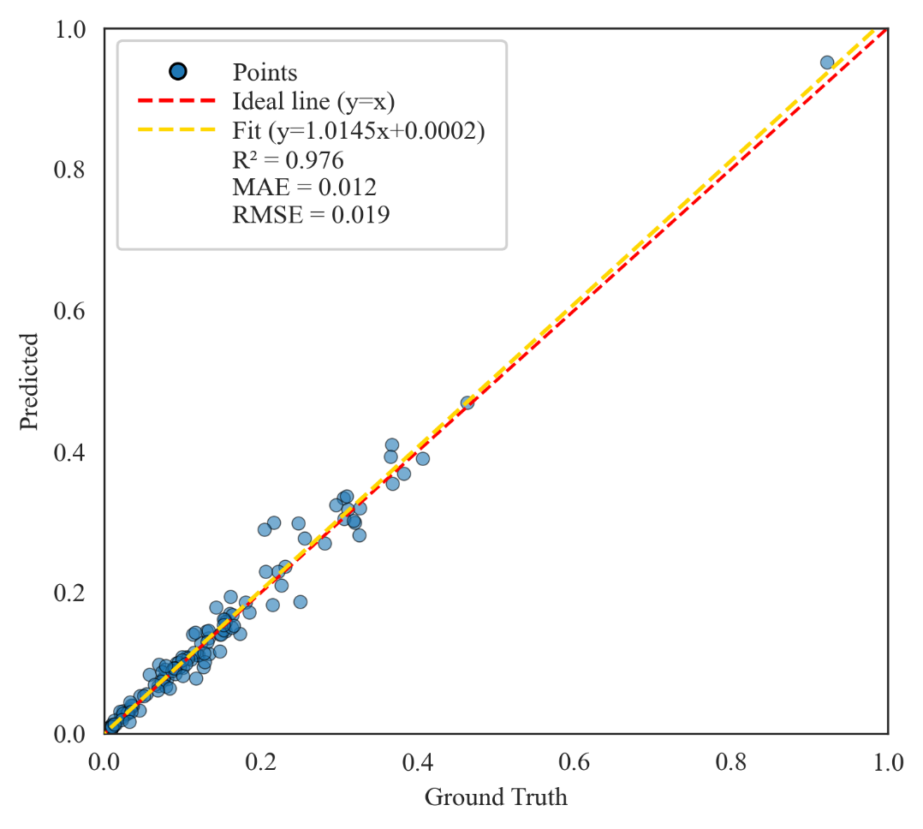
Fig. S1. Regression analysis of disease severity predicted by the proposed SimEffB0-RepUNet model against the ground truth values. The x-axis represents the ground truth, while the y-axis denotes the predicted values. Each scatter point reflects the deviation between the predicted result and the actual label for an individual sample.
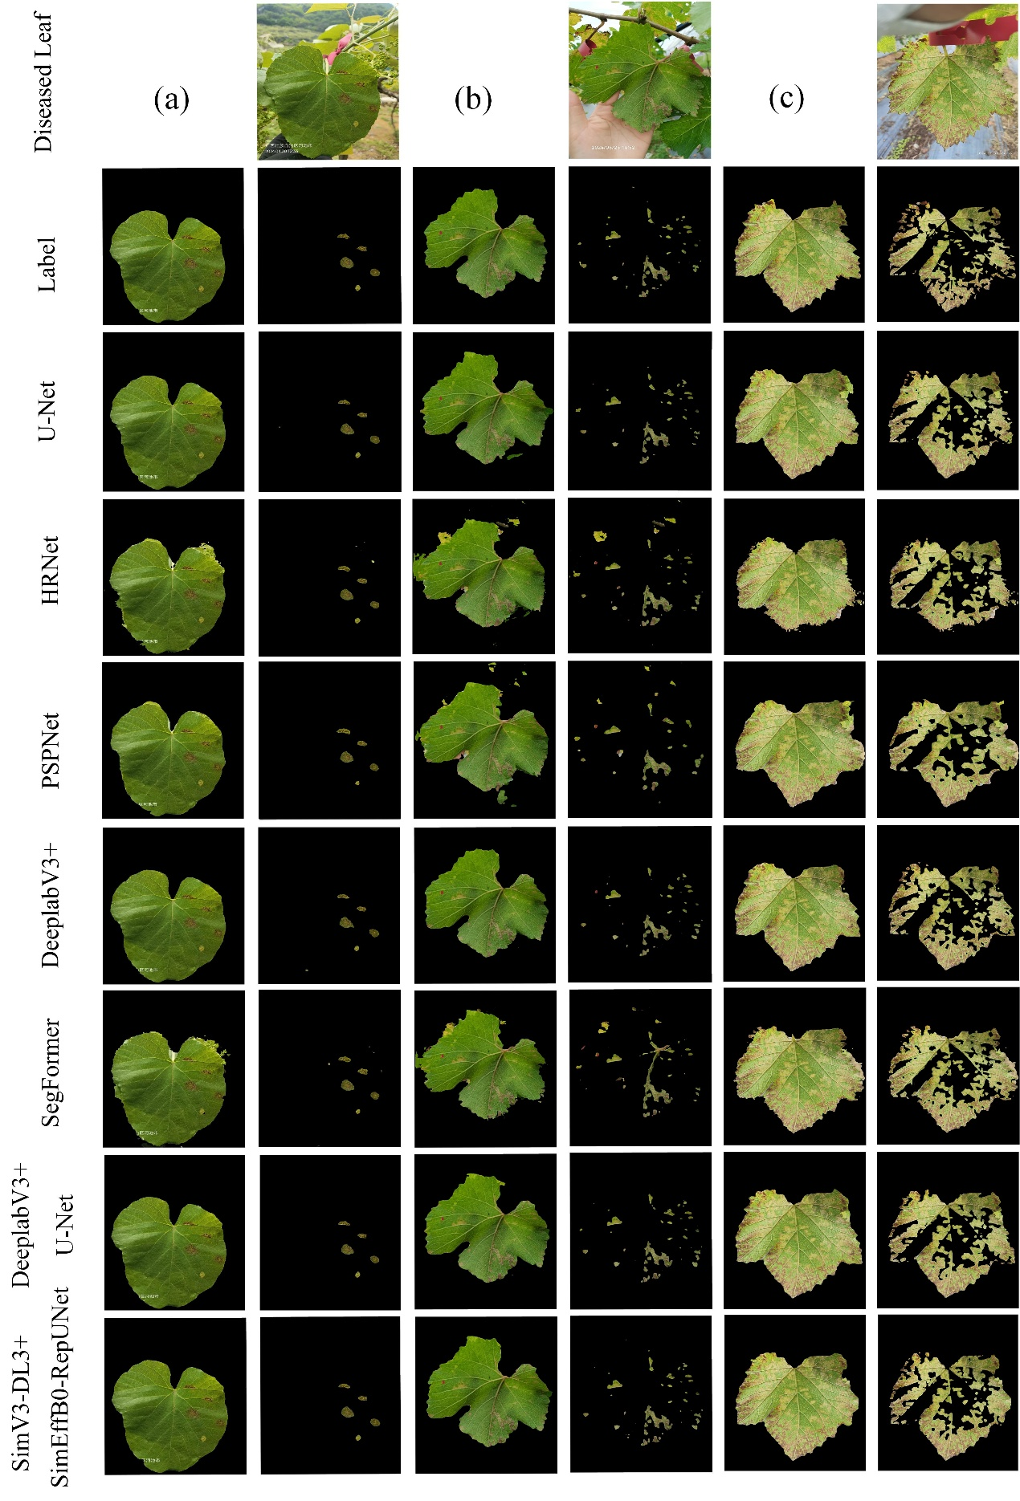
Fig. S2. The actual segmentation results on three images generated by the five single-stage models and the dual-stage models, including U-Net, HRNet, PSPNet, DeepLabV3+, SegFormer, DeepLabV3+U-Net, and SimV3-DL3+SimEffB0-RepUNet.
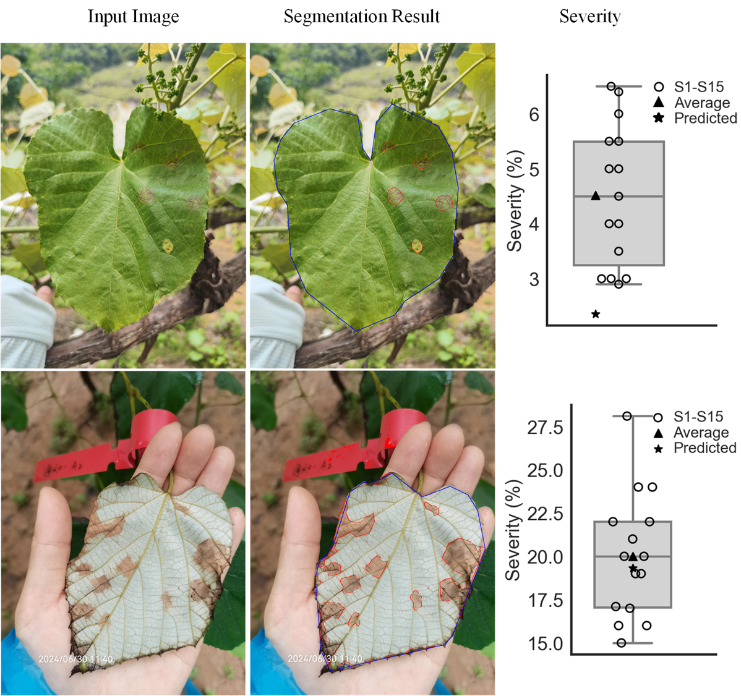
Fig. S3. Illustrative comparison of predicted severity with expert visual estimates, where S1–S15 represent the expert visual estimate, average for the average value of the total 15 expert estimates, and predicted for predicted severity with our model.
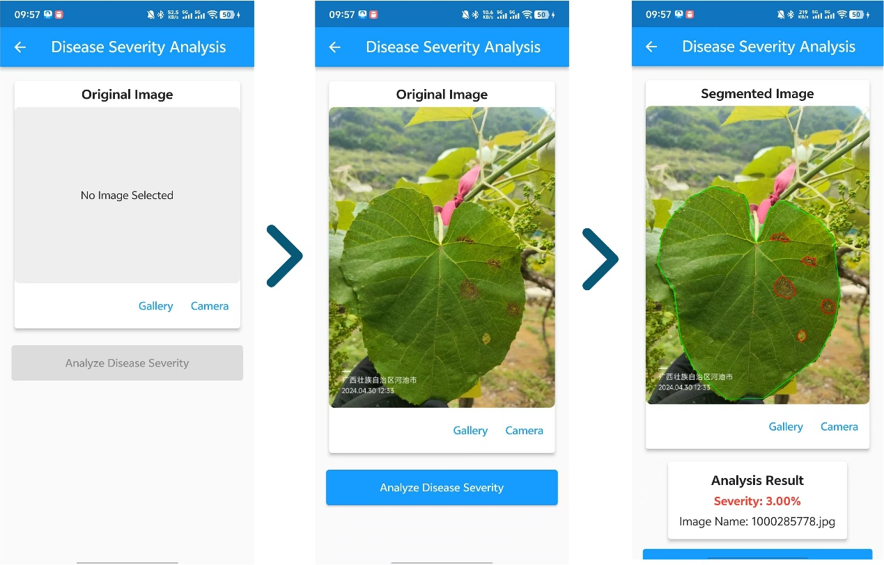
Fig. S4. The mobile application and its pipeline for leaf disease severity estimation.

