Irrigation strategies under contrasting water-storage and rainfall conditions in the North China Plain
Linjia Yao^{1,†}, Bin Chen^{2,†}, Hao Feng², Qiang Yu^{2,*}, Gang Zhao^{2,*}
¹ College of Natural Resources and Environment, Northwest A&F University, Yangling 712100, China
² State Key Laboratory of Soil and Water Conservation and Desertification Control, College of Soil and Water Conservation Science and Engineering, Northwest A&F University, Yangling, Shaanxi 712100, China
† Linjia Yao and Bin Chen contributed equally to this work and share first authorship.
* Corresponding authors: Qiang Yu (yuq@nwafu.edu.cn) and Gang Zhao (gang.zhao@nwafu.edu.cn).

Cover letter
Dear Editor,
Please consider the research article “Irrigation strategies under contrasting water-storage and rainfall conditions in the North China Plain” for publication in Agricultural Water Management.
Reducing irrigation while sustaining grain production requires balancing water consumption and the distribution of production losses. Using a process-based crop model, the study compares uniform and spatially targeted irrigation under equal water budgets and tests whether satellite water-storage information improves rainfall-based irrigation decisions.
At the same 50% irrigation reduction, targeting retained 4.87% more simulated grain than uniform cuts, but increased evapotranspiration and reduced grain production in some locations. Adding regional storage information did not change irrigation quotas or outcomes relative to matched rainfall-only strategies within the tested design.
These model-based findings support irrigation strategies that combine production goals with limits on consumptive use and safeguards for local production. Their focus on irrigation allocation and crop water use makes the study well suited to Agricultural Water Management.
Thank you for considering this manuscript.
Sincerely,
Qiang Yu and Gang Zhao
State Key Laboratory of Soil and Water Conservation and Desertification Control, College of Soil and Water Conservation Science and Engineering, Northwest A&F University, Yangling, Shaanxi 712100, China
yuq@nwafu.edu.cn; gang.zhao@nwafu.edu.cn

Highlights
- Targeting retained 0.732 t ha⁻¹ yr⁻¹ more dry grain than uniform 50% cuts.
- The same irrigation budget produced 20.76 mm yr⁻¹ more simulated ET.
- At 50% cuts, mean grain was below uniform allocation on 37.60% of the area.
- Over nine GRACE years, grain retention was 96.27% (95% target) and 99.63% (98%).
- Matched rainfall-only controls differed in grain production by 0% at both targets.

Manuscript

Abstract
Efficient irrigation allocation is essential for sustaining grain production while limiting water consumption in the North China Plain wheat–maize rotation. How spatial targeting redistributes production losses, and whether regional water-storage information improves rainfall-based irrigation decisions, remain unresolved. Continuous process-based crop simulations compared uniform and targeted allocations under equal irrigation budgets and evaluated annual storage–rainfall strategies against matched rainfall-only controls during 2014–2025. Growth parameters were fitted to multisite observations; water-use parameters were calibrated against Wuqiao treatments in 2016–2018 and retrospectively tested in 2019. At a 50% irrigation reduction, targeting retained 0.73 t ha⁻¹ yr⁻¹ more simulated combined dry grain than uniform cuts across 9.87 million rotation hectares, equivalent to 7.22 million t yr⁻¹ or 4.87% of uniform production. Mean production was lower than under uniform cuts on 37.60% of mapped area, while crop-plus-fallow evapotranspiration increased by 20.76 mm yr⁻¹ (2.05 km³ yr⁻¹). Across nine years with eligible Gravity Recovery and Climate Experiment (GRACE) observations, strategies selected at 95% and 98% grain targets retained 96.27% and 99.63% of conventional production, respectively. The 95% strategy reduced irrigation by 130.72 mm and evapotranspiration by 36.84 mm per rotation. Matched storage–rainfall and rainfall-only strategies selected identical quotas and produced identical outcomes. These conditional results support joint production and consumptive-use constraints and local production safeguards, while showing that additional storage information provides no decision benefit within the tested quota design.

Keywords
winter wheat–summer maize rotation; irrigation management; crop modeling; GRACE; water availability; consumptive water use

1. Introduction
Irrigation management in the North China Plain must reconcile grain production with water-resource constraints across the winter wheat–summer maize rotation (Yang et al., 2022). Wheat grows through a relatively dry season, whereas maize receives more summer rainfall; soil-water reserves connect their responses to irrigation (Yang et al., 2024). Long-term well-watered observations show that rising grain yield has accompanied increasing actual evapotranspiration (ET), despite comparatively stable reference ET (Zhang et al., 2011). Maintaining production with less irrigation therefore requires attention to both the water delivered to fields and the water consumed over the complete rotation.
The timing and location of irrigation supply determine its marginal production return. A sixteen-year experiment in 2003–2018 compared seven wheat–maize irrigation schedules and found diminishing production gains as irrigation increased (Yang et al., 2022). A four-year Wuqiao experiment also showed that precipitation conditions influenced the preferred wheat schedule and grain production in the subsequent maize crop (Yang et al., 2024). These responses reflect the sequence of crop demand, rainfall and soil-water carry-over across both seasons (Yang et al., 2024; Yang et al., 2022). At regional scale, irrigation requirements vary among locations and hydrological years (Ren et al., 2022; Wu et al., 2019). Crop-model optimization and irrigation-allocation studies provide approaches for using this heterogeneity to guide management (Jiang et al., 2016; Xiao et al., 2024). Under a common water budget, targeting locations with larger marginal grain returns can improve regional production retention, while changing the distribution of production losses.
Assessing these allocation consequences requires consistent crop and water accounting. Field delivery, ET, return flows and storage changes describe different quantities, so a reduction in irrigation does not directly establish an equivalent reduction in consumption (Grafton et al., 2018; Perry et al., 2009). Process-based applications of APSIM and RZ-SHAW in the North China Plain connect crop production with water productivity, field water balance and ET (Chen et al., 2010; Fang et al., 2014). However, transpiration formulation remains a major source of variation in simulated wheat water use (Cammarano et al., 2016). Phenology, canopy, biomass, grain and ET observations therefore constrain complementary processes, while documented irrigation treatments assess their combined response to water supply. Continuous simulation retains the soil-water carry-over needed to compare complete rotation histories.
Spatial allocation determines where irrigation is supplied, while antecedent hydrological conditions can inform the annual irrigation budget. Recent rainfall describes water input at the crop-system scale, whereas GRACE total water storage integrates several terrestrial stores over a regional footprint (Save et al., 2016; Scanlon et al., 2016). Recent aquifer recovery under water transfers, abstraction management and changing climate illustrates the broader context of regional storage variation (Long et al., 2025; Xu et al., 2026). Storage information may thus characterize conditions beyond local rainfall. Its practical value for irrigation nevertheless depends on whether it changes the selected action or improves the resulting grain–water outcome relative to rainfall-based decisions.
Two connected management questions remain unresolved. First, it is unclear how much grain spatial targeting can retain under an identical irrigation budget, and what consumptive-water costs and persistent local production losses accompany that regional benefit. Rotation-wide accounting must retain soil-water carry-over to assess these outcomes together. Second, the additional decision value of regional storage information beyond antecedent rainfall remains uncertain. A storage indicator can distinguish hydrological conditions without changing an irrigation choice. Comparisons using the same production targets, candidate quotas and monitoring availability are needed to isolate its contribution to management outcomes.
The objectives were to (i) quantify rotation grain production, crop-plus-fallow ET and profile drainage under uniform and spatially targeted irrigation allocations with common regional water budgets; (ii) characterize the spatial distribution, magnitude and annual persistence of allocation-related grain gains and losses; and (iii) assess whether antecedent regional storage information changes annual irrigation quotas and grain–water outcomes relative to rainfall-only controls under matched selection and monitoring conditions. Continuous Open Crop Model simulations of the North China Plain wheat–maize rotation, parameterized using multisite crop observations and documented irrigation treatments, provide the basis for these conditional comparisons during 2014–2025.

2. Materials and methods

2.1. Overall workflow
The framework connects crop-response estimation with spatial allocation and annual irrigation-quota selection (Figure 1). Multisite crop observations support growth-parameter estimates, while documented Wuqiao treatments in 2016–2018 constrain eight water coefficients per crop. Wuqiao 2019 provides retrospective testing; station observations characterize transfer under the recorded management and initialization. Observation coverage and the distinct estimation and evaluation partitions are summarized in Figure 3. Daily weather, mapped rotation area and layered soil profiles define 32 regional representatives.
The same crop and water parameters drive continuous crop and fallow histories under five irrigation levels. Spatial allocations selected from 1997–2013 responses share identical regional delivery budgets with uniform reductions. Annual storage–rainfall and rainfall-only strategies are selected from matched 2003–2013 responses and compared with common monitoring availability. Grain production, field irrigation, crop-plus-fallow ET and profile drainage are evaluated during 2014–2025.
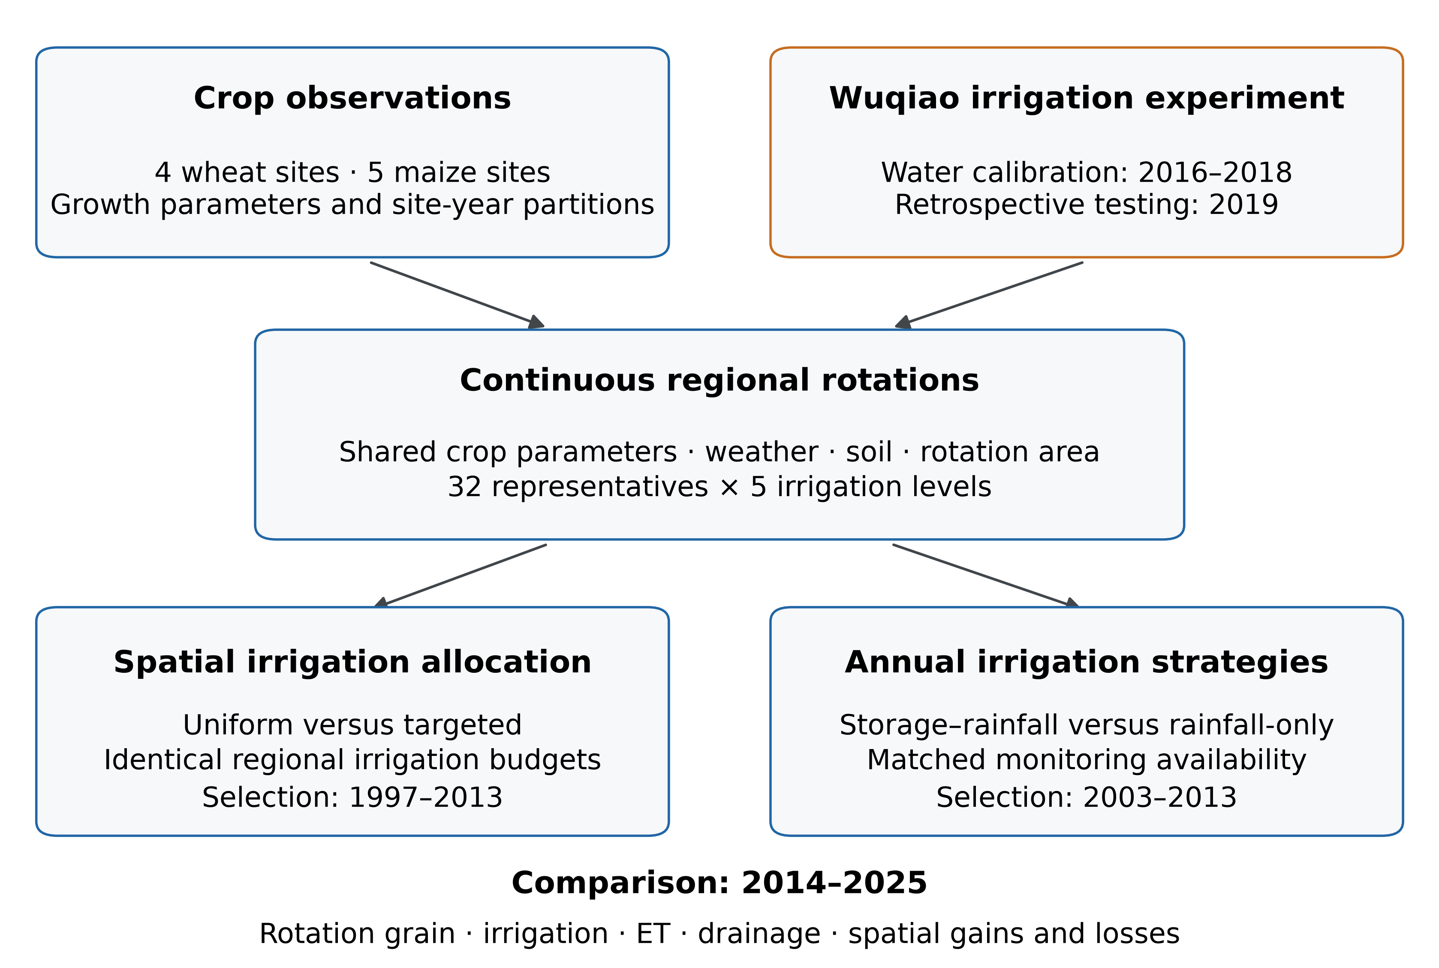
Figure 1. Study workflow. Multisite observations support growth parameters, while documented Wuqiao treatments calibrate water-use parameters and provide retrospective testing. Shared parameters drive continuous regional rotations. Spatial allocation compares uniform and targeted irrigation under identical budgets; annual strategies compare storage–rainfall and rainfall-only selection under matched monitoring availability. Outcomes cover 2014–2025.

2.2. Study area
The study area covers the winter-wheat–summer-maize lowlands of the North China Plain within 112–121.5°E and 32–41°N, including the Beijing–Tianjin–Hebei sector and the Henan–Anhui–Jiangsu lowlands (Figure 2). Catchment screening, elevation ≤200 m and slope ≤2° define a connected lowland area of 404,658 km². Terrain was represented at 0.01° resolution using resampled SRTM elevation and derived slope (NASA JPL, 2013). The boundary is a reproducible agricultural study-area definition; geographical and terrain-threshold sensitivities are reported in Supplementary Section S3.
The 2020 ChinaCP winter-wheat–summer-maize class was corrected by the corresponding CPM cropland percentage to reduce full-pixel area inflation (Qiu et al., 2022). The resulting rotation footprint was 9,866,733 ha before soil exclusions. Three cells with wholly missing soil profiles, totaling 131 ha, were excluded, leaving 9,866,602 ha in 3,641 AgERA5 cells. A fixed 2020 footprint applies to all climate years, so modeled totals describe climatic and management responses over a common area rather than historical production trends. The 2015–2021 area series, terrain-threshold alternatives and a common-extent comparison with CCD2020 quantify mapping and boundary sensitivity in the supplementary material.
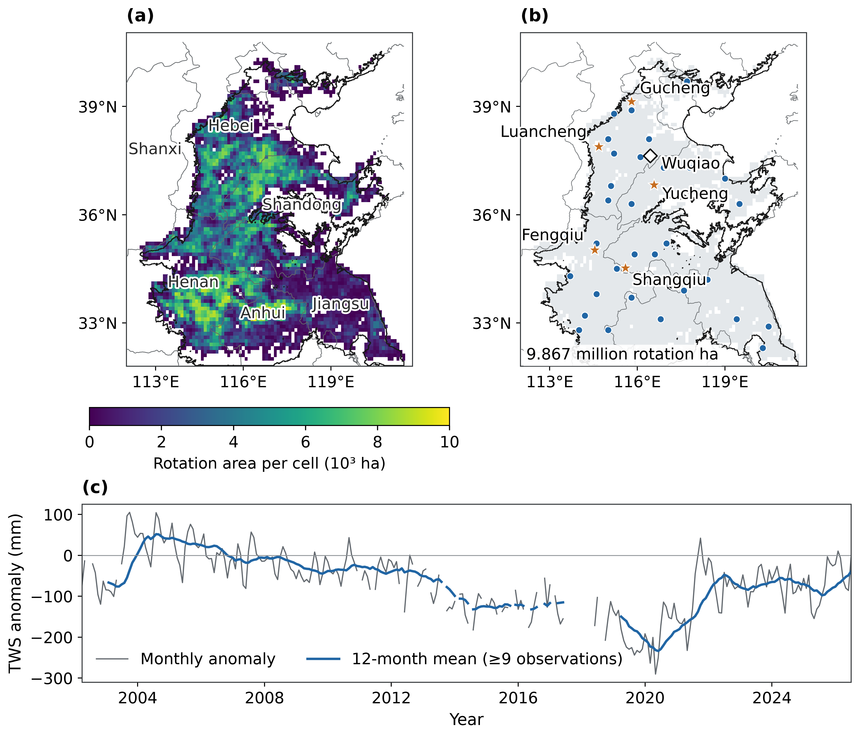
Figure 2. Study domain, rotation area, observation sites and regional water storage. (a) Mapped 2020 wheat–maize rotation area. (b) Five crop-observation sites, the Wuqiao irrigation experiment and 32 regional simulation units. (c) Observed CSR monthly terrestrial-water-storage anomalies and a 12-calendar-month mean requiring at least nine observations. Missing months remain gaps. Thin grey lines show provincial boundaries; black outlines delimit the operational physiographic study domain. Maps use an equirectangular projection (36°N, 117°E). Provincial boundaries: Natural Earth Admin 1 v5.1.1 (Natural Earth, n.d.).

2.3. Field observations and environmental data

2.3.1. Multisite crop observations
Winter-wheat and summer-maize observations were assembled from the National Ecosystem Science Data Center and linked archives at Fengqiu, Gucheng, Luancheng, Shangqiu and Yucheng. The sources contain long-term crop monitoring and the Gucheng maize sowing-date experiment. Archived crop-season groups span 2004–2008 at Fengqiu and Luancheng, 2018–2020 at Gucheng, 2001–2007 at Shangqiu and 1998–2022 at Yucheng. Coverage is intermittent; exact crop-by-site years and dataset identifiers are listed in Tables S1 and S2.
The archive retains 132 crop–plot–season trajectories in 71 original calibration and 61 retrospective-evaluation cases (Figure 3). Quality-controlled targets occur in 127 cases. The 7,397 scored records comprise 795 LAI measurements, 543 in-season aboveground-biomass measurements, 5,675 daily ET measurements, 192 grain-yield samples and 192 harvest-biomass samples (Table 1). Daily ET is available at Fengqiu and Yucheng; grain and harvest-biomass samples are confined to Yucheng. Six quadrats within a crop-year characterize sampling variation rather than six independent growing seasons.
Observations and predictions share recorded sampling dates or documented averaging windows. Stage-indexed Gucheng LAI measurements use the corresponding observed stage dates as sampling coordinates; those dates do not prescribe simulated development. Fengqiu ET identifies the lysimeter observation plot. Yucheng ET retains the measurement definitions of its source archive. Provider grain and aboveground dry masses in g m⁻² are multiplied by 10 to obtain kg ha⁻¹.
Eligibility requires valid dates, compatible crop and plot identities, consistent stage sequences and documented quantity units. Wheat LAI above 7 m² m⁻² is excluded under the study-specific screening rule, with raw values and reasons preserved. The six-replicate maize harvest vectors in Yucheng 2012 and 2017 are identical despite different dates and cultivar labels. Both groups remain excluded because their source authenticity is unresolved; 12 samples account for 24 grain and harvest-biomass records. Other observations and all eligible sites remain available.
Complete irrigation histories matched to station plots remain unconfirmed. Station growth and ET consequently supply conditional transfer comparisons; no station observation enters the current water-parameter objective. Twenty-six Fengqiu cases retain complete 0–1.5 m moisture profiles from the preceding calendar month: 11 in the original calibration partition and 15 in retrospective evaluation. Volumetric percentages from fifteen 100-mm source layers are conservatively remapped to the model layers without depth extrapolation or clipping. Their monthly timing and subplot support do not establish a measured sowing-day state. Cases without an eligible profile retain their archived initialization.
Table 1. Eligible station-observation records by site and variable.
Site | LAI | Biomass | Daily ET | Yield | Harvest biomass
Fengqiu | 159 | 163 | 962 | 0 | 0
Gucheng | 216 | 0 | 0 | 0 | 0
Luancheng | 123 | 165 | 0 | 0 | 0
Shangqiu | 114 | 148 | 0 | 0 | 0
Yucheng | 183 | 67 | 4713 | 192 | 192
Counts denote individual observations, not independent experiments. Station comparisons retain inherited growth-fitting history and unconfirmed complete management. Yucheng grain and harvest biomass contain six dry-matter samples per crop-year; the duplicated 2012 and 2017 maize groups remain excluded.

2.3.2. Field irrigation experiment
The Wuqiao experiment at 37.630°N, 116.444°E contains four wheat irrigation schedules, W0–W3, during the 2015–2019 rotation (Yang et al., 2024). Dated 75-mm events, sowing and harvest dates, nitrogen input of 158.4 kg ha⁻¹ per crop and treatment-specific initial total water storage in 2 m are retained. Maize irrigation is identical among treatments within each year: zero in 2016 and 2018, and 75 mm on 18 June in 2017 and 2019. Its W0–W3 labels therefore identify preceding wheat management. Seasonal initial water distribution among layers is assumed. Field capacity, wilting point and bulk density are transferred from the published Luancheng profile, with its bottom 10 cm extrapolated (Sun et al., 2006). Conductivity follows a separate SoilGrids–Saxton–Rawls prior (ISRIC — World Soil Information, 2020; Saxton and Rawls, 2006); the particle-density prior is 2.75 g cm⁻³.
Published seasonal ET equals rainfall plus irrigation plus depletion of 0–2 m storage, with runoff and drainage treated as negligible (Yang et al., 2024). The model represents both outflows. The 2016 maize balance uses 499.1 mm of maize-season rainfall; the 599.6-mm rotation total also contains 100.5 mm during wheat. This period reconciliation reproduces the four printed maize ET values within 0.9 mm of rounding, and all 32 crop–treatment–season ET targets remain eligible. Simulations retain their exact archived weather forcing. Wheat crop-start storage follows the pre-sowing simulation, whereas maize is independently initialized from observed treatment-specific total storage. Reported wheat-straw mulch has no measured cover fraction, so the maize simulations retain the exposed-soil evaporation boundary (Yang et al., 2024).
Harvest aboveground biomass includes grain and residues cut at ground level and oven-dried to constant mass. Its dry-matter basis requires no moisture adjustment. Published grain yields are standardized to 13% moisture (Yang et al., 2024). Annual 2016–2019 means and standard errors are digitized from the source Supplementary Figure S2 and reconciled with its eight printed four-year means. Pixel tolerances are approximately 0.043 t ha⁻¹ for wheat and 0.056 t ha⁻¹ for maize. Observed grain is multiplied by 0.87 for dry-matter fitting; model dry grain is divided by 0.87 for comparisons reported at 13% moisture. Annual and four-year means overlap and do not provide separate independent observations.
The 2016–2018 harvest years contribute 12 treatment seasons per crop to the water fit, with seasonal ET, dry grain, dry aboveground biomass and annual W3−W0 ET contrasts as targets. The four 2019 treatment means per crop are excluded from fitting and parameter selection. Their prior inspection during model development makes this test retrospective (Figure 3).

2.3.3. Meteorological, soil and spatial data
Daily AgERA5 v2.0 weather data for 1996–2025 supplied minimum and maximum air temperature, precipitation, solar radiation, reference evapotranspiration, vapor pressure and 10-m wind speed (Copernicus Climate Change Service, 2020). Reference evapotranspiration (${ET}_{0}$) entered the water-balance module directly.
Native 250 m SoilGrids v2.0 maps of texture, bulk density, organic carbon and coarse fragments were averaged to 0.01°, then aggregated over mapped rotation pixels within 0.1° meteorological cells, for six depth intervals between 0 and 2 m (ISRIC — World Soil Information, 2020). Hydraulic properties were derived using Saxton–Rawls equations with bulk-density and gravel adjustments (Saxton and Rawls, 2006). Organic matter was approximated using an assumed organic-matter/organic-carbon ratio of 1.724, and air-dry water content was assumed to equal half the wilting-point value. Hydraulic derivation is detailed in Supplementary Section S2.
The 2020 ChinaCP wheat–maize class and its CPM cropland fractions defined rotation-area weights (Qiu et al., 2022). SRTM elevation supported the terrain screen and slope calculation (NASA JPL, 2013). Regional aggregation retained the common 0.1° meteorological grid and the study-area definition in Section 2.2.

2.3.4. Terrestrial-water-storage observations
CSR RL06.3 monthly GRACE/GRACE-FO total-water-storage anomalies were aggregated using physical cell areas and the official CSR land mask (Save, 2020; Save et al., 2016). The land-mask overlap covers 395,969 km² within the 404,658-km² study area; excluded coastal supports account for 2.15% of its area. The archive contains 259 observed monthly solutions from April 2002 to July 2026 relative to the 2004–2009 mean. Source values in centimeters were converted to millimeters, and missing months remain missing. A 12-calendar-month moving mean requires at least nine observations. The 0.25° product grid is finer than the effective GRACE observation scale, so one regional storage indicator is shared across all simulation units (Save, 2020; Save et al., 2016). Soil, surface and other stores were not subtracted; the indicator represents total water storage rather than groundwater alone.
The corresponding aggregation without the CSR land mask is retained as a sensitivity analysis. Regional storage changes provide hydrological context for water-management pressures, with no causal attribution to particular irrigation treatments, water transfers or groundwater regulations (Long et al., 2025; Long et al., 2020).

2.4. Crop model description
Open Crop Model (OCM) couples crop growth and a layered soil-water balance at a daily time step. Wheat development combines temperature, vernalization and photoperiod responses; maize development follows thermal time. Development stage (DVS) is anchored at emergence, flowering and maturity. Germination begins when water above the wilting-point storage is available in the represented layer containing the seed; subsequent thermal development starts from that date. Stage coefficients remain fixed, while the soil-water state can alter establishment timing. Recorded or prescribed harvest dates define the management endpoint separately. Soil-water storage passes continuously through crops and fallows.
Canopy interception of radiation follows Beer–Lambert attenuation. Aboveground production depends on intercepted PAR, crop-specific RUE, temperature, prescribed nutrition and an empirical power response to realized transpiration supply. PAR is 0.45 of incident shortwave radiation (Kiniry et al., 1989). Stage-specific SLA determines new leaf area, while established cohorts retain their birth area-to-mass ratio (de Wit and Berghuijs, n.d.). Stage-dependent thermal senescence and a separate daily stress-loss fraction determine leaf survival (Tan et al., 2020). LAI emerges from these carbon and area balances without a maximum-LAI parameter. Simulated biomass at wheat flowering or maize silking determines grain number; fixed individual grain mass defines sink capacity, and assimilate supply and wheat stem reserves constrain grain filling.
The water balance represents interception, ponding, infiltration, evaporation, root uptake, runoff and bottom drainage. Atmospheric demands are partitioned from reference ET using canopy cover and effective transpiration and evaporation coefficients. Soil evaporation follows a storage-based two-stage reduction (Allen et al., 1998). Root uptake depends on rooted-layer water, local depletion stress and a bounded compensation fraction that redirects unmet demand toward better-supplied rooted layers. Vertical transport uses van Genuchten–Mualem hydraulic functions (Mualem, 1976; van Genuchten, 1980), signed gravity–matric gradients and conservative storage bounds. Relative-arithmetic interface mobility and adaptive internal steps permit wetting and redistribution within 24 daily outer steps. The lower boundary is free drainage with no capillary-rise supply. This explicit layered approximation differs from a full implicit Richards-equation solution. Profile depths follow the supplied inputs, including 2 m for Wuqiao and regional simulations.

2.5. Model parameterization, calibration and evaluation
Phenological coefficients, stage-specific specific leaf area and senescence, initial LAI, stem-reserve coefficients and nutrition modifiers follow the crop parameterization described in Section S2. RUE, leaf allocation and grain-number parameters were estimated from 480 wheat and 433 maize growth and harvest observations across four wheat sites and five maize sites. Whole site-years retain their original partitions, with balanced contributions from variables, sites, site-years and crop cases. Station simulations retain their recorded site and cultivar parameterization; Wuqiao and regional simulations use the shared crop parameters (Table S3). Individual grain masses are fixed at 0.045 g for wheat and 0.300 g for maize (APSIM Initiative, 2026).
Eight water-use parameters per crop are fitted to the documented Wuqiao treatments in 2016–2018: the transpiration coefficient, soil evaporation coefficient, readily available water fraction, assimilation water-stress exponent, root-density decay, maximum rooting depth, root water-uptake coefficient and root compensation fraction. Each crop contributes 12 seasonal ET, 12 dry-grain and 12 dry-biomass targets, with three annual W3−W0 ET contrasts derived from the same treatment seasons. RUE, leaf allocation and grain-number parameters remain fixed. Bounded least squares combines scaled observation residuals and weak parameter priors; objective weights, bounds and convergence settings are specified in Section S2.4.
The fitted water parameters are fixed before comparison with the four 2019 treatment means per crop. Previous inspection of these outcomes makes the test retrospective. Station observations have zero weight in this water fit and assess transfer under unconfirmed complete irrigation histories. Regional strategy selection uses historical weather responses; the crop-calibration years overlap the 2014–2025 regional comparison period, so those outcomes are conditional scenarios rather than time-independent crop validation. Observed and simulated quantities retain matched sampling windows and grain-moisture bases.
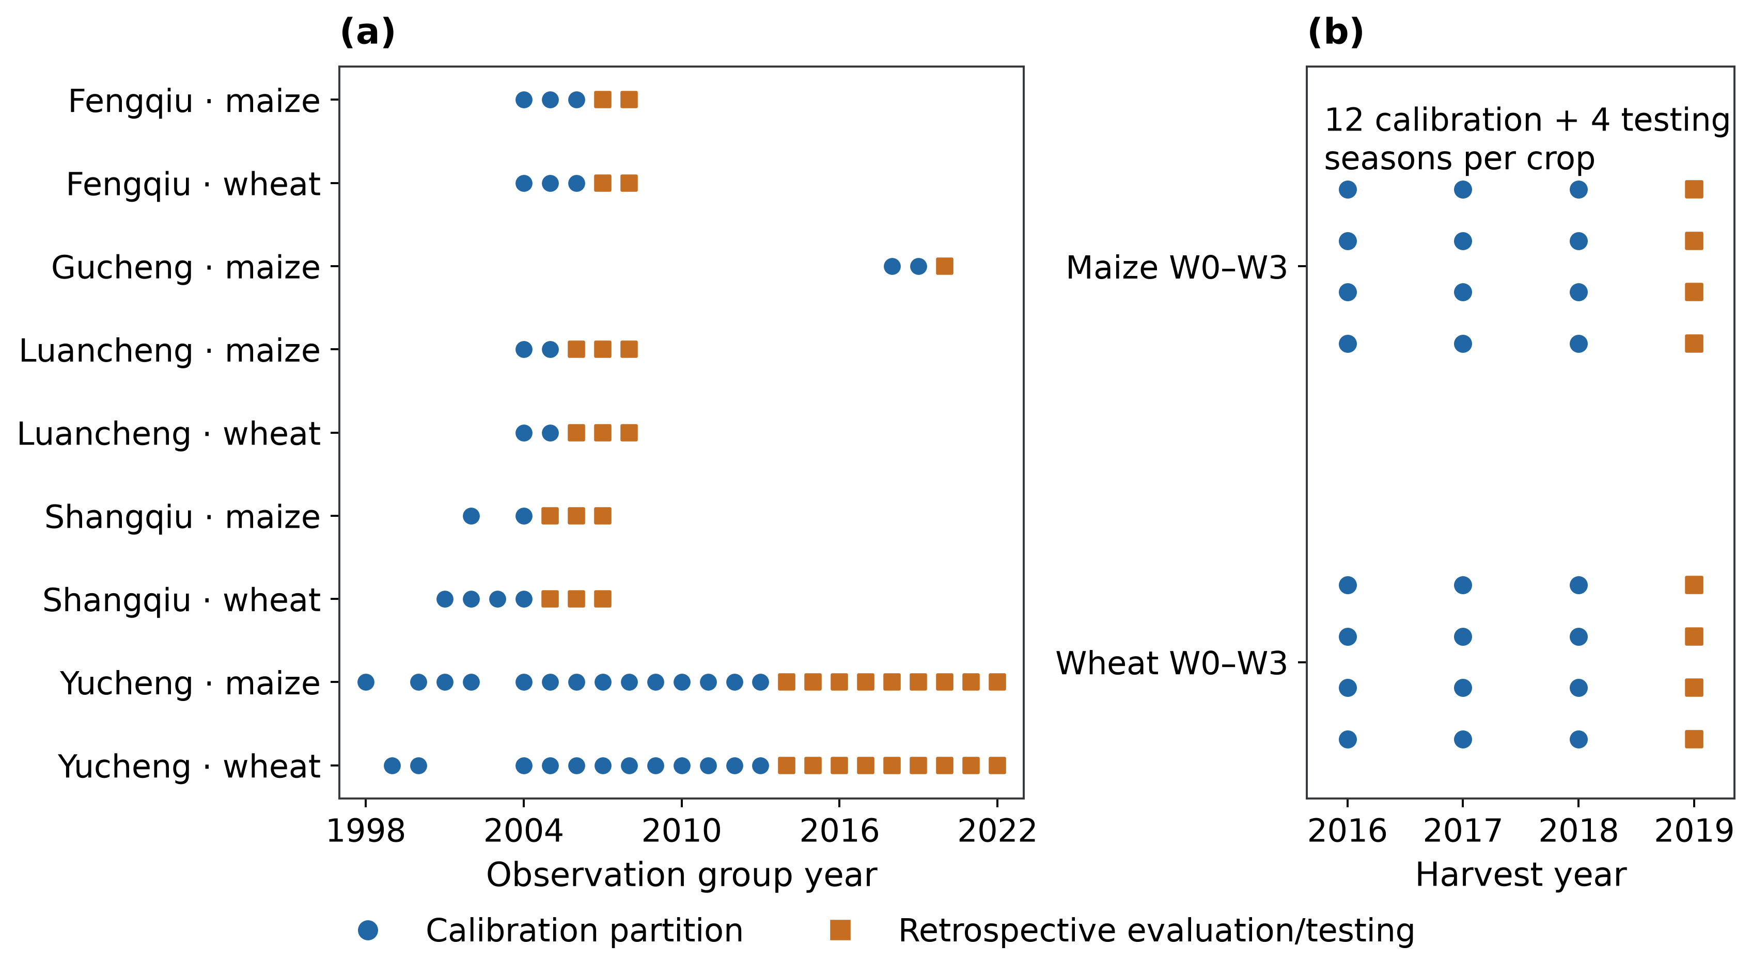
Figure 3. Evidence partitions. (a) Whole station site-years retain their original calibration and retrospective-evaluation partitions; dates denote observation-group years. All five eligible sites are included. (b) Four Wuqiao treatment means per crop-year provide 12 calibration seasons in 2016–2018 and four retrospective testing seasons in 2019. Station comparisons retain earlier growth-fitting history and unconfirmed complete irrigation management.

2.6. Regional upscaling and irrigation scenarios
Thirty-two area-weighted climate–soil representatives were selected from actual source cells using deterministic clustering of latitude, longitude, plant-available water, and 1997–2013 mean precipitation and reference ET. Features were standardized with rotation-area weights. Each cluster uses the actual cell nearest its centroid; the full source-cell mapping and represented areas are retained. Climate years used for policy evaluation do not enter the climate features used for selection. Shared crop parameter sets are transferred regionally without extrapolating site-specific adjustments.
Each representative has five continuous histories at irrigation fractions 0, 0.25, 0.50, 0.75 and 1.00. The conventional wheat schedule is 60 mm at sowing on 12 October, 90 mm on 25 March, 90 mm on 15 April and 60 mm on 10 May, totaling 300 mm. Maize receives 80 mm at sowing on 15 June. These common schedules are declared scenarios and are not observed universal practice across the plain. Every event amount is multiplied by the irrigation fraction, with its timing fixed. Wheat is simulated through 10 June and maize through 5 October; intervening fallows carry the soil state forward. Initial plant-available water is 80% at the start of the 1996 spin-up, with no subsequent seasonal storage reset. All crop and fallow ET, drainage and runoff are included. The final 2025 cycle ends on 5 October because the next fallow lies outside the declared endpoint. Nutrition is represented by prescribed fertilized-crop modifiers; nitrogen cycling and spatially varying nutrient limitations are not dynamically simulated.
Eight purposively selected non-representative cells provide paired spatial aggregation checks under all five irrigation fractions. Two cells from each latitude quartile have the largest area-times-feature-distance score. Actual-cell weather and profiles use the same continuous model and crop parameters. Their differences from representative-cell predictions measure crop-model aggregation error rather than field-observation accuracy (Supplementary Section S3).

2.7. Irrigation strategies and comparisons

2.7.1. Spatial allocation under common irrigation budgets
Uniform allocation assigns the same irrigation fraction to every represented hectare. Targeted allocation chooses area shares $x_{jk}$ for representative j and simulated irrigation fraction k by linear programming. The objective maximizes $\sum_{j}{A_{j}\sum_{k}{x_{jk}{\overset{¯}{Y}}_{jk}}}$, where ${\overset{¯}{Y}}_{jk}$ is mean annual wheat-plus-maize grain in 1997–2013. Constraints require $\sum_{k}{x_{jk}=1}$, $0≤x_{jk}≤1$ and $\sum_{j}{A_{j}\sum_{k}{x_{jk}I_{k}=(1−r)\sum_{j}{A_{j}I_{1}}}}$, with reductions $r=0.25$, 0.50 or 0.75. Within-representative mixtures describe shares of area receiving actual simulated irrigation treatments; crop responses are not interpolated between irrigation fractions. Allocations remain fixed in 2014–2025. Both policies deliver exactly the same total field-irrigation water in every year, so their differences reflect allocation under the same volume constraint.
Spatial contrasts at the common 50% irrigation cut use frozen shares of complete continuous irrigation histories. Their area-weighted grain, ET and drainage differences map from 32 representatives to 3,641 source cells. Fixed southern (32–36°N), central (36–38°N) and northern (38–41°N) bands summarize the distribution. Counts of positive annual contrasts describe consistency within the modeled record (Figure 7; Table S9).

2.7.2. Annual quotas based on antecedent water availability
Relative water-availability classes combine two antecedent indicators: regional total-water-storage status and local rainfall before wheat sowing. The storage indicator is the mean of available August and September GRACE observations in the calendar year preceding harvest, with at least one monthly solution required. Precipitation is accumulated from 1 July to 30 September at each simulation unit, covering 92 days before the prescribed 12 October wheat sowing. The corresponding precipitation/reference-ET ratio is retained as a diagnostic of climatic water availability. These antecedent indicators do not use rainfall or crop outcomes from the subsequent growing season.
Thresholds use 2003–2013 harvest years, the common selection period with antecedent GRACE coverage. The regional storage median is 13.38 mm, and the rotation-area-weighted precipitation median is 431.74 mm. Values below their respective thresholds define lower storage and lower rainfall; values at or above define higher storage and higher rainfall. Crossing the two indicators gives four hydroclimatic classes. The classes describe relative antecedent water availability, rather than absolute water scarcity derived from water demand, allocation rights or access. Spatial differences within a year arise from precipitation; GRACE does not supply independently resolved field-scale storage classes.
For each class, five continuous irrigation histories provide paired grain and ET responses relative to conventional irrigation, weighted by rotation area and year. The primary candidate is the lowest fraction retaining at least 95% of class-mean conventional grain in 2003–2013; a 98% target assesses a stricter production criterion. Selected fractions and class thresholds remain frozen in 2014–2025. Higher-storage classes have no evaluation exposure. Required GRACE observations are missing for 2014, 2018 and 2019.
Two annual strategies apply the irrigation fractions selected from fixed-fraction responses at grain-retention targets of 95% and 98%. At each simulation unit, the antecedent storage–rainfall class determines the fraction before wheat sowing. This fraction scales all four wheat applications and the subsequent maize application in the same rotation year. Application dates, crop parameters, weather, hydraulic profiles and the free-drainage lower boundary are identical to those in the fixed-fraction experiment. Conventional irrigation applies before 2003 and whenever an eligible storage class is unavailable, including evaluation harvest years 2014, 2018 and 2019.
Each strategy is simulated continuously from the 1996 spin-up through 2025. Soil-water states pass between crops and fallows and across annual changes in irrigation fraction. Conventional irrigation supplies the paired continuous reference; replays at two simulation units verify the scenario driver against conventional outputs. Class thresholds and irrigation fractions remain fixed after selection. Outcomes cover all twelve comparison years and, separately, the nine years with eligible classes. Production retention is the ratio of period-mean regional grain production to its corresponding conventional mean; annual ratios describe variation within the period. The strategies assume access to antecedent observation periods, while release availability of GRACE before sowing remains unverified.

2.7.3. Rainfall-only controls and matched monitoring coverage
Rainfall-only controls use the same 2003–2013 simulation-unit years with eligible GRACE observations, the same rotation-area weights, irrigation candidates and grain-retention targets. Selection groups responses by antecedent rainfall alone and chooses the lowest fraction meeting the relevant target. The rainfall threshold is identical to that in the joint classification. Matched controls receive conventional irrigation whenever the storage–rainfall strategy lacks an eligible class, preserving both the selection cohort and monitoring coverage. Continuous differences between these paired strategies consequently assess the incremental effect of storage-based grouping.
Separate rainfall-available controls apply the selected rainfall-only fractions whenever an eligible rainfall group exists, including years without GRACE coverage. Their complete histories assess the combined effect of rainfall-based management and greater monitoring availability. Irrigation changes in earlier gap years can alter the soil-water state of later crops, so these controls are reported separately from the matched comparison.

2.8. Evaluation metrics, spatial statistics and water accounting
Performance is summarized by RMSE, mean bias error, nRMSE relative to observed mean, Nash–Sutcliffe efficiency (NSE) (Nash and Sutcliffe, 1970) and squared Pearson correlation (R²). Station scores give equal weight to available sites, site-years within sites, crop cases within site-years and records within cases. Wuqiao treatment means receive equal weights within each crop and partition. Field calibration and retrospective testing remain separate. Grain and harvest biomass in station comparisons are dry matter; Wuqiao grain results retain the published 13% moisture basis, with a single 0.87 conversion between dry and reported grain. Biomass remains dry matter throughout.
Seasonal curves group matching observations and predictions into 15-day wheat and 7-day maize bins at observation-window midpoints in days after sowing. Case means receive equal weight within site-years, site-year means within sites and available sites within bins. Standard errors describe variation among contributing site-year means rather than model uncertainty. Site-specific curves use equal site-year weights. Coverage varies among bins, and gaps remain uninterpolated. Accuracy scores use unbinned records. Yucheng harvest error bars describe quadrat sampling variation within crop-years.
ET sums use identical observed and simulated measurement days within each case and retain the station balancing weights. They exclude unmeasured days and do not represent complete-season observed totals. Regional grain production uses dry mass and rotation-area weights; actual ET includes crops and fallows. Paired policy differences cover 2014–2025. Daily water and carbon residuals and continuity of carried soil-water storage assess numerical conservation. Field irrigation, ET, drainage below 2 m and groundwater storage have distinct accounting boundaries.
Spatial distribution statistics describe targeted-minus-uniform policy contrasts in mean annual combined wheat–maize dry grain and water fluxes over 2014–2025. The 3,641 mapped 0.1° source cells carry outcomes from 32 representative response units. Cell weights are the static 2020 mapped rotation areas after cropland-fraction correction; they represent mapped rotation area rather than observed harvested area. Gains and losses exceed +10⁻⁶ and fall below −10⁻⁶ kg ha⁻¹, respectively; contrasts within these bounds are classified as unchanged. Group means use rotation-area weights, regional contributions sum area multiplied by the corresponding contrast, and weighted quantiles use the inverse empirical cumulative area distribution. Annual loss frequencies use the same sign threshold across the 12 years. Connected loss footprints comprise occupied cells sharing a horizontal or vertical grid edge (rook adjacency). The statistics describe the conditional modeled allocation footprint; mapped cells do not provide independent replication or cell-specific validation.

3. Results

3.1. Conditional multisite crop comparisons
Retrospective-evaluation LAI RMSE was 1.843 m² m⁻² for wheat and 0.995 m² m⁻² for maize, with NSE of 0.184 and 0.689, respectively (Figure 4). LAI RMSE in the original calibration partition was 1.727 and 1.138 m² m⁻². In-season biomass RMSE in retrospective evaluation was 4.413 and 2.789 t ha⁻¹, with biases of +1.314 and +1.158 t ha⁻¹ and NSE of 0.349 and 0.796. Site-specific seasonal comparisons retain their available observations and original partitions (Figures S6–S11).
Dry-grain RMSE was 1.256 t ha⁻¹ for wheat and 1.402 t ha⁻¹ for maize in the original calibration partition, compared with 0.834 and 2.286 t ha⁻¹ in retrospective evaluation (Figure S5). Evaluation grain biases were +0.485 and -1.586 t ha⁻¹, and NSE was 0.099 and -1.566. Evaluation harvest-biomass RMSE was 2.736 t ha⁻¹ for wheat and 3.719 t ha⁻¹ for maize; the corresponding observation counts were 54 in nine wheat years and 48 in eight maize years.
Daily ET RMSE in retrospective evaluation was 1.809 mm d⁻¹ for wheat and 2.572 mm d⁻¹ for maize, with biases of +0.141 and -0.734 mm d⁻¹ and NSE of 0.121 and 0.012 (Figure 4). ET summed over matched measurement days had evaluation RMSE of 51.29 mm for wheat and 74.17 mm for maize, biases of +25.94 and −55.58 mm, and NSE of 0.826 and 0.118 (Table 2). These sums exclude days without ET measurements.
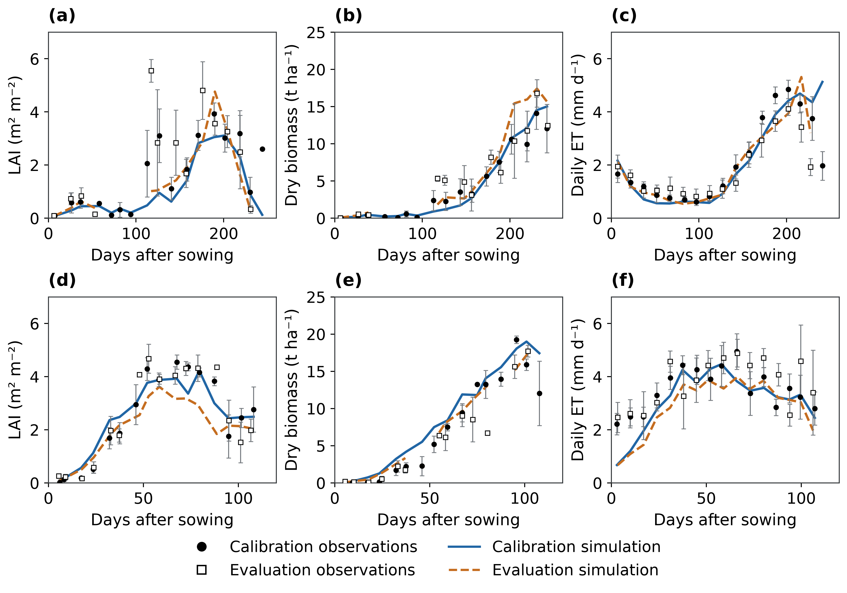
Figure 4. Multisite seasonal crop comparisons. Wheat and maize occupy the top and bottom rows; columns show LAI, aboveground dry biomass and daily actual ET. Filled and open observations distinguish the original calibration and retrospective-evaluation partitions; solid blue and dashed orange lines show the corresponding simulations. Error bars describe standard errors among site-year means. Balanced means use 15-day wheat and seven-day maize bins, and unobserved bins remain gaps. Accuracy scores use unbinned records. Complete station irrigation management remains unconfirmed.
Table 2. Conditional station ET sums on matched measurement days.
Crop | Dataset | Seasons | NSE | RMSE (mm) | MBE (mm)
Maize | Prior calibration partition | 11 | 0.511 | 45.60 | -34.92
Maize | Retrospective evaluation | 10 | 0.118 | 74.17 | -55.58
Wheat | Prior calibration partition | 11 | -0.300 | 84.94 | -23.53
Wheat | Retrospective evaluation | 11 | 0.826 | 51.29 | 25.94
Observed and simulated sums use identical measurement days within cases, with balanced site, site-year and case weights. Unmeasured days are excluded. Original calibration partitions retain an earlier growth-fitting history; evaluation is retrospective. Complete irrigation-log matching remains unconfirmed.

3.2. Wuqiao calibration and retrospective testing
Seasonal ET calibration RMSE was 40.19 mm for wheat and 37.44 mm for maize across 12 treatment seasons per crop, with biases of −12.65 and +3.60 mm and nRMSE of 8.97% and 12.69% (Table 3; Figure 5). Across the four 2019 testing means per crop, ET RMSE was 73.80 and 55.64 mm, bias was +48.93 and −35.90 mm, nRMSE was 21.98% and 14.13%, and NSE was 0.503 and −0.346, respectively.
At 13% grain moisture, calibration RMSE was 1.249 t ha⁻¹ for wheat and 2.267 t ha⁻¹ for maize; retrospective-testing RMSE was 3.161 and 1.700 t ha⁻¹. Testing grain biases were +3.108 and +1.403 t ha⁻¹, with nRMSE of 83.27% and 15.97% and NSE of −4.654 and −3.641 (Table 3; Figure 5). Dry aboveground-biomass RMSE was 4.222 and 4.688 t ha⁻¹ in calibration and 5.427 and 2.038 t ha⁻¹ in testing, respectively. Testing biomass nRMSE was 55.66% for wheat and 10.44% for maize.
W3−W0 seasonal ET-contrast RMSE was 45.79 mm for wheat and 66.84 mm for maize across three calibration years; the absolute 2019 contrast errors were 116.37 and 52.74 mm. For grain contrasts of W1–W3 relative to same-year W0, calibration RMSE was 0.519 and 1.669 t ha⁻¹ and retrospective-testing RMSE was 1.316 and 1.323 t ha⁻¹, respectively, at 13% moisture (Table S5; Figure S2). Maize treatment labels denote preceding wheat irrigation; maize irrigation was identical within each year.
Table 3. Wuqiao water calibration and retrospective testing.
Crop | Period | Target | n | Unit | RMSE | MBE | nRMSE (%) | NSE | R²
Maize | 2016–2018 | Seasonal ET | 12 | mm | 37.444 | 3.604 | 12.69 | 0.533 | 0.619
Maize | 2016–2018 | Grain | 12 | t ha⁻¹ | 2.267 | -1.738 | 18.78 | -2.940 | 0.128
Maize | 2016–2018 | Biomass | 12 | t ha⁻¹ | 4.688 | -4.188 | 21.79 | -5.625 | 0.073
Maize | 2019 | Seasonal ET | 4 | mm | 55.637 | -35.902 | 14.13 | -0.346 | 0.343
Maize | 2019 | Grain | 4 | t ha⁻¹ | 1.700 | 1.403 | 15.97 | -3.641 | 0.972
Maize | 2019 | Biomass | 4 | t ha⁻¹ | 2.038 | 0.726 | 10.44 | -0.313 | 0.123
Wheat | 2016–2018 | Seasonal ET | 12 | mm | 40.188 | -12.649 | 8.97 | 0.689 | 0.758
Wheat | 2016–2018 | Grain | 12 | t ha⁻¹ | 1.249 | -0.445 | 16.74 | 0.746 | 0.817
Wheat | 2016–2018 | Biomass | 12 | t ha⁻¹ | 4.222 | -2.480 | 25.48 | 0.496 | 0.781
Wheat | 2019 | Seasonal ET | 4 | mm | 73.805 | 48.929 | 21.98 | 0.503 | 0.915
Wheat | 2019 | Grain | 4 | t ha⁻¹ | 3.161 | 3.108 | 83.27 | -4.654 | 0.870
Wheat | 2019 | Biomass | 4 | t ha⁻¹ | 5.427 | 4.908 | 55.66 | -0.752 | 0.924
Calibration uses 12 treatment seasons per crop in 2016–2018; retrospective testing uses four in 2019. Counts are treatment means rather than independent replicate seasons. ET is a 0–2 m water-balance estimate under negligible runoff and drainage assumptions. Grain is at 13% moisture and aboveground biomass is dry matter. Annual grain means and SE are digitized from source Supplementary Figure S2. Initial total storage is observed; layer distribution and transferred hydraulics remain conditional.
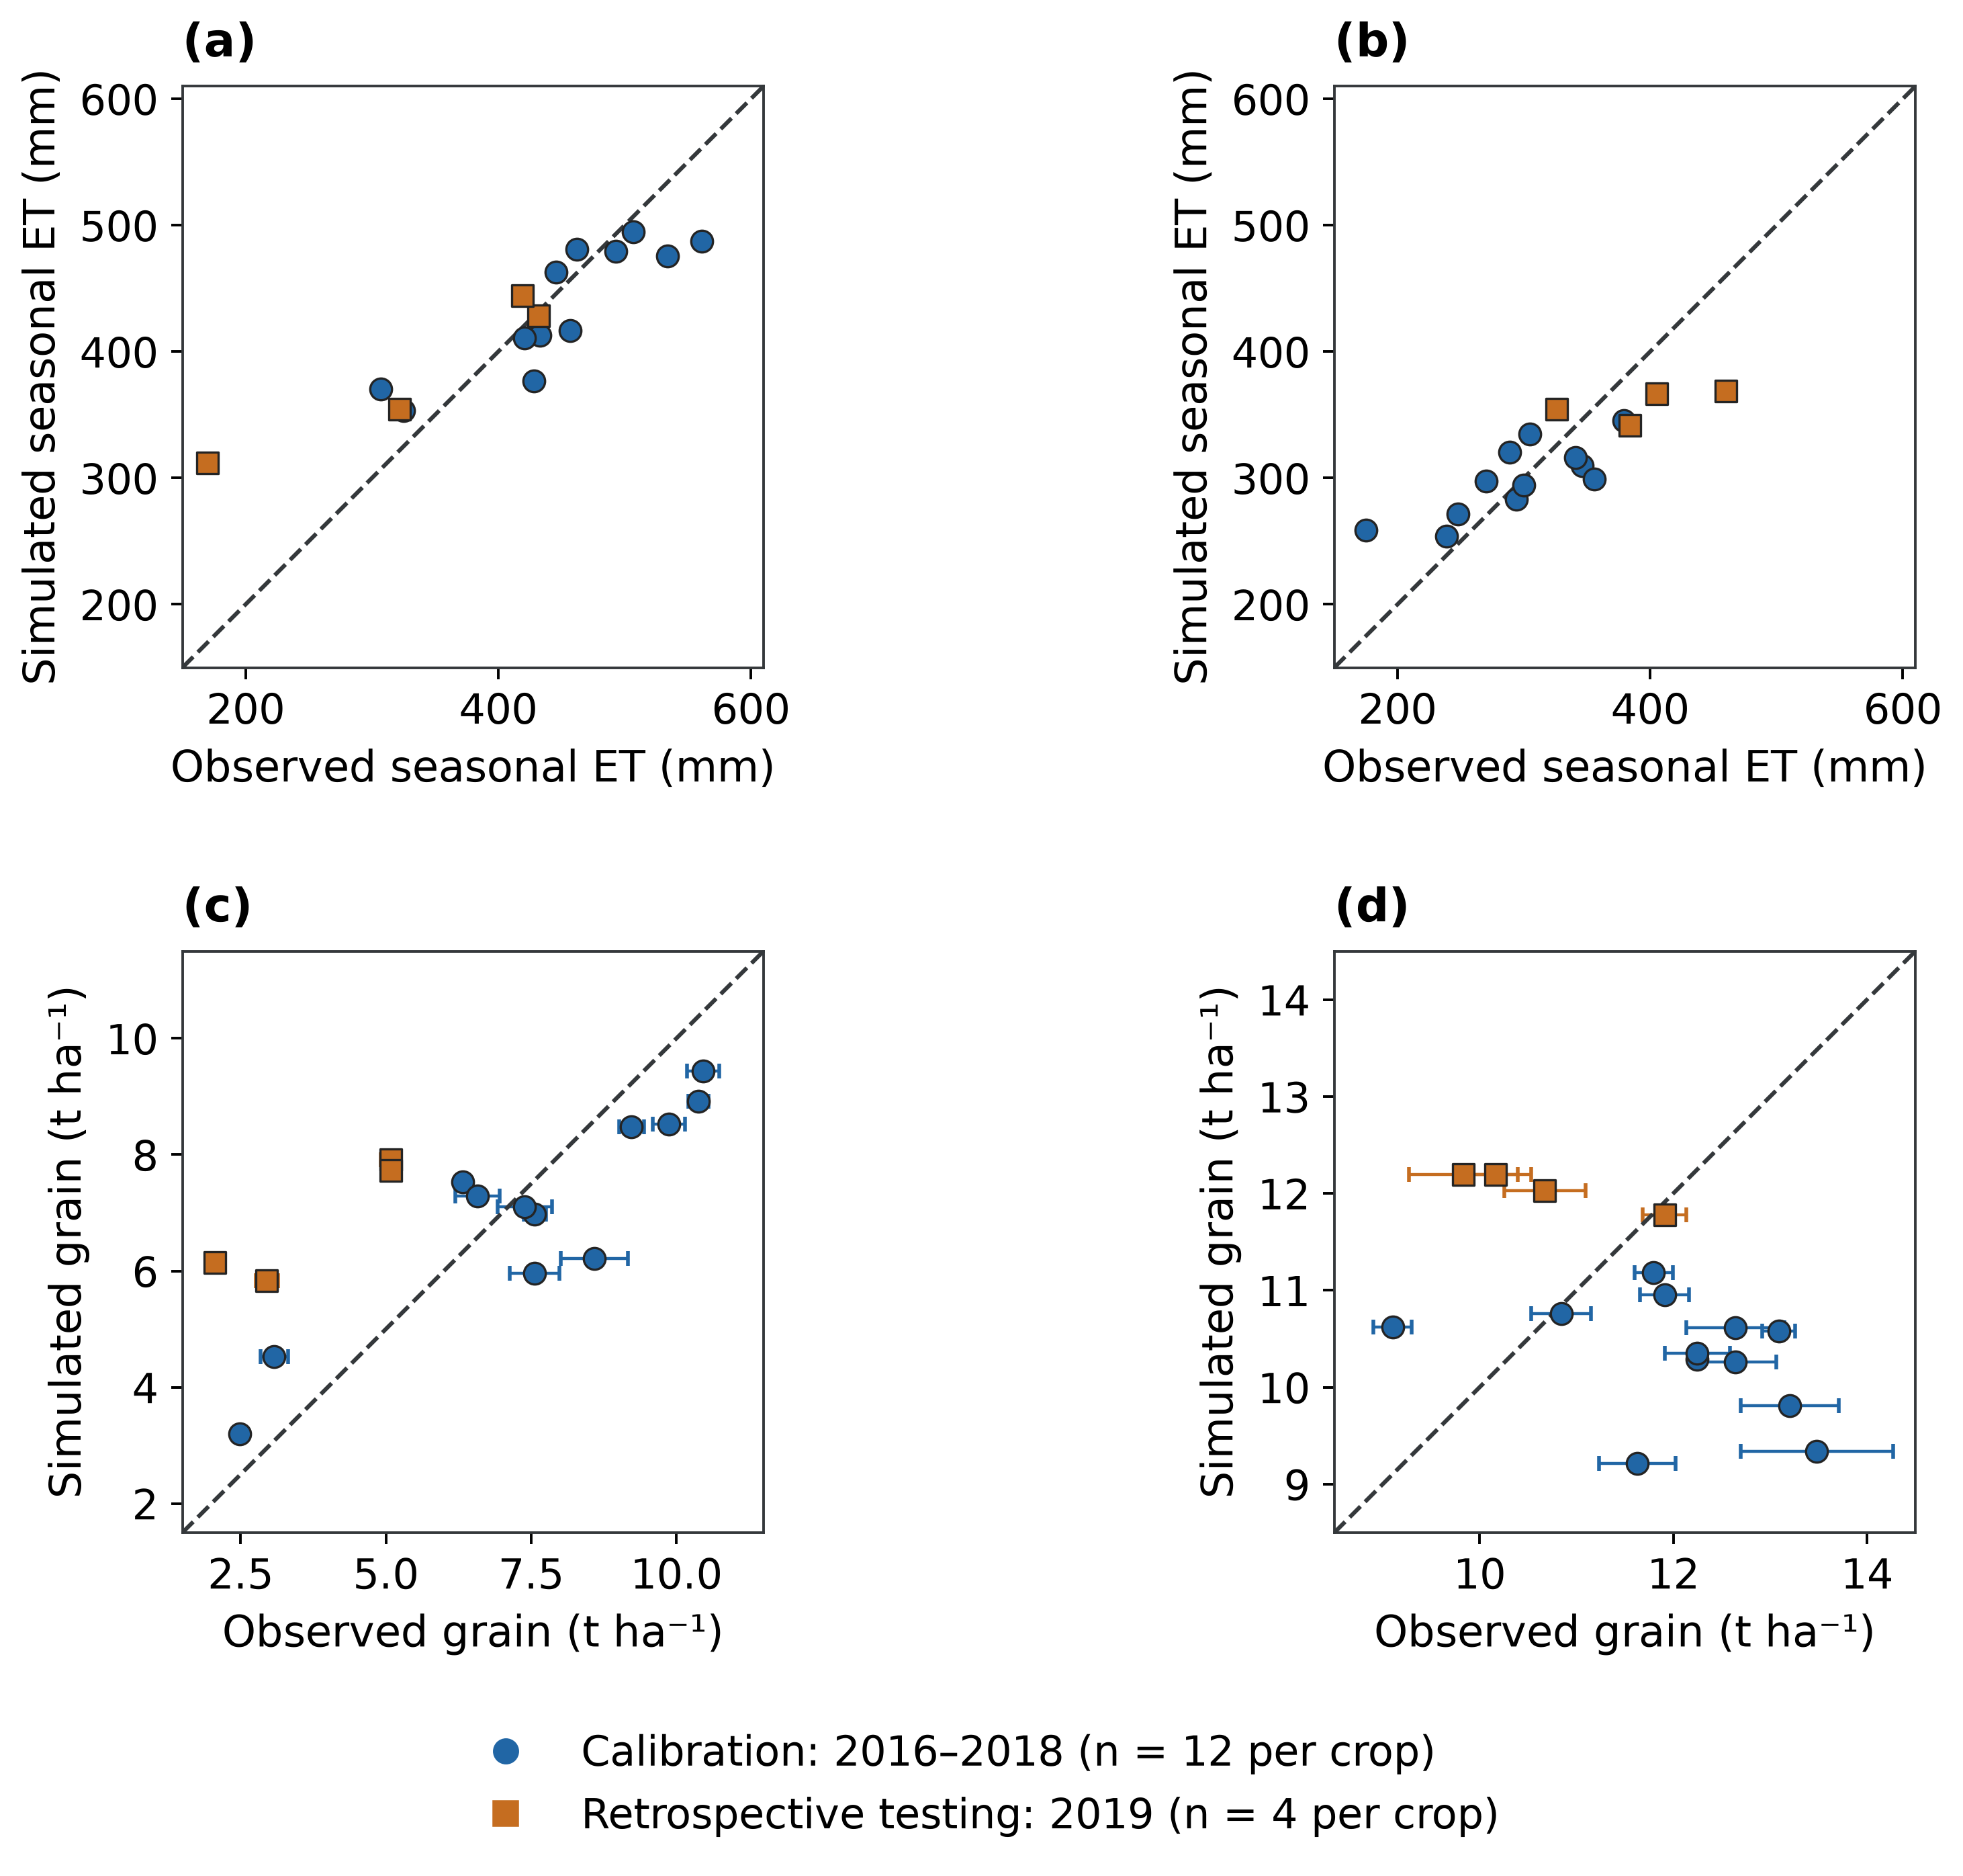
Figure 5. Wuqiao calibration and retrospective testing. (a,b) Seasonal ET; (c,d) annual treatment-mean grain at 13% moisture. Wheat occupies the left column and maize the right. Circles show 2016–2018 treatments used to fit water-use parameters; squares show 2019, withheld from the fit and selection. Dashed lines denote 1:1 agreement. Crop-specific grain axes focus on their observed ranges. Horizontal grain error bars are the published SE from three field replicates. Observed ET follows the published 0–2 m water balance; simulated dry grain is converted once by division by 0.87. Maize labels retain preceding wheat management with identical maize irrigation within each year.

3.3. Grain production and water balance under irrigation allocation
At a 50% regional irrigation reduction, targeted allocation gave a simulated annual rotation dry-grain yield of 15.761 t ha⁻¹ yr⁻¹ for wheat and maize combined, compared with 15.029 under uniform cuts. Both yields remained below the conventional yield of 16.756 t ha⁻¹ yr⁻¹. Targeting therefore retained 0.732 t ha⁻¹ yr⁻¹ more grain than uniform allocation (4.87% of uniform production), equivalent to 7.219 million t yr⁻¹ across the fixed 9.867 million rotation hectares (Table 4; Figure 6). Targeted production remained 9.813 million t yr⁻¹ below conventional production.
Both allocations supplied 190 mm yr⁻¹ of field irrigation. Targeted and uniform crop-plus-fallow ET averaged 827.70 and 806.94 mm yr⁻¹, respectively. The grain advantage was accompanied by 20.76 mm yr⁻¹ (2.048 km³ yr⁻¹) greater ET. Profile drainage was 79.04 versus 96.34 mm yr⁻¹, and runoff was 14.43 versus 18.99 mm yr⁻¹ (Table 4).
The targeted-minus-uniform grain contrast at the 50% cut was positive in all twelve comparison years (Figure 6c). The positive regional contrast was accompanied by spatially contrasting yield responses (Section 3.4).
Table 4. Simulated annual rotation production and water balance under equal irrigation reductions, 2014–2025.
Strategy | Dry grain (t ha⁻¹ yr⁻¹) | Irrigation (mm yr⁻¹) | ET (mm yr⁻¹) | Drainage (mm yr⁻¹) | Runoff (mm yr⁻¹)
Conventional | 16.756 | 380.00 | 887.43 | 185.26 | 39.32
Uniform, 25% cut | 16.177 | 285.00 | 856.41 | 135.94 | 25.71
Targeted, 25% cut | 16.562 | 285.00 | 870.81 | 125.90 | 19.86
Uniform, 50% cut | 15.029 | 190.00 | 806.94 | 96.34 | 18.99
Targeted, 50% cut | 15.761 | 190.00 | 827.70 | 79.04 | 14.43
Uniform, 75% cut | 13.347 | 95.00 | 741.57 | 68.72 | 15.83
Targeted, 75% cut | 14.018 | 95.00 | 752.30 | 60.01 | 13.68
All per-hectare means use the same 9.866602 million mapped rotation hectares. Dry grain combines wheat and maize harvests; ET includes crops and fallows. Regional grain in million tonnes equals rotation yield multiplied by mapped area in million hectares. Regional water in km³ equals depth in mm multiplied by hectares and 10, divided by 10⁹. The conventional schedule supplies 300 mm to wheat and 80 mm to maize.
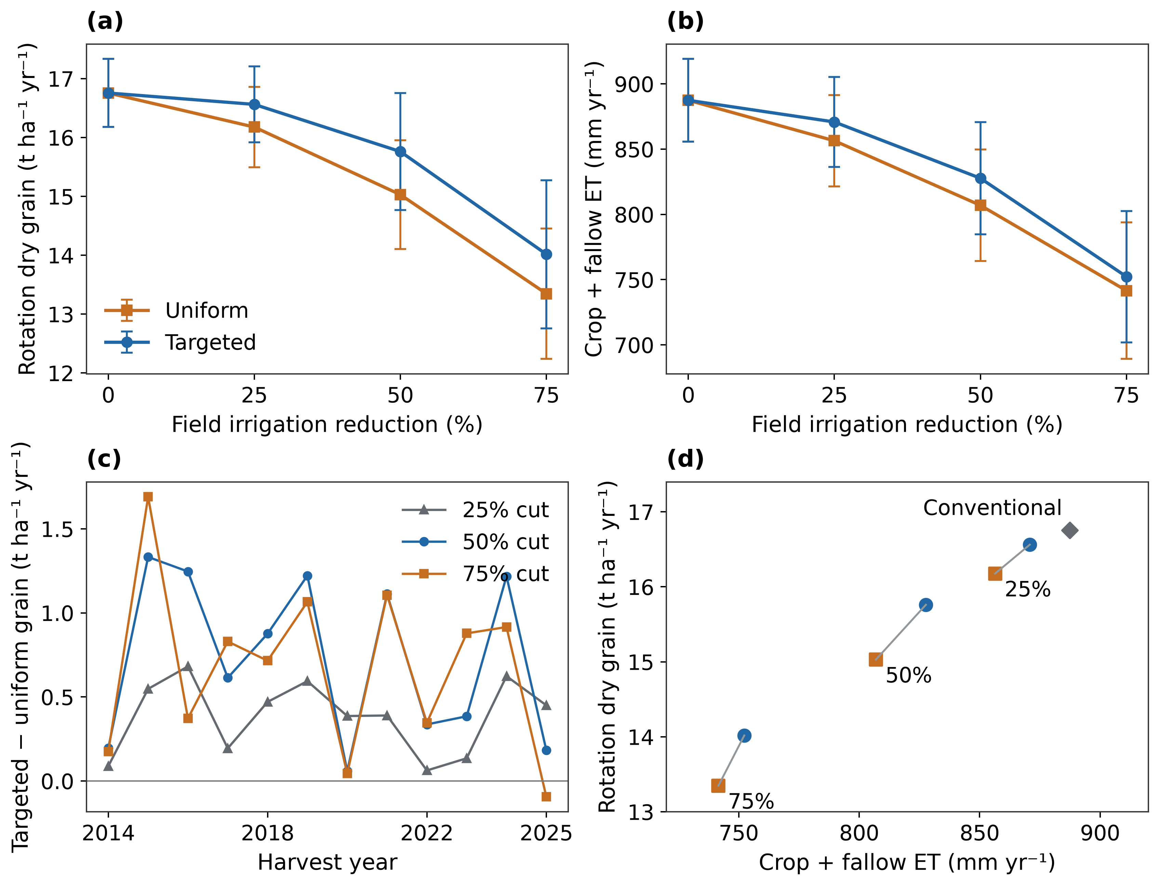
Figure 6. Irrigation allocation and grain–water trade-offs during 2014–2025. (a,b) Rotation-area-weighted annual combined wheat–maize dry grain and crop-plus-fallow ET; error bars are between-year SD. (c) Annual targeted-minus-uniform grain at identical irrigation budgets. (d) Period means; connectors join policies with the same budget. Values per hectare use the same 9.867 million mapped rotation hectares, rather than separate crop areas. Targeting retains more grain than uniform cuts while remaining below conventional production.

3.4. Spatial distribution and persistence of yield contrasts
Relative to uniform allocation, the central and northern latitude bands contributed grain gains of 7.475 and 1.886 million t yr⁻¹, while the southern band contributed a loss of 2.142 million t yr⁻¹. The southern band occupied 60.7% of mapped rotation area. Mean rotation-yield contrasts were +2.415, +2.420 and −0.357 t ha⁻¹ yr⁻¹ in the central, northern and southern bands, respectively (Figure 7; Table S9).
At the 50% regional irrigation reduction, targeted allocation increased mean annual combined wheat–maize dry grain relative to uniform reduction on 43.92% of the mapped rotation area (4.333 Mha), decreased it on 37.60% (3.710 Mha), and left it unchanged on 18.48% (1.823 Mha). Mean contrasts within the gain and loss areas were +2.439 and -0.903 t ha⁻¹ yr⁻¹, respectively. Their regional contributions were +10.568 and -3.349 Mt yr⁻¹, giving a net regional grain difference of 7.219 Mt yr⁻¹ (0.732 t ha⁻¹ yr⁻¹ across the full mapped area). Local losses offset 31.69% of the gross positive contribution (Figure 7d).
The area-weighted median grain contrast was 0.000 t ha⁻¹ yr⁻¹, and the 10th and 90th percentiles were -1.182 and +3.553 t ha⁻¹ yr⁻¹. Relative to uniform reduction, mean annual field irrigation increased by 119.0 mm yr⁻¹ in the gain area and decreased by 139.0 mm yr⁻¹ in the loss area. The corresponding crop-plus-fallow ET contrasts were +94.4 and -55.1 mm yr⁻¹. Irrigation changes balanced at regional scale, whereas the area-weighted mean ET contrast was +20.8 mm yr⁻¹.
Negative yield contrasts persisted over 2014–2025: 21.34% of the mapped rotation area had lower yields than under uniform allocation in all 12 years, and 37.60% experienced a loss in at least one year. Every response unit with a negative period-mean contrast recorded losses in at least 9 years; all response units with a positive period-mean contrast recorded gains in all 12 years. Across years, the mean annual area exposed to a loss was 35.37%. Mapped cells with negative period-mean contrasts formed 8 connected components under rook adjacency. The largest contained 3.700 Mha of mapped rotation area (99.73% of all loss area), with occupied cell centers extending from 32.0 to 36.3°N and 112.8 to 121.5°E.
Negative period-mean yield contrasts occupied 32.80%, 37.60%, and 60.08% of mapped rotation area at reductions of 25%, 50%, and 75%, respectively. At the 75% reduction, the area-weighted median contrast became negative (-0.788 t ha⁻¹ yr⁻¹), although gains on 37.04% of the area produced a positive regional balance. Gross positive and negative contributions at that reduction were +14.100 and -7.487 Mt yr⁻¹, leaving a net gain of 6.614 Mt yr⁻¹, below the net gain at the 50% reduction.
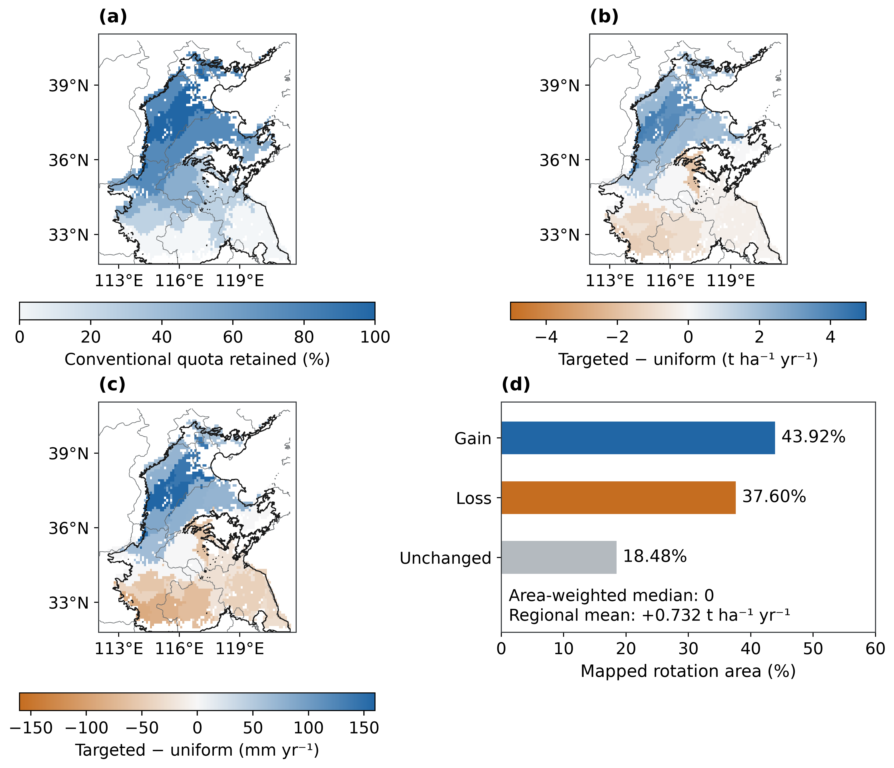
Figure 7. Spatial redistribution at a common 50% regional irrigation reduction, 2014–2025. (a) Targeted fraction of the conventional quota; uniform allocation retains 50% everywhere. (b,c) Targeted-minus-uniform combined rotation dry grain and crop-plus-fallow ET. (d) Mapped rotation-area shares with positive, negative or unchanged mean grain contrasts. The 3,641 cells inherit 32 representative responses. Thin grey provincial lines and black study-domain outlines follow Figure 2; unmapped areas remain blank.

3.5. Antecedent water availability and annual irrigation strategies
Four antecedent storage–rainfall classes occurred during 2003–2013. Nine comparison years had eligible GRACE observations, all in the lower-storage category; three years without eligible GRACE observations received conventional irrigation quotas. At the 95% grain target, both storage strata selected an irrigation fraction of 0.75 under lower rainfall and 0.50 under higher rainfall. The 98% target selected 1.00 and 0.75, respectively (Table 5).
Continuous strategies selected at the 95% and 98% targets retained 96.27% and 99.63% of conventional grain production over the nine years with eligible GRACE observations. Field-irrigation reductions were 130.72 and 35.72 mm per rotation; corresponding ET reductions were 36.84 and 6.17 mm (Figure 8; Table S7). The 95% strategy retained at least 95% in 8 of nine years, with a minimum of 92.12%.
Storage–rainfall and matched rainfall-only strategies selected identical irrigation fractions and produced identical grain, ET, drainage and irrigation histories at both targets. Rainfall-only strategies that applied decisions during GRACE gaps followed different irrigation histories and carried different soil-water states into subsequent crops (Table S8).
Table 5. Selected irrigation candidates by relative water-availability class.
Class | Irrigation fraction | Wheat irrigation (mm) | Maize irrigation (mm) | Selection grain retention (%)
Higher storage dry | 0.750 | 225.000 | 60.000 | 95.537
Higher storage wet | 0.500 | 150.000 | 40.000 | 97.093
Lower storage dry | 0.750 | 225.000 | 60.000 | 96.617
Lower storage wet | 0.500 | 150.000 | 40.000 | 97.431
Fractions meet the 95% class-mean grain target during selection years 2003–2013. Current shared crop parameters apply throughout. Both storage strata select identical fractions within each rainfall group; higher-storage classes have no later-period exposure.
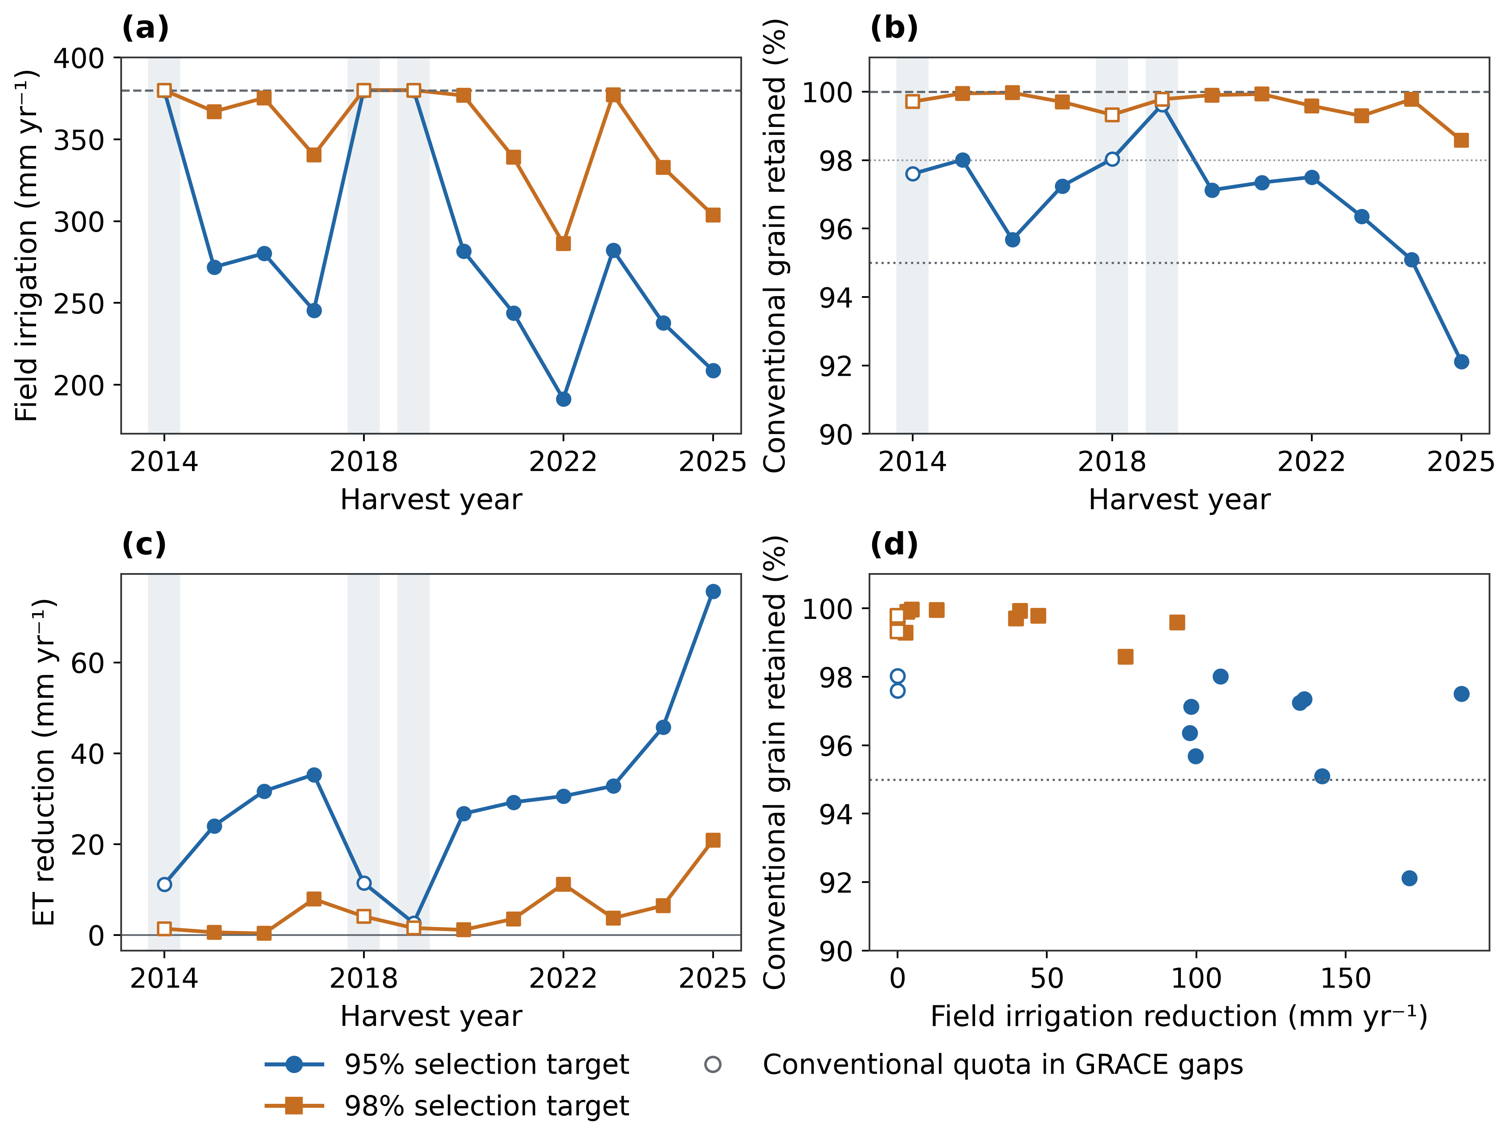
Figure 8. Continuous annual irrigation strategies during 2014–2025. (a) Field irrigation; (b) grain retained relative to conventional irrigation; (c) crop-plus-fallow ET reduction; (d) annual production–irrigation combinations. Blue circles and orange squares identify 95% and 98% selection targets. Shading and open markers identify missing-GRACE years with conventional quotas. Grain and ET can still differ in those years because preceding strategy decisions alter carried soil-water states. Matched rainfall-only histories coincide with the storage–rainfall histories.

4. Discussion
We used a calibrated crop model to simulate continuous winter wheat–summer maize rotations across the North China Plain, compare uniform and spatially targeted irrigation under equal water budgets, and test whether antecedent regional water storage improved decisions based on rainfall. Sustaining grain production under restricted irrigation requires consideration of both consumptive water use and the distribution of production losses across locations. The conditional results show that higher regional grain retention can accompany greater evapotranspiration and lower production in some locations, whereas storage information did not change the selected irrigation quotas within the tested design. The management value of these strategies therefore depends on accounting for the complete rotation water balance, soil-water carry-over across crops and fallows, and reliable crop responses to irrigation.

4.1. Marginal irrigation returns and spatial allocation
Spatial targeting exploits differences in marginal grain response to irrigation. Diminishing production gains across field schedules (Yang et al., 2022) and spatial variation in irrigation requirements (Wu et al., 2019) provide a basis for redistributing a limited supply, consistent with regional allocation studies (Jiang et al., 2016). The equal-budget comparison attributes the simulated production difference to delivery allocation. Complete continuous histories retain the effects of earlier irrigation and rainfall on subsequent crop responses.
At the 50% delivery reduction, targeting retained 0.732 t ha⁻¹ yr⁻¹ more combined wheat–maize dry grain than uniform cuts. Across 9.8666 million rotation hectares, the corresponding reduction in grain loss was 7.219 million t yr⁻¹, or 4.87% of the uniform total. Targeted production remained below conventional production. The positive contrast in all twelve years indicates consistent regional gains within the simulated record. Its magnitude remains dependent on the crop-response functions and declared management schedules (Table 4; Figure 6).
The spatial distribution sharpens this distinction between regional and local outcomes. Relative to uniform allocation, mean losses occupy 37.60% of mapped rotation area, and losses persist in every comparison year on 21.34%. Gross gains of 10.568 Mt yr⁻¹ are partly offset by losses of 3.349 Mt yr⁻¹; the area-weighted median is zero despite a positive regional mean. The regional grain objective balances gains and losses among locations. Local production floors constitute an additional allocation constraint.
Regional gain has a pronounced distributional cost. Central and northern band-mean rotation yields increased by 2.415 and 2.420 t ha⁻¹ yr⁻¹, while the southern mean decreased by 0.357 t ha⁻¹ yr⁻¹. The southern band covers 60.7% of the rotation area, so its losses substantially offset gains elsewhere (Figure 7; Table S9). The production objective maximizes the area-weighted regional total and supplies no minimum yield for an individual location. Local production floors and constraints on the distribution of irrigation reductions are therefore separate requirements for allocation that protects affected farms.

4.2. Rotation carry-over and the timing of water supply
The spatial production response integrates water effects across both crops. Wheat irrigation can support canopy growth and grain formation, replenish water available to maize or increase drainage. Reduced wheat delivery can increase subsequent dependence on summer rainfall, producing different annual grain responses under different rainfall sequences. The sixteen-year irrigation experiment shows diminishing production gains, and the Wuqiao experiment links precipitation conditions with wheat scheduling and subsequent maize production (Yang et al., 2024; Yang et al., 2022). These coupled responses make the complete rotation the relevant unit for irrigation allocation.
Continuous soil-water histories preserve the delayed benefits and costs of allocation and annual quota changes (Figure S3). Production can be maintained by drawing down profile storage, with later rainfall or irrigation determining its replenishment. A finite-period delivery reduction can therefore include a contribution from stored soil water. Crop-plus-fallow accounting also captures evaporation and drainage between harvest and sowing. Their inclusion connects apparent production retention with the water remaining for the next crop and the complete rotation water balance.
The field evidence constrains only part of this carry-over mechanism. Wuqiao simulations use reported total profile storage with an assumed layer distribution. Wheat crop-start storage follows the pre-sowing simulation, whereas maize is independently initialized from treatment-specific observations. Maize irrigation is identical among treatments within each year, and its treatment labels identify preceding wheat schedules (Yang et al., 2024). Maize comparisons thus evaluate crop responses to the initial state associated with wheat management (Figure 5; Figure S2). Regional carry-over additionally depends on the model's continuous propagation and vertical redistribution of water between crops.

4.3. Production, consumptive use and groundwater accounting
The production benefit of targeting carries a consumptive-use trade-off. At the common 50% delivery reduction, targeting increased ET by 2.048 km³ yr⁻¹ and reduced profile drainage by 1.707 km³ yr⁻¹ relative to uniform allocation. With rainfall and total irrigation held constant, differences in ET are balanced by drainage, runoff and soil-storage change (Table 4). A shared delivery constraint therefore permits different consumptive outcomes. Irrigation productivity and consumptive-water savings require distinct objectives (Grafton et al., 2018; Perry et al., 2009).
The soil-profile balance also has a different boundary from the aquifer balance. Drainage below 2 m enters a deeper vadose zone, with storage and transit outside the modeled profile (Wu et al., 2023). Reduced field delivery or profile drainage therefore provides insufficient information to quantify changes in pumping, aquifer recharge or groundwater storage. Production and ET comparisons can identify agronomic trade-offs, while groundwater outcomes require the corresponding subsurface and abstraction accounting.
GRACE offers regional storage context at a broader scale. Its anomalies integrate groundwater with other terrestrial stores, and its effective observation scale exceeds the displayed grid resolution (Save et al., 2016; Scanlon et al., 2016). Recent aquifer recovery reflects water transfers, abstraction management and hydroclimatic conditions (Long et al., 2025; Xu et al., 2026). The crop-model scenarios quantify changes in field delivery, consumption and profile outflow without attributing those observed storage changes to individual irrigation strategies.

4.4. When storage information changes an irrigation decision
A storage indicator adds decision value when its inclusion changes the selected action or improves the grain–water outcome under common constraints. GRACE represents regional storage conditions, while antecedent rainfall describes more local water input (Save et al., 2016; Scanlon et al., 2016). Their different physical support motivates joint classification, but decision value also depends on how the resulting classes distinguish among the available irrigation fractions.
Both storage strata selected the same fraction for a given rainfall group at the 95% and 98% grain targets. Storage–rainfall and matched rainfall-only strategies consequently produced identical complete histories of irrigation, crop states, grain, ET and drainage. The storage split supplied additional environmental description without changing an irrigation action in this five-level quota design. All nine later years with eligible observations fell in the lower-storage category, so the higher-storage choices also lacked later-period exposure (Table 5; Figure 8). These features delimit the configuration and conditions represented by the equal outcomes.
Monitoring coverage must remain distinct from the grouping criterion. Rainfall-available controls can change irrigation during GRACE gaps, and those earlier decisions alter the soil-water state inherited in later years. Their outcomes therefore combine rainfall-based selection with additional years of management. Matched coverage preserves the appropriate comparison for the incremental effect of storage information. Finer quota choices, alternative thresholds and verified release availability would define different decision experiments with their own selection and evaluation requirements.

4.5. Crop-response constraints and management reliability
Management selection depends on the modeled marginal response to water, in addition to absolute grain and canopy agreement. Intercepted-PAR radiation-use efficiency (Kiniry et al., 1989), cohort-specific leaf area and thermal senescence connect canopy development with carbon supply; grain number and fixed individual grain mass constrain the sink. Root uptake and the assimilation stress exponent then determine how water shortage changes production. Variation among wheat-model transpiration formulations demonstrates the sensitivity of water-use predictions to these processes (Cammarano et al., 2016). Water coefficients near their prescribed bounds remain effective empirical estimates whose physiological interpretation and uniqueness are limited.
The estimation and evaluation data provide different evidence for these responses. Earlier growth estimates use 480 wheat and 433 maize observations across four wheat sites and five maize sites, with whole site-years and balanced site contributions. Incomplete station irrigation histories limit transfer comparisons, and station observations have no weight in the fitted water-response objective. Wuqiao 2016–2018 supplies the documented treatment seasons for that fit. Wuqiao 2019 supplies a single test year with reported total storage, assumed layer distributions and transferred soil hydraulics; prior inspection of its outcomes makes the test retrospective (Figures 3–5). Regional comparison years also overlap crop-fitting years, so regional production differences characterize model scenarios rather than time-forward crop validation.
The absolute regional production reference also depends on the prescribed management and crop parameters. Conventional simulations produce 8.065 t ha⁻¹ of wheat dry grain and 8.691 t ha⁻¹ of maize dry grain per year. These values represent fixed irrigation dates, crop calendars and nutrition modifiers rather than an independently validated regional harvest inventory. The 0.732 t ha⁻¹ yr⁻¹ allocation advantage depends on the same simulated marginal responses; its regional scaling does not remove field-response uncertainty.
Substantial field-test errors constrain confidence in irrigation-response transfer. Wheat grain nRMSE was 83.27%, with a bias of +3.108 t ha⁻¹ at the published 13% moisture basis; the absolute W3−W0 ET-contrast error was 116.37 mm. Maize ET NSE was negative, with an ET-contrast error of 52.74 mm (Table 3; Table S5). These discrepancies affect the response functions used to select regional allocations. Numerical water-balance closure demonstrates conservation but supplies no measure of response accuracy. The eight purposive actual-cell checks address a separate uncertainty, spatial aggregation, and provide no regional field-validation sample. Depth-resolved soil water and complete dated management would better constrain uptake and redistribution; canopy and soil-moisture assimilation also requires treatment of retrieval errors and observation operators (Ines et al., 2013).
Production-retention targets introduce a further management distinction between period means and annual reliability. Mean retention of 96.27% and 99.63% coincided with annual minima of 92.12% and 98.58%; the 95% strategy met that threshold in eight of nine class-available years (Figure 8). A mean target consequently supplies no shortfall probability or guarantee for an individual farm. Local production floors, acceptable shortfall frequency and a reserve entering the next crop can complement regional delivery and consumption constraints. Forecast-based irrigation studies illustrate explicit treatment of water-stress risk (Roy et al., 2021). Field scheduling additionally requires current soil-water information, weather forecasts and application timing.

4.6. Limitations and future directions
The principal limitation is uncertainty in the crop responses used for strategy selection. Field testing covers a single, previously inspected year, while incomplete station management and assumed initial water profiles constrain transfer. Remaining errors in ET and grain responses prevent the simulated policy advantages from being interpreted as independently validated field benefits. Further evaluation requires new site-years with complete management records, withheld from both model development and strategy selection. Concurrent measurements of soil water by depth, ET, canopy development and harvest would allow separate assessment of water redistribution, crop stress and irrigation-treatment contrasts.
Regional results also depend on a static rotation map, representative climate–soil units, prescribed irrigation dates and fixed nutrition modifiers. Checks at purposively selected source cells cannot bound regional uncertainty. Dynamic nitrogen cycling is absent, and changes in crop area or actual farm practices are not reconstructed. Future analyses should expand evaluation at individual source cells and propagate uncertainty in crop parameters, soil hydraulics, weather and spatial aggregation through paired policy histories. Allocation stability and the magnitude and persistence of local losses require uncertainty assessment alongside the regional mean.
The storage comparison is specific to the tested quota grid, classification thresholds and lower-storage conditions represented during later comparison years. GRACE release availability before sowing remains unverified, so the scenarios do not establish operational scheduling performance. Prospective decision experiments should use information available on each decision date, maintain matched rainfall-only controls and evaluate both storage states. Finer quotas and application timing informed by soil water could be tested with constraints on consumptive use, local production and the risk of production shortfalls.
Finally, the profile uses free drainage at its lower boundary, with no capillary supply or deeper subsurface storage, and field irrigation is not linked to measured abstraction. Groundwater applications require joint accounting of soil water and aquifer flows, constrained by observations of pumping, recharge and storage change. Delivery capacity, irrigation costs and farmer participation also require assessment before the agronomic scenarios can support operational management.

5. Conclusions
At an identical 50% irrigation reduction, targeted allocation retained 0.732 t ha⁻¹ yr⁻¹ more simulated combined wheat–maize dry grain than uniform cuts during 2014–2025. This reduced regional grain loss by 7.219 million t yr⁻¹ (4.87% of uniform production), while increasing crop-plus-fallow ET by 20.76 mm yr⁻¹ (2.048 km³ yr⁻¹). Relative to uniform allocation, mean grain losses occurred on 37.60% of mapped rotation area and persisted in all twelve years on 21.34%. Regional production retention therefore requires separate consumption and local production constraints.
Annual strategies selected at 95% and 98% grain-retention targets retained 96.27% and 99.63% of conventional production over nine years with eligible GRACE observations. The 95% strategy reduced irrigation by 130.72 mm and ET by 36.84 mm per rotation. Matched rainfall-only controls selected identical quotas and produced identical outcomes, so storage classification provided no additional decision benefit within the tested quota design and monitoring coverage.
Continuous rotation accounting preserves the influence of preceding management on subsequent production and water use. The field-test errors and incomplete station management delimit confidence in transferring the estimated crop responses. Translation of these regional scenarios into irrigation management depends on observed response accuracy, explicit production-risk constraints and field scheduling informed by soil water and forecasts. Groundwater effects additionally require pumping, recharge and deeper subsurface storage beyond the crop-model boundary.

Data and code availability
Model code, frozen calibration and regional inputs, observation subsets and quality exclusions, weather, calibrated parameters, predictions, evaluation metrics and figure-data tables are available at https://github.com/SmartAG-Team/agri_water_management. The repository includes a standalone Open Crop Model package, pinned dependencies, reproduction commands and SHA-256 provenance. Reproduction uses the included inputs without another model checkout or access to the historical workspace. Original datasets retain their provider licences and attribution requirements, documented in the repository source catalogue.

Declaration of generative AI and AI-assisted technologies
AI assisted with grammar checking.

Supplementary material

Supplementary methods and results

S1. Observation sources and eligibility
The station archive preserves 132 crop–plot–season trajectories, whole site-year partitions and source metadata. The 7,397 eligible records occur in 127 cases and retain all five observation sites for their available variables. Calibration and retrospective-evaluation trajectory counts remain 71 and 61. Variable-specific availability and missing combinations are retained in the accompanying case and site tables; missing measurements do not become zero observations.
Wheat LAI above 7 m² m⁻² remains excluded under the study-specific rule. Duplicated six-replicate maize harvest vectors in Yucheng 2012 and 2017 account for 24 excluded grain and biomass records, divided equally between the original calibration and evaluation partitions. These source-based exclusions retain raw values and do not depend on prediction residuals.
Earlier multisite growth estimates retain 480 wheat and 433 maize calibration observations. Current station growth and ET comparisons are conditional on archived management whose full irrigation-log completeness is unresolved. They have zero weight in the water-parameter fit. Wuqiao 2016–2018 supplies 12 documented treatment seasons per crop for that fit (Yang et al., 2024); 2019 supplies four retrospective testing seasons per crop. Seasonal ET, grain and biomass targets refer to the same treatment-season population, while ET contrasts are derived from those seasonal targets.
Twenty-six Fengqiu cases retain antecedent moisture initialization from the preceding calendar month. Complete fifteen-layer 0–1.5 m volumetric profiles map conservatively to the represented model layers, preserving depth-integrated storage. The identical eligibility rule applies to 11 original calibration and 15 evaluation cases. Monthly timing, aggregation and subplot support remain unresolved relative to the exact sowing-day state. Original cases remain available when a measured antecedent profile is absent.
Table S1. Crop seasons and calibration/evaluation case counts by site.
Site | Crop | Years | Calibration cases | Evaluation cases
Fengqiu | Maize | 2004, 2005, 2006, 2007, 2008 | 11 | 9
Fengqiu | Wheat | 2004, 2005, 2006, 2007, 2008 | 11 | 10
Gucheng | Maize | 2018, 2019, 2020 | 8 | 4
Luancheng | Maize | 2004, 2005, 2006, 2007, 2008 | 2 | 3
Luancheng | Wheat | 2004, 2005, 2006, 2007, 2008 | 2 | 3
Shangqiu | Maize | 2002, 2004, 2005, 2006, 2007 | 2 | 6
Shangqiu | Wheat | 2001, 2002, 2003, 2004, 2005, 2006, 2007 | 9 | 8
Yucheng | Maize | 1998, 2000, 2001, 2002, 2004, 2005, 2006, 2007, 2008, 2009, 2010, 2011, 2012, 2013, 2014, 2015, 2016, 2017, 2018, 2019, 2020, 2021, 2022 | 14 | 9
Yucheng | Wheat | 1999, 2000, 2004, 2005, 2006, 2007, 2008, 2009, 2010, 2011, 2012, 2013, 2014, 2015, 2016, 2017, 2018, 2019, 2020, 2021, 2022 | 12 | 9
Years denote archived crop-season groups, which retain all their plot cases. Coverage is intermittent; years absent from the table are not assumed to have observations.
Table S2. Source datasets for evaluated field observations.
Site | Dataset | DOI | Source
Fengqiu | 2004-2008年河南封丘站作物生育及生长动态监测数据 | 10.12199/nesdc.ecodb.mon.2020.dp2011.fqa.002 | National Ecosystem Science Data Center / Science Data Bank
Fengqiu | 2005-2008年河南封丘站农田土壤水分物理性质监测数据 | 10.12199/nesdc.ecodb.mon.2020.dp2011.fqa.006 | National Ecosystem Science Data Center / Science Data Bank
Gucheng | 2018–2021年华北北部不同播期对玉米生长发育的影响数据集 | 10.57760/sciencedb.o00119.00017 | National Ecosystem Science Data Center / Science Data Bank
Luancheng | 2000-2008年河北栾城站作物生育及生长动态监测数据 | 10.12199/nesdc.ecodb.mon.2020.dp2011.lca.002 | National Ecosystem Science Data Center / Science Data Bank
Shangqiu | 2000-2007年河南商丘站作物生育及生长动态监测数据 | 10.12199/nesdc.ecodb.mon.2020.dp2011.sqa.003 | National Ecosystem Science Data Center / Science Data Bank
Yucheng | 1998-2006年山东禹城站作物生育及生长动态监测数据 | 10.12199/nesdc.ecodb.mon.2020.dp2011.yca.003 | National Ecosystem Science Data Center / Science Data Bank
Yucheng | 禹城站2005-2022年生物要素观测数据集 | 10.12199/nesdc.ecodb.2021YFF0703900.yca.2025.2 | National Ecosystem Science Data Center / Science Data Bank
Yucheng | 禹城站2005-2022年水环境要素观测数据集 | 10.12199/nesdc.ecodb.2021YFF0703900.yca.2025.3 | National Ecosystem Science Data Center / Science Data Bank
Dataset DOIs identify official source records; original metadata and observation-row provenance are retained in the reproducibility archive.

S2. Crop processes, parameter definitions and water accounting

S2.1. Model structure and phenological development
Open Crop Model simulates phenology, green leaf area, live and dead aboveground biomass, grain dry matter, rooting depth and layered soil-water storage. Inputs comprise weather, soil profiles, crop parameters, dated sowing and harvest, and irrigation events. Soil water carries continuously between crop and fallow segments in regional histories; Wuqiao crop starts retain their separately specified storage conditioning.
Wheat stage development combines temperature, vernalization and photoperiod modifiers with inherited stage requirements. Maize uses a subdaily temperature response reconstructed from daily extrema, with base, optimum and maximum temperatures of 6, 30 and 44 °C. The shared medium-maturity maize card requires approximately 1,909 °C d to reach R6. DVS anchors are wheat BBCH 09, 61 and 89 and maize VE, R1 and R6 (Meier, 2018). Wheat dough stage and full ripeness retain their distinct definitions.
Seed-layer water above wilting-point storage permits germination. The represented layer is selected by sowing depth, with a 50-mm prior when no depth is supplied. Thermal development and wheat vernalization begin from the first eligible germination day rather than accumulating during dry-seed days. This layer-average availability is an effective establishment condition, not a measured seed-scale water potential. Fixed stage coefficients therefore do not imply fixed calendar-stage predictions across water states. New biomass production ends at wheat full ripeness or maize physiological maturity; green maize area can persist under the terminal senescence rate until harvest. Harvest is a separate management endpoint and does not substitute for an observed maturity date.

S2.2. Canopy development, biomass accumulation and grain yield
Green cover is $f_{c}=1−exp(−k_{L}LAI)$. Daily aboveground dry-matter production is $ΔB=10R_{s}p_{PAR}f_{c}εf_{T}f_{W}^{γ}f_{N}$, where $R_{s}$ is incident shortwave radiation, $p_{PAR}=0.45$, ε is RUE per MJ of intercepted PAR, $f_{T}$ is the temperature modifier, $f_{N}$ is the prescribed nutrition factor and $f_{W}$ is realized transpiration divided by remaining potential transpiration demand after wet-canopy evaporation. The factor 10 converts g m⁻² to kg ha⁻¹. PAR enters once (Kiniry et al., 1989). The fitted empirical assimilation exponents are 1.85985 for wheat and 0.25000 for maize. They govern carbon response separately from leaf-expansion and leaf-survival sensitivity.
SLA is linearly interpolated through DVS 0, 0.5, 1 and 2, with the DVS-2 value equal to DVS 1. New leaf dry matter acquires area using current SLA; established cohorts retain their birth area-to-mass ratio (de Wit and Berghuijs, n.d.). Thermal senescence hazard $h(DVS)$ is interpolated through DVS 0, 1, 1.4, 1.7 and 2, with a constant preflowering rate and increasing grain-filling rates (Tan et al., 2020). Daily survival is $exp\left[−h(DVS)max(T_{mean}−T_{base},0)\right](1−q_{s})$, with $q_{s}=0.025(1−f_{W}f_{N})$. The terminal hazard continues at maize R6, whereas wheat BBCH 89 senesces remaining green leaves. LAI emerges from the cohort area balance; no maximum-LAI parameter or cap enters this formulation.
Leaf allocation follows crop development, with separate early and late vegetative multipliers for maize and additional temperature, water-supply and nutrition limits on leaf expansion. Initial LAI is an emergence condition. Stage-specific SLA and senescence coefficients retain their inherited estimates and conditional trait priors (APSIM Initiative, 2026; de Wit, 2022; de Wit, 2020); their values do not represent universal physiological bounds.
Grain number is fixed at the first grain-set day as $N_{g}=0.1B_{f}c_{g}$, where $B_{f}$ is simulated aboveground dry mass immediately before grain set and $c_{g}$ is the grain-number coefficient. Grain set starts at wheat BBCH 61 and maize R1. Maximum grain dry mass is $Q_{g}=10N_{g}m_{g}$, with fixed $m_{g}$ of 0.045 g grain⁻¹ for wheat and 0.300 g grain⁻¹ for maize (APSIM Initiative, 2026). Assimilate supply and development-dependent filling capacity constrain grain accumulation. Wheat remobilization transfers an explicit subset of stem mass to grain while conserving total aboveground mass. Live and dead leaves, stems and grain remain in the aboveground carbon pool; observed yield or harvest index does not initialize grain.
Prescribed nutrition factors distinguish archived fertilized and unfertilized management classes. Wuqiao and regional simulations retain the fertilized class. These factors describe effective growth limitations; the model does not resolve a mechanistic nitrogen balance.

S2.3. Soil-water balance and actual evapotranspiration
Potential transpiration and exposed-soil evaporation are $T_{p}=K_{T}{ET}_{0}f_{c}$ and $E_{p}=K_{E}{ET}_{0}(1−f_{c})$, with ${ET}_{0}$ supplied by AgERA5. Rainfall interception fills a canopy store of capacity 1 mm × $f_{c}$. Wet-canopy evaporation reduces the transpiration demand remaining within each outer water step. Actual ET is $T_{a}+E_{s}+E_{c}$, the sum of transpiration, soil evaporation and canopy evaporation. Wuqiao residue cover is unmeasured and its exposed-soil boundary is retained; prescribed organic mulch, where supplied, reduces potential soil evaporation using the FAO-56 cover approximation (Allen et al., 1998).
Two-stage evaporation depends on actual surface-layer storage. Total evaporable water is $TEW=(θ_{FC}−θ_{AD})Δz_{1}$ and readily evaporable water is $REW=0.30TEW$. Surface depletion is $D_{e}=(θ_{FC}−θ_{1})Δz_{1}$. The evaporation reduction is $K_{r}=min\left[1,max\left(0,\frac{TEW−D_{e}}{TEW−REW}\right)\right]$, with actual extraction bounded by storage above air dry. Ponded water evaporates before soil storage. This storage closure follows the two-stage drying principle (Allen et al., 1998) without resolving a complete dual-crop-coefficient surface balance.
Root activity integrates an exponential depth distribution over rooted parts of each layer and is normalized over the represented rooted volume. Local depletion stress is $s_{i}=min\left[1,\frac{max(0,W_{i}−θ_{WP,i}Δz_{i})}{(1−p)(θ_{FC,i}−θ_{WP,i})Δz_{i}}\right]$, where p is the fitted readily available water fraction. Base uptake combines root activity, local stress, atmospheric demand and the daily extraction coefficient; accessible storage and extraction capacity bound each contribution. The compensation fraction allocates a bounded part of unmet demand to rooted layers whose stress factors equal or exceed the activity-weighted mean. Total uptake remains bounded by demand times the best rooted-layer stress factor and by available extraction capacity. Compensation redistributes demand and does not eliminate uniformly dry-profile stress.
Effective saturation is $S_{e}=\frac{θ−θ_{AD}}{θ_{SAT}−θ_{AD}}$. With $m=1−\frac{1}{n}$, the retention relation is $S_{e}={\left[1+(α|h|)^{n}\right]}^{−m}$ (van Genuchten, 1980), and conductivity is $K=K_{sat}S_{e}^{1/2}{\left[1−{\left(1−S_{e}^{1/m}\right)}^{m}\right]}^{2}$ (Mualem, 1976; van Genuchten, 1980). Adjacent half-layer saturated resistances define $K_{sat,face}=\frac{d}{\frac{Δz_{i}}{2K_{sat,i}}+\frac{Δz_{i+1}}{2K_{sat,i+1}}}$, where $d=\frac{Δz_{i}+Δz_{i+1}}{2}$. Relative-arithmetic face mobility is $r_{face}=\frac{Δz_{i+1}r_{i}+Δz_{i}r_{i+1}}{Δz_{i}+Δz_{i+1}}$, with $r_{i}=\frac{K_{i}}{K_{sat,i}}$. Thus $K_{face}=K_{sat,face}r_{face}$. This interface approximation permits a wet layer to supply a dry neighbor while retaining the resistance of low-conductivity material.
Signed interface flux is $q_{i}=K_{face}\left[1+\frac{h_{i}−h_{i+1}}{d}\right]$, positive downward. Transfers have equal and opposite contributions in neighboring layer balances and are bounded by donor storage and receiving pore capacity. Twenty-four outer steps partition daily forcing, evaporation and uptake; adaptive internal transport steps limit net θ increments to 0.005. The free-drainage bottom flux equals the current unsaturated conductivity under unit hydraulic gradient. Upward redistribution is an internal profile flux, with no external capillary-rise supply. This bounded explicit layered approximation does not resolve the full implicit Richards system or saturated positive pressure.
For a field of profile storage S, the accounting identity is $ΔS=P+I−{ET}_{a}−D−Q$. Applied irrigation I is a field-boundary input. Flood-irrigation scenarios wet the entire field, with application, drift and conveyance losses set to zero at that boundary. Drainage D leaves the modeled profile and is distinct from water reaching an aquifer after deeper vadose-zone transport (Wu et al., 2023).

S2.4. Hydraulic derivation, shared crop parameters and numerical checks
Saxton–Rawls equations use normalized sand and clay fractions and organic matter percent (Saxton and Rawls, 2006). SoilGrids carbon in dg kg⁻¹ is converted to organic matter percent by $\frac{1.724×SOC}{100}$; bulk density in cg cm⁻³ is divided by 100; coarse fragments in permille are divided by 1,000 (ISRIC — World Soil Information, 2020). Regional porosity uses $1−\frac{BD}{2.65}$, with prescribed density and gravel adjustments. Air-dry water content retains its declared prior. Field-capacity, wilting-point and saturation ordering is checked before simulation; unavailable complete profiles remain excluded under the spatial-source rule.
The van Genuchten α and n values are conditional hydraulic priors reconstructed from supplied field-capacity and wilting-point endpoints at pressure heads of −3,300 and −150,000 mm, with $θ_{AD}$ as residual water and $θ_{SAT}$ as saturated content. Endpoint reconstruction preserves those storage thresholds rather than fitting curves to crop outcomes. Neither depth-resolved Wuqiao retention measurements nor exact seasonal initial layer distributions are available. The separate Wuqiao particle-density prior is 2.75 g cm⁻³.
Table S3 contains effective shared crop values after applying the frozen fit multipliers. Regional and Wuqiao inputs use identical shared cards within each crop. Maximum root depth is limited by the supplied profile depth. Stage-specific SLA and senescence, fixed grain mass and inherited growth coefficients remain distinct from the eight water coefficients fitted in the current run. Near-zero root-density decay yields approximately uniform activity over represented rooted volume; it does not identify an observed root-mass profile.
The 164 selected station and field trajectories conserve daily water and aboveground carbon, with maximum absolute residuals of 1.00 × 10⁻¹² mm and 6.71 × 10⁻¹² kg ha⁻¹. Exact inputs, observation identities, frozen parameters, source snapshots and SHA-256 provenance accompany the predictions. Conservation establishes arithmetic consistency; hydraulic and crop-response accuracy depend on the conditional observations and retrospective field test.
Eight existing water-response coefficients per crop are estimated from documented Wuqiao management in 2016–2018: the transpiration multiplier, soil evaporation coefficient, readily available water fraction, assimilation water-stress exponent, root-density decay, maximum rooting depth, log₁₀ daily root extraction coefficient and root compensation fraction. RUE, leaf allocation and grain-number multipliers remain fixed. Each crop contributes 12 seasonal ET, 12 dry-grain and 12 dry-biomass targets, together with three W3−W0 ET contrasts derived from the same seasonal targets. The criterion retains weights of 0.325, 0.175, 0.15 and 0.10 for those components. ET residual scales are max(50 mm, 0.15 × observed ET); grain and biomass scales are max(1,000 kg ha⁻¹, 0.20 × observed dry mass). Contrast residuals use 50 mm. Eight coefficient-prior terms have total weight 0.01, with inherited bounds, centres and scales.
Bounded least squares starts from the inherited water vector, with coefficients scaled to their prescribed intervals, a 40-evaluation limit and convergence tolerances of 8 × 10⁻⁵. Reference and refitted coefficients use the identical field-only criterion; the equal-crop mean calibration data loss is 0.592580 for the reference and 0.577934 for the selected refit. Selection excludes prior penalties from this comparison and precedes 2019 testing. Station observations, daily ET and phase ET with unresolved sampling windows have zero weight in the water-parameter fit. Source observations, weather, soil priors, initialization rules and native process equations remain fixed during this refit.
Table S3. Shared crop parameters transferred to regional simulations.
Parameter | Unit | Wheat | Maize
Radiation-use efficiency | g MJ⁻¹ intercepted PAR | 3.082080 | 3.379974
Specific leaf area at DVS 0 | m² g⁻¹ | 0.028482 | 0.024045
Specific leaf area at DVS 0.5 | m² g⁻¹ | 0.027578 | 0.029960
Specific leaf area at DVS 1 | m² g⁻¹ | 0.023462 | 0.024000
Leaf senescence rate before flowering | (°C d)⁻¹ | 0.000536 | 0.000010
Leaf senescence rate at DVS 1.4 | (°C d)⁻¹ | 0.001907 | 0.000023
Leaf senescence rate at DVS 1.7 | (°C d)⁻¹ | 0.005327 | 0.001650
Leaf area index at emergence | m² m⁻² | 0.141900 | 0.070844
Grain number per biomass at grain set | grains g⁻¹ | 26.272389 | 4.242740
Maximum individual grain mass | g grain⁻¹ | 0.045000 | 0.300000
Transpiration coefficient | dimensionless | 0.838813 | 1.023273
Soil evaporation coefficient | dimensionless | 1.295161 | 0.100000
Root water uptake coefficient | d⁻¹ | 0.042671 | 0.033543
Leaf biomass partitioning multiplier | dimensionless | 1.010797 | —
Early vegetative leaf partitioning multiplier | dimensionless | — | 0.912989
Late vegetative leaf partitioning multiplier | dimensionless | — | 1.779539
Stem reserve fraction | dimensionless | 0.270612 | —
Stem reserve release fraction | dimensionless | 0.067334 | —
Assimilation water-stress exponent | dimensionless | 1.859851 | 0.250000
Readily available water fraction | dimensionless | 0.543149 | 0.674994
Root density decay | m⁻¹ | 3.41 × 10⁻¹⁰ | 2.27 × 10⁻¹³
Maximum rooting depth | mm | 1888.654910 | 1699.999998
Root compensation fraction | dimensionless | 1.000000 | 6.62 × 10⁻⁸
Readily evaporable water fraction | dimensionless | 0.300000 | 0.300000
Effective shared crop parameters from the selected current cards. RUE uses intercepted PAR with PAR fraction 0.45. DVS-2 SLA equals its DVS-1 value; senescence is a thermal hazard with a separate daily stress loss. Wheat BBCH 89 terminates remaining green leaf area; maize retains its terminal hazard at R6. Grain mass is fixed. Water coefficients are estimated from Wuqiao 2016–2018; growth coefficients retain inherited multisite estimates. Root depth is limited by profile depth. Dashes denote crop-specific processes. No maximum-LAI parameter is fitted.

S3. Study-area and spatial aggregation checks
The SRTM-derived terrain grid (NASA JPL, 2013) contains 720 eligible lowland components; the connected component retained by the operational definition covers 404,658 km². Disconnected eligible terrain totals 6,465 km² and contains approximately 7,068 ha of CPM-corrected rotation area. The main definition reaches the southern and eastern bounding-box edges, so geographic sensitivity remains relevant to regional interpretation. Nine elevation–slope alternatives combine elevations 100, 200 and 300 m with slopes 1°, 2° and 3°. Seven annual mapped-area layers cover 2015–2021.
A common-extent comparison between ChinaCP plus CPM (Qiu et al., 2022) and the 2020 China Crop Dataset layer (Fu et al., 2026; Fu et al., 2025) yields 9.694 and 7.841 million ha, respectively; CCD2020 is 19.11% lower on that common support. This disagreement is map uncertainty rather than proof of either product’s accuracy. The modeled 2020 area is held fixed to isolate climate and irrigation effects. Historical crop expansion, rotation switching and double-counting of harvested crop area are not estimated.
Thirty-two actual-cell representatives use rotation-area weights and selection-period climate means. Eight purposively selected non-representative cells test approximation under all five continuous irrigation fractions. Each crop–fraction comparison retains 96 evaluation cell-years in 2014–2025. Absolute grain, ET and management-response differences compare actual-cell with representative-cell model predictions. The sample measures aggregation sensitivity rather than observed regional accuracy or a probabilistic error bound (Table S4; Figure S1).
Table S4. Crop-model spatial aggregation errors in eight purposively selected simulation cells.
Crop | Irrigation fraction | Variable | Unit | N | RMSE | Bias
Maize | 0.000 | Grain yield | t ha⁻¹ | 96 | 1.17 | 0.18
Maize | 0.000 | ET | mm | 96 | 35.21 | 6.41
Maize | 0.250 | Grain yield | t ha⁻¹ | 96 | 0.72 | 0.13
Maize | 0.250 | ET | mm | 96 | 27.39 | 5.17
Maize | 0.500 | Grain yield | t ha⁻¹ | 96 | 0.50 | 0.08
Maize | 0.500 | ET | mm | 96 | 22.19 | 3.82
Maize | 0.750 | Grain yield | t ha⁻¹ | 96 | 0.39 | 0.08
Maize | 0.750 | ET | mm | 96 | 17.85 | 4.38
Maize | 1.000 | Grain yield | t ha⁻¹ | 96 | 0.35 | 0.09
Maize | 1.000 | ET | mm | 96 | 14.97 | 5.69
Wheat | 0.000 | Grain yield | t ha⁻¹ | 96 | 1.49 | 0.19
Wheat | 0.000 | ET | mm | 96 | 51.66 | -3.18
Wheat | 0.250 | Grain yield | t ha⁻¹ | 96 | 1.39 | 0.07
Wheat | 0.250 | ET | mm | 96 | 43.32 | -4.26
Wheat | 0.500 | Grain yield | t ha⁻¹ | 96 | 1.19 | -7.41 × 10⁻³
Wheat | 0.500 | ET | mm | 96 | 37.97 | -4.56
Wheat | 0.750 | Grain yield | t ha⁻¹ | 96 | 0.89 | -0.01
Wheat | 0.750 | ET | mm | 96 | 31.90 | -2.05
Wheat | 1.000 | Grain yield | t ha⁻¹ | 96 | 0.64 | 0.11
Wheat | 1.000 | ET | mm | 96 | 24.70 | 3.21
Current model aggregation discrepancies against eight actual-cell simulations under all five irrigation fractions. Grain is converted from kg ha⁻¹ to t ha⁻¹ in every displayed grain-valued column. Exactly zero irrigation discrepancies are omitted from display; full inputs and metrics remain in the current-results product.
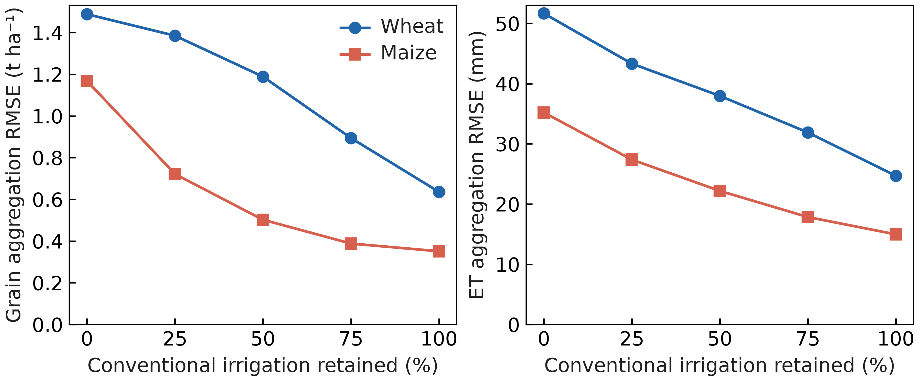
Figure S1. Current crop-model spatial aggregation errors under all five irrigation fractions in eight purposively selected cells during 2014–2025. Actual-cell and representative predictions share the current native model and crop parameters. These discrepancies assess spatial representation rather than field-observation accuracy.

S4. Annual field yields and irrigation-treatment contrasts
Annual Wuqiao grain targets comprise sixteen treatment-year means per crop in 2016–2019, digitized with standard errors from the primary Supplementary Figure S2. Grain retains its 13% moisture basis in comparisons. The twelve 2016–2018 means per crop enter calibration after a single multiplication by 0.87 to dry matter. The four 2019 means remain outside fitting and selection but had been inspected during earlier development. Four-year means summarize the same years and supply no additional independent targets.
Annual grain calibration RMSE is 1.249 t ha⁻¹ for wheat and 2.267 t ha⁻¹ for maize; retrospective-testing RMSE is 3.161 and 1.700 t ha⁻¹ at 13% moisture. Within-year W1–W3 minus W0 grain-contrast RMSE is 0.519 and 1.669 t ha⁻¹ in calibration and 1.316 and 1.323 t ha⁻¹ in 2019 (Table S5; Figure S2). Maize treatment labels retain preceding wheat management because maize irrigation is identical within each year.
All printed seasonal ET targets remain eligible after matching the 2016 maize rainfall period. Maize-season rainfall of 499.1 mm excludes the 100.5 mm during wheat from the 599.6-mm rotation total. Reconstructed balance residuals for W0–W3 are +0.1, +0.1, −0.9 and +0.1 mm. Source ET and depletion values remain unchanged. Storage-depletion diagnostics share the source ET balance and its unconfirmed exact sampling dates; they are conditional accounting comparisons rather than independent soil-water validation.
Table S5. Wuqiao annual grain and within-year treatment contrasts by fitting and testing partition.
Crop | Dataset | Comparison | N | RMSE (t/ha) | Bias (t/ha) | NSE | R²
Maize | Calibration (2016–2018) | Annual grain yield | 12 | 2.267 | -1.738 | -2.940 | 0.128
Maize | Calibration (2016–2018) | Within-year W1–W3 minus W0 | 9 | 1.669 | 0.296 | -0.788 | 0.076
Maize | Retrospective evaluation (2019) | Annual grain yield | 4 | 1.700 | 1.403 | -3.641 | 0.972
Maize | Retrospective evaluation (2019) | Within-year W1–W3 minus W0 | 3 | 1.323 | -0.836 | -1.403 | 1.000
Wheat | Calibration (2016–2018) | Annual grain yield | 12 | 1.249 | -0.445 | 0.746 | 0.817
Wheat | Calibration (2016–2018) | Within-year W1–W3 minus W0 | 9 | 0.519 | 0.064 | 0.857 | 0.882
Wheat | Retrospective evaluation (2019) | Annual grain yield | 4 | 3.161 | 3.108 | -4.654 | 0.870
Wheat | Retrospective evaluation (2019) | Within-year W1–W3 minus W0 | 3 | 1.316 | -1.312 | -0.712 | 0.994
Grain is at 13% moisture. Calibration comprises 2016–2018 and retrospective testing comprises 2019. Source means and standard errors are digitized from Supplementary Figure S2, with pixel tolerances near 0.043 t ha⁻¹ for wheat and 0.056 for maize. Contrasts compare W1–W3 with same-year W0. Four-year means overlap these annual targets; maize contrasts retain preceding wheat histories.
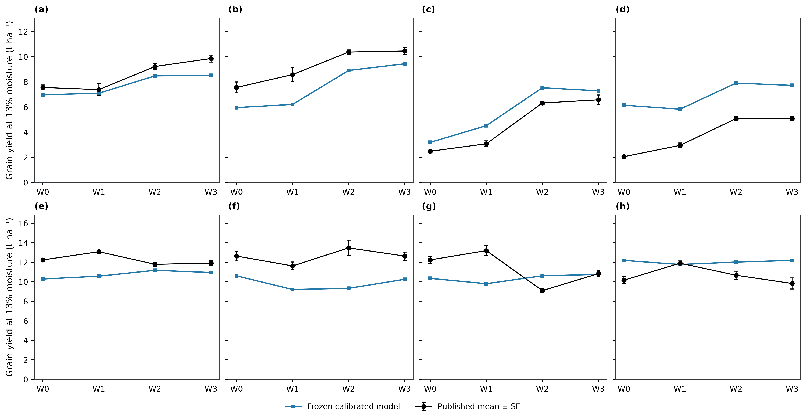
Figure S2. Annual Wuqiao grain at 13% moisture under the selected current parameters. Panels (a–d) show wheat and (e–h) maize; columns from left to right show 2016, 2017, 2018 and 2019. Black points and error bars are published means ± standard error of three replicates; blue squares show current predictions. The 2016–2018 treatment means contribute to water calibration after conversion to dry grain; 2019 is retrospective testing, excluded from fitting and selection. Maize irrigation is identical within each year and labels retain preceding wheat management. Source means and SE are digitized from Supplementary Figure S2 of the primary experiment.

S5. Class exposure, continuous states and rainfall-only controls
All nine common GRACE-available years occupy lower-storage classes; three other years use conventional fallback. The selected current quotas are identical across storage strata within each rainfall group. Matched rainfall-only and storage–rainfall histories have identical actions, crop states and outcomes throughout the modeled record.
Available-rainfall controls apply reduced quotas during monitoring gaps and therefore create different carried water states before later common years. These history effects are separate from the value of the storage classification. Table S7 reports all-year and common-year retention and water use; Table S8 reports the matched and available-rainfall controls.
Table S6. Class exposure and missing-storage coverage by period.
Period | Class | Unit-years | Years | Area–years (ha yr) | Area–year fraction
evaluation | Lower storage / lower rainfall | 174 | 9 | 55410278.787 | 0.468
evaluation | Lower storage / higher rainfall | 114 | 9 | 33389136.355 | 0.282
evaluation | Missing storage | 96 | 3 | 29599805.048 | 0.250
selection | Higher storage / lower rainfall | 68 | 6 | 19466918.675 | 0.179
selection | Higher storage / higher rainfall | 124 | 6 | 39732691.420 | 0.366
selection | Lower storage / lower rainfall | 109 | 5 | 34747673.179 | 0.320
selection | Lower storage / higher rainfall | 51 | 5 | 14585335.233 | 0.134
Table S7. Continuous class-adaptive irrigation evaluation during 2014–2025.
Strategy | Period | Years | Grain retained (%) | Irrigation cut (mm) | ET cut (mm) | Minimum grain (%)
Storage–rainfall 95% | Nine GRACE years | 9 | 96.270 | 130.721 | 36.842 | 92.115
Storage–rainfall 95% | All twelve years | 12 | 96.818 | 98.040 | 29.733 | 92.115
Storage–rainfall 98% | Nine GRACE years | 9 | 99.626 | 35.721 | 6.171 | 98.579
Storage–rainfall 98% | All twelve years | 12 | 99.622 | 26.790 | 5.208 | 98.579
Conventional | Nine GRACE years | 9 | 100.000 | 0.000 | 0.000 | 100.000
Conventional | All twelve years | 12 | 100.000 | 0.000 | 0.000 | 100.000
Current continuous histories. Grain retention is a ratio of period-mean regional dry-grain production to conventional irrigation. ET includes crops and fallows. All-year summaries include conventional fallback; common-year summaries use the nine GRACE-available years.
Table S8. Continuous GRACE–rainfall and rainfall-only strategy comparison during 2014–2025.
Strategy | Period | Grain retained (%) | Irrigation (mm) | ET (mm)
Storage–rainfall 95% | Nine GRACE years | 96.27 | 249.279 | 848.527
Storage–rainfall 95% | All twelve years | 96.82 | 281.960 | 857.698
Storage–rainfall 98% | Nine GRACE years | 99.63 | 344.279 | 879.197
Storage–rainfall 98% | All twelve years | 99.62 | 353.210 | 882.223
Rainfall 95%, available | Nine GRACE years | 95.40 | 249.279 | 844.203
Rainfall 95%, available | All twelve years | 95.04 | 248.565 | 842.945
Rainfall 95%, matched | Nine GRACE years | 96.27 | 249.279 | 848.527
Rainfall 95%, matched | All twelve years | 96.82 | 281.960 | 857.698
Rainfall 98%, available | Nine GRACE years | 99.41 | 344.279 | 878.151
Rainfall 98%, available | All twelve years | 99.36 | 343.565 | 879.669
Rainfall 98%, matched | Nine GRACE years | 99.63 | 344.279 | 879.197
Rainfall 98%, matched | All twelve years | 99.62 | 353.210 | 882.223
Matched controls share the complete GRACE-availability and fallback calendar. Available-rainfall controls act during missing-storage years and alter subsequent soil states. All values use current parameters; differences do not identify causal groundwater responses.
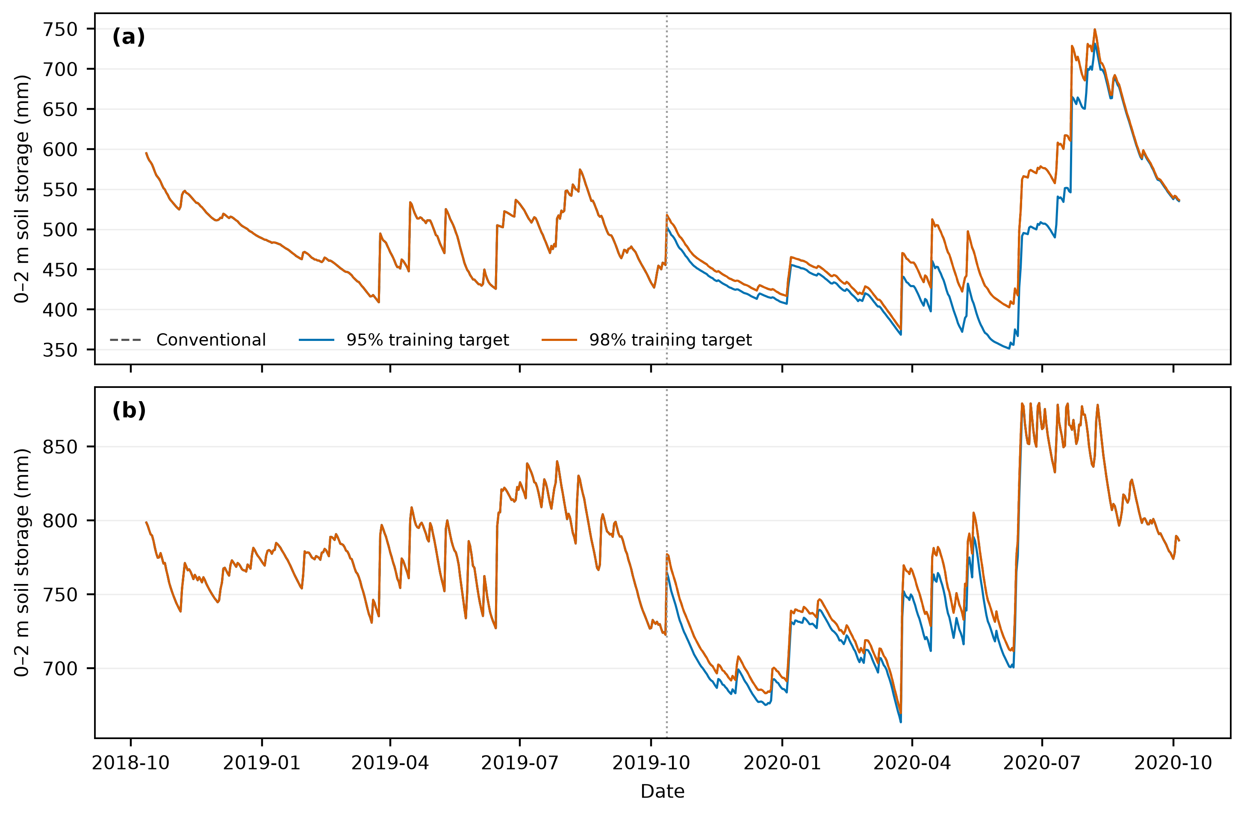
Figure S3. Simulated 0–2 m soil-water storage in representative units (a) 0 and (b) 31. State carries continuously through wheat, maize, fallows and annual irrigation choices. Displayed histories compare conventional irrigation with selected current strategies; they are model states rather than observed groundwater levels.

S6. Harvest data quality and crop model recalibration
Original Yucheng harvest sources contain identical six-replicate maize vectors in 2012 and 2017 under different date and cultivar labels. Both groups are retained as raw evidence and excluded from scored grain and harvest biomass. Eligibility depends on source authenticity rather than model residuals. Current plots preserve observed quadrat variation and the original whole site-year partitions (Figure S4).
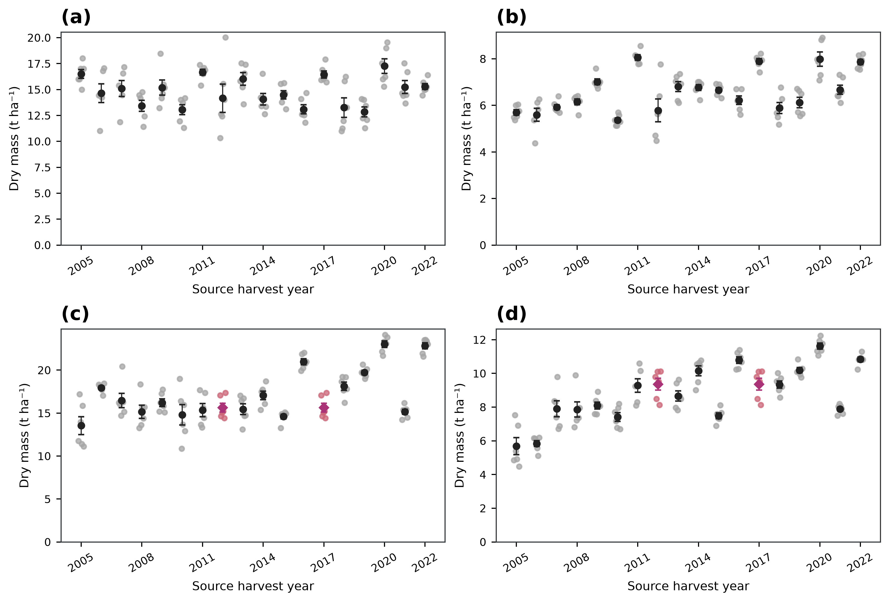
Figure S4. Original Yucheng harvest observations at YCAZH01ABC_01. Panels (a, b) show wheat aboveground biomass and grain; panels (c, d) show maize aboveground biomass and grain. Faint points are six quadrat observations; dark markers and error bars are means ± replicate standard error. Magenta diamonds identify the identical full maize source vectors in 2012 and 2017. Raw values remain displayed for source inspection; both groups are excluded from comparisons with quality-controlled observations. Error bars describe sampling variation, rather than model or policy uncertainty.

S7. Spatial decomposition under the common irrigation budget
Frozen area shares weight complete current irrigation histories before spatial aggregation. Dry-grain differences in kg ha⁻¹ multiply represented hectares and divide by 1,000 for tonnes; water depths multiply hectares by 10 for cubic metres. Independent sums reproduce regional contrasts. Latitude bands describe the distribution of gains and losses, while the 3,641 mapped cells inherit 32 simulated representative responses (Table S9).
Table S9. Spatial decomposition at a common 50% regional irrigation reduction during 2014–2025.
Latitude band | Area share (%) | Targeted irrigation fraction | Grain change (t ha⁻¹) | ET change (mm) | Grain contribution (Mt)
Southern (32–36°N) | 60.733 | 0.305 | -0.357 | -25.599 | -2.142
Central (36–38°N) | 31.369 | 0.799 | 2.415 | 93.497 | 7.475
Northern (38–41°N) | 7.897 | 0.813 | 2.420 | 88.358 | 1.886
Current targeted-minus-uniform means at the same 50% regional irrigation cut. Latitude bands are reporting partitions. Source cells inherit representative responses and are not independent observations.

S8. Seasonal crop trajectories and harvest outcomes
Current seasonal curves use the selected frozen parameters and all sites with eligible observations for each variable. Observation and prediction channels share windows, case identities and aggregation weights. Bins span 15 days for wheat and 7 days for maize; site-year contributions and populations can change among bins. Standard errors describe variation across site-year means and are omitted for single-year bins. Missing bins remain gaps. Unbinned records determine performance scores (Figures S6–S11).
The original station calibration partitions retain earlier growth-fitting history; all station comparisons are conditional on unconfirmed complete irrigation management. Station observations have no weight in the latest water fit. Yucheng has no eligible in-season biomass evaluation observations, while its harvest-biomass endpoints remain separately available. Figure S5 shows dry-grain and aboveground harvest means with quadrat SE. Six samples within a crop-year describe sampling variation, and the duplicated 2012 and 2017 maize groups remain excluded. Exact case availability, site-specific metrics, bin contributions and harvest source rows accompany the figures.
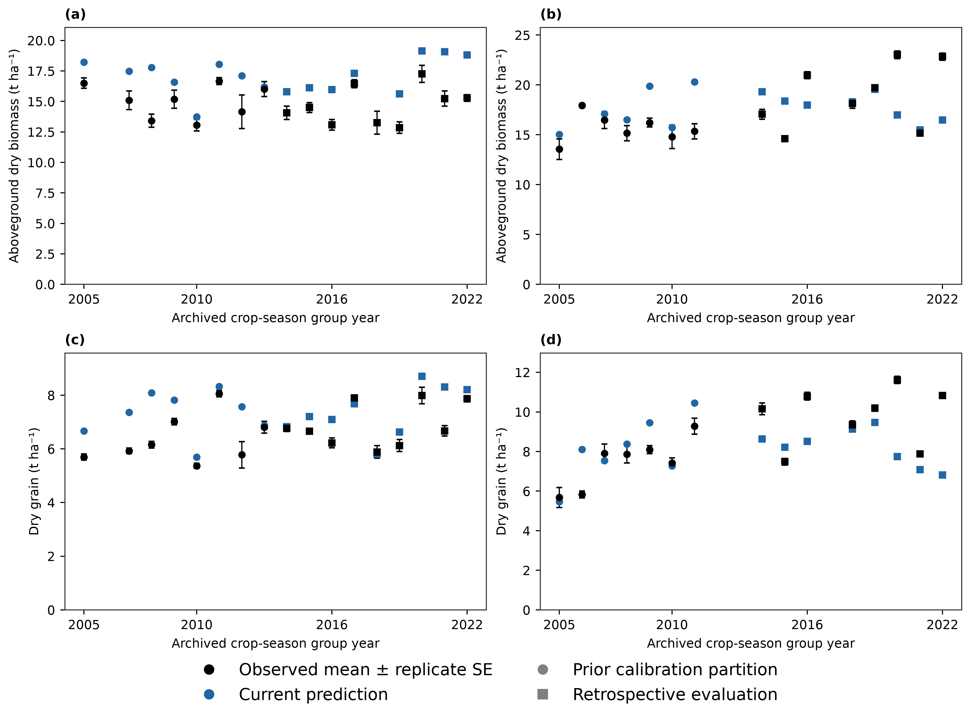
Figure S5. Conditional Yucheng harvest comparisons. Wheat occupies the left column and maize the right; the top row shows aboveground biomass and the bottom row grain. Black points show observed means ± standard errors among six quadrat samples per crop-year; blue points show current coupled-model predictions at the same sampling windows. Circles and squares distinguish the original calibration and retrospective-evaluation partitions. Grain and total aboveground biomass are dry matter. The duplicated maize 2012 and 2017 source vectors remain excluded. Within-year replicates describe spatial sampling variation and are not independent crop seasons. Management completeness remains unconfirmed and current water coefficients use Wuqiao fitting targets, while growth coefficients retain their earlier multisite fitting history.
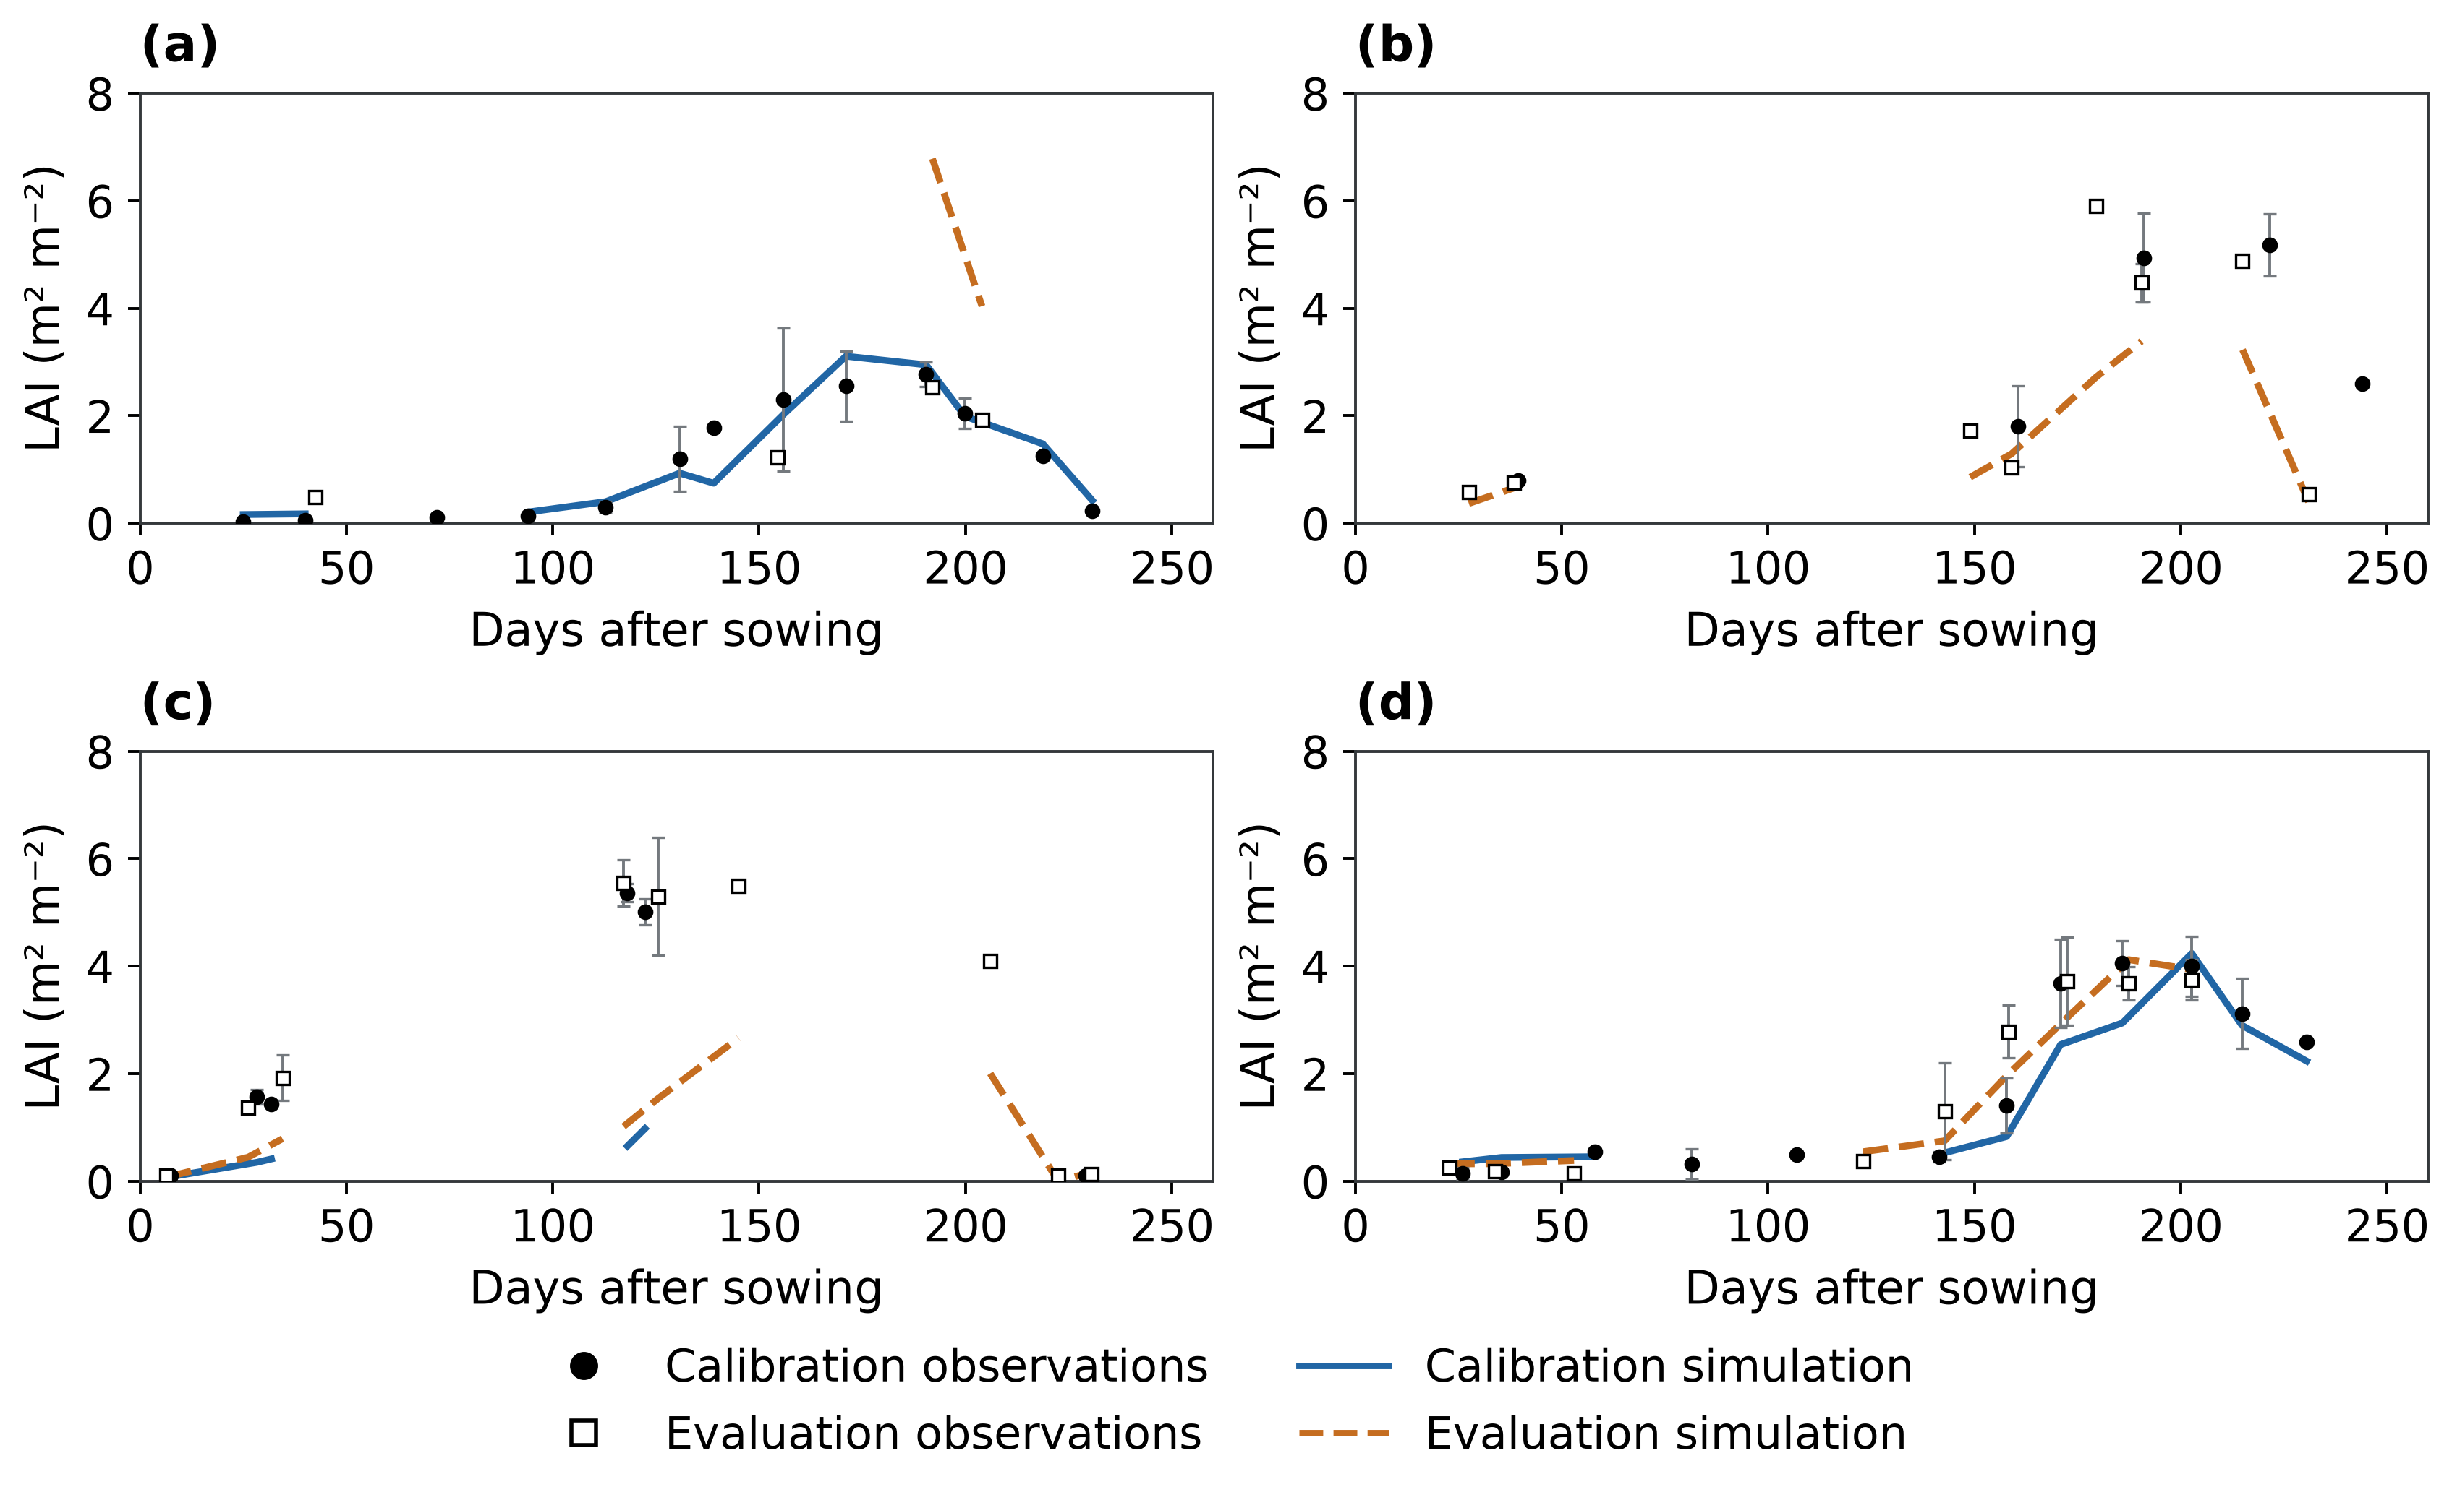
Figure S6. Site-specific wheat LAI comparisons: (a) Fengqiu; (b) Luancheng; (c) Shangqiu; (d) Yucheng. Calibration and retrospective-evaluation observations and simulations share the same axes within each site. Error bars describe site-year standard errors; gaps are retained. The observations, weighting and conditional management interpretation follow Figure 4.
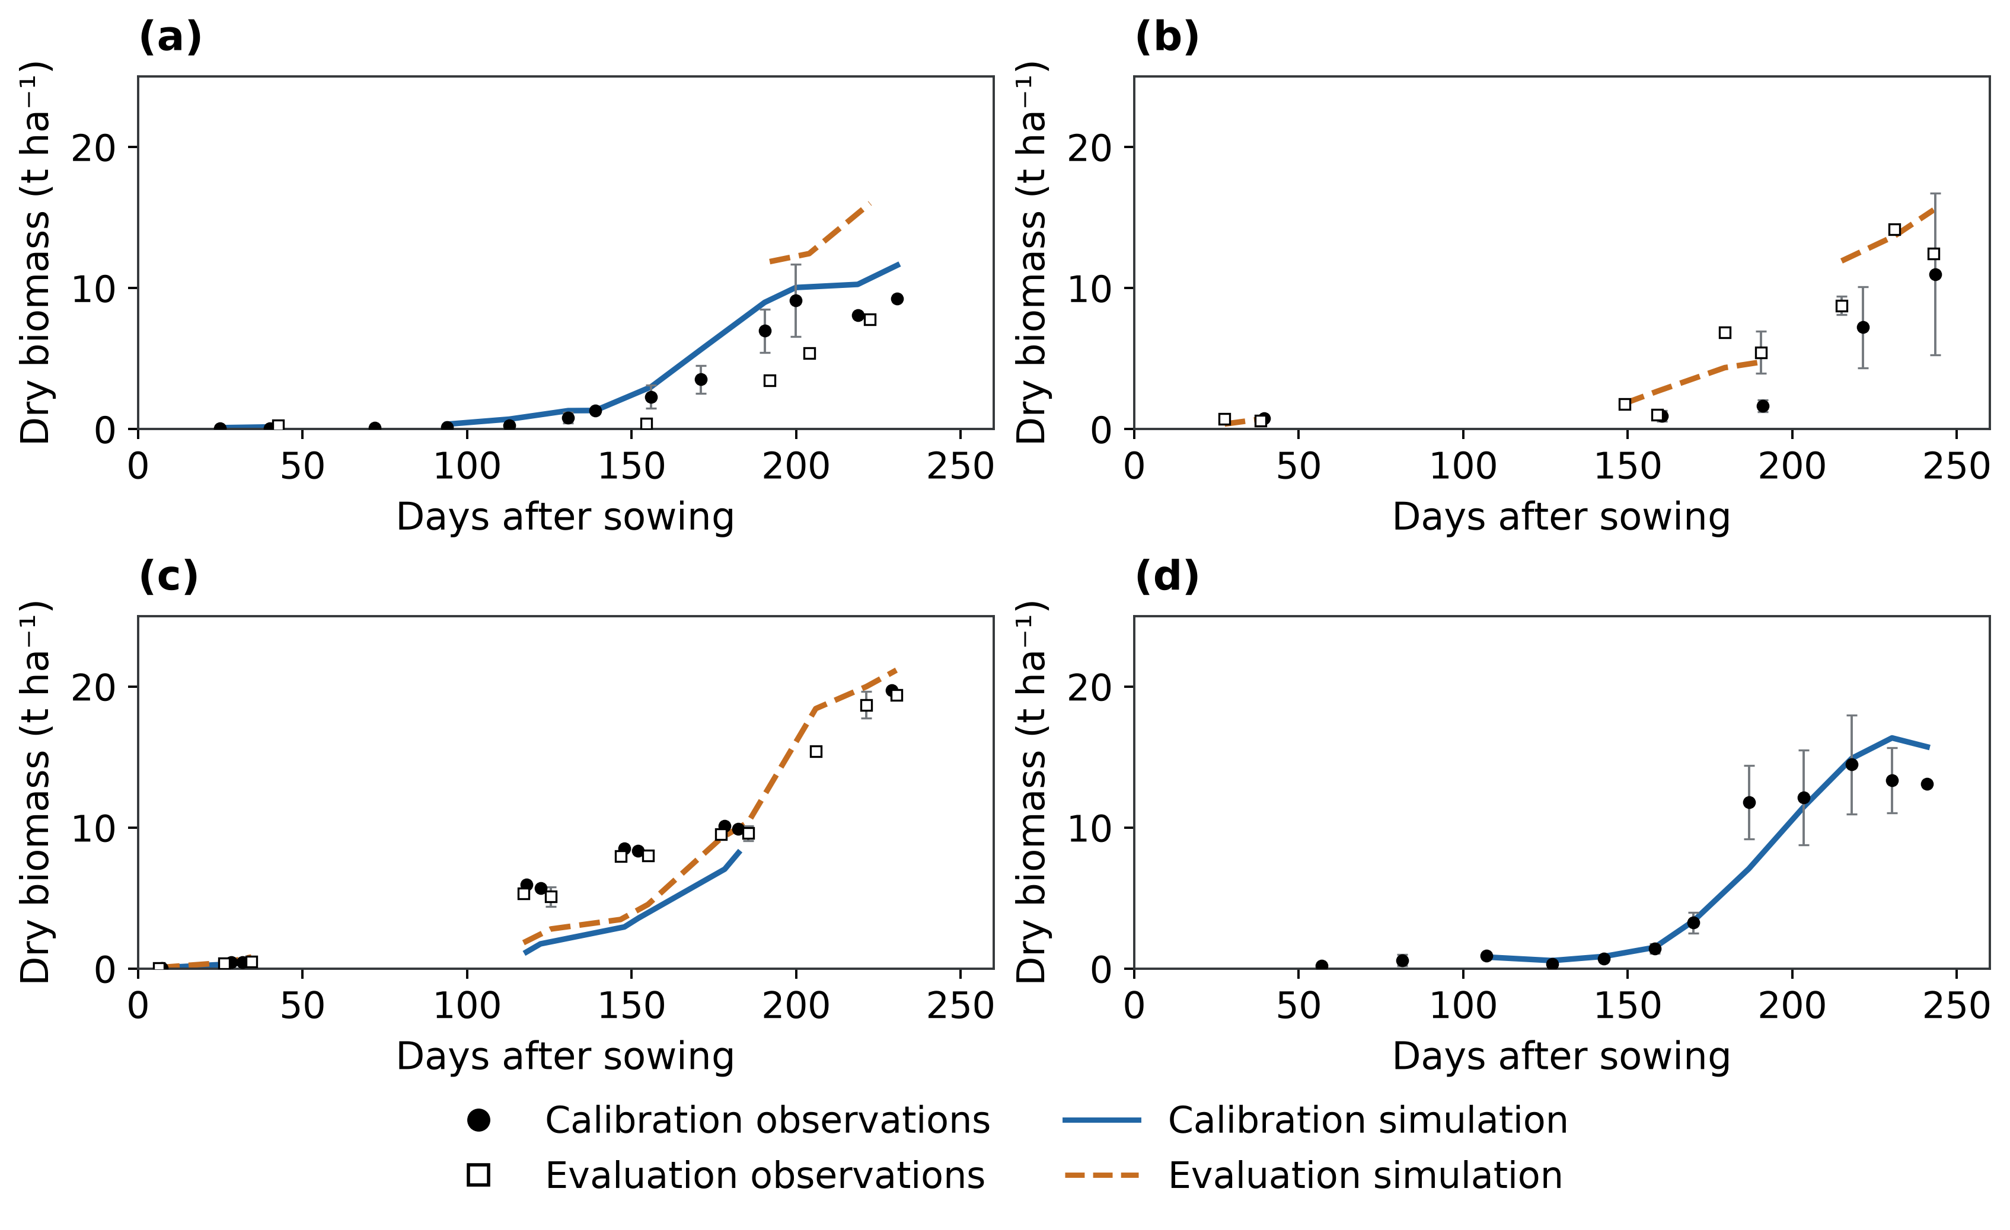
Figure S7. Site-specific wheat aboveground biomass comparisons: (a) Fengqiu; (b) Luancheng; (c) Shangqiu; (d) Yucheng. Calibration and retrospective-evaluation observations and simulations share the same axes within each site. Error bars describe site-year standard errors; gaps are retained. The observations, weighting and conditional management interpretation follow Figure 4.
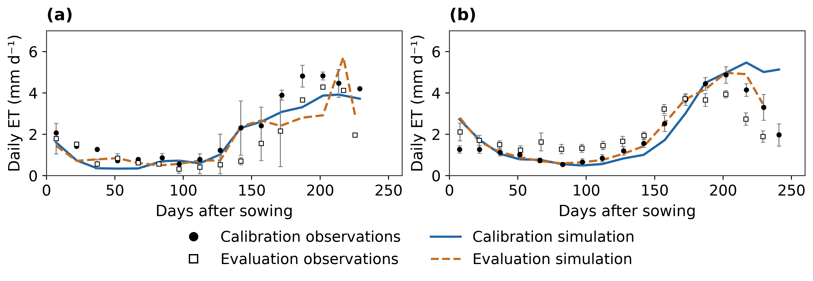
Figure S8. Site-specific wheat ET comparisons: (a) Fengqiu; (b) Yucheng. Calibration and retrospective-evaluation observations and simulations share the same axes within each site. Error bars describe site-year standard errors; gaps are retained. The observations, weighting and conditional management interpretation follow Figure 4.
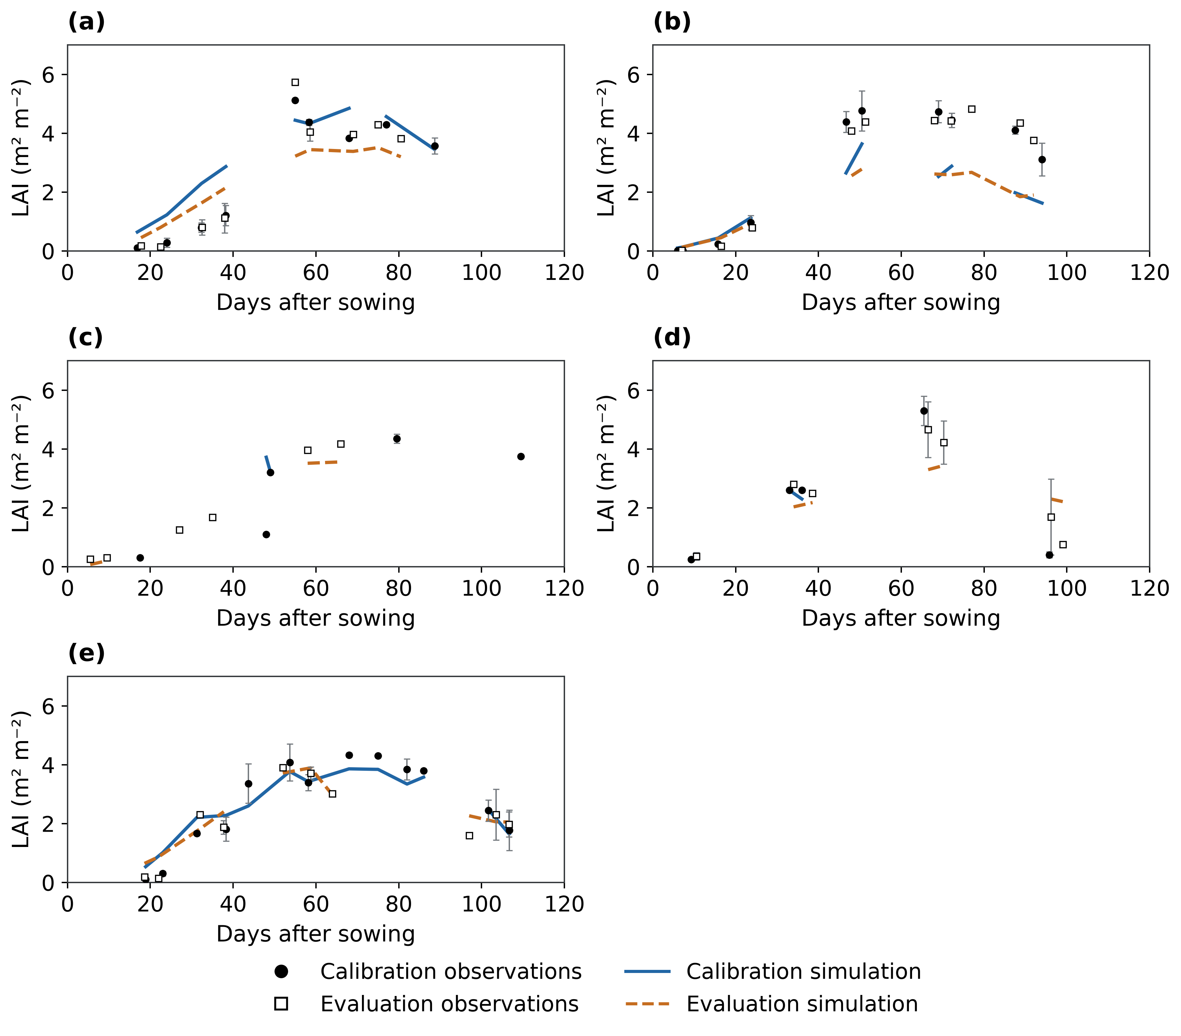
Figure S9. Site-specific maize LAI comparisons: (a) Fengqiu; (b) Gucheng; (c) Luancheng; (d) Shangqiu; (e) Yucheng. Calibration and retrospective-evaluation observations and simulations share the same axes within each site. Error bars describe site-year standard errors; gaps are retained. The observations, weighting and conditional management interpretation follow Figure 4.
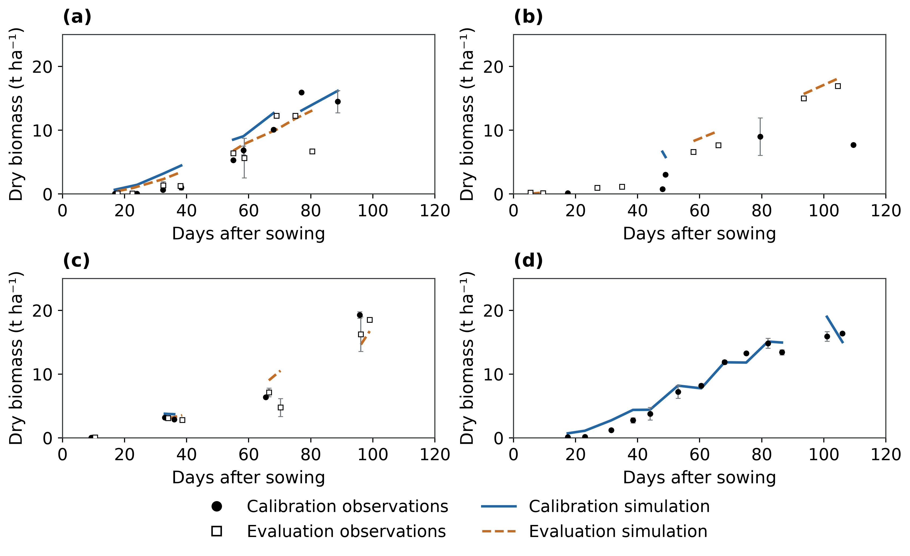
Figure S10. Site-specific maize aboveground biomass comparisons: (a) Fengqiu; (b) Luancheng; (c) Shangqiu; (d) Yucheng. Calibration and retrospective-evaluation observations and simulations share the same axes within each site. Error bars describe site-year standard errors; gaps are retained. The observations, weighting and conditional management interpretation follow Figure 4.
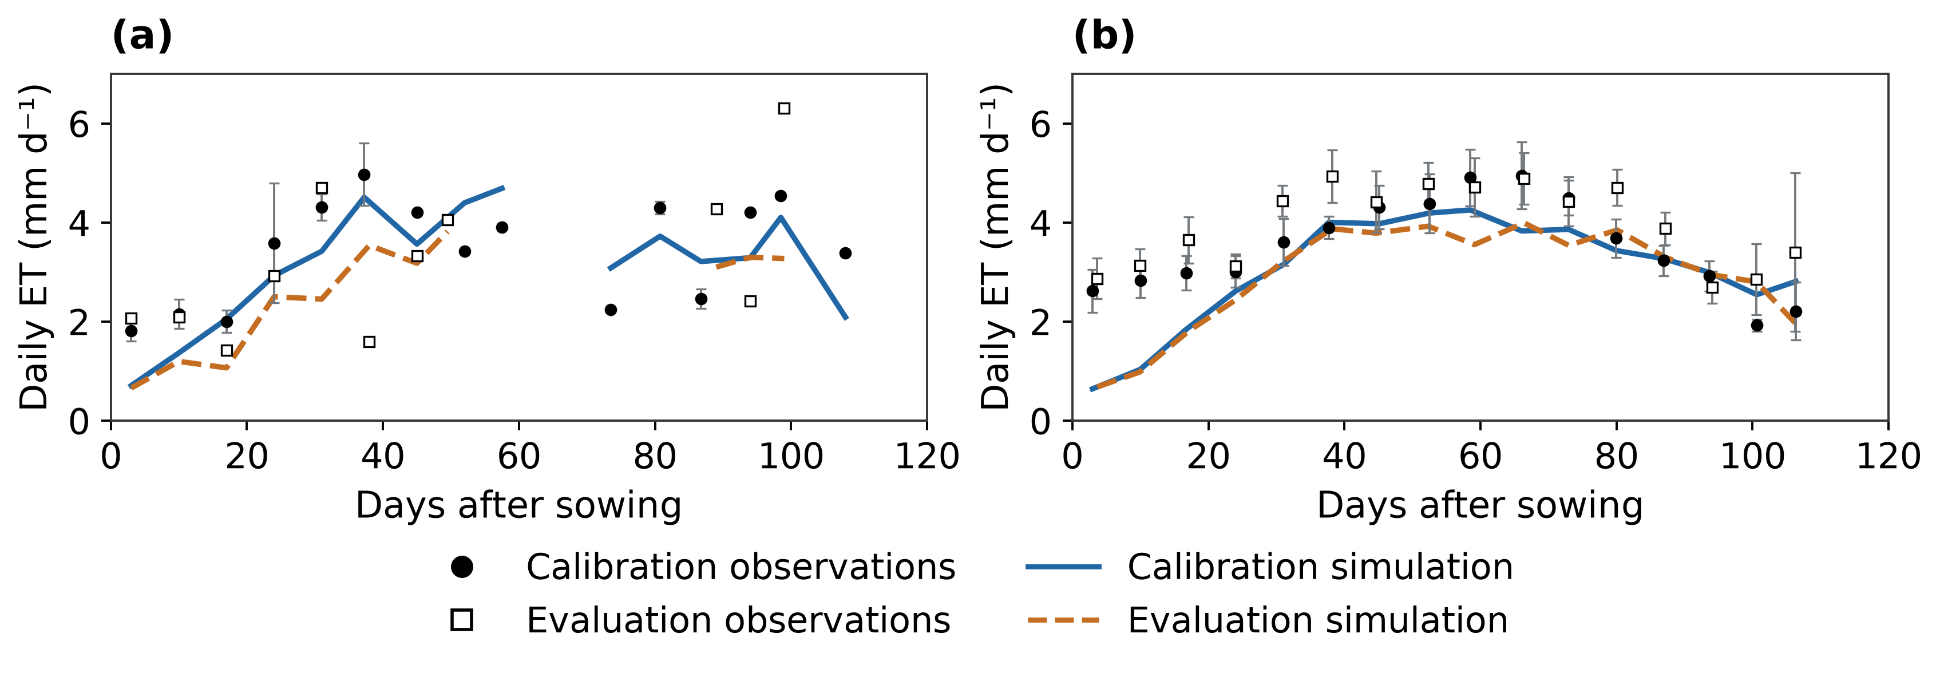
Figure S11. Site-specific maize ET comparisons: (a) Fengqiu; (b) Yucheng. Calibration and retrospective-evaluation observations and simulations share the same axes within each site. Error bars describe site-year standard errors; gaps are retained. The observations, weighting and conditional management interpretation follow Figure 4.

References
Yang, X., Wang, G., Chen, Y., Sui, P., Pacenka, S., Steenhuis, T.S., Siddique, K.H.M., 2022. Reduced groundwater use and increased grain production by optimized irrigation scheduling in winter wheat–summer maize double cropping system—A 16-year field study in North China Plain. Field Crops Res. 275, 108364. https://doi.org/10.1016/j.fcr.2021.108364
Yang, L., Fang, X., Zhou, J., Zhao, J., Hou, X., Yang, Y., Zang, H., Zeng, Z., 2024. Optimal irrigation for wheat-maize rotation depending on precipitation in the North China Plain: Evidence from a four-year experiment. Agric. Water Manag. 294, 108726. https://doi.org/10.1016/j.agwat.2024.108726
Zhang, X., Chen, S., Sun, H., Shao, L., Wang, Y., 2011. Changes in evapotranspiration over irrigated winter wheat and maize in North China Plain over three decades. Agric. Water Manag. 98, 1097–1104. https://doi.org/10.1016/j.agwat.2011.02.003
Wu, D., Fang, S., Li, X., He, D., Zhu, Y., Yang, Z., Xu, J., Wu, Y., 2019. Spatial-temporal variation in irrigation water requirement for the winter wheat-summer maize rotation system since the 1980s on the North China Plain. Agric. Water Manag. 214, 78–86. https://doi.org/10.1016/j.agwat.2019.01.004
Ren, P., Huang, F., Li, B., 2022. Spatiotemporal patterns of water consumption and irrigation requirements of wheat-maize in the Huang-Huai-Hai Plain, China and options of their reduction. Agric. Water Manag. 263, 107468. https://doi.org/10.1016/j.agwat.2022.107468
Xiao, L., Wang, G., Wang, E., Liu, S., Chang, J., Zhang, P., Zhou, H., Wei, Y., Zhang, H., Zhu, Y., Shi, Z., Luo, Z., 2024. Spatiotemporal co-optimization of agricultural management practices towards climate-smart crop production. Nature Food 5, 59–71. https://doi.org/10.1038/s43016-023-00891-x
Jiang, Y., Xu, X., Huang, Q., Huo, Z., Huang, G., 2016. Optimizing regional irrigation water use by integrating a two-level optimization model and an agro-hydrological model. Agricultural Water Management 178, 76–88. https://doi.org/10.1016/j.agwat.2016.08.035
Perry, C., Steduto, P., Allen, R.G., Burt, C.M., 2009. Increasing productivity in irrigated agriculture: Agronomic constraints and hydrological realities. Agric. Water Manag. 96, 1517–1524. https://doi.org/10.1016/j.agwat.2009.05.005
Grafton, R.Q., Williams, J., Perry, C.J., Molle, F., Ringler, C., Steduto, P., Udall, B., Wheeler, S.A., Wang, Y., Garrick, D., Allen, R.G., 2018. The paradox of irrigation efficiency. Science 361, 748–750. https://doi.org/10.1126/science.aat9314
Chen, C., Wang, E., Yu, Q., 2010. Modelling the effects of climate variability and water management on crop water productivity and water balance in the North China Plain. Agric. Water Manag. 97, 1175–1184. https://doi.org/10.1016/j.agwat.2008.11.012
Fang, Q.X., Ma, L., Flerchinger, G.N., Qi, Z., Ahuja, L.R., Xing, H.T., Li, J., Yu, Q., 2014. Modeling evapotranspiration and energy balance in a wheat–maize cropping system using the revised RZ-SHAW model. Agricultural and Forest Meteorology 194, 218–229. https://doi.org/10.1016/j.agrformet.2014.04.009
Cammarano, D., Rötter, R.P., Asseng, S., Ewert, F., Wallach, D., Martre, P., Hatfield, J.L., Jones, J.W., Rosenzweig, C., Ruane, A.C., Boote, K.J., Thorburn, P.J., Kersebaum, K.C., Aggarwal, P.K., Angulo, C., Basso, B., Bertuzzi, P., Biernath, C., Brisson, N., Challinor, A.J., Doltra, J., Gayler, S., Goldberg, R., Heng, L., Hooker, J., Hunt, L.A., Ingwersen, J., Izaurralde, R.C., Müller, C., Kumar, S.N., Nendel, C., O’Leary, G.J., Olesen, J.E., Osborne, T.M., Palosuo, T., Priesack, E., Ripoche, D., Semenov, M.A., Shcherbak, I., Steduto, P., Stöckle, C.O., Stratonovitch, P., Streck, T., Supit, I., Tao, F., Travasso, M., Waha, K., White, J.W., Wolf, J., 2016. Uncertainty of wheat water use: Simulated patterns and sensitivity to temperature and CO2. Field Crops Research 198, 80–92. https://doi.org/10.1016/j.fcr.2016.08.015
Save, H., Bettadpur, S., Tapley, B.D., 2016. High‐resolution CSR GRACE RL05 mascons. Journal of Geophysical Research: Solid Earth 121, 7547–7569. https://doi.org/10.1002/2016jb013007
Scanlon, B.R., Zhang, Z., Save, H., Wiese, D.N., Landerer, F.W., Long, D., Longuevergne, L., Chen, J., 2016. Global evaluation of new GRACE mascon products for hydrologic applications. Water Resources Research 52, 9412–9429. https://doi.org/10.1002/2016wr019494
Long, D., Xu, Y., Cui, Y., Cui, Y., Butler, J.J., Dong, L., Wang, L., Liu, D., Wada, Y., Hu, L., Bai, G., Li, B., Wang, S., Nong, X., Cai, Y., Cheng, C., Mu, Y., Qiao, Y., Wang, J., Wang, H., Scanlon, B.R., 2025. Unprecedented large-scale aquifer recovery through human intervention. Nat. Commun. 16, 7296. https://doi.org/10.1038/s41467-025-62719-5
Xu, Y., Long, D., Jiang, W., Cui, Y., Chen, F., Wang, J., Wada, Y., 2026. Quantifying Human and Climatic Contributions of Large‐Scale Groundwater Recovery in the North China Plain. Water Resour. Res. 62, e2025WR043052. https://doi.org/10.1029/2025wr043052
NASA JPL, 2013. NASA Shuttle Radar Topography Mission Global 1 arc second. https://doi.org/10.5067/MEASURES/SRTM/SRTMGL1.003
Qiu, B., Hu, X., Chen, C., Tang, Z., Yang, P., Zhu, X., Yan, C., Jian, Z., 2022. Maps of cropping patterns in China during 2015–2021. Scientific Data. https://doi.org/10.1038/s41597-022-01589-8
Natural Earth, n.d. Natural Earth, 1:10m Admin 1 – States, Provinces (version 5.1.1).
Sun, H.-Y., Liu, C.-M., Zhang, X.-Y., Shen, Y.-J., Zhang, Y.-Q., 2006. Effects of irrigation on water balance, yield and WUE of winter wheat in the North China Plain. Agric. Water Manag. 85, 211–218. https://doi.org/10.1016/j.agwat.2006.04.008
ISRIC — World Soil Information, 2020. SoilGrids250m version 2.0.
Saxton, K.E., Rawls, W.J., 2006. Soil Water Characteristic Estimates by Texture and Organic Matter for Hydrologic Solutions. Soil Science Society of America Journal 70, 1569–1578. https://doi.org/10.2136/sssaj2005.0117
Copernicus Climate Change Service, 2020. Agrometeorological indicators from 1979 to present derived from reanalysis. https://doi.org/10.24381/CDS.6C68C9BB
Save, H., 2020. CSR GRACE and GRACE-FO RL06 Mascon Solutions v02. https://doi.org/10.15781/cgq9-nh24
Long, D., Yang, W., Scanlon, B.R., Zhao, J., Liu, D., Burek, P., Pan, Y., You, L., Wada, Y., 2020. South-to-North Water Diversion stabilizing Beijing’s groundwater levels. Nat. Commun. 11, 3665. https://doi.org/10.1038/s41467-020-17428-6
Kiniry, J.R., Jones, C.A., O'toole, J.C., Blanchet, R., Cabelguenne, M., Spanel, D.A., 1989. Radiation-use efficiency in biomass accumulation prior to grain-filling for five grain-crop species. Field Crops Research. https://doi.org/10.1016/0378-4290(89)90023-3
de Wit; Berghuijs, n.d.. Python Crop Simulation Environment: WOFOST leaf dynamics implementation [software]. Version Archived master-branch source snapshot. https://github.com/ajwdewit/pcse/blob/master/pcse/crop/leaf_dynamics.py (accessed 4 October 2026).
Tan, M., Gou, F., Stomph, T.J., Wang, J., Yin, W., Zhang, L., Chai, Q., van der Werf, W., 2020. Dynamic process-based modelling of crop growth and competitive water extraction in relay strip intercropping: Model development and application to wheat-maize intercropping. Field Crops Research 246, 107613. https://doi.org/10.1016/j.fcr.2019.107613
Allen, R.G., Pereira, L.S., Raes, D., Smith, M., 1998. Crop evapotranspiration: Guidelines for computing crop water requirements, FAO Irrigation and Drainage Paper. Food and Agriculture Organization of the United Nations, Rome.
van Genuchten, M.T., 1980. A Closed‐form Equation for Predicting the Hydraulic Conductivity of Unsaturated Soils. Soil Science Society of America Journal 44, 892–898. https://doi.org/10.2136/sssaj1980.03615995004400050002x
Mualem, Y., 1976. A new model for predicting the hydraulic conductivity of unsaturated porous media. Water Resources Research 12, 513–522. https://doi.org/10.1029/wr012i003p00513
APSIM Initiative, 2026. APSIM Next Generation (ApsimX): wheat and maize model definitions [software]. Version 074d15f. https://github.com/APSIMInitiative/ApsimX/tree/074d15f51889a386d3667acfed184d03e4e8f65f/Models/Resources (accessed 4 October 2026).
Nash, J.E., Sutcliffe, J.V., 1970. River flow forecasting through conceptual models part I — A discussion of principles. Journal of Hydrology 10, 282–290. https://doi.org/10.1016/0022-1694(70)90255-6
Wu, L., Min, L., Liu, M., Zhang, Y., Pei, H., Li, H., Zhang, G., Wang, S., Shen, Y., 2023. Monitoring of Thick Vadose Zone Water Dynamics Under Irrigation Using a 48 m Deep Caisson at the Luancheng Critical Zone Observatory. Water Resour. Res. 59, e2022WR032965. https://doi.org/10.1029/2022wr032965
Ines, A.V.M., Das, N.N., Hansen, J.W., Njoku, E.G., 2013. Assimilation of remotely sensed soil moisture and vegetation with a crop simulation model for maize yield prediction. Remote Sens. Environ. 138, 149–164. https://doi.org/10.1016/j.rse.2013.07.018
Roy, A., Narvekar, P., Murtugudde, R., Shinde, V., Ghosh, S., 2021. Short and Medium Range Irrigation Scheduling Using Stochastic Simulation‐Optimization Framework With Farm‐Scale Ecohydrological Model and Weather Forecasts. Water Resources Research 57, e2020WR029004. https://doi.org/10.1029/2020wr029004
Meier, U. (Ed.), 2018. Growth stages of mono- and dicotyledonous plants: BBCH Monograph. Julius Kühn-Institut, Quedlinburg. https://doi.org/10.5073/20180906-074619
de Wit, A., 2020. Parameter sets for the WOFOST 7.2/7.3 cropping system model for wheat.
de Wit, A., 2022. Parameter sets for the WOFOST 7.2/7.3 model for simulating maize.
Fu, Y., Dong, J., Shen, R., Peng, Q., Li, X., Zheng, Y., Pan, B., Dong, J., Qiu, B., Huang, J., Yuan, W., 2025. China Crop Dataset: A long-term and high-resolution crop distribution dataset in China. https://doi.org/10.57760/sciencedb.32361
Fu, Y., Dong, J., Shen, R., Peng, Q., Li, X., Zheng, Y., Pan, B., Dong, J., Qiu, B., Huang, J., Huang, X., Yuan, W., 2026. A 30-m annual distribution dataset of major crops in China from 2001-2024. Scientific Data 13, 1074. https://doi.org/10.1038/s41597-026-07370-5

