Supplementary material: Irrigation strategies under contrasting water-storage and rainfall conditions in the North China Plain
Linjia Yao^{1,†}, Bin Chen^{2,†}, Hao Feng², Qiang Yu^{2,*}, Gang Zhao^{2,*}
¹ College of Natural Resources and Environment, Northwest A&F University, Yangling 712100, China
² State Key Laboratory of Soil and Water Conservation and Desertification Control, College of Soil and Water Conservation Science and Engineering, Northwest A&F University, Yangling, Shaanxi 712100, China
† Linjia Yao and Bin Chen contributed equally to this work and share first authorship.
* Corresponding authors: Qiang Yu (yuq@nwafu.edu.cn) and Gang Zhao (gang.zhao@nwafu.edu.cn).

Supplementary methods and results

S1. Observation sources and eligibility
The station archive preserves 132 crop–plot–season trajectories, whole site-year partitions and source metadata. The 7,397 eligible records occur in 127 cases and retain all five observation sites for their available variables. Calibration and retrospective-evaluation trajectory counts remain 71 and 61. Variable-specific availability and missing combinations are retained in the accompanying case and site tables; missing measurements do not become zero observations.
Wheat LAI above 7 m² m⁻² remains excluded under the study-specific rule. Duplicated six-replicate maize harvest vectors in Yucheng 2012 and 2017 account for 24 excluded grain and biomass records, divided equally between the original calibration and evaluation partitions. These source-based exclusions retain raw values and do not depend on prediction residuals.
Earlier multisite growth estimates retain 480 wheat and 433 maize calibration observations. Current station growth and ET comparisons are conditional on archived management whose full irrigation-log completeness is unresolved. They have zero weight in the water-parameter fit. Wuqiao 2016–2018 supplies 12 documented treatment seasons per crop for that fit (Yang et al., 2024); 2019 supplies four retrospective testing seasons per crop. Seasonal ET, grain and biomass targets refer to the same treatment-season population, while ET contrasts are derived from those seasonal targets.
Twenty-six Fengqiu cases retain antecedent moisture initialization from the preceding calendar month. Complete fifteen-layer 0–1.5 m volumetric profiles map conservatively to the represented model layers, preserving depth-integrated storage. The identical eligibility rule applies to 11 original calibration and 15 evaluation cases. Monthly timing, aggregation and subplot support remain unresolved relative to the exact sowing-day state. Original cases remain available when a measured antecedent profile is absent.
Table S1. Crop seasons and calibration/evaluation case counts by site.
Site | Crop | Years | Calibration cases | Evaluation cases
Fengqiu | Maize | 2004, 2005, 2006, 2007, 2008 | 11 | 9
Fengqiu | Wheat | 2004, 2005, 2006, 2007, 2008 | 11 | 10
Gucheng | Maize | 2018, 2019, 2020 | 8 | 4
Luancheng | Maize | 2004, 2005, 2006, 2007, 2008 | 2 | 3
Luancheng | Wheat | 2004, 2005, 2006, 2007, 2008 | 2 | 3
Shangqiu | Maize | 2002, 2004, 2005, 2006, 2007 | 2 | 6
Shangqiu | Wheat | 2001, 2002, 2003, 2004, 2005, 2006, 2007 | 9 | 8
Yucheng | Maize | 1998, 2000, 2001, 2002, 2004, 2005, 2006, 2007, 2008, 2009, 2010, 2011, 2012, 2013, 2014, 2015, 2016, 2017, 2018, 2019, 2020, 2021, 2022 | 14 | 9
Yucheng | Wheat | 1999, 2000, 2004, 2005, 2006, 2007, 2008, 2009, 2010, 2011, 2012, 2013, 2014, 2015, 2016, 2017, 2018, 2019, 2020, 2021, 2022 | 12 | 9
Years denote archived crop-season groups, which retain all their plot cases. Coverage is intermittent; years absent from the table are not assumed to have observations.
Table S2. Source datasets for evaluated field observations.
Site | Dataset | DOI | Source
Fengqiu | 2004-2008年河南封丘站作物生育及生长动态监测数据 | 10.12199/nesdc.ecodb.mon.2020.dp2011.fqa.002 | National Ecosystem Science Data Center / Science Data Bank
Fengqiu | 2005-2008年河南封丘站农田土壤水分物理性质监测数据 | 10.12199/nesdc.ecodb.mon.2020.dp2011.fqa.006 | National Ecosystem Science Data Center / Science Data Bank
Gucheng | 2018–2021年华北北部不同播期对玉米生长发育的影响数据集 | 10.57760/sciencedb.o00119.00017 | National Ecosystem Science Data Center / Science Data Bank
Luancheng | 2000-2008年河北栾城站作物生育及生长动态监测数据 | 10.12199/nesdc.ecodb.mon.2020.dp2011.lca.002 | National Ecosystem Science Data Center / Science Data Bank
Shangqiu | 2000-2007年河南商丘站作物生育及生长动态监测数据 | 10.12199/nesdc.ecodb.mon.2020.dp2011.sqa.003 | National Ecosystem Science Data Center / Science Data Bank
Yucheng | 1998-2006年山东禹城站作物生育及生长动态监测数据 | 10.12199/nesdc.ecodb.mon.2020.dp2011.yca.003 | National Ecosystem Science Data Center / Science Data Bank
Yucheng | 禹城站2005-2022年生物要素观测数据集 | 10.12199/nesdc.ecodb.2021YFF0703900.yca.2025.2 | National Ecosystem Science Data Center / Science Data Bank
Yucheng | 禹城站2005-2022年水环境要素观测数据集 | 10.12199/nesdc.ecodb.2021YFF0703900.yca.2025.3 | National Ecosystem Science Data Center / Science Data Bank
Dataset DOIs identify official source records; original metadata and observation-row provenance are retained in the reproducibility archive.

S2. Crop processes, parameter definitions and water accounting

S2.1. Model structure and phenological development
Open Crop Model simulates phenology, green leaf area, live and dead aboveground biomass, grain dry matter, rooting depth and layered soil-water storage. Inputs comprise weather, soil profiles, crop parameters, dated sowing and harvest, and irrigation events. Soil water carries continuously between crop and fallow segments in regional histories; Wuqiao crop starts retain their separately specified storage conditioning.
Wheat stage development combines temperature, vernalization and photoperiod modifiers with inherited stage requirements. Maize uses a subdaily temperature response reconstructed from daily extrema, with base, optimum and maximum temperatures of 6, 30 and 44 °C. The shared medium-maturity maize card requires approximately 1,909 °C d to reach R6. DVS anchors are wheat BBCH 09, 61 and 89 and maize VE, R1 and R6 (Meier, 2018). Wheat dough stage and full ripeness retain their distinct definitions.
Seed-layer water above wilting-point storage permits germination. The represented layer is selected by sowing depth, with a 50-mm prior when no depth is supplied. Thermal development and wheat vernalization begin from the first eligible germination day rather than accumulating during dry-seed days. This layer-average availability is an effective establishment condition, not a measured seed-scale water potential. Fixed stage coefficients therefore do not imply fixed calendar-stage predictions across water states. New biomass production ends at wheat full ripeness or maize physiological maturity; green maize area can persist under the terminal senescence rate until harvest. Harvest is a separate management endpoint and does not substitute for an observed maturity date.

S2.2. Canopy development, biomass accumulation and grain yield
Green cover is $f_{c}=1−exp(−k_{L}LAI)$. Daily aboveground dry-matter production is $ΔB=10R_{s}p_{PAR}f_{c}εf_{T}f_{W}^{γ}f_{N}$, where $R_{s}$ is incident shortwave radiation, $p_{PAR}=0.45$, ε is RUE per MJ of intercepted PAR, $f_{T}$ is the temperature modifier, $f_{N}$ is the prescribed nutrition factor and $f_{W}$ is realized transpiration divided by remaining potential transpiration demand after wet-canopy evaporation. The factor 10 converts g m⁻² to kg ha⁻¹. PAR enters once (Kiniry et al., 1989). The fitted empirical assimilation exponents are 1.85985 for wheat and 0.25000 for maize. They govern carbon response separately from leaf-expansion and leaf-survival sensitivity.
SLA is linearly interpolated through DVS 0, 0.5, 1 and 2, with the DVS-2 value equal to DVS 1. New leaf dry matter acquires area using current SLA; established cohorts retain their birth area-to-mass ratio (de Wit and Berghuijs, n.d.). Thermal senescence hazard $h(DVS)$ is interpolated through DVS 0, 1, 1.4, 1.7 and 2, with a constant preflowering rate and increasing grain-filling rates (Tan et al., 2020). Daily survival is $exp\left[−h(DVS)max(T_{mean}−T_{base},0)\right](1−q_{s})$, with $q_{s}=0.025(1−f_{W}f_{N})$. The terminal hazard continues at maize R6, whereas wheat BBCH 89 senesces remaining green leaves. LAI emerges from the cohort area balance; no maximum-LAI parameter or cap enters this formulation.
Leaf allocation follows crop development, with separate early and late vegetative multipliers for maize and additional temperature, water-supply and nutrition limits on leaf expansion. Initial LAI is an emergence condition. Stage-specific SLA and senescence coefficients retain their inherited estimates and conditional trait priors (APSIM Initiative, 2026; de Wit, 2022; de Wit, 2020); their values do not represent universal physiological bounds.
Grain number is fixed at the first grain-set day as $N_{g}=0.1B_{f}c_{g}$, where $B_{f}$ is simulated aboveground dry mass immediately before grain set and $c_{g}$ is the grain-number coefficient. Grain set starts at wheat BBCH 61 and maize R1. Maximum grain dry mass is $Q_{g}=10N_{g}m_{g}$, with fixed $m_{g}$ of 0.045 g grain⁻¹ for wheat and 0.300 g grain⁻¹ for maize (APSIM Initiative, 2026). Assimilate supply and development-dependent filling capacity constrain grain accumulation. Wheat remobilization transfers an explicit subset of stem mass to grain while conserving total aboveground mass. Live and dead leaves, stems and grain remain in the aboveground carbon pool; observed yield or harvest index does not initialize grain.
Prescribed nutrition factors distinguish archived fertilized and unfertilized management classes. Wuqiao and regional simulations retain the fertilized class. These factors describe effective growth limitations; the model does not resolve a mechanistic nitrogen balance.

S2.3. Soil-water balance and actual evapotranspiration
Potential transpiration and exposed-soil evaporation are $T_{p}=K_{T}{ET}_{0}f_{c}$ and $E_{p}=K_{E}{ET}_{0}(1−f_{c})$, with ${ET}_{0}$ supplied by AgERA5. Rainfall interception fills a canopy store of capacity 1 mm × $f_{c}$. Wet-canopy evaporation reduces the transpiration demand remaining within each outer water step. Actual ET is $T_{a}+E_{s}+E_{c}$, the sum of transpiration, soil evaporation and canopy evaporation. Wuqiao residue cover is unmeasured and its exposed-soil boundary is retained; prescribed organic mulch, where supplied, reduces potential soil evaporation using the FAO-56 cover approximation (Allen et al., 1998).
Two-stage evaporation depends on actual surface-layer storage. Total evaporable water is $TEW=(θ_{FC}−θ_{AD})Δz_{1}$ and readily evaporable water is $REW=0.30TEW$. Surface depletion is $D_{e}=(θ_{FC}−θ_{1})Δz_{1}$. The evaporation reduction is $K_{r}=min\left[1,max\left(0,\frac{TEW−D_{e}}{TEW−REW}\right)\right]$, with actual extraction bounded by storage above air dry. Ponded water evaporates before soil storage. This storage closure follows the two-stage drying principle (Allen et al., 1998) without resolving a complete dual-crop-coefficient surface balance.
Root activity integrates an exponential depth distribution over rooted parts of each layer and is normalized over the represented rooted volume. Local depletion stress is $s_{i}=min\left[1,\frac{max(0,W_{i}−θ_{WP,i}Δz_{i})}{(1−p)(θ_{FC,i}−θ_{WP,i})Δz_{i}}\right]$, where p is the fitted readily available water fraction. Base uptake combines root activity, local stress, atmospheric demand and the daily extraction coefficient; accessible storage and extraction capacity bound each contribution. The compensation fraction allocates a bounded part of unmet demand to rooted layers whose stress factors equal or exceed the activity-weighted mean. Total uptake remains bounded by demand times the best rooted-layer stress factor and by available extraction capacity. Compensation redistributes demand and does not eliminate uniformly dry-profile stress.
Effective saturation is $S_{e}=\frac{θ−θ_{AD}}{θ_{SAT}−θ_{AD}}$. With $m=1−\frac{1}{n}$, the retention relation is $S_{e}={\left[1+(α|h|)^{n}\right]}^{−m}$ (van Genuchten, 1980), and conductivity is $K=K_{sat}S_{e}^{1/2}{\left[1−{\left(1−S_{e}^{1/m}\right)}^{m}\right]}^{2}$ (Mualem, 1976; van Genuchten, 1980). Adjacent half-layer saturated resistances define $K_{sat,face}=\frac{d}{\frac{Δz_{i}}{2K_{sat,i}}+\frac{Δz_{i+1}}{2K_{sat,i+1}}}$, where $d=\frac{Δz_{i}+Δz_{i+1}}{2}$. Relative-arithmetic face mobility is $r_{face}=\frac{Δz_{i+1}r_{i}+Δz_{i}r_{i+1}}{Δz_{i}+Δz_{i+1}}$, with $r_{i}=\frac{K_{i}}{K_{sat,i}}$. Thus $K_{face}=K_{sat,face}r_{face}$. This interface approximation permits a wet layer to supply a dry neighbor while retaining the resistance of low-conductivity material.
Signed interface flux is $q_{i}=K_{face}\left[1+\frac{h_{i}−h_{i+1}}{d}\right]$, positive downward. Transfers have equal and opposite contributions in neighboring layer balances and are bounded by donor storage and receiving pore capacity. Twenty-four outer steps partition daily forcing, evaporation and uptake; adaptive internal transport steps limit net θ increments to 0.005. The free-drainage bottom flux equals the current unsaturated conductivity under unit hydraulic gradient. Upward redistribution is an internal profile flux, with no external capillary-rise supply. This bounded explicit layered approximation does not resolve the full implicit Richards system or saturated positive pressure.
For a field of profile storage S, the accounting identity is $ΔS=P+I−{ET}_{a}−D−Q$. Applied irrigation I is a field-boundary input. Flood-irrigation scenarios wet the entire field, with application, drift and conveyance losses set to zero at that boundary. Drainage D leaves the modeled profile and is distinct from water reaching an aquifer after deeper vadose-zone transport (Wu et al., 2023).

S2.4. Hydraulic derivation, shared crop parameters and numerical checks
Saxton–Rawls equations use normalized sand and clay fractions and organic matter percent (Saxton and Rawls, 2006). SoilGrids carbon in dg kg⁻¹ is converted to organic matter percent by $\frac{1.724×SOC}{100}$; bulk density in cg cm⁻³ is divided by 100; coarse fragments in permille are divided by 1,000 (ISRIC — World Soil Information, 2020). Regional porosity uses $1−\frac{BD}{2.65}$, with prescribed density and gravel adjustments. Air-dry water content retains its declared prior. Field-capacity, wilting-point and saturation ordering is checked before simulation; unavailable complete profiles remain excluded under the spatial-source rule.
The van Genuchten α and n values are conditional hydraulic priors reconstructed from supplied field-capacity and wilting-point endpoints at pressure heads of −3,300 and −150,000 mm, with $θ_{AD}$ as residual water and $θ_{SAT}$ as saturated content. Endpoint reconstruction preserves those storage thresholds rather than fitting curves to crop outcomes. Neither depth-resolved Wuqiao retention measurements nor exact seasonal initial layer distributions are available. The separate Wuqiao particle-density prior is 2.75 g cm⁻³.
Table S3 contains effective shared crop values after applying the frozen fit multipliers. Regional and Wuqiao inputs use identical shared cards within each crop. Maximum root depth is limited by the supplied profile depth. Stage-specific SLA and senescence, fixed grain mass and inherited growth coefficients remain distinct from the eight water coefficients fitted in the current run. Near-zero root-density decay yields approximately uniform activity over represented rooted volume; it does not identify an observed root-mass profile.
The 164 selected station and field trajectories conserve daily water and aboveground carbon, with maximum absolute residuals of 1.00 × 10⁻¹² mm and 6.71 × 10⁻¹² kg ha⁻¹. Exact inputs, observation identities, frozen parameters, source snapshots and SHA-256 provenance accompany the predictions. Conservation establishes arithmetic consistency; hydraulic and crop-response accuracy depend on the conditional observations and retrospective field test.
Eight existing water-response coefficients per crop are estimated from documented Wuqiao management in 2016–2018: the transpiration multiplier, soil evaporation coefficient, readily available water fraction, assimilation water-stress exponent, root-density decay, maximum rooting depth, log₁₀ daily root extraction coefficient and root compensation fraction. RUE, leaf allocation and grain-number multipliers remain fixed. Each crop contributes 12 seasonal ET, 12 dry-grain and 12 dry-biomass targets, together with three W3−W0 ET contrasts derived from the same seasonal targets. The criterion retains weights of 0.325, 0.175, 0.15 and 0.10 for those components. ET residual scales are max(50 mm, 0.15 × observed ET); grain and biomass scales are max(1,000 kg ha⁻¹, 0.20 × observed dry mass). Contrast residuals use 50 mm. Eight coefficient-prior terms have total weight 0.01, with inherited bounds, centres and scales.
Bounded least squares starts from the inherited water vector, with coefficients scaled to their prescribed intervals, a 40-evaluation limit and convergence tolerances of 8 × 10⁻⁵. Reference and refitted coefficients use the identical field-only criterion; the equal-crop mean calibration data loss is 0.592580 for the reference and 0.577934 for the selected refit. Selection excludes prior penalties from this comparison and precedes 2019 testing. Station observations, daily ET and phase ET with unresolved sampling windows have zero weight in the water-parameter fit. Source observations, weather, soil priors, initialization rules and native process equations remain fixed during this refit.
Table S3. Shared crop parameters transferred to regional simulations.
Parameter | Unit | Wheat | Maize
Radiation-use efficiency | g MJ⁻¹ intercepted PAR | 3.082080 | 3.379974
Specific leaf area at DVS 0 | m² g⁻¹ | 0.028482 | 0.024045
Specific leaf area at DVS 0.5 | m² g⁻¹ | 0.027578 | 0.029960
Specific leaf area at DVS 1 | m² g⁻¹ | 0.023462 | 0.024000
Leaf senescence rate before flowering | (°C d)⁻¹ | 0.000536 | 0.000010
Leaf senescence rate at DVS 1.4 | (°C d)⁻¹ | 0.001907 | 0.000023
Leaf senescence rate at DVS 1.7 | (°C d)⁻¹ | 0.005327 | 0.001650
Leaf area index at emergence | m² m⁻² | 0.141900 | 0.070844
Grain number per biomass at grain set | grains g⁻¹ | 26.272389 | 4.242740
Maximum individual grain mass | g grain⁻¹ | 0.045000 | 0.300000
Transpiration coefficient | dimensionless | 0.838813 | 1.023273
Soil evaporation coefficient | dimensionless | 1.295161 | 0.100000
Root water uptake coefficient | d⁻¹ | 0.042671 | 0.033543
Leaf biomass partitioning multiplier | dimensionless | 1.010797 | —
Early vegetative leaf partitioning multiplier | dimensionless | — | 0.912989
Late vegetative leaf partitioning multiplier | dimensionless | — | 1.779539
Stem reserve fraction | dimensionless | 0.270612 | —
Stem reserve release fraction | dimensionless | 0.067334 | —
Assimilation water-stress exponent | dimensionless | 1.859851 | 0.250000
Readily available water fraction | dimensionless | 0.543149 | 0.674994
Root density decay | m⁻¹ | 3.41 × 10⁻¹⁰ | 2.27 × 10⁻¹³
Maximum rooting depth | mm | 1888.654910 | 1699.999998
Root compensation fraction | dimensionless | 1.000000 | 6.62 × 10⁻⁸
Readily evaporable water fraction | dimensionless | 0.300000 | 0.300000
Effective shared crop parameters from the selected current cards. RUE uses intercepted PAR with PAR fraction 0.45. DVS-2 SLA equals its DVS-1 value; senescence is a thermal hazard with a separate daily stress loss. Wheat BBCH 89 terminates remaining green leaf area; maize retains its terminal hazard at R6. Grain mass is fixed. Water coefficients are estimated from Wuqiao 2016–2018; growth coefficients retain inherited multisite estimates. Root depth is limited by profile depth. Dashes denote crop-specific processes. No maximum-LAI parameter is fitted.

S3. Study-area and spatial aggregation checks
The SRTM-derived terrain grid (NASA JPL, 2013) contains 720 eligible lowland components; the connected component retained by the operational definition covers 404,658 km². Disconnected eligible terrain totals 6,465 km² and contains approximately 7,068 ha of CPM-corrected rotation area. The main definition reaches the southern and eastern bounding-box edges, so geographic sensitivity remains relevant to regional interpretation. Nine elevation–slope alternatives combine elevations 100, 200 and 300 m with slopes 1°, 2° and 3°. Seven annual mapped-area layers cover 2015–2021.
A common-extent comparison between ChinaCP plus CPM (Qiu et al., 2022) and the 2020 China Crop Dataset layer (Fu et al., 2026; Fu et al., 2025) yields 9.694 and 7.841 million ha, respectively; CCD2020 is 19.11% lower on that common support. This disagreement is map uncertainty rather than proof of either product’s accuracy. The modeled 2020 area is held fixed to isolate climate and irrigation effects. Historical crop expansion, rotation switching and double-counting of harvested crop area are not estimated.
Thirty-two actual-cell representatives use rotation-area weights and selection-period climate means. Eight purposively selected non-representative cells test approximation under all five continuous irrigation fractions. Each crop–fraction comparison retains 96 evaluation cell-years in 2014–2025. Absolute grain, ET and management-response differences compare actual-cell with representative-cell model predictions. The sample measures aggregation sensitivity rather than observed regional accuracy or a probabilistic error bound (Table S4; Figure S1).
Table S4. Crop-model spatial aggregation errors in eight purposively selected simulation cells.
Crop | Irrigation fraction | Variable | Unit | N | RMSE | Bias
Maize | 0.000 | Grain yield | t ha⁻¹ | 96 | 1.17 | 0.18
Maize | 0.000 | ET | mm | 96 | 35.21 | 6.41
Maize | 0.250 | Grain yield | t ha⁻¹ | 96 | 0.72 | 0.13
Maize | 0.250 | ET | mm | 96 | 27.39 | 5.17
Maize | 0.500 | Grain yield | t ha⁻¹ | 96 | 0.50 | 0.08
Maize | 0.500 | ET | mm | 96 | 22.19 | 3.82
Maize | 0.750 | Grain yield | t ha⁻¹ | 96 | 0.39 | 0.08
Maize | 0.750 | ET | mm | 96 | 17.85 | 4.38
Maize | 1.000 | Grain yield | t ha⁻¹ | 96 | 0.35 | 0.09
Maize | 1.000 | ET | mm | 96 | 14.97 | 5.69
Wheat | 0.000 | Grain yield | t ha⁻¹ | 96 | 1.49 | 0.19
Wheat | 0.000 | ET | mm | 96 | 51.66 | -3.18
Wheat | 0.250 | Grain yield | t ha⁻¹ | 96 | 1.39 | 0.07
Wheat | 0.250 | ET | mm | 96 | 43.32 | -4.26
Wheat | 0.500 | Grain yield | t ha⁻¹ | 96 | 1.19 | -7.41 × 10⁻³
Wheat | 0.500 | ET | mm | 96 | 37.97 | -4.56
Wheat | 0.750 | Grain yield | t ha⁻¹ | 96 | 0.89 | -0.01
Wheat | 0.750 | ET | mm | 96 | 31.90 | -2.05
Wheat | 1.000 | Grain yield | t ha⁻¹ | 96 | 0.64 | 0.11
Wheat | 1.000 | ET | mm | 96 | 24.70 | 3.21
Current model aggregation discrepancies against eight actual-cell simulations under all five irrigation fractions. Grain is converted from kg ha⁻¹ to t ha⁻¹ in every displayed grain-valued column. Exactly zero irrigation discrepancies are omitted from display; full inputs and metrics remain in the current-results product.
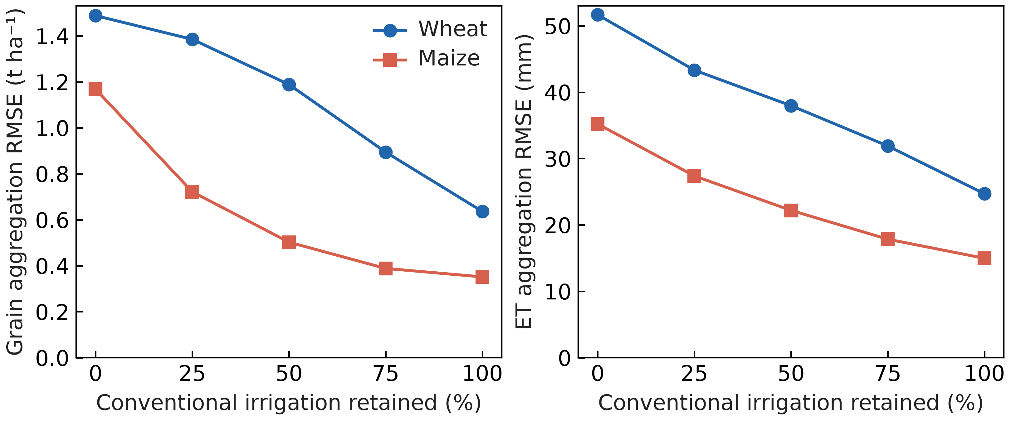
Figure S1. Current crop-model spatial aggregation errors under all five irrigation fractions in eight purposively selected cells during 2014–2025. Actual-cell and representative predictions share the current native model and crop parameters. These discrepancies assess spatial representation rather than field-observation accuracy.

S4. Annual field yields and irrigation-treatment contrasts
Annual Wuqiao grain targets comprise sixteen treatment-year means per crop in 2016–2019, digitized with standard errors from the primary Supplementary Figure S2. Grain retains its 13% moisture basis in comparisons. The twelve 2016–2018 means per crop enter calibration after a single multiplication by 0.87 to dry matter. The four 2019 means remain outside fitting and selection but had been inspected during earlier development. Four-year means summarize the same years and supply no additional independent targets.
Annual grain calibration RMSE is 1.249 t ha⁻¹ for wheat and 2.267 t ha⁻¹ for maize; retrospective-testing RMSE is 3.161 and 1.700 t ha⁻¹ at 13% moisture. Within-year W1–W3 minus W0 grain-contrast RMSE is 0.519 and 1.669 t ha⁻¹ in calibration and 1.316 and 1.323 t ha⁻¹ in 2019 (Table S5; Figure S2). Maize treatment labels retain preceding wheat management because maize irrigation is identical within each year.
All printed seasonal ET targets remain eligible after matching the 2016 maize rainfall period. Maize-season rainfall of 499.1 mm excludes the 100.5 mm during wheat from the 599.6-mm rotation total. Reconstructed balance residuals for W0–W3 are +0.1, +0.1, −0.9 and +0.1 mm. Source ET and depletion values remain unchanged. Storage-depletion diagnostics share the source ET balance and its unconfirmed exact sampling dates; they are conditional accounting comparisons rather than independent soil-water validation.
Table S5. Wuqiao annual grain and within-year treatment contrasts by fitting and testing partition.
Crop | Dataset | Comparison | N | RMSE (t/ha) | Bias (t/ha) | NSE | R²
Maize | Calibration (2016–2018) | Annual grain yield | 12 | 2.267 | -1.738 | -2.940 | 0.128
Maize | Calibration (2016–2018) | Within-year W1–W3 minus W0 | 9 | 1.669 | 0.296 | -0.788 | 0.076
Maize | Retrospective evaluation (2019) | Annual grain yield | 4 | 1.700 | 1.403 | -3.641 | 0.972
Maize | Retrospective evaluation (2019) | Within-year W1–W3 minus W0 | 3 | 1.323 | -0.836 | -1.403 | 1.000
Wheat | Calibration (2016–2018) | Annual grain yield | 12 | 1.249 | -0.445 | 0.746 | 0.817
Wheat | Calibration (2016–2018) | Within-year W1–W3 minus W0 | 9 | 0.519 | 0.064 | 0.857 | 0.882
Wheat | Retrospective evaluation (2019) | Annual grain yield | 4 | 3.161 | 3.108 | -4.654 | 0.870
Wheat | Retrospective evaluation (2019) | Within-year W1–W3 minus W0 | 3 | 1.316 | -1.312 | -0.712 | 0.994
Grain is at 13% moisture. Calibration comprises 2016–2018 and retrospective testing comprises 2019. Source means and standard errors are digitized from Supplementary Figure S2, with pixel tolerances near 0.043 t ha⁻¹ for wheat and 0.056 for maize. Contrasts compare W1–W3 with same-year W0. Four-year means overlap these annual targets; maize contrasts retain preceding wheat histories.
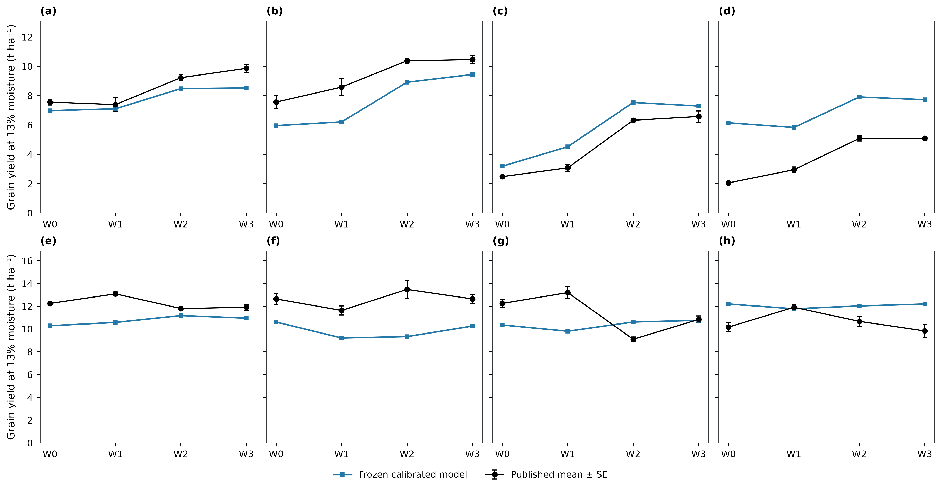
Figure S2. Annual Wuqiao grain at 13% moisture under the selected current parameters. Panels (a–d) show wheat and (e–h) maize; columns from left to right show 2016, 2017, 2018 and 2019. Black points and error bars are published means ± standard error of three replicates; blue squares show current predictions. The 2016–2018 treatment means contribute to water calibration after conversion to dry grain; 2019 is retrospective testing, excluded from fitting and selection. Maize irrigation is identical within each year and labels retain preceding wheat management. Source means and SE are digitized from Supplementary Figure S2 of the primary experiment.

S5. Class exposure, continuous states and rainfall-only controls
All nine common GRACE-available years occupy lower-storage classes; three other years use conventional fallback. The selected current quotas are identical across storage strata within each rainfall group. Matched rainfall-only and storage–rainfall histories have identical actions, crop states and outcomes throughout the modeled record.
Available-rainfall controls apply reduced quotas during monitoring gaps and therefore create different carried water states before later common years. These history effects are separate from the value of the storage classification. Table S7 reports all-year and common-year retention and water use; Table S8 reports the matched and available-rainfall controls.
Table S6. Class exposure and missing-storage coverage by period.
Period | Class | Unit-years | Years | Area–years (ha yr) | Area–year fraction
evaluation | Lower storage / lower rainfall | 174 | 9 | 55410278.787 | 0.468
evaluation | Lower storage / higher rainfall | 114 | 9 | 33389136.355 | 0.282
evaluation | Missing storage | 96 | 3 | 29599805.048 | 0.250
selection | Higher storage / lower rainfall | 68 | 6 | 19466918.675 | 0.179
selection | Higher storage / higher rainfall | 124 | 6 | 39732691.420 | 0.366
selection | Lower storage / lower rainfall | 109 | 5 | 34747673.179 | 0.320
selection | Lower storage / higher rainfall | 51 | 5 | 14585335.233 | 0.134
Table S7. Continuous class-adaptive irrigation evaluation during 2014–2025.
Strategy | Period | Years | Grain retained (%) | Irrigation cut (mm) | ET cut (mm) | Minimum grain (%)
Storage–rainfall 95% | Nine GRACE years | 9 | 96.270 | 130.721 | 36.842 | 92.115
Storage–rainfall 95% | All twelve years | 12 | 96.818 | 98.040 | 29.733 | 92.115
Storage–rainfall 98% | Nine GRACE years | 9 | 99.626 | 35.721 | 6.171 | 98.579
Storage–rainfall 98% | All twelve years | 12 | 99.622 | 26.790 | 5.208 | 98.579
Conventional | Nine GRACE years | 9 | 100.000 | 0.000 | 0.000 | 100.000
Conventional | All twelve years | 12 | 100.000 | 0.000 | 0.000 | 100.000
Current continuous histories. Grain retention is a ratio of period-mean regional dry-grain production to conventional irrigation. ET includes crops and fallows. All-year summaries include conventional fallback; common-year summaries use the nine GRACE-available years.
Table S8. Continuous GRACE–rainfall and rainfall-only strategy comparison during 2014–2025.
Strategy | Period | Grain retained (%) | Irrigation (mm) | ET (mm)
Storage–rainfall 95% | Nine GRACE years | 96.27 | 249.279 | 848.527
Storage–rainfall 95% | All twelve years | 96.82 | 281.960 | 857.698
Storage–rainfall 98% | Nine GRACE years | 99.63 | 344.279 | 879.197
Storage–rainfall 98% | All twelve years | 99.62 | 353.210 | 882.223
Rainfall 95%, available | Nine GRACE years | 95.40 | 249.279 | 844.203
Rainfall 95%, available | All twelve years | 95.04 | 248.565 | 842.945
Rainfall 95%, matched | Nine GRACE years | 96.27 | 249.279 | 848.527
Rainfall 95%, matched | All twelve years | 96.82 | 281.960 | 857.698
Rainfall 98%, available | Nine GRACE years | 99.41 | 344.279 | 878.151
Rainfall 98%, available | All twelve years | 99.36 | 343.565 | 879.669
Rainfall 98%, matched | Nine GRACE years | 99.63 | 344.279 | 879.197
Rainfall 98%, matched | All twelve years | 99.62 | 353.210 | 882.223
Matched controls share the complete GRACE-availability and fallback calendar. Available-rainfall controls act during missing-storage years and alter subsequent soil states. All values use current parameters; differences do not identify causal groundwater responses.
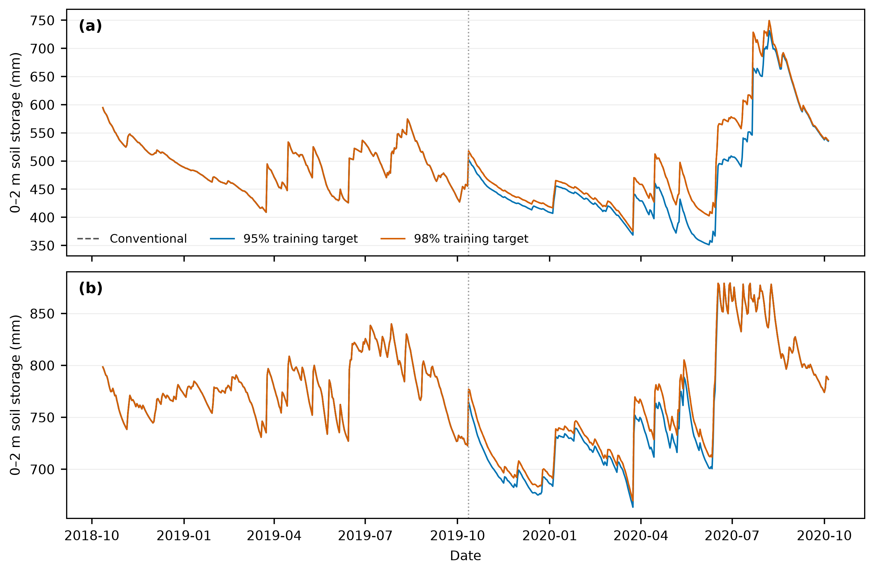
Figure S3. Simulated 0–2 m soil-water storage in representative units (a) 0 and (b) 31. State carries continuously through wheat, maize, fallows and annual irrigation choices. Displayed histories compare conventional irrigation with selected current strategies; they are model states rather than observed groundwater levels.

S6. Harvest data quality and crop model recalibration
Original Yucheng harvest sources contain identical six-replicate maize vectors in 2012 and 2017 under different date and cultivar labels. Both groups are retained as raw evidence and excluded from scored grain and harvest biomass. Eligibility depends on source authenticity rather than model residuals. Current plots preserve observed quadrat variation and the original whole site-year partitions (Figure S4).
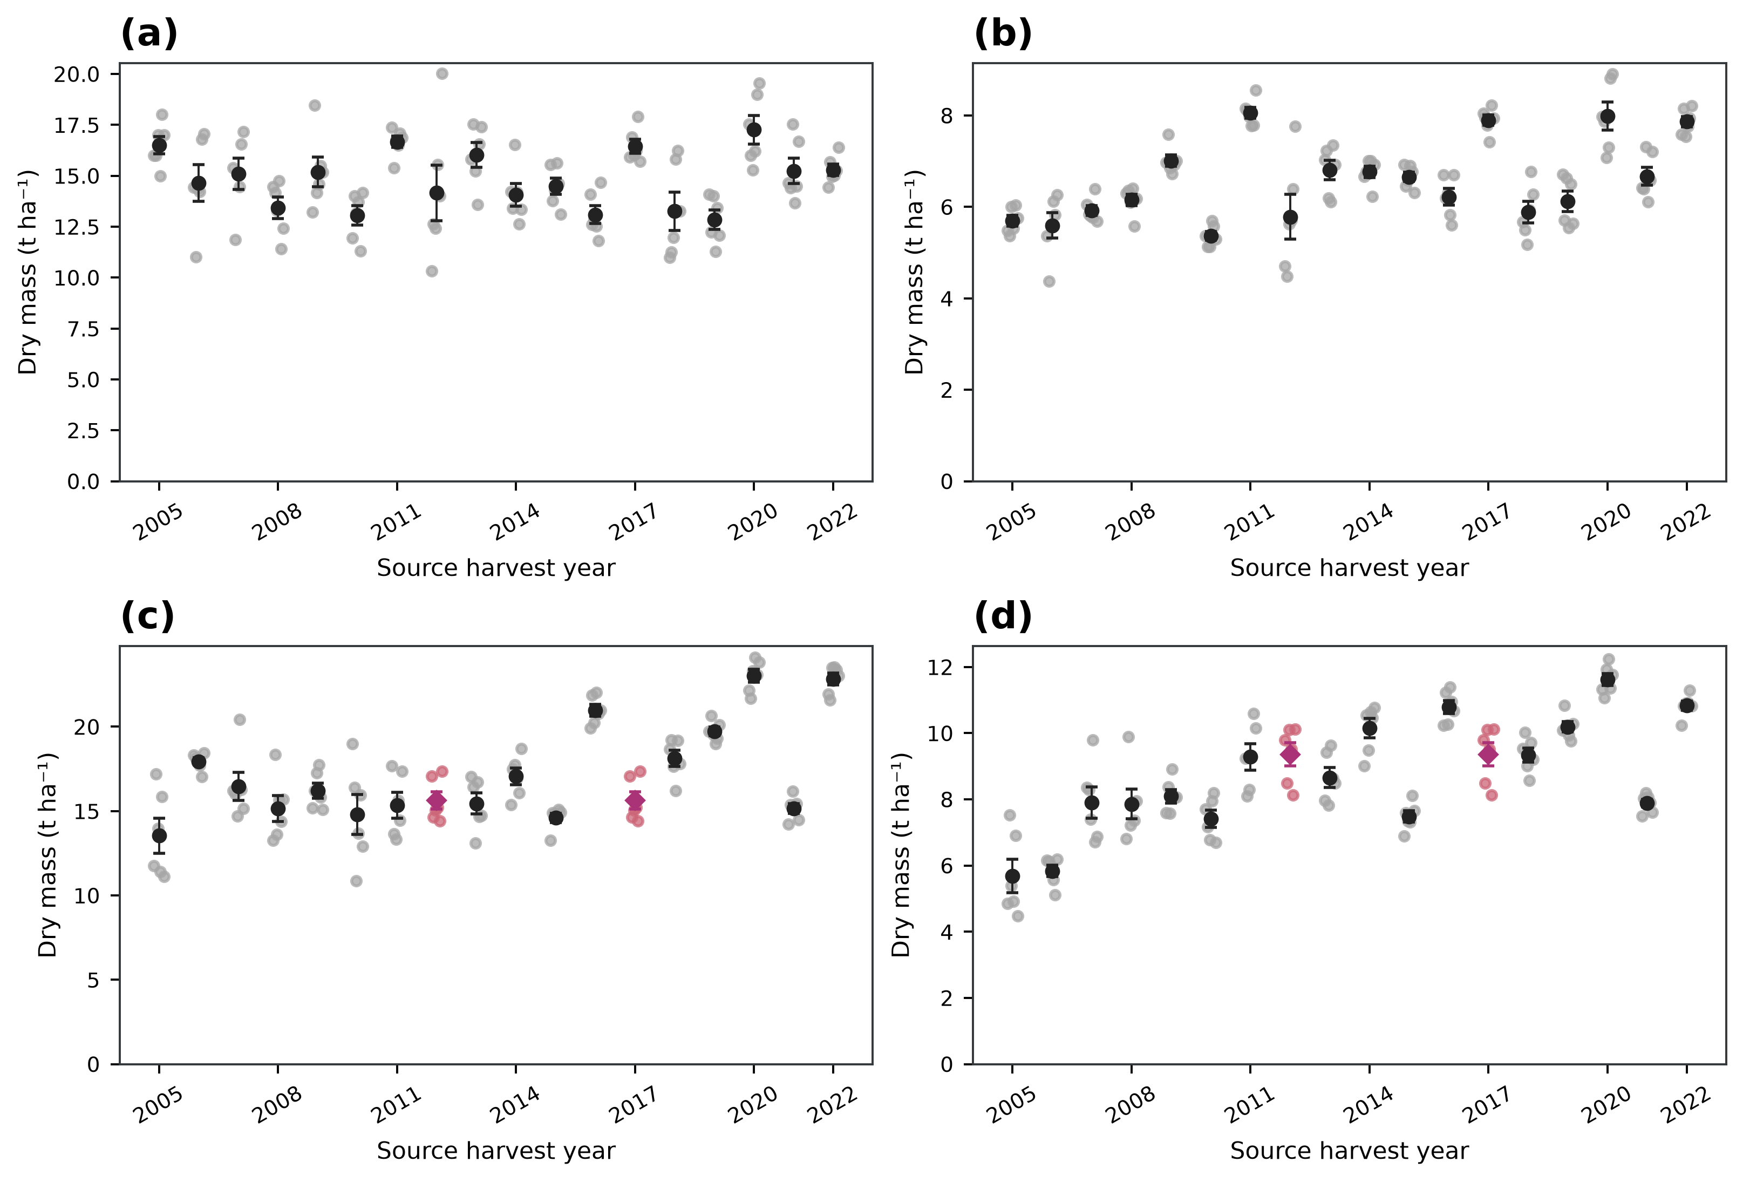
Figure S4. Original Yucheng harvest observations at YCAZH01ABC_01. Panels (a, b) show wheat aboveground biomass and grain; panels (c, d) show maize aboveground biomass and grain. Faint points are six quadrat observations; dark markers and error bars are means ± replicate standard error. Magenta diamonds identify the identical full maize source vectors in 2012 and 2017. Raw values remain displayed for source inspection; both groups are excluded from comparisons with quality-controlled observations. Error bars describe sampling variation, rather than model or policy uncertainty.

S7. Spatial decomposition under the common irrigation budget
Frozen area shares weight complete current irrigation histories before spatial aggregation. Dry-grain differences in kg ha⁻¹ multiply represented hectares and divide by 1,000 for tonnes; water depths multiply hectares by 10 for cubic metres. Independent sums reproduce regional contrasts. Latitude bands describe the distribution of gains and losses, while the 3,641 mapped cells inherit 32 simulated representative responses (Table S9).
Table S9. Spatial decomposition at a common 50% regional irrigation reduction during 2014–2025.
Latitude band | Area share (%) | Targeted irrigation fraction | Grain change (t ha⁻¹) | ET change (mm) | Grain contribution (Mt)
Southern (32–36°N) | 60.733 | 0.305 | -0.357 | -25.599 | -2.142
Central (36–38°N) | 31.369 | 0.799 | 2.415 | 93.497 | 7.475
Northern (38–41°N) | 7.897 | 0.813 | 2.420 | 88.358 | 1.886
Current targeted-minus-uniform means at the same 50% regional irrigation cut. Latitude bands are reporting partitions. Source cells inherit representative responses and are not independent observations.

S8. Seasonal crop trajectories and harvest outcomes
Current seasonal curves use the selected frozen parameters and all sites with eligible observations for each variable. Observation and prediction channels share windows, case identities and aggregation weights. Bins span 15 days for wheat and 7 days for maize; site-year contributions and populations can change among bins. Standard errors describe variation across site-year means and are omitted for single-year bins. Missing bins remain gaps. Unbinned records determine performance scores (Figures S6–S11).
The original station calibration partitions retain earlier growth-fitting history; all station comparisons are conditional on unconfirmed complete irrigation management. Station observations have no weight in the latest water fit. Yucheng has no eligible in-season biomass evaluation observations, while its harvest-biomass endpoints remain separately available. Figure S5 shows dry-grain and aboveground harvest means with quadrat SE. Six samples within a crop-year describe sampling variation, and the duplicated 2012 and 2017 maize groups remain excluded. Exact case availability, site-specific metrics, bin contributions and harvest source rows accompany the figures.
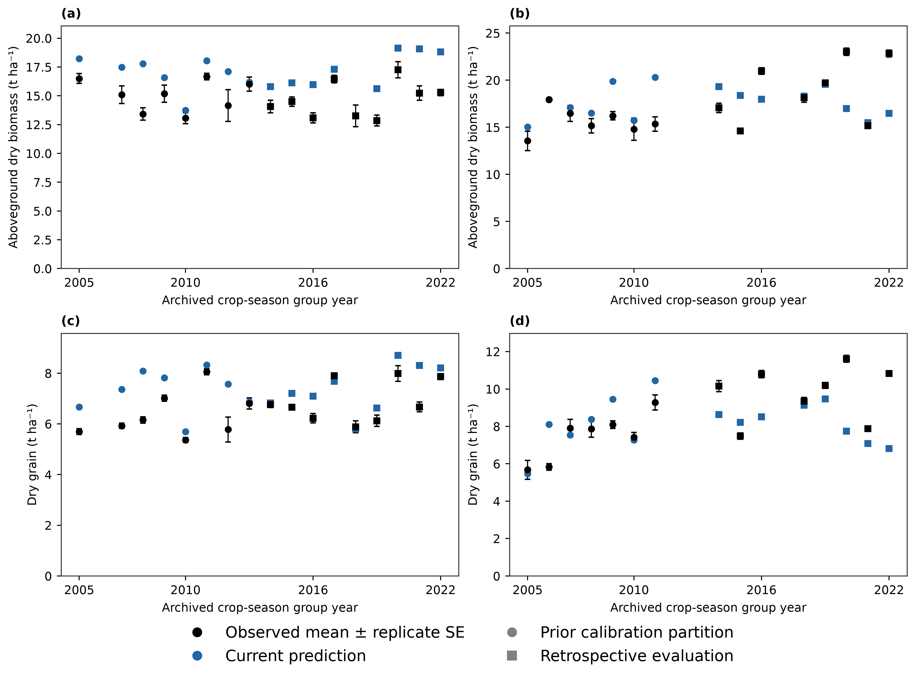
Figure S5. Conditional Yucheng harvest comparisons. Wheat occupies the left column and maize the right; the top row shows aboveground biomass and the bottom row grain. Black points show observed means ± standard errors among six quadrat samples per crop-year; blue points show current coupled-model predictions at the same sampling windows. Circles and squares distinguish the original calibration and retrospective-evaluation partitions. Grain and total aboveground biomass are dry matter. The duplicated maize 2012 and 2017 source vectors remain excluded. Within-year replicates describe spatial sampling variation and are not independent crop seasons. Management completeness remains unconfirmed and current water coefficients use Wuqiao fitting targets, while growth coefficients retain their earlier multisite fitting history.
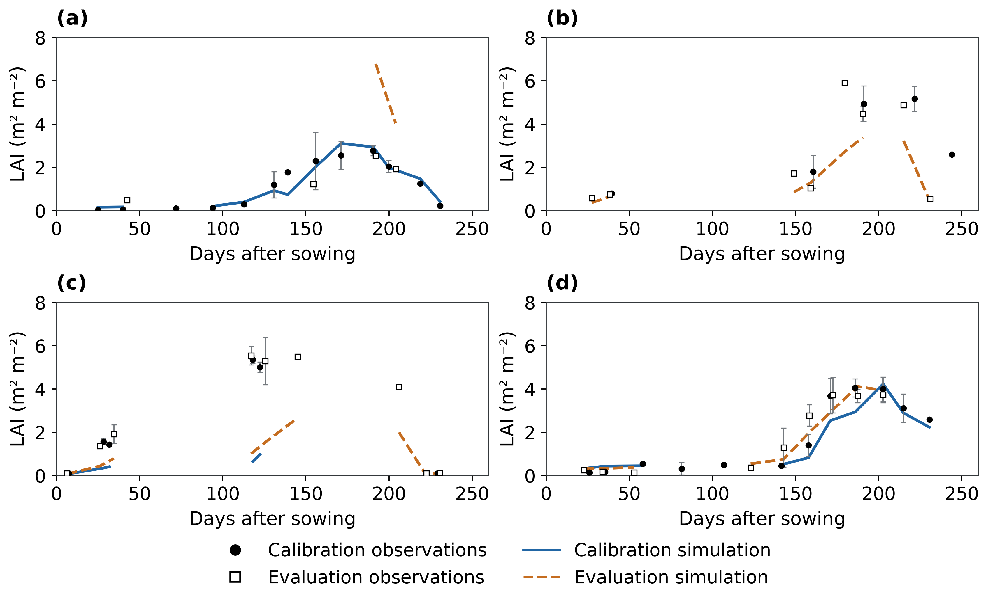
Figure S6. Site-specific wheat LAI comparisons: (a) Fengqiu; (b) Luancheng; (c) Shangqiu; (d) Yucheng. Calibration and retrospective-evaluation observations and simulations share the same axes within each site. Error bars describe site-year standard errors; gaps are retained. The observations, weighting and conditional management interpretation follow Figure 4.
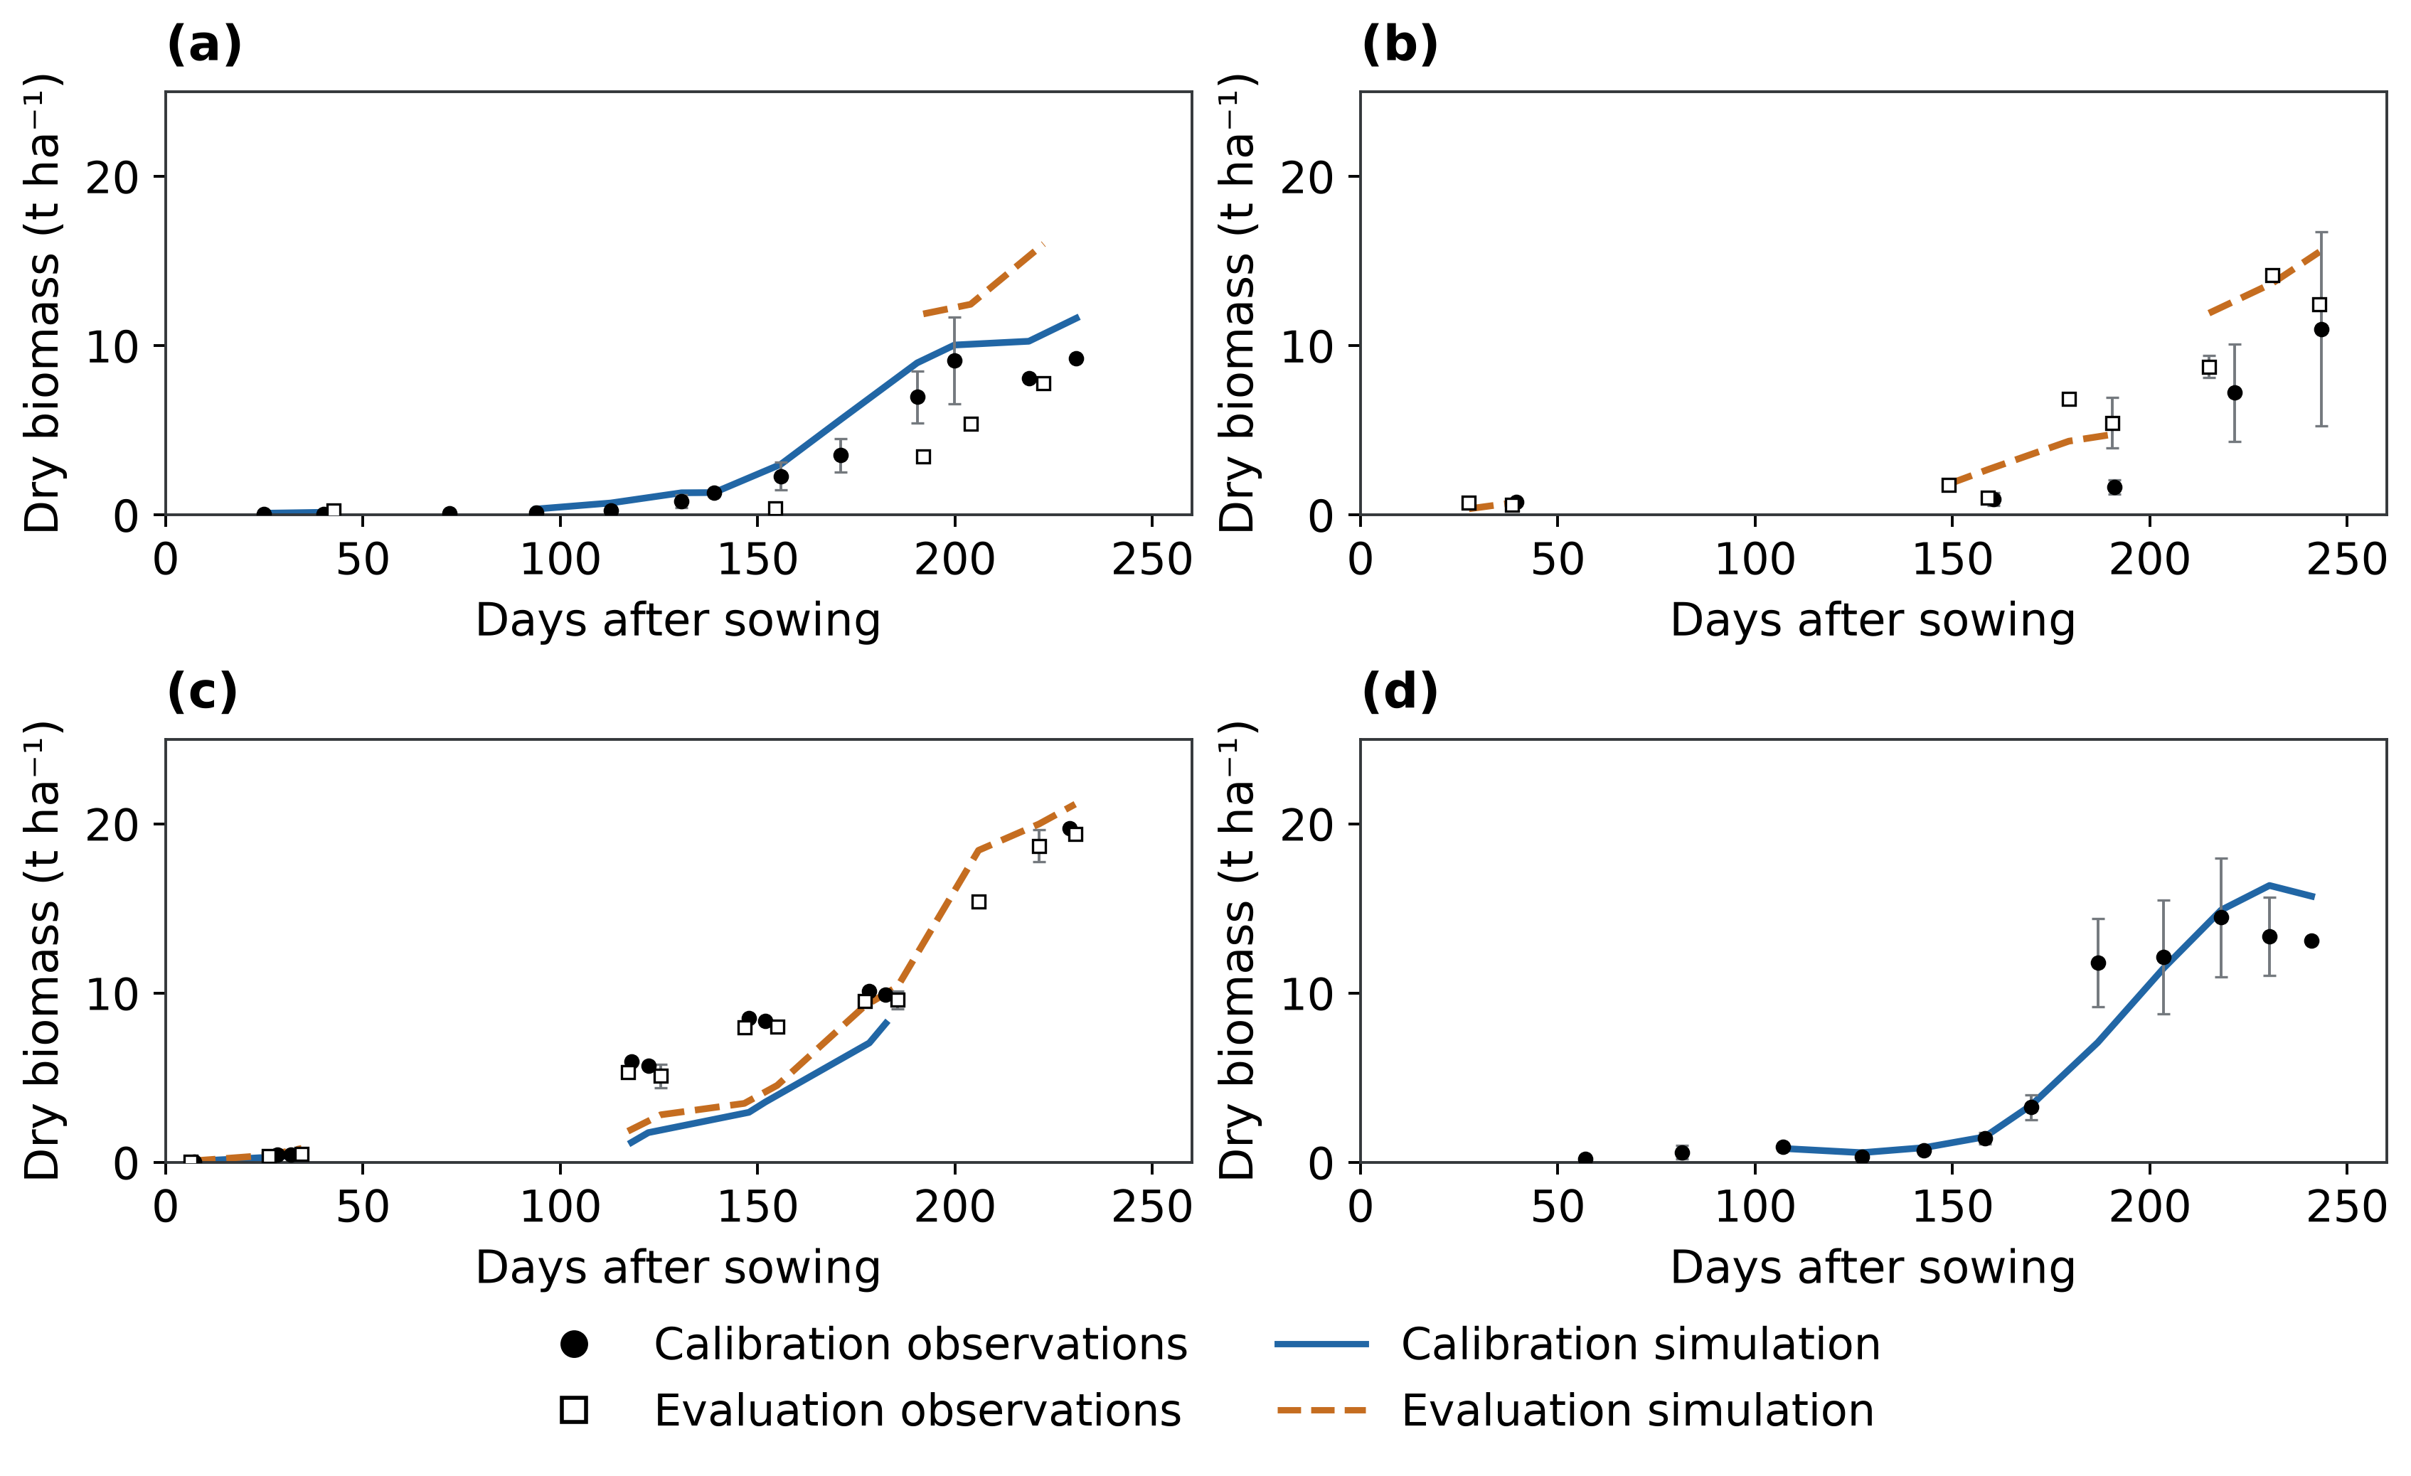
Figure S7. Site-specific wheat aboveground biomass comparisons: (a) Fengqiu; (b) Luancheng; (c) Shangqiu; (d) Yucheng. Calibration and retrospective-evaluation observations and simulations share the same axes within each site. Error bars describe site-year standard errors; gaps are retained. The observations, weighting and conditional management interpretation follow Figure 4.
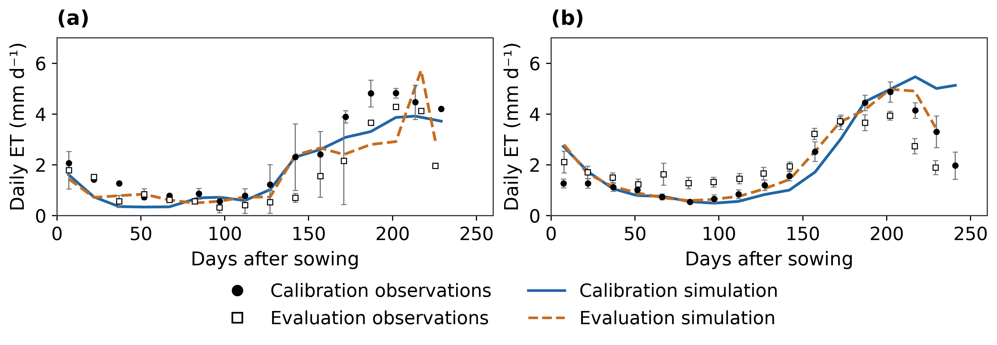
Figure S8. Site-specific wheat ET comparisons: (a) Fengqiu; (b) Yucheng. Calibration and retrospective-evaluation observations and simulations share the same axes within each site. Error bars describe site-year standard errors; gaps are retained. The observations, weighting and conditional management interpretation follow Figure 4.
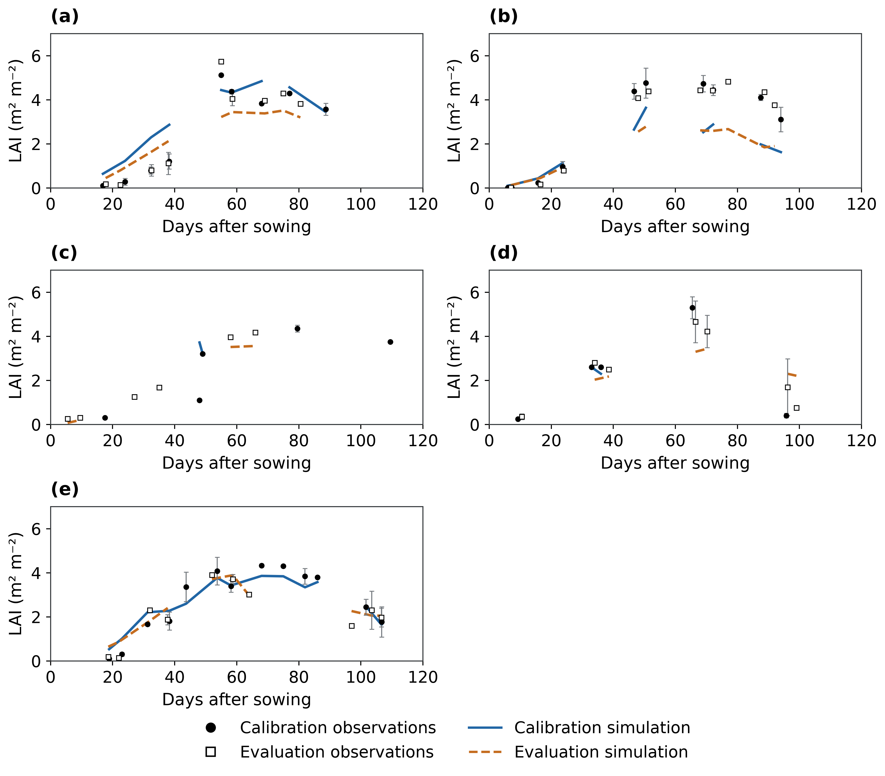
Figure S9. Site-specific maize LAI comparisons: (a) Fengqiu; (b) Gucheng; (c) Luancheng; (d) Shangqiu; (e) Yucheng. Calibration and retrospective-evaluation observations and simulations share the same axes within each site. Error bars describe site-year standard errors; gaps are retained. The observations, weighting and conditional management interpretation follow Figure 4.
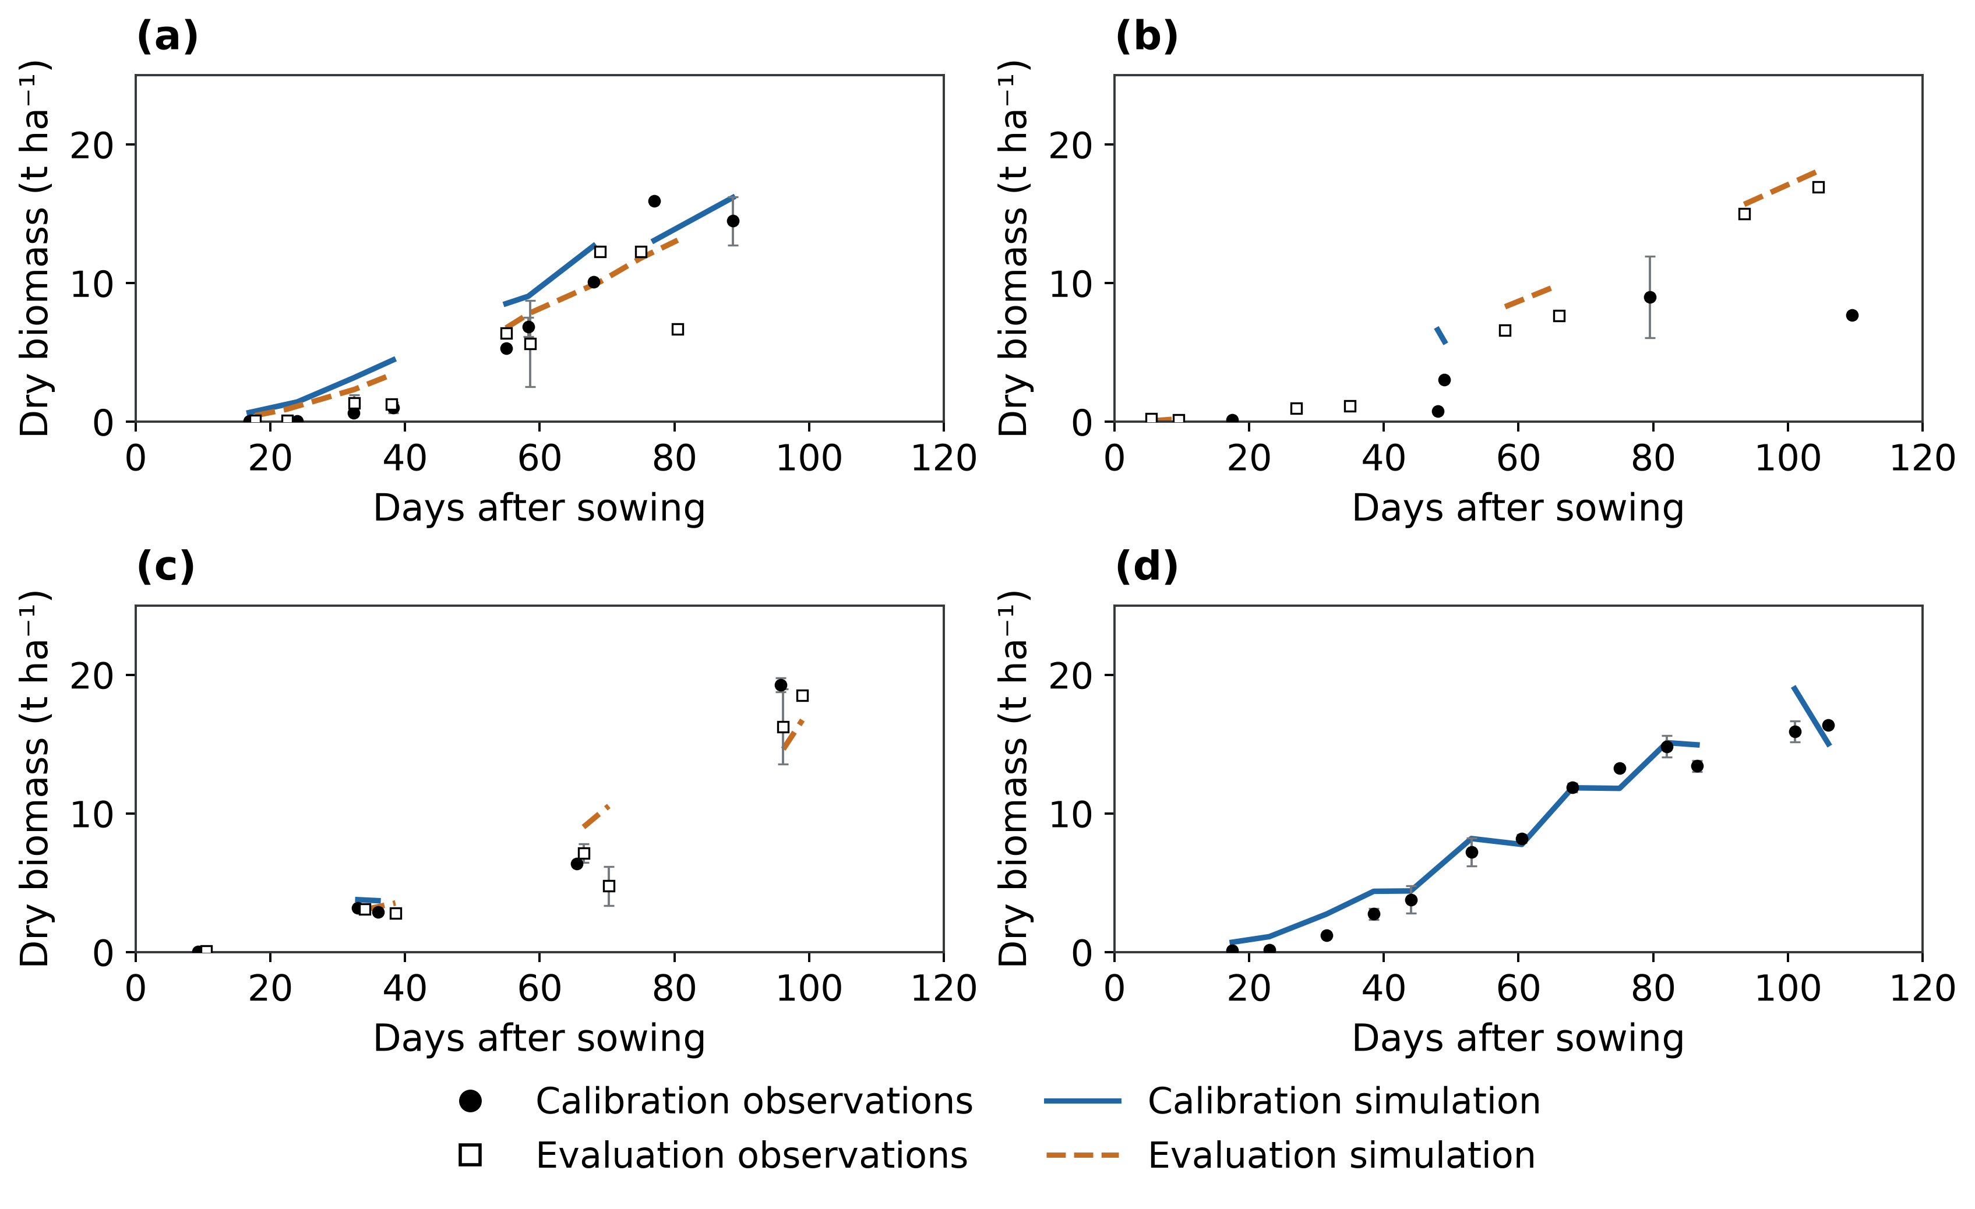
Figure S10. Site-specific maize aboveground biomass comparisons: (a) Fengqiu; (b) Luancheng; (c) Shangqiu; (d) Yucheng. Calibration and retrospective-evaluation observations and simulations share the same axes within each site. Error bars describe site-year standard errors; gaps are retained. The observations, weighting and conditional management interpretation follow Figure 4.
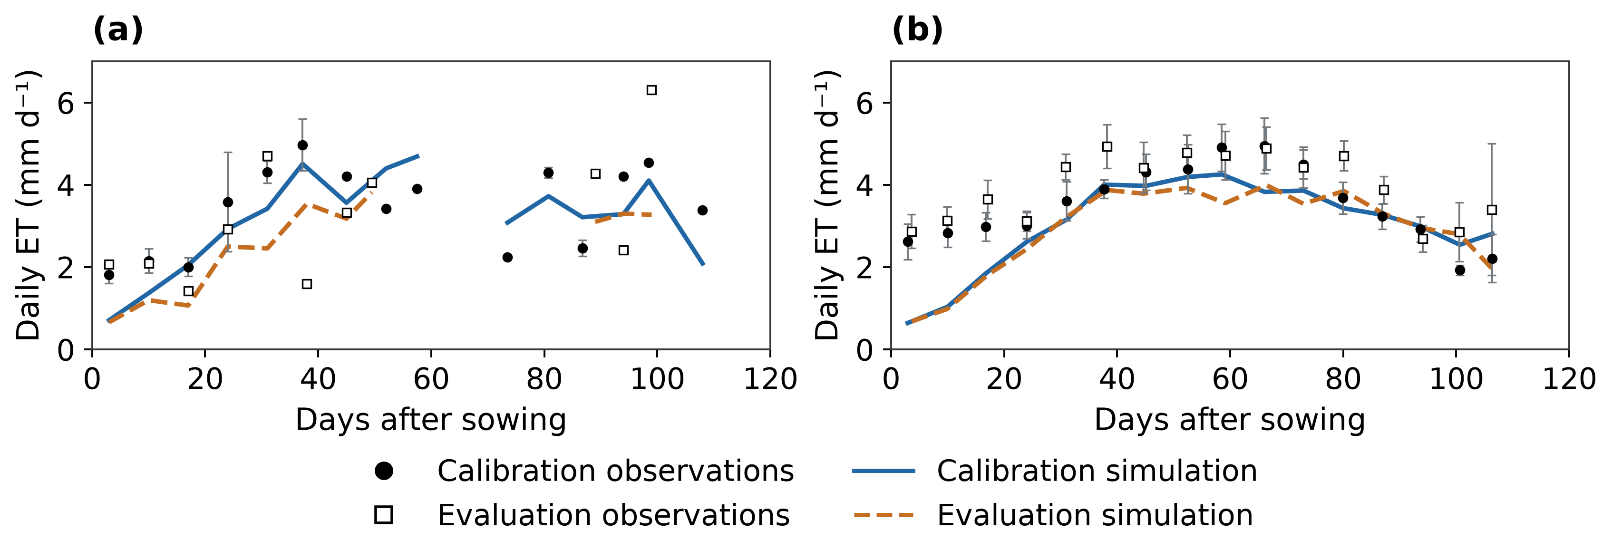
Figure S11. Site-specific maize ET comparisons: (a) Fengqiu; (b) Yucheng. Calibration and retrospective-evaluation observations and simulations share the same axes within each site. Error bars describe site-year standard errors; gaps are retained. The observations, weighting and conditional management interpretation follow Figure 4.

References
Yang, L., Fang, X., Zhou, J., Zhao, J., Hou, X., Yang, Y., Zang, H., Zeng, Z., 2024. Optimal irrigation for wheat-maize rotation depending on precipitation in the North China Plain: Evidence from a four-year experiment. Agric. Water Manag. 294, 108726. https://doi.org/10.1016/j.agwat.2024.108726
Meier, U. (Ed.), 2018. Growth stages of mono- and dicotyledonous plants: BBCH Monograph. Julius Kühn-Institut, Quedlinburg. https://doi.org/10.5073/20180906-074619
Kiniry, J.R., Jones, C.A., O'toole, J.C., Blanchet, R., Cabelguenne, M., Spanel, D.A., 1989. Radiation-use efficiency in biomass accumulation prior to grain-filling for five grain-crop species. Field Crops Research. https://doi.org/10.1016/0378-4290(89)90023-3
de Wit; Berghuijs, n.d.. Python Crop Simulation Environment: WOFOST leaf dynamics implementation [software]. Version Archived master-branch source snapshot. https://github.com/ajwdewit/pcse/blob/master/pcse/crop/leaf_dynamics.py (accessed 4 October 2026).
Tan, M., Gou, F., Stomph, T.J., Wang, J., Yin, W., Zhang, L., Chai, Q., van der Werf, W., 2020. Dynamic process-based modelling of crop growth and competitive water extraction in relay strip intercropping: Model development and application to wheat-maize intercropping. Field Crops Research 246, 107613. https://doi.org/10.1016/j.fcr.2019.107613
de Wit, A., 2020. Parameter sets for the WOFOST 7.2/7.3 cropping system model for wheat.
de Wit, A., 2022. Parameter sets for the WOFOST 7.2/7.3 model for simulating maize.
APSIM Initiative, 2026. APSIM Next Generation (ApsimX): wheat and maize model definitions [software]. Version 074d15f. https://github.com/APSIMInitiative/ApsimX/tree/074d15f51889a386d3667acfed184d03e4e8f65f/Models/Resources (accessed 4 October 2026).
Allen, R.G., Pereira, L.S., Raes, D., Smith, M., 1998. Crop evapotranspiration: Guidelines for computing crop water requirements, FAO Irrigation and Drainage Paper. Food and Agriculture Organization of the United Nations, Rome.
van Genuchten, M.T., 1980. A Closed‐form Equation for Predicting the Hydraulic Conductivity of Unsaturated Soils. Soil Science Society of America Journal 44, 892–898. https://doi.org/10.2136/sssaj1980.03615995004400050002x
Mualem, Y., 1976. A new model for predicting the hydraulic conductivity of unsaturated porous media. Water Resources Research 12, 513–522. https://doi.org/10.1029/wr012i003p00513
Wu, L., Min, L., Liu, M., Zhang, Y., Pei, H., Li, H., Zhang, G., Wang, S., Shen, Y., 2023. Monitoring of Thick Vadose Zone Water Dynamics Under Irrigation Using a 48 m Deep Caisson at the Luancheng Critical Zone Observatory. Water Resour. Res. 59, e2022WR032965. https://doi.org/10.1029/2022wr032965
Saxton, K.E., Rawls, W.J., 2006. Soil Water Characteristic Estimates by Texture and Organic Matter for Hydrologic Solutions. Soil Science Society of America Journal 70, 1569–1578. https://doi.org/10.2136/sssaj2005.0117
ISRIC — World Soil Information, 2020. SoilGrids250m version 2.0.
NASA JPL, 2013. NASA Shuttle Radar Topography Mission Global 1 arc second. https://doi.org/10.5067/MEASURES/SRTM/SRTMGL1.003
Qiu, B., Hu, X., Chen, C., Tang, Z., Yang, P., Zhu, X., Yan, C., Jian, Z., 2022. Maps of cropping patterns in China during 2015–2021. Scientific Data. https://doi.org/10.1038/s41597-022-01589-8
Fu, Y., Dong, J., Shen, R., Peng, Q., Li, X., Zheng, Y., Pan, B., Dong, J., Qiu, B., Huang, J., Yuan, W., 2025. China Crop Dataset: A long-term and high-resolution crop distribution dataset in China. https://doi.org/10.57760/sciencedb.32361
Fu, Y., Dong, J., Shen, R., Peng, Q., Li, X., Zheng, Y., Pan, B., Dong, J., Qiu, B., Huang, J., Huang, X., Yuan, W., 2026. A 30-m annual distribution dataset of major crops in China from 2001-2024. Scientific Data 13, 1074. https://doi.org/10.1038/s41597-026-07370-5

