Supplementary Information
Wheat phenology partly offsets projected increases in Septoria damage across Europe
Gang Zhao

Supplementary Methods

Crop, disease and yield relationships
Daily climate data drive wheat-phenology and Septoria-disease calculations. Wheat phenology determines leaf appearance, unfolding and the flowering-to-soft-dough interval. The disease model predicts damage on those leaves; its damage does not feed back into crop-development rates. After symptom detection, damage is mapped to an assumed loss of leaf function. Integration gives HAD loss, and a published coefficient converts HAD loss to a conditional disease-related yield estimate. This final calculation is separate from a complete crop-yield model.
The reference upper-three-leaf canopy has maximum LAI of one. Disease-induced HAD loss integrates the assumed loss of functional green leaf area over time, with units of GLAI-days. Division by maximum reference LAI gives normalized HAD loss, expressed as equivalent days of reference canopy function lost. Numerical values are identical in the unit-LAI scenario. Relative HAD loss is the ratio of HAD loss to reference HAD and describes loss of assumed canopy function over the integration interval. Measured leaf-lesion percentage has a different denominator and temporal meaning.

Full-grid climate estimates
The experiment includes all 14,941 wheat land-use cells, with eligible calendars for 14,932 cells. Invalid seasons have unavailable outcomes. Symptom timing requires detection, while symptom frequency includes complete seasons without symptoms. Each metric has its own valid historical–future pairs. Corresponding positions in the two 30-year periods are paired within a climate model and SSP.
Spatial means divide the harvested-area-weighted sum of paired changes by the harvested-area-weighted number of valid pairs. Historical and future means use these same pairs. Climate-model ranges span three independently aggregated estimates. The full-grid calculation has no spatial sampling error. Environmental regions follow EEA centroid assignment and countries follow dominant SPAM source-country labels; outside-region and unassigned cells remain explicit.

Field observations and prediction scores
Pooled disease evaluation excludes calibration records and combines geographically eligible records from both archives. Source identifiers and assessment definitions remain in the evidence files. Calibration and evaluation have no shared field identifiers. Coordinate-year identities define geographic bootstrap groups, with overlapping identities treated as the same group.
An assessment weight is the reciprocal of the number of coordinate-years multiplied by the reciprocals of fields, source leaves and observations within successive groups. RMSE is the square root of the weighted mean squared error. Twenty thousand paired coordinate-year bootstrap resamples, with seed 20261008, give 95% percentile intervals. Every resample retains both predictions and all field, leaf and date records in a sampled group. The intervals exclude parameter-selection uncertainty and verification of independent biological-site identities.
Symptom-onset comparisons use observed intervals bracketing first symptoms and specified penalties for missed positive observations. Crop-stage evaluation also uses two-sided observation intervals; plotted interval centres are display locations, not exact observed event dates. Calibration profiles and nested model selection are separate from pooled evaluation. German station observations evaluate the established phenology formulation; field support for added upper-leaf stages and soft dough remains limited.

Canopy-based yield estimates
Published protected and unprotected treatment means retain their leaf coverage, growth-stage interval, cultivar and disease exposure. The eight contrasts across five backgrounds include two with STB alone, two with yellow rust and four with mixed diseases. Absolute and relative yield scores describe aggregate treatment means when each genetic background is excluded from fitting. Raw plot variation and covariance are unavailable.
The grid yield estimate is a linear conversion of HAD loss under the assumed upper-three-leaf canopy. Fixed coefficients and alternative GS31–85 and GS65–85 intervals assess dependence on these assumptions. The primary interval is shorter than the source coefficient interval, so the conversion requires field validation. Positive projected yield changes denote a decrease in the estimated disease-loss component; they do not establish a gain in total yield under future climate.

Severity-based field yield comparisons
The consolidated Tunisia/Nordic inventory contains 423 dated leaf or treatment assessments sharing 272 yield keys. Exclusion of a known control alias and post-harvest assessments leaves 412 assessments and 263 outcomes. These inventory counts do not denote independent environments. The Nordic predictive population contains 62 treated–untreated contrasts in five trials; subsets with known assessment stage and an earlier matched assessment contain 51 and 40 contrasts, respectively. Missing treated-plot stem-extension assessments remain unavailable. Growth-stage interactions use recorded ordinal GS, rather than elapsed time. The fixed stage-regression basis is severity reduction multiplied by (GS − 75)/10. The secondary nonnegative basis uses severity reduction multiplied by (85 − GS)/10. Neither basis represents observed infection timing.
The Tunisian plot table contains incidence-weighted lesion area on flag and immediately lower leaves. Flag leaves were assessed at GS75 in both years; lower leaves were assessed at GS61 in 2018 and GS73 in 2019. The leaf-stage and year differences prevent separate identification of leaf-specific physiological coefficients. No same-leaf AUDPC or HAD is reconstructed. Cultivar proportions define composition predictors and shared mixture identities; treatment numbers are year-specific. Two-way whole-year transfer evaluates absolute yield on 82 outcomes. The 40 source-matched reference contrasts retain one negative response; within-year validation excludes entire mixture compositions or source replicate groups. These comparisons remain within one site-year and do not establish external environmental validity.
German source harmonization preserves the original site-table precision and follows the documented source treatment coding, while excluding drought-suffixed WF references from unsuffixed NF/WF pairs. One nonnumeric severity token remains unavailable. Treatment means retain yield and severity replicate counts separately; missing protected severity is not imputed. The primary endpoint population contains 3,264 comparisons across 16 site-years and five locations. The subset with observed severity on both management groups contains 954 comparisons across seven site-years and four locations. Common-population benchmarks accompany each comparison. The primary and temporal comparisons give site-years equal weight; geographic transfer gives locations equal weight. Site-specific rating comparability and incomplete assessment timing remain limitations.
The complete source inventory includes raw field observations, regional survey aggregates, published model-adjusted means, fitted curves and model inputs. Fitted response grids, duplicate archive copies and published parameter tables do not increase observational sample size. Older Nordic/Baltic yield and weather-derived recommendation tables do not provide observed severity–yield pairs. New data-source identities, eligibility, fixed protocols, held-out predictions and independent numerical checks are retained with the current source data.

Weather and wheat-phenology contributions
The separate decomposition uses four historical–future combinations of disease weather and wheat-phenology trajectories in the 64-draw sample. Twenty pairs exceeding the accepted temperature range in a recombined trajectory are excluded. The two Shapley contributions share the interaction equally and sum to the net change on the same valid pairs. Phenology offsets use the identical pair set in numerator and denominator. The three-model ensemble offset is a ratio of mean contributions.
The main maps and regional estimates describe the completed full-grid experiment. Decomposition and structural sensitivity describe the separate sampled analysis. Field figures describe prediction errors on retrospective observations, and published yield figures describe treatment-mean contrasts. These datasets support different quantities and do not define a single overall model-accuracy percentage.

References
1.Savary, S. et al. The global burden of pathogens and pests on major food crops. Nature Ecology & Evolution3, 430–439 (2019).
2.Parker, S. R., Welham, S., Paveley, N. D., Foulkes, J. & Scott, R. K. Tolerance of septoria leaf blotch in winter wheat. Plant Pathology53, 1–10 (2004).
3.Silva, J. V. et al. Agronomic management drives the wheat yield plateau in high-yielding environments of northwest Europe. Nat. Food7, 45–54 (2026).
4.Chaloner, T. M., Gurr, S. J. & Bebber, D. P. Plant pathogen infection risk tracks global crop yields under climate change. Nature Climate Change11, 710–715 (2021).
5.Pequeno, D. N. L. et al. Production vulnerability to wheat blast disease under climate change. Nat. Clim. Change14, 178–183 (2024).
6.Shaw, M. W. & Royle, D. J. Airborne inoculum as a major source of Septoria tritici (Mycosphaerella graminicola) infections in winter wheat crops in the UK. Plant Pathology38, 35–43 (1989).
7.Lovell, D. J., Parker, S. R., Hunter, T., Welham, S. J. & Nichols, A. R. Position of inoculum in the canopy affects the risk of septoria tritici blotch epidemics in winter wheat. Plant Pathology53, 11–21 (2004).
8.Lovell, D. J., Hunter, T., Powers, S. J., Parker, S. R. & van den Bosch, F. Effect of temperature on latent period of septoria leaf blotch on winter wheat under outdoor conditions. Plant Pathology53, 170–181 (2004).
9.Suffert, F. & Sache, I. Relative importance of different types of inoculum to the establishment of Mycosphaerella graminicola in wheat crops in north‐west Europe. Plant Pathology60, 878–889 (2011).
10.Baccar, R. et al. Modelling the effect of wheat canopy architecture as affected by sowing density on Septoria tritici epidemics using a coupled epidemic–virtual plant model. Annals of Botany108, 1179–1194 (2011).
11.Foulkes, M. J. et al. Major genetic changes in wheat with potential to affect disease tolerance. Phytopathology96, 680–688 (2006).
12.van den Berg, F., Paveley, N. D., Bingham, I. J. & van den Bosch, F. Physiological traits determining yield tolerance of wheat to foliar diseases. Phytopathology107, 1468–1478 (2017).
13.Bryson, R. J., Paveley, N. D., Clark, W. S., Sylvester-Bradley, R. & Scott, R. K. Use of in-field measurements of green leaf area and incident radiation to estimate the effects of yellow rust epidemics on the yield of winter wheat. European Journal of Agronomy7, 53–62 (1997).
14.Nordic Field Trial System. Nordic Field Trial System: wheat disease assessments and harvest-yield treatment means, 2023–2025. (2026).
15.Ben M’Barek, S. et al. Improved control of septoria tritici blotch in durum wheat using cultivar mixtures. Plant Pathology69, 1655–1665 (2020).
16.Wang, T.-C. et al. Multi-environment field trials for wheat yield, stability and breeding progress in Germany. https://doi.org/10.6084/m9.figshare.27910269.v1 (2025).
17.Bancal, M.-O., Robert, C. & Ney, B. Modelling wheat growth and yield losses from late epidemics of foliar diseases using loss of green leaf area per layer and pre-anthesis reserves. Annals of Botany100, 777–789 (2007).
18.Bancal, P., Bancal, M.-O., Collin, F. & Gouache, D. Identifying traits leading to tolerance of wheat to Septoria tritici blotch. Field Crops Research180, 176–185 (2015).
19.Bregaglio, S. et al. Comparing process-based wheat growth models in their simulation of yield losses caused by plant diseases. Field Crops Research265, 108108 (2021).
20.McDonald, A. J. et al. Time management governs climate resilience and productivity in the coupled rice–wheat cropping systems of eastern India. Nat. Food3, 542–551 (2022).
21.European Commission. A Vision for Agriculture and Food. https://eur-lex.europa.eu/legal-content/EN/TXT/?uri=CELEX%3A52025DC0075 (2025).
22.International Food Policy Research Institute. Global Spatially-Disaggregated Crop Production Statistics Data for 2020, SPAM2020 v2r2. Harvard Dataverse https://doi.org/10.7910/DVN/SWPENT (2026).
23.Jägermeyr, J., Müller, C., Minoli, S., Ray, D. & Siebert, S. GGCMI Phase 3 crop calendar. Zenodo https://doi.org/10.5281/zenodo.5062513 (2021).
24.NASA Center for Climate Simulation. NEX-GDDP-CMIP6 Version 2 Technical Note. https://www.nccs.nasa.gov/wp-content/uploads/2025/06/NEX-GDDP-CMIP6-v2-Tech_Note.pdf (2025).
25.European Environment Agency. Biogeographical regions, Europe 2016, version 1. (2016).
26.Holst, N. Data from 56 fungicide trials in wheat fields across Europe 2017–2019. Zenodo https://doi.org/10.5281/zenodo.6521175 (2022).
27.Holst, N. & Donner, M. Data from 168 fungicide trials in wheat fields across Europe 2014–2018. Zenodo https://doi.org/10.5281/zenodo.6352615 (2022).
28.Karisto, P. et al. Improved control of Septoria tritici blotch in durum wheat using cultivar mixtures. https://doi.org/10.5061/dryad.r2280gbb5 (2020).

Table S1a | German station calibration event-date evaluation. All process models use identical station/sowing-cycle/stage matches. Coverage includes observed events lacking shared predictions; Missing n counts unavailable predictions for the individual model. The distinct own-matched denominator is retained in Source Data. The station split does not withhold calendar years. Errors describe realized-weather, known-sowing hindcasts.
Model | BBCH | Matched n | Observed n | Coverage (%) | MAE (d) | RMSE (d) | Bias (d) | Missing n
GDD | 10 | 5577 | 5699 | 97.9 | 5.35 | 8.99 | 1.26 | 122
GDD | 31 | 5159 | 5159 | 100.0 | 17.22 | 24.80 | -3.39 | 0
GDD | 51 | 5352 | 5352 | 100.0 | 10.38 | 14.14 | -0.96 | 0
GDD | 85 | 1969 | 1969 | 100.0 | 10.46 | 13.88 | -1.13 | 0
GDD | overall | 18057 | 18179 | 99.3 | 10.79 | 16.76 | -0.99 | 122
T-P | 10 | 5577 | 5699 | 97.9 | 5.35 | 8.99 | 1.26 | 122
T-P | 31 | 5159 | 5159 | 100.0 | 11.23 | 15.39 | -0.50 | 0
T-P | 51 | 5352 | 5352 | 100.0 | 6.03 | 8.23 | 0.55 | 0
T-P | 85 | 1969 | 1969 | 100.0 | 7.07 | 9.26 | 0.13 | 0
T-P | overall | 18057 | 18179 | 99.3 | 7.42 | 11.05 | 0.42 | 122
T-P-V | 10 | 5577 | 5699 | 97.9 | 5.35 | 8.99 | 1.26 | 122
T-P-V | 31 | 5159 | 5159 | 100.0 | 10.17 | 13.37 | 0.09 | 0
T-P-V | 51 | 5352 | 5352 | 100.0 | 5.61 | 7.65 | 0.74 | 0
T-P-V | 85 | 1969 | 1969 | 100.0 | 6.73 | 8.73 | 0.11 | 0
T-P-V | overall | 18057 | 18179 | 99.3 | 6.96 | 10.08 | 0.65 | 122

Table S1b | German station validation event-date evaluation. All process models use identical station/sowing-cycle/stage matches. Coverage includes observed events lacking shared predictions; Missing n counts unavailable predictions for the individual model. The distinct own-matched denominator is retained in Source Data. The station split does not withhold calendar years. Errors describe realized-weather, known-sowing hindcasts.
Model | BBCH | Matched n | Observed n | Coverage (%) | MAE (d) | RMSE (d) | Bias (d) | Missing n
GDD | 10 | 12653 | 13931 | 90.8 | 5.97 | 10.54 | 1.93 | 1278
GDD | 31 | 11259 | 11699 | 96.2 | 18.99 | 27.27 | -4.02 | 436
GDD | 51 | 11636 | 12201 | 95.4 | 11.61 | 15.74 | -0.48 | 554
GDD | 85 | 2585 | 2706 | 95.5 | 11.96 | 15.87 | -2.65 | 118
GDD | overall | 38133 | 40537 | 94.1 | 11.94 | 18.68 | -0.87 | 2386
T-P | 10 | 12653 | 13931 | 90.8 | 5.97 | 10.54 | 1.93 | 1278
T-P | 31 | 11259 | 11699 | 96.2 | 12.85 | 17.59 | -1.27 | 436
T-P | 51 | 11636 | 12201 | 95.4 | 7.08 | 9.74 | 0.53 | 552
T-P | 85 | 2585 | 2706 | 95.5 | 7.99 | 10.53 | -0.81 | 118
T-P | overall | 38133 | 40537 | 94.1 | 8.48 | 12.83 | 0.37 | 2384
T-P-V | 10 | 12653 | 13931 | 90.8 | 5.97 | 10.54 | 1.93 | 1278
T-P-V | 31 | 11259 | 11699 | 96.2 | 11.63 | 15.32 | -0.51 | 439
T-P-V | 51 | 11636 | 12201 | 95.4 | 6.61 | 9.14 | 0.73 | 550
T-P-V | 85 | 2585 | 2706 | 95.5 | 7.47 | 9.76 | -0.44 | 118
T-P-V | overall | 38133 | 40537 | 94.1 | 7.94 | 11.75 | 0.68 | 2385

Table S1c | German station testing event-date evaluation. All process models use identical station/sowing-cycle/stage matches. Coverage includes observed events lacking shared predictions; Missing n counts unavailable predictions for the individual model. The distinct own-matched denominator is retained in Source Data. The station split does not withhold calendar years. Errors describe realized-weather, known-sowing hindcasts.
Model | BBCH | Matched n | Observed n | Coverage (%) | MAE (d) | RMSE (d) | Bias (d) | Missing n
GDD | 10 | 13471 | 14665 | 91.9 | 6.03 | 10.28 | 1.90 | 1194
GDD | 31 | 12109 | 12539 | 96.6 | 19.10 | 27.23 | -4.45 | 425
GDD | 51 | 12541 | 13094 | 95.8 | 11.84 | 15.96 | -0.86 | 531
GDD | 85 | 2757 | 2879 | 95.8 | 11.75 | 15.20 | -2.28 | 117
GDD | overall | 40878 | 43177 | 94.7 | 12.07 | 18.66 | -1.11 | 2267
T-P | 10 | 13471 | 14665 | 91.9 | 6.03 | 10.28 | 1.90 | 1194
T-P | 31 | 12109 | 12539 | 96.6 | 12.79 | 17.48 | -1.48 | 426
T-P | 51 | 12541 | 13094 | 95.8 | 7.29 | 10.11 | 0.30 | 544
T-P | 85 | 2757 | 2879 | 95.8 | 7.85 | 10.17 | -0.50 | 120
T-P | overall | 40878 | 43177 | 94.7 | 8.54 | 12.79 | 0.25 | 2284
T-P-V | 10 | 13471 | 14665 | 91.9 | 6.03 | 10.28 | 1.90 | 1194
T-P-V | 31 | 12109 | 12539 | 96.6 | 11.59 | 15.27 | -0.84 | 424
T-P-V | 51 | 12541 | 13094 | 95.8 | 6.85 | 9.54 | 0.47 | 541
T-P-V | 85 | 2757 | 2879 | 95.8 | 7.44 | 9.61 | -0.27 | 120
T-P-V | overall | 40878 | 43177 | 94.7 | 8.02 | 11.75 | 0.50 | 2279

Table S2 | Pooled field developmental-stage observation coverage and interval errors. Calibration and evaluation remain separate; eligible evaluation records from both archives are combined. Mean excess uses equal coordinate-year and field weighting on genuinely two-sided intervals. Unavailable intervals remain distinct from zero prediction error.
Cohort | BBCH | Fields | Two-sided n | Left n | Right n | Unavailable n | Mean excess (days)
Calibration | 10 | 27 | 0 | 27 | 0 | 0 | Unavailable
Calibration | 31 | 27 | 0 | 27 | 0 | 0 | Unavailable
Calibration | 32 | 27 | 1 | 26 | 0 | 0 | 0.00
Calibration | 33 | 27 | 5 | 22 | 0 | 0 | 0.00
Calibration | 37 | 27 | 6 | 21 | 0 | 0 | 0.17
Calibration | 39 | 27 | 9 | 18 | 0 | 0 | 1.33
Calibration | 51 | 27 | 20 | 6 | 1 | 0 | 1.60
Calibration | 65 | 27 | 20 | 4 | 3 | 0 | 1.47
Calibration | 85 | 27 | 0 | 0 | 27 | 0 | Unavailable
Field evaluation | 10 | 161 | 0 | 161 | 0 | 0 | Unavailable
Field evaluation | 31 | 161 | 3 | 158 | 0 | 0 | 6.33
Field evaluation | 32 | 161 | 8 | 153 | 0 | 0 | 0.75
Field evaluation | 33 | 161 | 14 | 147 | 0 | 0 | 1.29
Field evaluation | 37 | 161 | 22 | 137 | 2 | 0 | 1.95
Field evaluation | 39 | 161 | 34 | 125 | 2 | 0 | 1.21
Field evaluation | 51 | 161 | 73 | 81 | 7 | 0 | 1.24
Field evaluation | 65 | 161 | 100 | 44 | 17 | 0 | 2.08
Field evaluation | 85 | 158 | 5 | 0 | 153 | 0 | 10.50

Table S3 | Pooled disease evaluation and paired benchmark comparisons. Onset values are days outside two-sided symptom intervals; severity values are percentage points and detection values are percentages. Calibration records are excluded. Scores preserve the coordinate-year, field, source-leaf and assessment hierarchy. Intervals use 20,000 paired coordinate-year bootstrap resamples conditional on fixed predictions; source measurement conventions remain explicit in the underlying data.
Endpoint | Score | Estimate | 95% interval | Records | Field seasons | Coordinate-years
symptom onset | model | 5.322 | 3.734 to 7.087 | 136 | 78 | 62
symptom onset | benchmark | 2.785 | 1.748 to 3.988 | 136 | 78 | 62
symptom onset | difference | 2.536 | 1.154 to 3.925 | 136 | 78 | 62
severity | model rmse | 31.193 | 28.473 to 33.876 | 2033 | 188 | 140
severity | model mae | 20.088 | 17.892 to 22.356 | 2033 | 188 | 140
severity | model bias | -17.565 | -20.220 to -14.941 | 2033 | 188 | 140
severity | benchmark rmse | 29.834 | 27.514 to 32.099 | 2033 | 188 | 140
severity | benchmark mae | 21.412 | 19.734 to 23.145 | 2033 | 188 | 140
severity | benchmark bias | -5.369 | -8.121 to -2.701 | 2033 | 188 | 140
severity | rmse difference | 1.359 | -0.204 to 2.823 | 2033 | 188 | 140
severity | mae difference | -1.324 | -2.788 to 0.127 | 2033 | 188 | 140
severity | bias difference | -12.196 | -13.783 to -10.479 | 2033 | 188 | 140
severity | model r2 | -0.125 | Not estimated | 2033 | 188 | 140
severity | benchmark r2 | -0.029 | Not estimated | 2033 | 188 | 140
symptom detection | model sensitivity | 97.156 | 95.925 to 98.179 | 2033 | 188 | 140
symptom detection | model specificity | 45.065 | 35.780 to 55.652 | 2033 | 188 | 140
symptom detection | model balanced accuracy | 71.110 | 66.607 to 76.236 | 2033 | 188 | 140
symptom detection | benchmark sensitivity | 85.581 | 82.766 to 88.270 | 2033 | 188 | 140
symptom detection | benchmark specificity | 72.014 | 62.312 to 82.501 | 2033 | 188 | 140
symptom detection | benchmark balanced accuracy | 78.798 | 74.034 to 83.982 | 2033 | 188 | 140
symptom detection | sensitivity difference | 11.575 | 9.048 to 14.205 | 2033 | 188 | 140
symptom detection | specificity difference | -26.950 | -35.157 to -19.377 | 2033 | 188 | 140
symptom detection | balanced accuracy difference | -7.687 | -11.888 to -3.804 | 2033 | 188 | 140

Table S4 | Fully nested selection re-estimates added stage thresholds, flowering proxy and weather preprocessing within each original-calibration training fold. Disease and phenology settings reproduce the original choices; three disease candidates share the nested minimum. Exact-minimum values and bracket counts show remaining threshold identification.
Model / stage | Selected threshold or setting | Nested loss / threshold range | Ties or exact minima | Original result | Original loss | Bracketed evidence
overwinter source model | a0.001_b10_L20_s120_i0.1 | 1.000 | 3 | a0.001_b10_L20_s120_i0.1 | 1.000 | 8 / 6
phenology only | phenology_s80_L20 | 0.167 | 1 | phenology_s80_L20 | 0.167 | 8 / 6
fold 0 BBCH 32 | 633.39 | 596.73 to 671.16 | 68 | Censored-loss fit | — | 1 genuinely two-sided fields
fold 0 BBCH 33 | 653.39 | 604.51 to 702.27 | 89 | Censored-loss fit | — | 3 genuinely two-sided fields
fold 0 BBCH 37 | 702.27 | 701.16 to 703.38 | 3 | Censored-loss fit | — | 4 genuinely two-sided fields
fold 0 BBCH 39 | 807.80 | 804.47 to 811.13 | 7 | Censored-loss fit | — | 6 genuinely two-sided fields
fold 1 BBCH 32 | 606.73 | 543.41 to 671.16 | 116 | Censored-loss fit | — | 0 genuinely two-sided fields
fold 1 BBCH 33 | 672.27 | 627.84 to 717.82 | 82 | Censored-loss fit | — | 4 genuinely two-sided fields
fold 1 BBCH 37 | 703.38 | 686.71 to 720.04 | 31 | Censored-loss fit | — | 5 genuinely two-sided fields
fold 1 BBCH 39 | 873.34 | 871.12 to 897.78 | 5 | Censored-loss fit | — | 7 genuinely two-sided fields
fold 2 BBCH 32 | 638.95 | 596.73 to 680.05 | 76 | Censored-loss fit | — | 1 genuinely two-sided fields
fold 2 BBCH 33 | 664.50 | 627.84 to 702.27 | 68 | Censored-loss fit | — | 3 genuinely two-sided fields
fold 2 BBCH 37 | 702.27 | 701.16 to 703.38 | 3 | Censored-loss fit | — | 3 genuinely two-sided fields
fold 2 BBCH 39 | 807.80 | 805.58 to 811.13 | 6 | Censored-loss fit | — | 5 genuinely two-sided fields

Table S5a | Published STB yield contrasts from Parker et al. (2004), Table 4. SX denotes Starcross and RM Rosemaund. Values are protected-minus-unprotected grain yield, t ha⁻¹. All 117 reported contrasts and five negative values are retained; dashes identify 33 unreported combinations. These are treatment contrasts from three-replicate experiments rather than raw plot observations.
Cultivar | SX95 | SX96 | SX97 | RM95 | RM96 | RM97
Admiral | 0.58 | 0.33 | 2.74 | 1.10 | 1.35 | 3.90
Andante | 0.01 | 1.04 | 1.50 | 0.67 | 1.56 | 2.25
Avalon | -0.36 | 1.25 | 0.31 | 0.35 | 1.20 | 2.74
Beaver | 0.31 | 0.87 | 1.85 | 0.64 | 1.15 | 3.69
Brigadier | 0.74 | 1.65 | 3.87 | 0.91 | 2.11 | 4.50
Cadenza | -0.04 | 1.29 | 1.98 | 0.58 | 2.75 | 3.99
Estica | 0.95 | 1.13 | — | 0.25 | 1.35 | 3.09
Flame | 0.33 | 0.63 | — | 0.52 | 1.00 | 2.45
Galahad | -0.06 | 1.45 | 1.68 | 0.24 | 1.34 | 3.34
Haven | 0.10 | 0.68 | 2.21 | 0.93 | 1.74 | 4.03
Hereward | 0.59 | 1.04 | 1.90 | 0.61 | 1.64 | 2.52
Hornet | -0.23 | — | — | 0.43 | — | —
Hunter | 0.06 | 1.87 | 1.38 | 0.68 | 1.63 | 3.76
Hussar | 0.67 | 1.87 | 2.80 | 0.89 | 1.54 | 4.03
Longbow | — | 1.66 | — | — | 2.66 | —
Lynx | -0.15 | — | 1.86 | 0.28 | — | —
Mercia | 0.69 | 1.58 | 2.21 | 1.08 | 2.49 | 2.82
Norman | 0.46 | 2.06 | 1.94 | 0.91 | 2.07 | 4.01
Pastiche | — | 1.07 | — | — | 1.10 | 1.14
Rialto | 0.24 | 1.39 | 1.53 | 0.58 | 1.61 | 2.96
Riband | 1.12 | 1.97 | 4.36 | 1.11 | 2.66 | 3.74
Ritmo | — | — | 2.24 | — | — | —
Soissons | — | — | 0.31 | — | — | —
Spark | — | — | 1.20 | — | — | —
Zodiac | 0.45 | 1.40 | — | 1.25 | 1.59 | —

Table S5b | Published top-three-leaf yield sensitivities from Parker et al. (2004), Table 5. All coefficients have units t ha⁻¹ per GLAI-day. The population transfer centre is 0.0180; cultivar predictions span 0.0141–0.0207. Fixed estimates and their standard errors are reported for 21 cultivars. Random predictions share environments and are not independent replications.
Cultivar | Random prediction | Fixed estimate | Fixed SE
Mercia | 0.0141 | 0.0153 | 0.0031
Avalon | 0.0150 | 0.0146 | 0.0034
Flame | 0.0161 | 0.0141 | 0.0033
Hunter | 0.0162 | 0.0157 | 0.0031
Galahad | 0.0170 | 0.0172 | 0.0034
Hussar | 0.0171 | 0.0164 | 0.0031
Hereward | 0.0171 | 0.0176 | 0.0035
Andante | 0.0173 | 0.0185 | 0.0035
Pastiche | 0.0174 | 0.0150 | 0.0048
Soissons | 0.0180 | — | —
Spark | 0.0180 | — | —
Ritmo | 0.0180 | — | —
Hornet | 0.0180 | — | —
Zodiac | 0.0182 | 0.0174 | 0.0036
Estica | 0.0184 | 0.0215 | 0.0036
Longbow | 0.0185 | 0.0224 | 0.0042
Riband | 0.0186 | 0.0225 | 0.0033
Cadenza | 0.0191 | 0.0194 | 0.0033
Admiral | 0.0192 | 0.0197 | 0.0034
Lynx | 0.0192 | 0.0184 | 0.0038
Norman | 0.0192 | 0.0220 | 0.0034
Beaver | 0.0194 | 0.0189 | 0.0033
Haven | 0.0201 | 0.0190 | 0.0034
Rialto | 0.0203 | 0.0213 | 0.0033
Brigadier | 0.0207 | 0.0206 | 0.0032

Table S6a | Foulkes et al. (2006), Table 2: paired mixed-model genotype-by-fungicide predicted means. HAD integrates the top five leaves from anthesis to complete canopy senescence, in GLAI-days. Yield is t ha⁻¹ at 85% dry matter. All eight contrasts are retained: two STB-only, two yellow-rust-only and four mixed-exposure means. The four site-years have unbalanced genotype and disease coverage. This broader canopy–yield evidence is not STB-specific epidemic validation. Average genotype-by-fungicide SED is 12.9 GLAI-days and 0.52 t ha⁻¹; these are not row-specific standard errors.
Genotype | Disease exposure | Protected HAD | Affected HAD | Protected yield | Affected yield
Mercia Rht-D1b | STB | 129.2 | 77.5 | 6.49 | 5.20
Mercia Rht-D1a | STB | 136.0 | 69.9 | 6.60 | 5.32
M. Huntsman Rht-D1b | Yellow rust | 118.9 | 48.3 | 6.49 | 4.04
M. Huntsman Rht-D1a | Yellow rust | 112.1 | 42.4 | 6.62 | 4.60
Hobbit awned | STB + yellow rust | 118.9 | 60.6 | 7.04 | 4.80
Hobbit unawned | STB + yellow rust | 114.6 | 64.1 | 6.45 | 5.08
Weston 1BL.1RS | STB + yellow rust | 123.3 | 60.8 | 8.04 | 5.47
Chaucer 1BL.1BS | STB + yellow rust | 112.7 | 59.3 | 7.69 | 5.26

Table S6b | Derived published contrasts and leave-one-genetic-background-out predictions. All eight disease-labelled contrasts are included. Each coefficient uses only the other four backgrounds. Relative losses divide protected-minus-affected differences by protected means; absolute response uses top-five HAD loss. Mercia, M. Huntsman, Hobbit, Weston and Chaucer receive equal total weights. Predictions reconstruct aggregate treatment means, rather than current-model field yield.
Background/line | HAD loss (%) | Yield loss (%) | Held prediction (%) | Yield loss (t ha⁻¹) | Held prediction (t ha⁻¹)
Mercia Rht-D1b | 40.02 | 19.88 | 24.10 | 1.290 | 1.930
Mercia Rht-D1a | 48.60 | 19.39 | 29.28 | 1.280 | 2.468
M. Huntsman Rht-D1b | 59.38 | 37.75 | 34.65 | 2.450 | 2.482
M. Huntsman Rht-D1a | 62.18 | 30.51 | 36.29 | 2.020 | 2.450
Hobbit awned | 49.03 | 31.82 | 28.30 | 2.240 | 2.006
Hobbit unawned | 44.07 | 21.24 | 25.43 | 1.370 | 1.737
Weston 1BL.1RS | 50.69 | 31.97 | 28.54 | 2.570 | 2.025
Chaucer 1BL.1BS | 47.38 | 31.60 | 26.40 | 2.430 | 1.718

Table S6c | Group-balanced prediction metrics for eight published mean contrasts in five backgrounds. Relative MAE, RMSE and bias are percentage points; absolute metrics are t ha⁻¹. The full-data absolute coefficient is t ha⁻¹ per top-five GLAI-day, and the relative coefficient is dimensionless. Full-data coefficients are descriptive fits; metric calculations use held-background predictions. No covariance-adjusted confidence intervals are identified.
Response | MAE | RMSE | Bias | R² | Full-data coefficient
Absolute | 0.541 | 0.617 | -0.009 | -0.432 | 0.03427
Relative | 4.793 | 5.156 | 0.022 | 0.247 | 0.57670

Table S7 | Compatibility of the retained published crop-response evidence. Disease exposure, leaf scope, integration window, predictor scale and grain-yield definition differ. The Foulkes dataset includes yellow-rust and mixed-disease contrasts. Study-specific observations, temporal scopes, units and limitations are retained in Source Data.
Study | Disease | Leaf scope | Predictor / outcome | Evidence role
Parker 2004 | STB | Top three | GLAI-days / t ha⁻¹ | Top-three transfer
Foulkes 2006 | STB; yellow rust | Top five | GLAI-days / t ha⁻¹ | Aggregate group holdout

Table S8 | Treatment-response prediction under held-out trial and year transfer. Trial-held-out endpoint and common-date window models retain their respective 67- and 50-contrast populations across five trial environments. Upper-three-leaf year transfer fits 2017–2018 treatment contrasts and evaluates 12 contrasts in 11 fields in 2019. Each model is compared with its own training-mean prediction; the populations and disease-percentage predictors retain distinct definitions. These comparisons evaluate management-associated relative yield responses rather than cause-specific STB yield loss or measured healthy-area duration.
Domain | Model | Contrasts | Environments / fields | RMSE (pp) | Baseline (pp) | MSE skill
Endpoint | Linear | 67 | 5 | 4.164 | 3.884 | -0.149
Window integral | Linear | 50 | 5 | 5.557 | 3.985 | -0.945
Four diseases | Linear | 131 | 8 | 122.770 | 6.460 | -360.228
Endpoint | Exponential | 67 | 5 | 4.170 | 3.884 | -0.153
Window integral | Exponential | 50 | 5 | 5.540 | 3.985 | -0.933
Four diseases | Exponential | 131 | 8 | 19.386 | 6.460 | -8.007
2019 year transfer; upper three leaves | Linear | 12 | 11 | 5.23 | 3.60 | -1.107
2019 year transfer; upper three leaves | Exponential | 12 | 11 | 5.04 | 3.60 | -0.958

Table S9 | Full-grid European climate impacts by emissions pathway and harvest period. Entries use fixed harvested-area weights over the valid historical–future season pairs for each metric. Timing is conditional on detected symptoms; occurrence includes symptom-free complete seasons. Relative HAD loss is HAD loss divided by reference HAD. Normalized HAD loss is HAD loss divided by maximum reference upper-canopy LAI, with units of days. Estimated disease-related yield change uses the reference coefficient and nominal reference LAI.
SSP | Period | Δ normalized HAD loss (days) | Δ timing (days) | Δ frequency (pp) | Δ relative HAD loss (pp) | Estimated Δ yield (kg ha⁻¹ per unit LAI) | Valid HAD area-time (%)
SSP126 | 2031-2060 | +1.11 | -1.62 | -0.026 | +3.54 | -20.1 | 99.958
SSP126 | 2071-2100 | +1.45 | -1.71 | -0.033 | +4.39 | -26.0 | 99.956
SSP245 | 2031-2060 | +0.77 | -0.96 | -0.069 | +2.46 | -13.8 | 99.960
SSP245 | 2071-2100 | +1.55 | -1.94 | -0.219 | +4.90 | -27.8 | 99.913
SSP585 | 2031-2060 | +1.53 | -1.81 | -0.087 | +4.77 | -27.5 | 99.958
SSP585 | 2071-2100 | +2.66 | -3.46 | -0.400 | +8.04 | -47.8 | 99.922

Table S10 | Sensitivity of late-century SSP5–8.5 model responses to fourteen prespecified settings. The diagnostic sample retains 64 spatial draws at 62 cells. Metric-specific common paired populations and coverage are retained. Climate-model ranges and spatial sampling error refer to this diagnostic sample separately from the full-grid analysis. Yield quantities are conditional canopy-conversion products.
Setting | Outcome | Mean change | Three-GCM range | Spatial MCSE | Common-pair coverage
baseline | Flag-leaf symptoms (days relative to anthesis) | -3.797 | -6.323 to -1.888 | 0.454 | 88.3–95.3%
baseline | Normalized HAD loss (days) | +2.617 | +1.283 to +4.392 | 0.327 | 100.0–100.0%
baseline | Conditional yield effect (t ha⁻¹ per nominal LAI) | +0.047 | +0.023 to +0.079 | 0.006 | 100.0–100.0%
decline end0 conversion0p5 | Flag-leaf symptoms (days relative to anthesis) | -3.797 | -6.323 to -1.888 | 0.454 | 88.3–95.3%
decline end0 conversion0p5 | Normalized HAD loss (days) | +0.629 | +0.308 to +1.068 | 0.075 | 100.0–100.0%
decline end0 conversion0p5 | Conditional yield effect (t ha⁻¹ per nominal LAI) | +0.011 | +0.006 to +0.019 | 0.001 | 100.0–100.0%
detection0p0001 | Flag-leaf symptoms (days relative to anthesis) | -3.800 | -7.331 to -1.109 | 0.888 | 88.3–95.3%
detection0p0001 | Normalized HAD loss (days) | +2.617 | +1.283 to +4.392 | 0.327 | 100.0–100.0%
detection0p0001 | Conditional yield effect (t ha⁻¹ per nominal LAI) | +0.047 | +0.023 to +0.079 | 0.006 | 100.0–100.0%
detection0p01 | Flag-leaf symptoms (days relative to anthesis) | -3.993 | -5.811 to -2.493 | 0.718 | 88.3–95.3%
detection0p01 | Normalized HAD loss (days) | +2.620 | +1.287 to +4.397 | 0.328 | 100.0–100.0%
detection0p01 | Conditional yield effect (t ha⁻¹ per nominal LAI) | +0.047 | +0.023 to +0.079 | 0.006 | 100.0–100.0%
functional conversion0p5 | Flag-leaf symptoms (days relative to anthesis) | -3.797 | -6.323 to -1.888 | 0.454 | 88.3–95.3%
functional conversion0p5 | Normalized HAD loss (days) | +1.308 | +0.642 to +2.196 | 0.164 | 100.0–100.0%
functional conversion0p5 | Conditional yield effect (t ha⁻¹ per nominal LAI) | +0.024 | +0.012 to +0.040 | 0.003 | 100.0–100.0%
functional conversion0p75 | Flag-leaf symptoms (days relative to anthesis) | -3.797 | -6.323 to -1.888 | 0.454 | 88.3–95.3%
functional conversion0p75 | Normalized HAD loss (days) | +1.962 | +0.962 to +3.294 | 0.245 | 100.0–100.0%
functional conversion0p75 | Conditional yield effect (t ha⁻¹ per nominal LAI) | +0.035 | +0.017 to +0.059 | 0.004 | 100.0–100.0%
local source off | Flag-leaf symptoms (days relative to anthesis) | -4.291 | -6.861 to -2.272 | 0.459 | 88.3–95.3%
local source off | Normalized HAD loss (days) | +2.317 | +1.005 to +4.136 | 0.290 | 100.0–100.0%
local source off | Conditional yield effect (t ha⁻¹ per nominal LAI) | +0.042 | +0.018 to +0.074 | 0.005 | 100.0–100.0%
primary objective tied runnerup | Flag-leaf symptoms (days relative to anthesis) | -3.524 | -5.728 to -1.871 | 0.500 | 88.3–95.3%
primary objective tied runnerup | Normalized HAD loss (days) | +2.582 | +1.265 to +4.388 | 0.322 | 100.0–100.0%
primary objective tied runnerup | Conditional yield effect (t ha⁻¹ per nominal LAI) | +0.046 | +0.023 to +0.079 | 0.006 | 100.0–100.0%
rank spacing160 | Flag-leaf symptoms (days relative to anthesis) | -3.762 | -6.438 to -1.730 | 0.473 | 88.3–95.3%
rank spacing160 | Normalized HAD loss (days) | +2.801 | +1.389 to +4.673 | 0.351 | 100.0–100.0%
rank spacing160 | Conditional yield effect (t ha⁻¹ per nominal LAI) | +0.050 | +0.025 to +0.084 | 0.006 | 100.0–100.0%
rank spacing80 | Flag-leaf symptoms (days relative to anthesis) | -3.348 | -5.685 to -1.612 | 0.491 | 88.3–95.3%
rank spacing80 | Normalized HAD loss (days) | +1.643 | +0.631 to +3.001 | 0.225 | 100.0–100.0%
rank spacing80 | Conditional yield effect (t ha⁻¹ per nominal LAI) | +0.030 | +0.011 to +0.054 | 0.004 | 100.0–100.0%
reference decline end0 | Flag-leaf symptoms (days relative to anthesis) | -3.797 | -6.323 to -1.888 | 0.454 | 88.3–95.3%
reference decline end0 | Normalized HAD loss (days) | +1.258 | +0.617 to +2.136 | 0.150 | 100.0–100.0%
reference decline end0 | Conditional yield effect (t ha⁻¹ per nominal LAI) | +0.023 | +0.011 to +0.038 | 0.003 | 100.0–100.0%
reference decline end0p5 | Flag-leaf symptoms (days relative to anthesis) | -3.797 | -6.323 to -1.888 | 0.454 | 88.3–95.3%
reference decline end0p5 | Normalized HAD loss (days) | +1.938 | +0.950 to +3.264 | 0.238 | 100.0–100.0%
reference decline end0p5 | Conditional yield effect (t ha⁻¹ per nominal LAI) | +0.035 | +0.017 to +0.059 | 0.004 | 100.0–100.0%
stage profile early37 | Flag-leaf symptoms (days relative to anthesis) | -5.464 | -9.195 to -2.675 | 0.671 | 88.3–95.3%
stage profile early37 | Normalized HAD loss (days) | +2.549 | +1.151 to +4.443 | 0.319 | 100.0–100.0%
stage profile early37 | Conditional yield effect (t ha⁻¹ per nominal LAI) | +0.046 | +0.021 to +0.080 | 0.006 | 100.0–100.0%
stage profile late37 | Flag-leaf symptoms (days relative to anthesis) | -1.543 | -2.802 to -0.729 | 0.286 | 88.3–95.3%
stage profile late37 | Normalized HAD loss (days) | +1.807 | +0.819 to +3.123 | 0.248 | 100.0–100.0%
stage profile late37 | Conditional yield effect (t ha⁻¹ per nominal LAI) | +0.033 | +0.015 to +0.056 | 0.004 | 100.0–100.0%

Table S11 | Parameter and scenario inventory. Values retain their model, calibration or registered-sensitivity provenance; uncertainty describes identification or scenario status, not a probability distribution unless explicitly stated. The complete nine-column machine-readable inventory is supplied as Parameter_inventory.csv.
Symbol | Parameter | Value | Unit | Role | Uncertainty
G_P_on | photoperiod_onset_gdd | 142.01 | effective degC d | fixed | Fixed in current study; inherited calibration; no current parameter interval.
G_P_off | photoperiod_stop_gdd | 1426.78 | effective degC d | fixed | Fixed in current study; inherited calibration; no current parameter interval.
U_V_on | vernalization_onset_tpp | 142.01 | effective degC d | fixed | Fixed in current study; inherited calibration; no current parameter interval.
U_V_off | vernalization_stop_tpp | 582.8 | effective degC d | fixed | Fixed in current study; inherited calibration; no current parameter interval.
T_base | thermal_zero_bound | 0 | degC | fixed | Intrinsic retained donor assumption; no uncertainty distribution.
T_cap | thermal_plateau_start | 20 | degC | fixed | Intrinsic retained donor assumption; no uncertainty distribution.
T_decline | thermal_decline_start | 30 | degC | fixed | Intrinsic retained donor assumption; no uncertainty distribution.
T_supported_max | maximum_supported_daily_mean | 40 | degC | fixed | Intrinsic retained donor assumption; no uncertainty distribution.
b_hot | thermal_decline_slope | 2 | effective degC per degC | fixed | Intrinsic retained donor assumption; no uncertainty distribution.
delta_amplitude | solar_declination_amplitude | 0.4093 | radian | fixed | Intrinsic retained donor assumption; no uncertainty distribution.
j_equ | solar_phase_day | 81 | day of year | fixed | Intrinsic retained donor assumption; no uncertainty distribution.
n_solar | astronomical_period | 365 | d | fixed | Intrinsic retained donor assumption; no uncertainty distribution.
ell_ref | photoperiod_reference_daylength | 16 | h | fixed | Intrinsic retained donor assumption; no uncertainty distribution.
b_P | photoperiod_response_slope | 0.09 | h^-1 | fixed | Intrinsic retained donor assumption; no uncertainty distribution.
v_knots_T | vernalization_temperature_knots | [-4, 0, 10, 16] | degC | fixed | Intrinsic retained donor assumption; no uncertainty distribution.
v_knots_R | vernalization_response_at_knots | [0, 1, 1, 0] | effective vernalization d per d | fixed | Intrinsic retained donor assumption; no uncertainty distribution.
V_early | early_vernalization_hot_loss_bound | 10 | effective vernalization d | fixed | Intrinsic retained donor assumption; no uncertainty distribution.
T_devern | maximum_temperature_hot_loss_bound | 30 | degC | fixed | Intrinsic retained donor assumption; no uncertainty distribution.
b_devern | hot_loss_slope | 0.5 | effective vernalization d per degC per d | fixed | Intrinsic retained donor assumption; no uncertainty distribution.
V_complete | vernalization_response_saturation | 40 | effective vernalization d | fixed | Intrinsic retained donor assumption; no uncertainty distribution.
f_V_min | minimum_vernalization_multiplier | 0.3 | 1 | fixed | Intrinsic retained donor assumption; no uncertainty distribution.
f_V_span | vernalization_multiplier_increment | 0.7 | 1 | fixed | Intrinsic retained donor assumption; no uncertainty distribution.
q | development_multiplier | 1 | 1 | fixed | Retained q=1; no rescaling in current runtime.
C_10 | BBCH10_threshold | 142.01 | effective degC d | fixed | Fixed in current study; inherited calibration; no current parameter interval.
C_31 | BBCH31_threshold | 542.3 | effective degC d | fixed | Fixed in current study; inherited calibration; no current parameter interval.
C_32 | BBCH32_threshold | 633.39175 | effective degC d | fitted | 0-d loss tolerance 596.732875–671.1615; 1-d loss tolerance 543.410875–772.251125; 2-d loss tolerance 543.410875–830.016625; weak identification; not confidence intervals.
C_33 | BBCH33_threshold | 664.4962499999999 | effective degC d | fitted | 0-d loss tolerance 627.837375–702.266; 1-d loss tolerance 544.52175–834.460125; 2-d loss tolerance 544.52175–896.669125; weak identification; not confidence intervals.
C_37 | BBCH37_threshold | 702.266 | effective degC d | fitted | 0-d loss tolerance 701.155125–703.376875; 1-d loss tolerance 568.961–907.777875; 2-d loss tolerance 545.632625–979.98475; weak identification; not confidence intervals.
C_39 | BBCH39_threshold | 807.799125 | effective degC d | fitted | 0-d loss tolerance 805.577375–811.13175; 1-d loss tolerance 635.6135–985.539125; 2-d loss tolerance 585.624125–985.539125; weak identification; not confidence intervals.
C_51 | BBCH51_threshold | 986.65 | effective degC d | fixed | Fixed in current study; inherited calibration; no current parameter interval.
C_65 | BBCH65_threshold | 1165.925558 | effective degC d | fitted | Inherited stage-only estimate; exact minimizing range 1152.462482–1177.144788; 1-d loss tolerance 1069.44018–1264.654782; not confidence intervals.
C_85 | BBCH85_threshold | 1760.39 | effective degC d | fixed | Fixed in current study; inherited calibration; no current parameter interval.
f_65 | flowering_threshold_fraction | 0.2317 | 1 | fitted | Stage-only grid [0.02,0.60]; exact minimum fractions [0.2143,0.2462]; not a confidence interval.
Delta | rank_spacing_units | 120.0 | effective degC d | fitted | Selected from 80,120,160 with disease signs/timing; not leaf-count or measured-phyllochron calibration.
alpha | primary_scale | 0.001 | d^-1 per relative-source unit | fitted | Grid 0.0001,0.001,0.01,0.1; source-scale dependent; no confidence interval.
beta | secondary_scale | 10.0 | d^-1 | fitted | Grid 0.1,1,10; selected upper grid boundary; weak identification; no confidence interval.
tau_L | latent_reference_days | 20.0 | reference d at 18 degC | fitted | Grid 20,30 d; effective latent-chain mean; finite-substep timing differs from continuous-time mean.
m | latent_stages | 3 | count | fixed | Fixed effective chain architecture; no uncertainty distribution.
tau_N | nonsporulating_reference_days | 3.0 | reference d at 18 degC | fixed | Effective assumption; not calibrated to disease magnitude.
tau_I | infectious_reference_days | 21.0 | reference d at 18 degC | fixed | Effective assumption; not calibrated to disease magnitude.
tau_M | residue_maturation_reference_days | 30.0 | reference d at 18 degC and exposure=1 | fixed | Effective source-competence assumption; no measured reproductive-maturation calibration.
tau_Q | residue_decay_reference_days | 90.0 | reference d at 18 degC | fixed | Effective common source-ageing assumption; same-fit half/double lifetime sensitivities.
f_0 | initial_ready_fraction | 0.5 | 1 | fixed | Initial relative-source partition assumption; no measured readiness.
lambda | rank_distance_scale | 2.0 | rank intervals | fixed | Effective canopy geometry assumption; no calibrated physical transport distance.
p_star | rain_scale_mm | 2.0 | mm | fixed | Effective splash-response assumption; no uncertainty distribution.
omega | local_airborne_fraction | 0.1 | 1 | fixed | Relative local establishment mixture; not a measured spore-source share.
kappa | contact_fraction | 0.2 | 1 | fixed | Effective neighboring-leaf contact multiplier; contact-off structural sensitivity.
M | constant_imported_pressure | 0.1 | relative-source units | fitted | Grid 0,0.1; no observed imported source; source-scale dependent; no confidence interval.
r_star | rain_rate_mm_hour | 0.45 | mm h^-1 | fitted | Training-only meteorological median; 2695 eligible rain days at 6432 unique location-days; no sampling interval supplied.
J_policy | juvenile_policy | "handover_31_39" | policy | scenario | Primary handover_31_39; persistent alternative tested without fitting new ecological rates.
D_J | juvenile_renewal_degree_day_scale | 300 | positive degC d | fixed | Retained juvenile renewal assumption; no measured turnover calibration.
T_ref | disease_thermal_reference | 18 | degC | fixed | Defines relative stage/source clock; no fitted temperature-response uncertainty.
H_RH | humid_bin_cutoff | 90 | percent RH | fixed | Daily exposure reconstruction assumption; no measured canopy-wetness error distribution.
eps_RH | humidity_cutoff_tolerance | 1e-07 | percentage points | fixed | Daily exposure reconstruction assumption; no measured canopy-wetness error distribution.
n_bin | synthetic_hourly_bins | 24 | count | fixed | Daily exposure reconstruction assumption; no measured canopy-wetness error distribution.
phi_bin | hourly_bin_phase_offset | 0.5 | h | fixed | Daily exposure reconstruction assumption; no measured canopy-wetness error distribution.
b_sat | saturation_exponent_coefficient | 17.625 | 1 | fixed | Daily exposure reconstruction assumption; no measured canopy-wetness error distribution.
T_sat | saturation_temperature_constant | 243.04 | degC | fixed | Daily exposure reconstruction assumption; no measured canopy-wetness error distribution.
n_bisect | humidity_bisection_iterations | 30 | count | fixed | Daily exposure reconstruction assumption; no measured canopy-wetness error distribution.
T_exp | exposure_temperature_optimum | 18 | degC | fixed | Daily exposure reconstruction assumption; no measured canopy-wetness error distribution.
sigma_exp | exposure_temperature_width | 8 | degC | fixed | Daily exposure reconstruction assumption; no measured canopy-wetness error distribution.
Q_0 | initial_local_source | 1.0 | relative-source units | scenario | Conditional unit initial source; local-source-off intervention does not identify causal source effects.
Delta_t_req | requested_time_step | 0.25 | d | fixed | Frozen numerical setting; convergence checks assess numerical behavior rather than biological uncertainty.
n_sub | daily_substeps | 4 | count | fixed | n=ceil(1/requested_step); current effective substep is 0.25 d.
epsilon | detection_fraction | 0.001 | normalized tissue fraction | scenario | Fixed detection operator; post-fit cutoffs 0.0001 and 0.01; not biological infection threshold.
D_miss | missing_positive_minimum_penalty | 30 | d | fixed | Scoring convention; missing-positive loss=max(30,forcing_end+1-upper_bound).
n_slot | leaf_slots | 8 | count | fixed | F1–F7 plus aggregate juvenile; does not estimate actual main-stem leaf number.
needs_V | vernalization_required | true | boolean | scenario | Winter-wheat requirement assumed; vernalization-off is a structural sensitivity.
L_star | standardized_upper3_lai | 1.0 | m2 lamina m^-2 ground | scenario | Nominal scenario maximum; actual disease-free reference area and natural senescence unmeasured.
b_1 | yield_transfer_slope | 0.0141 | t ha^-1 per GLAI d | scenario | Published cultivar-range scenario; not confidence or prediction interval; no local yield calibration.
b_2 | yield_transfer_slope | 0.018 | t ha^-1 per GLAI d | scenario | Published cultivar-range scenario; not confidence or prediction interval; no local yield calibration.
b_3 | yield_transfer_slope | 0.0207 | t ha^-1 per GLAI d | scenario | Published cultivar-range scenario; not confidence or prediction interval; no local yield calibration.
Y_ref | reference_yield_t_ha | — | t ha^-1 | scenario | Absent by default; independently supplied positive value required for percentage diagnostic; not inferred.
f_proxy | functional_loss_conversion | "N+I+D" | normalized functional fraction | scenario | Unmeasured model proxy; latent tissue excluded; field/public runtime integrates pre-detection values.
gate_climate | climate_functional_detection_gate | "zero until first symptom fraction >= 0.001" | policy | scenario | Climate reporting convention only; differs from current field/public-runtime functional postprocessing.
W_window | yield_window | "inclusive first BBCH65 to first BBCH85" | calendar window | scenario | Development-window adaptation; GS31–85 sensitivity separately reported; no measured physiological yield window.
H | spatial_strata | 16 | count | fixed | Geographical stratification conditional on area/calendar registry.
n_h | draws_per_stratum | 4 | count | fixed | Independent area-proportional replacement draws; MCSE separately estimated.
seed_spatial | sampling_seed | 20261005 | integer | fixed | Exact draw identities supplied; 64 draws at 62 unique cells.
phi_breaks | latitude_strata_breaks | [34, 43, 51, 59, 68] | degrees north | fixed | Design constants; no uncertainty distribution.
lon_breaks | longitude_strata_breaks | [-10, 8, 25, 42, 60] | degrees east | fixed | Design constants; no uncertainty distribution.
n_year | period_year_count | 30 | yr | fixed | Historical 1991–2020; future 2031–2060 and 2071–2100; relative-year pairing.
n_GCM | climate_model_count | 3 | count | scenario | ACCESS-CM2, MPI-ESM1-2-HR, MRI-ESM2-0; range is not a confidence interval.
calendar_type | regional_crop_calendar_type | "winter wheat/rainfed on all-wheat registered area" | policy | scenario | Genetic wheat type not verified; calendar and area mismatch is a structural limitation.

Table S12a | Four-combination Shapley decomposition for GS65–85 upper-three-leaf HAD proxy loss under SSP5–8.5. Interaction is allocated equally between the two contributions; weather plus host equals the net. Twenty of 5,751 finite pairs are excluded because a hybrid active-day disease-weather mean exceeds 40 °C. The seasons meeting the weather input rules and all decomposition terms share the remaining 5,731 pairs. Contributions are model-response components, not physical causal effects or measured yield.
Component | Mean (HAD days) | GCM range | Spatial MCSE | Coverage | Draw-year pairs
Weather contribution | +9.004 | +6.528 to +12.221 | 0.621 | 99.20–99.86% | 1909–1912
Wheat-phenology contribution | -6.360 | -7.774 to -5.244 | 0.377 | 99.20–99.86% | 1909–1912
Net HAD change | +2.644 | +1.285 to +4.447 | 0.329 | 99.20–99.86% | 1909–1912
Weather × host interaction | -2.784 | -3.119 to -2.372 | 0.300 | 99.20–99.86% | 1909–1912

Table S12b | Host development offsets part of the weather contribution to modeled canopy damage. HAD changes are days per unit nominal reference LAI on the common seasons meeting the weather input rules. Host offset is −100 × host/weather; the ensemble percentage is the ratio of the three-model mean contributions, not the mean of the model-specific percentages. The interaction is already allocated equally to the weather and host terms. Percentages are descriptive model ratios without probability intervals and do not measure the benefit of an adaptation intervention.
Climate model | Weather ΔHAD | Host ΔHAD | Net ΔHAD | Host offset (%)
ACCESS-CM2 | +12.221 | -7.774 | +4.447 | 63.6
MPI-ESM1-2-HR | +8.261 | -6.061 | +2.200 | 73.4
MRI-ESM2-0 | +6.528 | -5.244 | +1.285 | 80.3
Three-model ensemble | +9.004 | -6.360 | +2.644 | 70.6

Table S13a | Full-grid late-century environmental-region changes in normalized HAD loss (days). Historical and future means use identical valid season pairs. Model ranges span three deterministic climate-model estimates. Unassigned and outside-region groups remain separate from the eight named EEA regions. All wheat grids are simulated, so these estimates have no spatial sampling error.
Region | SSP | Mean change | Three-model range | Eligible cells | Reference area (Mha) | Valid area-time (%)
Alpine | SSP126 | +1.599 | +0.817 to +2.454 | 828 | 0.996 | 99.025
Alpine | SSP245 | +1.410 | -0.128 to +3.308 | 828 | 0.996 | 99.049
Alpine | SSP585 | +2.279 | +1.376 to +3.994 | 828 | 0.996 | 99.043
Atlantic | SSP126 | +1.358 | -5.265 to +5.703 | 1455 | 5.964 | 99.964
Atlantic | SSP245 | +1.999 | -1.832 to +6.573 | 1455 | 5.964 | 99.967
Atlantic | SSP585 | +4.849 | +0.583 to +8.233 | 1455 | 5.964 | 99.967
Black Sea | SSP126 | +0.780 | -1.038 to +2.379 | 24 | 0.119 | 100.000
Black Sea | SSP245 | +0.419 | -1.267 to +2.563 | 24 | 0.119 | 100.000
Black Sea | SSP585 | -0.621 | -2.024 to +0.529 | 24 | 0.119 | 100.000
Boreal | SSP126 | +2.611 | -0.399 to +5.535 | 2914 | 3.317 | 99.716
Boreal | SSP245 | +3.774 | +2.141 to +6.900 | 2914 | 3.317 | 99.750
Boreal | SSP585 | +7.841 | +5.062 to +12.517 | 2914 | 3.317 | 99.729
Continental | SSP126 | +1.966 | -0.135 to +3.365 | 5057 | 23.097 | 100.000
Continental | SSP245 | +2.007 | +0.828 to +4.106 | 5057 | 23.097 | 100.000
Continental | SSP585 | +3.453 | +2.019 to +5.538 | 5057 | 23.097 | 99.990
Europe | SSP126 | +1.446 | -0.428 to +2.688 | 14932 | 54.405 | 99.956
Europe | SSP245 | +1.546 | +0.472 to +3.599 | 14932 | 54.405 | 99.913
Europe | SSP585 | +2.656 | +1.232 to +4.570 | 14932 | 54.405 | 99.922
Mediterranean | SSP126 | +0.199 | -0.456 to +0.571 | 1535 | 3.663 | 100.000
Mediterranean | SSP245 | +0.090 | -1.300 to +2.531 | 1535 | 3.663 | 100.000
Mediterranean | SSP585 | -1.401 | -1.878 to -1.129 | 1535 | 3.663 | 99.996
Outside EEA regions | SSP126 | +0.389 | +0.069 to +0.932 | 76 | 0.085 | 100.000
Outside EEA regions | SSP245 | +0.768 | +0.253 to +1.717 | 76 | 0.085 | 99.829
Outside EEA regions | SSP585 | +1.735 | +0.874 to +2.890 | 76 | 0.085 | 99.731
Pannonian | SSP126 | +2.417 | +1.678 to +3.177 | 285 | 1.766 | 100.000
Pannonian | SSP245 | +2.087 | +0.676 to +4.500 | 285 | 1.766 | 100.000
Pannonian | SSP585 | +3.335 | +2.350 to +5.170 | 285 | 1.766 | 100.000
Steppic | SSP126 | +0.620 | +0.370 to +0.749 | 2105 | 14.932 | 99.989
Steppic | SSP245 | +0.484 | +0.049 to +1.064 | 2105 | 14.932 | 99.819
Steppic | SSP585 | +0.365 | -0.078 to +1.228 | 2105 | 14.932 | 99.852
Unassigned | SSP126 | +1.112 | -2.251 to +3.568 | 653 | 0.466 | 99.826
Unassigned | SSP245 | +1.196 | -1.190 to +4.361 | 653 | 0.466 | 99.837
Unassigned | SSP585 | +2.648 | +0.169 to +5.269 | 653 | 0.466 | 99.832

Table S13b | Full-grid late-century environmental-region changes in relative HAD loss (percentage points). Historical and future means use identical valid season pairs. Model ranges span three deterministic climate-model estimates. Unassigned and outside-region groups remain separate from the eight named EEA regions. All wheat grids are simulated, so these estimates have no spatial sampling error.
Region | SSP | Mean change | Three-model range | Eligible cells | Reference area (Mha) | Valid area-time (%)
Alpine | SSP126 | +5.525 | +3.193 to +8.683 | 828 | 0.996 | 99.025
Alpine | SSP245 | +5.743 | +0.551 to +11.942 | 828 | 0.996 | 99.049
Alpine | SSP585 | +8.537 | +5.874 to +13.801 | 828 | 0.996 | 99.043
Atlantic | SSP126 | +4.256 | -13.506 to +16.722 | 1455 | 5.964 | 99.964
Atlantic | SSP245 | +6.632 | -4.025 to +19.900 | 1455 | 5.964 | 99.967
Atlantic | SSP585 | +15.349 | +3.207 to +25.356 | 1455 | 5.964 | 99.967
Black Sea | SSP126 | +1.959 | -3.541 to +6.973 | 24 | 0.119 | 100.000
Black Sea | SSP245 | +0.776 | -3.909 to +6.286 | 24 | 0.119 | 100.000
Black Sea | SSP585 | -3.295 | -7.095 to -1.373 | 24 | 0.119 | 100.000
Boreal | SSP126 | +8.272 | -0.840 to +17.742 | 2914 | 3.317 | 99.716
Boreal | SSP245 | +11.936 | +6.470 to +22.201 | 2914 | 3.317 | 99.750
Boreal | SSP585 | +23.990 | +15.300 to +38.564 | 2914 | 3.317 | 99.729
Continental | SSP126 | +5.893 | -0.103 to +10.355 | 5057 | 23.097 | 100.000
Continental | SSP245 | +6.361 | +2.461 to +12.823 | 5057 | 23.097 | 100.000
Continental | SSP585 | +10.489 | +6.467 to +16.592 | 5057 | 23.097 | 99.990
Europe | SSP126 | +4.387 | -0.831 to +8.222 | 14932 | 54.405 | 99.956
Europe | SSP245 | +4.898 | +1.723 to +11.050 | 14932 | 54.405 | 99.913
Europe | SSP585 | +8.037 | +4.077 to +13.527 | 14932 | 54.405 | 99.922
Mediterranean | SSP126 | +0.572 | -1.226 to +1.703 | 1535 | 3.663 | 100.000
Mediterranean | SSP245 | +0.341 | -3.551 to +7.227 | 1535 | 3.663 | 100.000
Mediterranean | SSP585 | -4.001 | -5.268 to -3.336 | 1535 | 3.663 | 99.996
Outside EEA regions | SSP126 | +1.544 | +0.390 to +3.534 | 76 | 0.085 | 100.000
Outside EEA regions | SSP245 | +2.812 | +0.957 to +6.099 | 76 | 0.085 | 99.829
Outside EEA regions | SSP585 | +5.830 | +2.974 to +9.544 | 76 | 0.085 | 99.731
Pannonian | SSP126 | +7.344 | +5.225 to +9.014 | 285 | 1.766 | 100.000
Pannonian | SSP245 | +6.550 | +1.990 to +13.924 | 285 | 1.766 | 100.000
Pannonian | SSP585 | +9.894 | +6.960 to +15.285 | 285 | 1.766 | 100.000
Steppic | SSP126 | +1.831 | +1.050 to +2.298 | 2105 | 14.932 | 99.989
Steppic | SSP245 | +1.334 | +0.017 to +2.861 | 2105 | 14.932 | 99.819
Steppic | SSP585 | +0.592 | -0.418 to +2.504 | 2105 | 14.932 | 99.852
Unassigned | SSP126 | +3.195 | -5.573 to +10.097 | 653 | 0.466 | 99.826
Unassigned | SSP245 | +3.515 | -2.957 to +12.395 | 653 | 0.466 | 99.837
Unassigned | SSP585 | +7.725 | +0.914 to +14.958 | 653 | 0.466 | 99.832

Table S13c | Full-grid late-century environmental-region changes in symptom timing (days relative to flowering). Historical and future means use identical valid season pairs. Model ranges span three deterministic climate-model estimates. Unassigned and outside-region groups remain separate from the eight named EEA regions. All wheat grids are simulated, so these estimates have no spatial sampling error.
Region | SSP | Mean change | Three-model range | Eligible cells | Reference area (Mha) | Valid area-time (%)
Alpine | SSP126 | -1.425 | -1.978 to -0.702 | 828 | 0.996 | 98.640
Alpine | SSP245 | -1.224 | -2.955 to -0.296 | 828 | 0.996 | 98.386
Alpine | SSP585 | -2.474 | -4.359 to -1.297 | 828 | 0.996 | 98.699
Atlantic | SSP126 | -0.111 | -2.602 to +4.272 | 1455 | 5.964 | 99.964
Atlantic | SSP245 | -1.101 | -3.589 to +0.857 | 1455 | 5.964 | 99.967
Atlantic | SSP585 | -3.233 | -5.218 to -0.559 | 1455 | 5.964 | 99.967
Black Sea | SSP126 | -1.621 | -2.480 to -0.769 | 24 | 0.119 | 99.211
Black Sea | SSP245 | -1.462 | -4.376 to +0.366 | 24 | 0.119 | 99.894
Black Sea | SSP585 | -0.843 | -2.635 to +1.796 | 24 | 0.119 | 100.000
Boreal | SSP126 | -2.815 | -5.338 to -0.080 | 2914 | 3.317 | 99.715
Boreal | SSP245 | -3.251 | -5.841 to -1.425 | 2914 | 3.317 | 99.750
Boreal | SSP585 | -7.434 | -11.059 to -4.624 | 2914 | 3.317 | 99.729
Continental | SSP126 | -2.183 | -3.311 to -0.438 | 5057 | 23.097 | 99.814
Continental | SSP245 | -2.248 | -3.699 to -1.364 | 5057 | 23.097 | 99.881
Continental | SSP585 | -4.409 | -6.952 to -2.334 | 5057 | 23.097 | 99.845
Europe | SSP126 | -1.708 | -2.689 to -0.081 | 14932 | 54.405 | 99.125
Europe | SSP245 | -1.941 | -3.687 to -0.763 | 14932 | 54.405 | 98.996
Europe | SSP585 | -3.463 | -6.020 to -1.572 | 14932 | 54.405 | 98.655
Mediterranean | SSP126 | +0.052 | -1.785 to +1.191 | 1535 | 3.663 | 98.131
Mediterranean | SSP245 | +1.408 | -1.597 to +2.954 | 1535 | 3.663 | 94.600
Mediterranean | SSP585 | +3.858 | +3.054 to +4.872 | 1535 | 3.663 | 89.308
Outside EEA regions | SSP126 | -2.032 | -2.899 to -1.460 | 76 | 0.085 | 96.656
Outside EEA regions | SSP245 | -2.765 | -3.815 to -1.143 | 76 | 0.085 | 96.769
Outside EEA regions | SSP585 | -4.621 | -5.663 to -4.078 | 76 | 0.085 | 97.328
Pannonian | SSP126 | -2.365 | -3.826 to -1.502 | 285 | 1.766 | 99.989
Pannonian | SSP245 | -1.233 | -2.618 to -0.478 | 285 | 1.766 | 100.000
Pannonian | SSP585 | -3.110 | -4.688 to -1.522 | 285 | 1.766 | 100.000
Steppic | SSP126 | -1.745 | -2.124 to -1.357 | 2105 | 14.932 | 97.699
Steppic | SSP245 | -2.451 | -3.891 to -1.310 | 2105 | 14.932 | 98.009
Steppic | SSP585 | -3.024 | -6.374 to -1.216 | 2105 | 14.932 | 98.094
Unassigned | SSP126 | -1.132 | -2.744 to +0.985 | 653 | 0.466 | 99.795
Unassigned | SSP245 | -1.628 | -4.164 to +0.147 | 653 | 0.466 | 99.725
Unassigned | SSP585 | -2.283 | -4.063 to -0.990 | 653 | 0.466 | 99.569

Table S14 | Country-group climate impacts under late-century SSP5–8.5. Groups follow the dominant SPAM source-country assignment of quarter-degree wheat cells within the study domain. Values are exact harvested-area-weighted model scenario responses rather than observed national averages. Cross-border cells are not partitioned, and the Russian Federation and Turkey entries cover only represented domain cells. All SSP-specific estimates, climate-model ranges and valid area-time coverage remain in Source Data.
Country group | Eligible cells | Reference area (Mha) | Δ normalized HAD loss (days) | Δ timing (days) | Δ relative HAD loss (pp) | Estimated Δ yield (kg ha⁻¹ per unit LAI)
Russian Federation | 4001 | 19.723 | +1.74 | -4.19 | +5.19 | -31.3
Ukraine | 1211 | 6.806 | +0.18 | -3.48 | -0.56 | -3.2
France | 1083 | 5.015 | +4.13 | -2.42 | +13.49 | -74.3
Germany | 714 | 2.971 | +7.41 | -5.68 | +22.52 | -133.3
Poland | 643 | 2.409 | +8.48 | -7.35 | +26.12 | -152.6
Romania | 437 | 2.155 | +0.75 | -0.93 | +2.51 | -13.5
Spain | 920 | 1.988 | -0.80 | +4.05 | -1.86 | +14.4
Italy | 578 | 1.730 | -2.02 | +2.94 | -6.99 | +36.3
United Kingdom | 482 | 1.674 | +5.21 | -3.75 | +16.42 | -93.8
Bulgaria | 200 | 1.204 | -1.42 | +1.02 | -4.74 | +25.5
Hungary | 175 | 0.940 | +3.43 | -3.19 | +10.25 | -61.8
Lithuania | 150 | 0.916 | +10.43 | -8.69 | +31.19 | -187.7
Czechia | 161 | 0.815 | +4.26 | -4.71 | +13.83 | -76.7
Belarus | 453 | 0.707 | +3.78 | -5.20 | +11.93 | -68.1
Serbia | 153 | 0.601 | +1.67 | -1.77 | +4.78 | -30.0
Denmark | 141 | 0.537 | +10.09 | -7.55 | +29.67 | -181.7
Latvia | 169 | 0.510 | +10.80 | -8.97 | +32.18 | -194.4
Sweden | 748 | 0.466 | +6.62 | -7.46 | +20.95 | -119.2
Slovakia | 103 | 0.389 | +4.68 | -3.86 | +14.97 | -84.2
Turkey | 54 | 0.364 | -0.52 | +0.42 | -2.89 | +9.4
Greece | 305 | 0.359 | -1.61 | +3.24 | -4.20 | +28.9
Republic of Moldova | 62 | 0.332 | +0.26 | -1.42 | +0.56 | -4.6
Austria | 147 | 0.266 | +1.52 | -2.15 | +8.03 | -27.3
Belgium | 57 | 0.204 | +6.04 | -3.89 | +19.41 | -108.8
Finland | 781 | 0.203 | +5.29 | -6.87 | +17.52 | -95.2
Estonia | 80 | 0.171 | +10.88 | -9.75 | +32.95 | -195.9
Kazakhstan | 133 | 0.156 | +0.66 | -5.57 | +1.91 | -11.9
Croatia | 114 | 0.143 | +2.00 | -1.55 | +6.43 | -36.0
Netherlands | 58 | 0.110 | +7.10 | -4.69 | +21.45 | -127.8
Switzerland | 29 | 0.086 | +3.85 | -2.69 | +13.68 | -69.3
Azerbaijan | 18 | 0.072 | +4.91 | -8.31 | +9.31 | -88.4
Norway | 248 | 0.071 | +6.21 | -5.95 | +20.21 | -111.7
North Macedonia | 41 | 0.067 | -0.04 | +1.59 | +0.00 | +0.8
Bosnia and Herzegovina | 49 | 0.064 | +2.01 | -1.20 | +6.90 | -36.2
Ireland | 46 | 0.058 | +3.58 | -1.48 | +14.01 | -64.5
Albania | 39 | 0.055 | -0.88 | +1.87 | -2.44 | +15.8
Slovenia | 39 | 0.028 | +2.94 | -2.53 | +9.19 | -52.9
Portugal | 103 | 0.027 | -2.50 | +3.80 | -5.91 | +44.9
Luxembourg | 4 | 0.014 | +5.60 | -3.66 | +18.59 | -100.9
Montenegro | 1 | 0.001 | -0.10 | -2.31 | -5.84 | +1.9
Georgia | 2 | 0.000 | -0.28 | -1.01 | +6.06 | +5.0

Table S15 | Exact harvested-area shares by climate-model canopy-response sign. Shares use all cells with complete three-model estimates under each scenario–period comparison. Positive ensemble means and unanimous positive signs are distinct classifications. Mixed signs include at least one positive and one negative model change; any zero-only combinations remain in Source Data.
SSP | Period | Positive ensemble (%) | All models positive (%) | All models negative (%) | Mixed signs (%) | Complete-model area (%)
SSP126 | 2031-2060 | 95.83 | 51.21 | 0.91 | 47.88 | 99.984
SSP126 | 2071-2100 | 93.36 | 50.01 | 0.78 | 49.22 | 99.983
SSP245 | 2031-2060 | 71.53 | 21.04 | 9.80 | 69.16 | 99.984
SSP245 | 2071-2100 | 86.22 | 55.36 | 5.70 | 38.94 | 99.984
SSP585 | 2031-2060 | 89.07 | 50.23 | 4.52 | 45.25 | 99.985
SSP585 | 2071-2100 | 77.29 | 65.17 | 14.86 | 19.98 | 99.985

Table S16 | Full-grid wheat-land-use and environmental-region coverage. Areas sum the fixed SPAM2020 all-wheat harvested-area registry. Calendar eligibility uses the imposed GGCMI winter-wheat rainfed scenario. Environmental assignment follows cell centroids; missing and outside-region assignments remain explicit.
Environmental region | Land-use cells | Eligible calendars | Reference wheat area (Mha)
Alpine | 828 | 828 | 0.9959
Atlantic | 1457 | 1455 | 5.9642
Black Sea | 24 | 24 | 0.1187
Boreal | 2914 | 2914 | 3.3170
Continental | 5057 | 5057 | 23.0971
Mediterranean | 1535 | 1535 | 3.6633
Outside EEA regions | 76 | 76 | 0.0846
Pannonian | 285 | 285 | 1.7656
Steppic | 2108 | 2105 | 14.9322
Unassigned | 657 | 653 | 0.4664

Table S17 | Additional field evidence for disease-related yield-response evaluation. The Tunisia/Nordic combined source inventory contains 423 assessments and 272 yield keys; excluding post-harvest measurements and one pooled-control alias leaves 412 assessments and 263 outcomes. Counts retain plot versus treatment-mean grain and do not represent independent environments. The German archive is separate from this combined inventory. None supplies compatible repeated leaf-area and harvested-yield measurements sufficient to validate the climate HAD conversion.
Source | Matched yield outcomes | Predictive comparisons | Environmental coverage | Measurement support
Nordic extension | 181 eligible treatment means | 62 treated–untreated contrasts | 5 prediction trials; 11 inventory trials | Dated symptoms; leaf ranks unconfirmed in prediction trials
Tunisia | 82 unprotected plots; 40 protected references | 82 cross-year yields; 40 reference gaps | 2 years at one site; references only in 2019 | Flag and lower leaf on different dates; protected severity missing
Germany | Cultivar treatment means from original site files | 3,264 matched protection responses | 16 site-years; 5 locations | Whole-plot severity; assessment dates and leaf ranks unspecified

Table S18 | Nordic grouped yield-response comparisons. The target is 1 − untreated yield / treated yield; values are percentage points. All candidates use their own common-population training-mean benchmark. Whole trials retain shared controls and repeated disease assessments. Nested selection uses training trials only. Intervals resample complete trials conditional on fixed held-out predictions and exclude refitting uncertainty. The nonnegative stage row is a secondary diagnostic after inspection of the unconstrained stage-model slopes. All specified model scores remain in Source Data; fitted coefficients accompany the held-out prediction CSVs in the evidence archive.
Population / validation | Model | n / trials | RMSE (pp) | Mean benchmark (pp) | 95% ΔRMSE (pp)
Endpoint / trial holdout | Training mean | 62 / 5 | 5.02 | 5.02 | +0.00 to +0.00
Endpoint / trial holdout | Severity, linear through origin | 62 / 5 | 7.24 | 5.02 | +0.00 to +4.01
Endpoint / trial holdout | Severity, exponential | 62 / 5 | 7.17 | 5.02 | -0.01 to +3.93
Endpoint / trial holdout | Severity + intercept | 62 / 5 | 4.83 | 5.02 | -0.60 to +0.64
Endpoint / trial holdout | Nested model selection | 62 / 5 | 4.88 | 5.02 | -0.33 to +0.00
Stage recorded / trial holdout | Training mean | 51 / 4 | 5.79 | 5.79 | +0.00 to +0.00
Stage recorded / trial holdout | Severity + intercept | 51 / 4 | 5.82 | 5.79 | -0.86 to +1.67
Stage recorded / trial holdout | Severity + assessment stage | 51 / 4 | 3.99 | 5.79 | -3.38 to +1.09
Stage recorded / trial holdout | Nested model selection | 51 / 4 | 6.06 | 5.79 | -0.01 to +1.10
Two assessments / trial holdout | Training mean | 40 / 5 | 5.38 | 5.38 | +0.00 to +0.00
Two assessments / trial holdout | Early + late severity, nonnegative | 40 / 5 | 7.97 | 5.38 | +1.11 to +4.18
Two assessments / trial holdout | Early + late severity | 40 / 5 | 6.04 | 5.38 | -0.26 to +2.26
Endpoint / 2024→2025 | Training mean | 38 / 3 | 5.06 | 5.06 | Not estimated
Endpoint / 2024→2025 | Severity, linear through origin | 38 / 3 | 5.62 | 5.06 | Not estimated
Endpoint / 2024→2025 | Severity + intercept | 38 / 3 | 5.04 | 5.06 | Not estimated
Endpoint / 2024→2025 | Training-selected model | 38 / 3 | 5.06 | 5.06 | Not estimated
Stage recorded / secondary | Stage response, nonnegative | 51 / 4 | 7.55 | 5.79 | +0.54 to +3.49

Table S19 | Tunisian leaf-rank models under grouped yield evaluation. Absolute-yield transfer gives the two years equal weight. Within-2019 response is 1 − unprotected yield / source-matched protected yield, with complete mixture compositions or source replicate groups excluded from fitting. The latter tests remain within one environment. Flag-leaf and lower-leaf predictors are observed incidence-weighted lesion percentages; protected severity is unavailable. Cultivar-composition predictors use four source cultivar proportions. The nonnegative model constrains higher damage to lower absolute yield or a larger relative protected-reference gap. One negative measured reference gap remains in all compatible comparisons.
Prediction task | Model | n / groups | RMSE | Mean benchmark | Units
Between years | Training mean | 82 / 2 | 3.24 | 3.24 | t ha⁻¹
Between years | Cultivar composition | 82 / 2 | 3.12 | 3.24 | t ha⁻¹
Between years | Flag-leaf severity | 82 / 2 | 3.27 | 3.24 | t ha⁻¹
Between years | Lower-leaf severity | 82 / 2 | 3.32 | 3.24 | t ha⁻¹
Between years | Both leaf severities | 82 / 2 | 3.32 | 3.24 | t ha⁻¹
Between years | Composition + both leaves | 82 / 2 | 3.28 | 3.24 | t ha⁻¹
Between years | Nonnegative damage | 82 / 2 | 3.42 | 3.24 | t ha⁻¹
2019 mixture holdout | Training mean | 40 / 10 | 10.06 | 10.06 | percentage points
2019 mixture holdout | Cultivar composition | 40 / 10 | 10.68 | 10.06 | percentage points
2019 mixture holdout | Flag-leaf severity | 40 / 10 | 9.92 | 10.06 | percentage points
2019 mixture holdout | Lower-leaf severity | 40 / 10 | 10.03 | 10.06 | percentage points
2019 mixture holdout | Both leaf severities | 40 / 10 | 10.12 | 10.06 | percentage points
2019 mixture holdout | Composition + both leaves | 40 / 10 | 10.48 | 10.06 | percentage points
2019 mixture holdout | Nonnegative damage | 40 / 10 | 10.06 | 10.06 | percentage points
2019 replicate holdout | Training mean | 40 / 4 | 10.01 | 10.01 | percentage points
2019 replicate holdout | Cultivar composition | 40 / 4 | 10.33 | 10.01 | percentage points
2019 replicate holdout | Flag-leaf severity | 40 / 4 | 9.76 | 10.01 | percentage points
2019 replicate holdout | Lower-leaf severity | 40 / 4 | 10.02 | 10.01 | percentage points
2019 replicate holdout | Both leaf severities | 40 / 4 | 9.99 | 10.01 | percentage points
2019 replicate holdout | Composition + both leaves | 40 / 4 | 10.38 | 10.01 | percentage points
2019 replicate holdout | Nonnegative damage | 40 / 4 | 10.01 | 10.01 | percentage points

Table S20 | German protection-response models under spatial and temporal transfer. All comparisons use source original site files, matching cultivar, nitrogen and source-coded water regime. The response is 1 − unprotected treatment-mean yield / protected treatment-mean yield. Drought-suffixed references and nonpositive yields are excluded; missing disease measurements are not imputed. Site-year and temporal scores weight site-years equally; geographic transfer weights locations equally. The observed-reduction subset requires recorded severity in both treatment groups, with its own benchmark. Treatment means retain their different disease and yield replicate coverage. These protection responses concern multiple diseases and are not causal estimates of STB-specific loss.
Population / validation | Model | n / groups | RMSE (pp) | Mean benchmark (pp)
Unprotected endpoint / site-year holdout | Training mean | 3264 / 16 | 17.57 | 17.57
Unprotected endpoint / site-year holdout | Nitrogen + water regime | 3264 / 16 | 16.82 | 17.57
Unprotected endpoint / site-year holdout | Septoria severity | 3264 / 16 | 17.66 | 17.57
Unprotected endpoint / site-year holdout | Severity + management | 3264 / 16 | 16.92 | 17.57
Unprotected endpoint / site-year holdout | Nonnegative damage | 3264 / 16 | 17.67 | 17.57
Unprotected endpoint / site holdout | Training mean | 3264 / 5 | 18.48 | 18.48
Unprotected endpoint / site holdout | Nitrogen + water regime | 3264 / 5 | 18.32 | 18.48
Unprotected endpoint / site holdout | Septoria severity | 3264 / 5 | 18.51 | 18.48
Unprotected endpoint / site holdout | Severity + management | 3264 / 5 | 18.48 | 18.48
Unprotected endpoint / site holdout | Nonnegative damage | 3264 / 5 | 18.51 | 18.48
Unprotected endpoint / 2018–2019 transfer | Training mean | 619 / 6 | 19.56 | 19.56
Unprotected endpoint / 2018–2019 transfer | Nitrogen + water regime | 619 / 6 | 17.55 | 19.56
Unprotected endpoint / 2018–2019 transfer | Septoria severity | 619 / 6 | 19.63 | 19.56
Unprotected endpoint / 2018–2019 transfer | Severity + management | 619 / 6 | 17.51 | 19.56
Unprotected endpoint / 2018–2019 transfer | Nonnegative damage | 619 / 6 | 19.65 | 19.56
Both severities observed / site-year holdout | Training mean | 954 / 7 | 16.29 | 16.29
Both severities observed / site-year holdout | Septoria severity | 954 / 7 | 16.47 | 16.29
Both severities observed / site-year holdout | Observed severity reduction | 954 / 7 | 17.23 | 16.29
Both severities observed / site-year holdout | Nonnegative damage | 954 / 7 | 17.42 | 16.29
Both severities observed / site holdout | Training mean | 954 / 4 | 16.95 | 16.95
Both severities observed / site holdout | Septoria severity | 954 / 4 | 22.62 | 16.95
Both severities observed / site holdout | Observed severity reduction | 954 / 4 | 23.45 | 16.95
Both severities observed / site holdout | Nonnegative damage | 954 / 4 | 24.51 | 16.95
Both severities observed / 2018–2019 transfer | Training mean | 515 / 5 | 22.37 | 22.37
Both severities observed / 2018–2019 transfer | Septoria severity | 515 / 5 | 22.91 | 22.37
Both severities observed / 2018–2019 transfer | Observed severity reduction | 515 / 5 | 22.86 | 22.37
Both severities observed / 2018–2019 transfer | Nonnegative damage | 515 / 5 | 22.94 | 22.37

Supplementary figures

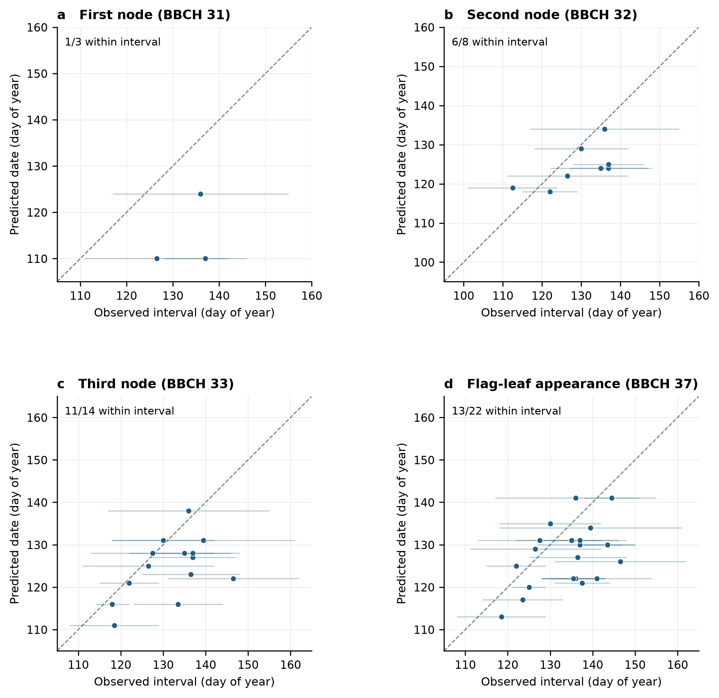
Figure S1 | Field evaluation of wheat phenological stage dates. Horizontal segments show observed two-sided stage intervals; their centers locate markers and are not treated as exact event dates. The dashed diagonal denotes equal dates, and an interval intersecting it contains the prediction. Counts give compatible intervals among all informative records. Observations from both field archives are pooled; calibration and evaluation remain separate. Intervals express observation resolution rather than statistical confidence.

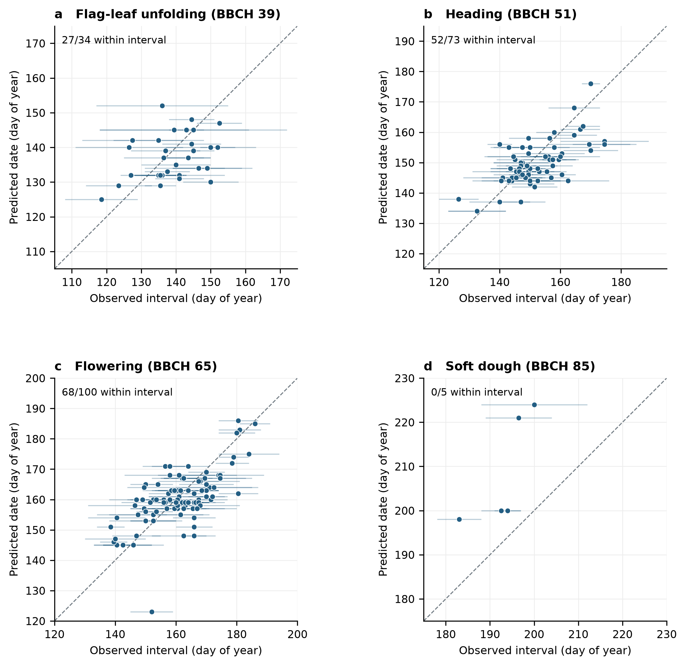
Figure S2 | Field evaluation of wheat phenological stage dates. Horizontal segments show observed two-sided stage intervals; their centers locate markers and are not treated as exact event dates. The dashed diagonal denotes equal dates, and an interval intersecting it contains the prediction. Counts give compatible intervals among all informative records. Observations from both field archives are pooled; calibration and evaluation remain separate. Intervals express observation resolution rather than statistical confidence.

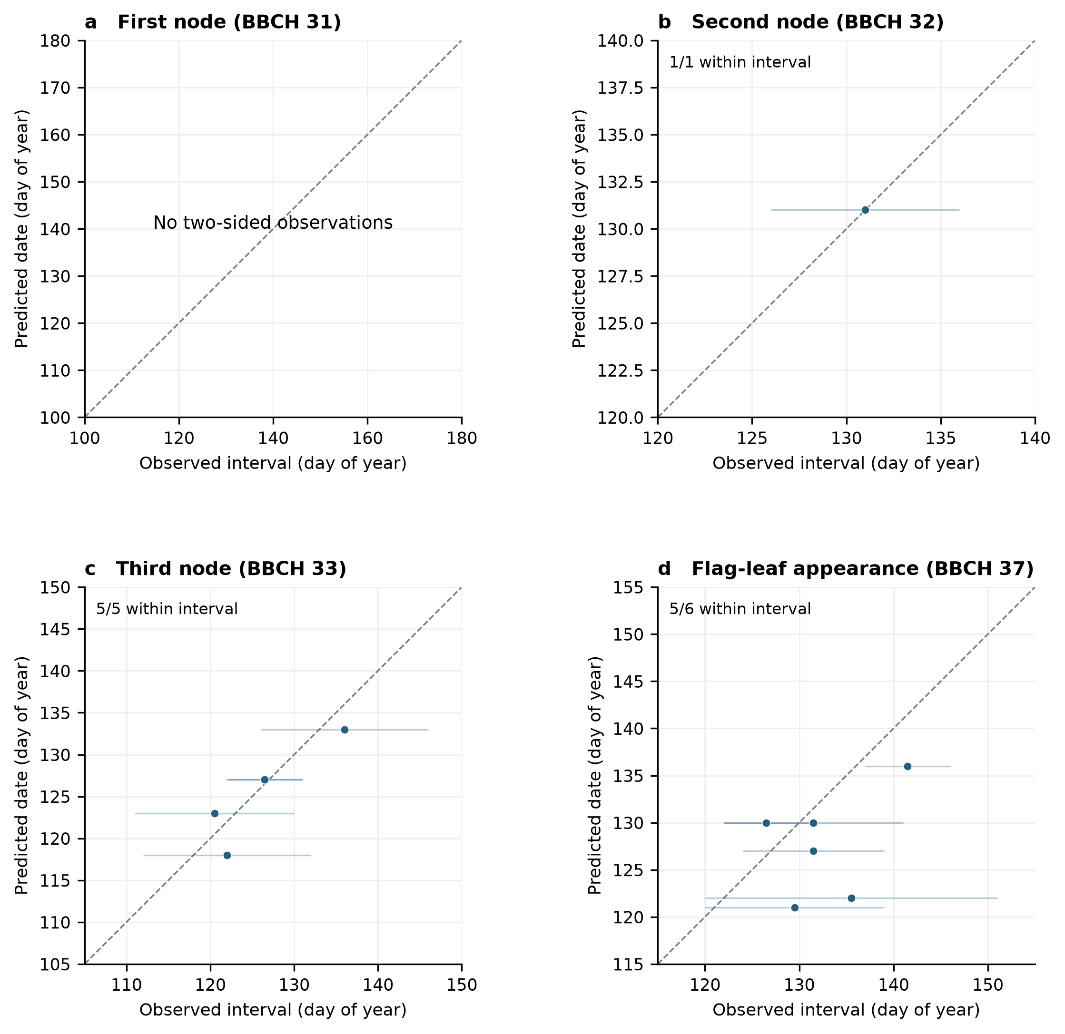
Figure S3 | Calibration of wheat phenological stage dates. Horizontal segments show observed two-sided stage intervals; their centers locate markers and are not treated as exact event dates. The dashed diagonal denotes equal dates, and an interval intersecting it contains the prediction. Counts give compatible intervals among all informative records. Observations from both field archives are pooled; calibration and evaluation remain separate. Intervals express observation resolution rather than statistical confidence.

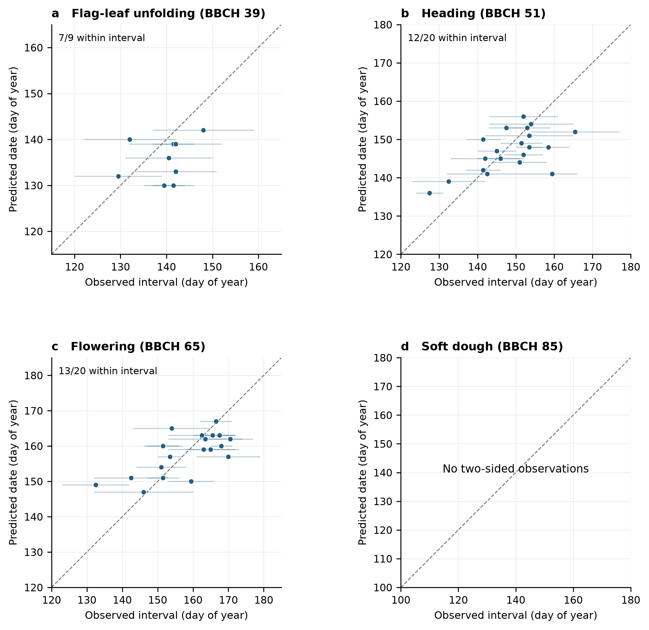
Figure S4 | Calibration of wheat phenological stage dates. Horizontal segments show observed two-sided stage intervals; their centers locate markers and are not treated as exact event dates. The dashed diagonal denotes equal dates, and an interval intersecting it contains the prediction. Counts give compatible intervals among all informative records. Observations from both field archives are pooled; calibration and evaluation remain separate. Intervals express observation resolution rather than statistical confidence.

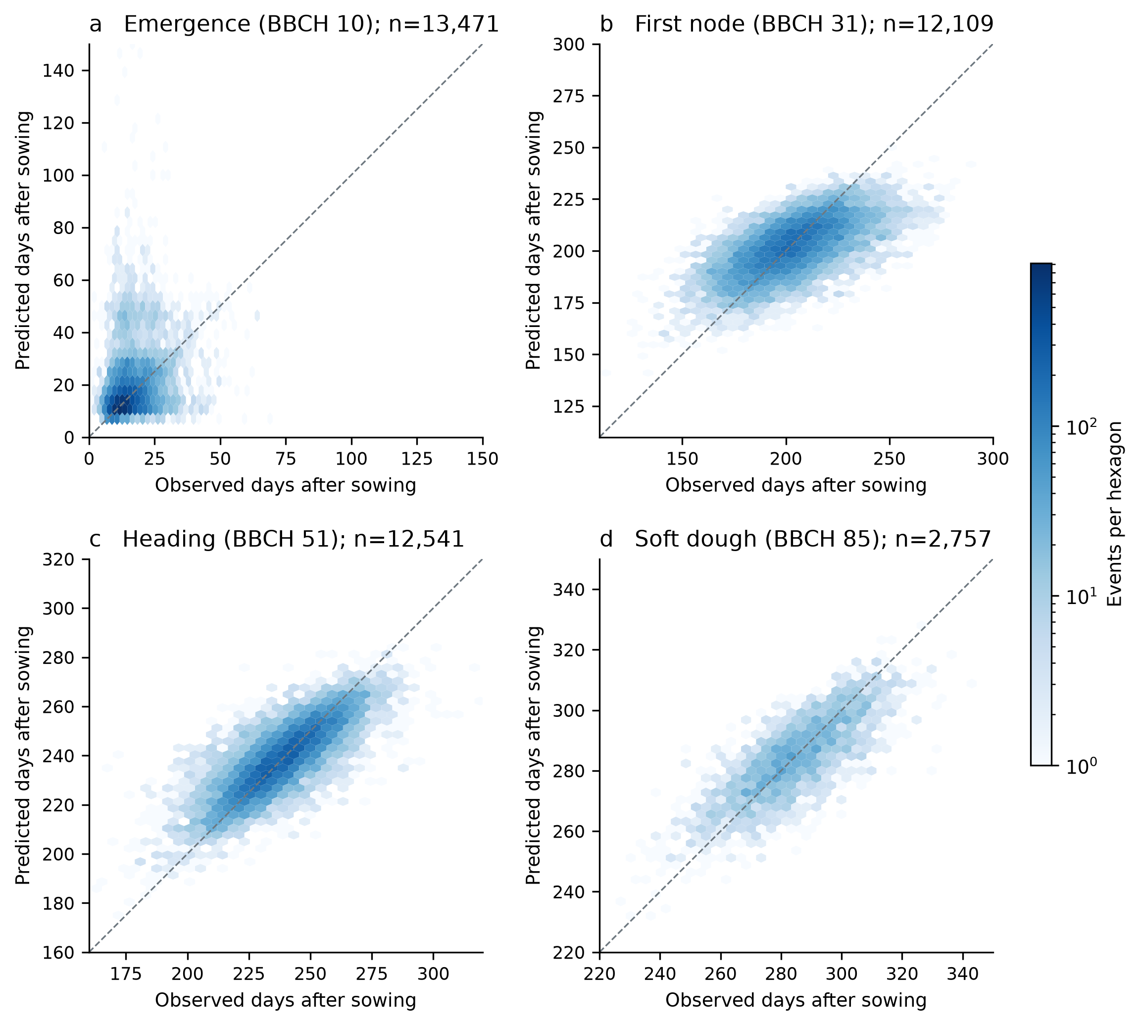
Figure S5 | Retained T–P–V predictions on the German station test cohort at BBCH 10, 31, 51 and 85. Every common matched test event is represented, including date-error tails. Both axes use days from the recorded sowing anchor to avoid calendar-year ambiguity. Hexagon colour shows count on a shared logarithmic scale; axis ranges vary by stage. Missing predictions remain in the coverage tables. The station holdout concerns realized-weather phenology, rather than disease or field-yield forecasts.

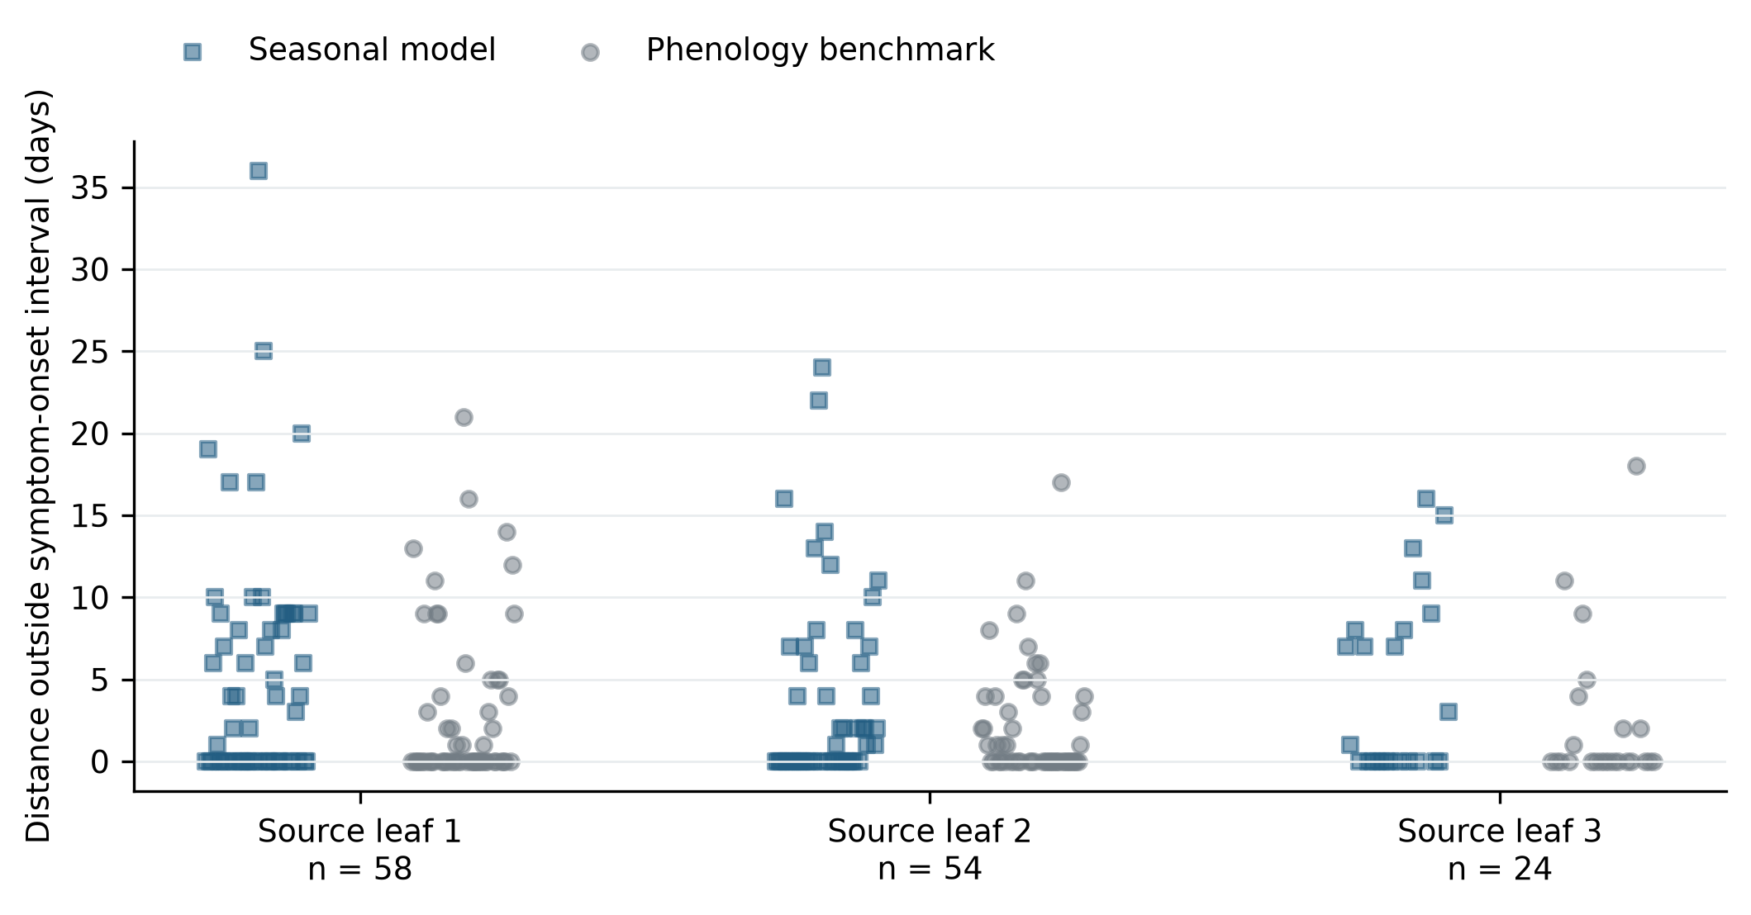
Figure S6 | Pooled symptom-onset errors for source-numbered leaves 1–3. All 136 genuinely two-sided histories remain represented. Horizontal displacement separates coincident records. Zero indicates a predicted date within the observation interval; missing positive predictions retain their predefined penalty. Source leaf numbers do not establish a common final-rank identity across archives. Scores use equal coordinate-year, field and leaf weighting.

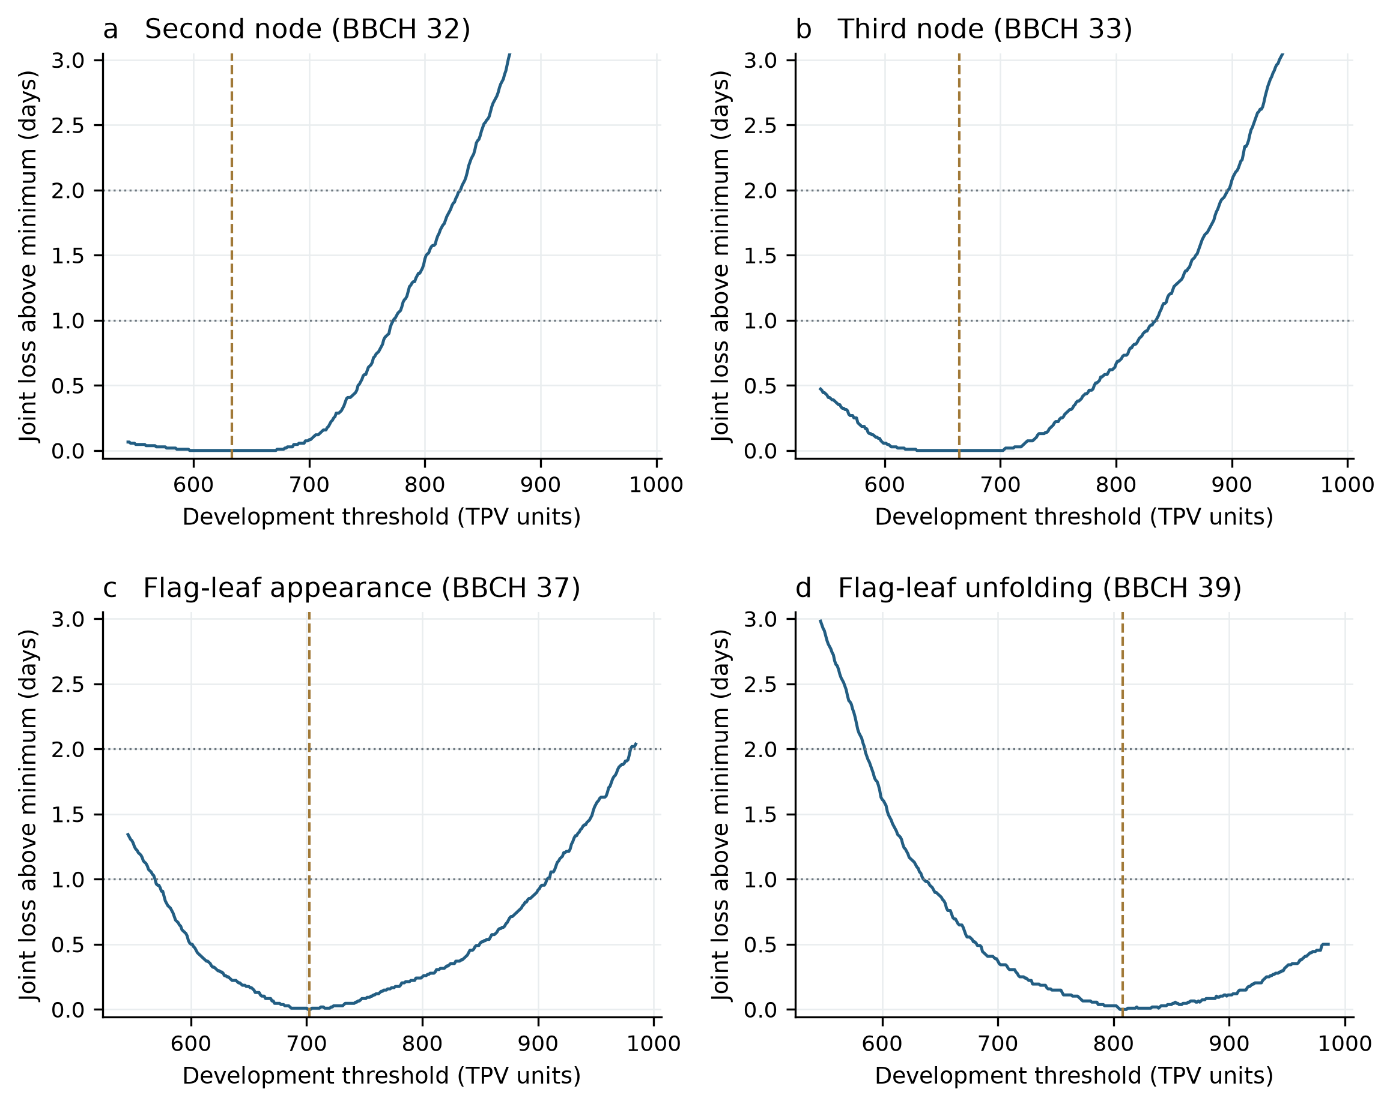
Figure S7 | Ordered stage-threshold identification from calibration-only observations. Each blue curve is the minimum joint loss conditional on that threshold, after optimizing the other ordered stage thresholds. Dashed vertical lines mark the selected values; horizontal lines show declared one- and two-day loss tolerances. The displayed range is zero to three days above the joint minimum; all 399 grid values for each event remain in Source Data. Loss-tolerance regions describe identification and are not statistical confidence intervals.

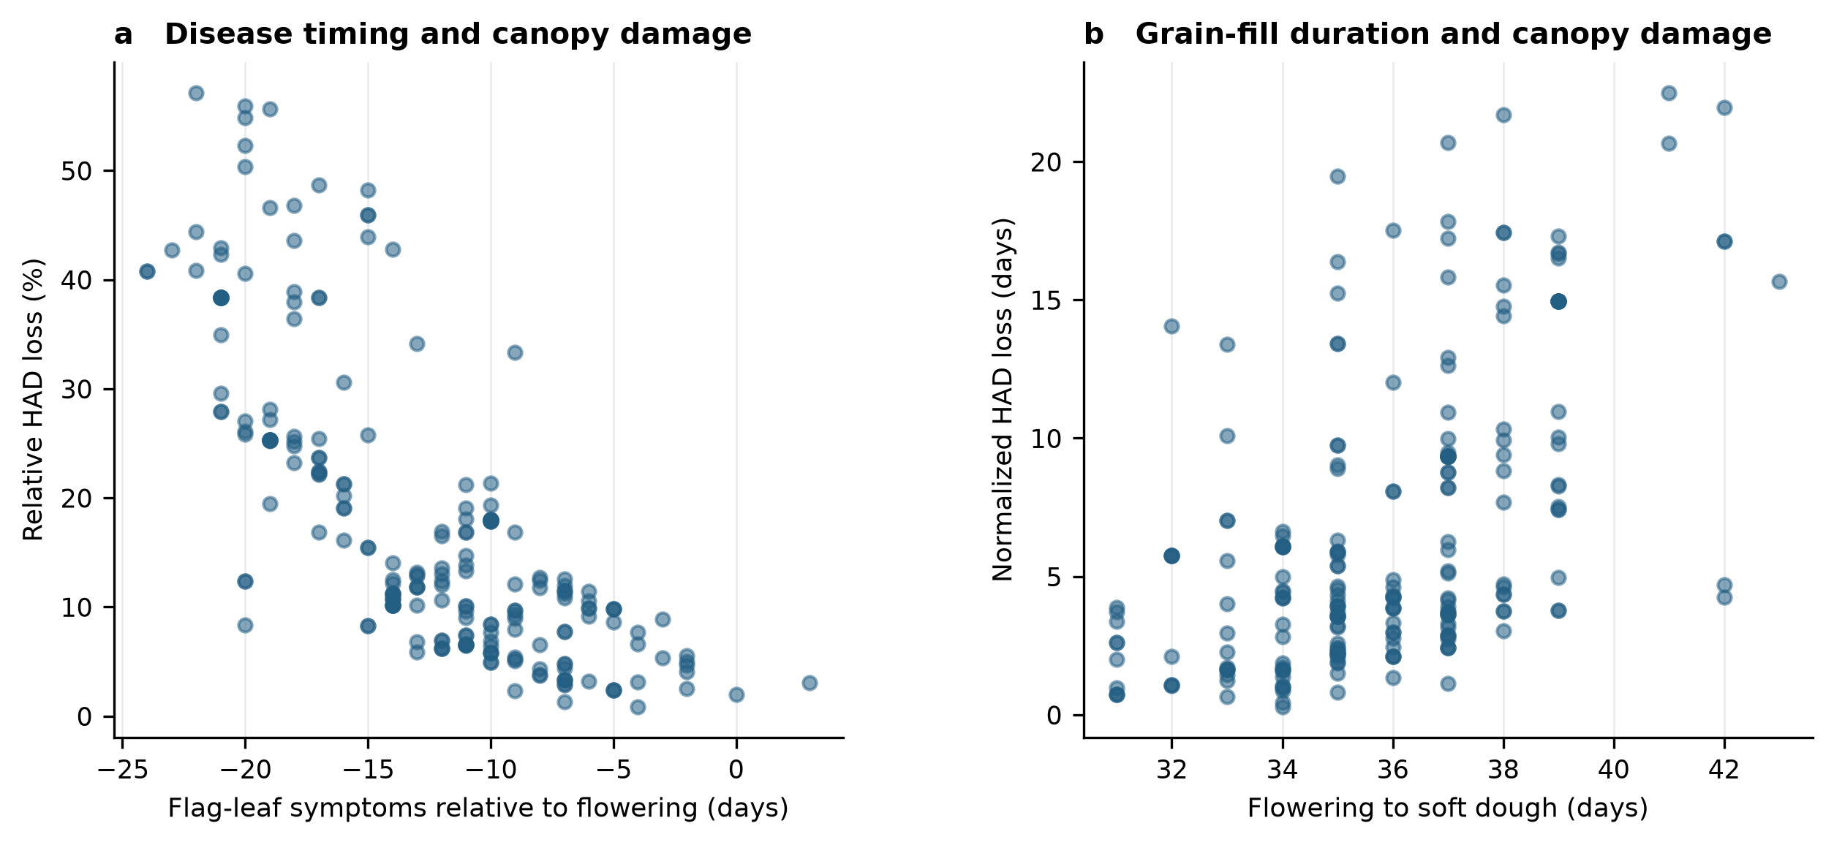
Figure S8 | Simulated disease timing and grain-fill canopy damage in field weather replays. Each point represents one of 218 full-season simulations. (a) Flag-leaf symptoms relative to flowering and relative HAD loss. (b) Flowering-to-soft-dough duration and HAD deficit. Reference upper-three-leaf LAI is nominally one. Both axes describe simulated quantities; these relationships do not validate observed disease severity or grain-yield loss.

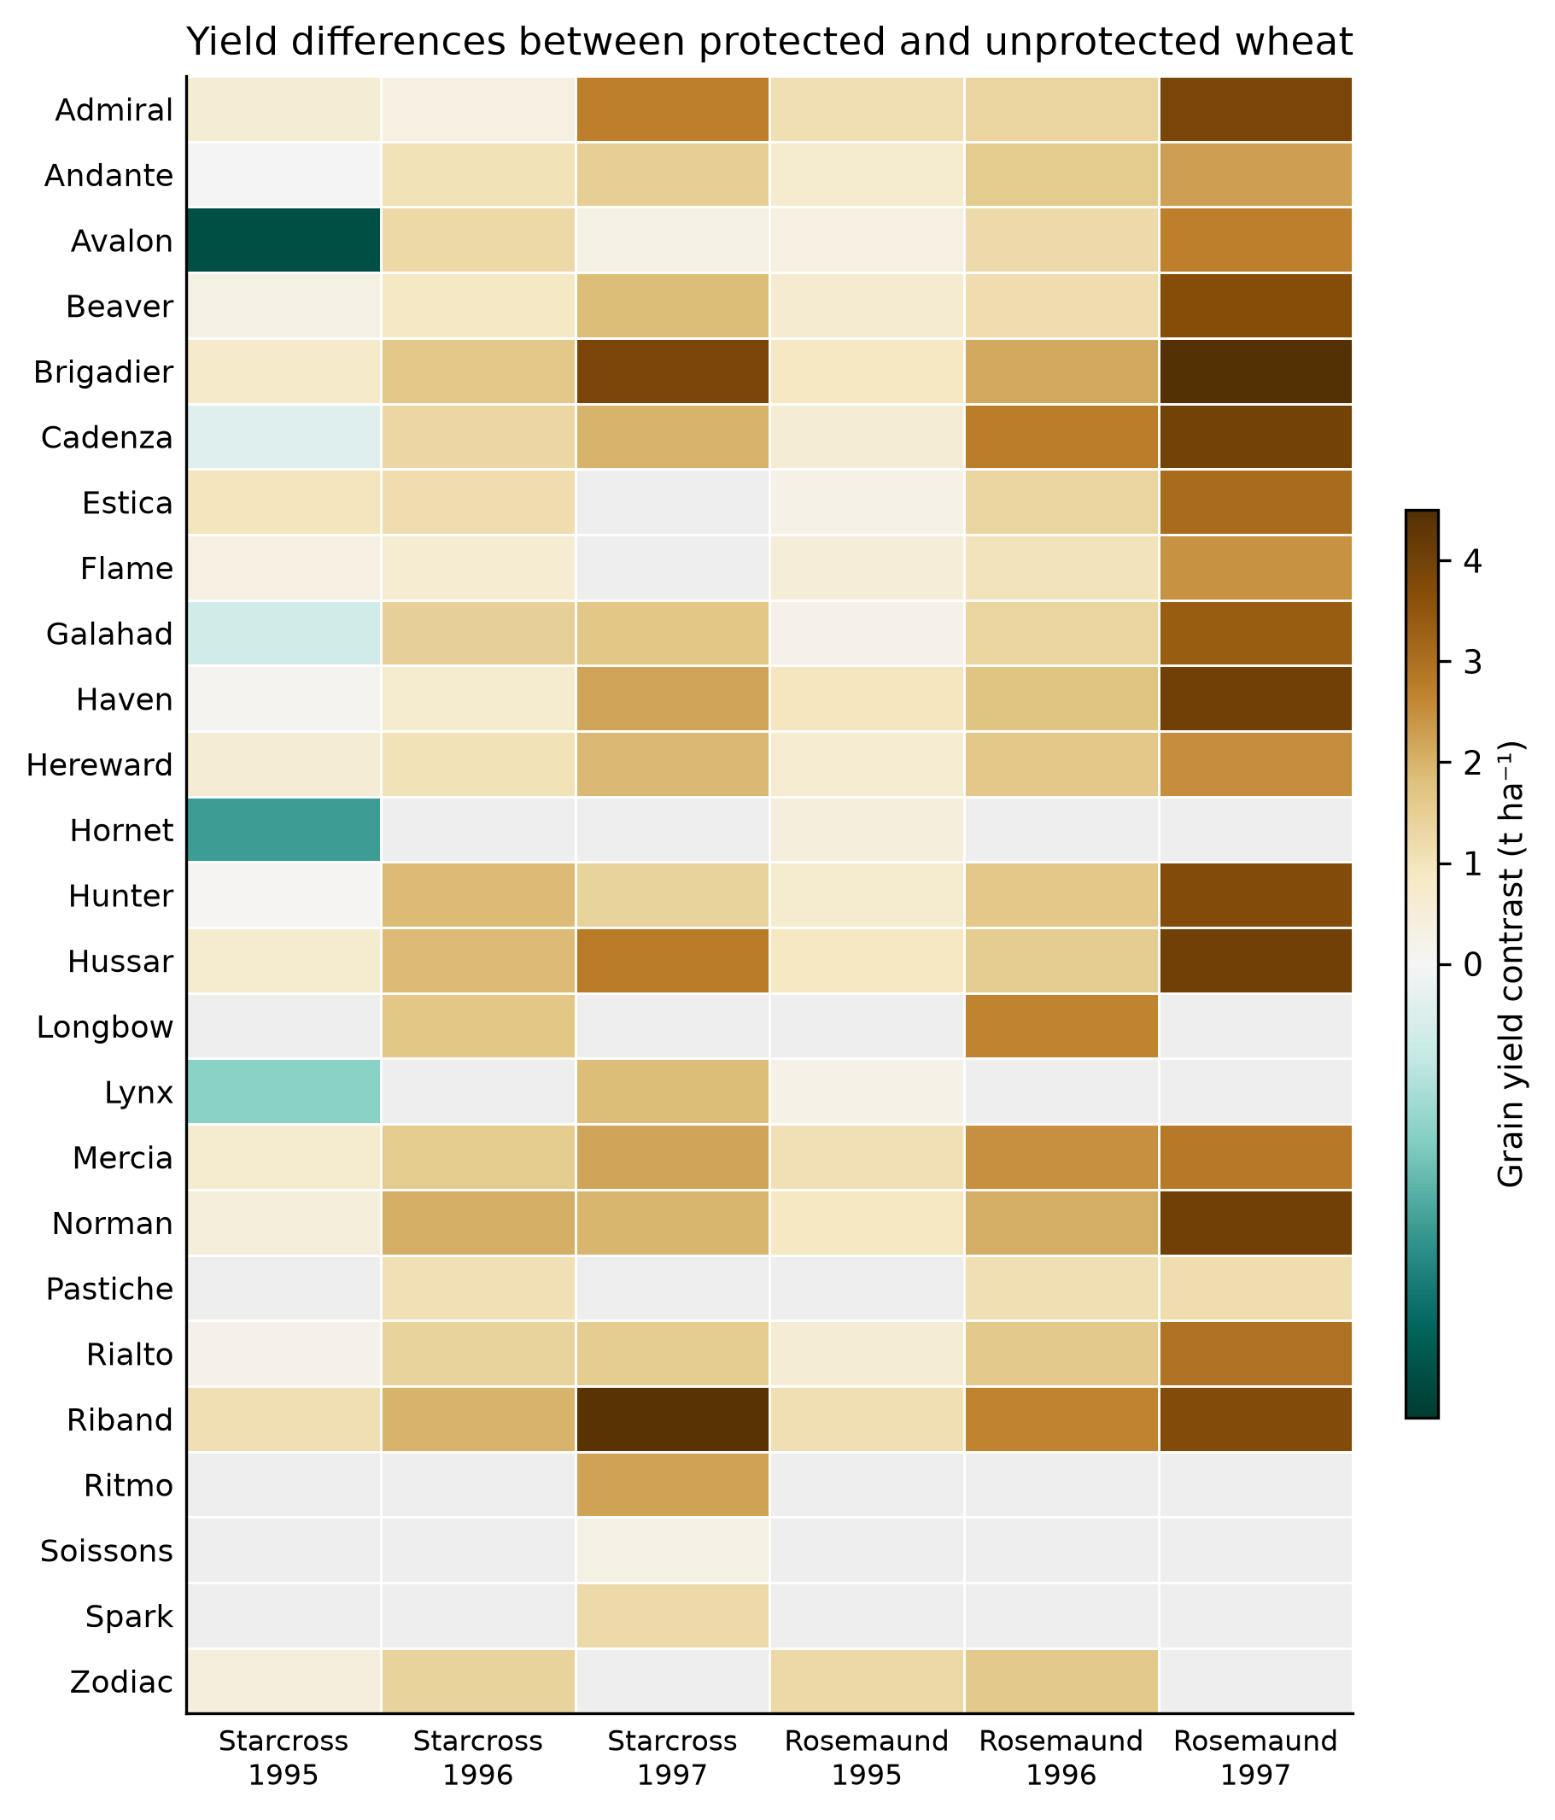
Figure S9 | All 117 reported protected-minus-unprotected grain-yield contrasts in Parker et al. (2004), Table 4. The 25 cultivars and six site-years are retained, including five negative contrasts; grey cells indicate unreported combinations. Values are published treatment contrasts from a three-replicate field design, not independent plot records. They supply empirical yield outcomes for the study whose crop-impact relationship integrates absolute green area over the top three leaves.

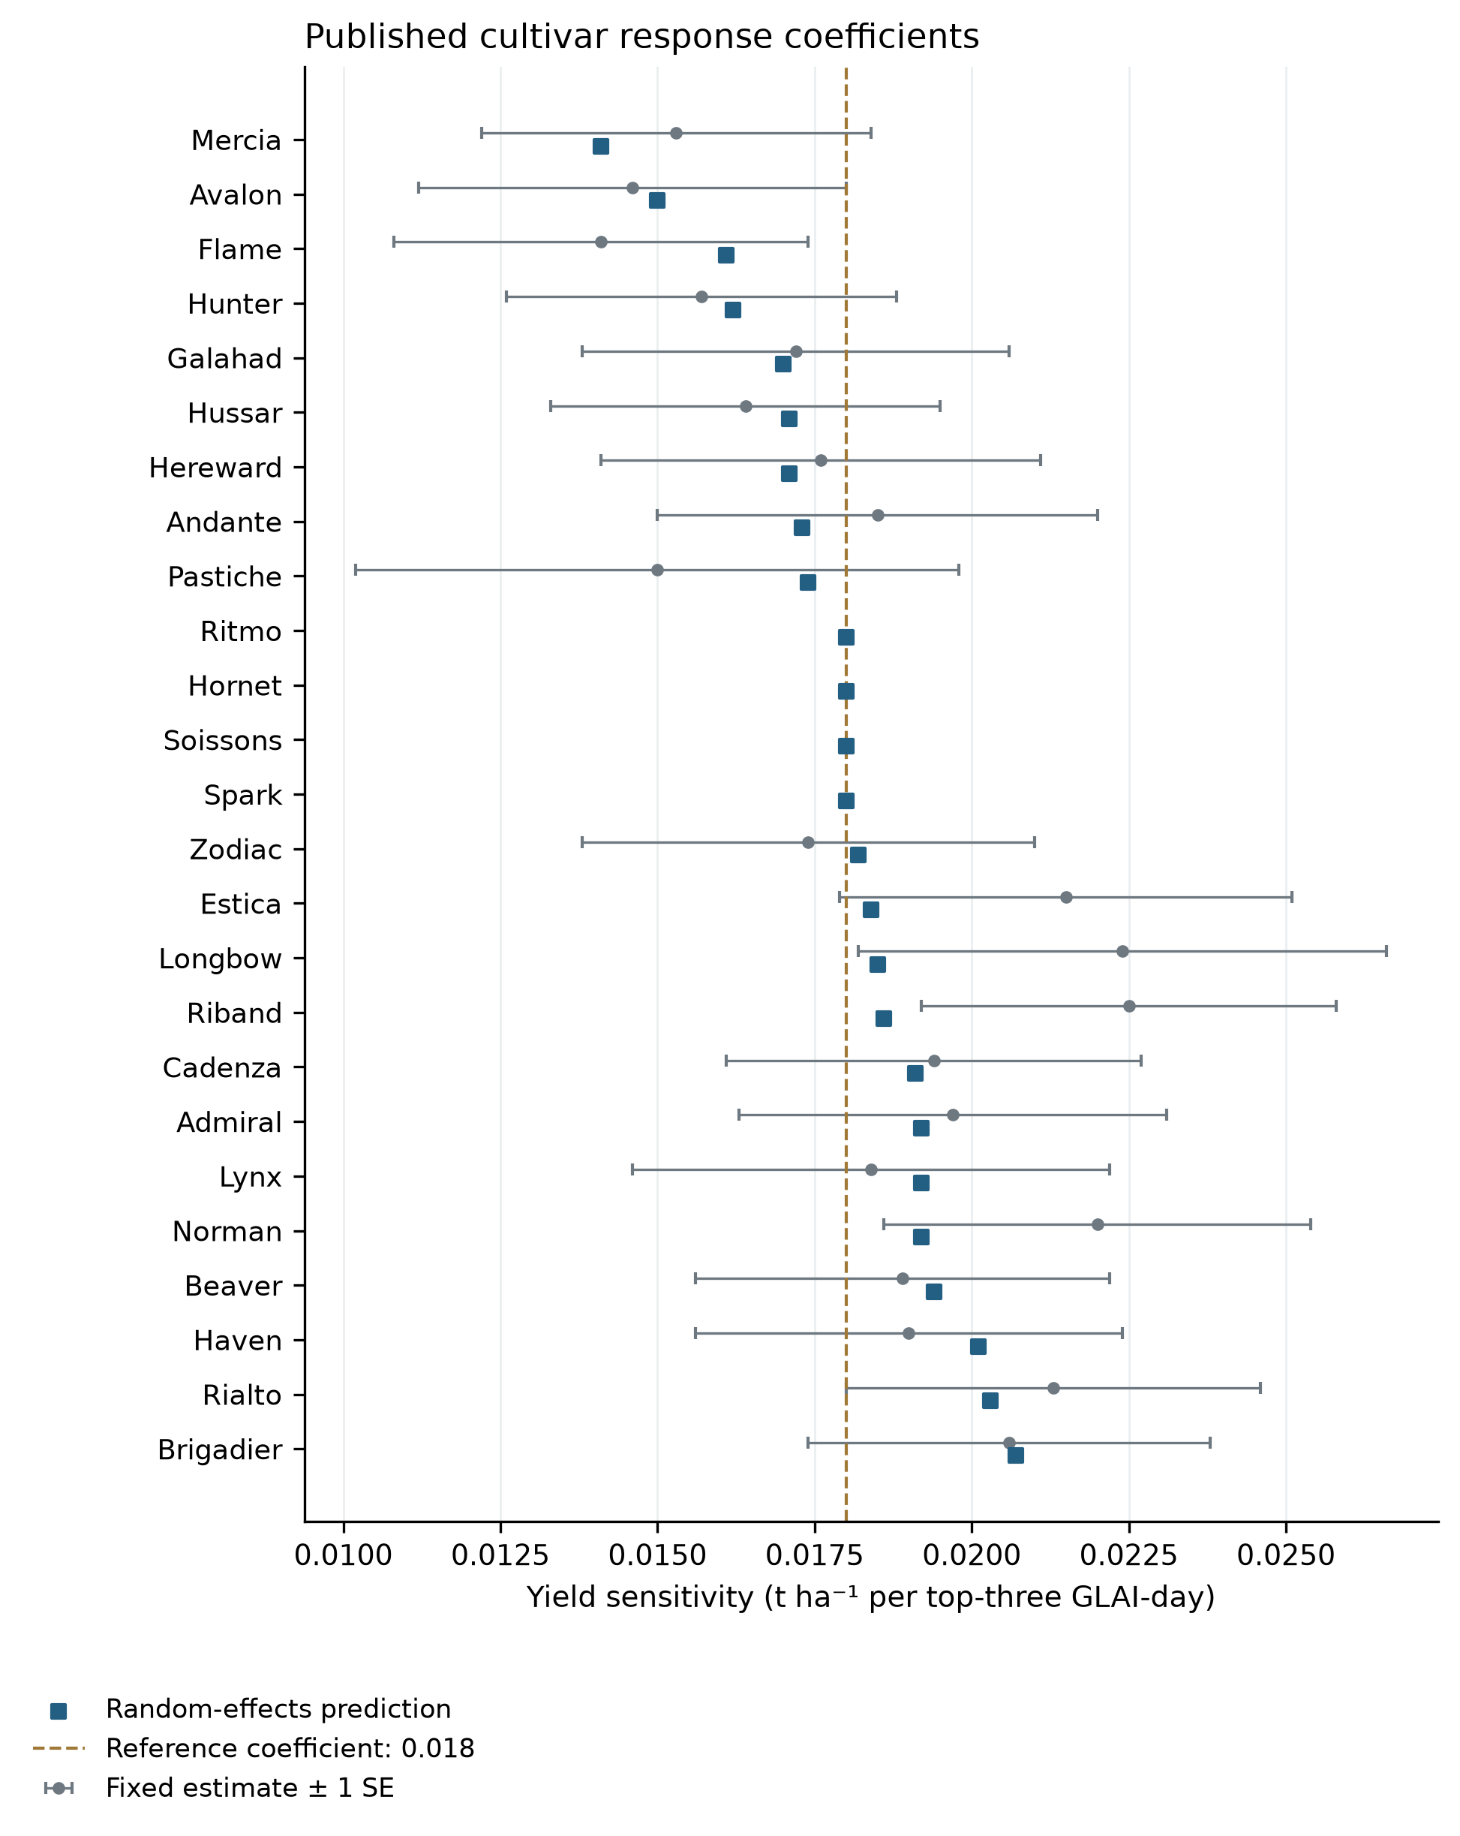
Figure S10 | All 25 cultivar response predictions from Parker et al. (2004), Table 5, with available fixed-effect estimates and their published standard errors. The dashed line identifies the retained 0.018 t ha⁻¹ per GLAI-day transfer centre. Random-effect predictions span 0.0141–0.0207; that cultivar range is not a confidence interval. Error bars represent one standard error of fixed-effect coefficients. BLUP prediction-error variances concern deviations from the population mean and are not substituted for uncertainty of complete slopes. Different cultivars share environments and are not independent field replications.

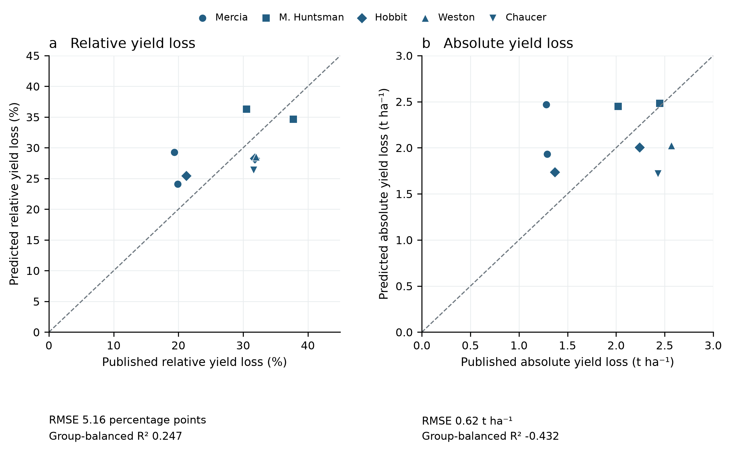
Figure S11 | Leave-one-genetic-background-out reproduction of the published top-five paired means. One nonnegative origin-constrained coefficient is fitted to the other four genetic backgrounds in each fold. (a) Relative HAD-loss to relative yield-loss transfer; (b) absolute HAD-loss to absolute grain-loss transfer. Metrics give each background equal weight, divided among its lines. This is a small aggregate-data benchmark with shared mixed-model means and unbalanced disease/site coverage. It is not raw-plot validation, does not remove environmental confounding and does not calibrate the current top-three transfer. Negative absolute-response R² identifies failure of a universal absolute slope.

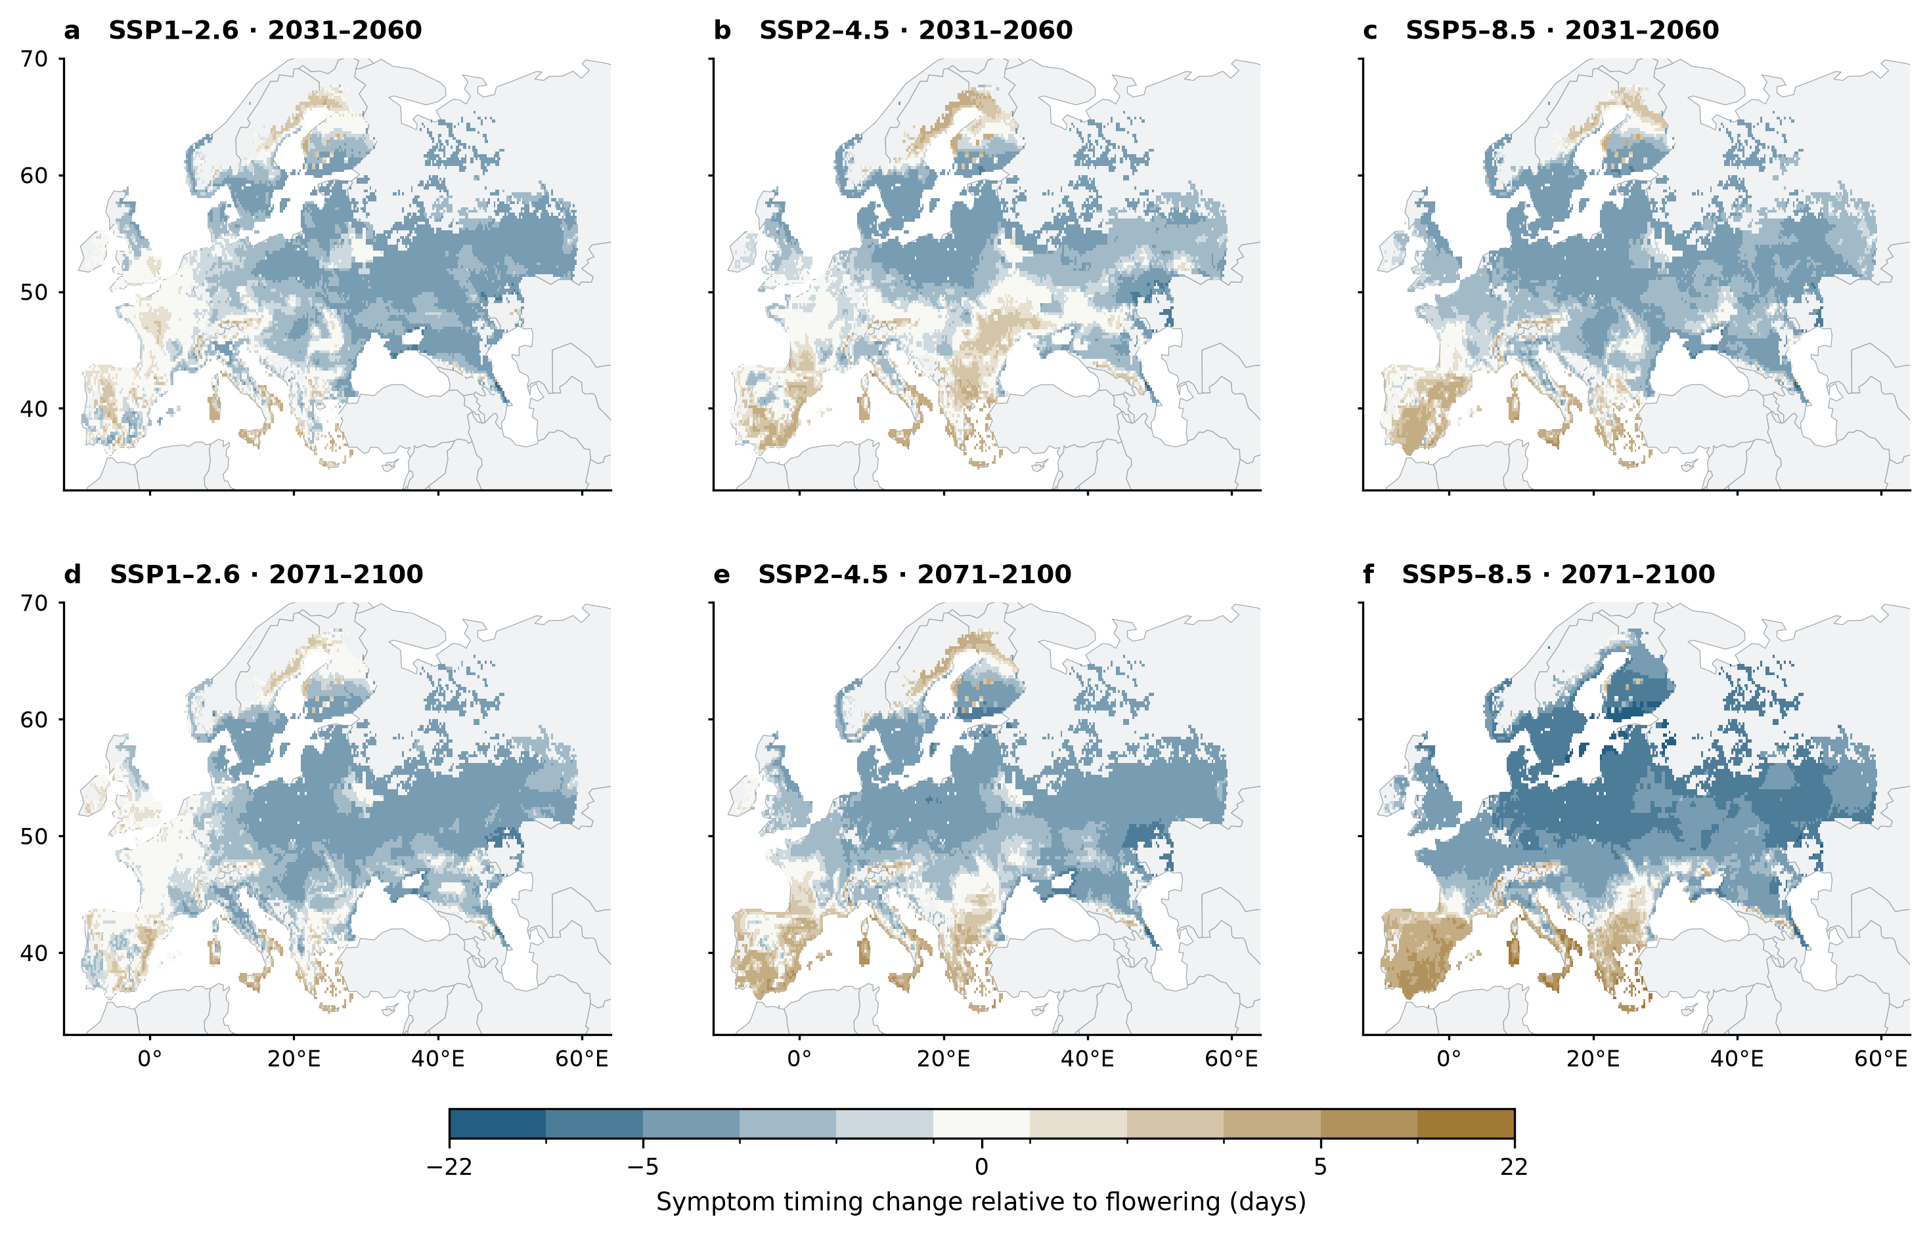
Figure S12 | Changes in flag-leaf symptom timing. Panels show three-climate-model means at every eligible wheat land-use grid for two future periods relative to 1991–2020. Each figure shares symmetric discrete color intervals retaining the full data range. Gray wheat pixels have unavailable estimates. Timing requires detected symptoms in both paired years. Estimated disease-related yield change is −0.018 times the HAD-loss change, converted to kg ha⁻¹ per reference LAI. The yield product depends on a fixed canopy–yield coefficient and nominal leaf area rather than a validated grain-yield model.

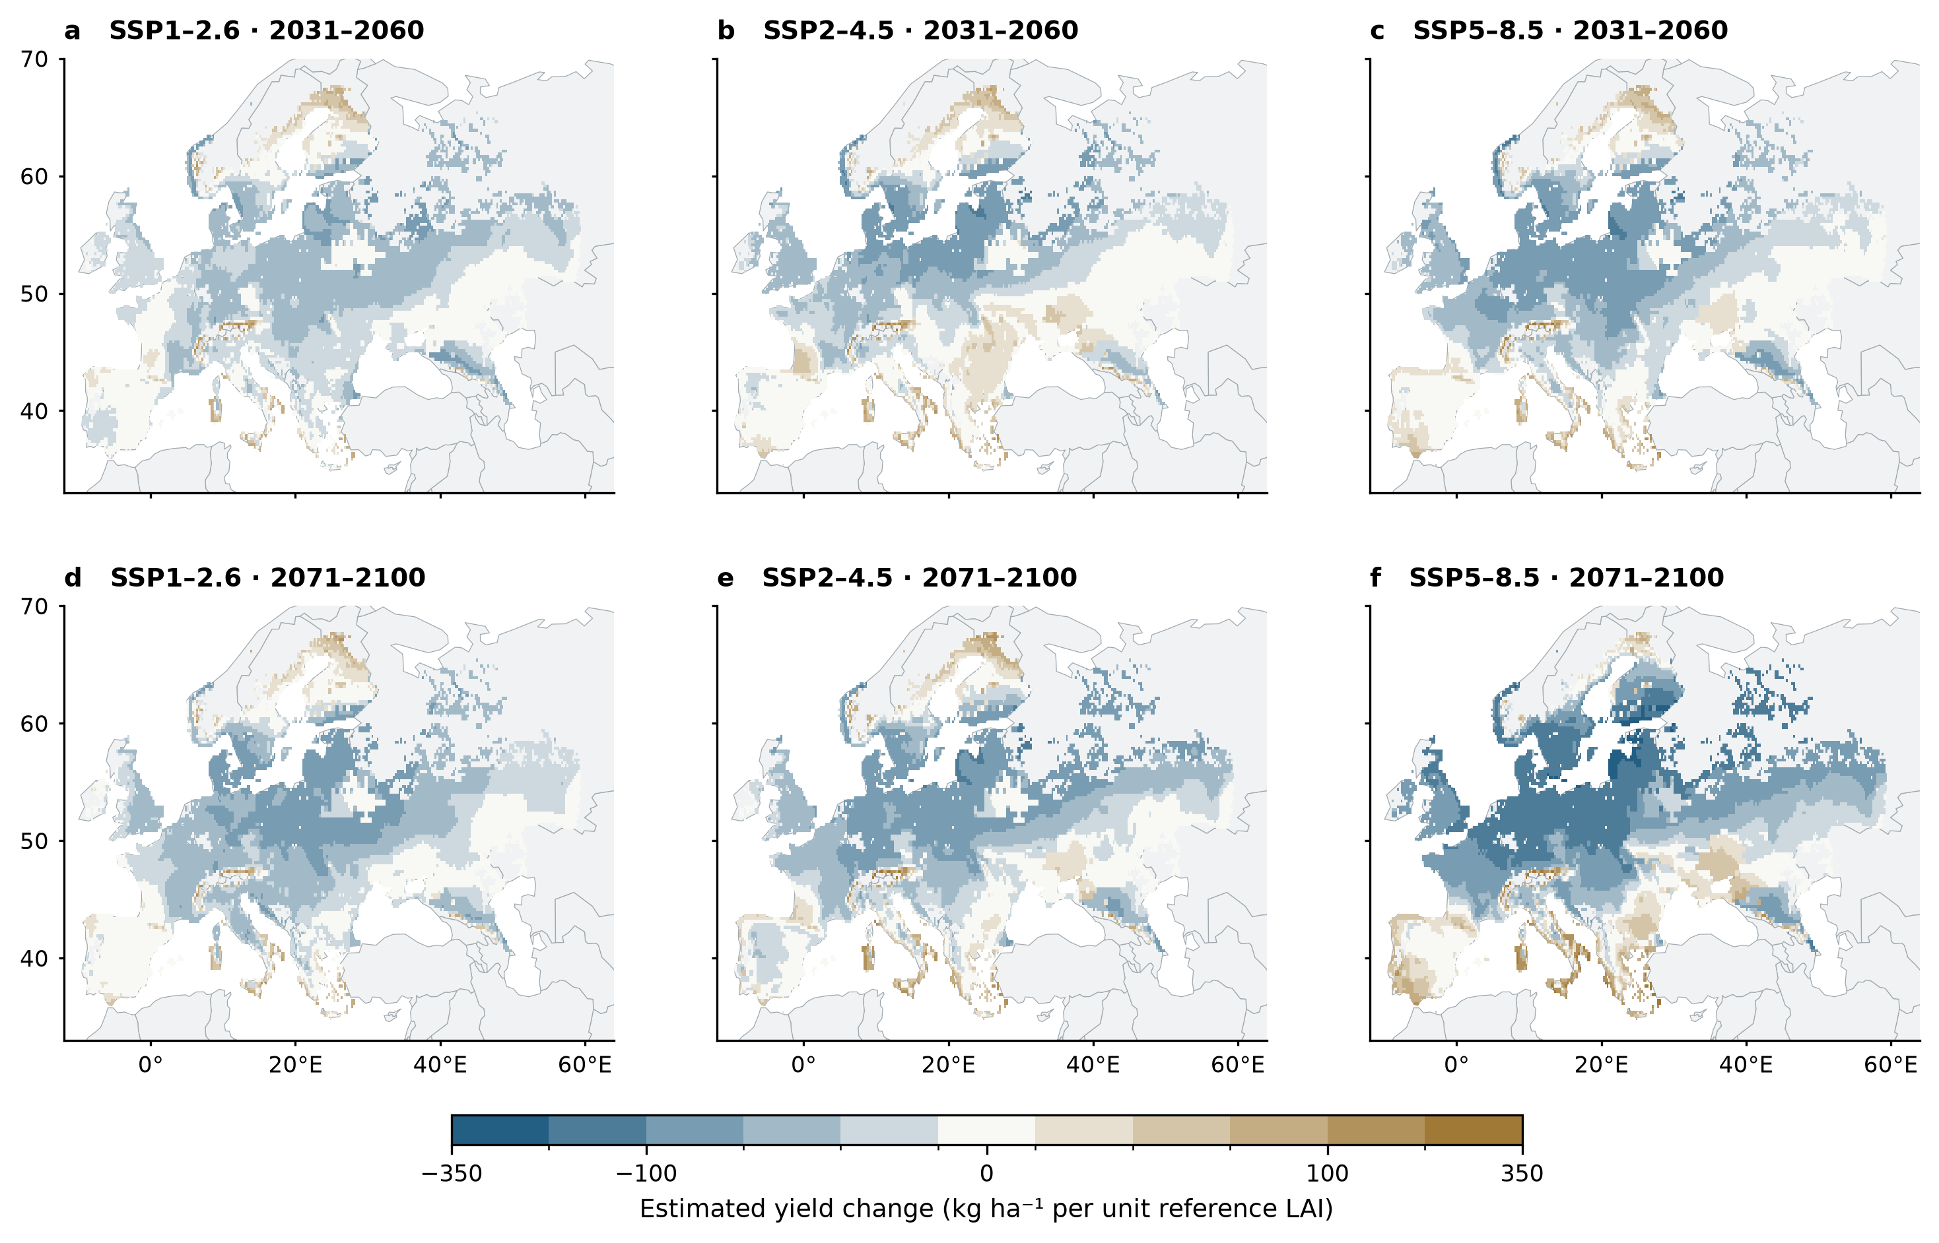
Figure S13 | Disease-related yield changes inferred from canopy damage. Panels show three-climate-model means at every eligible wheat land-use grid for two future periods relative to 1991–2020. Each figure shares symmetric discrete color intervals retaining the full data range. Gray wheat pixels have unavailable estimates. Timing requires detected symptoms in both paired years. Estimated disease-related yield change is −0.018 times the HAD-loss change, converted to kg ha⁻¹ per reference LAI. The yield product depends on a fixed canopy–yield coefficient and nominal leaf area rather than a validated grain-yield model.

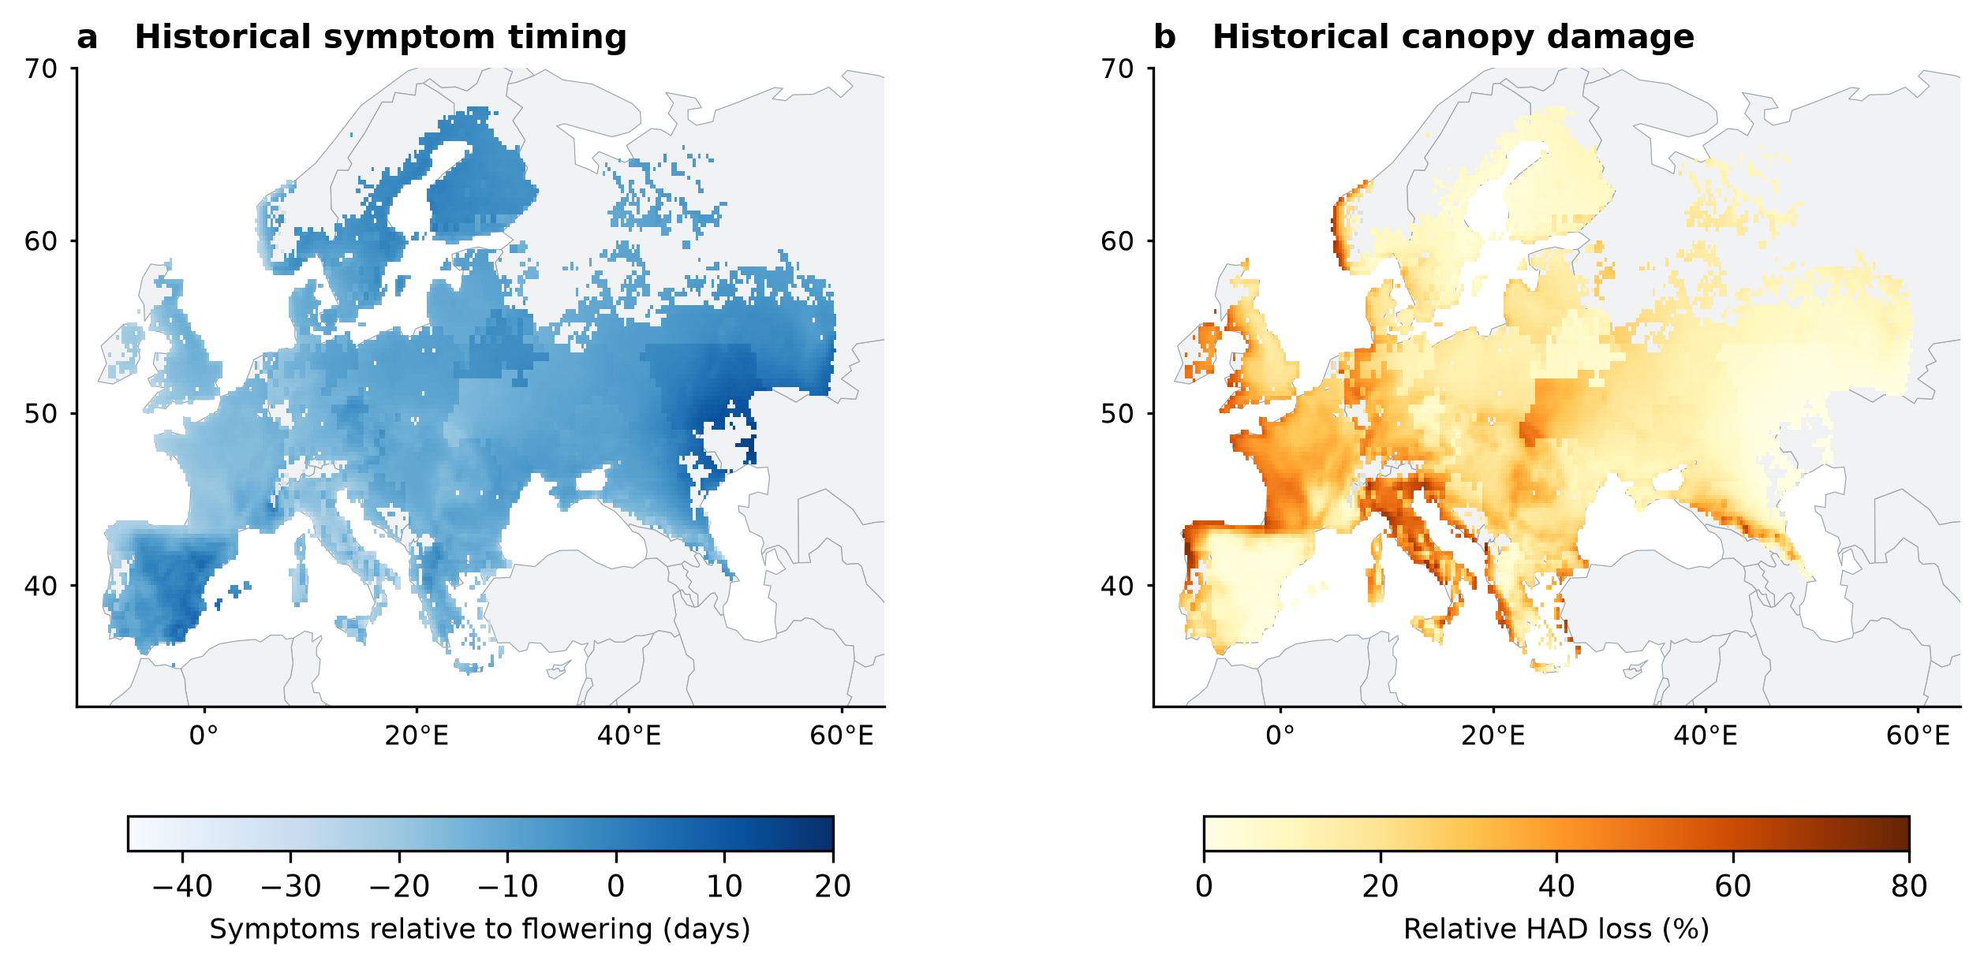
Figure S14 | Historical simulated disease timing and canopy damage across the full wheat domain. Panels show the 1991–2020 reference means on the corresponding seasons included in the late-century SSP5–8.5 comparison, averaged across three climate models. (a) Flag-leaf symptoms relative to flowering. (b) Relative HAD loss during grain filling. Gray wheat pixels have unavailable estimates. These modeled reference distributions differ from observed historical disease prevalence.

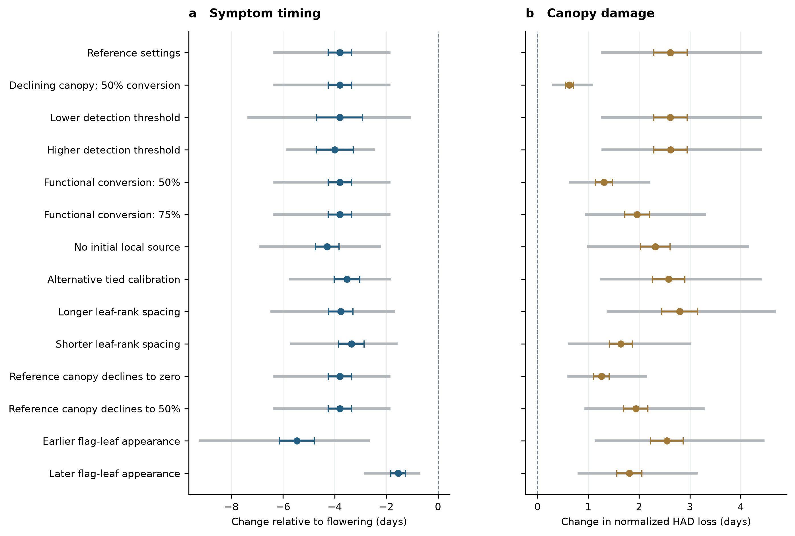
Figure S15 | Sensitivity of simulated climate responses to structural and reporting assumptions. (a) Flag-leaf symptom timing relative to flowering. (b) Normalized HAD loss during grain filling. All fourteen settings retain their common paired late-century SSP5–8.5 diagnostic population. Gray segments span three climate-model means; colored whiskers show one spatial Monte Carlo standard error for 64 area-proportional draws. Settings describe selected model assumptions rather than a probability distribution of future disease outcomes; precise settings and coverage remain in Supplementary Table S10.

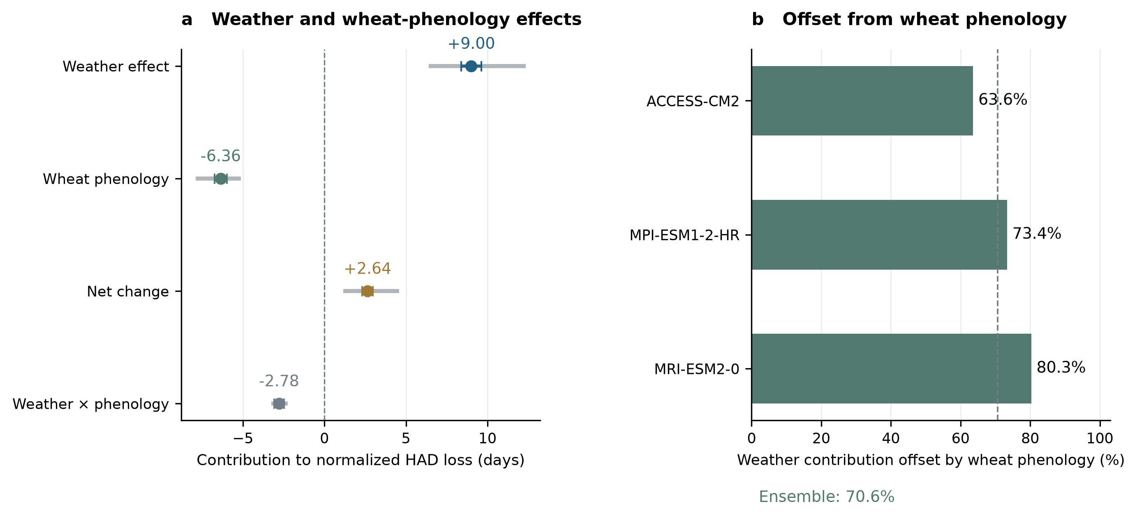
Figure S16 | Weather and wheat-phenology contributions and offsets. (a) Weather, crop-phenology and net HAD contributions with the full interaction shown separately. The interaction is already allocated equally between the two Shapley contributions and is not added again to the net. Gray segments span climate-model means; colored whiskers show one spatial Monte Carlo standard error. (b) Model-specific offsets and their ensemble-contribution ratio. The same 5,731 supported paired seasons underlie all HAD terms. The sampled analysis is separate from the full-grid estimates and does not measure intervention benefits.

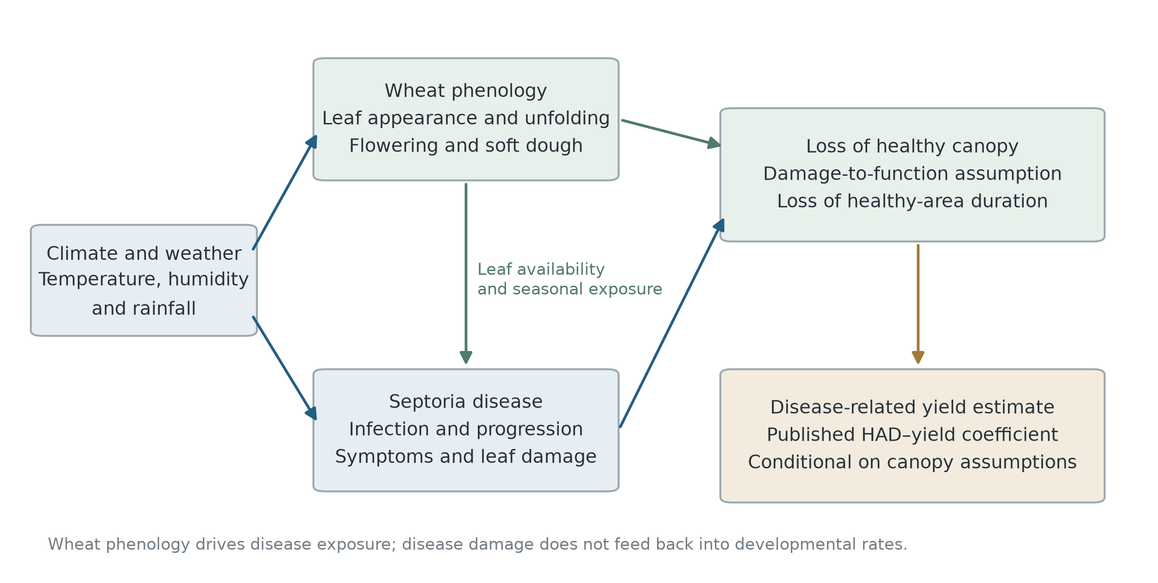
Figure S17 | Relationships among climate, wheat phenology, Septoria disease and the estimated yield response. Wheat phenology comprises leaf appearance, unfolding, flowering and soft dough. Weather drives these stage dates and disease. Leaf availability and seasonal timing connect wheat phenology to infection and damage. Disease damage is mapped to an assumed loss of canopy function and integrated as HAD loss. A published coefficient provides a conditional disease-related yield estimate. The model has no disease feedback on crop-development rates and no complete crop carbon-balance calculation.

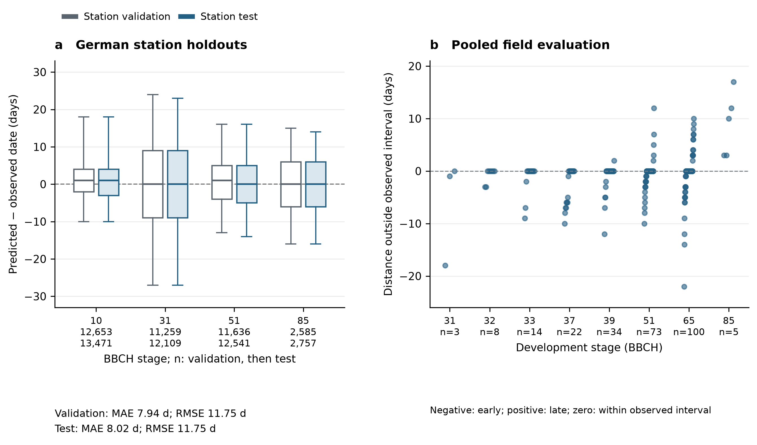
Figure S18 | Evaluation of retained crop-development stages. (a) German station-held-out date errors at BBCH 10, 31, 51 and 85. Boxes span the interquartile range; whiskers span the fifth to ninety-fifth percentiles. (b) Pooled field errors outside genuine two-sided developmental-stage intervals, with all informative records represented. The station and field endpoints have different observation resolutions. Counts beneath stages give sample sizes; observation intervals do not define statistical confidence intervals.

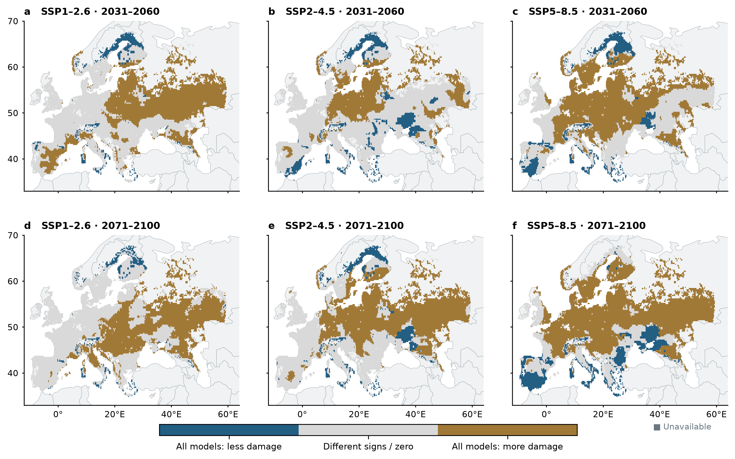
Figure S19 | Agreement in projected canopy-damage direction across climate models. Colors indicate a negative change in all three models, a positive change in all three models, or other sign combinations. Each panel shows independently simulated wheat grids for one emissions pathway and future period relative to 1991–2020. Model agreement is deterministic scenario consistency rather than a probability estimate. Unavailable wheat pixels remain distinguishable from complete mixed-sign estimates in Source Data.

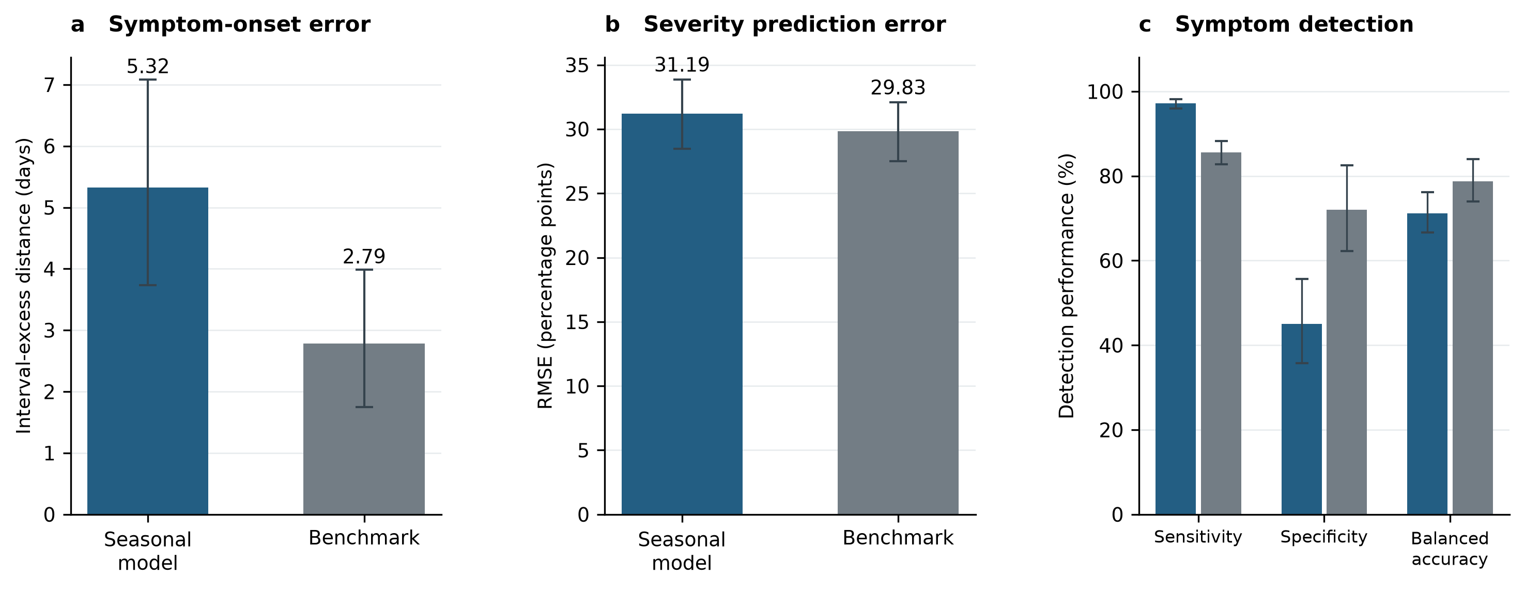
Figure S20 | Pooled evaluation of disease predictions. (a) Mean distance outside genuine two-sided symptom-onset intervals for 136 histories from 78 field seasons and 62 coordinate-years. (b) Numerical severity RMSE for 2,033 assessments from 188 field seasons and 140 coordinate-years. (c) Assessment-level symptom-detection sensitivity, specificity and balanced accuracy on the same 2,033 records. Blue bars represent the seasonal model and gray bars the corresponding calibration-selected benchmark. Whiskers are 95% percentile intervals from 20,000 paired coordinate-year bootstrap resamples. Coordinate-years, fields, source leaves and their assessments receive equal weight within each hierarchy level. Calibration records are excluded. Source scoring conventions and unresolved final leaf-rank mappings remain in the pooled evidence.

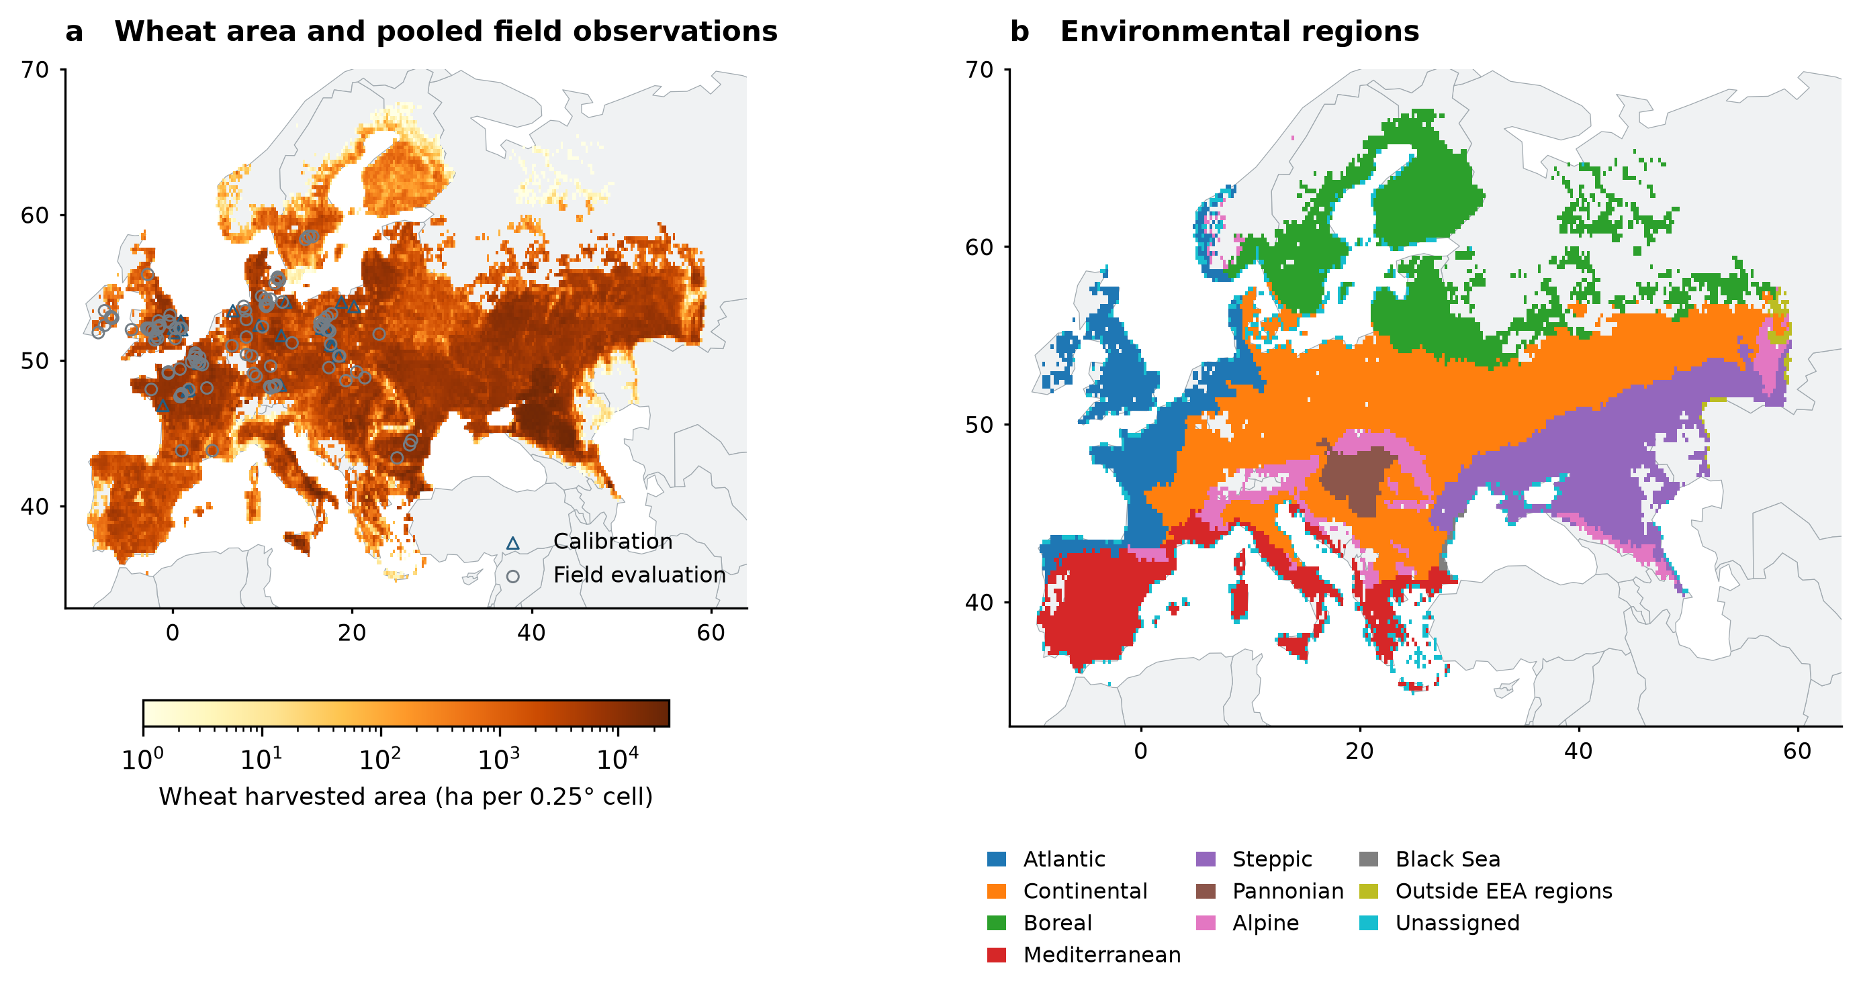
Figure S21 | Wheat-land-use domain, pooled observation locations and environmental regions. (a) SPAM2020 all-wheat harvested area with calibration and pooled evaluation locations; coincident sites retain their true reported coordinates. (b) EEA biogeographical regions assigned by wheat-cell centroid intersection. Outside-region and unassigned cells remain separate. The 14,941-cell fixed mask and imposed winter-wheat rainfed calendar define the climate-analysis scenario. These maps specify the study design and do not display projected disease outcomes.

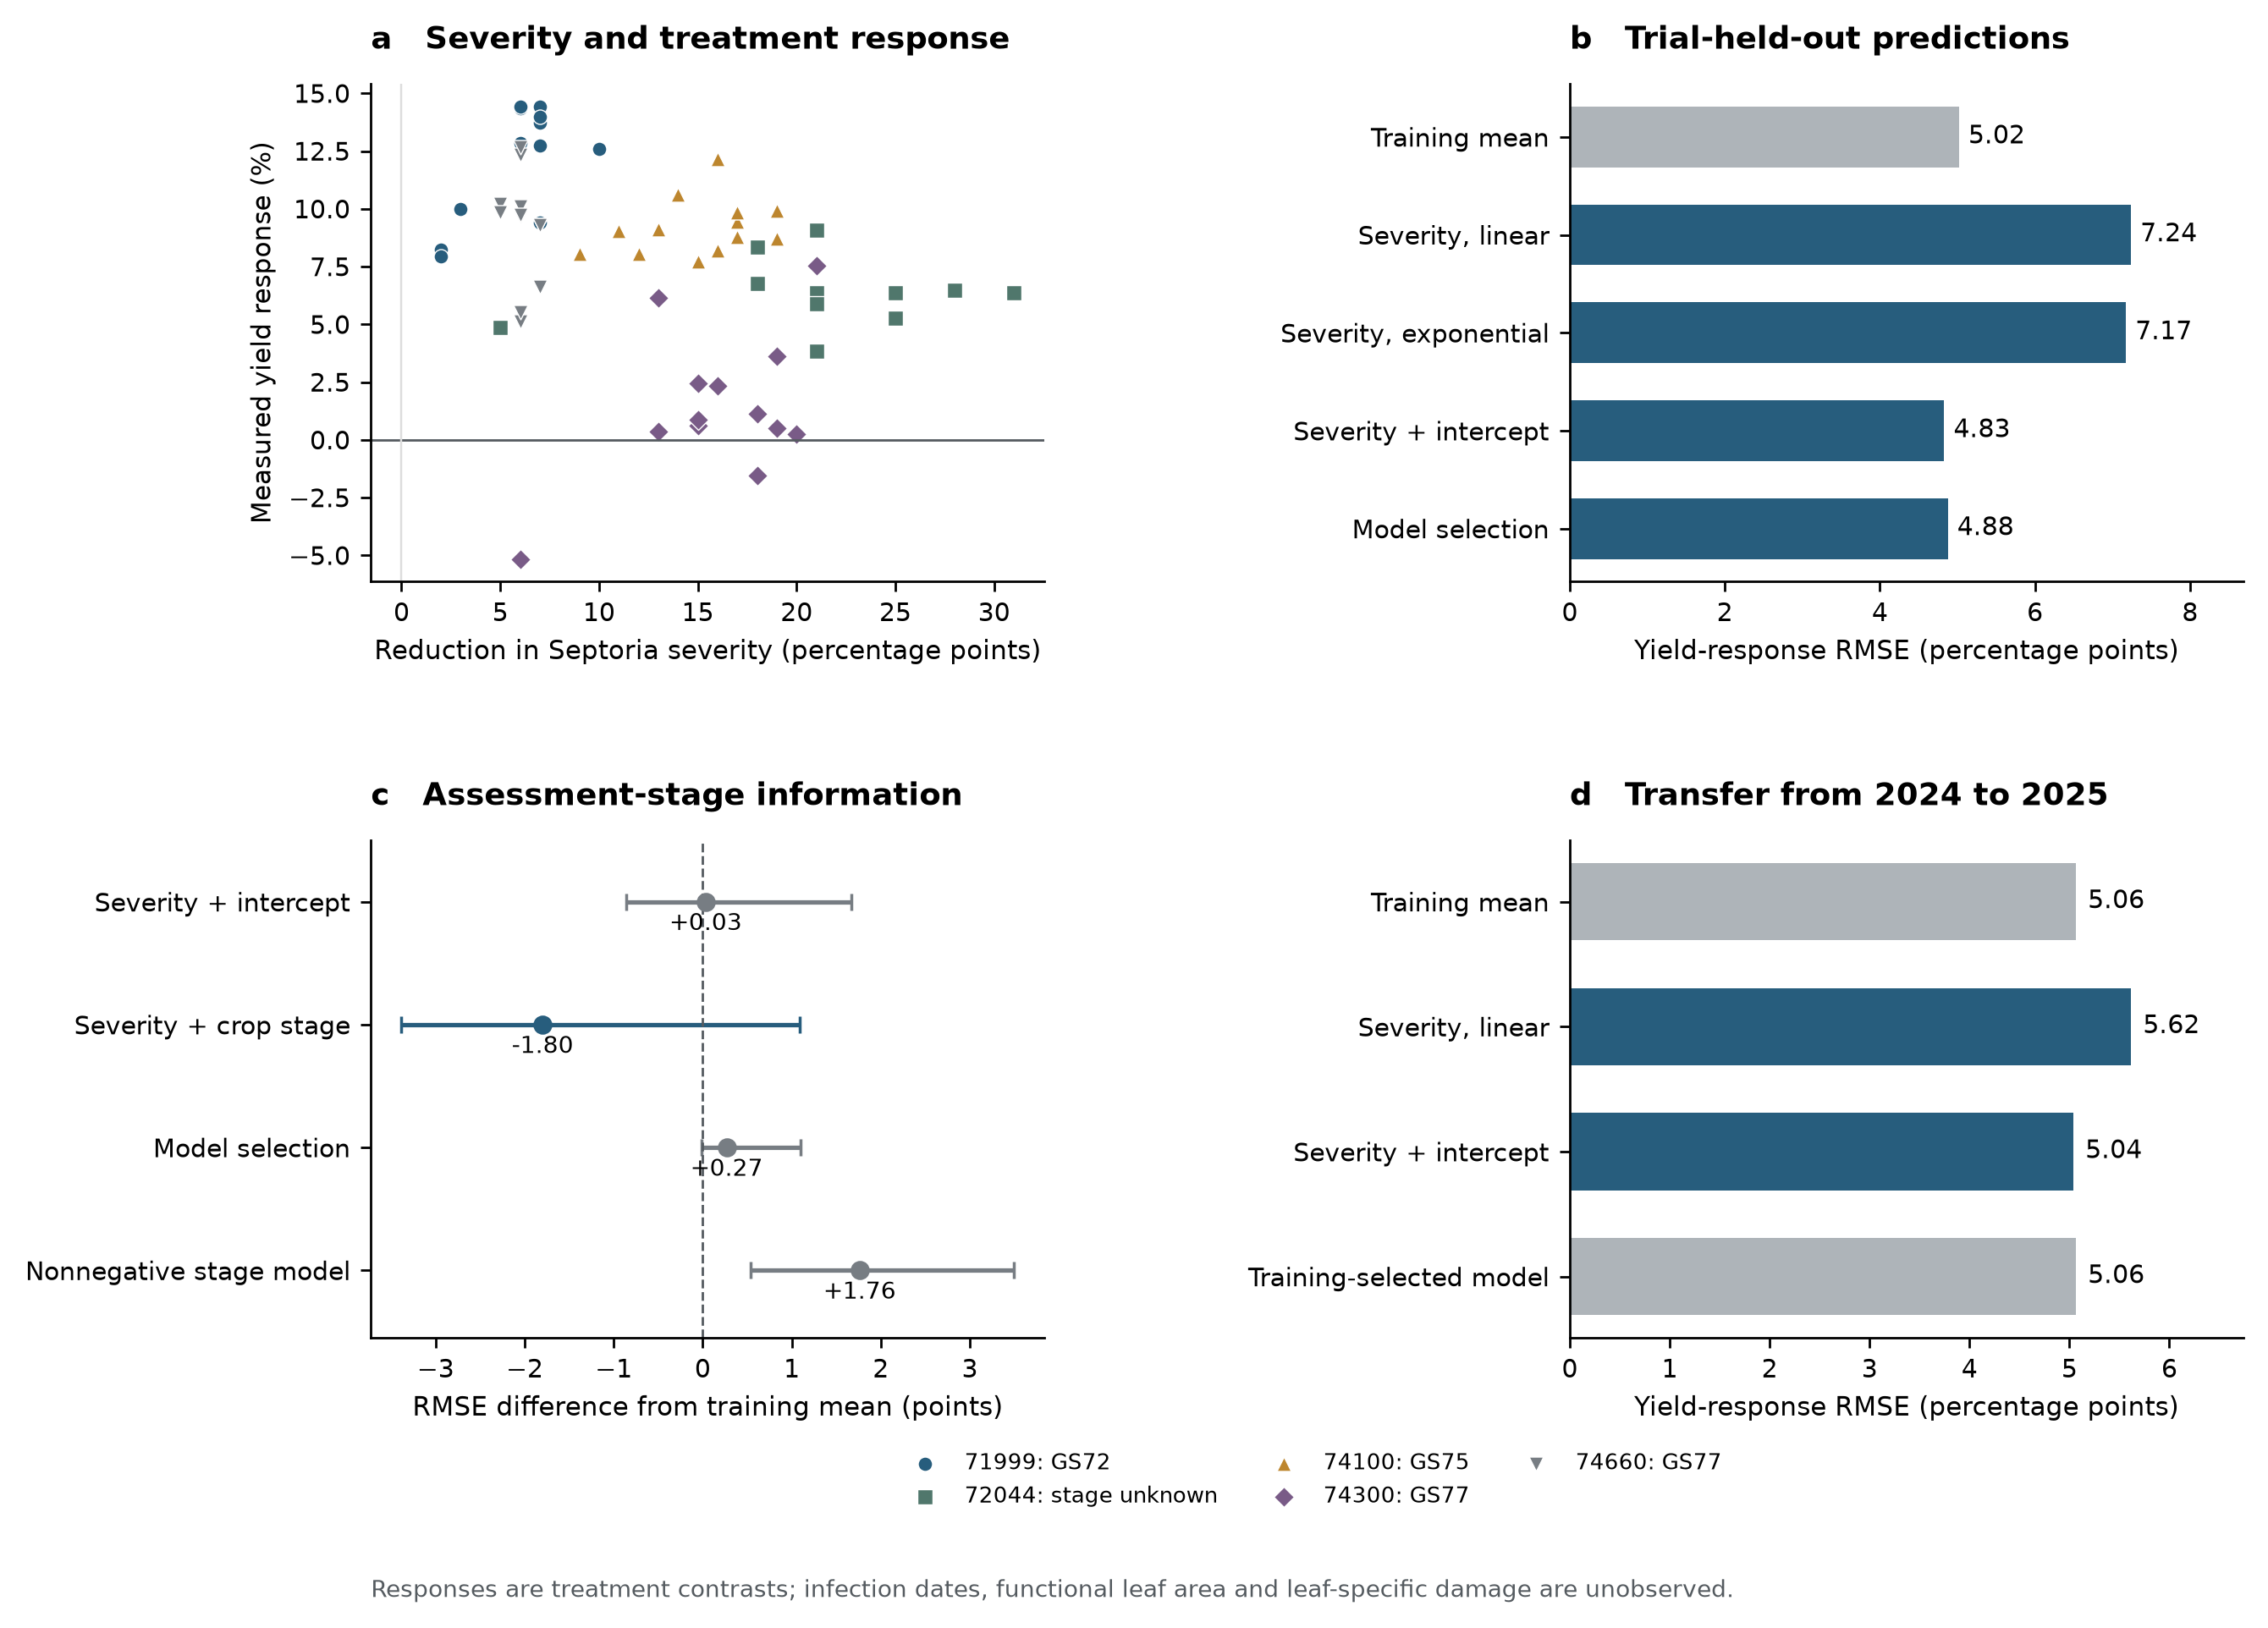
Figure S22 | Nordic yield-response prediction and assessment stage. (a) Same-date severity reduction and relative treated–untreated yield response, retaining negative responses. (b) Entire-trial-held-out prediction on 62 contrasts from five trials. (c) RMSE differences from the matched training mean for the 51-contrast, four-trial population with recorded growth stage. Whiskers are 95% paired trial-bootstrap intervals conditional on fixed held-out predictions. The nonnegative stage model is a secondary sign diagnostic. (d) Forward transfer from 2024 to 2025, with 38 contrasts in three evaluation trials; the training-selected model is the training mean. The data describe protection responses against multiple diseases, rather than isolated Septoria loss or measured HAD.

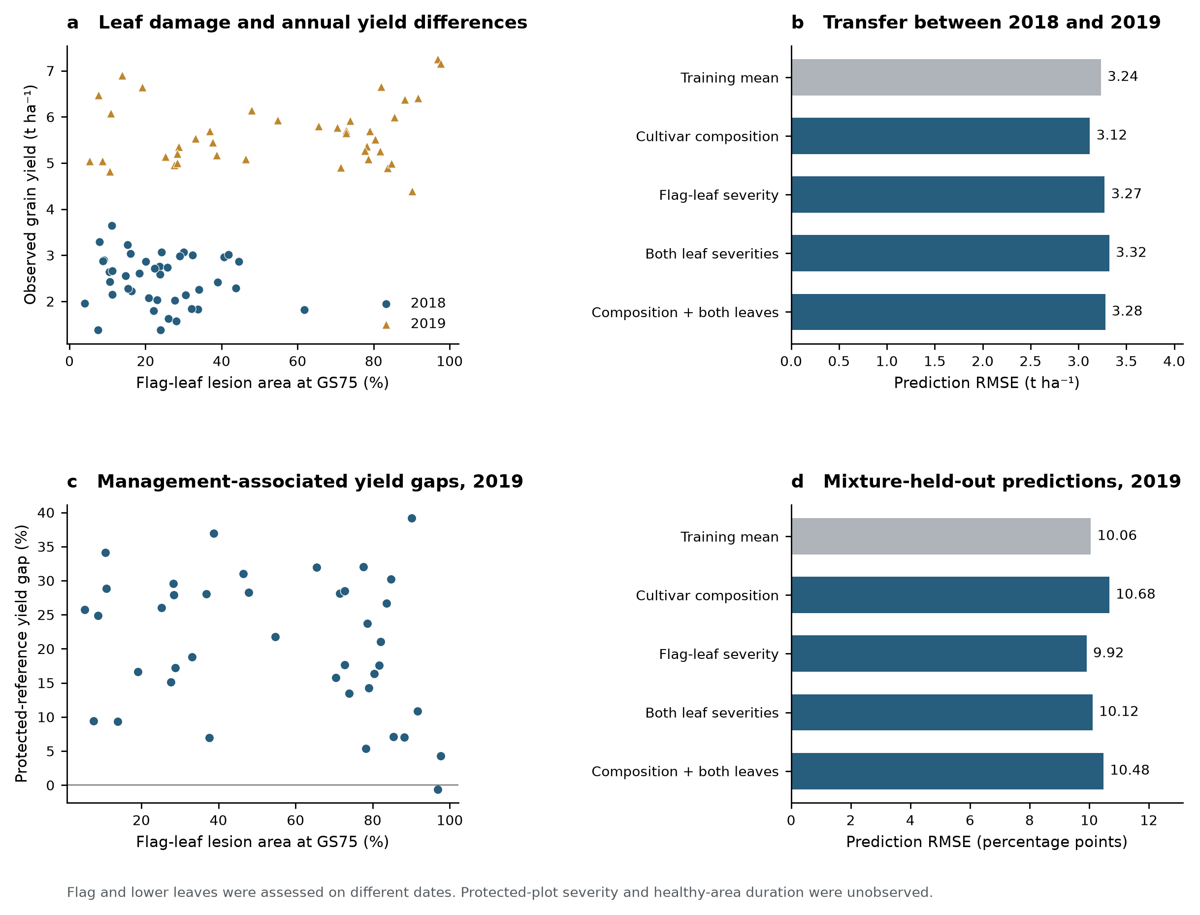
Figure S23 | Leaf-rank severity and yield-response transfer in Tunisia. (a) Flag-leaf incidence-weighted lesion area at GS75 and observed yield for 82 plot-season outcomes in 2018–2019. (b) Absolute-yield errors under two-way whole-year transfer, with years given equal weight. (c) Observed protected-reference yield gaps and unprotected flag-leaf severity in 40 paired 2019 outcomes. (d) Entire-mixture-held-out prediction in that single environment. The lower leaf was assessed at GS61 in 2018 and GS73 in 2019, on different dates from the flag leaf. Protected severity and functional leaf area are unobserved; the two leaf assessments do not establish a disease time integral. Yield moisture basis is unspecified.

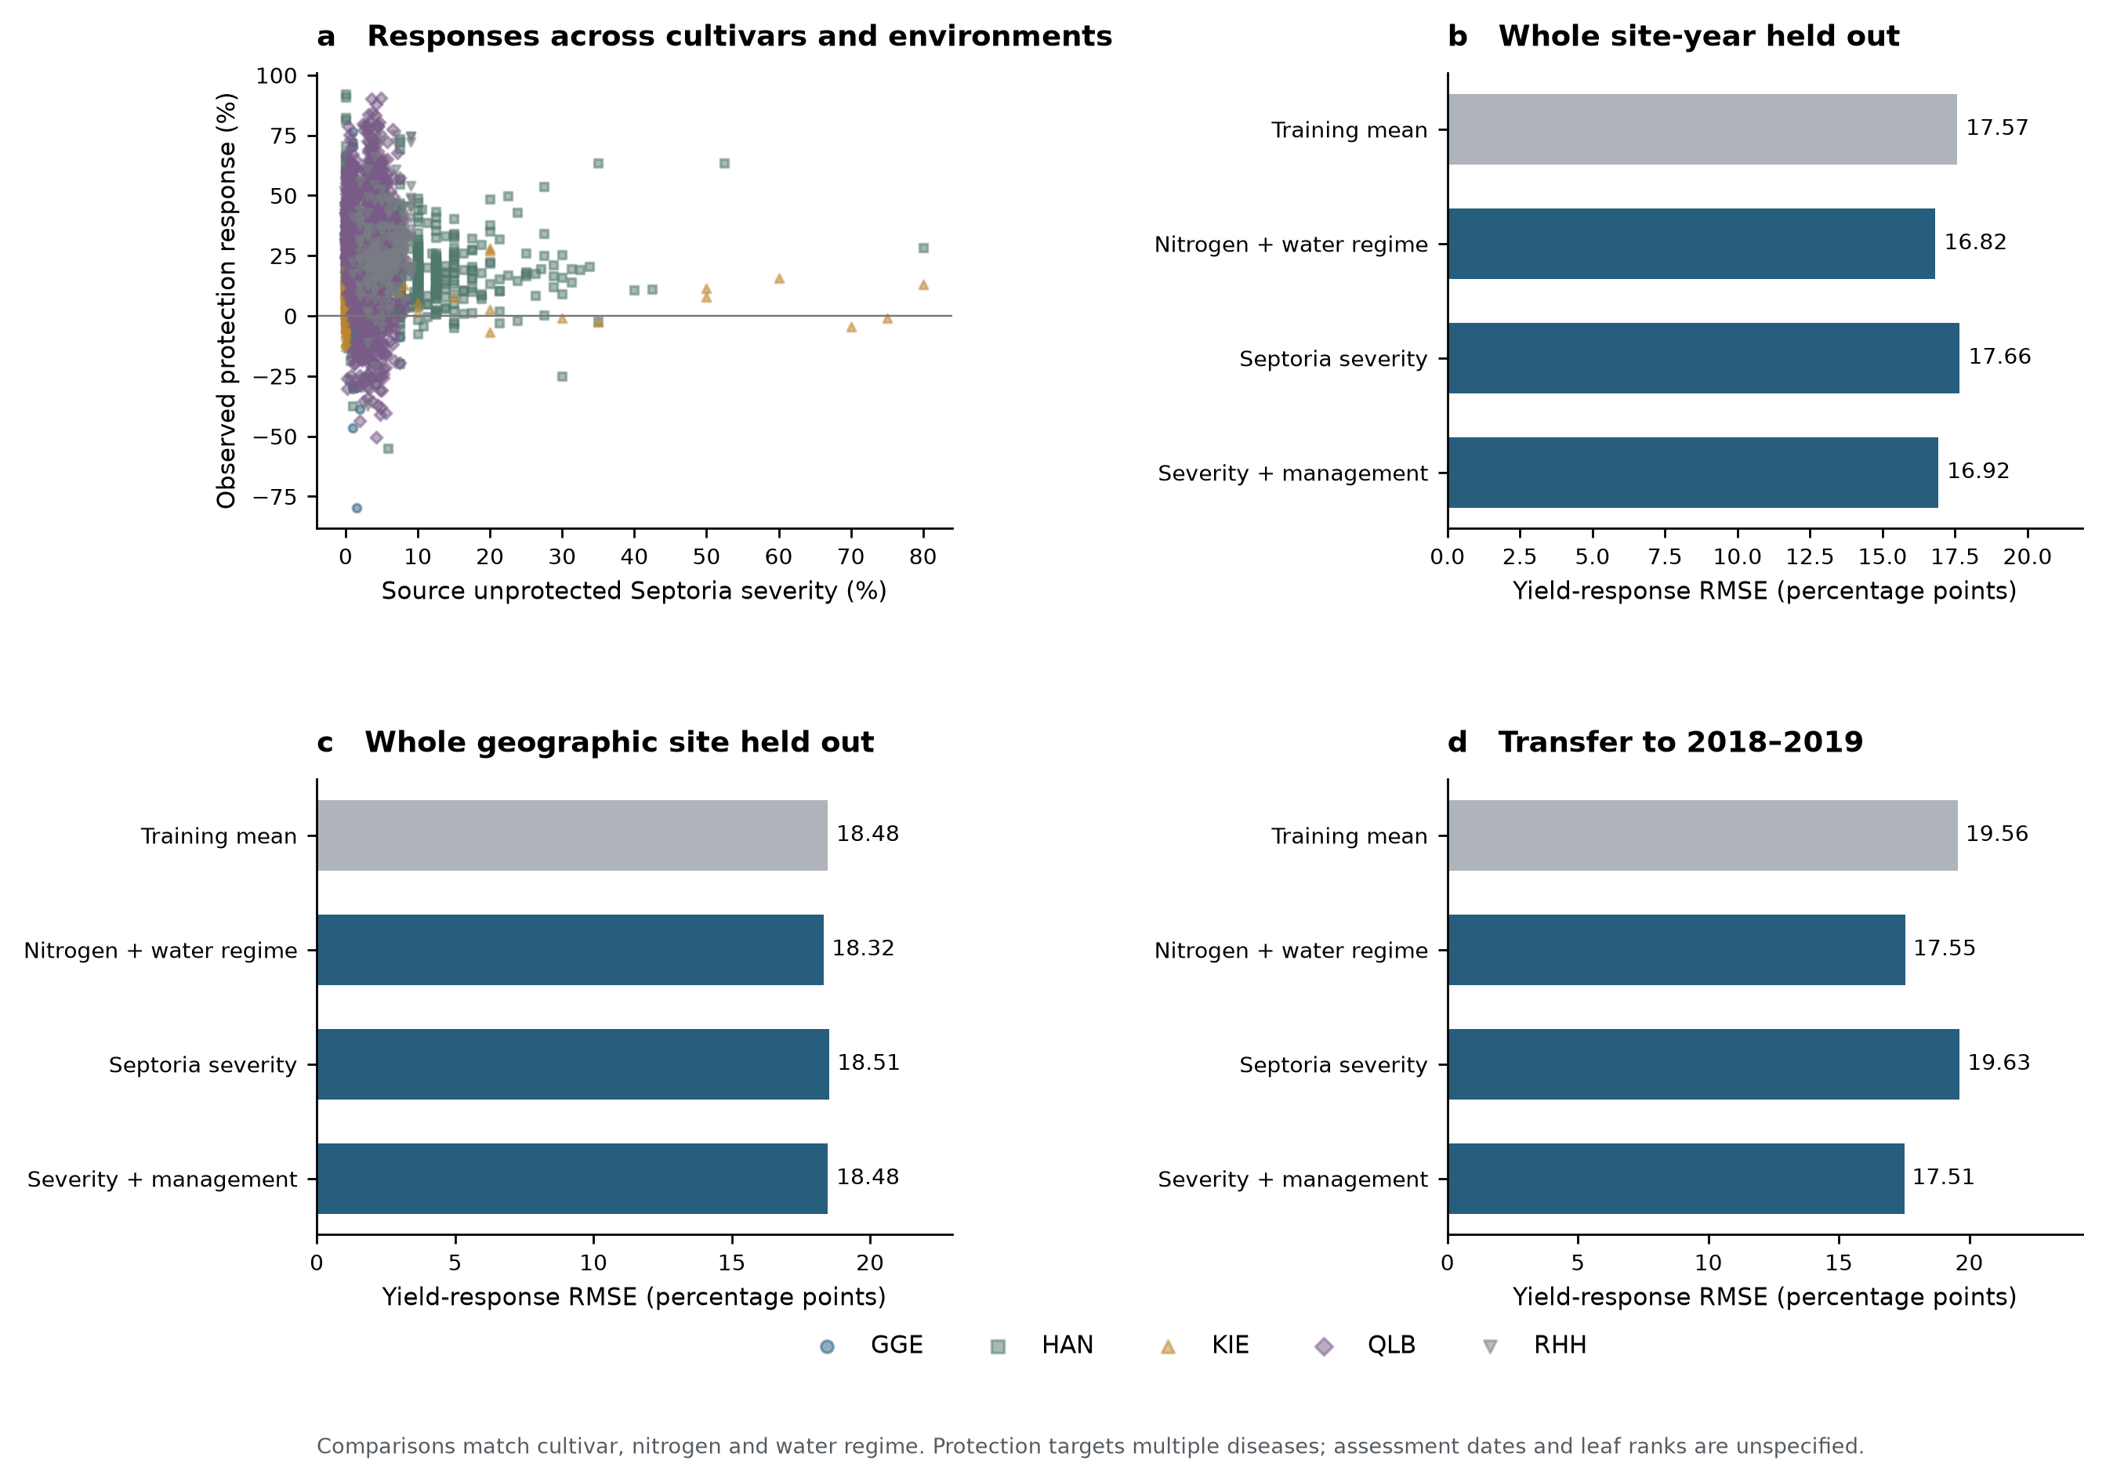
Figure S24 | German multi-environment protection-response prediction. (a) Unprotected Septoria severity and observed relative protection response for 3,264 cultivar–management comparisons from 16 site-years at five locations. Negative responses remain in the data. Treatment means match cultivar, nitrogen and source-coded water regime; drought-suffixed references are excluded. (b) Whole-site-year-held-out errors, with site-years weighted equally. (c) Whole-geographic-site-held-out errors, with locations weighted equally. (d) Forward transfer from 2015–2017 to 619 comparisons in six site-years during 2018–2019. German yields share a dry-mass basis, which cancels in the relative response. Missing severity remains unknown. Protection targets multiple diseases; disease-assessment dates and final-leaf ranks are undocumented.

Supplementary model specification
The complete editable mathematical specification and its rendered PDF are supplied as separate files. The 84-entry parameter inventory is reproduced in Table S12 and Parameter_inventory.csv.

