Climate change reshapes Septoria tritici blotch damage across European wheat-growing regions
Gang Zhao*
College of Soil and Water Conservation Science and Engineering (Institute of Soil and Water Conservation), Northwest A&F University, Yangling, Shaanxi, China
*Correspondence: gang.zhao@nwafu.edu.cn

Abstract
Septoria tritici blotch threatens European wheat production as climate change alters conditions for disease. How shifts in leaf emergence, flowering and grain filling modify future disease damage remains poorly quantified. We linked wheat phenology and Septoria disease models to project canopy damage across Europe using three climate models and three emissions pathways. Under SSP5–8.5 in 2071–2100, normalized loss of healthy-area duration during grain filling increased by 2.66 days relative to 1991–2020, with greater damage across 77.3% of reference wheat area. Regional changes ranged from -1.40 days in the Mediterranean to +7.84 days in the Boreal region. The fraction of healthy-area duration lost increased by 8.04 percentage points. Shifts in wheat phenology offset an estimated 71% of the increase in canopy damage attributable to weather. These projections show that crop timing strongly modifies climate-driven disease damage, with contrasting regional priorities for protecting European wheat production.
Wheat production under climate change depends on both crop performance and losses caused by disease. Septoria tritici blotch (STB), caused by Zymoseptoria tritici, damages wheat leaves and can reduce grain yield. Temperature, rainfall and humidity affect disease development, while changing climate also alters the crop that the pathogen infects. Understanding these linked effects is important for maintaining European wheat production. ^{[1, 2, 3]}
Weather favourable for infection does not by itself determine yield loss. Wheat phenology, including the timing of upper-leaf emergence, flowering and grain filling, determines which leaves are exposed and when they support grain growth. Disease progression determines when those leaves become damaged. A shift in either process changes the amount of healthy canopy available during grain filling. Climate assessments based only on infection conditions can therefore miss changes in the timing of damage relative to crop phenology. ^{[4, 5, 6, 7, 8]}
For Septoria tritici blotch, symptoms follow a period of infection and disease development within the leaf. Rainfall, moisture conditions, inoculum availability and canopy development influence the seasonal epidemic. Upper-leaf appearance and unfolding are relevant because damage to these leaves can affect the canopy supporting grain filling. Healthy-area duration (HAD), the integral of healthy leaf area over time, provides a measure linking disease damage to crop function. Its relationship with grain yield varies among cultivars and depends on the leaves and growth stages included in the calculation. ^{[2, 9, 10, 11, 12, 13]}
The unresolved question is how climate effects on wheat phenology modify Septoria damage across European growing regions. A linked wheat-phenology and disease model quantifies changes in symptoms and canopy damage across the complete wheat land-use grid under three emissions pathways. Environmental-region and country summaries describe where these changes occur. A separate analysis distinguishes weather effects on disease from the effects of changing wheat phenology. Published canopy–yield relationships provide conditional estimates of the disease-related component of yield change, while field observations establish the limits of model prediction accuracy.
Results
Regional differences in projected Septoria damage
Projected Septoria-related canopy damage varied across European wheat-growing grids and emissions pathways (Fig. 1). By 2071–2100, the harvested-area-weighted normalized disease-induced loss of healthy-area duration (HAD) changed by +1.45, +1.55 and +2.66 days under SSP1–2.6, SSP2–4.5 and SSP5–8.5, respectively, relative to 1991–2020. The corresponding mid-century changes were +1.11, +0.77 and +1.53 days. Normalized HAD loss is the time-integrated loss of healthy leaf area divided by maximum reference upper-canopy leaf area index (LAI), expressed as equivalent days of reference canopy function lost to disease. Larger values indicate greater accumulated damage. The averages combine areas of increasing and declining damage (Supplementary Table S9).
Under late-century SSP5–8.5, the European normalized HAD loss changed from 6.30 to 8.95 days; the three-climate-model change range was +1.23 to +4.57 days. The ensemble mean indicated increasing damage across 77.3% of the available reference wheat area. All three models agreed on greater damage across 65.2% of area and less damage across 14.9%; model predictions differed in sign across 20.0%. The continental increase thus coexisted with areas of declining damage (Supplementary Fig. S19; Supplementary Table S15).
Disease symptoms and canopy damage during grain filling
Symptom frequency changed little despite increasing canopy damage (Fig. 2). The area-weighted frequency of flag-leaf symptoms before soft dough was 99.731% in 1991–2020 and 99.332% under late-century SSP5–8.5, a change of -0.400 percentage points. Symptoms were predicted in almost every complete season in both periods. The mean fraction of reference HAD lost during grain filling increased from 18.03% to 26.07%, or +8.04 percentage points, with a climate-model range of +4.08 to +13.53 points. Relative HAD loss describes accumulated canopy-function loss; observed lesion percentage measures a different quantity (Supplementary Tables S9 and S13b).
Flag-leaf symptoms appeared 3.46 days earlier relative to flowering, with model-specific changes of -6.02 to -1.57 days. The interval from the fixed sowing date to first symptoms shortened by 30.78 days, spanning -45.39 to -18.74 days across climate models (Fig. 2b, d). Flag-leaf symptoms were present during 97.37% of grain-fill days in 1991–2020 and 97.42% in the future. The number of grain-fill days with symptoms changed by +0.24 days, alongside a +0.25-day change in the flowering-to-soft-dough interval. The large advance in symptoms after sowing accompanied earlier flowering and soft dough, with little change in the duration of grain filling. Timing estimates include symptoms detected in both paired seasons; frequency estimates also include complete seasons without symptoms (Supplementary Figs. S12 and S14).
Differences among environmental regions and countries
Environmental-region means differed substantially (Fig. 3a; Table 1). Under late-century SSP5–8.5, normalized HAD-loss changes were +4.85 days in the Atlantic region, +3.45 days in the Continental region, +7.84 days in the Boreal region, -1.40 days in the Mediterranean region, and +0.37 days in the Steppic region. Among the eight named environmental regions, the largest mean increase occurred in the Boreal region and the largest decrease in the Mediterranean region. The Boreal change spanned +5.06 to +12.52 days across climate models, compared with -1.88 to -1.13 days in the Mediterranean region. Alpine, Pannonian and Black Sea cells were included alongside the five larger regions (Supplementary Tables S13a–c and S16).
Country summaries also showed increasing and declining damage. Among the twelve country groups with the largest reference wheat area, late-century SSP5–8.5 HAD changes ranged from -2.02 days in Italy to +10.43 days in Lithuania. Yield changes inferred from their canopy damage differed in sign and magnitude (Fig. 3b). The full set of country means and climate-model ranges includes all country-assigned wheat cells within the study domain, with calendar eligibility and valid-season coverage reported for each group (Supplementary Table S14).
Yield changes inferred from canopy damage
Applying the reference HAD–yield coefficient converted the late-century SSP5–8.5 HAD change into an estimated disease-related yield change of -47.8 kg ha⁻¹ per unit reference upper-canopy LAI. The three-climate-model range was -82.3 to -22.2 kg ha⁻¹ per reference LAI. At coefficients of 0.0141–0.0207 t ha⁻¹ per green-leaf-area-index day (GLAI-day), the same canopy response produced a conversion range of -55.0 to -37.4 kg ha⁻¹ per reference LAI. A negative change indicates greater estimated disease-related yield loss. These estimates depend on the assumed canopy area and linear HAD–yield relationship (Fig. 3b; Supplementary Fig. S13).
Evaluation of the canopy–yield relationship showed limited prediction accuracy across genetic backgrounds. Eight treatment-mean contrasts across five genetic backgrounds gave leave-one-background-out relative-yield RMSE of 5.16 percentage points and R² of 0.247, but absolute-yield RMSE of 0.617 t ha⁻¹ and R² of −0.432. Two contrasts concerned STB alone; the other six involved yellow rust or mixed diseases. Models based on disease severity also had larger errors than their training-mean benchmarks. The grid estimates provide a disease-related yield index under specified assumptions. Total wheat yield and national production changes require additional crop-yield modelling and validation (Supplementary Figs. S9–S11; Supplementary Tables S5–S8). ^{[2, 11]}
Wheat phenology offsets part of the increase in disease damage
Changes in wheat phenology offset 70.6% of the increase in canopy damage attributable to weather under late-century SSP5–8.5 (Fig. 4). The weather contribution increased normalized HAD loss by 9.00 days, while wheat phenology reduced it by 6.36 days, giving a net increase of 2.64 days. All three climate models showed these opposing effects, with offsets of 63.6–80.3%. The decomposition uses 5,731 valid season pairs from 62 wheat-growing grid cells. Its net estimate is close to the full-grid increase of 2.66 days, although the two calculations use different sets of cells and valid seasons (Supplementary Tables S12a, b).
Flowering and soft dough advanced by 26.77 and 26.64 days after sowing, while mean grain-fill duration changed little. The wheat-phenology contribution combines changes in upper-leaf appearance and unfolding with shifts in flowering and soft-dough dates. These changes alter leaf availability and the seasonal weather experienced by the upper canopy. A −2.78-day weather–crop interaction was allocated equally between the two Shapley contributions. Twenty additional finite pairs were excluded because recombined weather and crop trajectories exceeded the accepted temperature range on an active day (Supplementary Fig. S16).
Sensitivity and prediction accuracy
All fourteen tested combinations of model structure, symptom detection and canopy assumptions gave earlier symptoms and increased HAD loss in all three climate models under late-century SSP5–8.5. Across these settings, mean symptom shifts spanned −5.46 to −1.54 days and HAD increases 0.63–2.80 days. These comparisons describe sensitivity to selected model assumptions and do not cover every source of uncertainty in future disease outbreaks (Supplementary Fig. S15; Supplementary Table S10).
Pooled field evaluation gave mean symptom-onset error outside the observation interval of 5.32 days versus 2.79 days for the phenology benchmark across 136 histories. The paired difference was +2.54 days (95% grouped-bootstrap interval 1.15–3.93). Across 2,033 disease assessments from 188 field seasons, severity RMSE was 31.19 versus 29.83 percentage points, with model bias -17.56 points. The paired RMSE difference was +1.36 points (95% interval -0.20–2.82). Wheat-stage predictions had station-held-out MAE of 8.02 days across 40,878 events. Disease prediction accuracy remains a major limitation on the interpretation of future damage magnitudes (Supplementary Figs. S18 and S20; Supplementary Tables S1–S4).
Discussion
The simulations project increasing average Septoria damage across European wheat-growing areas, alongside decreases in some regions. These differences arise from weather effects on disease combined with changes in wheat phenology. Because symptoms were predicted in almost every season, symptom presence alone was a weak measure of the projected change. The timing of symptoms and the amount of healthy canopy lost during grain filling provided more information about the modelled disease impact.
The analysis links three processes: weather affects wheat phenology and disease progression; wheat phenology determines the leaves and seasonal conditions available to the disease; and disease damage reduces the assumed healthy canopy contributing to grain filling. The opposing weather and phenology contributions show why favourable infection conditions do not translate directly into proportional increases in canopy damage. The crop–disease interaction is represented through leaf availability and timing. Disease damage is converted to a yield estimate after simulation, while disease feedback on wheat phenology and a complete crop carbon balance are absent. These distinctions separate the projected disease component from the total effect of climate change on wheat production. ^{[3, 4, 5]}
The regional contrasts identify areas where crop and disease observations would be informative for adaptation trials. Greater projected damage in Boreal and Atlantic wheat-growing areas warrants testing disease resistance, crop calendars and canopy persistence together. Declining disease damage in the Mediterranean region also requires field verification because a decline in the disease component does not establish an increase in total grain yield. Country estimates describe the area included in the fixed wheat grid and imposed winter-wheat calendar. Differences in cultivar, irrigation, crop management and cross-border grid assignment limit their interpretation as national forecasts.
The link from disease damage to grain yield is the least directly validated part of the analysis. Disease-assessment percentages, functional canopy loss and grain yield describe different quantities. The assumed conversion from disease damage to functional loss requires physiological measurements, and the published HAD–yield coefficients were fitted to a wider growth-stage interval than the main flowering-to-soft-dough calculation. The available treatment means span mixed diseases and give poor absolute-yield predictions across genetic backgrounds. Canopy-based yield estimates remain conditional indices, with actual production losses requiring compatible measurements of leaf area, canopy function and grain yield. ^{[2, 11, 12]}
Disease-model performance adds substantial uncertainty. The model had greater symptom-onset error than the phenology benchmark and underestimated measured disease severity. High symptom-detection sensitivity with low specificity is consistent with the near-universal symptom occurrence in the simulations. Added developmental stages, including the end of the grain-filling interval, have limited informative field observations. Agreement among climate models cannot establish epidemic prediction accuracy. Reconstructed humidity, fixed inoculum assumptions, cultivar resistance and future pathogen adaptation also affect the applicability of the projected changes.
Regional adaptation assessments for European wheat need to consider disease resistance alongside crop phenology and canopy persistence. Coordinated observations of crop stages, disease symptoms, healthy leaf area and harvested grain would help identify whether adaptation reduces exposure, prevents damage or improves yield tolerance. Resistance and calendar trials across contrasting regions can evaluate these mechanisms under consistent measurement definitions. Intervention effectiveness and effects on production require validation in field trials. ^{[14, 15]}
Methods
Wheat-growing area and climate data
The European SPAM2020 all-wheat registry contains 14,941 cells with positive harvested wheat area at 0.25° resolution. A fixed GGCMI winter-wheat rainfed calendar is available for 14,932 cells; nine cells have unavailable simulation outcomes. The all-wheat area mask combined with a winter-wheat rainfed calendar defines the crop-management scenario. It is not a census of observed winter-wheat management. Harvested area provides fixed weights for spatial aggregation. Supplementary Fig. S21 shows the study area, field-observation locations and environmental regions. ^{[16, 17]}
Daily NEX-GDDP-CMIP6v2 data represent ACCESS-CM2, MPI-ESM1-2-HR and MRI-ESM2-0 under SSP1–2.6, SSP2–4.5 and SSP5–8.5. The harvest periods are 1991–2020, 2031–2060 and 2071–2100. The 810 model–scenario–year combinations cover 12,094,920 calendar-eligible grid-seasons. Monthly adjustment coefficients align climate variables with the reference weather data, with separate historical adjustments for each SSP continuation. Daily series include the preceding calendar year to represent overwintering seasons. Input files, adjustment coefficients and model configurations are identified by checksums. ^{[18]}
Disease calculations use daily temperature, relative humidity and rainfall. A synthetic reconstruction of humidity within each day estimates moisture exposure from daily forcing; it does not supply measured leaf wetness. Missing weather and daily mean temperatures above 40 °C produce unavailable outcomes under the model input rules.
Linking wheat phenology to Septoria disease
A temperature–photoperiod–vernalization model calculates wheat phenological stages from sowing to soft dough. Additional ordered developmental thresholds determine upper-leaf appearance and unfolding, and a calibrated flowering threshold defines the start of the grain-filling interval. These crop trajectories determine which leaves are available to infection and the seasonal weather experienced by each leaf. The Septoria module calculates disease establishment, progression and visible damage using weather and these leaf trajectories. Disease damage does not alter the calculated crop-development trajectory. Model equations, parameter sources and observation definitions appear in the supplementary model specification and the 84-entry parameter inventory. ^{[6, 7, 8, 9, 10]}
Calibrated parameters remain fixed across climate scenarios. The maximum reference LAI of the upper three leaves is one, divided equally among leaves and scaled by unfolding. Cultivar-specific canopy area and future changes in resistance are not estimated. Soft dough marks season completion. Missing crop calendars, invalid weather and failure to reach the endpoint remain separate unavailable outcomes, rather than zero disease or zero loss.
Symptoms, canopy damage and healthy-area duration
Symptom frequency is the fraction of complete simulated seasons with detectable flag-leaf symptoms before soft dough. First-symptom timing is measured relative to flowering or sowing and is unavailable when symptoms are not detected. Symptomatic grain-fill days count days with detectable flag-leaf symptoms between flowering and soft dough. Symptoms are visible model states following disease development; their dates are distinct from the modelled dates of initial infection.
The disease-damage fraction after symptom detection is treated as the fraction of reference leaf area that has lost function. This assumption connects modelled disease to canopy damage. HAD loss integrates this fraction multiplied by daily reference leaf area across the flag leaf and two leaves below it. The primary interval is flowering to soft dough (GS65–85), with GS31–85 used for sensitivity analysis. HAD and disease-induced HAD loss have units of green leaf area index multiplied by days (GLAI-days). Normalized HAD loss divides the time-integrated functional loss by maximum reference upper-canopy LAI and expresses it as equivalent days of reference canopy function lost. With reference LAI equal to one, normalization leaves numerical values unchanged. Relative HAD loss is HAD loss divided by reference HAD, expressed as a percentage; it describes average accumulated canopy-function loss, not instantaneous lesion percentage. ^{[2, 12]}
Historical–future comparisons and spatial summaries
Each future harvest year is paired with the corresponding position in the 30-year historical period for the same climate model and SSP. This indexing supports comparisons of period means without identifying historical and future years as the same physical event. A pair is included only when both metric values are finite. For grid i, x_i is the sum of valid paired differences divided by 30, and z_i is the number of valid pairs divided by 30. The grid mean change is x_i/z_i. Reference and future means use the same valid pairs. The valid seasons may differ among symptom timing, symptom frequency and canopy metrics.
For domain indicator I_i and fixed harvested area w_i, the mean change is Σw_i I_i x_i / Σw_i I_i z_i. Separate estimates for each climate model give the reported three-model mean and range. EEA 2016 boundaries assign environmental regions from wheat-cell centroids. Country assignment uses the dominant SPAM source-country label of each cell; cross-border cells are not divided among countries. Country estimates apply only to represented wheat cells within the study domain. Source Data includes all eight named environmental regions, outside-region and unassigned cells, and all country groups. ^{[19]}
Maps show model means at the native 0.25° grid resolution, without interpolation or filling unavailable cells. Area shares by direction of change use fixed harvested-area weights over cells with complete three-model estimates. Model ranges describe spread among three climate models and are not confidence intervals. All wheat cells are simulated, so full-grid estimates have no spatial-sampling Monte Carlo error. Other uncertainties include climate-model choice, model parameters, observations and the canopy–yield relationship. The twelve countries in Fig. 3 are selected by reference wheat area independently of the projected change.
Estimating the disease-related yield response
The estimated disease-related yield change is −b times the change in HAD loss. The reference coefficient b is 0.018 t ha⁻¹ per GLAI-day, with 0.0141 and 0.0207 used as fixed alternatives from the published upper-three-leaf study. Multiplication by 1,000 converts t ha⁻¹ to kg ha⁻¹. Results are expressed per unit reference upper-canopy LAI because actual canopy area is unspecified. The source relationship began at GS31, whereas the primary climate calculation covers GS65–85; its use in this shorter interval is an unvalidated adaptation. Coefficient alternatives represent cultivar differences, not statistical confidence limits. The calculation estimates a disease-related yield component under these assumptions, without modelling the direct effects of heat, water limitation, CO₂ or other stresses on total grain yield. Yield percentages and national production tonnages require independently validated canopy area and grain yield. ^{[2, 11]}
Separating weather and wheat-phenology effects
The decomposition and fourteen-setting sensitivity analysis use 64 harvested-area-proportional draws at 62 unique cells. Four simulations combine historical or future disease weather with historical or future wheat-phenology trajectories. Their differences separate weather and wheat-phenology contributions, with one half of their interaction allocated to each Shapley contribution. Of 5,751 finite historical–future pairs, 20 have an active day outside the accepted temperature range in a recombined trajectory and are excluded, leaving 5,731 pairs. Spatial Monte Carlo standard errors apply to this sample and are separate from full-grid climate estimates.
The phenology offset is −100 times the phenology contribution divided by the weather contribution, using identical valid pairs. The ensemble percentage is the ratio of three-model mean contributions. Sensitivity settings vary model structure, symptom detection, reference canopy area and damage-to-function conversion. These calculations assess model assumptions and do not represent trials of a sowing-date or cultivar intervention.
Field evaluation
Disease observations from the two public field archives are pooled after exclusion of calibration records and application of geographic eligibility criteria. The evaluation contains 2,033 assessments from 188 field seasons in 140 coordinate-years and 136 symptom-onset histories from 78 field seasons in 62 coordinate-years. Onset histories concern source-defined leaves 1–3 and have observations bracketing symptom appearance. Original identifiers, units and percentage denominators remain in the evidence files. Source leaf numbers do not establish a common final-leaf rank across archives. ^{[20, 21]}
Evaluation weights are equal among coordinate-years, fields within coordinate-years, source leaves within fields and assessments within leaves. Symptom-onset error measures distance outside the two-sided observation interval, with the predefined penalty for missed positive observations. Severity predictions are compared with the calibration-leaf-mean benchmark; timing and detection use the phenology benchmark selected on calibration data. Model and benchmark predictions are compared on identical records. The 95% intervals use 20,000 paired bootstrap resamples of entire coordinate-year groups. They describe uncertainty in these fixed predictions on reused retrospective observations and exclude parameter-selection uncertainty. Duplicate coordinate-year identities are grouped across archives.
Wheat phenological stage dates are evaluated on 40,878 matched events from German stations held out of calibration, at BBCH 10, 31, 51 and 85. Added leaf stages use pooled field observation intervals, with calibration observations reported separately. Evaluation of the canopy–yield relationship uses eight published treatment-mean contrasts across five genetic backgrounds, including STB, yellow rust and mixed disease. Leaving each background out of fitting gives backgrounds equal evaluation weight. Severity-based yield models use their specified held-out trial or year comparisons and corresponding training-mean benchmarks. ^{[11]}
Reproducibility
Annual outputs record input-weather identities, model configurations, grid-cell order, numerical checks and output hashes. Aggregation records source hashes, counts of valid pairs and spatial coverage for each metric. Independent calculations check pooled field scores and selected full-grid regional means. Source Data contains figure and table values. The software archive regenerates documents from completed numerical evidence; a climate-driven model rerun additionally requires the external raw weather products.
Data availability
Source data and numerical evidence supporting the findings are publicly available at https://github.com/SmartAG-Team/paper_cc_impact_wheat_disease, with the manuscript-specific files in publication/european_wheat_stb. Dataset references identify the public disease archives, NEX-GDDP-CMIP6v2 climate data, GGCMI calendars, SPAM2020 wheat area and EEA environmental boundaries. Source_Data.xlsx contains completed grid summaries, environmental-region and country statistics, area shares by direction of change, pooled field evaluation and published canopy–yield evidence. Original labels and assessment definitions remain in the underlying records. ^{[16, 17, 18, 19, 20, 21]}
The repository includes completed summaries, selected diagnostic outputs, input and output hashes, and numerical evidence for document regeneration. The complete raw climate and annual-output archives are external because of their size. Model reruns require the recorded climate products and adjustment files. Raw plot observations and physiological measurements unavailable in the source studies are not reconstructed.
Code availability
Simulation, statistical-analysis and document-generation code are publicly available at https://github.com/SmartAG-Team/paper_cc_impact_wheat_disease. The repository includes the accompanying evidence manifests. REPRODUCIBILITY.txt documents regeneration and model-rerun requirements. The supplementary model specification contains 29 numbered equations, and Parameter_inventory.csv records 84 fixed, fitted and scenario quantities.

References
1.Savary, S. et al. The global burden of pathogens and pests on major food crops. Nature Ecology & Evolution3, 430–439 (2019).
2.Parker, S. R., Welham, S., Paveley, N. D., Foulkes, J. & Scott, R. K. Tolerance of septoria leaf blotch in winter wheat. Plant Pathology53, 1–10 (2004).
3.Silva, J. V. et al. Agronomic management drives the wheat yield plateau in high-yielding environments of northwest Europe. Nat. Food7, 45–54 (2026).
4.Chaloner, T. M., Gurr, S. J. & Bebber, D. P. Plant pathogen infection risk tracks global crop yields under climate change. Nature Climate Change11, 710–715 (2021).
5.Pequeno, D. N. L. et al. Production vulnerability to wheat blast disease under climate change. Nat. Clim. Change14, 178–183 (2024).
6.Shaw, M. W. & Royle, D. J. Airborne inoculum as a major source of Septoria tritici (Mycosphaerella graminicola) infections in winter wheat crops in the UK. Plant Pathology38, 35–43 (1989).
7.Lovell, D. J., Parker, S. R., Hunter, T., Welham, S. J. & Nichols, A. R. Position of inoculum in the canopy affects the risk of septoria tritici blotch epidemics in winter wheat. Plant Pathology53, 11–21 (2004).
8.Lovell, D. J., Hunter, T., Powers, S. J., Parker, S. R. & van den Bosch, F. Effect of temperature on latent period of septoria leaf blotch on winter wheat under outdoor conditions. Plant Pathology53, 170–181 (2004).
9.Suffert, F. & Sache, I. Relative importance of different types of inoculum to the establishment of Mycosphaerella graminicola in wheat crops in north‐west Europe. Plant Pathology60, 878–889 (2011).
10.Baccar, R. et al. Modelling the effect of wheat canopy architecture as affected by sowing density on Septoria tritici epidemics using a coupled epidemic–virtual plant model. Annals of Botany108, 1179–1194 (2011).
11.Foulkes, M. J. et al. Major genetic changes in wheat with potential to affect disease tolerance. Phytopathology96, 680–688 (2006).
12.van den Berg, F., Paveley, N. D., Bingham, I. J. & van den Bosch, F. Physiological traits determining yield tolerance of wheat to foliar diseases. Phytopathology107, 1468–1478 (2017).
13.Bryson, R. J., Paveley, N. D., Clark, W. S., Sylvester-Bradley, R. & Scott, R. K. Use of in-field measurements of green leaf area and incident radiation to estimate the effects of yellow rust epidemics on the yield of winter wheat. European Journal of Agronomy7, 53–62 (1997).
14.McDonald, A. J. et al. Time management governs climate resilience and productivity in the coupled rice–wheat cropping systems of eastern India. Nat. Food3, 542–551 (2022).
15.European Commission. A Vision for Agriculture and Food. https://eur-lex.europa.eu/legal-content/EN/TXT/?uri=CELEX%3A52025DC0075 (2025).
16.International Food Policy Research Institute. Global Spatially-Disaggregated Crop Production Statistics Data for 2020, SPAM2020 v2r2. Harvard Dataverse https://doi.org/10.7910/DVN/SWPENT (2026).
17.Jägermeyr, J., Müller, C., Minoli, S., Ray, D. & Siebert, S. GGCMI Phase 3 crop calendar. Zenodo https://doi.org/10.5281/zenodo.5062513 (2021).
18.NASA Center for Climate Simulation. NEX-GDDP-CMIP6 Version 2 Technical Note. https://www.nccs.nasa.gov/wp-content/uploads/2025/06/NEX-GDDP-CMIP6-v2-Tech_Note.pdf (2025).
19.European Environment Agency. Biogeographical regions, Europe 2016, version 1. (2016).
20.Holst, N. Data from 56 fungicide trials in wheat fields across Europe 2017–2019. Zenodo https://doi.org/10.5281/zenodo.6521175 (2022).
21.Holst, N. & Donner, M. Data from 168 fungicide trials in wheat fields across Europe 2014–2018. Zenodo https://doi.org/10.5281/zenodo.6352615 (2022).
Author contributions
G.Z. takes responsibility for the design, analysis, interpretation and reporting of the study.
Funding
This study received no external funding.
Competing interests
The author declares no competing interests.

Table 1 | Late-century climate impacts across European wheat environmental regions. Values are harvested-area-weighted three-climate-model mean paired changes under SSP5–8.5 in 2071–2100 relative to 1991–2020. Positive normalized HAD-loss and relative HAD-loss changes indicate greater accumulated loss of assumed canopy function; negative timing changes indicate earlier symptoms relative to flowering. Estimated disease-related yield change uses the fixed coefficient 0.018 t ha⁻¹ per GLAI-day and a nominal upper-three-leaf reference LAI of one. The yield column reports a disease-related index, not validated harvested yield. Model ranges, exact regional areas and valid-season coverage are supplied in Supplementary Table S13.
Environmental region | Δ normalized HAD loss (days) | Δ symptom timing (days) | Δ relative HAD loss (pp) | Estimated Δ yield (kg ha⁻¹ per unit LAI)
Europe | +2.66 | -3.46 | +8.04 | -47.8
Atlantic | +4.85 | -3.23 | +15.35 | -87.3
Continental | +3.45 | -4.41 | +10.49 | -62.2
Boreal | +7.84 | -7.43 | +23.99 | -141.1
Mediterranean | -1.40 | +3.86 | -4.00 | +25.2
Steppic | +0.37 | -3.02 | +0.59 | -6.6
Pannonian | +3.34 | -3.11 | +9.89 | -60.0
Alpine | +2.28 | -2.47 | +8.54 | -41.0
Black Sea | -0.62 | -0.84 | -3.30 | +11.2

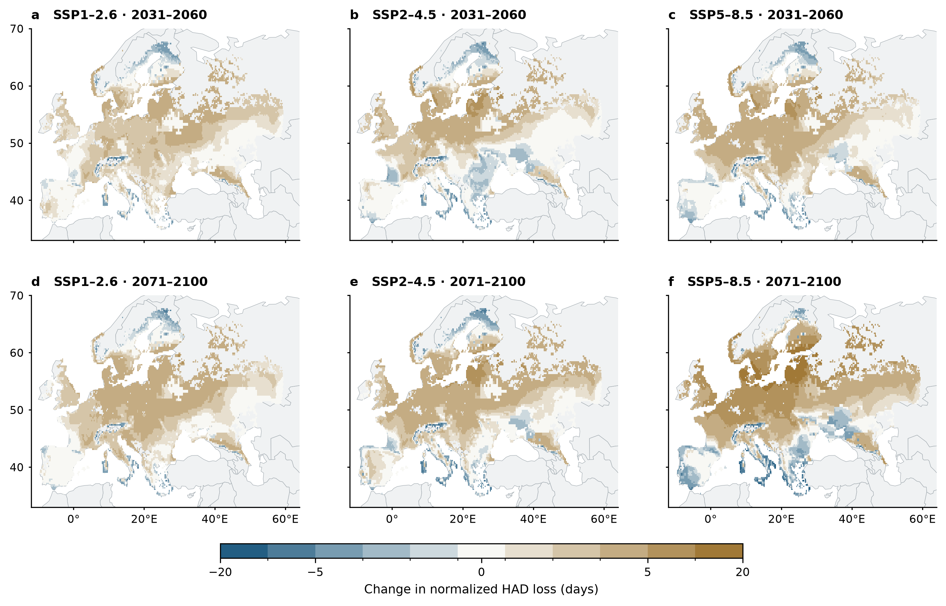
Figure 1 | Projected changes in Septoria-related canopy damage across European wheat-growing areas. (a–f) Three-climate-model mean changes in normalized loss of healthy-area duration (HAD) during flowering to soft dough for two future periods relative to 1991–2020. HAD loss is divided by maximum reference upper-three-leaf LAI and expressed in days. Each 0.25° pixel represents a separately simulated wheat-growing cell. Positive values indicate increasing accumulated canopy damage; negative values indicate decreasing damage. The six maps share a symmetric colour scale. The fixed SPAM2020 all-wheat mask contains 14,941 cells, of which 14,932 have a winter-wheat rainfed calendar. Grey wheat pixels have unavailable estimates. Country and regional summaries use fixed harvested-area weights. Supplementary Fig. S19 shows agreement among climate models.

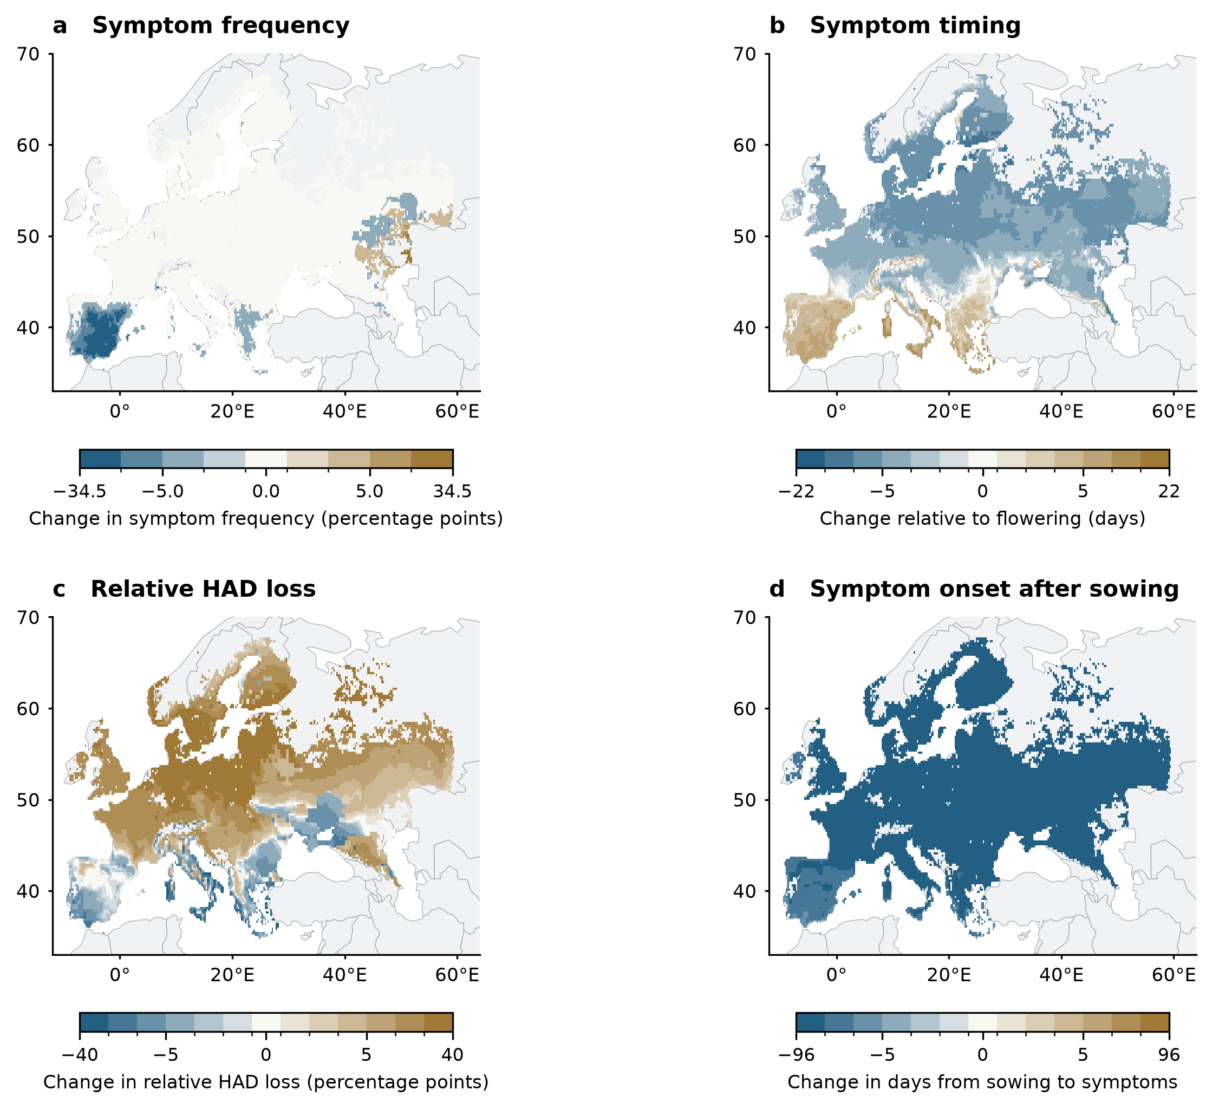
Figure 2 | Projected changes in Septoria symptoms and canopy damage. Panels show three-model mean changes under SSP5–8.5 in 2071–2100 relative to 1991–2020. (a) Frequency of seasons with flag-leaf symptoms before soft dough. (b) First symptoms relative to flowering; negative changes indicate earlier symptoms. (c) Relative HAD loss, the fraction of reference healthy-area duration lost during grain filling, expressed as a percentage-point change. This modelled loss of canopy function differs from measured lesion percentage. (d) Days from the fixed sowing date to first symptoms; negative changes indicate a shorter interval. Each panel has its own symmetric colour scale. Timing requires symptoms in both paired seasons, whereas frequency includes complete seasons without symptoms. Grey wheat pixels have unavailable estimates.

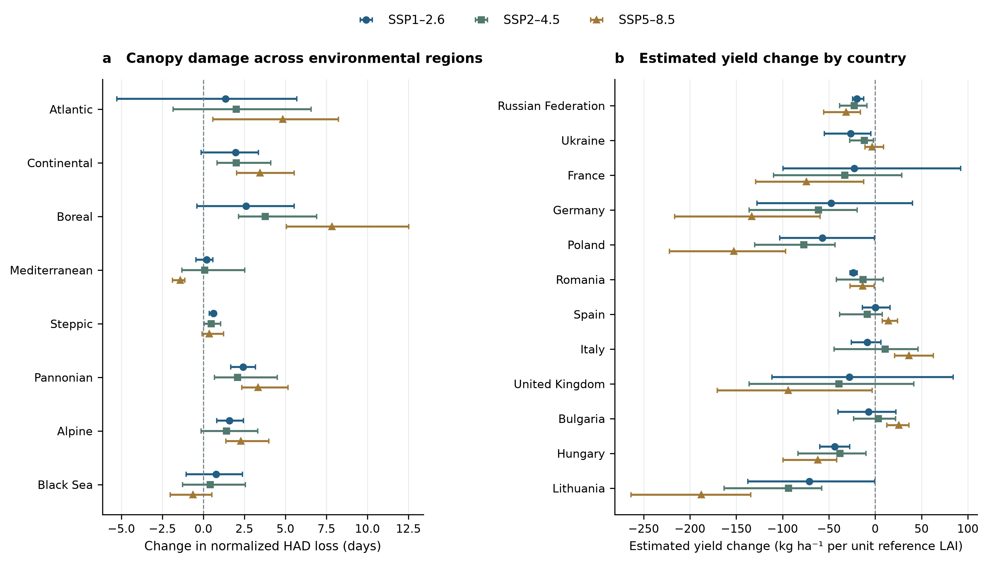
Figure 3 | Regional differences in canopy damage and inferred yield response. (a) Harvested-area-weighted changes in normalized HAD loss within eight EEA biogeographical regions. (b) Estimated disease-related yield changes for the twelve countries with the largest reference wheat area within the study domain. Both panels compare 2071–2100 with 1991–2020 under three emissions pathways. Points show three-model means; whiskers span model-specific estimates and are not confidence intervals. Country assignment follows the dominant SPAM source-country label of each cell. The yield estimate uses the change in HAD loss and the fixed coefficient 0.018 t ha⁻¹ per GLAI-day, normalized to unit reference upper-canopy LAI. Negative values indicate increased estimated disease-related yield loss. These estimates require validation of the canopy–yield relationship and do not describe total national production. Source Data includes all country groups.

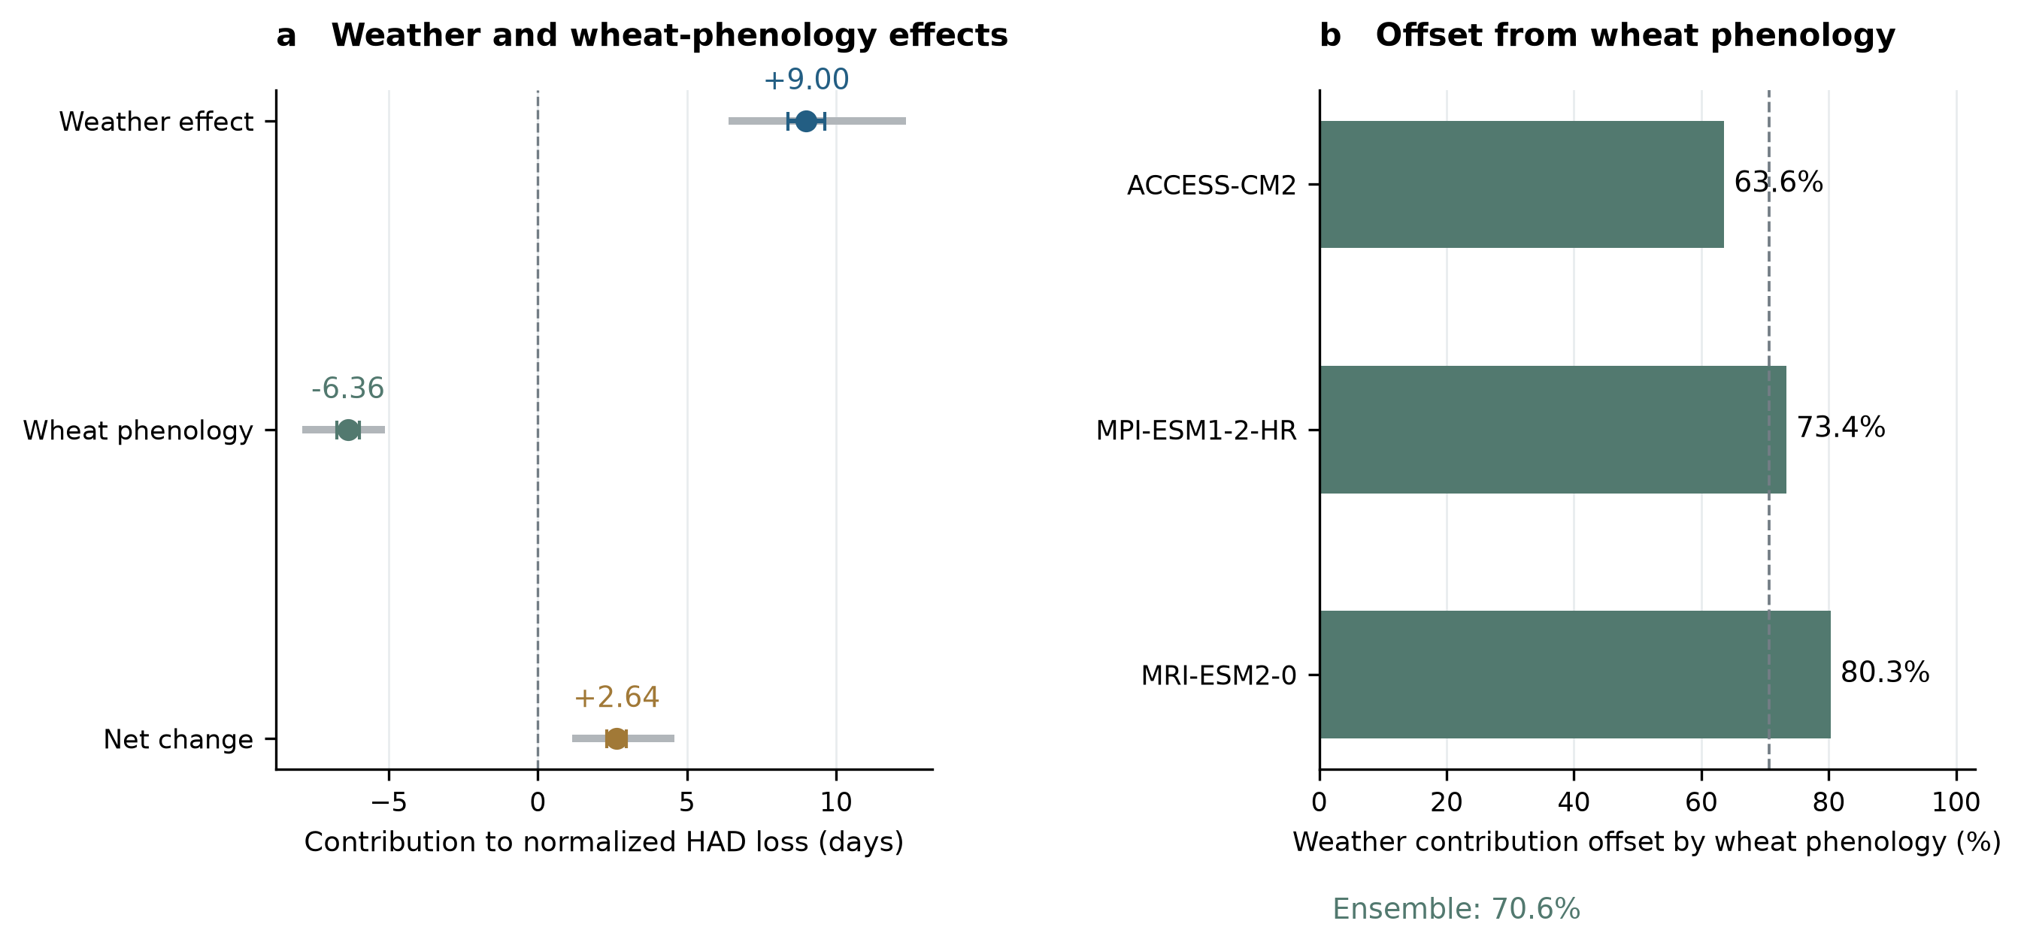
Figure 4 | Wheat phenology offsets part of the weather contribution to Septoria damage. (a) Weather and wheat-phenology contributions to normalized HAD loss during grain filling, and their sum, under late-century SSP5–8.5. The phenology contribution includes changes in upper-leaf appearance and unfolding and the flowering-to-soft-dough interval. The analysis uses 64 harvested-area-proportional draws at 62 cells and 5,731 valid season pairs. Grey segments span climate-model means; coloured whiskers show one spatial Monte Carlo standard error. Each Shapley contribution includes half of the weather–phenology interaction, shown separately in Supplementary Fig. S16. (b) Percentage of the weather contribution offset by wheat phenology in each climate model. The dashed line shows the ratio of ensemble contributions, 70.6%. These comparisons separate effects within the model; they do not estimate the effectiveness of changing sowing dates or cultivars.

