Customer Requirements Specification

**SA Glasses**

**ـــــــــــــــــــــــــــــــــــــــــــــــــــــــــــــــــــــــــــــــــــــــــــــــــــــــــــــــــــــــــــــــــــــــــــــــــــــــــــــــــــــــــــــــــــــــــــــــــــــــــــــــــــــــــــــــــــــــــــــــــــــــ**

**Table of Contents**

Document Status:………………………………………………………………...1 Document History:………………………………………………………………..1 Reference Document:…………………………………………………………....2 Project Description:……………………………………………………………....3

**Document Status:**

| **Name** | PO_SAG_CRS_Glasses |
| --- | --- |
| **Version** | V1.0 |
| **Status** | Proposed |
| **Author** | Reham Essam |
| **Date** | [28-9-2022] |

**Document History:**

| **Version** | **Author** | **Date** | **Date Change** |
| --- | --- | --- | --- |
| 1.0 | Reham Essam | [28/9/2022] | ● Initial Creation ● Add definition  ● Add features  ● Add Key elements  ● Add System Context  ● Add CRS Requirements |

**Reference Document:**

| **Ref.number** | **Doc.Name Version** | **Status** |
| --- | --- | --- |
| 1 | PO_SAG_CR_Glasses | Proposed |

**Project Description:**

Definition:

The Design of the project is glasses closed around the head, between the two lenses of the glasses there is a camera, on the right hand there is a power button , flash and mic , on the left side there are three buttons and a speaker.

Features:

* Glasses’ features can be controlled by the user.
* Glasses have two modes (Day mode - Night mode).
* Glasses can capture images.
* Glasses support the voice command.
* Glasses can speak.
* ECU protection and maintenance.
* The glasses’ OS is a real time OS.

Key Elements:

* Glasses support the user's security as each user has his own voice signature on it, another option is using the fingerprint sensor.
* Glasses have a power button and three buttons that control Features.
* Glasses can work in Day / Night Mode.
* Glasses can detect the night mode using LDR.
* Glasses have a camera that supports real-time capturing.
* Glasses have a microphone through which it receives voice commands.
* Glasses have a speaker to play any audio (mp3 files are received from the machine learning models).
* Voltage and temperature level can be tracked.
* DC fan used to decrease heat.
* Generate a customized OS with specific configurations.

System Context:

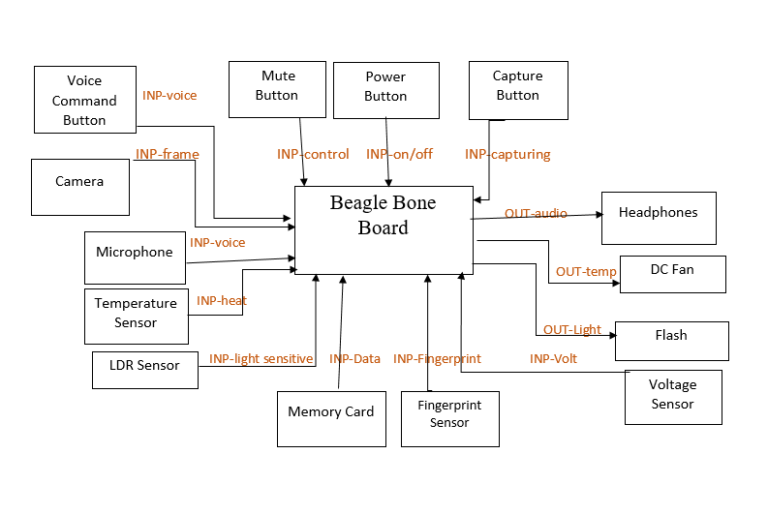

CRS Requirements:

**Req_ID** Req_PO_SAG_CRS_Glasses_***001***-V1.0 **Covers**_PO_SAG_CR_Glasses_***007***-V1.0

**Description:** User starts to speak until the glasses recognize him.

**Req_ID** Req_PO_SAG_CRS_Glasses_***002***-V1.0 **Covers**_PO_SAG_CR_Glasses_***001***-V1.1

**Description:**Touch a fingerprint sensor on the power button in case the glasses don’t recognize him.

**Req_ID** Req_PO_SAG_CRS_Glasses_***002***-V1.0 **Covers**_PO_SAG_CR_Glasses_***003***-V1.1

**Description:** The glasses select mode(Day mode, Night mode).

**Req_ID** Req_PO_SAG_CRS_Glasses_***003***-V1.0 **Covers**_PO_SAG_CR_Glasses_***004***-V1.1

**Description:** The LDR sensor detects the night mode and opens Flash.

**Req_ID** Req_PO_SAG_CRS_Glasses_***004***-V1.0 **Covers**_PO_SAG_CR_Glasses_***002***-V1.1

**Description:**The glasses start to detect everything, until the user presses the muted button.

**Req_ID** Req_PO_SAG_CRS_Glasses_***005***-V1.0 **Covers**_PO_SAG_CR_Glasses_***005***-V1.1

**Description:**Press capturing button,if the user wants to know the person’s activities surround him.

**Req_ID** Req_PO_SAG_CRS_Glasses_***006***-V1.0 **Covers**_PO_SAG_CR_Glasses_***007***-V1.0

**Description:**press the voice button to activate mic to receive voice command.

**Req_ID** Req_PO_SAG_CRS_Glasses_***007***-V1.0 **Covers**_PO_SAG_CR_Glasses_***006***-V1.2

**Description:**speaker plays any audio (mp3 files are received from the machine learning models).

**Req_ID** Req_PO_SAG_CRS_Glasses_***008***-V1.0 **Covers**_PO_SAG_CR_Glasses_***008***-V1.2

**Description:**Voltage sensor measures the battery volt and sends a signal if the battery needs to charge.

**Req_ID** Req_PO_SAG_CRS_Glasses_***009***-V1.0 **Covers**_PO_SAG_CR_Glasses_***008***-V1.2

**Description:**Temperature sensor measures heat of board.

**Req_ID**Req_PO_SAG_CRS_Glasses_***0010***-V1.0**Covers**_PO_SAG_CR_Glasses_***009***-V1.1

**Description**:DC fan decreases the heat of the board.