Software Requirements Specification

SAG ML Face Recognition

**ــــــــــــــــــــــــــــــــــــــــــــــــــــــــــــــــــــــــــــــــــــــــــــــــــــــــــــــــــــــــــــــــــــــــــــــــــــــــــــــــــــــــــــــــــــــــــــــــــــــــــــــــــــــــــــــــــــــــــــ**

**Table of Contents**

Document Status: 1

Document History: 2

Reference Document: 2

Project Description: 3

Definition: 3

Features: 3

Key elements 3

Software context: 3

SRS Requirements: 3

## Document Status:

|  |  |  |
| --- | --- | --- |
| **Name** | PO_SAG_SRS_ML_Face_Recg | |
| **Version** | 1.0 | |
| **Status** | Proposed | |
| **Author** | SAM | |
| **Date** | 9/2/2023 | |
| **Team Approval** |  |  |
| **Mentor Approval** |  |  |
| **Final Approval** |  |  |

## Document History:

|  |  |  |  |
| --- | --- | --- | --- |
| **Version** | **Author** | **Date** | **Change** |
| 1.0 | SAM | 9/2/2023 | Initial creation |

## Reference Document:

|  |  |  |  |
| --- | --- | --- | --- |
| **Ref.number** | **Doc.Name** | **Version** | **Status** |
| 1 | Po_SAG_CRS_ML_Face_Recog | V1.3 | Released |

## Project Description:

### Definition:

Face recognition is the process of taking a face in an image and identifying who the face belongs to.

Face recognition is a form of person identification.

### Features:

* Face recognition.

### Key elements

* The face recognition model shall recognize people determined by the user.

## Software context:

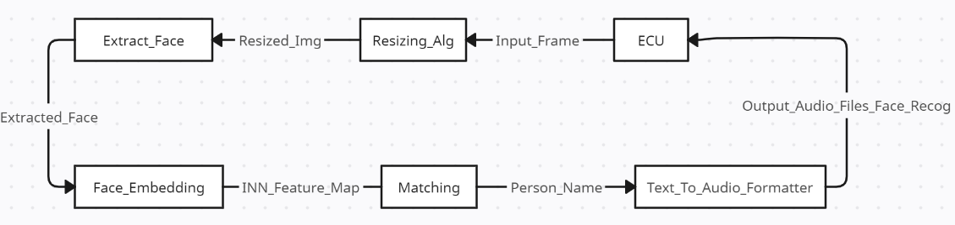

## SRS Requirements:

|  |  |  |  |
| --- | --- | --- | --- |
| **Req_ID** | Req_PO_ٍSAG_SRS_ML_Face_Recog _001-V1.0 | **Covers** | Req_SAG_ML_FaceRecog_CRS_***001***-V1.1 |
| **Description** | The Resizing_Alg shall resize the Input_Frames to suit the model. | | |
| **Inputs** | Input_Frames | **Outputs** | Resized_Img |

|  |  |  |  |
| --- | --- | --- | --- |
| **Req_ID** | Req_PO_ٍSAG_SRS_ML_Face_Recog _002-V1.0 | **Covers** | Req_SAG_ML_FaceRecog_CRS_***001***-V1.1 |
| **Description** | The MTCNN shall extract face from image. | | |
| **Inputs** | Resized_Img | **Outputs** | Extracted_Face |

|  |  |  |  |
| --- | --- | --- | --- |
| **Req_ID** | Req_PO_ٍSAG_SRS_ML_Face_Recog _003-V1.0 | **Covers** | Req_SAG_ML_FaceRecog_CRS_***002***-V1.2 |
| **Description** | The VGGFace with resnet50 weights shall extract Face_embedding. | | |
| **Inputs** | Extracted | **Outputs** | INN_Feature_Map |

|  |  |  |  |
| --- | --- | --- | --- |
| **Req_ID** | Req_PO_ٍSAG_SRS_ML_Face_Recog _004-V1.0 | **Covers** | Req_SAG_ML_FaceRecog_CRS_***003***-V1.3 |
| **Description** | The cosine similarity algorithm shall compare entire INN_Feature_Map with stored embeddings. | | |
| **Inputs** | INN_Feature_Map | **Outputs** | Passed_feature |

|  |  |  |  |
| --- | --- | --- | --- |
| **Req_ID** | Req_PO_ٍSAG_SRS_ML_Face_Recog _005-V1.0 | **Covers** | Req_SAG_ML_FaceRecog_CRS_***004***-V1.3 |
| **Description** | The cosine similarity algorithm shall output person name as text. | | |
| **Inputs** | Passed_feature | **Outputs** | Person name |

|  |  |  |  |
| --- | --- | --- | --- |
| **Req_ID** | Req_PO_ٍSAG_SRS_ML_Face_Recog _006-V1.0 | **Covers** | Req_SAG_ML_FaceRecog_CRS_***005***-V1.2 |
| **Description** | The Text_To_Audio_Formatter shall convert person name from text to Output_Audio_Files_Face_Recog. | | |
| **Inputs** | Person name | **Outputs** | Output_Audio_Files_Face_Recog |

|  |  |  |  |
| --- | --- | --- | --- |
| **Req_ID** | Req_PO_ٍSAG_SRS_ML_Face_Recog _007-V1.0 | **Covers** | Req_SAG_ML_FaceRecog_CRS_***006***-V1.2 |
| **Description** | The Text_To_Audio_Formatter shall return Output_Audio_Files_Face_Recog to ECU. | | |
| **Inputs** | Output_Audio_Files_Face_Recog | **Outputs** | Output_Audio_Files_Face_Recog |