## Customer Requirements Speciﬁcation

**PO_ٍSAG_CRS_ML_Img_Cap ــــــــــــــــــــــــــــــــــــــــــــــــــــــــــــــــــــــــــــــــــــــــــــــــــــــــــــــــــــــــــــــــــــــــــــــــــــــــــــــــــــــــــــــــــــــــــــــــــــــــــــــــــــــــــــــــــــــــــــــ**

**Table of Contents**

Document Status 1

Document History 1

Reference Document 2

Project Description 2

# Document Status:

|  |  |
| --- | --- |
| **Name** | PO_ٍSAG_CRS_ML_Img_Cap |
| **Version** | V1.0 |
| **Status** | proposed |
| **Author** | SAM |
| **Date** | [8-11-2022] |
| **Team Approval** |  |
| **Mentor Approval** |  |
| **Final Approval** |  |

# Document History:

|  |  |  |  |
| --- | --- | --- | --- |
| **Version** | **Author** | **Date** | **Change** |
| 1.0 | SAM | [8-11-2022] | * Initial Creation * Add definition * Add features * Add Key elements * Add System Context * Add CRS Requirements |

# Reference Document:

|  |  |  |  |
| --- | --- | --- | --- |
| **Ref.number** | **Doc.Name** | **Version** | **Status** |
| 1 | PO_SAG_CR_ML_Img_Cap | V1.0 | Released |

# Project Description:

## Definition:

The project aims to help the blind using computer vision to help them identify different things around them and NLP to interact with the user using voice commands.

The project simulates the natural vision of humans using AI techniques enabling the blind to function more normally and independently.

## Features:

* Activity recognition

## Key Elements:

* A resize algorithm shall resize the input frames to suit the model.
* The CNN model shall process the frames to extract distinguished features (context vector)
* The RNN model shall understand the context vector
* The RNN model shall output the expressive description in the form of text
* Output formatter shall format the text output to mp3 format
* The model shall return description to ECU



## **image captioning**

## System Context:

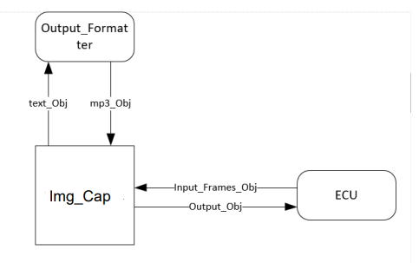

## CRS Requirements:

|  |  |  |  |
| --- | --- | --- | --- |
| **Req_ID** | Req_PO_SAG_CRS_ML_Img_Cap_***001***-V1.0 | **Covers** | PO_SAG_CR_ML_001-V1.0 |
| **Description** | A resize algorithm shall resize the input frames to suit the model. | | |

|  |  |  |  |
| --- | --- | --- | --- |
| **Req_ID** | Req_PO_SAG_CRS_ML_Img_Cap_***002***-V1.0 | **Covers** | PO_SAG_CR_ML_001-V1.0 |
| **Description** | The CNN model shall process the frames to extract distinguished features | | |

|  |  |  |  |
| --- | --- | --- | --- |
| **Req_ID** | Req_PO_SAG_CRS_ML_Img_Cap_***003***-V1.0 | **Covers** | PO_SAG_CR_ML_001-V1.0 |
| **Description** | The RNN model shall understand the context | | |

|  |  |  |  |
| --- | --- | --- | --- |
| **Req_ID** | Req_PO_SAG_CRS_ML_Img_Cap_***004***-V1.0 | **Covers** | PO_SAG_CR_ML_001-V1.0 |
| **Description** | The RNN model shall output the expressive description in the form of text | | |

|  |  |  |  |
| --- | --- | --- | --- |
| **Req_ID** | Req_PO_SAG_CRS_ML_Img_Cap_***005***-V1.0 | **Covers** | PO_SAG_CR_ML_001-V1.0 |
| **Description** | The RNN model shall understand the context | | |

|  |  |  |  |
| --- | --- | --- | --- |
| **Req_ID** | Req_PO_SAG_CRS_ML_Img_Cap_***006***-V1.0 | **Covers** | PO_SAG_CR_ML_001-V1.0 |
| **Description** | Output formatter shall format the text output to mp3 format | | |

|  |  |  |  |
| --- | --- | --- | --- |
| **Req_ID** | Req_PO_SAG_CRS_ML_Img_Cap_***007***-V1.0 | **Covers** | PO_SAG_CR_ML_001-V1.0 |
| **Description** | The model shall return the description to ECU | | |