## Customer Requirements Speciﬁcation

**SAG DASHBOARD**

**ـــــــــــــــــــــــــــــــــــــــــــــــــــــــــــــــــــــــــــــــــــــــــــــــــــــــــــــــــــــــــــــــــــــــــــــــــــــــــــــــــــــــــــــــــــــــــــــــــــــــــــــــــــــــــــــــــــــــــــــــــــ**

**Table of Contents**

Document Status…………………………………………………………………. 1

Document History………………………………………………………………… 1

Reference Document……………………………………………………………. 2

Project Description………………………………………………………………. 3

# Document Status:

| **Name** | PO_SAG_CRS_DB |
| --- | --- |
| **Version** | V1.0 |
| **Status** | Proposed |
| **Author** | orabii |
| **Date** | [27-9-2022] |

# 

# 

# 

# 

# Document History:

| **Version** | **Author** | **Date** | **Change** |
| --- | --- | --- | --- |
| 1.0 | orabii | [8-9-2021] | * Initial Creation * Add definition * Add features * Add Key elements * Add CRS Requirements |

# Reference Document:

| **Ref.number** | **Doc.Name** | **Version** | **Status** |
| --- | --- | --- | --- |
| 1 | PO_SAG_CR_DB | V1.0 | Released |

Project Description:

Definition:

website is used to present the product and the features that contain it. and users can buy it. and dashboard that can show overview and statistics about the product..

Features:

* You can buy the product through the E-commerce Website.
* A dashboard to manage the data.
* You can deal with payment gateway to buy the product.
* You will get code through your gmail to connect with mobile app

Key Elements:

* Landing page shows features about the product.
* Place and track order.
* User has an account.
* Users can send feedback and report technical issues.
* Dashboard has different users’ roles.
* Each Dashboard user has an account.
* Each Dashboard role has a different permissions.
* Dashboard generates statistics and summary about the website.
* Dashboard users can handle payment logs.
* Dashboard users can handle and keep track of customers.
* Dashboard admin can handle and keep track of dashboard users.

## System Context:

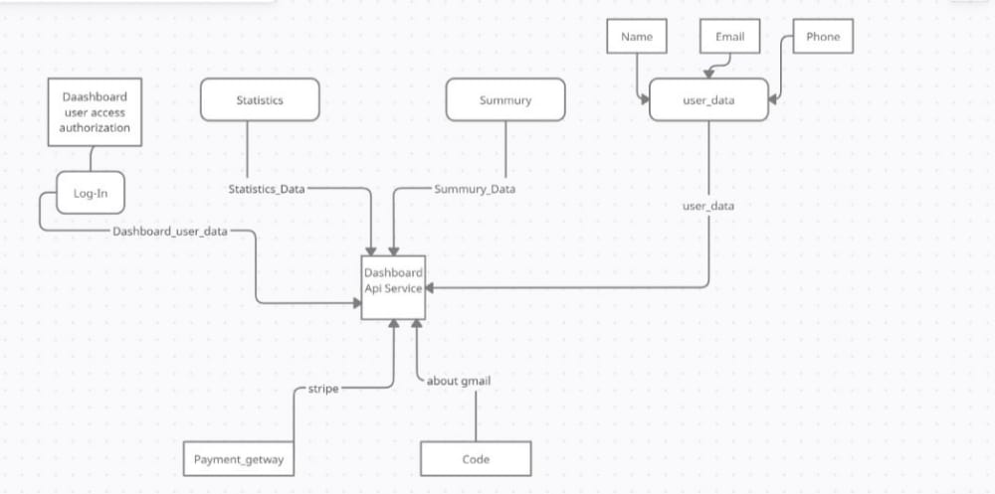

## CRS Requirements:

| **Req_ID** | Req_PO_SAG_CRS_***001***-V1.0 | **Covers** | Covers_PO_SAG_CR_WEB_***001***-V1.0 |
| --- | --- | --- | --- |
| **Description** | User shows features about the product. | | |

| **Req_ID** | Req_PO_SAG_CRS_***002***-V1.0 | **Covers** | Covers_PO_SAG_CR_WEB_***002***-V1.1 |
| --- | --- | --- | --- |
| **Description** | User can know information about his product and track the order. | | |

| **Req_ID** | Req_PO_SAG_CRS_***003***-V1.0 | **Covers** | Covers_PO_SAG_CR_WEB_***003***-V1.1 |
| --- | --- | --- | --- |
| **Description** | User can create account using email | | |

| **Req_ID** | Req_PO_SAG_CRS_***004***-V1.0 | **Covers** | Covers_PO_SAG_CR_WEB_***003***-V1.1 |
| --- | --- | --- | --- |
| **Description** | User can login to a pre-existing account | | |

| **Req_ID** | Req_PO_SAG_CRS_***005***-V1.0 | **Covers** | Covers_PO_SAG_CR_WEB_***003***-V1.1 |
| --- | --- | --- | --- |
| **Description** | User can sign in using google authentication | | |

| **Req_ID** | Req_PO_SAG_CRS_***006***-V1.0 | **Covers** | Covers_PO_SAG_CR_WEB_***003***-V1.1 |
| --- | --- | --- | --- |
| **Description** | User can reset password using email | | |

| **Req_ID** | Req_PO_SAG_CRS_***007***-V1.0 | **Covers** | Covers_PO_SAG_CR_WEB_***003***-V1.1 |
| --- | --- | --- | --- |
| **Description** | User can edit his profile through settings | | |

| **Req_ID** | Req_PO_SAG_CRS_***008***-V1.0 | **Covers** | Covers_PO_SAG_CR_WEB_***003***-V1.1 |
| --- | --- | --- | --- |
| **Description** | User can change personal information. | | |

| **Req_ID** | Req_PO_SAG_CRS_***09***-V1.0 | **Covers** | Covers_PO_SAG_CR_WEB_***003***-V1.1 |
| --- | --- | --- | --- |
| **Description** | User views about us page through settings. | | |

| **Req_ID** | Req_PO_SAG_CRS_***010***-V1.0 | **Covers** | Covers_PO_SAG_CR_WEB_***003***-V1.1 |
| --- | --- | --- | --- |
| **Description** | User can see more information about product. | | |

| **Req_ID** | Req_PO_SAG_CRS_***011***-V1.0 | **Covers** | Covers_PO_SAG_CR_WEB_***004***-V1.1 |
| --- | --- | --- | --- |
| **Description** | Users can send feedback and report technical issues. | | |

| **Req_ID** | Req_PO_SAG_CRS_***012***-V1.0 | **Covers** | Covers_PO_SAG_CR_WEB_***005***-V1.1 |
| --- | --- | --- | --- |
| **Description** | Dashboard users have an account to access the dashboard | | |

| **Req_ID** | Req_PO_SAG_CRS_***013***-V1.0 | **Covers** | Covers_PO_SAG_CR_WEB_***006***-V1.1 |
| --- | --- | --- | --- |
| **Description** | Each Dashboard role has a different permissions | | |

| **Req_ID** | Req_PO_SAG_CRS_***014***-V1. | **Covers** | Covers_PO_SAG_CR_WEB_***007***-V1.1 |
| --- | --- | --- | --- |
| **Description** | only super admin can manage dashboard and control it . | | |

| **Req_ID** | Req_PO_SAG_CRS_***015***-V1.0 | **Covers** | Covers_PO_SAG_CR_WEB_***008***-V1.1 |
| --- | --- | --- | --- |
| **Description** | Users of dashboard can see the summary of the cases | | |

| **Req_ID** | Req_PO_SAG_CRS_***016***-V1.0 | **Covers** | Covers_PO_SAG_CR_WEB_***009***-V1.1 |
| --- | --- | --- | --- |
| **Description** | there are many way to pay through the dashboard | | |

| **Req_ID** | Req_PO_SAG_CRS_***017***-V1.0 | **Covers** | Covers_PO_SAG_CR_WEB_***010***-V1.1 |
| --- | --- | --- | --- |
| **Description** | Dashboard generates statistics and summary about customers | | |

| **Req_ID** | Req_PO_SAG_CRS_***018***-V1.0 | **Covers** | Covers_PO_SAG_CR_WEB_***011***-V1.1 |
| --- | --- | --- | --- |
| **Description** | Dashboard generates statistics and summary about users | | |