**Software Requirement**

**Specification**

**for**

**SmartBard**

**Requirements for Version 2.0**

| **Team:** | Peter Chong, Brandon Ly, Ricky Taing, An Tran, Sandy Yang, Jarod Durkin |
| --- | --- |
| **Faculty Advisor:** | Jeff Salvage |
| **Project Stakeholder:** | Pam McGonigle |

**<May 20, 2023>**

Revision History

| Name | Date | Reason for Changes | Version |
| --- | --- | --- | --- |
| Peter Chong, Brandon Ly, Ricky Taing, An Tran, Sandy Yang, Jarod Durkin | 11/9/22 | Initial draft and sections outlined. | 1.0 |
| Peter Chong, Brandon Ly, Ricky Taing, An Tran, Sandy Yang, Jarod Durkin | 1/13/23 | Revised document and updated requirements. | 1.1 |
| Peter Chong, Brandon Ly, Ricky Taing, An Tran, Sandy Yang, Jarod Durkin | 1/17/23 | Fixed grammar and punctuation. | 1.2 |
| Peter Chong, Brandon Ly, Ricky Taing, An Tran, Sandy Yang, Jarod Durkin | 4/18/23 | Revised requirements and updated pictures. | 1.3 |
| Peter Chong, Brandon Ly, Ricky Taing, An Tran, Sandy Yang, Jarod Durkin | 5/20/23 | Updated and finalized requirements. | 2.0 |

Table of Contents

**1. Introduction 7**

1.1 Purpose 7

1.2 Scope 7

1.3 Definitions, Acronyms, and Abbreviations 8

**2. User Interface and Functional Requirements 8**

2.1 Login Page 8

R2.1 Login Page Requirements 10

R2.1.1 Login Button 10

R2.1.2 Continue with Google Button 11

R2.1.3 Settings Button 11

2.2 Landing Page 11

R2.2 Landing Page Requirements 12

R2.2.1 Navigation Bar 12

R2.2.2 Request Button 13

R2.2.3 Admin Button 13

R2.2.4 Logout Button 13

R2.2.5 Carousel 13

R2.2.6 Announcement Posts 14

R2.2.7 Settings Button 14

2.3 Detailed Announcement Page 14

R2.3 Detailed Announcement Page Requirements 16

R2.3.1 Navigation Bar 16

R2.3.2 SmartBard Logo 16

R2.3.3 Request Button 16

R2.3.4 Admin Button 16

R2.3.5 Logout Button 16

R2.3.6 Detailed Announcement 17

R2.3.7 Text-to-Speech Button 17

R2.3.8 Attached Documents Button 17

R2.3.9 Settings Button 17

2.4 Request Page 18

R2.4 Request Page Requirements 20

R2.4.1 Navigation Bar 20

R2.4.2 SmartBard Logo 20

R2.4.3 Request Button 20

R2.4.4 Logout Button 20

R2.4.5 Request Table 20

R2.4.6 Filter Button 21

R2.4.7 Create New Request Table 21

R2.4.8 Settings Button 21

2.5 Create Request Page 21

R2.5 Create Request Page Requirements 22

R2.5.2 SmartBard Logo 23

R2.5.3 Request Button 23

R2.5.4 Admin Button 23

R2.5.5 Logout Button 23

R2.5.6 New Request 23

R2.5.7 Settings Button 24

2.6 Admin Request Page 24

R2.6 Admin Request Page Requirements 25

R2.6.1 Navigation Bar 25

R2.6.2 SmartBard Logo 25

R2.6.3 Admin Button 26

R2.6.4 Logout Button 26

R2.6.5 Settings Button 26

2.7 Request Detailed Page 26

R2.7 Request Detailed Page Requirements 28

R2.7.1 Navigation Bar 28

R2.7.2 SmartBard Logo 28

R2.7.3 Request Button 29

R2.7.4 Admin Button 29

R2.7.5 Logout Button 29

R2.7.6 Accept Button 29

R2.7.7 Reject Button 29

R2.7.8 Edit Button 30

R2.7.9 Return Button 30

R2.7.10 Make Priority Button 30

R2.7.11 Settings Button 30

2.8 Settings Modal 31

R2.8 Settings Modal Requirements 32

R2.8.1 Font Size Dropdown 32

R2.8.2 Text Color Dropdown 32

R2.8.3 Theme Dropdown 32

**3. Other Nonfunctional Requirements 33**

3.1 Performance Requirements 33

3.1.1 Response Time 33

3.1.2 Software 33

3.2 Software Quality Requirements 33

3.2.1 Availability 33

3.2.2 Usability 33

3.2.3 Scalability 34

3.2.4 Security 34

**4. System Evolution 34**

4.1 New Accessibility Features 34

4.2 Touch Screen Component 35

# **Introduction**

## 1.1 Purpose

The purpose of this document is to specify the requirements and features of SmartBard. SmartBard is a bulletin board web application for Overbrook School of the Blind designed to help those visually impaired effortlessly access items that would be inaccessible on a physical bulletin board.

This document is intended for any user, developer, and/or tester that needs to understand the basic system of SmartBard and its specification.

## 1.2 Scope

This application offers an accessible way to view different items that are traditionally placed on a bulletin board (i.e., announcements, pictures, etc.). Content on the bulletin board is accessible through various accessibility features (i.e., font size, font color, theme, etc.), which are customized per user. In addition, users may request to add content to the bulletin board. The application consists of two groups of users, Students, and Administrators. Students request content to be added and Administrators moderate all content on the bulletin board by approving, rejecting, and editing any requests.

SmartBard provides those visually impaired students to access content that would be normally difficult to visually see on a traditional bulletin board through various accessibility features.

## 1.3 Definitions, Acronyms, and Abbreviations

**AWS**  - Amazon Web Services, a cloud computing platform.

**MB -** Megabyte; A measure of computer processor storage.

**Navbar -** Navigation Bar.

**Obfuscated** - Text is hidden as black dots while entering in an input field.

**OBS -** Overbrook School for the Blind

**Post/Announcement** - An item that would be traditionally placed on a bulletin board, such as an general announcement, notice, picture, and or document.

**Visual Impairment** - Loosely defined in vision that, even with correction, such as with glasses or contacts, they still have trouble seeing things.

# User Interface and Functional Requirements

## 2.1 Login Page

Upon opening the application, users are met with the ***Login Page*** screen. Users must have a valid OBS account to be able to log in to the system. The user can click on the ***Login*** ***Button*** and will be navigated to the ***AWS Cognito Hosted UI*** ***Page*** (Figure 2), and then can log in using the ***Continue with Google Button*** to authenticate with Google (Figure 3). The ***Login Page*** contains the ***SmartBard*** ***Logo*** displayed above the ***Login Button***. The ***Settings*** ***Button*** is located in the lower left-hand corner of the page, to navigate to the ***Settings Modal***.

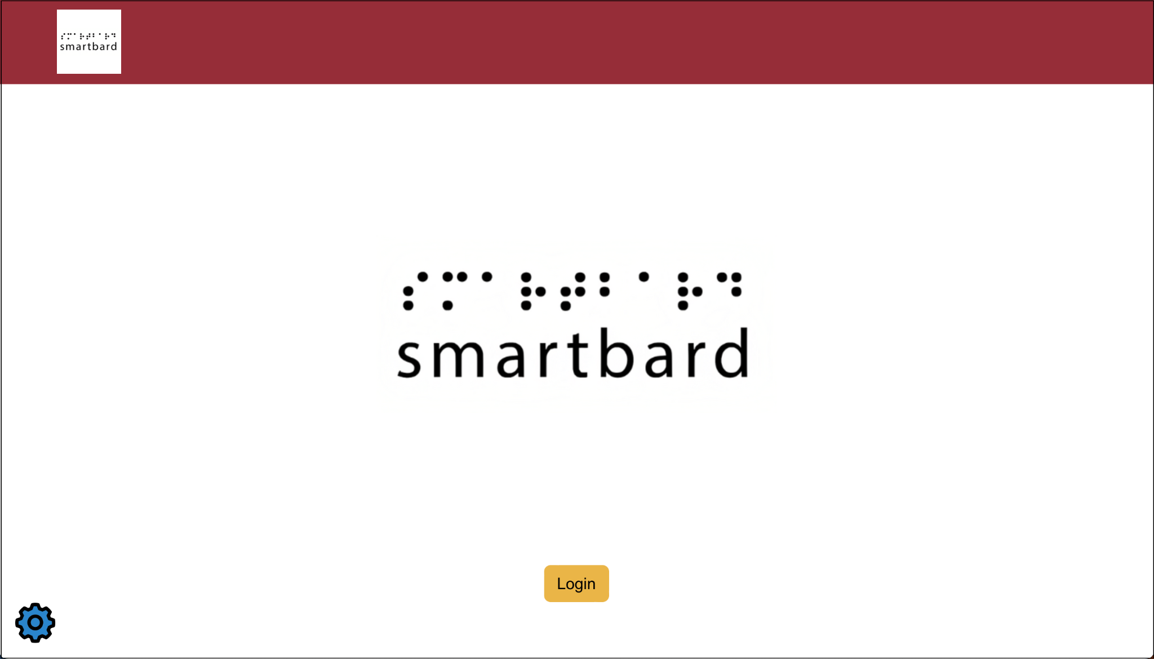

Figure 1. **Login Page**

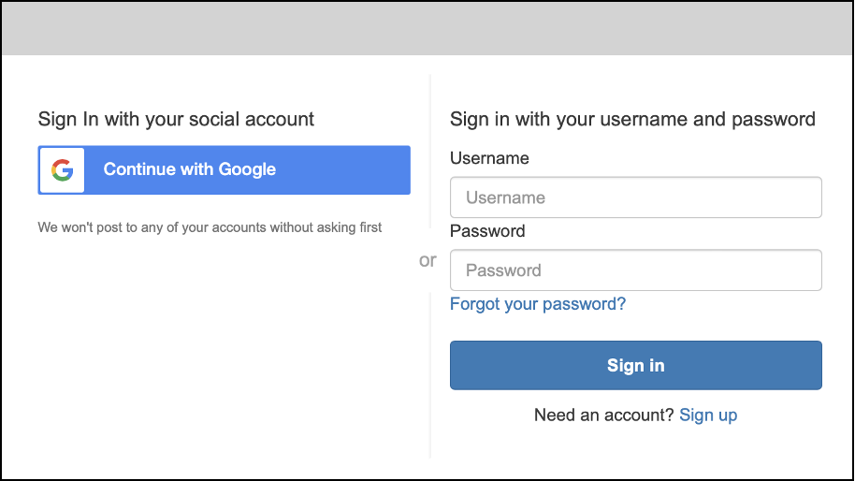

Figure 2. **AWS Cognito Hosted UI Page**

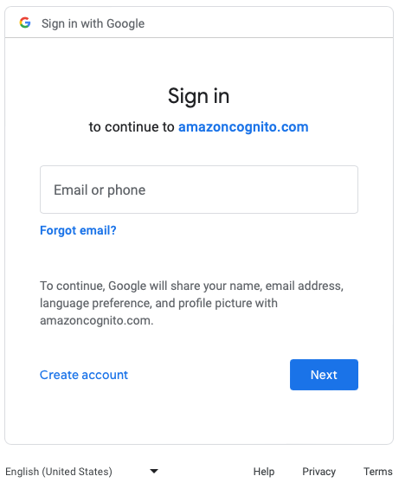

Figure 3. **Sign in with Google Page**

## R2.1 Login Page Requirements

### R2.1.1 Login Button

**R2.1.1.1** Clicking on the ***Login Button*** brings the user to the **AWS Cognito Hosted UI Page** (Figure 2).

### R2.1.2 Continue with Google Button

**R2.1.2.1** Clicking the ***Continue with Google*** ***Button*** (Figure 2)brings the user to the ***Sign in with Google Page*** (Figure 3)***.***

**R2.1.2.2** Successful authentication using a valid OBS account logs the user in the application and brings the user to the ***Landing Page***.

**R2.1.2.3** Unsuccessful authentication brings the user back to the ***Login Page***.

### R2.1.3 Settings Button

**R2.1.3.1** Clicking the ***Settings Button*** brings the user to the ***Settings Modal***.

## 2.2 Landing Page

The ***Landing Page*** is displayed once a user is successfully authenticated with SmartBard. The top of the page contains the ***Navigation Bar*** with the ***SmartBard*** ***Logo***, the ***Request Button***,and the ***Logout Button***.If the user is an ***Administrator***, the ***Admin Button*** is visible, replacing the ***Request Button***. The ***Request Button*** navigates the user to the ***Request Page***, the ***Logout Button*** logs the current user out of the application and navigates the user back to the ***Login Page***, and the ***Admin Button*** navigates the user to the ***Admin Request Page***.

The ***Landing Page*** provides the user with the bulletin board’s priority announcement and a carousel of various other posts. Each post has a title, a body description, and optionally a media attachment. The carousel automatically rotates to the next post and has a left and right arrow button to cycle through the carousel to view different posts. Double clicking on any post brings the user to the post’s ***Detailed Announcement Page***. The ***Settings*** ***Button*** is located in the lower left-hand corner of the page, to navigate to the ***Settings Modal***.

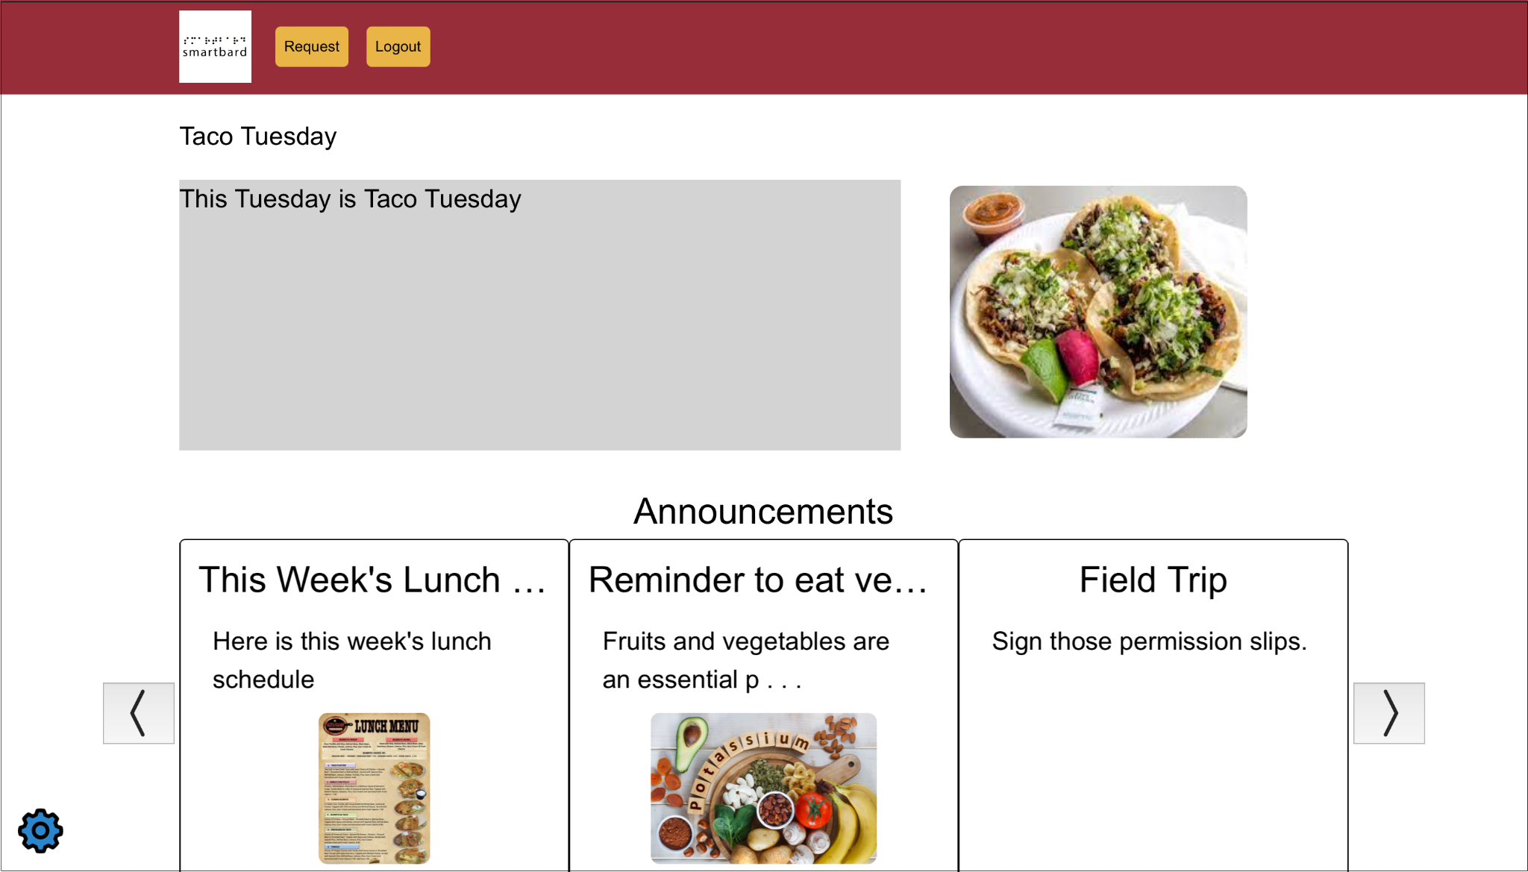

Figure 4. **Landing Page**

## R2.2 Landing Page Requirements

### R2.2.1 Navigation Bar

**R2.2.1.1** The ***Navigation Bar*** contains the ***SmartBard*** ***Logo***, the ***Request Button***,and the ***Logout Button***.

**R2.2.1.2** If the user is an ***Administrator***,the ***Navigation Bar*** contains the ***Admin Button***, instead of the ***Request Button***.

### R2.2.2 Request Button

**R2.2.2.1** Clicking the ***Request Button*** brings the user to the ***Request Page***.

### R2.2.3 Admin Button

**R2.2.3.1** Clicking the ***Admin Button*** brings the user to the ***Admin Request Page***.

### R2.2.4 Logout Button

**R2.2.4.1** Clicking the ***Logout Button*** logs out the current user and brings the user to the ***Login Page***.

### R2.2.5 Carousel

**R2.2.5.1** The carousel displays 3 posts at a time, with a left and right arrow button on each side.

**R2.2.5.2** Clicking the left arrow button rotates the current center post to the right, moving the current left post to the center, and moving a new post to the left.

**R2.2.5.3** Clicking the right arrow button rotates the current center post to the left, moving the current right post to the center, and moving a new post to the right.

**R2.2.5.4** The carousel automatically rotates to the next post every 5 seconds.

**R2.2.5.5** Overflow from the carousel announcement title is truncated using an ellipsis.

**R2.2.5.6** Overflow from the carousel announcement body description is truncated using an ellipsis.

### R2.2.6 Announcement Posts

**R2.2.6.1** The priority announcement displays its full title, and its full description.

**R2.2.6.2** The priority announcement displays its media attachment if there exists one.

**R2.2.6.3** Clicking on any post, brings the user to the ***Detailed Announcement Page***.

### R2.2.7 Settings Button

**R2.2.7.1** Clicking the ***Settings Button*** brings the user to the ***Settings Modal***.

## 2.3 Detailed Announcement Page

The ***Detailed Announcement Page*** expands upon the post that the user double clicks into for more detail. The top of the page contains the ***Navigation Bar*** with the ***SmartBard*** ***Logo***, the ***Request Button***,and the ***Logout Button***.If the user is an ***Administrator***, the ***Admin Button*** is visible, replacing the ***Request Button***. The ***Request Button*** navigates the user to the ***Request Page***, the ***Logout Button*** logs the current user out of the application and navigates the user back to the ***Login Page***, and the ***Admin Button*** navigates the user to the ***Admin Request Page***.

The full title, full body description, and any additional media attachment is visible to the user. The title is displayed at the top of the page followed by the description. If the post has a media attachment, it is displayed with the body description and an ***Attached Documents*** button becomes visible for the user to click on to download the attachment. If the user wants the body description to be read aloud, the user can click on the ***Text-to-Speech Button*** at the bottom right of the body description box. The ***Settings*** ***Button*** is located in the lower left-hand corner of the page, to navigate to the ***Settings Modal***.

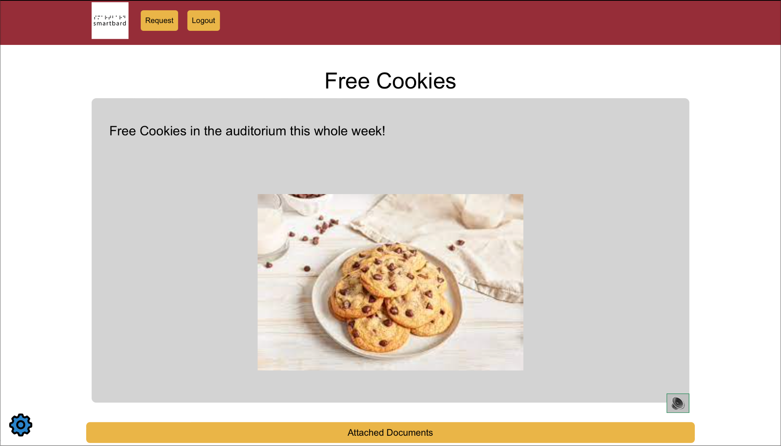

Figure 5. **Detailed Announcement Page**

## R2.3 Detailed Announcement Page Requirements

### R2.3.1 Navigation Bar

**R2.3.1.1** The ***Navigation Bar*** contains the ***SmartBard*** ***Logo***, the ***Request Button***, and the ***Logout button***.

**R2.3.1.2** If the user is an ***Administrator***,the ***Navigation Bar*** contains the ***Admin Button***, instead of the ***Request Button***.

### R2.3.2 SmartBard Logo

**R2.3.2.1** Clicking the ***SmartBard Logo*** brings the user to the ***Landing Page***.

### R2.3.3 Request Button

**R2.3.3.1** Clicking the ***Request Button*** brings the user to the ***Request Page***.

### R2.3.4 Admin Button

**R2.3.4.1** Clicking the ***Admin Button*** brings the user to the ***Admin Request Page***.

### R2.3.5 Logout Button

**R2.3.5.1** Clicking the ***Logout Button*** brings the user to the ***Login Page***.

### R2.3.6 Detailed Announcement

**R2.3.6.1** The title is centered at the top of the page.

**R2.3.6.2** The body description text is underneath the title.

**R2.3.6.3**  If there is a media attachment, it is underneath the body description.

### R2.3.7 Text-to-Speech Button

**R2.3.7.1**. Clicking on the ***Text-to-Speech Button*** will read aloud the body description.

### R2.3.8 Attached Documents Button

**R2.3.8.1** If there is a media attachment, the ***Attached Documents Button*** is underneath the picture.

**R2.3.8.2** The ***Attached Documents Button*** is underneath the body description.

**R2.3.8.3** Clicking the ***Attached Documents Button*** allows the user to download the media attachment.

### R2.3.9 Settings Button

**R2.3.9.1** Clicking the ***Settings Button*** brings the user to the ***Settings Modal***.

## 2.4 Request Page

Clicking on the **Request Button** in the **Navigation Bar** brings the user to the ***Request Page***. Here the user can view all requests they’ve created in a table sorted by three categories, Pending, Accepted, and Rejected. When the user clicks on each tab, the **Request Table** displays only the requests of that category. The user can click on the ***Filter Button*** at the top of the **Request Table** to filter posts by Title, Date Range, and or by Priority. At the bottom right-hand side of the **Request Table** is the ***Create New Request Button***, which brings the user to the ***Create Request Page***. To view more details of the request, the user can click on the **Details Button**, to navigate to the **Request Detailed Page**

The top of the page contains the ***Navigation Bar*** with the ***SmartBard*** ***Logo***, the ***Request Button***,and the ***Logout Button***. The ***Request Button*** navigates the user to the ***Request Page*** and the ***Logout Button*** logs the current user out of the application and navigates the user back to the ***Login Page***. The ***Settings*** ***Button*** is located in the lower left-hand corner of the page, to navigate to the ***Settings Modal***.

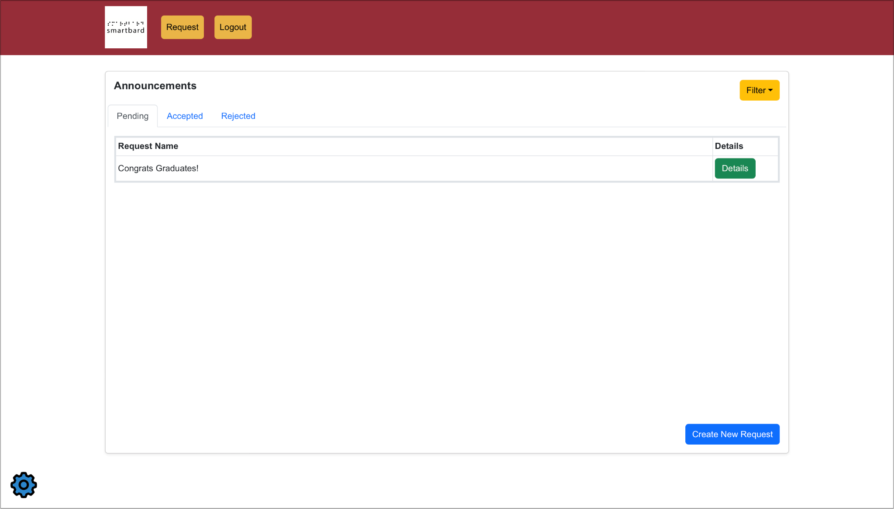

Figure 6. **Request Page**

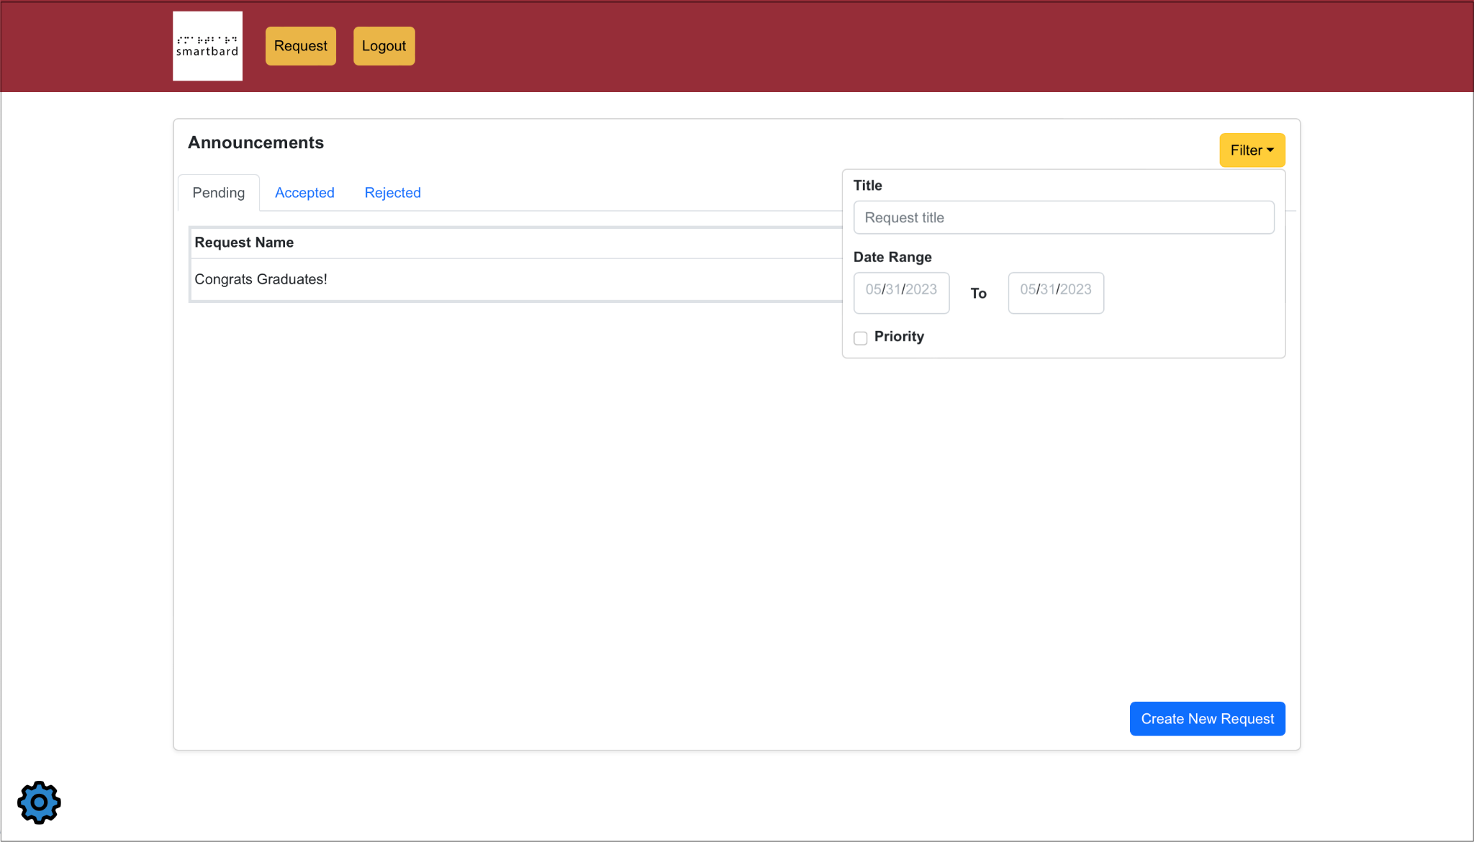

Figure 7. **Request Page with Filter**

## R2.4 Request Page Requirements

### R2.4.1 Navigation Bar

**R2.4.1.1** The ***Navigation Bar*** contains the ***SmartBard*** ***Logo***, the ***Request Button***,and the ***Logout button***.

### R2.4.2 SmartBard Logo

**R2.4.2.1** Clicking the ***SmartBard Logo*** brings the user to the ***Landing Page***.

### R2.4.3 Request Button

**R2.4.3.1** Clicking the ***Request Button*** brings the user to the ***Request Page***.

### R2.4.4 Logout Button

**R2.4.4.1** Clicking the ***Logout Button*** brings the user to the ***Login Page***.

### R2.4.5 Request Table

**R2.4.5.1** The **Request Table** has 3 tabs.

**R2.4.5.2** The tabs available are Pending, Accepted, and Rejected.

**R2.4.5.3** The **Request Table** displays different requests depending on the tab selected.

### R2.4.6 Filter Button

**R2.4.6.1** Clicking the ***Filter Button*** displays the options to filter by Title, Date Range, and or Priority.

### R2.4.7 Create New Request Table

**R2.4.7.1** Clicking the ***Create New Request Button*** brings the user to the ***Create Request Page***.

### R2.4.8 Settings Button

**R2.4.8.1** Clicking the ***Settings Button*** brings the user to the ***Settings Modal***.

## 2.5 Create Request Page

Clicking the ***Create New Request Button*** from the ***Request Page***brings the user to the ***Create Request Page***. The **Create New Request Page** is the same for both Student and Administrator users. A new request contains input fields for entering the title, body description, date range, and or an media attachment. On the bottom right hand corner is a ***Submit Button*** that sends the request for an Administrator to approve.

The top of the page contains the ***Navigation Bar*** with the ***SmartBard*** ***Logo***, the ***Request Button***,and the ***Logout Button***. The ***Request Button*** navigates the user to the ***Request Page*** and the ***Logout Button*** logs the current user out of the application and navigates the user back to the ***Login Page***. If the user is an ***Administrator***, an ***Admin Button*** is also located at the top, replacing the ***Request Button***, and navigates the user to the ***Admin Request Page***. The ***Settings*** ***Button*** is located in the lower left-hand corner of the page, to navigate to the ***Settings Modal***.

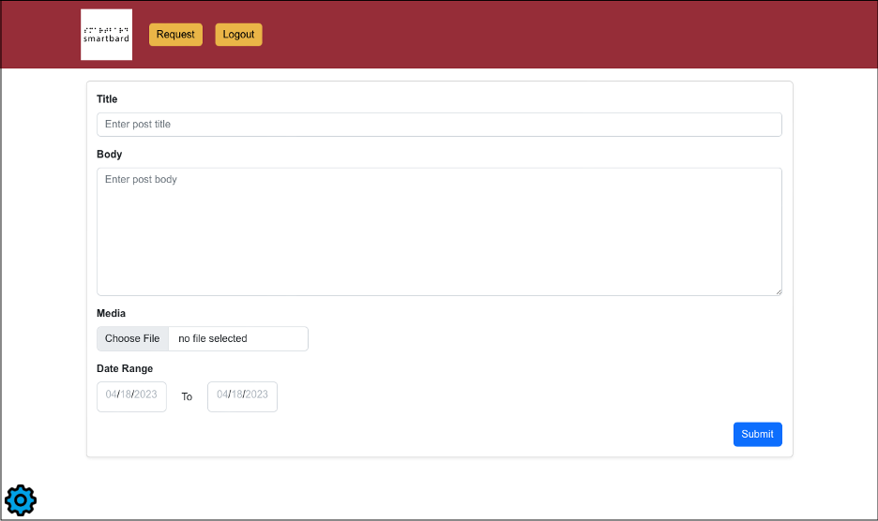

Figure 8. **Create Request Page**

## R2.5 Create Request Page Requirements

R2.5.1 Navigation Bar

**R2.5.1.1** The ***Navigation Bar*** contains the ***SmartBard*** ***Logo***, the ***Request Button*** and the ***Logout button***.

**R2.5.1.2** If the user is an ***Administrator***,the ***Navigation Bar*** contains the ***Admin Button***, instead of the ***Request Button***.

### R2.5.2 SmartBard Logo

**R2.5.2.1** Clicking the ***SmartBard Logo*** brings the user to the ***Landing Page***.

### R2.5.3 Request Button

**R2.5.3.1** Clicking the ***Request Button*** brings the user to the ***Request Page***.

### R2.5.4 Admin Button

**R2.5.4.1** Clicking the ***Admin Button*** brings the user to the ***Admin Request Page***.

### R2.5.5 Logout Button

**R2.5.5.1** Clicking the ***Logout Button*** brings the user to the ***Login Page***.

### R2.5.6New Request

**R2.5.6.1** A valid title is between 1 and 120 characters long consisting of alphanumeric, space, hyphen and underscore characters.

**R2.5.6.2** A valid description is between 1 and 560 characters long consisting of alphanumeric, space, hyphen and underscore characters.

**R2.5.6.3** A valid media attachment is a .pdf, .jpg, and or .jpeg file under 10mb.

**R2.5.6.4** A valid date range starts on the current day or future date and ends on another future date.

### R2.5.7 Settings Button

**R2.5.7.1** Clicking the ***Settings Button*** brings the user to the ***Settings Modal***.

## 2.6 Admin Request Page

Clicking on the ***Admin Button*** in the **Navigation Bar** brings the user to the **Admin Request Page**. Here the user can view all requests in a table sorted by three categories, Pending, Accepted, and Rejected. When the user clicks on each tab, the **Request Table** displays only the requests of that category. The user can click on the ***Filter Button*** at the top of the **Request Table** to filter posts by Title, Date Range, and or by Priority. At the bottom right-hand side of the **Request Table** is the ***Create New Request Button***, which brings the user to the ***Create Request Page***. To view more details of the request, the user can click on the **Details Button**, to navigate to the **Request Detailed Page**.

The top of the page contains the ***Navigation Bar*** with the ***SmartBard*** ***Logo***, the ***Admin Button***,and the ***Logout Button***. The ***Admin Button*** navigates the user to the ***Admin Request Page*** and the ***Logout Button*** logs the current user out of the application and navigates the user back to the ***Login Page***. The ***Settings*** ***Button*** is located in the lower left-hand corner of the page, to navigate to the ***Settings Modal***.

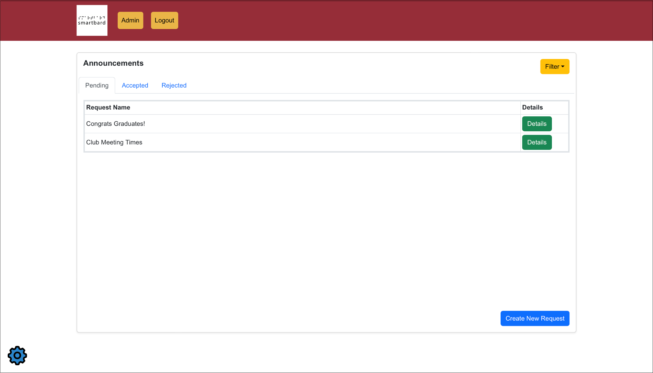

Figure 9. **Admin Request Page**

## R2.6 Admin Request Page Requirements

### R2.6.1 Navigation Bar

**R2.6.1.1** The ***Navigation Bar*** contains the ***SmartBard*** ***Logo***, the ***Admin Button***,and the ***Logout button***.

### R2.6.2 SmartBard Logo

**R2.6.2.1** Clicking the ***SmartBard Logo*** brings the user to the ***Landing Page***.

### R2.6.3 Admin Button

**R2.6.3.1** Clicking the ***Admin Button*** brings the user to the ***Admin Request Page***.

### R2.6.4 Logout Button

**R2.6.4.1** Clicking the ***Logout Button*** brings the user to the ***Login Page***.

### R2.6.5 Settings Button

**R2.6.5.1** Clicking the ***Settings Button*** brings the user to the ***Settings Modal***.

## 2.7 Request Detailed Page

Clicking on the ***Details Button*** on any request in the **Request Table** brings the user to the ***Request Detailed Page***. If the user is a Student, the user will only see the details of their own request and a **Return Button** to navigate back to the ***Request Page***. If the user is an Administrator, the user will see additional buttons to either **Accept**, **Reject**, and **Edit**, in addition to the **Return Button**. Accepting a request moves it to the **Accepted Tab** and is visible in the ***Landing Page*** and rejecting a request moves it to the **Rejected Tab.** Accepted requests have an additional **Make Priority Button** to make a request a **Priority Announcement**. Requests can be edited and returns the request back into the **Pending Tab**.

The top of the page contains the ***Navigation Bar*** with the ***SmartBard*** ***Logo***, the ***Admin Button***,and the ***Logout Button***. The ***Admin Button*** navigates the user to the ***Admin Request Page*** and the ***Logout Button*** logs the current user out of the application and navigates the user back to the ***Login Page***. The ***Settings*** ***Button*** is located in the lower left-hand corner of the page, to navigate to the ***Settings Modal***.

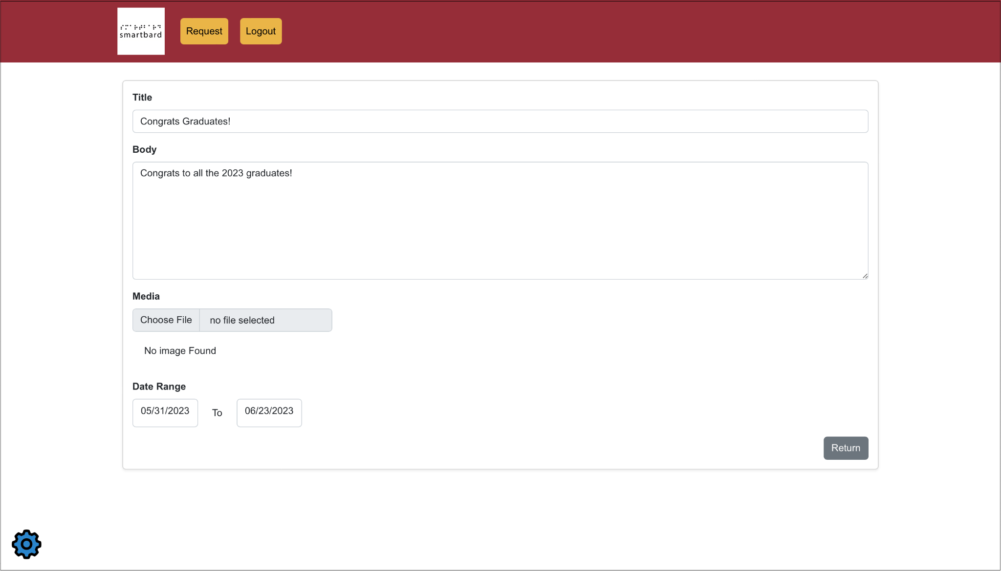

Figure 10. **Student Request Detailed Page**

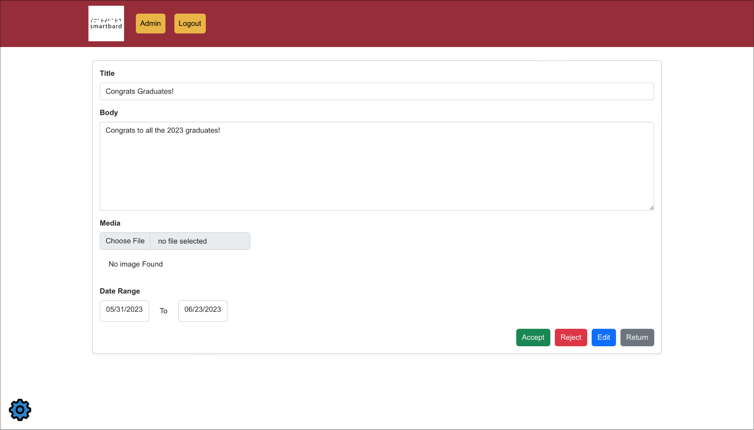

Figure 11. **Admin Request Detailed Page**

## R2.7 Request Detailed Page Requirements

### R2.7.1 Navigation Bar

**R2.7.1.1** The ***Navigation Bar*** contains the ***SmartBard*** ***Logo***, the ***Admin Button***,and the ***Logout button***.

### R2.7.2 SmartBard Logo

**R2.7.2.1** Clicking the ***SmartBard Logo*** brings the user to the ***Landing Page***.

### R2.7.3 Request Button

**R2.7.3.1** Clicking the ***Request Button*** brings the user to the ***Request Page***.

### R2.7.4 Admin Button

**R2.7.4.1** Clicking the ***Admin Button*** brings the user to the ***Admin Request Page***.

### R2.7.5 Logout Button

**R2.7.5.1** Clicking the ***Logout Button*** brings the user to the ***Login Page***.

### R2.7.6 Accept Button

**R2.7.6.1** Clicking the ***Accept Button*** approves the request.

**R2.7.6.2** The newly accepted request is moved from the **Pending Tab** to the **Accepted Tab**.

**R2.7.6.3** The request is now visible on the ***Landing Page***.

### R2.7.7 Reject Button

**R2.7.7.1** Clicking the ***Reject Button*** rejects the request.

**R2.7.7.2** The newly rejected request is moved from the current tab to the **Rejected Tab**.

**R2.7.6.3** The request is removed from the ***Landing Page***if previously accepted.

### R2.7.8 Edit Button

**R2.7.8.1** Clicking the ***Edit Button*** brings the user to the ***Create Request Page*** auto filled with the request data.

**R2.7.8.2** The newly edited request is moved from the current tab back to the **Pending Tab**.

**R2.7.6.3** The request is removed from the ***Landing Page***if previously accepted.

### R2.7.9 Return Button

**R2.7.9.1** Clicking the ***Return Button*** brings the user back to the ***Request Page*** or ***Admin Request Page***.

### R2.7.10 Make Priority Button

**R2.7.10.1** Clicking the ***Make Priority Button*** makes the accepted request a **Priority Announcement**.

**R2.7.10.2** The request is a Priority Announcement in the ***Landing Page***.

**R2.7.10.3** The request is visible using the Priority filter.

### R2.7.11 Settings Button

**R2.7.11.1** Clicking the ***Settings Button*** brings the user to the ***Settings Modal***.

## 2.8 Settings Modal

Clicking on the ***Settings Button*** on any page brings the user to the ***Settings Modal***. The **Settings Modal** contains different components to change the properties of **SmartBard**, such as font size, text color, and theme. The user can click on the respective component dropdown to select a different setting to customize their experience. All selected changes persist throughout the application onto each page. The user can click outside the **Settings Modal** or the ‘**X**’ button at the top right to exit the **Settings Modal**.

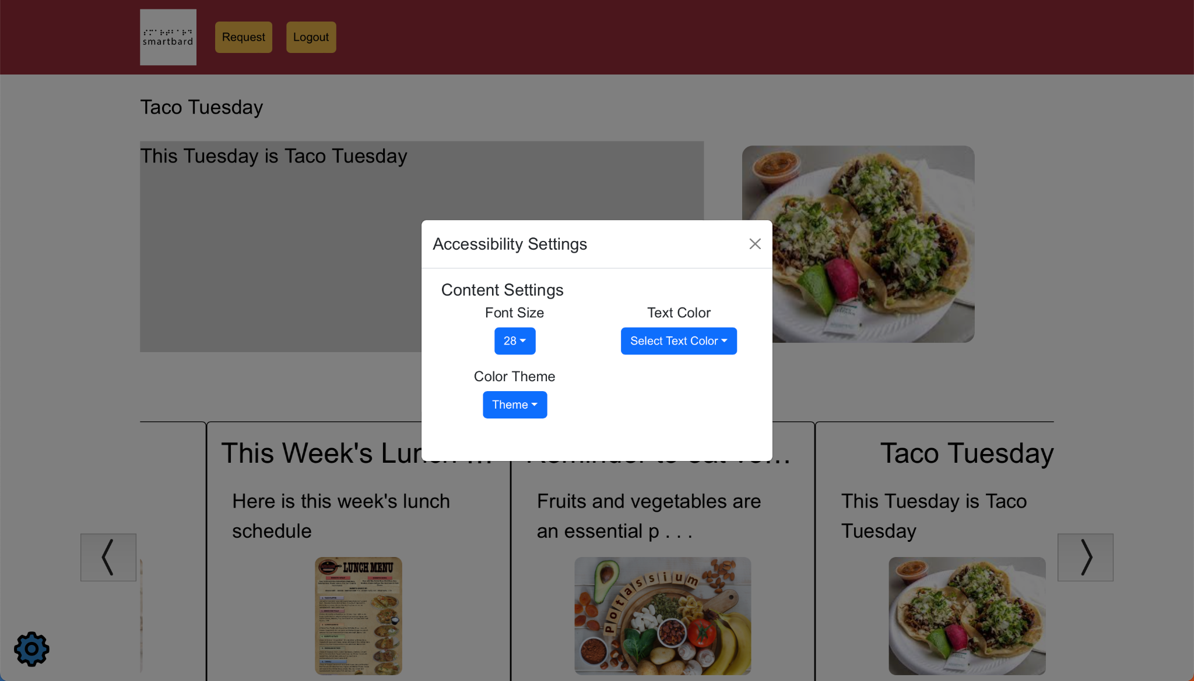

Figure 12. **Settings Modal**

## R2.8 Settings Modal Requirements

### R2.8.1 Font Size Dropdown

**R2.8.1.1** A nonnegative number representing the size of text.

**R2.8.1.2** The default minimum value is 28.

**R2.8.1.3** Font size starts in increments of 2, then it increases up to 72.

**R2.8.1.4** A valid font size is between 12 and 72.

**R2.8.1.5** Font size changes affect title and body description of all text in all announcements.

### R2.8.2 Text Color Dropdown

**R2.8.2.1** A color picker is visible to select a custom color for text.

**R2.8.2.2** Color changes affect the font color of all text in all announcements.

### R2.8.3 Theme Dropdown

**R2.8.3.1** Color theme palettes are button color and then navbar color.

# Other Nonfunctional Requirements

## 3.1 Performance Requirements

### 3.1.1 Response Time

**3.1.1.1** User interaction with the system completes execution in under 1 second.

**3.1.1.2** System response time for all actions to the system completes execution in under 1 second.

### 3.1.2 Software

**3.1.2.1** The server and database supports multiple, concurrent connections.

## 3.2 Software Quality Requirements

### 3.2.1 Availability

**3.2.1.1** Users can access the system during working hours. The system may be offline for maintenance during non-working hours.

### 3.2.2 Usability

**3.2.2.1** The system must handle and react accordingly between page transitions and to changes of the accessibility settings.

### 3.2.3 Scalability

**3.2.3.1** The application handles a peak load of 500 concurrent users and 250 concurrent users during enrollment period.

### 3.2.4 Security

**3.2.4.1** Encrypt and authenticate all communications from client to database.

# System Evolution

The initial scope of SmartBard depends on a set of requirements that meet the bare minimum of what those visually impaired at OBS require of a website that serves as a bulletin board. First, the font size must be adjustable according to the user’s needs. Second, the post’s contents must have a text-to-speech component that allows the text to be read aloud. Lastly, the site’s default colors must abide well to the majority of the visually impaired, but also present the option to change the color palette to a different preset palette if the user so desires to. As SmartBard evolves, more accessibility features will be added along with a touchscreen variant.

## 4.1 New Accessibility Features

With more time, more accessibility features would be introduced. Existing features would also evolve into more detailed versions that give the users more control over how to view the application.

**4.1.1** Custom color palettes: The user manually customizes their choice of colors instead of only choosing between a given set of palettes.

**4.1.2** Custom text: The user changes the font size of both the title and body text individually.

**4.1.2** Keyboard Navigation: The site is navigated purely through the usage of a keyboard, with the currently selected options highlighted with a brighter color for better viewing.

**4.1.3** Screen Reader: A tool which allows blind users to have the entire screen be read out as speech or braille.

**4.1.4** Adjust Line Height: Increases or decreases the spacing between lines.

**4.1.5** Adjust Letter Spacing: Increases or decreases the spacing between individual letters.

**4.1.6** Text Alignment: Gives the user the option to set how the general text is aligned. The user chooses between left, center, or right alignment.

**4.1.7** Highlightable Titles and Images: If the user wishes to only see the titles or images, there is the option to have only the titles and images be highlighted.

**4.1.8** Magnifier Cursor: The user hovers over a given set of text to greatly zoom in on the text.

**4.1.9** Hide Images: Gives the user the option to hide all images on the application.

## 4.2 Touch Screen Component

A larger, touch compatible monitor that is implemented within Overbrook School for the Blind. Additional implementation is required upon successful installation of this device within the school. However, it would eliminate the general clutter that a modern browser brings, and displays only the carousel of posts. It brings with it the option to physically interact with the posts, giving it a similar feeling to a physical bulletin board, while also having the general size of everything being substantially larger than what any computer screen could offer.