**Final Project Report On**

**RIGHT ROUTE**

**Submitted To**

**UNIVERSITY OF MUMBAI**

**For**

**PARTIAL/FULFILMENT OF**

**B.Sc. IN COMPUTER SCIENCE**

**BY**

**Mr. RAJAM SHREYASH UTTAM**

**Project Guide**

**Prof. Yogita Kandalgoankar**

**Through**

**S.H.KELKAR COLLEGE, DEVGAD**

**2020-2021**

**INDEX**

|  |  |  |  |
| --- | --- | --- | --- |
|  |  | **Preliminary Investigation** | **Page No.** |
|  | 1. 1 | Introduction |  |
|  |  | Description of Present System |  |
|  |  | Hardware Software Requirements |  |
|  |  | Website Technical Details |  |
|  |  | Advantages of Proposed System |  |
|  |  | Stakeholder |  |
|  |  | Gantt Chart |  |
|  |  | **System Analysis** |  |
|  |  | Use Case Diagram |  |
|  |  | ERD |  |
|  |  | Activity Diagram |  |
|  |  | Sequence Diagram |  |
|  |  | Class Diagram |  |
|  |  | **System Design** |  |
|  |  | Design Class Diagram |  |
|  |  | **System Coding** |  |
|  |  | List of tables with attribute and constraints |  |
|  |  | System Validation |  |
|  |  | System Layouts & Report Layouts |  |
|  |  | Program Listing |  |
|  |  | **Reference & Bibliography** |  |

**Acknowledgement**

It is my prime duty to offer my sincere gratitude to the University of Mumbai to include the project work in the syllabus of the Third Year Bachelor’s Degree to develop interest in research work among the students like us.

I wish to express my sincere thanks to Prof. Suraj , Head of the Department of Computer Science for allowing me to complete the project work by providing facilities in the department and providing valuable guidance to complete the task.

I am greatly obliged to Prof. Yogita Kandalgoankar Lecturer in the Department of Computer Science who provided valuable guidelines and conceptual guidance throughout the project work also helped out in clearing about the Project.

I am also grateful to Principal Dr. Principal of S.H.Kelkar college, Devagd for providing all necessary facilities of laboratory and library at S.H.Kelkar college, Devgad.

Last but not the least my special thanks to my parents, my friends and all those people who have encouraged me, helped me to complete this course successfully in time.

**INTRODUCTION**

This is to show **Right Route** to patient in Emergency conditions to help them & show Right Route towards their cure, avoiding all false positives that is wrong nurturing given by locals and Relatives. There by making right Decisions in less time.

**PRILIMINARY**

**INVESTIGATION**

**Description of Present System**

**In the current system, when an accident or medical emergency had done there is a lot of tension and fear in the patient and their relatives. So they didn't get the correct decision. And also their relatives with incorrect information give the wrong direction to the patient.**

**Present System**

* **Waste of money**
* **Waste of time**
* **Living loss**
* **No information about government facilites.**

**Limitation of Present Systems**

* **The patient doesn't get the right information on time.**
* **Wastage of money**
* **Waste of time**
* **Living loss**
* **No information about government facilities.**

**Hardware and Software Requirements**

* **Hardware :-**
* It is website so run on any device
* **Software :-**
* Any web browser
* **Languages :-**
  + - * Html as a Front End
      * Php and Sql as Back End

**Project Technical Details**

* **Name of the Project :-**
  + **Right Route**
* **Designer of the Project :-**
  + **Rajam Shreyash Uttam**
* **Languages :-**
* **SQL as Database**
* **Html, JavaScript as front End**
* **Php as backend**

**Advantage of Proposed System**

* **The patient gets the right information at the right time.**
* **Patient save money**
* **Save the life of the Patient don't go in a dangerous situation.**
* **Get information on government facilities.**

**Stakeholders**

**Hospital: Add information related to the hospital that helps the patient to get the right path.**

**Doctors : The Doctors add their qualification and specialty, give answers to question and get the bounty**

**Patient : The patient task to add their reports and get the right path of their health journey**

**Gantt Chart**

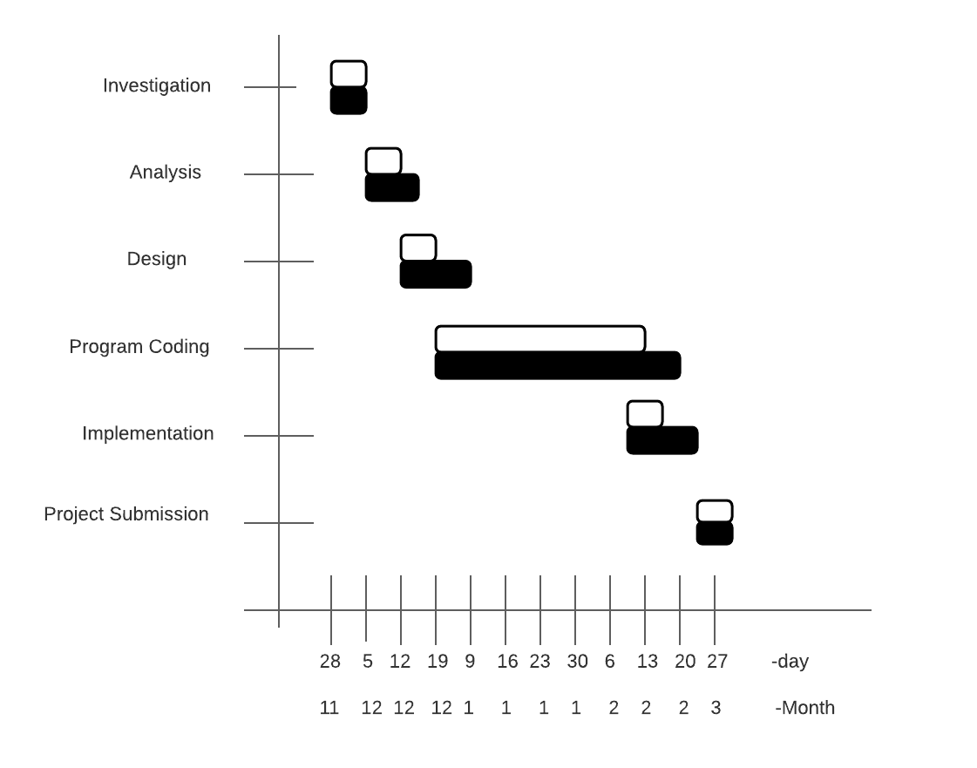

**SYSTEM**

**ANALYSIS**

**Use-Case Diagram**

* **For Patient Right Path**

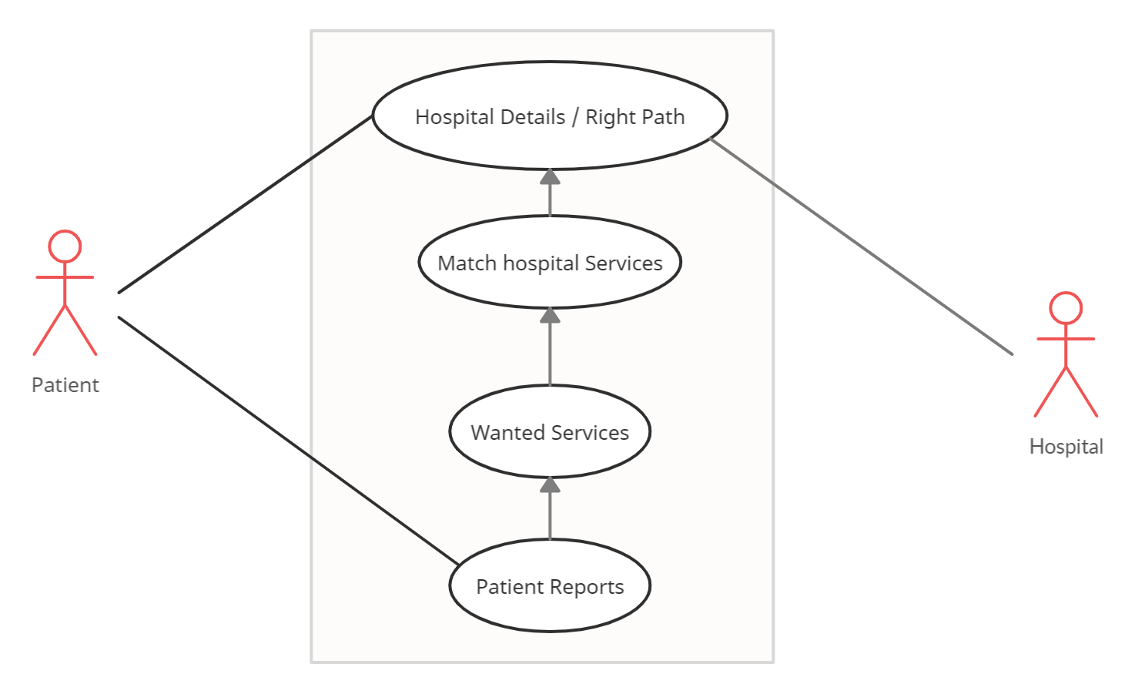

**ERD (Entity Relationship Diagram)**

**Doctor**

**Hospital**

**Patient**

**Blog**

**Right Route**

**Questions**

**Doctor Database**

**Blog & QNA**

**Hospital Database**

**Patient Database**

**Info & services**

**Info & specialization**

**Symptoms & repots**

**Activity Diagram**

**Activity for Hospital or Right Route**

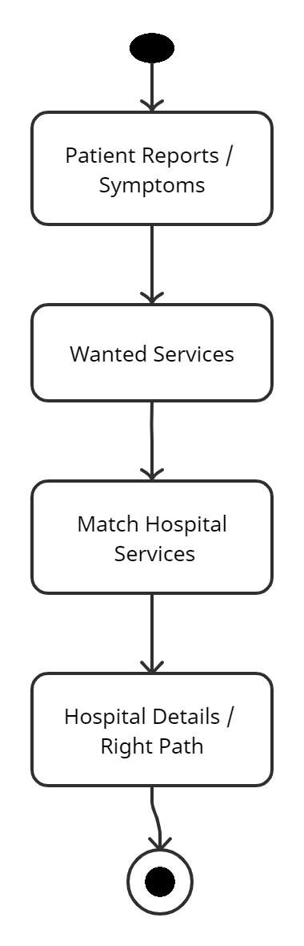

**Sequence Diagram**

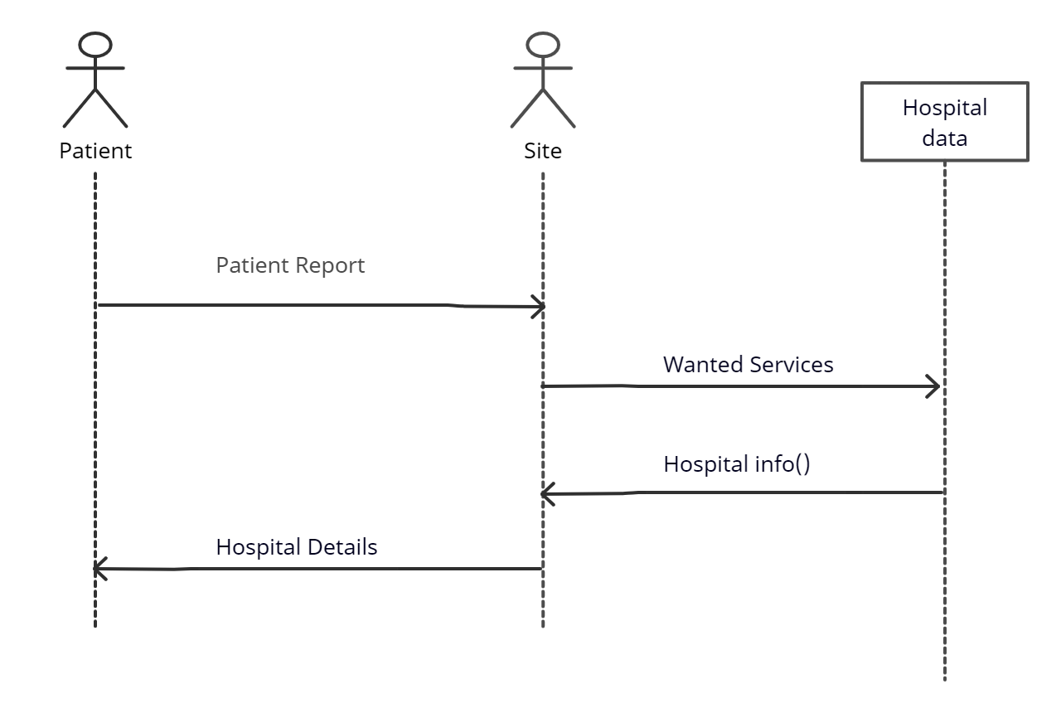

**Class Diagram**

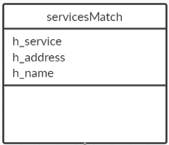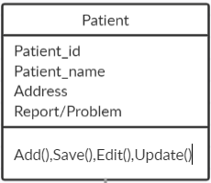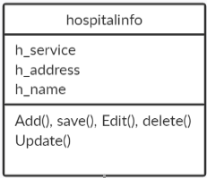

**Design Class Diagram**

**Design class for Patient :-**

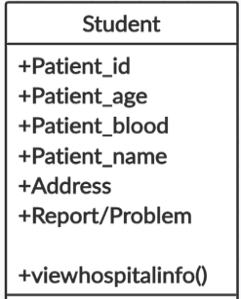

**Design Class for Hospital:-**

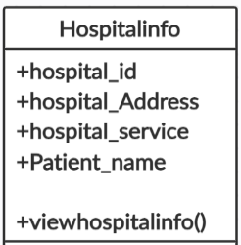

**List of table with Attribute**

**Patient Registration:-**

|  |  |
| --- | --- |
| **Field Name** | **Data Type** |
| P_id | Int(11) auto increment |
| P_name | Varchar(30) |
| P_address | Varchar(30) |
| P_age | Int(11) |
| P_blood | Varchar(30) |
| P_problem | Varchar(30) |
| P_report | Blob |
| Dateofenter | Datetime |
| O_problem | Varchar(30) |
| P_password | Varchar(255) |
| P_username | Varchar(50) Primary |

**Hospital Registration:**

|  |  |
| --- | --- |
| **Field Name** | **Data Type** |
| H_no | Int(11) auto increment |
| H_service | Varchar(50) |
| H_address | Varchar(30) |
| H_name | Varchar(30) |
| H_username | Varchar(30) |
| H_Password | Varchar(255 |

**System Validation**

**Class Name: Patient Registration Information**

|  |  |
| --- | --- |
| **Field To Validate** | **Validation** |
| Patient Name | Not empty. No numbers are allowed |
| Patient Age | Not empty. No characters are allowed |
| Patient Problem | Not empty. |
| Patient Username | Unique only |
| Patient Password | Min 6 max 22 Include 1 special character, 1 Uppercase, 1 lowercase, 1 number |

**Class name: Hospital Registration Information**

|  |  |
| --- | --- |
| **Field To Validate** | **Validation** |
| Hospital name | Not empty |
| Hospital username | Unique only |
| Hospital password | Min 6 max 22 Include 1 special character, 1 Uppercase, 1 lowercase, 1 number |
| Hospital address | Not empty |
| Hospital Service | Not empty |

**Forms Layout And Repots Layout**

**Index**

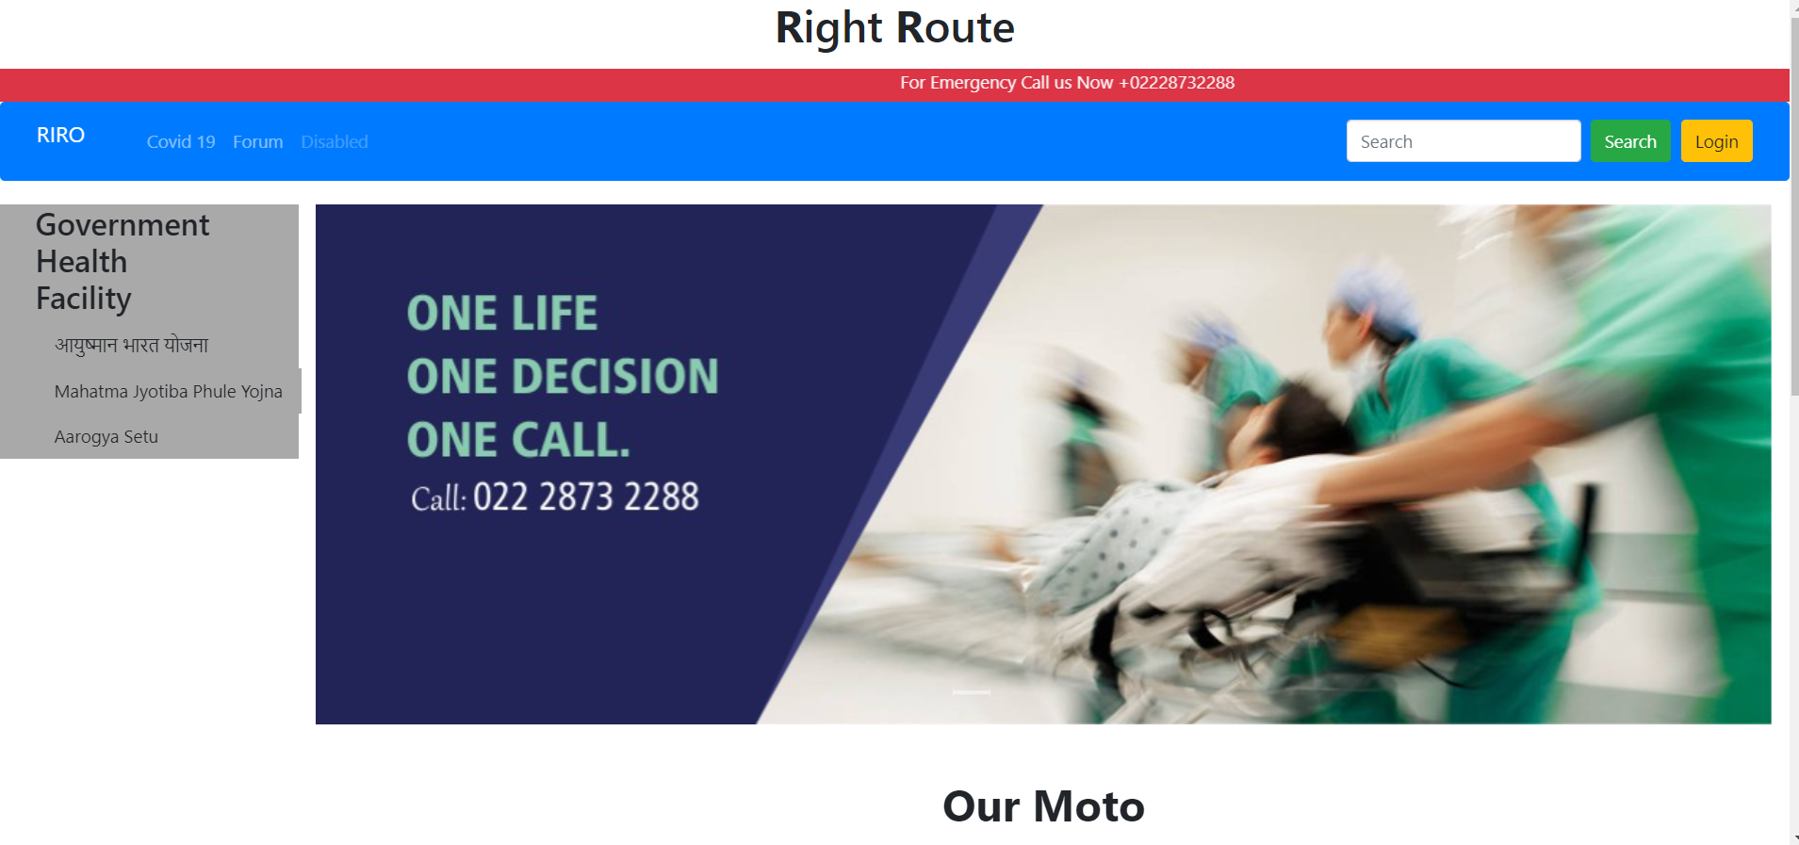 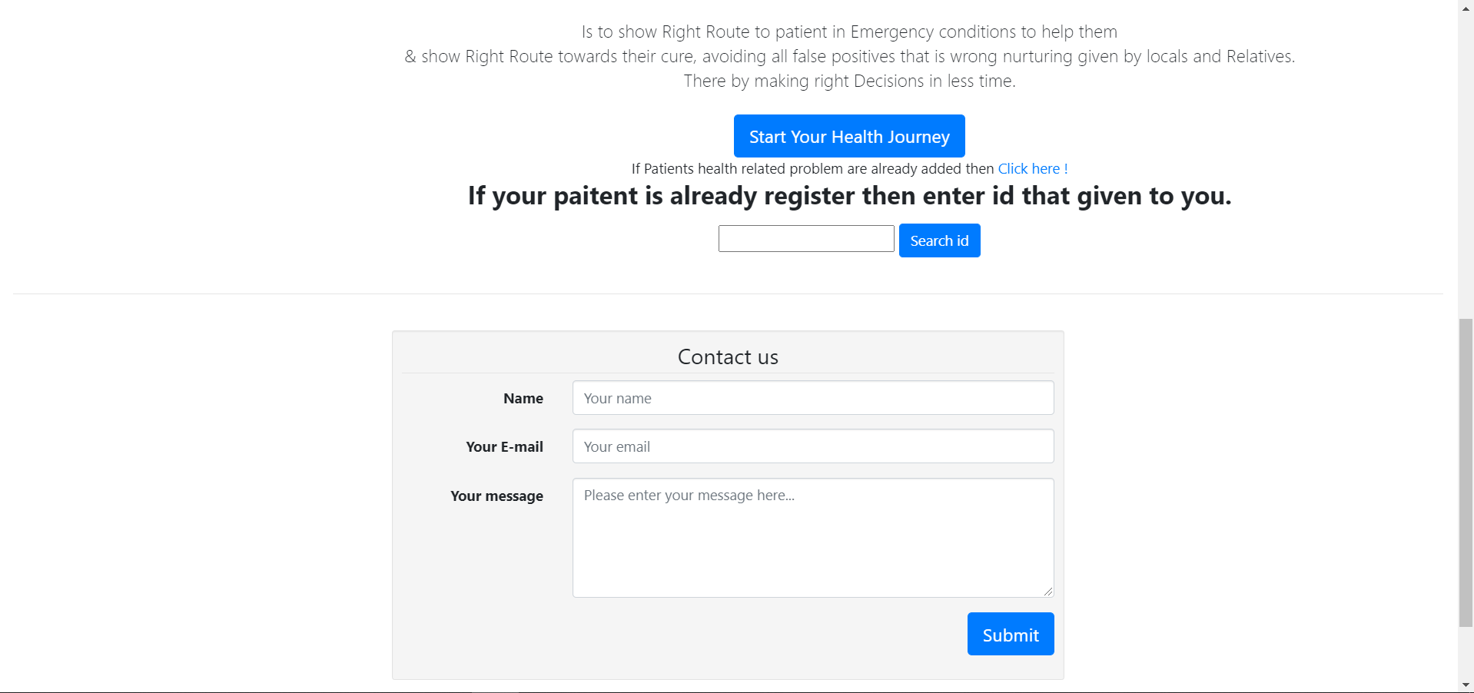 

**User Identification Form:**

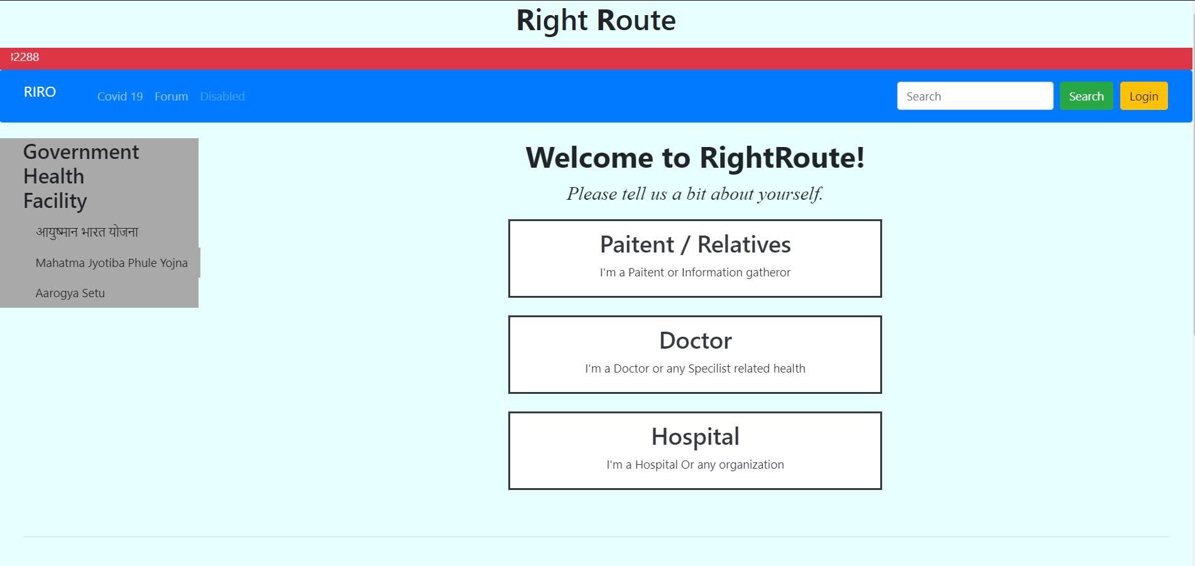

**Patient Registration Form:**

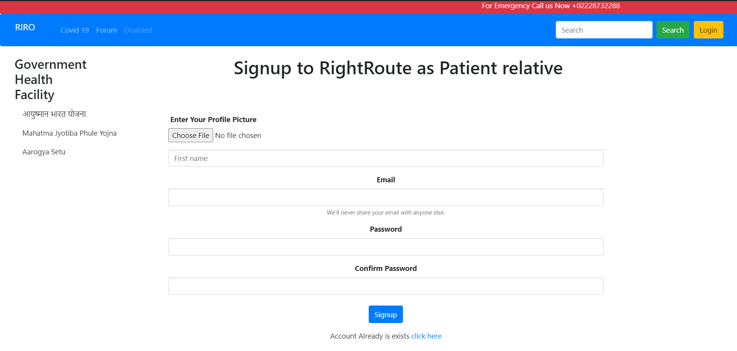

**Hospital Registration form:**

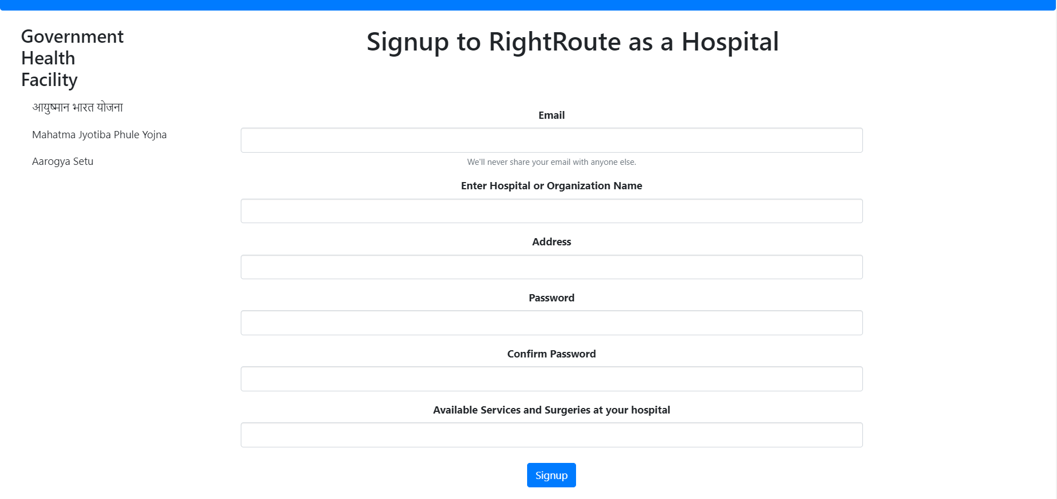

**Login Form:**

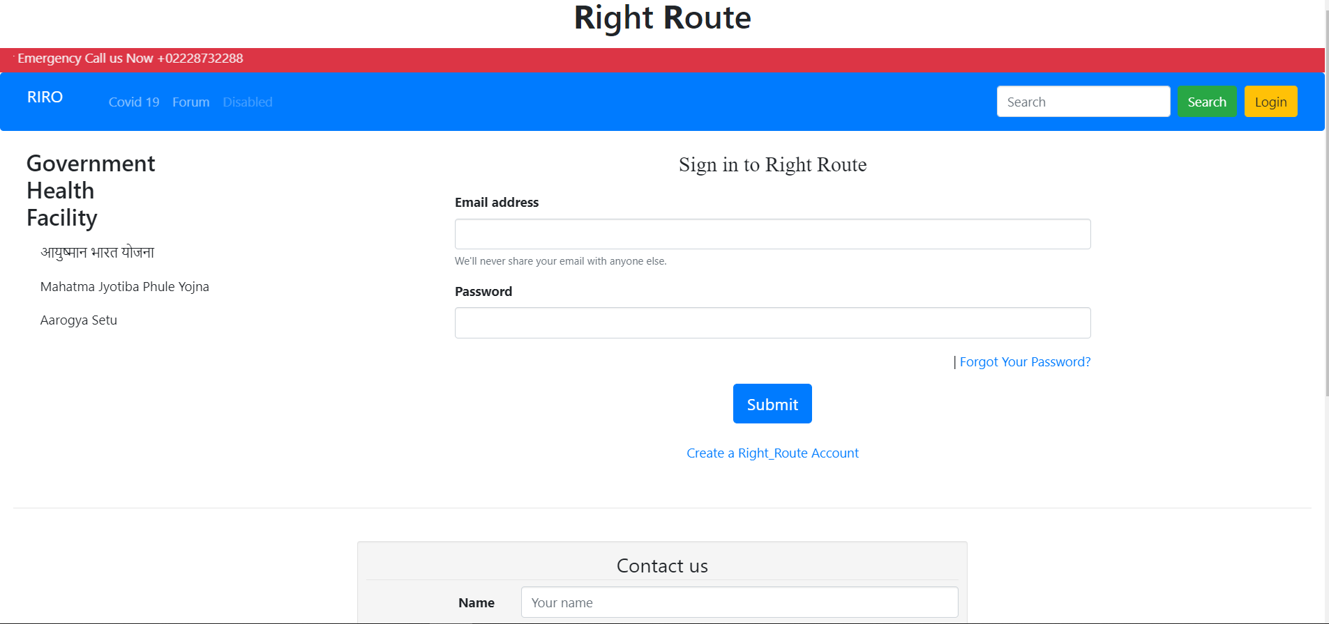

**Right Route Details:**

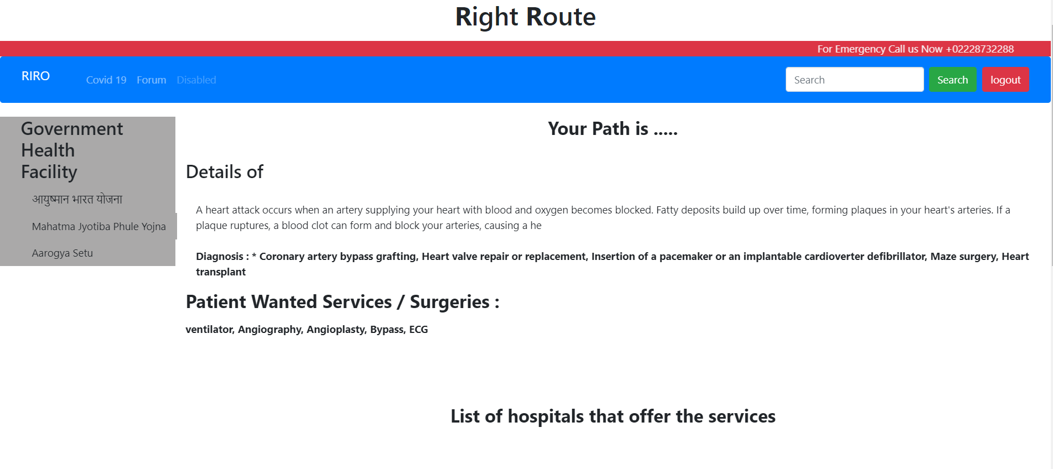 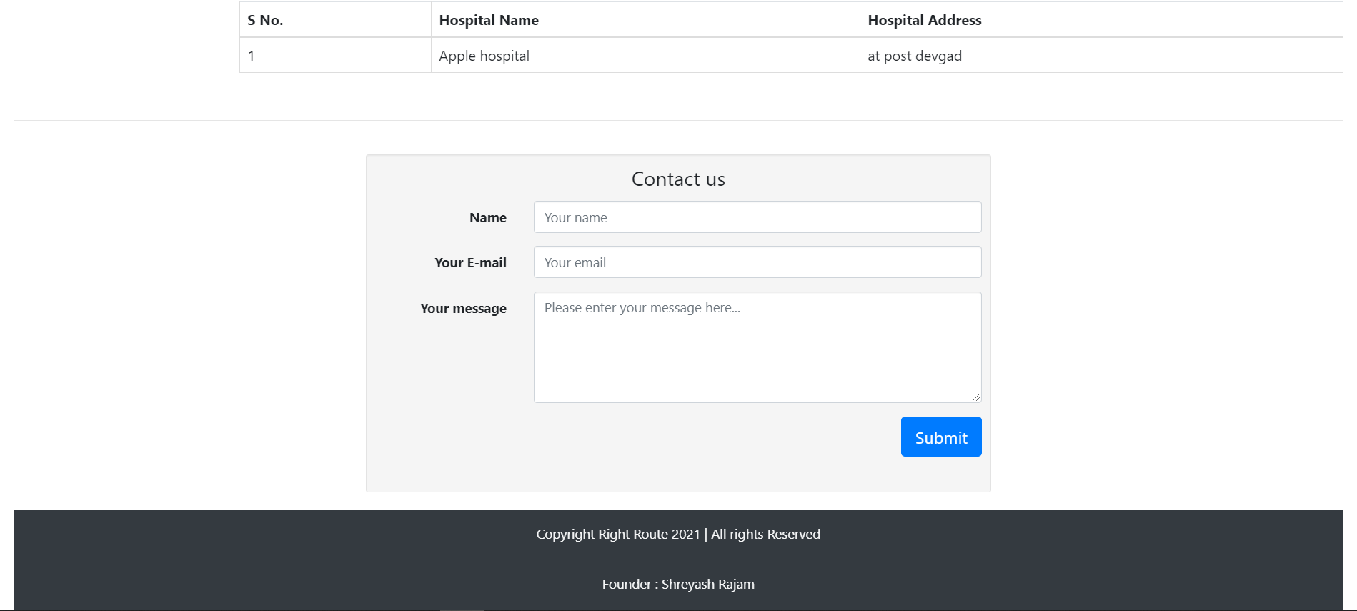

**RiRo Forums:**

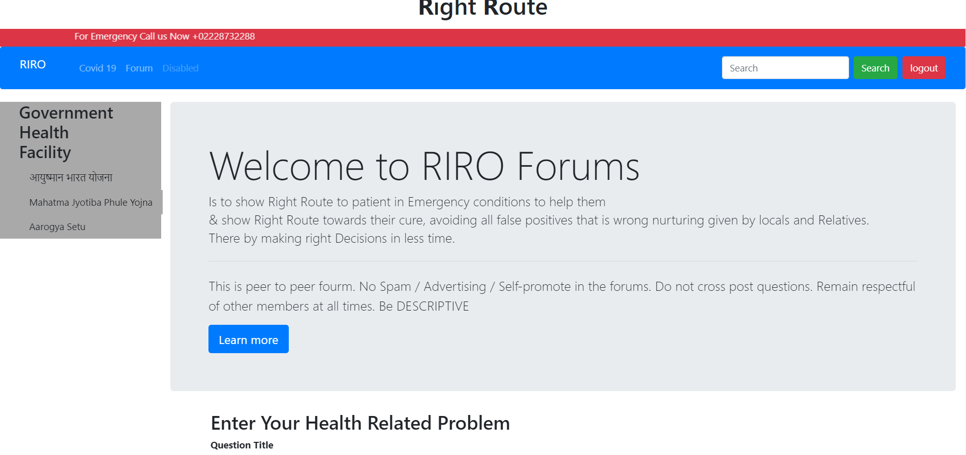 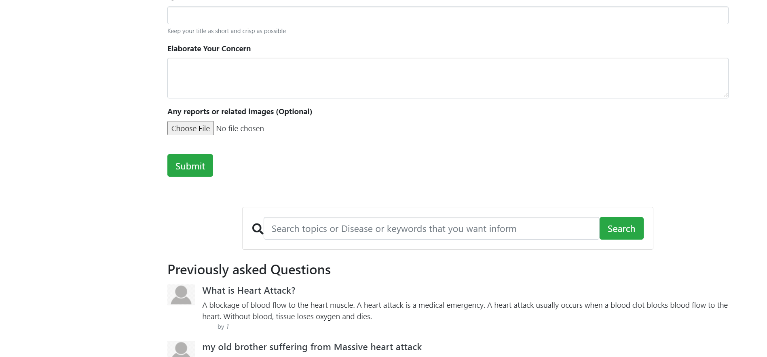

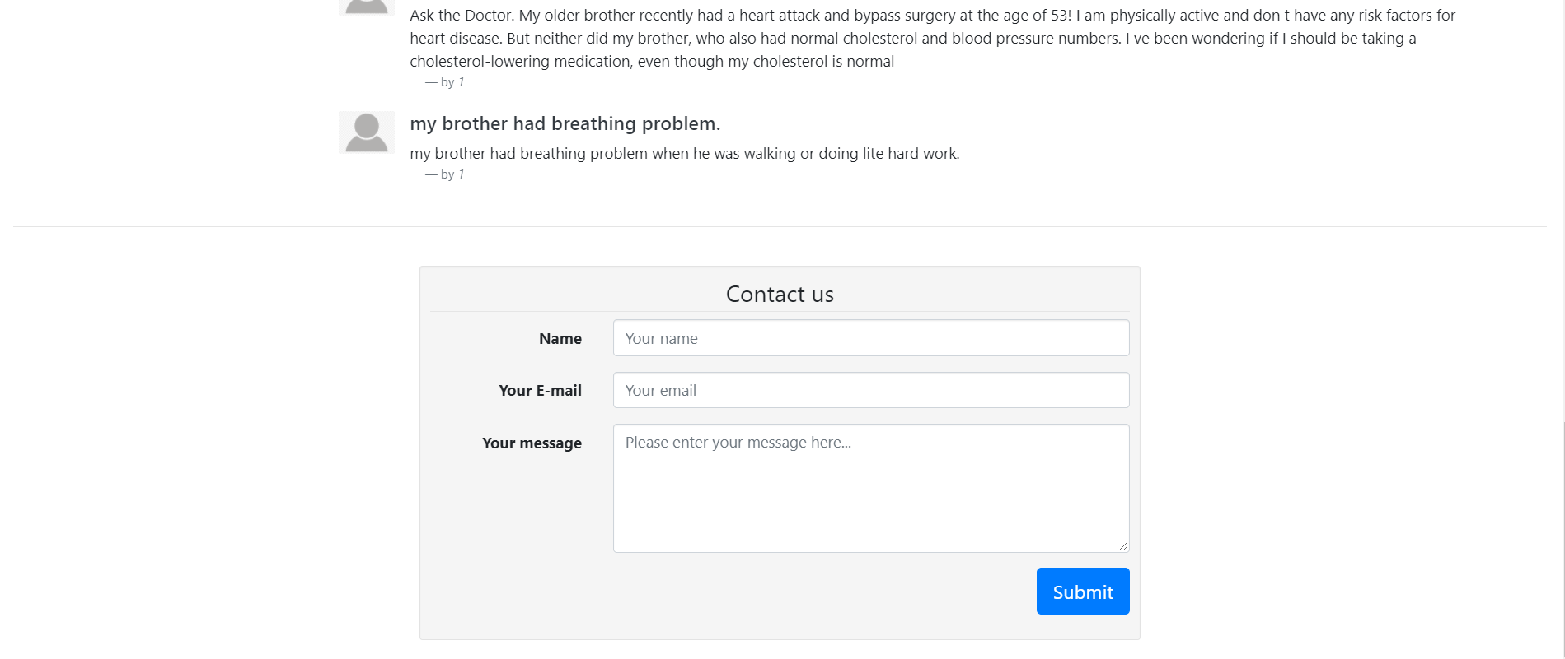

**Source Code**

Index.php

<?php

session_start();

if ($_SERVER["REQUEST_METHOD"] == "POST") {

  $accessid = $_POST["accessid"];

  header("location: https://localhost/startup/journeydetails.php?aid=$accessid");

}

?>

<!DOCTYPE html>

<html lang="en">

<head>

  <title>Right Route</title>

  <meta charset="utf-8">

  <meta name="viewport" content="width=device-width, initial-scale=1">

  <link rel="stylesheet" href="https://maxcdn.bootstrapcdn.com/bootstrap/3.4.1/css/bootstrap.min.css">

  <script src="https://ajax.googleapis.com/ajax/libs/jquery/3.5.1/jquery.min.js"></script>

  <script src="https://maxcdn.bootstrapcdn.com/bootstrap/3.4.1/js/bootstrap.min.js"></script>

  <link rel="stylesheet" href="partials/_startup.css">

  <!-- Required meta tags -->

  <meta charset="utf-8">

  <meta name="viewport" content="width=device-width, initial-scale=1, shrink-to-fit=no">

  <meta name="viewport" content="width=device-width, initial-scale=1">

  <link rel="stylesheet" href="https://www.w3schools.com/w3css/4/w3.css">

  <link rel="stylesheet" href="https://cdn.jsdelivr.net/npm/bootstrap@4.5.3/dist/css/bootstrap.min.css" integrity="sha384-TX8t27EcRE3e/ihU7zmQxVncDAy5uIKz4rEkgIXeMed4M0jlfIDPvg6uqKI2xXr2" crossorigin="anonymous">

</head>

<body>

  <?php require "partials/_header.php";

  //$mode=$_SESSION['mode'];

  //echo $mode;?>

  <?php require "partials/_nav.php"; ?>

  <div class="container-fluid">

    <div class="row">

      <div class="col-sm-2 sidenav">

        <?php require "partials/_sidebar.php"; ?>

      </div>

      <div class="col-sm-10">

        <div id="carouselExampleIndicators" class="carousel slide" data-ride="carousel">

          <ol class="carousel-indicators">

            <li data-target="#carouselExampleIndicators" data-slide-to="0" class="active"></li>

          </ol>

          <div class="carousel-inner">

            <div class="carousel-item active">

              <img src="partials/images/call.jpg" class="d-block w-100" alt="...">

            </div>

          </div>

        </div><br><br>

        <center>

          <h1 class="mb-4"><b>Our Moto</b></h1>

          <p class="lead mb-4">Is to show Right Route to patient in Emergency conditions to help them<br> & show Right Route towards their cure, avoiding all false positives that is wrong nurturing given by locals and Relatives.<br>There by making right Decisions in less time.</p>

        <a href="http://localhost/startup/journey.php"><button type="button" class="btn btn-primary btn-lg">Start Your Health Journey</button></a><br>

        If Patients health related problem are already added then

        <a href="http://localhost/startup/journeydetails.php">Click here !</a>

        <form method="POST" action="/startup/index.php">

        <h3 class="mb-3"><b>If your paitent is already register then enter id that given to you.</b></h3>

        <input type="text"  id="accessid" name="accessid">

         <button type="submit" class="btn btn-primary">Search id</button>

        </form>

        </center>

      </div>

    </div>

  </div>

  <div class="container-fluid">

    <?php require "partials/_footer.php"; ?>

  </div>

</body>

</html>

CreateUser.php as patient

<?php

$showAlert = false;

$showError = false;

if ($_SERVER["REQUEST_METHOD"] == "POST") {

    include '../partials/_dbconnect.php';

    $firstname = $_POST["fname"];

    $username = $_POST["username"];

    $password = md5($_POST["password"]);

    $cpassword = md5($_POST["cpassword"]);

    $pic = $_POST["pic"];

    // check whather username or mobile no exist;

    $exists = false;

    $existSql = "SELECT * FROM `patient` WHERE u_username = '$username'";

    $result = mysqli_query($conn, $existSql);

    $numExistRows = mysqli_num_rows($result);

    if ($numExistRows > 0) {

        $exists = true;

        $showError = " Username already Exist. Try another one!!";

    } else {

        $exists = false;

        if (($password == $cpassword) && $exists == false) {

            $sql= "INSERT INTO `patient`(`u_fname`, `u_username`, `u_password`, `u_pic`, `dateofenter`) VALUES ('$firstname', '$username', '$password', '$pic', current_timestamp())";

            //$sql = "INSERT INTO `patient`(`u_fname`, `u_username`, `u_relation`, `p_name`, `p_address`, `p_age`, `p_blood`, `p_problem`, `p_report`, `dateofenter`, `o_problem`, `u_password`, `u_pic`) VALUES ('$firstname', '$username', '$password', '$pic', current_timestamp())";

            $result = mysqli_query($conn, $sql);

            if ($result) {

                $showAlert = true;

                header("location: ../journey.php");

            } else {

                echo "Something went's wrong";

            }

        } else {

            $showError = "Password do not match";

        }

    }

}

?>

<!DOCTYPE html>

<html lang="en">

<head>

    <title>Right Route</title>

    <meta charset="utf-8">

    <meta name="viewport" content="width=device-width, initial-scale=1">

    <link rel="stylesheet" href="https://maxcdn.bootstrapcdn.com/bootstrap/3.4.1/css/bootstrap.min.css">

    <script src="https://ajax.googleapis.com/ajax/libs/jquery/3.5.1/jquery.min.js"></script>

    <script src="https://maxcdn.bootstrapcdn.com/bootstrap/3.4.1/js/bootstrap.min.js"></script>

    <link rel="stylesheet" href="partials/_startup.css">

    <!-- Required meta tags -->

    <meta charset="utf-8">

    <meta name="viewport" content="width=device-width, initial-scale=1, shrink-to-fit=no">

    <meta name="viewport" content="width=device-width, initial-scale=1">

    <link rel="stylesheet" href="https://www.w3schools.com/w3css/4/w3.css">

    <link rel="stylesheet" href="https://cdn.jsdelivr.net/npm/bootstrap@4.5.3/dist/css/bootstrap.min.css" integrity="sha384-TX8t27EcRE3e/ihU7zmQxVncDAy5uIKz4rEkgIXeMed4M0jlfIDPvg6uqKI2xXr2" crossorigin="anonymous">

</head>

<body>

    <?php require "../partials/_header.php";

    if ($showAlert) {

        echo '<div class="alert alert-warning alert-success" role="alert">

    <strong>Success</strong> your account is created successfully!!!!

    <button type="button" class="close" data-dismiss="alert" aria-label="Close">

      <span aria-hidden="true">&times;</span>

    </button>

    </div>';

    }

    if ($showError) {

        echo '<div class="alert alert-warning alert-danger" role="alert">

      <strong>Error!</strong>' . $showError . '

      <button type="button" class="close" data-dismiss="alert" aria-label="Close">

      <span aria-hidden="true">&times;</span>

      </button>

      </div>';

    }

    ?>

    <?php require "../partials/_nav.php"; ?>

    <div class="container-fluid">

        <div class="row">

            <div class="col-sm-2 sidenav">

                <?php require "../partials/_sidebar.php"; ?>

            </div>

            <div class="col-sm-10">

                <!--<div class ="container col-sm-8">-->

                <center>

                    <h1>Signup to RightRoute as Patient relative &nbsp;&nbsp;&nbsp;&nbsp;&nbsp;&nbsp;&nbsp;&nbsp;&nbsp;&nbsp;&nbsp;&nbsp; </h1>

                    <br>

                    <br>

                    <br>

                    <div class="container">

                        <form action="http://localhost/startup/user/createUser.php" method="post">

                            <div class="form-group col-md-3">

                                <label for="exampleFormControlFile1">Enter Your Profile Picture &nbsp;&nbsp;&nbsp;&nbsp;&nbsp;&nbsp;&nbsp;&nbsp;&nbsp;&nbsp;&nbsp;&nbsp;&nbsp;&nbsp;</label>

                                <input type="file" class="form-control-file" id="pic" name="pic">

                            </div>

                            <div class="form-group col-md-10">

                                <div class="row">

                                    <div class="col">

                                        <input type="text" class="form-control" placeholder="First name" name="fname">

                                    </div>

                                </div>

                            </div>

                            <div class="form-group col-md-10">

                                <label for="username">Email</label>

                                <input type="email" class="form-control" id="username" name="username" aria-describedby="emailHelp">

                                <small id="emailHelp" class="form-text text-muted">We'll never share your email with anyone else.</small>

                            </div>

                            <div class="form-group col-md-10">

                                <label for="password">Password</label>

                                <input type="password" class="form-control" id="password" name="password">

                            </div>

                            <div class="form-group col-md-10">

                                <label for="cpassword">Confirm Password</label>

                                <input type="password" class="form-control" id="cpassword" name="cpassword">

                                <br>

                                <button type="submit" class="btn btn-primary">Signup</button></div>

                            <input type="hidden" id="usermode" name="usermode" value="user">

                            <div class="form-group col-md-10">

                                <p>Account Already is exists <a href="http://localhost/startup/loginSystem/login.php">click here</a></p>

                            </div>

                        </form>

                    </div>

                </center>

            </div>

        </div>

    </div>

    <div class="container-fluid">

        <?php require "../partials/_footer.php"; ?>

    </div>

</body>

</html>

Login.php

<?php

$showAlert = false;

$showError = false;

if ($_SERVER["REQUEST_METHOD"] == "POST") {

    include '../partials/_dbconnect.php';

    $firstname = $_POST["fname"];

    $username = $_POST["username"];

    $password = md5($_POST["password"]);

    $cpassword = md5($_POST["cpassword"]);

    $pic = $_POST["pic"];

    // check whather username or mobile no exist;

    $exists = false;

    $existSql = "SELECT * FROM `patient` WHERE u_username = '$username'";

    $result = mysqli_query($conn, $existSql);

    $numExistRows = mysqli_num_rows($result);

    if ($numExistRows > 0) {

        $exists = true;

        $showError = " Username already Exist. Try another one!!";

    } else {

        $exists = false;

        if (($password == $cpassword) && $exists == false) {

            $sql= "INSERT INTO `patient`(`u_fname`, `u_username`, `u_password`, `u_pic`, `dateofenter`) VALUES ('$firstname', '$username', '$password', '$pic', current_timestamp())";

            $result = mysqli_query($conn, $sql);

            if ($result) {

                $showAlert = true;

                header("location: ../journey.php");

            } else {

                echo "Something went's wrong";

            }

        } else {

            $showError = "Password do not match";

        }

    }

}

?>

<!DOCTYPE html>

<html lang="en">

<head>

    <title>Right Route</title>

    <meta charset="utf-8">

    <meta name="viewport" content="width=device-width, initial-scale=1">

    <link rel="stylesheet" href="https://maxcdn.bootstrapcdn.com/bootstrap/3.4.1/css/bootstrap.min.css">

    <script src="https://ajax.googleapis.com/ajax/libs/jquery/3.5.1/jquery.min.js"></script>

    <script src="https://maxcdn.bootstrapcdn.com/bootstrap/3.4.1/js/bootstrap.min.js"></script>

    <link rel="stylesheet" href="partials/_startup.css">

    <!-- Required meta tags -->

    <meta charset="utf-8">

    <meta name="viewport" content="width=device-width, initial-scale=1, shrink-to-fit=no">

    <meta name="viewport" content="width=device-width, initial-scale=1">

    <link rel="stylesheet" href="https://www.w3schools.com/w3css/4/w3.css">

    <link rel="stylesheet" href="https://cdn.jsdelivr.net/npm/bootstrap@4.5.3/dist/css/bootstrap.min.css" integrity="sha384-TX8t27EcRE3e/ihU7zmQxVncDAy5uIKz4rEkgIXeMed4M0jlfIDPvg6uqKI2xXr2" crossorigin="anonymous">

</head>

<body>

    <?php require "../partials/_header.php";

    if ($showAlert) {

        echo '<div class="alert alert-warning alert-success" role="alert">

    <strong>Success</strong> your account is created successfully!!!!

    <button type="button" class="close" data-dismiss="alert" aria-label="Close">

      <span aria-hidden="true">&times;</span>

    </button>

    </div>';

    }

    if ($showError) {

        echo '<div class="alert alert-warning alert-danger" role="alert">

      <strong>Error!</strong>' . $showError . '

      <button type="button" class="close" data-dismiss="alert" aria-label="Close">

      <span aria-hidden="true">&times;</span>

      </button>

      </div>';

    }

    ?>

    <?php require "../partials/_nav.php"; ?>

    <div class="container-fluid">

        <div class="row">

            <div class="col-sm-2 sidenav">

                <?php require "../partials/_sidebar.php"; ?>

            </div>

            <div class="col-sm-10">

                <!--<div class ="container col-sm-8">-->

                <center>

                    <h1>Signup to RightRoute as Patient relative &nbsp;&nbsp;&nbsp;&nbsp;&nbsp;&nbsp;&nbsp;&nbsp;&nbsp;&nbsp;&nbsp;&nbsp; </h1>

                    <br>

                    <br>

                    <br>

                    <div class="container">

                        <form action="http://localhost/startup/user/createUser.php" method="post">

                            <div class="form-group col-md-3">

                                <label for="exampleFormControlFile1">Enter Your Profile Picture &nbsp;&nbsp;&nbsp;&nbsp;&nbsp;&nbsp;&nbsp;&nbsp;&nbsp;&nbsp;&nbsp;&nbsp;&nbsp;&nbsp;</label>

                                <input type="file" class="form-control-file" id="pic" name="pic">

                            </div>

                            <div class="form-group col-md-10">

                                <div class="row">

                                    <div class="col">

                                        <input type="text" class="form-control" placeholder="First name" name="fname">

                                    </div>

                                </div>

                            </div>

                            <div class="form-group col-md-10">

                                <label for="username">Email</label>

                                <input type="email" class="form-control" id="username" name="username" aria-describedby="emailHelp">

                                <small id="emailHelp" class="form-text text-muted">We'll never share your email with anyone else.</small>

                            </div>

                            <div class="form-group col-md-10">

                                <label for="password">Password</label>

                                <input type="password" class="form-control" id="password" name="password">

                            </div>

                            <div class="form-group col-md-10">

                                <label for="cpassword">Confirm Password</label>

                                <input type="password" class="form-control" id="cpassword" name="cpassword">

                                <br>

                                <button type="submit" class="btn btn-primary">Signup</button></div>

                            <input type="hidden" id="usermode" name="usermode" value="user">

                            <div class="form-group col-md-10">

                                <p>Account Already is exists <a href="http://localhost/startup/loginSystem/login.php">click here</a></p>

                            </div>

                        </form>

                    </div>

                </center>

            </div>

        </div>

    </div>

    <div class="container-fluid">

        <?php require "../partials/_footer.php"; ?>

    </div>

</body>

</html>

CreateHospital.php

<?php

$showAlert = false;

$showError = false;

if ($_SERVER["REQUEST_METHOD"] == "POST") {

    include '../partials/_dbconnect.php';

    $name = $_POST["name"];

    $username = $_POST["username"];

    $address = $_POST["address"];

    $password = md5($_POST["password"]);

    $cpassword = md5($_POST["cpassword"]);

    $service = $_POST["service"];

    // check whather username or mobile no exist;

    $exists = false;

    $existSql = "SELECT * FROM `hosptialinfo` WHERE h_username = '$username'";

    $result = mysqli_query($conn, $existSql);

    $numExistRows = mysqli_num_rows($result);

    if ($numExistRows > 0) {

        $exists = true;

        $showError = " Username already Exist. Try another one!!";

    } else {

        $exists = false;

        if (($password == $cpassword) && $exists == false) {

            $sql = "INSERT INTO `hosptialinfo`(`h_service`, `h_address`, `h_name`, `h_username`, `h_password`) VALUES ('$service', '$address', '$name', '$username', '$password')";

            $result = mysqli_query($conn, $sql);

            if ($result) {

                $showAlert = true;

                header("location: hospitalinfo.php");

            } else {

                echo "Something went's wrong";

            }

        } else {

            $showError = "Password do not match";

        }

    }

}

?>

<!DOCTYPE html>

<html lang="en">

<head>

  <title>Right Route</title>

  <meta charset="utf-8">

  <meta name="viewport" content="width=device-width, initial-scale=1">

  <link rel="stylesheet" href="https://maxcdn.bootstrapcdn.com/bootstrap/3.4.1/css/bootstrap.min.css">

  <script src="https://ajax.googleapis.com/ajax/libs/jquery/3.5.1/jquery.min.js"></script>

  <script src="https://maxcdn.bootstrapcdn.com/bootstrap/3.4.1/js/bootstrap.min.js"></script>

  <link rel="stylesheet" href="partials/_startup.css">

  <!-- Required meta tags -->

  <meta charset="utf-8">

  <meta name="viewport" content="width=device-width, initial-scale=1, shrink-to-fit=no">

  <meta name="viewport" content="width=device-width, initial-scale=1">

  <link rel="stylesheet" href="https://www.w3schools.com/w3css/4/w3.css">

  <link rel="stylesheet" href="https://cdn.jsdelivr.net/npm/bootstrap@4.5.3/dist/css/bootstrap.min.css" integrity="sha384-TX8t27EcRE3e/ihU7zmQxVncDAy5uIKz4rEkgIXeMed4M0jlfIDPvg6uqKI2xXr2" crossorigin="anonymous">

</head>

<body>

  <?php require "../partials/_header.php";

  if ($showAlert) {

    echo '<div class="alert alert-warning alert-success" role="alert">

<strong>Success</strong> your account is created successfully!!!!

<button type="button" class="close" data-dismiss="alert" aria-label="Close">

  <span aria-hidden="true">&times;</span>

</button>

</div>';

}

if ($showError) {

    echo '<div class="alert alert-warning alert-danger" role="alert">

  <strong>Error!</strong>' . $showError . '

  <button type="button" class="close" data-dismiss="alert" aria-label="Close">

  <span aria-hidden="true">&times;</span>

  </button>

  </div>';

}?>

  <?php require "../partials/_nav.php"; ?>

  <div class="container-fluid">

    <div class="row">

      <div class="col-sm-2 sidenav">

        <?php require "../partials/_sidebar.php"; ?>

      </div>

      <div class="col-sm-10">

      <center>

                    <h1>Signup to RightRoute as a Hospital&nbsp;&nbsp;&nbsp;&nbsp;&nbsp;&nbsp;&nbsp;&nbsp;&nbsp;&nbsp;&nbsp;&nbsp; </h1>

                    <br>

                    <br>

                    <br>

                    <div class="container">

                        <form action="http://localhost/startup/hospital/createhospital.php" method="post">

                            <div class="form-group col-md-10">

                                <label for="username">Email</label>

                                <input type="email" class="form-control" id="username" name="username" aria-describedby="emailHelp">

                                <small id="emailHelp" class="form-text text-muted">We'll never share your email with anyone else.</small>

                            </div>

                            <div class="form-group col-md-10">

                                <label for="company">Enter Hospital or Organization Name</label>

                                <input type="text" class="form-control" id="name" name="name">

                            </div>

                            <div class="form-group col-md-10">

                                <label for="address">Address</label>

                                <input type="text" class="form-control" id="address" name="address">

                            </div>

                            <div class="form-group col-md-10">

                                <label for="password">Password</label>

                                <input type="password" class="form-control" id="password" name="password">

                            </div>

                            <div class="form-group col-md-10">

                                <label for="cpassword">Confirm Password</label>

                                <input type="password" class="form-control" id="cpassword" name="cpassword">

                            </div>

                            <div class="form-group col-md-10">

                                <label for="address">Available Services and Surgeries at your hospital</label>

                                <input type="text" class="form-control" id="service" name="service">

                            <br>

                                <button type="submit" class="btn btn-primary">Signup</button>

                            </div>

                            <div class="form-group col-md-10">

                                <p>Account Already is exists <a href="http://localhost/startup/hospital/hospitalLogin.php">click here</a></p>

                            </div>

                        </form>

                    </div>

                </center>

      </div>

    </div>

  </div>

  <div class="container-fluid">

    <?php require "../partials/_footer.php"; ?>

  </div>

</body>

</html>

JourneyDetails.php

<?php

session_start();

//if ($_SERVER["REQUEST_METHOD"] == "GET") {

include 'partials/_dbconnect.php';

if (!isset($_SESSION['loggedin']) || $_SESSION['loggedin'] != true) {

  header("location: http://localhost/startup/loginSystem/login.php");

}

if ($_SESSION['id'] = true) {

  $accessid = $_SESSION["id"];

  //header("location: https://localhost/startup/journeydetail.php?aid=$accessid");

} else {

  header("location: http://localhost/startup/loginSystem/login.php");

}

//$word = $_POST["problem"];

$sql_query = "SELECT p_problem from patient where u_id = $accessid";

$result = mysqli_query($conn, $sql_query);

$word = $result;

$condition = "d_title LIKE '%" . mysqli_real_escape_string($word, $conn) . "%' OR ";    //searching words in problem table

$condition = substr($condition, 0, -4);

$sql_query = "SELECT * FROM disease WHERE " . $condition;

$result_d = mysqli_query($conn, $sql_query);      // after it will show result in table format $result

//fectch hospital services related problem

?>

<!DOCTYPE html>

<html lang="en">

<head>

  <title>Right Route</title>

  <meta charset="utf-8">

  <meta name="viewport" content="width=device-width, initial-scale=1">

  <link rel="stylesheet" href="https://maxcdn.bootstrapcdn.com/bootstrap/3.4.1/css/bootstrap.min.css">

  <script src="https://ajax.googleapis.com/ajax/libs/jquery/3.5.1/jquery.min.js"></script>

  <script src="https://maxcdn.bootstrapcdn.com/bootstrap/3.4.1/js/bootstrap.min.js"></script>

  <link rel="stylesheet" href="partials/_startup.css">

  <!-- Required meta tags -->

  <meta charset="utf-8">

  <meta name="viewport" content="width=device-width, initial-scale=1, shrink-to-fit=no">

  <meta name="viewport" content="width=device-width, initial-scale=1">

  <link rel="stylesheet" href="https://www.w3schools.com/w3css/4/w3.css">

  <link rel="stylesheet" href="https://cdn.jsdelivr.net/npm/bootstrap@4.5.3/dist/css/bootstrap.min.css" integrity="sha384-TX8t27EcRE3e/ihU7zmQxVncDAy5uIKz4rEkgIXeMed4M0jlfIDPvg6uqKI2xXr2" crossorigin="anonymous">

</head>

<body>

  <?php require "partials/_header.php";

  //$mode=$_SESSION['mode'];

  //echo $mode;

  ?>

  <?php require "partials/_nav.php"; ?>

  <div class="container-fluid">

    <div class="row">

      <div class="col-sm-2 sidenav">

        <?php require "partials/_sidebar.php"; ?>

      </div>

      <div class="col-sm-10">

        <h3>

          <center><b>Your Path is ..... </b></center><br>

          Details of <?php //echo $result;

                      ?>

        </h3><br>

        <p class="col-sm-12">

          <?php

          if (mysqli_num_rows($result_d) > 0) {

            while ($row = mysqli_fetch_array($result_d)) {

              $service = $row['p_service'];

              echo $row["d_desc"] . '<br><br>';

              echo '<b>Diagnosis  :  </b>';

              echo '<b>* <tr><td>' . $row["d_sol"] . '</td></tr> </b> <br>';

              echo '</p>

                    <p>

                    <h3>

                    <b>Patient Wanted Services / Surgeries  :</b>

                    </h3>

                    </p>';

              echo '<b> <tr><td>' . $row["p_service"] . '</td></tr> </b> <br>';

            }

          } else {

            echo '<label>Data not Found</label>';

          }

          ?>

        </p><br><br><br>

        <p>

        <h3>

          <center><b>List of hospitals that offer the services</b></center><br>

        </h3>

        <?php

        $word = $service;

        $condition = "h_service LIKE '%" . mysqli_real_escape_string($word , $conn) . "%' OR ";    //searching words in problem table

        $condition = substr($condition, 0, -4);

        $sql_query = "SELECT * FROM hosptialinfo WHERE " . $condition ;

        $result_d = mysqli_query($conn, $sql_query);

        ?>

        <table class="table table-bordered" width=800>

          <thead>

            <tr >

              <th scope="col">S No.</th>

              <th scope="col">Hospital Name</th>

              <th scope="col">Hospital Address</th>

            </tr>

          </thead>

          <?php

          $x = 1;

          if (mysqli_num_rows($result_d) > 0) {

            while ($row = mysqli_fetch_array($result_d)) {

              echo "<tr><td>" . $x . "</td><td>" . $row["h_name"] . "</td><td>" . $row["h_address"] . "</td></tr>";

              $x++;

            }

          } else {

            echo '<label>Data not Found</label>';

            }

          ?>

        </table>

        </p>

      </div>

    </div>

  </div>

  <div class="container-fluid">

    <?php require "partials/_footer.php"; ?>

  </div>

</body>

</html>

Forum.php

<?php

session_start();

if ($_SERVER["REQUEST_METHOD"] == "POST") {

    include 'partials/_dbconnect.php';

    $title = $_POST["title"];

    $desc = $_POST["desc"];

    $image = $_POST["image"];

    //Please enter user id i will set it deault as 1;

    $sql = "INSERT INTO `threads`(`t_title`, `t_desc`, `t_userid`, `t_time`, `t_img`) VALUES ('$title', '$desc', 1, current_timestamp(), '$image')";

    $result = mysqli_query($conn, $sql);

    if ($result) {

        echo '<div class="alert alert-success alert-dismissible fade show" role="alert">

        <strong>Success!</strong> Your Question has been added! Please wait for communinty to respond.

        <button type="button" class="close" data-dismiss="alert" aria-label="Close">

          <span aria-hidden="true">&times;</span>

        </button>

      </div>';

    } else {

        echo '<div class="alert alert-danger alert-dismissible fade show" role="alert">

        <strong>Failed!</strong> Your Question has been not added! Please try again.

        <button type="button" class="close" data-dismiss="alert" aria-label="Close">

          <span aria-hidden="true">&times;</span>

        </button>

      </div>';

    }

}

?>

<!DOCTYPE html>

<html lang="en">

<head>

    <title>Right Route</title>

    <meta charset="utf-8">

    <meta name="viewport" content="width=device-width, initial-scale=1">

    <link rel="stylesheet" href="https://maxcdn.bootstrapcdn.com/bootstrap/3.4.1/css/bootstrap.min.css">

    <script src="https://ajax.googleapis.com/ajax/libs/jquery/3.5.1/jquery.min.js"></script>

    <script src="https://maxcdn.bootstrapcdn.com/bootstrap/3.4.1/js/bootstrap.min.js"></script>

    <link rel="stylesheet" href="partials/_startup.css">

    <!-- Required meta tags -->

    <meta charset="utf-8">

    <meta name="viewport" content="width=device-width, initial-scale=1, shrink-to-fit=no">

    <meta name="viewport" content="width=device-width, initial-scale=1">

    <link rel="stylesheet" href="https://www.w3schools.com/w3css/4/w3.css">

    <link rel="stylesheet" href="https://cdn.jsdelivr.net/npm/bootstrap@4.5.3/dist/css/bootstrap.min.css" integrity="sha384-TX8t27EcRE3e/ihU7zmQxVncDAy5uIKz4rEkgIXeMed4M0jlfIDPvg6uqKI2xXr2" crossorigin="anonymous">

    <link href="//maxcdn.bootstrapcdn.com/bootstrap/4.1.1/css/bootstrap.min.css" rel="stylesheet" id="bootstrap-css">

    <script src="//maxcdn.bootstrapcdn.com/bootstrap/4.1.1/js/bootstrap.min.js"></script>

    <script src="//cdnjs.cloudflare.com/ajax/libs/jquery/3.2.1/jquery.min.js"></script>

    <!------ Include the above in your HEAD tag ---------->

    <link rel="stylesheet" href="https://use.fontawesome.com/releases/v5.1.0/css/all.css" integrity="sha384-lKuwvrZot6UHsBSfcMvOkWwlCMgc0TaWr+30HWe3a4ltaBwTZhyTEggF5tJv8tbt" crossorigin="anonymous">

</head>

<body>

    <?php require "partials/_header.php"; ?>

    <?php require "partials/_nav.php"; ?>

    <div class="container-fluid">

        <div class="row">

            <div class="col-sm-2 sidenav">

                <?php require "partials/_sidebar.php"; ?>

            </div>

            <div class="col-sm-10">

                <div class="jumbotron">

                    <h1 class="display-4">Welcome to RIRO Forums</h1>

                    <p class="lead">Is to show Right Route to patient in Emergency conditions to help them<br> & show Right Route towards their cure, avoiding all false positives that is wrong nurturing given by locals and Relatives.<br>There by making right Decisions in less time.</p>

                    <hr class="my-4">

                    <p>This is peer to peer fourm. No Spam / Advertising / Self-promote in the forums. Do not cross post questions. Remain respectful of other members at all times. Be DESCRIPTIVE</p>

                    <a class="btn btn-primary btn-lg" href="http://localhost/startup/FTerm.php" role="button">Learn more</a>

                </div>

                <div class="container">

                    <h2>Enter Your Health Related Problem</h2>

                    <form method="post" action="http://localhost/startup/forum.php">

                        <div class="form-group">

                            <label for="exampleInputEmail1">Question Title</label>

                            <input type="text" class="form-control" id="title" name="title" aria-describedby="emailHelp">

                            <small id="emailHelp" class="form-text text-muted">Keep your title as short and crisp as possible</small>

                        </div>

                        <div class="form-group">

                            <label for="desc">Elaborate Your Concern</label>

                            <textarea class="form-control" id="desc" name="desc" rows="3"></textarea>

                        </div>

                        <div class="form-group">

                            <label for="image">Any reports or related images (Optional)</label>

                            <input type="file" class="form-control-file" id="image" name="image">

                        </div>

                        <br>

                        <div class="form-group">

                            <button class="btn btn-lg btn-success" type="submit">Submit</button>

                        </div>

                        </form>

                </div>

                <br />

                <center>

                    <br />

                    <div class="row justify-content-center">

                        <div class="col-12 col-md-10 col-lg-8">

                            <form class="card card-sm">

                                <div class="card-body row no-gutters align-items-center">

                                    <div class="col-auto">

                                        <i class="fas fa-search h4 text-body"></i>

                                    </div>

                                    <!--end of col-->

                                    <div class="col">

                                        <input class="form-control form-control-lg form-control-borderless" type="search" placeholder="Search topics or Disease or keywords that you want inform">

                                    </div>

                                    <!--end of col-->

                                    <div class="col-auto">

                                        <button class="btn btn-lg btn-success" type="submit">Search</button>

                                    </div>

                                    <!--end of col-->

                                </div>

                            </form>

                        </div>

                        <!--end of col-->

                    </div>

                </center>

                <br />

                <div class="container">

                    <h3>Previously asked Questions</h3>

                    <?php include "partials/_dbconnect.php";

                    $results = mysqli_query($conn, "SELECT * FROM threads");

                    while ($row = mysqli_fetch_array($results)) {

                        $t_id = $row['t_id']; ?>

                        <div class="media">

                            <img src="http://localhost/startup/partials/images/defaultUserPhoto.png" width="54px" class="mr-3" alt="...">

                            <div class="media-body">

                                <a class="text-dark" href="http://localhost/startup/thread.php?threadid=<?php echo $t_id; ?>">

                                    <h5 class="mt-0"><?php echo $row['t_title']; ?></h5>

                                </a>

                                <?php echo $row['t_desc']; ?>

                                <div class="blockquote-footer col-md-12">by <cite><?php echo $row['t_userid']; ?></cite></div><br><br>

                          </div>

                        </div>

                    <?php } ?>

                </div>

            </div>

        </div>

    </div>

    <div class="container-fluid">

        <?php require "partials/_footer.php"; ?>

    </div>

</body>

</html>

_dbconnect.php

<?php

$server = "localhost";

$username = "root";

$password = "";

$database = "startup";

$conn = mysqli_connect($server, $username, $password, $database);

if ($conn){

 //   echo "Success";

}

else{

    die("Error".mysqli_connect_error());

}

?>

_footer.php

<br><hr size="10"><br>

<div class="container col-md-12">

<div class="col-md-6 col-md-offset-3">

  <div class="well well-sm">

    <form class="form-horizontal" action="#" method="post">

      <fieldset>

        <legend class="text-center">Contact us</legend>

        <!-- Name input-->

        <div class="form-group">

          <label class="col-md-3 control-label" for="name">Name</label>

          <div class="col-md-9">

            <input id="name" name="name" type="text" placeholder="Your name" class="form-control">

          </div>

        </div>

        <!-- Email input-->

        <div class="form-group">

          <label class="col-md-3 control-label" for="email">Your E-mail</label>

          <div class="col-md-9">

            <input id="email" name="email" type="text" placeholder="Your email" class="form-control">

          </div>

        </div>

        <!-- Message body -->

        <div class="form-group">

          <label class="col-md-3 control-label" for="message">Your message</label>

          <div class="col-md-9">

            <textarea class="form-control" id="message" name="message" placeholder="Please enter your message here..." rows="5"></textarea>

          </div>

        </div>

        <!-- Form actions -->

        <div class="form-group">

          <div class="col-md-12 text-right">

            <button type="submit" class="btn btn-primary btn-lg">Submit</button>

          </div>

        </div>

      </fieldset>

    </form>

  </div>

</div>

</div>

<br>

<div class="container-fluid bg-dark text-light col-md-12">

  <p class="text-center py-3 mb-1">Copyright Right Route 2021 | All rights Reserved</p>

  <p class="text-center py-3 mb-1">Founder : Shreyash Rajam </p>

</div>

_header.php

<center><h1><strong>R</strong>ight <strong>R</strong>oute</p></h1></center>

**Bibliography**

* **Murex VB.NET**
* **VB.NET 2010 MSDN HELP**
* **ERRORS STACKOVERFLOW**
* **System analysis and design** 
  + - **Elias M.Award**
* **Database System Concept**
  + - **Abraham Silberschatz**
    - **Henry F.Korth**
    - **S.Surdhashan**