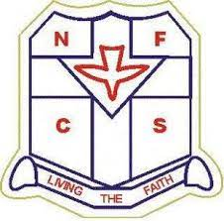

NIGERIA FEDERATION OF CATHOLIC STUDENTS
UNIVERSITY OF NIGERIA NSUKKA
HOLY TRINITY PARISH, HILLTOP CHAPTER
Email: nfcshtp@gmail.com

MOTTO: Living the Faith

DATE: 26th August 2025

Mr. Iyaji Samuel Lehi-owa
Phone: 09137838594
QUERY FOR NON-REPAYMENT OF LOAN
Dear Mr. Iyaji Samuel Lehi-owa,
This letter serves as a formal query regarding your failure to repay the loan of ₦50,000 (Fifty Thousand Naira only) granted to you by the NFCS Hilltop Chapter on 26th May, 2025, for the purpose of house rent.
According to the Loan Agreement duly signed by you, the repayment was to be made in full on or before 20th August, 2025. As of today, the said amount remains unpaid.
You are hereby directed to make immediate repayment of the full loan amount within the next seven (7) days. Kindly note that continued default will compel the NFCS Hilltop Chapter to take appropriate measures to recover the debt, as stipulated in the agreement.
We trust you will treat this matter with urgency to avoid further action.
Yours Sincerely,
Onwubiko Daniel Chukwuemeka
Financial Secretary
Okeke Chinedu Emmanuel
President

