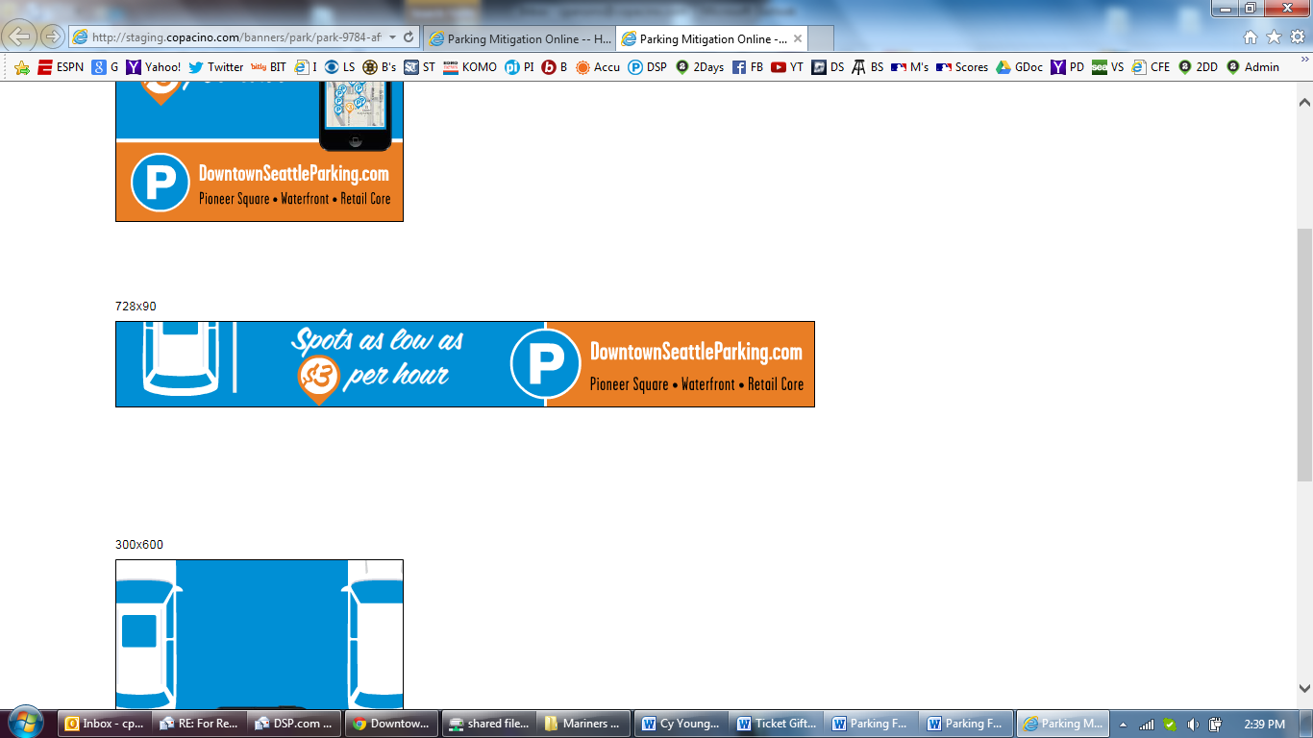

Parking FAQ

Welcome to [DowntownSeattleParking.com](http://downtownseattleparking.com). This website is a tool to help you find fast and affordable short-term parking near Seattle’s Waterfront, Pioneer Square, and Retail Core neighborhoods. It is just one of the tools the Washington State Department of Transportation (WSDOT) Alaskan Way Viaduct (AWV) Replacement Program uses to help drivers find parking during construction.

# What are the special rates?

Trevor:Users:lfoster:Documents:projects:parking:art:images:key-low.pngThe $3 per hour flat rate (tax included) is for short-term parking, up to four hours. After four hours, normal rates apply. Garages offering this rate are noted with an orange marker.

Trevor:Users:lfoster:Documents:projects:parking:art:images:key-flat.pngThe teal markers indicate where there is a flat rate of $7 or less for night and weekend parking.

# Do you manage or run the garages on your website?

Trevor:Users:lfoster:Documents:projects:parking:art:images:marker-epark.pngTrevor:Users:lfoster:Documents:projects:parking:art:images:marker-flat-rate.pngTrevor:Users:lfoster:Documents:projects:parking:art:images:marker-normal.pngTrevor:Users:lfoster:Documents:projects:parking:art:images:marker-3-dollar.pngWSDOT does not own or manage the garages in the program. For questions regarding special arrangements, accomodations, or event rates, please contact the garages directly by clicking on specific location markers.

# How do I contact these garages?

Phone numbers for each parking location can be found on the website by clicking on specific location markers (desktop) or opening a specific garage (mobile).

# Is there a mobile app for DowntownSeattleParking.com?

Our site is optimized for mobile use. Visit [DowntownSeattleParking.com](http://downtownseattleparking.com) on any mobile phone browser to find parking near you. Bookmark the site on your smartphone for easy access.

# Your site only lists parking rates for up to four hours. How much do I have to pay if I park for more than four hours (e.g. I’m going on an Argosy Cruise)?

Trevor:Users:lfoster:Documents:projects:parking:art:images:key-flat.pngBe sure to check with the individual facility on rates beyond the four hour limit. Some garages in the Retail Core offer discounted evening and weekend flat rates for $7 or less. Those locations are identified with a teal marker.

# Where can I park my over-height vehicle, trailer or SUV etc.?

Each parking location has different height and width restrictions. For larger vehicles, a surface parking lot would be recommended. Please contact parking locations directly to inquire about rates and capacity to accommodate special vehicles by clicking on specific location markers (desktop) or opening a specific garage (mobile).

# Can I Advertise on DowntownSeattleParking.com?

Not at this time.

# I believe I was overcharged for the duration of my parking, please refund my money.

The fastest way to get help is to contact the garage/parking company directly. Phone numbers for each parking location can be found on the website by clicking on specific garage/lot location markers (desktop) or opening a specific garage (mobile).

# How late can I park in a garage? Can I leave my vehicle overnight?

Some garages allow overnight parking. Be sure to check the garage hours as you enter the facility or contact parking locations directly to inquire before your trip. Phone numbers for each parking location can be found on the website by clicking on the specific garage/lot location markers (desktop) or opening a specific garage (mobile).

# Who do I contact if my facility wants to become a member garage?

Please contact:

Brendan Lemkin

Commute Seattle

[BrendanL@CommuteSeattle.com](mailto:BrendanL@CommuteSeattle.com)

# I have other questions. Who can answer them?

Please contact us at [viaduct@wsdot.wa.gov](mailto:viaduct@wsdot.wa.gov).