Resume

Experienced Electronics Engineer | PCB Design & Firmware Development Expert

**Overview**

I am a highly experienced **Electronics Engineer** with over **10 years of expertise** in **PCB design, firmware development, and product engineering**. My skill set spans from designing **high-speed, multi-layer PCBs** to developing **firmware for embedded systems** and managing entire product development cycles—from **concept to mass production**.

Whether you need a **complex 12-layer high-speed PCB**, **a custom firmware solution**, or **a fully engineered product ready for manufacturing**, I have the **technical expertise** and **project management experience** to bring your ideas to life.

**🔹 PCB Design & Layout**

✅ **High-Speed PCB Design** (up to **12 layers**, considering **EMI/EMC**)  
✅ **Flexible & Rigid-Flex PCB Design**  
✅ **Expert in Altium Designer, EasyEDA, Eagle**  
✅ **3D Modeling & Integration (SolidWorks)**

**🔹 Firmware Development & Embedded Systems**

✅ **ESP-IDF (ESP32, ESP8266)**  
✅ **STM32 Development (STM32CubeIDE)**  
✅ **Microchip PIC (MPLAB X)**  
✅ **ARM Cortex, AVR, and IoT Device Firmware**

**🔹 Product Development & Prototyping**

✅ **Concept-to-Mass-Production Experience**  
✅ **Hardware & Firmware Integration**  
✅ **DFM (Design for Manufacturing) & DFA (Design for Assembly) Optimization**  
✅ **Embedded Systems & IoT Product Design**

🔹 Leadership & Project Management

As a Product Manager, I have successfully led multiple projects from initial concept to mass production, ensuring efficiency, reliability, and cost-effectiveness at every stage.

💡 Let’s turn your idea into a reality! Whether you need a custom PCB, embedded firmware, or a full product design, I am here to help. Contact me now to discuss your project! 🚀

**AI-Powered Driver Assistance System Using Raspberry Pi CM4**

This **AI-driven Driver Assistant Device** leverages the power of the **Raspberry Pi Compute Module 4 (CM4)** to enhance road safety and driving efficiency. Equipped with **real-time object detection, lane departure warnings, and driver monitoring**, this system provides an intelligent co-pilot experience for any vehicle.

**Key Features:**

✅ **AI-Powered Object Detection** – Identifies pedestrians, vehicles, and obstacles in real-time.  
✅ **Lane Departure Warning System (LDWS)** – Alerts drivers if they unintentionally leave their lane.  
✅ **Driver Fatigue & Distraction Monitoring** – Detects drowsiness and inattentiveness using facial recognition.  
✅ **Speed Limit & Traffic Sign Recognition** – Reads traffic signs and provides alerts.  
✅ **Night Vision Support** – Enhances visibility in low-light conditions.  
✅ **Customizable Alerts & Notifications** – Provides audio/visual warnings for improved driver awareness.  
✅ **Lightweight & Compact Design** – Optimized for easy installation and low power consumption.

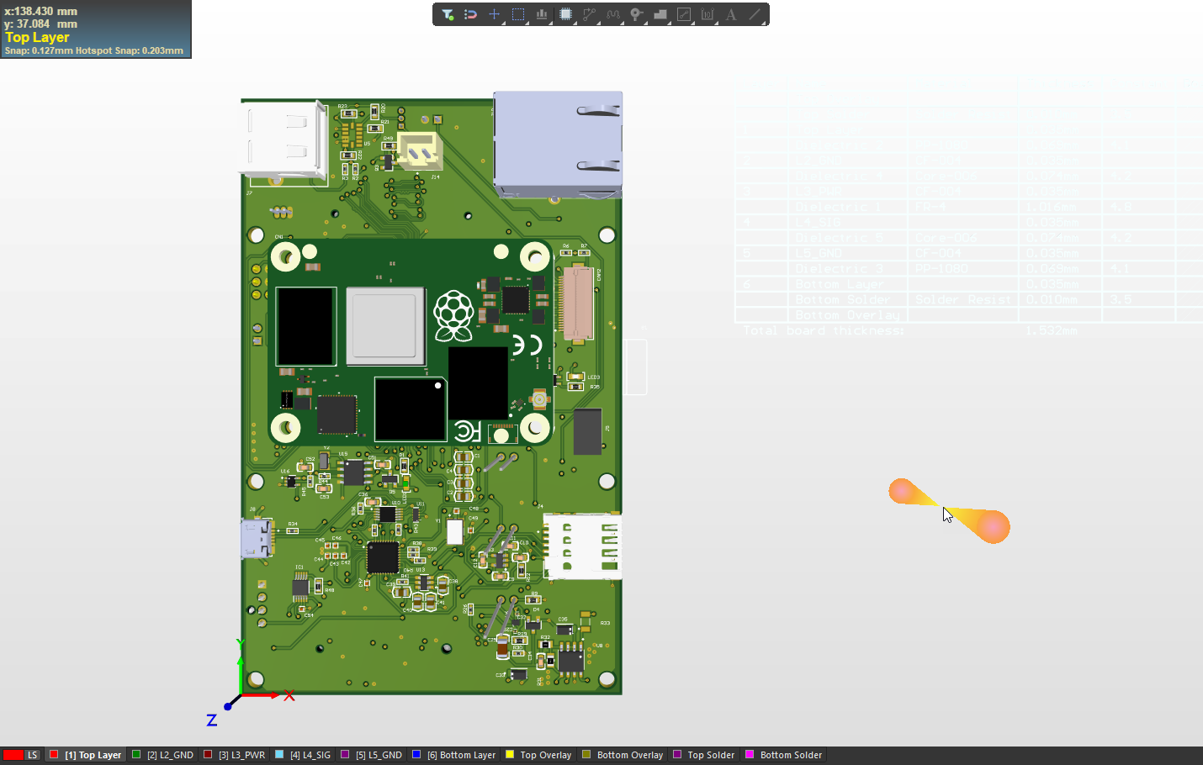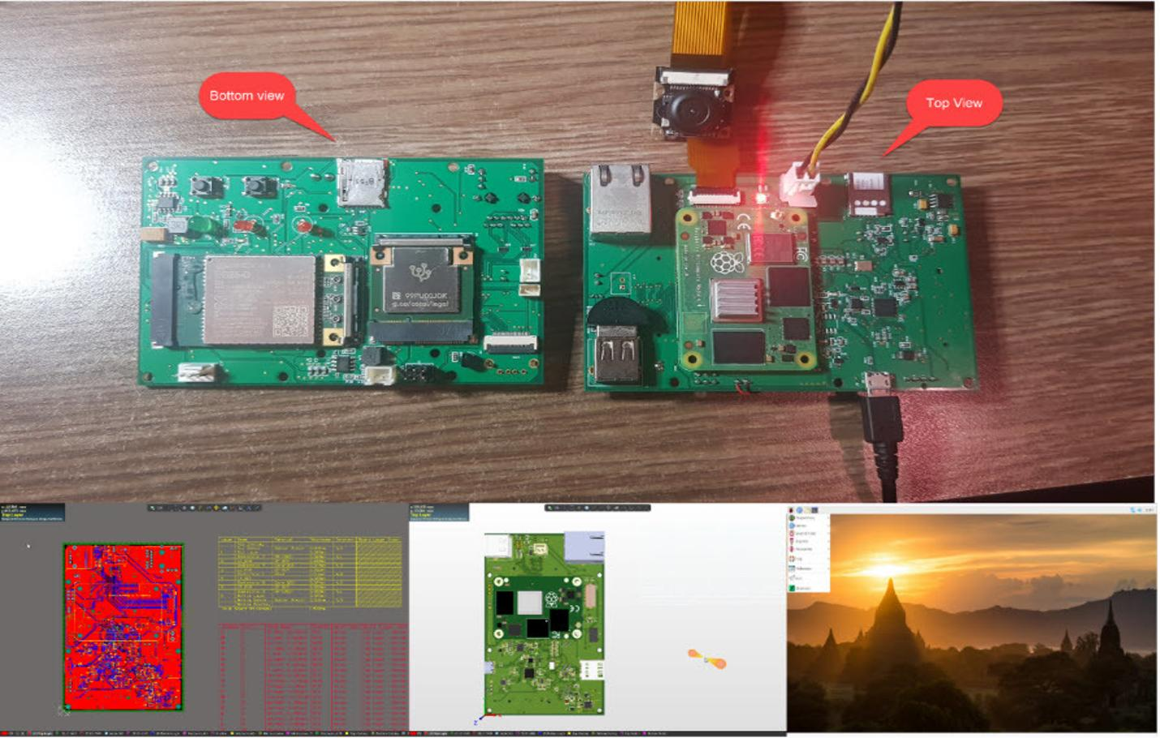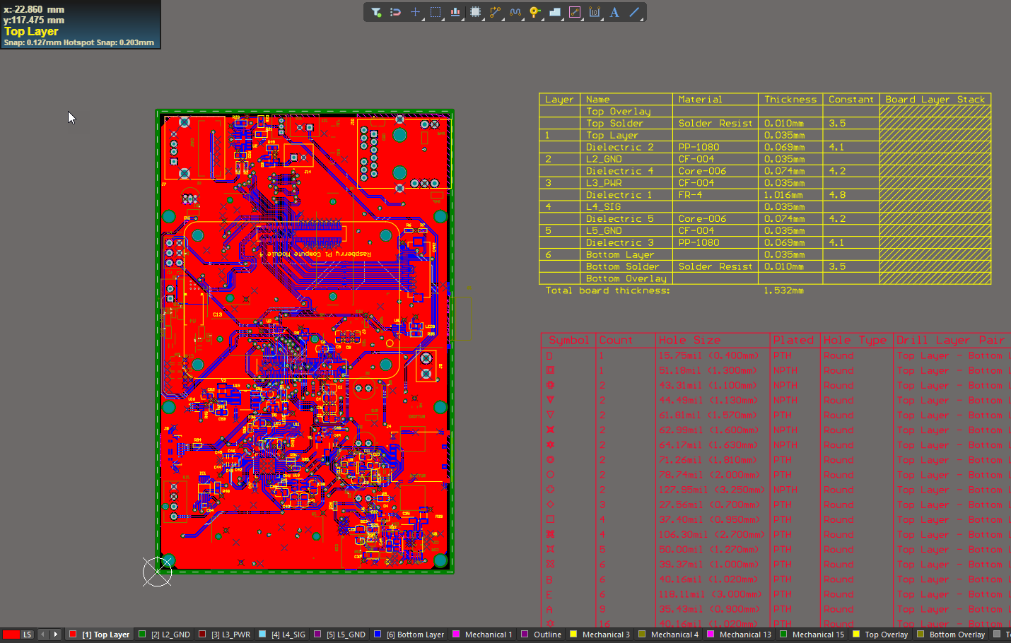

**Project Description:**

This device is a **BLE 5.0 secret key fob**, designed for easy-to-use authentication in electronic accessories such as **keyboards**, **digital headsets**, **electronic cigarettes**, and other BLE-enabled devices. It serves as a secure solution for authentication and anti-counterfeiting purposes, ensuring that only authorized users can access or operate the connected devices.

**Key Features:**

* **nRF52811** from **Nordic Semiconductor**: Low-power Bluetooth 5.0 SoC for reliable and secure communication.
* **A10006** from **NXP**: A secure element chip for enhanced security features and key storage.
* **Multicolor LED**: Visual feedback for various status indications.
* **CR2032 Battery**: Long-lasting, compact power source for the device.

**Software Tools:**

* **Altium**: Used for PCB design, ensuring a high-quality and efficient layout for the key fob.
* **Keil & nRF SDK16**: Used for firmware development to program and manage the device’s features and communication.

This device aims to provide a simple and reliable way to authenticate users and prevent counterfeit products using the power of **BLE 5.0** technology.

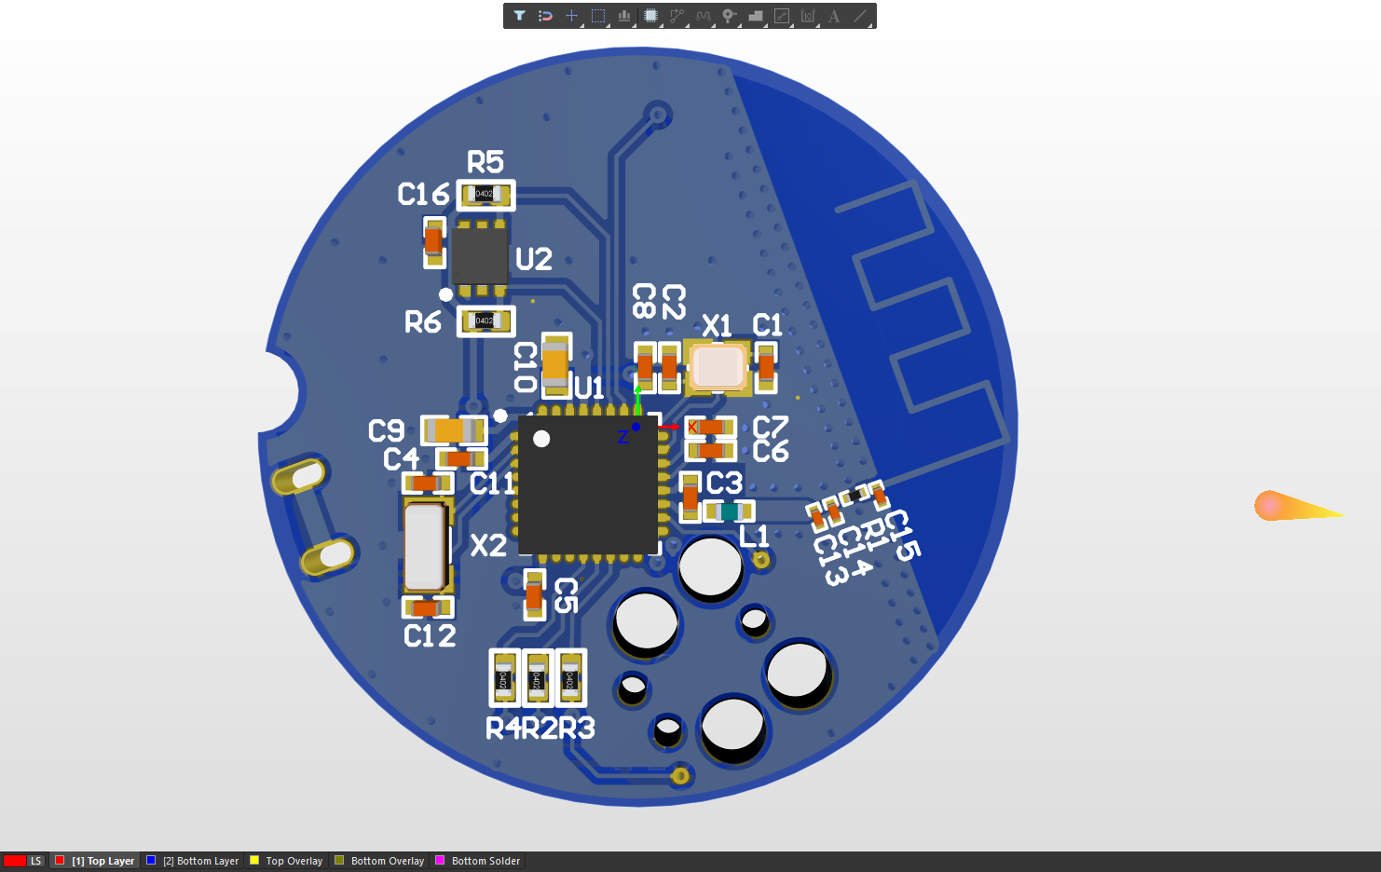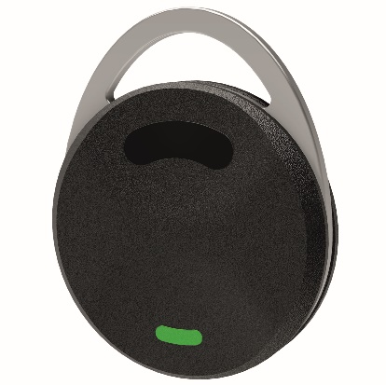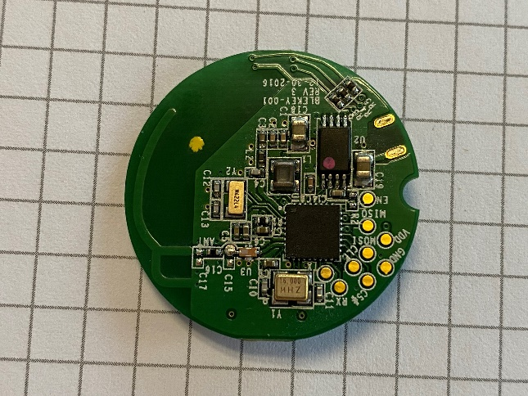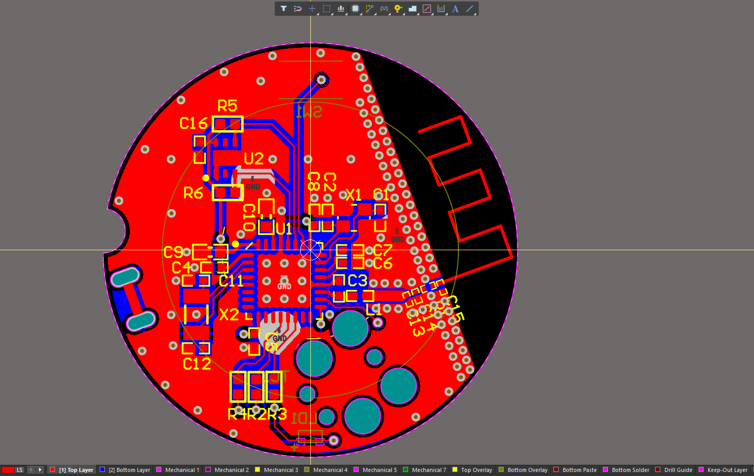

The **Vehicle GPS Race Tracker** is an advanced device designed to monitor and track key vehicle data in real-time, enhancing the driving and racing experience. It integrates various sensors and communication modules to provide seamless tracking and status reporting, while offering the flexibility of multiple data transfer methods.

**Key Features:**

* **Vehicle Monitoring**: Monitors and tracks vehicle status using data from the **ODB II port**, ensuring real-time updates on vehicle performance.
* **GPS Position Tracking**: Gathers precise vehicle location data via a **GPS antenna** for accurate positioning and tracking during races or trips.
* **Data Transfer via BLE**: Sends tracked data directly to the **user’s mobile** using **Bluetooth Low Energy (BLE)**, offering convenient remote monitoring.
* **USB-C Data Interface**: Provides the ability to send data to **USB devices** via a **USB-C** port, making data extraction easy and compatible with a variety of devices.
* **Built-in Data Storage**: Saves all collected data to an integrated **SD card**, ensuring that information is stored securely for future use.
* **Integrated IMU**: Includes a **6-axis Inertial Measurement Unit (IMU)** to track vehicle movement dynamics, providing extra insights for performance analysis.
* **Li-ion Battery Charger**: Comes with an integrated **Li-ion battery charger**, ensuring the device is always ready for use with a reliable power source.
* **Addressable RGB LEDs**: Features **three WS2813B addressable RGB LEDs**, offering customizable lighting effects for status indication or aesthetic appeal.

This device aims to provide vehicle enthusiasts, racers, and drivers with a comprehensive tracking solution that combines GPS, performance data, and smart connectivity into one compact, powerful tool.

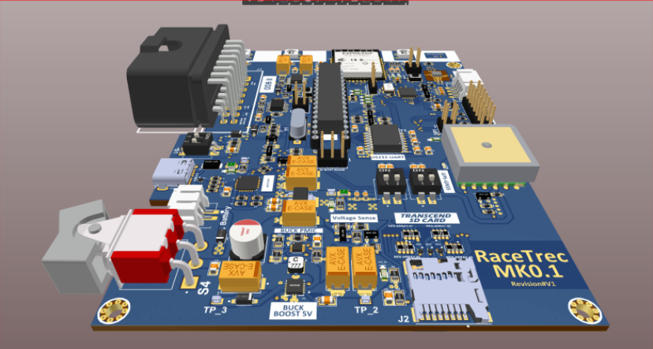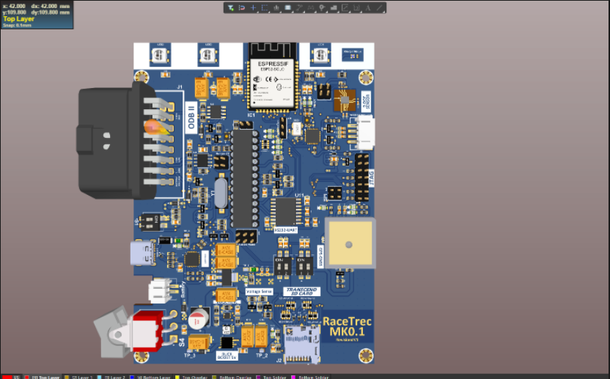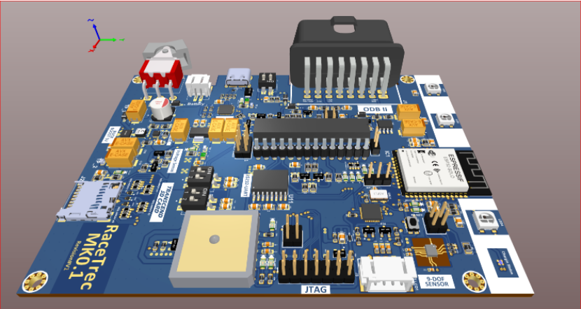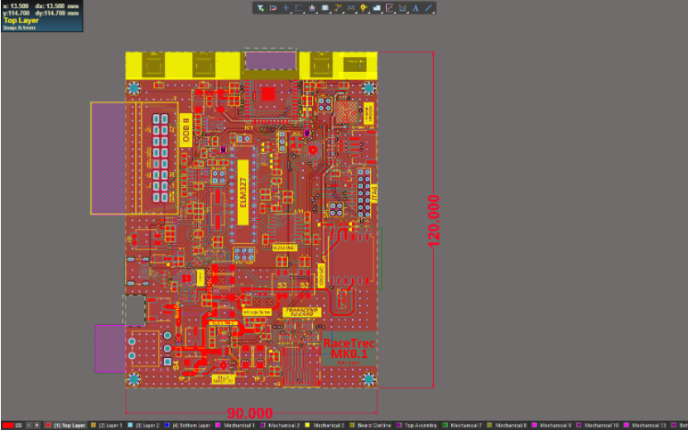

**Project Description:**

The **Encrypted Keyboard Logger & Router** is a secure solution for decrypting encrypted bank keyboard data and storing it with AES256 encryption on a built-in SD card. It also securely transmits the data to **HTTPS** and **MQTT** servers over **GSM** and **GPRS** using **SSL certificates**. This project ensures high security and data privacy throughout the entire process.

**Key Features:**

* **Data Decryption and Storage**: Decrypts encrypted bank keyboard data and stores it on an SD card with AES256 encryption.
* **Secure Data Transmission**: Sends data securely to remote servers over HTTPS and MQTT, utilizing SSL certificates for encryption.
* **Onboard GPS and GSM Antenna**: Includes integrated **GPS** and **GSM antennas** for location tracking and communication.
* **USB CDC Communication**: Supports USB CDC communication to interface with Android phones for easy data transfer.

**Main MCU and Modules:**

* **STM32F407**: Main microcontroller for handling all operations.
* **SIM7600G**: GSM module for secure data transmission over mobile networks.

**Software Tools Used:**

* **Altium** for PCB design.
* **STM32CubeIDE** and **Keil** for firmware development.

**Technology:**

* **FreeRTOS** for real-time multitasking.
* **AES256 Encryption and Decryption** for secure data storage.
* **HTTP and MQTT communication** for server interaction.
* **USB CDC communication** for Android integration.

This device provides a robust and secure method of logging, storing, and transmitting sensitive data, ensuring high-level encryption and communication security.

