Building the EVSE
In order to build a complete EVSE (charging station) you will also need:
- 2/4 pole contactor with 230V AC coil, rated for the max charging current.
Note that energy efficient (AC/DC) contactors will NOT work correctly!
- Fixed charging cable or socket with locking actuator.
- Enclosure with DIN rail. (EPN2205 or Famatel type 3958)
- optional Residual Current Monitor to protect against DC residual currents
- Terminal blocks (Wago TOPJOB S)
When using a fixed charging cable, please check if there is a resistor between PP and PE in the Charging Plug. Otherwise the EV will not start charging.
220 Ohm = 32A Cable
680 Ohm = 16A Cable
This resistor determines the max charge current the cable can handle, and is already fitted on all factory made cables.
Do not connect the PP wire to the SmartEVSE, when using a fixed cable! The contactor should be connected to terminals N and C1.
The C2 output is for an optional second contactor (1-Phase – 3-Phase charge selection).
Please note that energy efficient (AC/DC) contactors will not work correctly!
! The EVSE needs to be protected with a circuit breaker and residual-current circuit breaker, usually located near or in the distribution board.

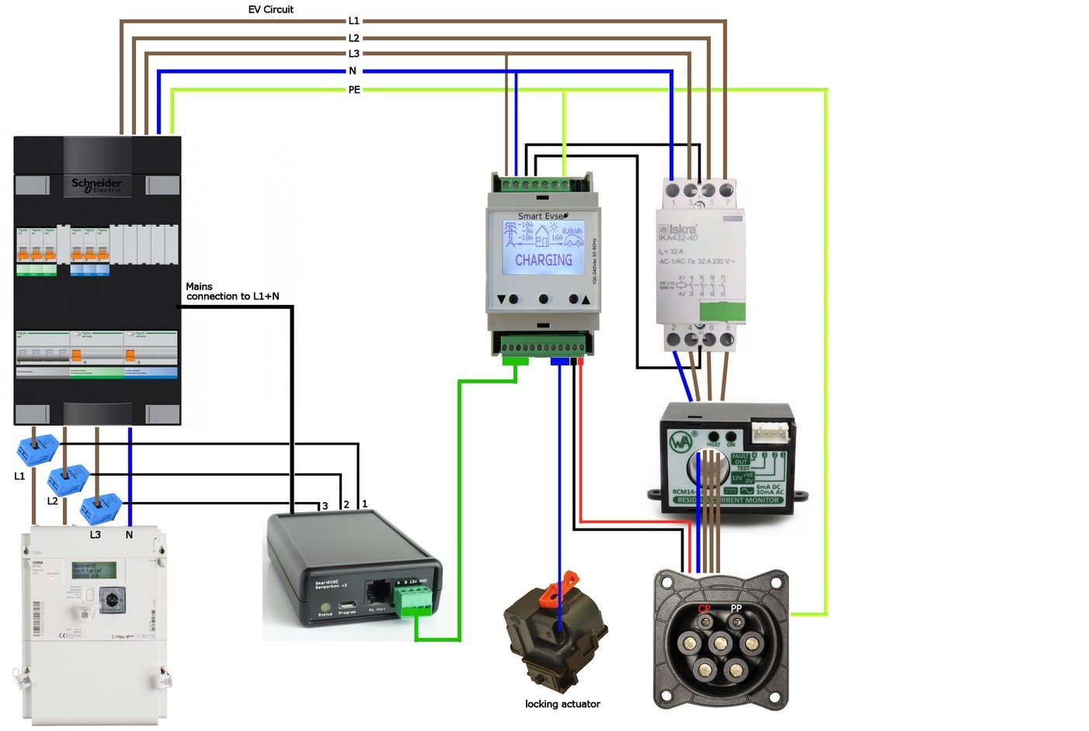
Diagram

Low voltage connections
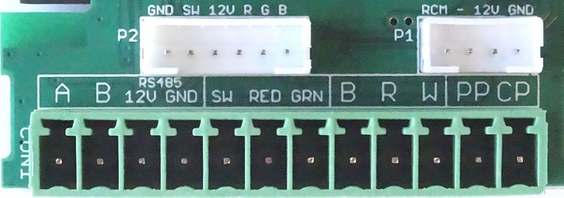
All low voltage connections are made with a 12 pin pluggable connector.
A, B, 12V and GND connections are used to connect the sensorbox. (optional)
A, B and GND should be connected to each module if you choose to use load balancing between SmartEVSE modules.
An optional 12v Bi-color LED can be connected between the 12V(+) and the RED(-) and GRN(-) terminals.
An optional switch or push button can be connected to the SW terminal and GND. It can be used to start/stop charging and toggle between charge modes.
B, R, W (lock) need to be connected to the locking solenoid or 12V motor that will lock the charging cable in it’s socket. (see next page)
PP (proximity pilot) signal will determine what max current the charging cable can handle, and needs to be connected to the charging socket. In case of a fixed cable, this signal is not used.
CP (control pilot) signal communicates with the EV, and will also inform the EV the maximum allowed charging current. This signal needs to be connected to the CP pin of the charging socket, or connected to the CP wire when using a fixed cable. The maximum total length of the CP wire+ charging cable is 15 meter.
P2: For (optional) push button with 12V RGB LED ring and ready made cable.
P1: For (optional) RCM14-03 residual current sensor.

Sensorbox (optional)
The SmartEVSE is capable of dynamically adjusting the charge current, depending on other loads that use the same mains connection. We call this smart mode, and it will require the following extra items:
- ‘Sensorbox plus’ with Current Transformers, one for each phase or ‘Sensorbox 2’ and a compatible smart meter with P1 port.
- 4+ wire cable for the connection between SmartEVSE and Sensorbox.
The Sensorbox should be placed where the mains connection enters the building. Usually this is just after the kWh meter, this allows it to measure the total current for each phase and send this information to the SmartEVSE. Clip the current transformers on the L1,L2 and L3 wires, and plug the other end of each cable into the Sensorbox.
For the Sensorbox2, plug the RJ12 cable into the smart meter and Sensorbox2
The data cable coming from the Sensorbox should be connected to terminals A, B, +12V and GND of the SmartEVSE.
This data cable can be more then 100 meters if needed.

The same function can be achieved without sensorbox, when having a smart meter (DSMR 5) with P1 port reader (e.g. SlimmeLezer, or ESPhome DSMR using MQTT or REST-API) or other (e.g. software only) solutions to send mains grid current measurements to this device.

The Locking Actuator
A locking actuator can be used to lock the charging plug into the socket. It will lock the cable when charging starts, and will unlock the cable after charging has stopped.
The SmartEVSE supports at least six types of locking actuators:

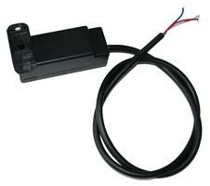
The DSIEC-EL, -ELB and -ELM locks have three wires and can be connected directly to the B(lue) R(ed) W(hite) terminals on the module.
Sometimes it locks, while it should unlock, you will then have to swap the Red and White wires.
Set the Lock option in the menu to SOLENOID

The DUOSIDA DSIEC-EL lock has 4 wires, connect them as follows: B: Blue, R: Yellow+White, W: Red
Set the Lock option in the menu to MOTOR

The DSIEC-ELC lock will not work with the SmartEVSE !

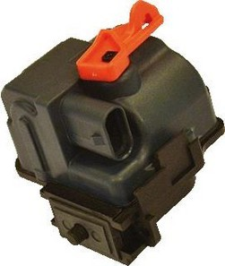
The Ratio lock has 3 wires, connect them as follows:
B: Blue, R: Black, W: Red.
Set the Lock option in the menu to SOLENOID

The Phoenix contact locking motor has 4 wires and needs to be connected as follows:
B: BL/YL, R: BL/GR + BL/BR, W: BL/RD
Set the Lock option in the menu to MOTOR

When using a fixed charging cable, the Lock option is not visible in the menu.

