

AI-POWERED PERSONAL SAVINGS COACH
(SMARTFIN)

MR. ANT BONE KYAW
MS. HNIN EI EI AUNG
MR. THAW ZIN MOE MYINT

A THESIS SUBMITTED IN PARTIAL FULFILLMENT
OF THE REQUIREMENTS FOR
THE DEGREE OF BACHELOR OF SCIENCE (COMPUTER SCIENCE)
SCHOOL OF INFORMATION TECHNOLOGY

KING MONGKUT’S UNIVERSITY OF TECHNOLOGY THONBURI
2026
AI-POWERED SAVINGS COACH (SMARTFIN)

Mr. Ant Bone Kyaw
Ms. Hnin Ei Ei Aung
Mr. Thaw Zin Moe Myint

This Project is Submitted in Partial Fulfillment of the Requirements for the Degree of Bachelor of Science (Computer Science) School of Information Technology
King Mongkut’s University of Technology Thonburi

2026

Project Committee

 Member and Project Advisor
(Dr. Debajyoti)

....................................................... Member
(Dr. Watanyoo)

....................................................... Member
(Assoc. Prof. Dr. Chonlameth)

....................................................... Member
(Assoc. Prof. Dr. Worarat)

....................................................... Member
(Dr. Punnarust)

Copyright reserved
Project Title | AI-Powered Personal Savings Coach (SmartFin)
Project Credits | 3
Candidate | Mister Ant Bone Kyaw
 | Miss Hnin Ei Ei Aung
 | Mister Thaw Zin Moe Myint
Project Advisor | Dr.Debajyoti

Program | Bachelor of Science
Field of Study | Computer Science (English Program)
Faculty | School of Information Technology
Academic Year | 2026

ABSTRACT
SmartFin is an AI-powered personal savings coach mobile application designed for Thai users aged 18 to 30. The application addresses three key challenges faced by young adults in Thailand: the tedium of manual expense tracking, the lack of personalized financial guidance, and the absence of savings-focused coaching tools tailored to Thai spending contexts.

The system integrates automated receipt scanning using Google Gemini Vision, which extracts structured transaction data from physical and QR receipts with high accuracy on Thai-language receipts. A comprehensive financial dashboard provides real-time budget monitoring, income and expense visualization, and spending category breakdowns.

The core contribution of SmartFin is its AI Savings Coach, implemented as a Retrieval-Augmented Generation pipeline powered by a fine-tuned Qwen3.5-4B language model. The model is fine-tuned using Low-Rank Adaptation on a domain-specific dataset of Thai personal finance savings instruction-response pairs, teaching the model SmartFin's savings coaching style, financial domain knowledge, and Thai merchant context. At inference time, the Go backend retrieves the user's profile and last 50 transactions from MongoDB Atlas and constructs a system prompt as context, enabling the model to deliver specific, data-driven savings recommendations grounded in the user's actual spending history rather than generic financial advice.

The RAG pipeline is evaluated using the RAGAS framework across five metrics — Faithfulness, Answer Relevancy, Context Precision, Context Recall, and Answer Correctness. The system is built using Flutter and Dart for the cross-platform mobile frontend, Go with GoFiber for the REST API backend, MongoDB Atlas for cloud data storage, and Firebase Authentication for identity management.

ACKNOWLEDGEMENTS

We extend our heartfelt gratitude to all the members of the project committees for their steadfast support and understanding in helping us overcome various challenges throughout our capstone project. Their valuable recommendations for improvement during the progress presentation sessions were instrumental in shaping our work.

We are especially grateful to our project advisor, Dr. Debajyoti, for his generous guidance, insightful advice, and unwavering support. His expertise and encouragement played a vital role in the successful completion of this project.

Lastly, we sincerely thank our friends who contributed valuable ideas and assisted in testing the application. Their feedback and suggestions helped refine our work and ensured a better user experience.

CONTENTS
ABSTRACT 2
ACKNOWLEDGEMENTS 3
CONTENTS 4
LIST OF TABLES 6
LIST OF FIGURES 7
CHAPTER 1 INTRODUCTION 8
1.1 Background Information 8
1.2 Objectives 8
1.3 Scopes 8
1.3.1 Target Audience 9
1.3.2 Features 9
1.3.3 Requirements 9
1.4 Expected Benefits 10
CHAPTER 2 FEASIBILITY STUDY 11
2.1 Introduction 11
2.2 Problem Statement 11
2.3 Related Research and Projects 12
2.3.1 Literature Review 12
2.3.2 System Benchmarking and Analysis 13
2.4 Requirement Specifications for the New System 13
2.5 Implementation Technique 14
2.5.1. Frontend Development 15
2.5.2. Backend Development 15
2.5.3. Database Integration 16
2.5.4. AI Model Fine-tuning (Qwen3.5-4B) 16
2.5.5. RAG Pipeline 16
2.5.6. Design Tools 16
2.5.7. Development Tools 16
2.5.8. Project Management 17
2.5.9. Deployment Tools 17

2.6 Implementation Plan 17
2.6.1 Gantt Chart 17
2.6.2 Work Breakdown Structure 19
CHAPTER 3 ANALYSIS AND DESIGN 23
3.1 Introduction 23
3.2 Analysis of the Existing System 23
3.2.1 Limitations of the Existing Systems 23
3.2.2 Identified Opportunities 24
3.3 User Requirement Analysis 24
3.4 System Design 25
3.4.1 System Architecture 26
3.4.2 IPOS Model 26
3.4.3 Database Design 27
3.4.4 Data Flow Diagrams 29
3.4.5 State Diagram 30

TABLES
Table Page
2.1 Competitor Analysis. 13
2.2 Technology Stack Table 15
3.1 IPOS Model Table 27
3.2 Users Collection Schema Table 28
3.3 Transactions Collection Schema Table 28

FIGURES
Figure Page
2.1 Problem Statement Fishbone Diagram 12
3.1 Use Case Diagram 25
3.2 System Architecture Diagram 26
3.3.1 Receipt Scanning Data Flow Diagram 29
3.3.2 AI Savings Coach Data Flow Diagram. 29
3.4 State Diagram of AI Savings Coach 30

CHAPTER 1 INTRODUCTION

1.1 Background Information

Personal financial management for university students and first-jobbers in Thailand is often a manual, labor-intensive process. Individuals typically rely on basic note-taking apps, spreadsheets, or sheer memory to track their daily expenses. Because modern spending heavily involves digital bank transfers, QR payments, and physical receipts, manually recording every transaction is tedious, inconsistent, and highly prone to human error.

Furthermore, existing financial applications mostly act as passive trackers — they show users what they spent but do not advise them on how to save. This lack of personalized insight and the cognitive overload of manually analyzing spending patterns lead to weak financial awareness, poor budgeting decisions, and a failure to build long-term savings strategies.

Consequently, there is a pressing need for an automated, intelligent system that not only reduces the friction of manual data entry but also actively coaches users toward building savings habits. SmartFin addresses this gap by combining automated receipt scanning with an AI Savings Coach — a fine-tuned large language model (Qwen3.5-4B) integrated into a Retrieval-Augmented Generation (RAG) pipeline that delivers personalized, data-driven savings recommendations based on the user's actual transaction history.

1.2 Objectives

This project aims to develop "SmartFin," an AI-powered mobile application that serves as a proactive financial coach. The primary objectives are:
- To automate the expense tracking process by extracting and digitizing structured data from physical receipts using Gemini Vision, eliminating manual data entry.
- To fine-tune Qwen3.5-4B-Instruct on Thai personal finance savings data using LoRA (Low-Rank Adaptation) to create a domain-specific AI Savings Coach.
- To implement a Retrieval-Augmented Generation (RAG) pipeline using direct context injection from MongoDB, enabling the fine-tuned model to provide personalized savings recommendations based on the user's real spending history.
- To evaluate the RAG pipeline using RAGAS metrics — Faithfulness, Answer Relevancy, Context Precision, Context Recall, and Answer Correctness — achieving an overall score above 0.85.
- To deliver a production-ready Flutter mobile application with a complete financial management dashboard, budget monitoring, and AI-powered savings coaching.

1.3 Scopes
SmartFin encompasses the development of a Flutter-based mobile application integrating a fine-tuned Qwen3.5-4B AI Savings Coach within a RAG architecture, automated receipt scanning via Gemini Vision, and a comprehensive financial management dashboard. The system is designed specifically for Thai users aged 18 to 30.
1.3.1 Target Audience
- University Students & First-Jobbers (The "Unaware Spender"): Tech-savvy young adults (ages 18–25) who rely heavily on digital and QR payments but lack the financial discipline to track small expenses and convert income into savings habits.
- Young Professionals (The "Busy Optimizer"): Time-constrained salaried individuals (ages 26–30) who need efficient, automated methods to track cash flow and forecast wealth without the manual effort of traditional spreadsheets.
- Financial Novices: Individuals with limited financial literacy seeking actionable, beginner-friendly coaching to optimize their budgets and reduce wasteful spending.
1.3.2 Features
- Automated Receipt Scanning: Users capture transaction data by photographing physical receipts. The system uses Gemini Vision to extract and structure key details including merchant name, date, and total amount, eliminating manual entry.
- AI Savings Coach: A fine-tuned Qwen3.5-4B model deployed via Hugging Face, integrated into a RAG pipeline. Users ask natural language questions about their finances and receive context-aware, personalized savings strategies based on their actual spending history.
- Financial Management Dashboard: A visual interface for monitoring income and expense trends, with manual transaction entry, budget limit alerts, and spending category breakdowns.
- Savings Intelligence: Identification of top spending categories, personalized savings goal recommendations, and actionable tips specific to Thai merchant context such as Grab, Line MAN, and 7-Eleven.

1.3.3 Requirements

Functional Requirements

- Automated Transaction Extraction: The system captures receipt images via the mobile camera and uses Gemini Vision to extract merchant name, date, and total amount.
- AI Savings Coach: A fine-tuned Qwen2.5-7B model receives user profile data and the last 50 transactions as context, then generates personalized savings recommendations in Thai.
- RAG Pipeline: The Go backend retrieves user profile and transaction data from MongoDB, constructs a system prompt as context, and passes it to the fine-tuned model on every request.
- Financial Dashboard: Visualizes income and expense trends; supports manual entry, editing, and deletion of transaction records.
- Budget Monitoring: Users define monthly budget limits; the system alerts when spending thresholds are approached or exceeded.
- Authentication: Secure user registration, login, and session management via Firebase Authentication with email/password and Google Sign-In.

Non-Functional Requirements

- Usability: The mobile application features an intuitive interface designed for the target demographic to minimize the learning curve.
- Security: Sensitive financial records are stored securely in MongoDB Atlas; authentication tokens are managed by Firebase.
- Performance: RAG chatbot interactions maintain low latency; the fine-tuned model is hosted on Hugging Face Inference API for reliable response times.
- Scalability: The Go/GoFiber backend handles concurrent requests efficiently; MongoDB Atlas scales horizontally as the user base grows.

1.4 Expected Benefits

For Users:

- Streamlined Expense Tracking: Automated receipt scanning eliminates tedious manual data entry and reduces recording errors.
- Personalized Savings Coaching: Unlike generic financial apps, SmartFin's AI Savings Coach delivers specific, actionable savings advice grounded in the user's actual spending patterns.
- Proactive Financial Wellness: The system shifts focus from backward-looking tracking to forward-looking savings goal achievement, reducing financial anxiety for young Thai adults.

For Developers:

- Experience with LLM Fine-tuning: The team gains hands-on experience fine-tuning Qwen3.5-4B using LoRA on domain-specific Thai financial data, including dataset generation, training on Google Colab, and deployment on Hugging Face.
- RAG Pipeline Architecture: Designing and evaluating a direct-context-injection RAG pipeline using RAGAS provides practical experience in production AI system evaluation.
- Modern Full-Stack Development: Building a scalable system with Go/GoFiber, Flutter, MongoDB Atlas, and Firebase positions the team at the forefront of modern software engineering practices.

CHAPTER 2 FEASIBILITY STUDY

2.1 Introduction

This chapter discusses the feasibility of developing the proposed system, SmartFin — AI-Powered Personal Savings Coach. A feasibility study is important because it helps determine whether the project is practical, achievable, and sustainable in terms of technology, cost, and real-world usage.
SmartFin is designed to help Thai users aged 18 to 30 build savings habits by combining automated receipt scanning, a comprehensive financial dashboard, and a fine-tuned AI Savings Coach. Since the system integrates multiple technologies including Gemini Vision, a fine-tuned Qwen3.5-4B model, MongoDB Atlas, Firebase, and a Go/GoFiber backend, it is necessary to evaluate whether these components can work together effectively within reasonable cost and resource limits.
This chapter analyzes the project from technical, economic, and operational perspectives, and concludes with an implementation plan.

2.2 Problem Statement

Managing personal finances is still a challenge for many people, especially students and young working adults. Most individuals either record their expenses manually or do not track them at all. This leads to several problems:
- Manual recording is time-consuming and prone to human error.
- Users frequently forget to record small daily expenses such as convenience store purchases and coffee.
- Existing financial applications display static charts but do not provide personalized, actionable savings advice.
- No existing application offers savings coaching grounded in the user's actual Thai spending context — Grab rides, Line MAN deliveries, 7-Eleven purchases, and BTS commutes.

Applications such as Money Manager and Expensify provide expense tracking features but focus exclusively on recording transactions and generating reports. They do not provide personalized financial coaching based on the user's own spending behavior, nor do they understand Thai-specific merchant and spending contexts.

SmartFin addresses this problem by integrating automated receipt scanning with a fine-tuned AI Savings Coach that delivers specific, context-aware savings recommendations based on the user's real transaction history.

To better understand the root causes and contributing factors, Figure 2.1 presents a fishbone diagram illustrating the problem statement.

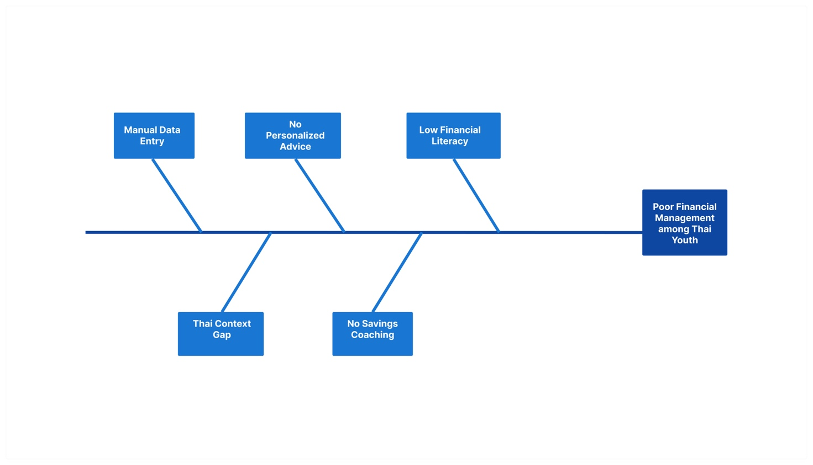
Figure 2.1: Problem Statement Fishbone diagram

2.3 Related Research and Projects

In recent years, financial technology (FinTech) has advanced significantly, particularly in personal finance management. Many mobile applications help users track expenses and manage budgets. Applications such as Money Manager and Expensify provide expense tracking and reporting features, but they mainly focus on transaction recording rather than intelligent financial guidance.

With the rise of artificial intelligence, models like OpenAI GPT-4 and Google Gemini Pro enable conversational and context-aware financial assistance. SmartFin builds on these technologies by combining automated receipt scanning, a financial dashboard, and a fine-tuned AI Savings Coach into a unified system.

2.3.1 Literature Review

Research in personal financial management emphasizes the importance of automation and data-driven decision support. Manual expense entry leads to inconsistency, while automated image recognition improves efficiency by reducing user effort.

Retrieval-Augmented Generation (RAG), introduced by Lewis et al. (2020), improves the relevance of AI responses by combining external data retrieval with large language model generation. This approach reduces hallucination while maintaining response quality. The RAGAS framework (Es et al., 2023) provides standardized metrics for evaluating RAG systems across Faithfulness, Answer Relevancy, Context Precision, Context Recall, and Answer Correctness.

Fine-tuning large language models using Low-Rank Adaptation (LoRA) enables domain-specific optimization with significantly reduced computational cost compared to full model fine-tuning, making it practical for capstone-level projects using free GPU resources.

These findings support SmartFin's design choice to implement a direct-context-injection RAG pipeline with a fine-tuned Qwen3.5-4B model, rather than a classic vector embedding approach, as the user data is already structured and user-specific — making vector similarity search unnecessary.

2.3.2 System Benchmarking and Analysis

To evaluate the feasibility of SmartFin, benchmarking was conducted against existing financial applications.

Feature | Money Manager | Expensify | SmartFin
Receipt Scanning | Manual Only | Basic OCR | Gemini Vision(Thai receipts)
Personalized Savings Advice | None | None | Fine-tuned Qwen3.5-4B RAG
Thai Language Support | Partial | None | Full
Conversation History | None | None | Multi-turn context maintained
Budeget Monitoring | Basic | Basic | Real-time with alerts

Table 2.1: Competitor Analysis

From the comparison, it can be observed that existing systems focus mainly on transaction recording and visualization. However, they do not provide intelligent financial advice based on user-specific spending behavior.

SmartFin differentiates itself by integrating AI-powered analysis with automated data collection, making it more comprehensive.

2.4 Requirement Specifications for the New System

The requirements of SmartFin are divided into functional and non-functional requirements.

Functional Requirements

- Users must be able to register and log in securely via email/password or Google Sign-In.
- Users must be able to scan physical receipts; the system extracts merchant name, date, and amount using Gemini Vision.
- The system must store and categorize financial records in MongoDB Atlas.
- The system must generate financial dashboards showing income versus expense trends with category breakdowns.
- The AI Savings Coach must retrieve the user's profile and last 50 transactions from MongoDB and pass them as context to the fine-tuned Qwen3.5-4B model.
- Users must be able to query the AI Savings Coach in natural language and receive personalized savings recommendations in Thai.
- Users must be able to set monthly budget limits; the system alerts when thresholds are approached.

Non-Functional Requirements

- Security: Financial data encrypted at rest in MongoDB Atlas; Firebase handles all authentication token management.
- Performance: AI Savings Coach response time under 5 seconds; receipt scanning processing under 3 seconds.
- Scalability: Go/GoFiber backend handles concurrent requests; MongoDB Atlas supports horizontal scaling.
- Usability: Interface designed for Thai users aged 18 to 30 with minimal learning curve.

2.5 Implementation Technique

The implementation of SmartFin followed an Agile methodology with iterative sprints. This approach enabled continuous development, regular evaluation, and incremental improvements. Each component — Flutter frontend, Go backend, MongoDB database, Gemini Vision integration, and Qwen3.5-4B fine-tuning — was developed, tested, and refined independently before integration.

Category | Tools / Technologies
Frontend | Flutter, Dart
Backend | Go Runtime, GoFiber
Database | MongoDB Atlas
Authentication | Firebase Authentication
Receipt Scanning | Gemini Vision (gemini-2.5-flash)
Al Savings Coach | Qwen3.5-4B (fine-tuned with LoRA)
Model Training | Kaggle, Hugging Face
RAG Evaluation | RAGAS framework
Design Tools | UI: Figma, Presentation: Canva
Development Tools | GitHub, Android Studio, Visual Studio Code, Postman
Project Management | MS Teams, Discord
Deployments Tools | Github Actions, Docker, NGINX

Table 2.2 Technology Stack Table

2.5.1. Frontend Development

The frontend was developed using Flutter, a modern open-source UI framework, and Dart, its programming language. Flutter enables cross-platform development using a single codebase, allowing the application to run efficiently on both Android and iOS platforms.

The user interface (UI) was designed with a strong focus on responsiveness, usability, and consistency. Flutter’s rich widget library facilitated the development of interactive dashboards, receipt scanning interfaces, and AI chat features while maintaining smooth performance across devices.

2.5.2. Backend Development

Go Runtime with GoFiber web framework was utilized to implement the backend. GoFiber provides a lightweight and high-performance environment for building RESTful APIs and handling concurrent requests efficiently.
The backend manages core business logic, processes financial transactions, integrates AI features, and connects with external services such as OCR and authentication APIs. Its modular structure ensures scalability and maintainability.

2.5.3. Database Integration

We used MongoDB, a NoSQL database, to manage application data. Its flexible JSON-like structure is suitable for storing financial records, user profiles, and transaction histories. Its scalable design ensures reliable performance and seamless integration with API-based services.

2.5.4. AI Model Fine-tuning (Qwen3.5-4B)

The AI Savings Coach is powered by Qwen2.5-7B-Instruct, fine-tuned on Thai personal finance savings data using LoRA (Low-Rank Adaptation). Qwen2.5-7B was selected for its superior numerical reasoning capability, strong multilingual Thai language support, and 128k token context window. Fine-tuning is performed on Google Colab using 4-bit quantization (QLoRA) to fit within free GPU memory constraints.
The training dataset of approximately 300 Thai instruction-response pairs is generated synthetically using Gemini, covering scenarios such as overspending, budget alerts, savings goal setting, and category-specific advice. The fine-tuned model is deployed on Hugging Face Spaces and called from the Go backend via HTTP.
2.5.5 RAG Pipeline
SmartFin implements a direct-context-injection RAG approach rather than classic vector embedding RAG. This design decision is justified by the structured nature of the data: all 50 retrieved transactions belong exclusively to the querying user, making vector similarity search unnecessary. The Go backend retrieves the user's profile and last 50 transactions from MongoDB, formats them into a system prompt, and passes this context along with the conversation history to the fine-tuned Qwen3.5-4B model.
2.5.6. Design Tools

The design and presentation phases utilized tools like Figma for creating intuitive UI prototypes and Canva for preparing visually appealing presentations. These tools streamlined collaboration during the design phase and ensured consistent visual standards across all deliverables.
2.5.7. Development Tools

A range of development tools facilitated efficient coding, testing, and deployment:
- GitHub: Version control and collaboration.
- GitHub Desktop: Simplified version control for local repositories.
- Android Studio and Visual Studio Code: Integrated Development Environments (IDEs) for frontend and backend development.
Postman: API testing and debugging.

2.5.8. Project Management

The Agile methodology was supported by tools such as MS Teams and Discord, which enabled effective communication and collaboration among team members. Daily stand-ups, sprint planning, and progress tracking were conducted using these platforms, ensuring that the team remained aligned and productive throughout the project.
2.5.9. Deployment Tools

- Jenkins CI/CD: For deployment Pipeline
- Docker: For maintaining each application as a container without any conflicts
- Nginx: To use as a Proxy.

2.6 Implementation Plan

Gantt Chart
Below is the Gantt Chart illustrating our project management approach.

WBS | Task Title | Dec '25 | Jan | Feb | Mar | Apr | May | Jun | Jul | Aug | Sep | Oct | Nov | Dec '26
1 | Concept Generation
2 | Preparation
3 | System Analysis & Design + Other Tasks
4 | UI/UX Design + Database Design
5 | Setting Up Database
6 | System Analysis & Design II
7 | Set Up Frontend + UI/UX
8 | Miscellaneous Update
9 | Final Design Presentation
 | — School Break —
10 | Backend Development
11 | Authentication & User Management
12 | Transaction Management Module
13 | Receipt Scanning Integration
14 | Budget & Alert System
15 | Fine-tune Qwen3.5-4B with LoRA on Kaggle
16 | Security & Performance
17 | Testing
18 | Deployment

Work Breakdown Structure (WBS)

Below is the Work Breakdown Structure (WBS) providing a detailed breakdown of all tasks, including start and due dates for each activity throughout the project timeline.

WBS NUMBER | TASK TITLE | START DATE | DUE DATE
1 | CONCEPT GENERATION
1.1 | Define Concept and Features | 20/12/2025 | 22/12/2025
1.2 | Project Proposal Writing | 15/01/2026 | 16/01/2026
1.3 | Consulting with Advisors | 14/01/2026 | 16/01/2026
2 | PREPARATION
2.1 | Estimate Finishing Time for Each Task | 17/01/2026 | 20/01/2026
2.2 | Create Sprint | 20/01/2026 | 25/01/2026
3 | SYSTEM ANALYSIS & DESIGN + OTHER TASKS
3.1 | Create User Journey Map | 26/01/2026 | 27/01/2026
3.2 | Persona | 27/01/2026 | 28/01/2026
3.3 | Architecture Diagram | 28/01/2026 | 29/01/2026
3.4 | Gantt Chart | 29/01/2026 | 31/01/2026
4 | UI/UX DESIGN + DATABASE DESIGN
4.1 | Create UI | 01/02/2026 | 05/02/2026
4.2 | Create Figma Prototype | 06/02/2026 | 08/02/2026
4.3 | Learning Tech Stack | 09/02/2026 | 12/02/2026
4.4 | Midterm Feasibility Study Presentation Preparation | 13/02/2026 | 19/02/2026
5 | SETTING UP DATABASE
5.1 | Requirement Gathering for Database | 21/02/2026 | 23/02/2026
5.2 | Database Design | 24/02/2026 | 28/02/2026
5.3 | Set Up Database Server | 01/03/2026 | 04/03/2026
5.4 | Connect to Flutter Project | 05/03/2026 | 11/03/2026
5.5 | Connect to Golang Backend | 05/03/2026 | 11/03/2026
5.6 | Add Data to Database | 12/03/2026 | 16/03/2026
6 | SYSTEM ANALYSIS & DESIGN II
6.1 | Implementation Diagram | 17/03/2026 | 23/03/2026
6.2 | Conceptual Diagram | 17/03/2026 | 23/03/2026
6.3 | Create AI Prototype | 24/03/2026 | 30/03/2026
7 | SET UP FRONTEND + UI/UX
7.1 | Environment Set Up | 01/04/2026 | 07/04/2026
7.2 | Connect to GitHub | 08/04/2026 | 14/04/2026
7.3 | Update UI | 15/04/2026 | 19/04/2026
7.4 | Update Figma Prototype | 20/04/2026 | 25/04/2026
8 | MISCELLANEOUS UPDATE
8.1 | WBS | 26/04/2026 | 09/05/2026
8.2 | Learning Tech Stack | 10/05/2026 | 19/05/2026
9 | FINAL DESIGN PRESENTATION
9.1 | Task Planning on MS Teams | 20/05/2026 | 26/05/2026
9.2 | Slide Preparation | 27/05/2026 | 29/05/2026
10 | BACKEND DEVELOPMENT
10.1 | Setup Backend Server (GoFiber) | 08/08/2026 | 18/08/2026
10.2 | Configure MongoDB Connection | 08/08/2026 | 18/08/2026
10.3 | Create Project Structure | 08/08/2026 | 18/08/2026
10.4 | Setup Environment Variables | 19/08/2026 | 25/08/2026
10.5 | Setup Middleware | 19/08/2026 | 25/08/2026
11 | AUTHENTICATION & USER MANAGEMENT
11.1 | Integrate Firebase Admin SDK | 26/08/2026 | 01/09/2026
11.2 | Implement JWT Verification Middleware | 26/08/2026 | 01/09/2026
11.3 | Protect Private Routes | 26/08/2026 | 01/09/2026
11.4 | Create User Model (MongoDB) | 02/09/2026 | 08/09/2026
11.5 | Sync Firebase UID with Database | 02/09/2026 | 08/09/2026
12 | TRANSACTION MANAGEMENT MODULE
12.1 | Create Transaction Model | 09/09/2026 | 15/09/2026
12.2 | Implement Create Transaction API | 09/09/2026 | 15/09/2026
12.3 | Implement Get Transaction API | 09/09/2026 | 15/09/2026
12.4 | Implement Update Transaction API | 16/09/2026 | 22/09/2026
12.5 | Implement Delete Transaction API | 16/09/2026 | 22/09/2026
12.6 | Add Filtering (Date / Category / Month) | 16/09/2026 | 22/09/2026
12.7 | Create Monthly Summary Endpoint | 23/09/2026 | 25/09/2026
12.8 | Implement Pagination | 26/09/2026 | 28/09/2026
13 | RECEIPT SCANNING INTEGRATION
13.1 | Create Receipt Upload Endpoint | 29/09/2026 | 01/10/2026
13.2 | Integrate Gemini Vision | 01/11/2026 | 03/11/2026
13.3 | Parse Merchant, Date, Amount | 04/11/2026 | 06/11/2026
13.4 | Validate Extracted Data | 07/11/2026 | 09/11/2026
13.5 | Save Parsed Transaction to Database | 10/11/2026 | 13/11/2026
13.6 | Handle Parsing Errors | 14/11/2026 | 17/11/2026
14 | BUDGET & ALERT SYSTEM
14.1 | Create Budget Model | 18/11/2026 | 19/11/2026
14.2 | Implement Set Monthly Budget API | 19/11/2026 | 23/11/2026
14.3 | Compare Expense with Budget Logic | 19/11/2026 | 23/11/2026
14.4 | Create Monthly Spending Report API | 19/11/2026 | 23/11/2026
15 | RAG CHATBOT INTEGRATION
15.1 | Generate 300 Thai Savings Instructions pairs via Gemini | 24/11/2026 | 25/11/2026
15.2 | Fine-tune Qwen3.5-4B with LoRA on Kaggle | 25/11/2026 | 30/11/2026
15.3 | Depoly fine-tuned model to Hugging Face Spaces | 25/11/2026 | 30/11/2026
15.4 | Implement Financial Q&A Endpoint | 25/11/2026 | 30/11/2026
15.5 | Implement Personalized Recommendation Endpoint | 25/11/2026 | 30/11/2026
15.6 | Optimize Prompt & Reduce Latency | 25/11/2026 | 30/11/2026
15.7 | Handle AI Error Responses | 25/11/2026 | 30/11/2026
16 | SECURITY & PERFORMANCE
16.1 | Implement Input Validation | 01/12/2026 | 02/12/2026
16.2 | Setup API Rate Limiting | 03/12/2026 | 05/12/2026
16.3 | Secure API Keys & Environment Config | 06/12/2026 | 14/12/2026
16.4 | Add MongoDB Indexing | 06/12/2026 | 14/12/2026
16.5 | Optimize Database Queries | 06/12/2026 | 14/12/2026
16.6 | Measure API Response Time | 06/12/2026 | 14/12/2026
17 | TESTING
17.1 | Unit Testing | 15/12/2026 | 29/12/2026
17.2 | API Testing with Postman | 15/12/2026 | 29/12/2026
17.3 | Integration Testing (Frontend + Backend) | 15/12/2026 | 29/12/2026
17.4 | Edge Case Testing (Receipt Parsing) | 15/12/2026 | 29/12/2026
17.5 | AI Response Testing | 15/12/2026 | 29/12/2026
18 | DEPLOYMENT
18.1 | Dockerize Backend | 15/12/2026 | 29/12/2026
18.2 | Setup GitHub Actions CI/CD | 15/12/2026 | 29/12/2026
18.3 | Deploy to Production Server | 15/12/2026 | 29/12/2026
18.4 | Monitor Logs & Fix Deployment Issues | 15/12/2026 | 29/12/2026

CHAPTER 3 ANALYSIS AND DESIGN

3.1 Introduction

This chapter presents the analysis and design of SmartFin — an AI-powered personal savings coach application for Thai users aged 18 to 30. The analysis phase identifies limitations of existing financial management systems and derives user requirements through structured analysis. The design phase translates these requirements into a concrete system architecture, database schema, user interface structure, and AI pipeline design.

SmartFin's design is guided by three core principles: (1) minimize friction in expense recording through automated receipt scanning, (2) deliver personalized savings advice through a fine-tuned AI model within a RAG pipeline, and (3) present financial insights through an intuitive mobile interface optimized for the target demographic.

3.2 Analysis of the Existing System

An analysis of existing personal finance management applications was conducted to identify capability gaps that SmartFin addresses. The primary systems examined were Money Manager, Expensify, and general-purpose AI assistants.

3.2.1 Limitations of the Existing Systems

Manual Data Entry Dependency: All major existing applications require users to manually type transaction details including merchant name, amount, category, and date. This creates friction that causes users to abandon tracking entirely after a short period. While some applications offer basic receipt scanning, accuracy on Thai-language receipts with mixed Thai and English text is poor.

Generic Financial Advice: Existing applications display retrospective charts and reports but provide no proactive guidance. The advice offered — when present — is generic and not grounded in the user's actual spending behavior. No existing application provides savings coaching calibrated to Thai-specific merchant contexts such as Grab, Line MAN, Big C, or 7-Eleven.

No Conversational Interface: Users cannot ask natural language questions such as "Can I afford a vacation this month?" or "What should I cut back on?" and receive personalized, data-driven answers. This limits the utility of financial data beyond passive visualization.
No Thai Language Optimization: Existing AI-powered financial tools are primarily designed for English-speaking markets. Thai users receive advice that does not account for local spending patterns, income levels, or merchant contexts.

3.2.2 Identified Opportunities

• Automated receipt scanning optimized for Thai receipts using multimodal AI (Gemini Vision).
• A conversational AI Savings Coach fine-tuned on Thai personal finance data, capable of delivering specific savings recommendations in Thai.
• A RAG pipeline that grounds every AI response in the user's actual MongoDB transaction data, eliminating generic advice.
• A mobile-first interface designed for Thai users aged 18 to 30 with a warm, encouraging interaction style.

3.3 User Requirement Analysis

User requirements were gathered through analysis of the target demographic — university students and young professionals in Thailand — and structured into functional and non-functional requirements.

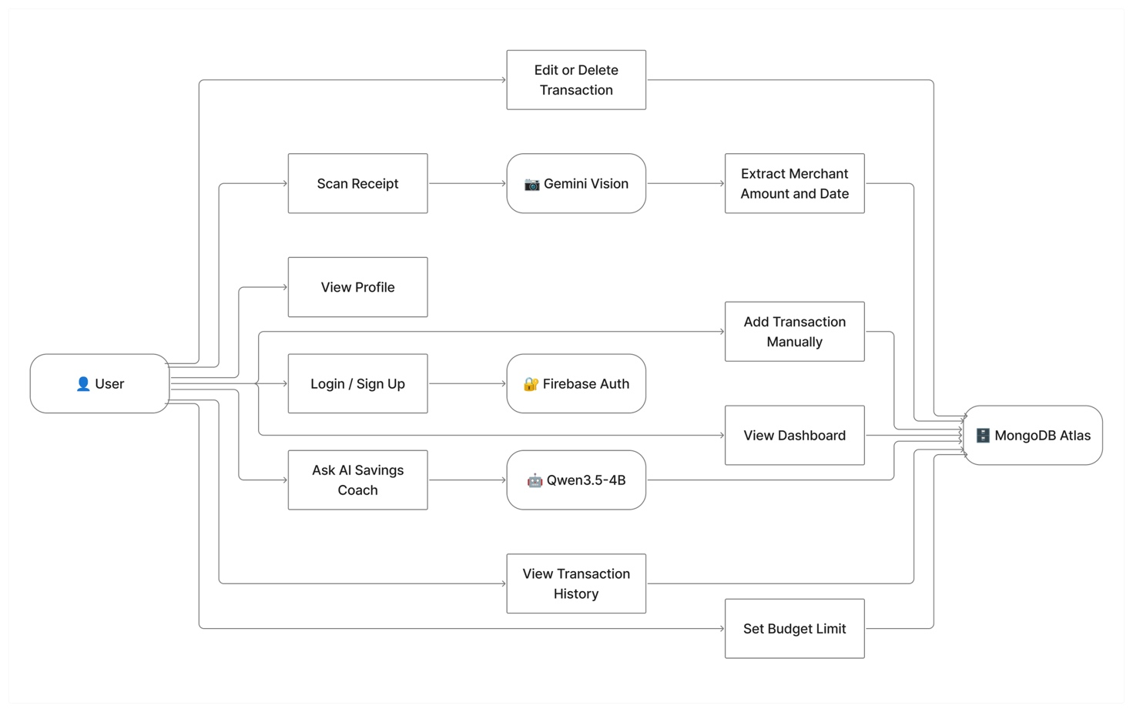
Figure 3.1: Use Case Diagram

3.4 System Design

This section presents the complete system design of SmartFin, covering the conceptual architecture, database design, AI pipeline design, and user interface structure.

3.4.1 System Architecture

SmartFin follows a three-tier architecture comprising the Flutter mobile client, the Go/GoFiber backend server, and cloud data services. The key architectural principle is that the Flutter client never communicates directly with MongoDB — all data access is mediated through the Go backend, maintaining proper security boundaries.

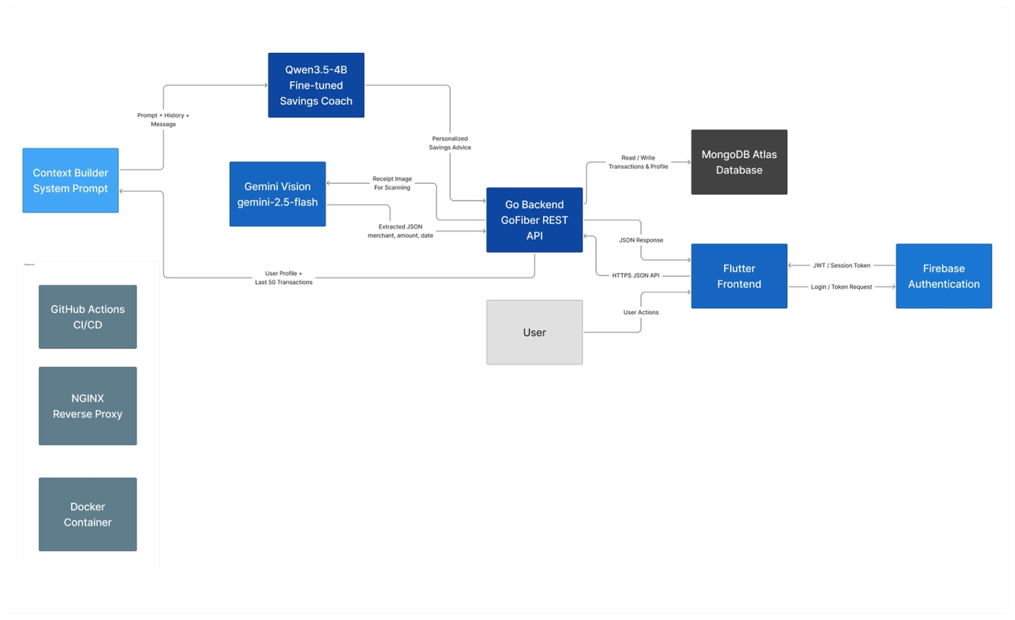

Figure 3.2: System Architecture Diagram
3.4.2 IPOS Model

Function | Input | Process | Output | Storage
User Registration | Email, password, name | Firebase createUserWithEmailAndPassword; POST /api/users | Firebase UID; MongoDB user document | Firebase Auth; MongoDB users
Receipt Scanning | Receipt photo (JPEG/PNG) | Multipart upload → Go backend → Gemini Vision API with structured prompt | merchant, amount, date, confidence (JSON) | MongoDB transactions (source: scanner)
Manual Transaction | Merchant, amount, type, category, date | Validation→POST/api/transactions | Saved transaction record | MongoDB transactions (source: manual)
Budget Summary | Firebase UID, month | MongoDB aggregation pipeline: sum income, sum expenses, group by category | total_income, total_expenses,available,category breakdown | Computed at query time from MongoDB
AI Savings Coach | User question + conversation history | Fetch profile + last 50 transactions → build system prompt → Qwen3.5-4B via Ollama | Personalized Thai savings advice | Conversation history in Flutter state
Budget Alert | Monthly expenses, budget_limit | Compare total_expenses vs budget_limit in Go backend | Alert flag in dashboard response | budget_limit in MongoDB users

Table 3.1: IPOS Model Table

3.4.3 Database Design
MongoDB Atlas stores application data in two collections. The users collection holds one document per registered user, and the transactions collection holds one document per financial transaction.

Users Collection Schema:

Field | Type | Description
_id | ObjectID | MongoDB auto-generated unique identifier
firebase_uid | String | Firebase Authentication UID – links auth to data
Name | String | User display name
email | String | User email address
monthly_income | Int64 | Monthly income in Thai Bhat
income_bracket | String | Income range
current_status | String | Student, Pro, or Founder
financial_health | String | Saving up, debt-free, etc.
budget_limit | Int64 | Monthly spending limit in Thai Baht
wellness_score | Int | AI-calculated financial wellness score(0-100)
level | Int | Gamification level starting at 1
created_at | Datetime | Account creation timestamp

Table 3.2: Users Collection Schema Table

Transactions Collection Schema:

Field | Type | Description
_id | ObjectID | MongoDB auto-generated unique identifier
user_id | String | Firebase UID of the transaction owner
merchant | String | Store or restaurant name
amount | Int64 | Amount in Thai Baht (no decimals)
type | String | expense or income
category | String | Food, Transport, Salary, etc.
source | String | manual (typed) or scanner (receipt)
receipt_image_url | String | URL of scanned receipt image if applicable
date | DateTime | When the transaction occurred
created_at | DateTime | When the record was created in the database

Table 3.3: Transactions Collection Schema Table

Entity Relationship:
One user (USERS) has zero or many transactions (TRANSACTIONS). The relationship is established via the firebase_uid field in USERS matching the user_id field in TRANSACTIONS. MongoDB does not enforce foreign key constraints — referential integrity is maintained at the application layer in the Go backend.

3.4.4 Data Flow Diagrams

The system operates across two main data flows:

Flow 1 – Receipt Scanning:

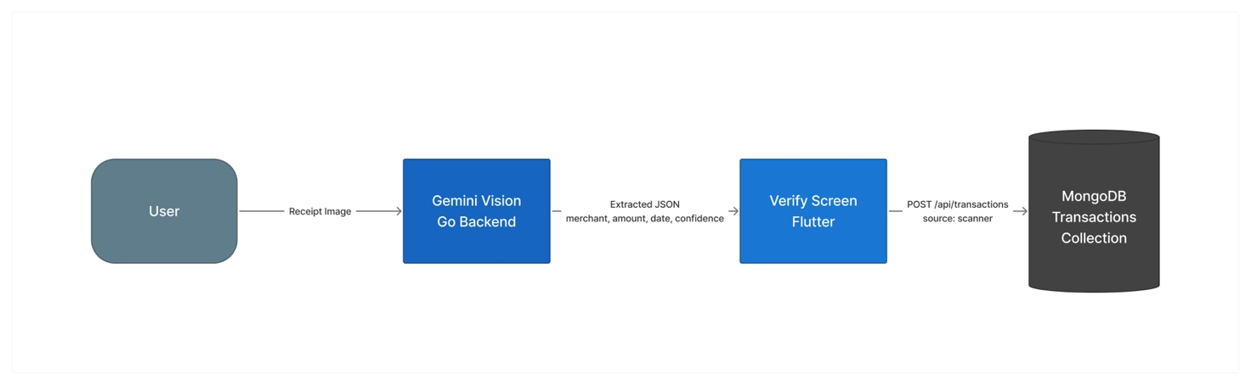
Figure 3.3.1: Receipt Scanning Data Flow Diagram

Flow 2 – AI Savings Coach (RAG):

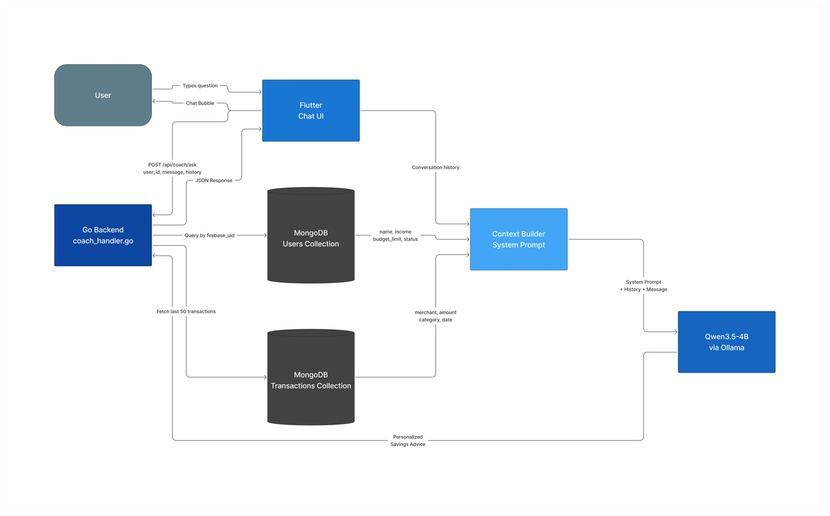

Figure 3.3.2: AI Savings Coach Data Flow Diagram
3.4.5 State Diagram – AI Savings Coach

The AI Savings Coach chat interface transitions through the following states:

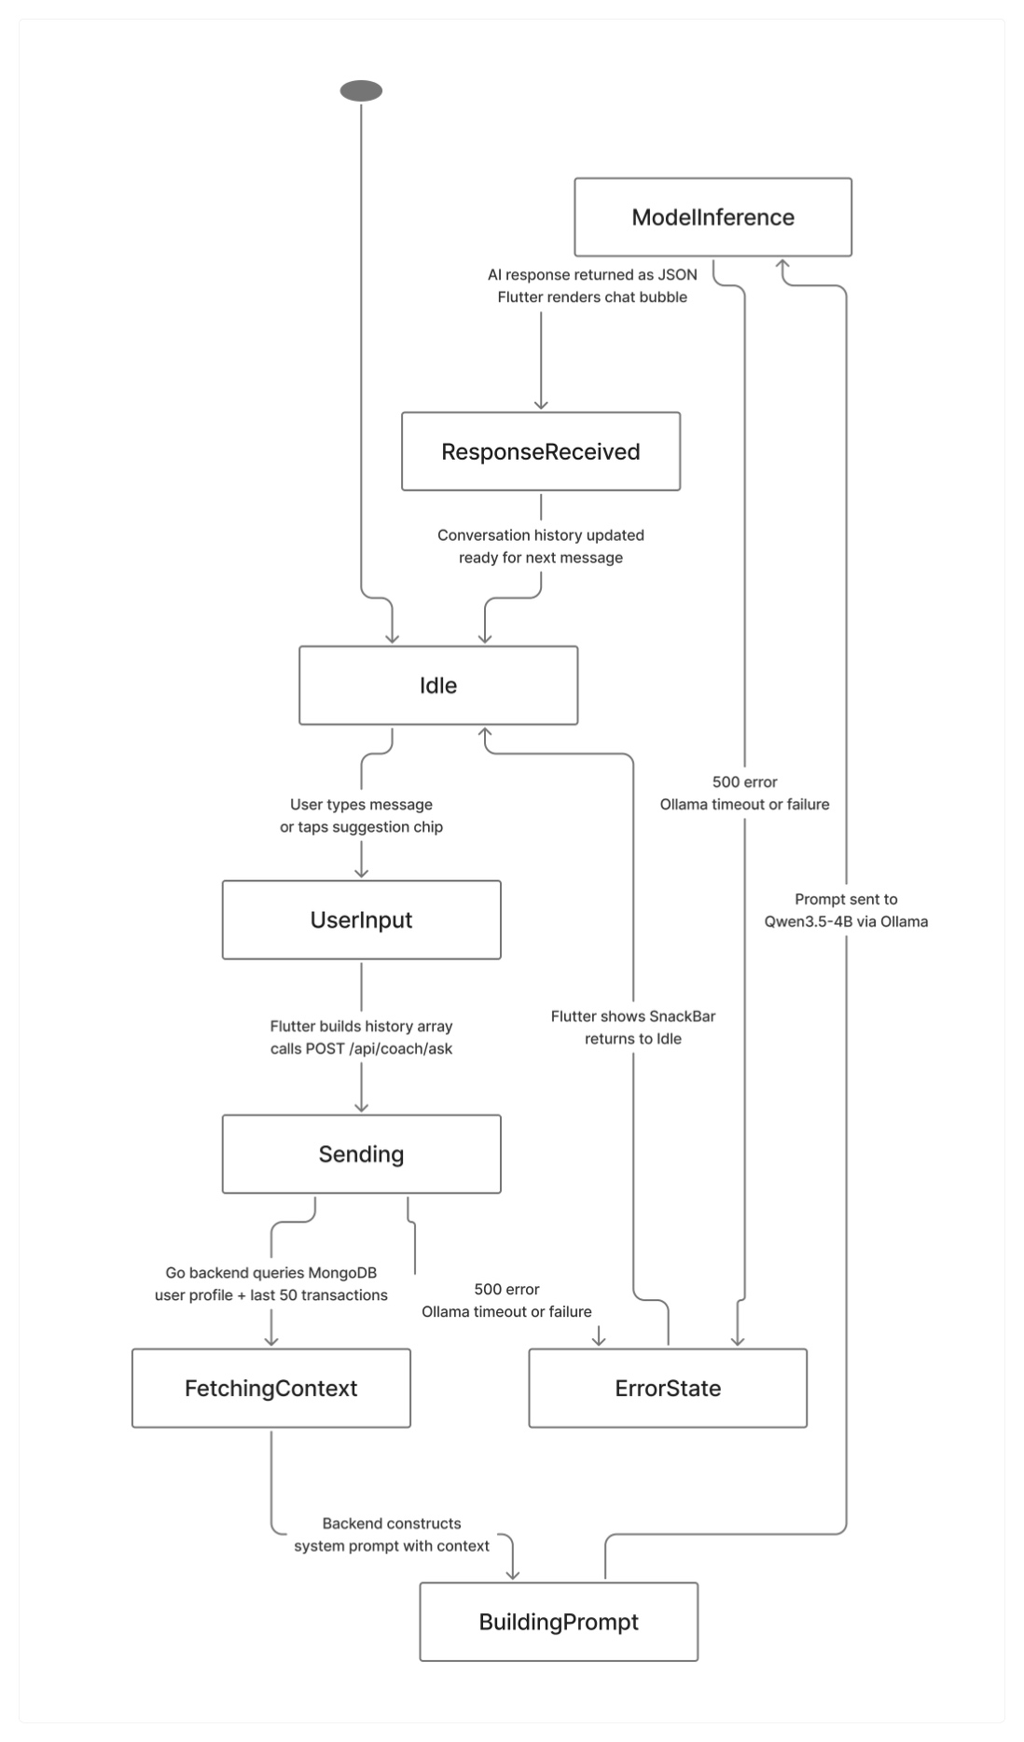
Figure 3.4: State Diagram of AI Savings Coach

