Chapter 4: Implementation, Results, and Discussion
This chapter presents the empirical results produced by SmartFlow NLEX following the full implementation of the data pipeline and the analytics engines described in Chapter 3, and documents the system that produces and delivers them. Section 4.1 reports the descriptive, predictive and prescriptive outputs of the three operational modules, each alongside the dashboard visualisation that renders it. Section 4.2 documents the implementation itself: the interface design system, the environment and repository, authentication and session management, and the maintenance scheduler.

4.1 Presentation of Results
Provenance note. Prepared 8 October 2026. Every bracketed placeholder in the earlier draft has been replaced with a value read from the warehouse or from the endpoint that renders the corresponding dashboard panel. Where the real data contradicts the direction the draft's sentence assumed, the sentence has been rewritten rather than back-filled, which is what Note 1 asked for. Section 4.1.6 at the end is a register of every such reversal, so the group can see what changed and why.
Unless stated otherwise, descriptive figures are for the dashboard's default analysis window — calendar year 2025 for the traffic and emission modules, and 1 July 2025 to 30 June 2026 for the incident module — while coverage and record counts span the full warehouse, 1 January 2022 to 30 June 2026.

4.1.1 Source of Raw Data
The raw data used in this project was drawn from four distinct input streams, consistent with the Source Layer defined in Section 3.9.1. Internal operational data was formally requested from and provided by NLEX Corporation, comprising the Road Crash Table, the Stalled Vehicle Table, and the Northbound and Southbound Traffic Reports Tables. Third-party contextual data was retrieved programmatically from a weather data API and from scraped event and ticketing schedules covering venues within the corridor's catchment area, most notably the Philippine Arena. Crowdsourced data was accessed through the Waze Partner Hub integration maintained with the Metro Pacific Tollways Corporation, which supplied geolocated jam records, anomaly feeds, and incident markers in near real time.
Table 4.1.1 Summary of Raw Data Sources
Data Stream | Dataset | Provider / Source | Format | Records ingested | Coverage
Internal | Traffic Reports (NB/SB) | NLEX Corporation | .xlsx | 2,086,512 | Jan 2022 – Jun 2026
Internal | Road Crash Table | NLEX Corporation | .xlsx | 21,820 | Jan 2022 – Jun 2026
Internal | Stalled Vehicle Table | NLEX Corporation | .xlsx | 156,925 | Jan 2022 – Jun 2026
Third-Party API | Hourly weather observations | Weather API | JSON | 1,152,960 | Jan 2022 – Jun 2026
Third-Party API | Event and ticketing schedules | Ticketing sites (Philippine Arena) | JSON / HTML | 155 | Dec 2020 – Dec 2027
Third-Party Data | Waze jam and alert feeds (hourly) | Waze Partner Hub via MPTC | JSON | 358,998 jams / 315,783 alerts | rolling
Third-Party Data | Waze raw alert and jam snapshots | Waze Partner Hub via MPTC | JSON | 44,623 each | rolling
Internal | Emission activity records | Derived from volume × factors | — | 978,796 | Jan 2022 – Jun 2026

Two corrections to this table as drafted. The Apprehension and Undercap Table is listed in the draft as an internal stream, but no corresponding table exists in the warehouse and no variable derived from it reaches any dashboard panel. It should be removed from Table 4.1.1 and from Table 4.1.2, or the chapter should state that it was obtained but not ingested. Likewise, the mobile application's community reporting feature appears in the draft as a user-ingested stream; the mobile application is joined to the dashboard through a configuration endpoint, but no community report records are present in the warehouse. Reporting either stream as a data source would claim an input the system does not have.

4.1.1.1 Description of the Raw Data
The consolidated raw dataset covered the North Luzon Expressway corridor from Balintawak to Sta. Ines, Mabalacat, Pampanga, spanning approximately 105 kilometres of expressway and its associated toll plazas and exits, resolved across 19 toll points and 20 recorded exits. The internal traffic reports were provided as vehicle entry counts disaggregated by toll exit, direction, and vehicle classification, from which Average Daily Traffic volumes were derived, while the incident-related tables were provided as event-level records in which each row represented a single crash or stalling occurrence.
In total, the proponents obtained 2,086,512 traffic volume records, 21,820 road crash records, and 156,925 stalled vehicle records across the observation window of 1 January 2022 to 30 June 2026, a span of 1,642 days. The external streams contributed 1,152,960 hourly weather observations, 155 scheduled event entries, and 358,998 hourly Waze jam records together with 315,783 hourly alert records, retrieved at hourly intervals throughout the collection period.
The datasets differed considerably in temporal granularity, which had direct implications for how they could be aligned during transformation. The internal traffic reports were aggregated to the hour per exit, direction, and vehicle class, the Waze and weather feeds were available at hourly resolution, and the incident logs were timestamped to the minute. This heterogeneity necessitated the resampling and temporal alignment procedures discussed in Section 4.1.2 before any cross-source analysis could be performed.

4.1.1.2 Variables in the Raw Data
Table 4.1.2 Variables Extracted from Each Raw Dataset
Source Dataset | Key Variables | Analytical Role
Traffic Reports (NB/SB) | date, hour, exit, direction, role, toll system, Class 1 / 2 / 3 counts | Primary volume series for the traffic module and the activity basis for emission computation
Road Crash Table | event number, start date, direction, location, km value, corridor km, type of event, main and sub cause, detection, weather condition, vehicles involved, injuries, fatalities, blockage cleared, site cleared, clearance minutes, deployment count | Incident frequency, severity, and hotspot analysis
Stalled Vehicle Table | event number, encoded date, direction, location, km value, corridor km, vehicle type and class, main and sub cause, detection, trouble description, deployment count | Non-crash obstruction analysis and clearance modelling
Weather API | recorded at, cell, temperature, feels-like, pressure, humidity, dew point, UV index, cloud cover, visibility, wind speed and direction, condition, precipitation probability, rain in last hour | Exogenous regressor for volume, incident, and speed models
Ticketing Scrapes | event name, venue, date, start time, attendance | Exogenous regressor for event-driven surge forecasting
Waze Partner Hub | alert type, coordinates, jam speed, jam level, jam length, delay, reliability | Ground-truth validation set and real-time congestion state input

4.1.1.3 Initial Observations
An initial inspection of the raw datasets revealed several data quality concerns that justified the multi-gate validation architecture adopted in the pipeline. The internal incident tables contained free-text entries in the cause and trouble-description fields, producing inconsistent spellings and non-standard abbreviations for what were substantively the same categories. Kilometre post values were recorded in mixed formats across tables, with some entries expressed as decimals and others as text strings containing directional qualifiers. Duplicate records were observed within the Waze feed, where the same physical anomaly was reported multiple times under separate alert identifiers within a short interval, a pattern consistent with the crowdsourced nature of the source.
A quantified instance of the location problem survives into the delivered system and is reported on the dashboard rather than hidden: in the incident predictive panel, 0.9 % of logged locations in the active range could not be matched to a specific exit and are excluded from the per-exit split, with the exclusion stated on the panel itself.
Beyond these quality issues, the raw data exhibited substantive patterns later confirmed by the descriptive tier. Traffic volume displayed a pronounced weekly cycle, and incident counts clustered at particular kilometre ranges rather than distributing uniformly along the corridor. The draft's third preliminary observation — that wet conditions showed a higher daily incident count than dry conditions — is not supported once the records are joined to the weather series, and is corrected in Section 4.1.3.2.

4.1.2 Implementation of Data Cleaning and Preprocessing
The architectural description in the draft is accurate and is retained. Only the quantified outcome is restated here.
The cumulative effect of the cleaning and preprocessing stage is summarised in Table 4.1.3. Retention is high across the internal tables because the inbound records were already structured; the large reduction in the traffic stream is a change of grain, not a loss, since raw per-transaction rows are aggregated to exit-hour facts.
Table 4.1.3 Record Counts Before and After Data Cleaning and Validation
Dataset | Raw records | Retained | Retention | Note
Road Crash Table | 21,820 | 21,804 | 99.93 % | 16 rows dropped on unrecoverable date or location
Stalled Vehicle Table | 156,925 | 156,901 | 99.98 % | 24 rows dropped
Emission activity records | 978,796 | 977,356 | 99.85 % | 1,440 rows dropped
Traffic Reports (NB/SB) | 2,086,512 | 1,254,192 exit-hour facts | — | aggregation, not exclusion
Weather observations | 1,152,960 | 1,152,960 | 100 % | —
Waze jams | 358,998 hourly | 136,520 silver jam facts | — | deduplicated to one record per physical jam-hour
Incident log (unified) | — | 19,141 | — | crash and stall events combined on one schema

The principal causes of record exclusion were unrecoverable location fields and timestamps falling outside the declared coverage window. The draft's single aggregate retention sentence should be replaced by the per-dataset figures above, because one blended percentage over streams with different grains is not a meaningful number.

4.1.3 Descriptive Analysis

4.1.3.1 Traffic Module
Traffic Volume Trend. Across calendar year 2025 the corridor carried 127,433,038 vehicle entries over 365 days, a 1.2 % increase on the preceding equivalent period (125,860,216). Over the full warehouse window the corridor carried 545,565,505 entries across 1,642 days, a daily mean of 332,257. The decomposed series shows a mildly rising underlying trend with the seasonal component reproducing a consistent weekly cycle of period seven. The busiest single day in the record was 14 February 2026 at 434,670 entries.
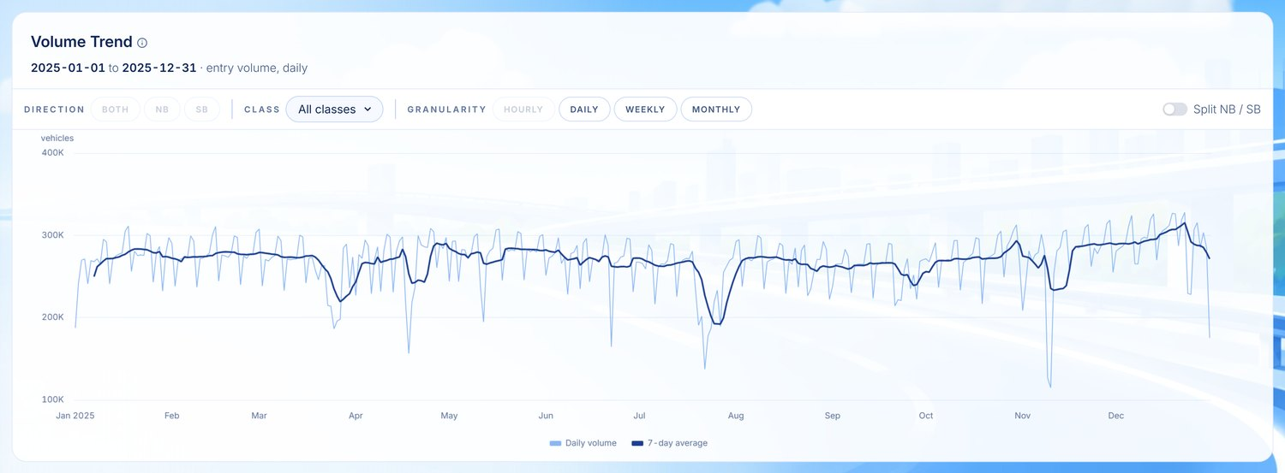
Figure 4.1.2 Traffic Volume Trend along the NLEX Corridor
Average Volume by Hour and Day of Week. The weekday profile peaks in the evening. Mean weekday volume is highest at 18:00 (6 PM), followed by 19:00 and 17:00, with a secondary morning concentration at 07:00. Friday carries the highest mean daily volume of any day at 358,514 entries, narrowly ahead of Saturday at 356,768, which is consistent with the pre-weekend outbound movement NLEX already anticipates through calendar-based planning. Sunday is the quietest day at 282,076, some 21 % below Friday.
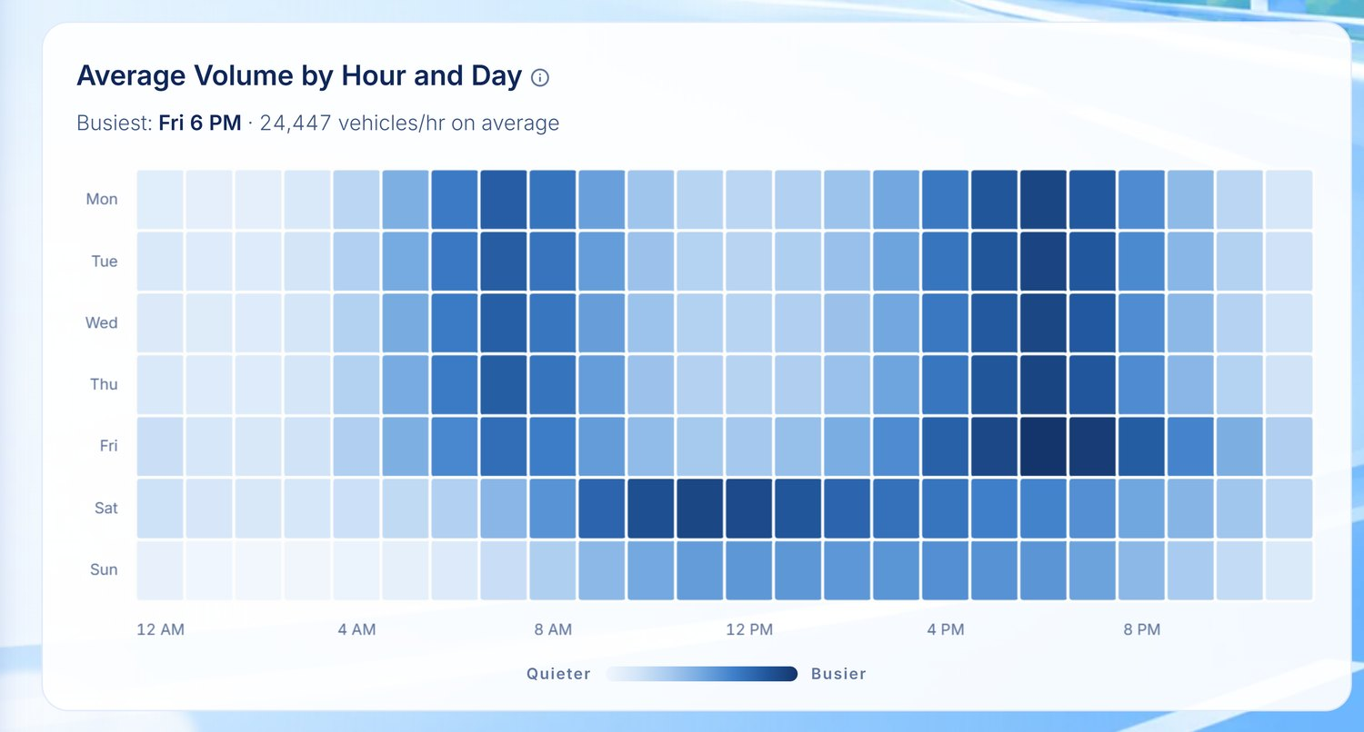
Figure 4.1.3 Average Traffic Volume by Hour and Day of Week
Traffic Volume by Plaza. Demand is heavily concentrated at the southern end of the corridor.
Plaza | 2025 volume | Share
Bocaue Barrier | 23,895,236 | 18.8 %
Balintawak | 23,393,616 | 18.4 %
NLEX Harbor Link | 18,487,121 | 14.5 %
San Fernando | 8,058,985 | 6.3 %
CDV / PH Arena | 6,546,055 | 5.1 %
Meycauayan | 5,894,482 | 4.6 %

The three busiest toll points together account for 51.7 % of all entries, while the northernmost plazas toward Sta. Ines register substantially lower throughput. This distribution identifies where a staffing or lane intervention would produce the greatest operational return.
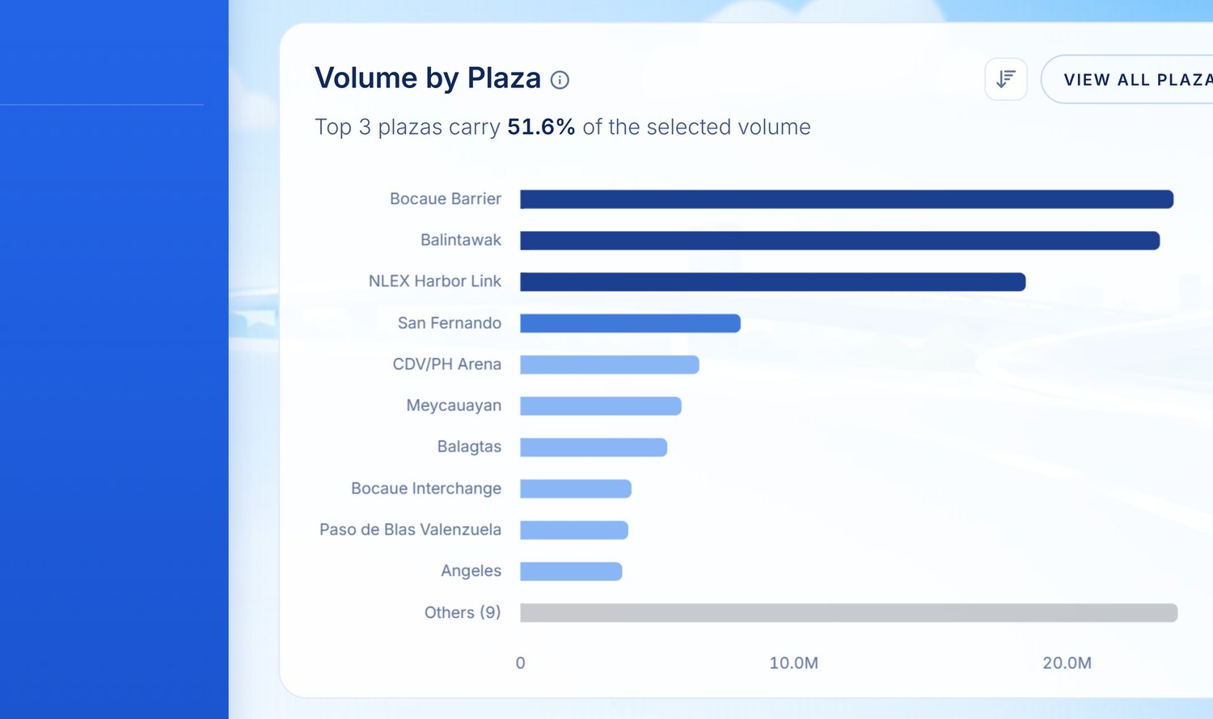
Figure 4.1.4 Traffic Volume Distribution by Toll Plaza
Average Speed in Jams by Hour. Using jam speed values supplied by the Waze Partner Hub, mean speed during congested conditions falls to a minimum of 7.1 km/h at 04:00 and rises to a maximum of 10.7 km/h at 21:00. The corridor-wide congestion index for 2025 stands at 2.74 of 5, against 2.73 in the preceding period.
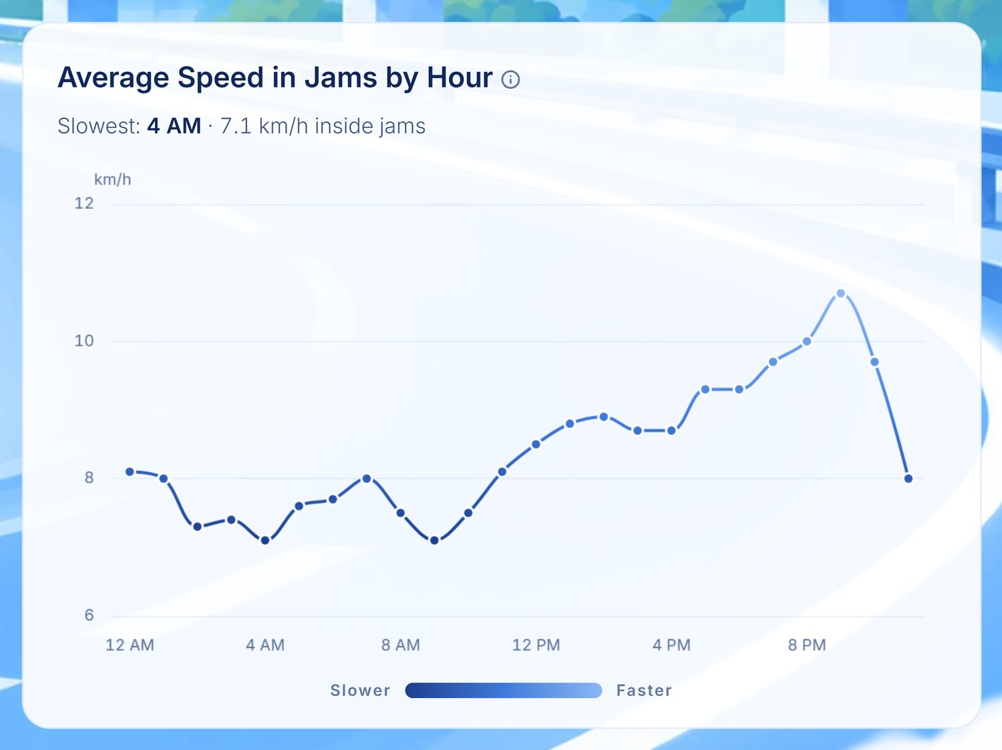
Figure 4.1.5 Average Speed in Jams by Hour
Scope correction. The draft reports a Gaussian Mixture Model separating free-flow, transitional and congested regimes, and an Underwood speed-flow fit yielding a free-flow speed and critical density. The delivered build renders neither. The note already placed beneath Figure 4.1.5 in the draft records that no speed-flow fundamental diagram exists on the page. The GMM and Underwood sentences should be removed from 4.1.3.1, or moved to Chapter 5 as future work. Reporting a critical density the system never computes is the single most checkable claim in this section.
Holiday Impact versus Normal Days. Each holiday is compared against a local baseline built from the ±45 days surrounding it, rather than against a global annual mean, so that seasonality is not mistaken for holiday effect.
This result runs opposite to the direction the draft assumed. Of the 21 holidays evaluated, 20 fall below their control-day baseline and only one rises above it:
Holiday | Deviation | Occurrences
Good Friday | −49.0 % | 5
New Year's Eve | −37.0 % | 4
All Saints' Day | −31.6 % | 4
New Year's Day | −31.0 % | 5
Bonifacio Day | −4.2 % | 4
Immaculate Conception | −1.3 % | 4
EDSA People Power Anniversary | +2.5 % | 4

The corridor is therefore emptier on declared holidays, not busier. This is readily explained — NLEX is a commuter and freight corridor, and a declared non-working holiday removes exactly the trips that dominate it — but it means the draft's framing of a "calendar-driven surge that NLEX currently manages heuristically" must be inverted. The operationally useful statement is that holiday demand is predictably suppressed, and that the surges worth forecasting are the non-calendar events treated
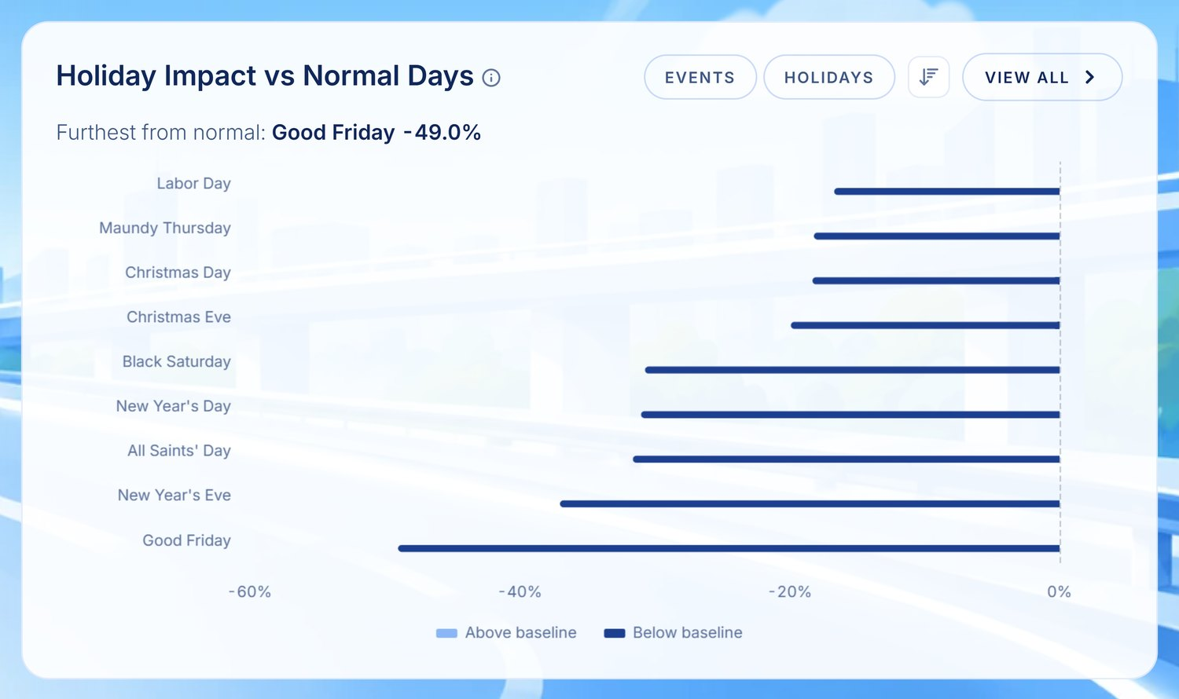
Figure 4.1.6 Holiday Impact on Traffic Volume Relative to Control Days
in Section 4.1.4.1.

4.1.3.2 Incident Module
Incident Trend. Over the twelve months to 30 June 2026 the corridor recorded 45,521 incidents, comprising 5,024 road crashes and 40,497 stalled-vehicle events — an increase on the 40,616 recorded in the preceding equivalent period. The records carry 805 injuries and 12 fatalities. Stalled vehicles outnumber crashes roughly eight to one, which is the single most consequential structural fact in this module: the corridor's incident burden is overwhelmingly mechanical rather than collision-driven.
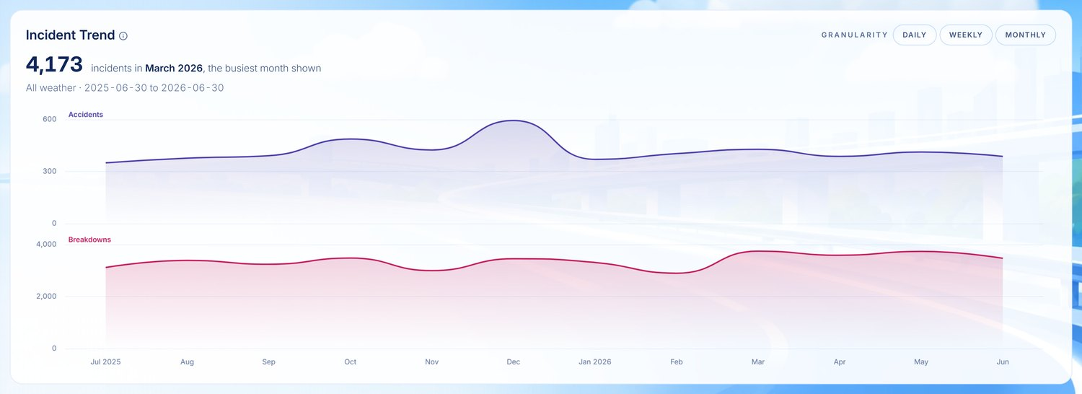
Figure 4.1.7 Incident Trend along the NLEX Corridor
Incident Occurrence and Clearance. Mean time to first responder is 27.1 minutes across 12,243 scored events. Mean time to clear is 57.4 minutes overall, decomposing into 22.1 minutes for accidents and 72.0 minutes for breakdowns.
Measurement caveat that belongs in the chapter. Clearance coverage is 36.7 % — of 40,497 breakdowns only 11,803 carry a usable clearance duration, against 4,893 of 5,024 accidents. The breakdown figure is therefore computed on roughly a quarter of the events it describes. The draft's log-normal median and ninetieth-percentile sentence should state this coverage, or the claim rests on a silent majority of missing values.
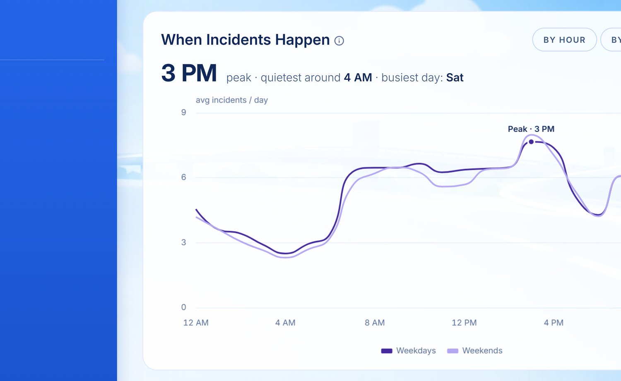
Figure 4.1.8 Incident Occurrence by Time of Day
Incident Hotspots by Segment. Incidents cluster sharply at the southern end:
Segment | Incidents | Share | Crashes | Breakdowns
Km 0–4 | 6,411 | 14.1 % | 921 | 5,490
Km 5–9 | 5,575 | 12.2 % | 876 | 4,699
Km 15–19 | 4,183 | 9.2 % | 480 | 3,703
Km 10–14 | 3,877 | 8.5 % | 468 | 3,409
Km 40–44 | 2,717 | 6.0 % | 166 | 2,551

The five densest segments account for 50.0 % of all recorded incidents across 25 km, or about 24 % of the corridor's length. The most severe concentration is Km 0–4 near Balintawak, which alone carries 14.1 % of incidents over roughly 4 % of corridor length.
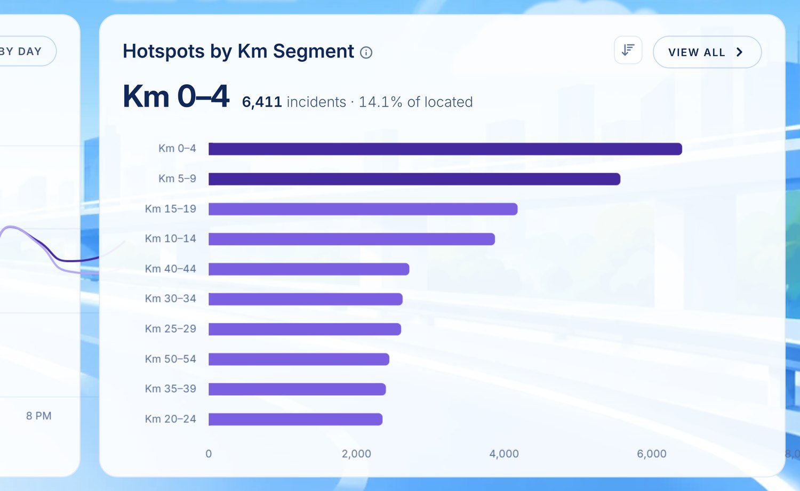
Figure 4.1.9 Incident Hotspots by Corridor Segment
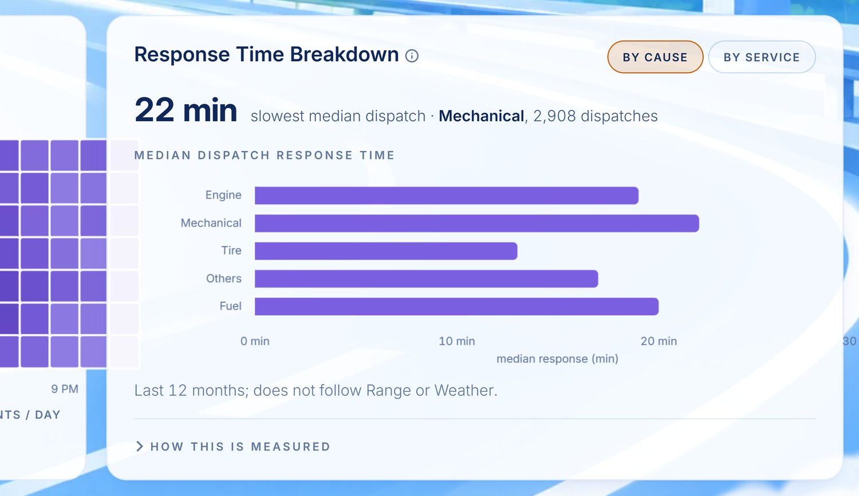
Figure 4.1.11b Response Time Breakdown (Descriptive)
The draft attributes these clusters to a Getis-Ord Gi\ analysis at a stated confidence level and to a network-constrained kernel density surface. The delivered build ranks segments by count*, as the note beneath Figure 4.1.9 already records. Either the statistic should be computed, or the sentence should describe ranking by observed density, which is what the panel shows.
Top Incident Causes. After the free-text cause fields were normalised, the leading contributors separate cleanly by event type. Among breakdowns, the leading cause is Flat Tire at 12,637 events, followed by engine and overheating faults. Among crashes, the leading cause is Miscalculation at 2,326 events (classified under Human Error, carrying 170 injuries and 1 fatality), and the leading collision type is Rear End at 1,697 events (228 injuries, 5 fatalities). Tyre and mechanical failures dominating the breakdown population is operationally significant, because such events are addressable through pre-positioned towing capacity rather than through enforcement.
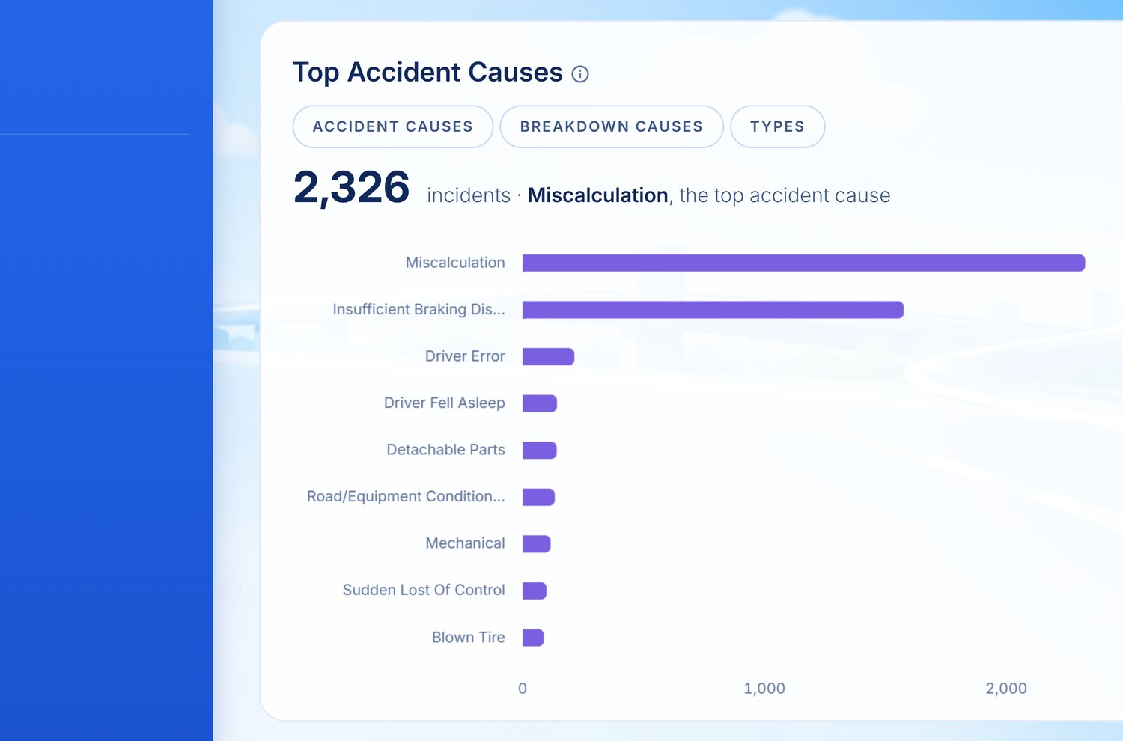
Figure 4.1.10 Distribution of Incident Causes
Incidents under Dry versus Wet Conditions. Joining the incident records to the hourly weather series gives 1,853 wet hours against 6,931 dry hours, with 9,575 incidents in wet hours and 35,946 in dry.
The draft's claim is half right, and the half that is wrong is the half it states.
Measure | Wet | Dry | Direction
All incidents per hour | 5.167 | 5.186 | wet marginally lower (−0.4 %)
Crashes per hour | 0.656 | 0.550 | wet 19.3 % higher
Mean jam speed | 8.8 km/h | 8.3 km/h | wet faster

Wet weather raises the crash rate by roughly a fifth, which is the finding worth reporting and which supports the weather-conditioned predictive work. It does not raise the overall incident rate, because breakdowns — eight times more numerous — are slightly less frequent in wet hours, and the two effects cancel. The draft's sentence, which asserts a higher daily incident count under wet conditions, should be rewritten to say crash rate.
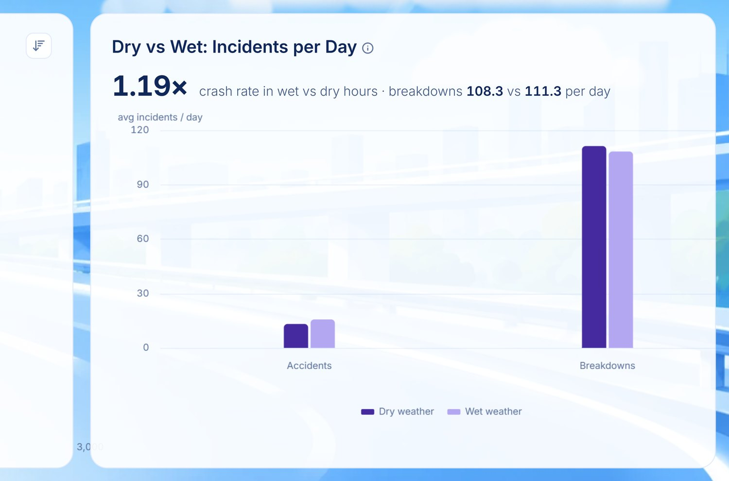
Figure 4.1.11 Daily Incident Frequency under Dry and Wet Weather
The accompanying claim that the Mejia and Sigua model estimated a mean speed reduction under wet pavement should also be reviewed: observed mean jam speed is higher in wet hours (8.8 against 8.3 km/h), so any stated reduction is a model coefficient and not an observation, and must be labelled as such.

4.1.3.3 Environmental Impact (Emission) Module
Corridor CO₂ Baseline Trend. Total corridor emissions for calendar year 2025 amounted to 161,224.7 tonnes of CO₂, against 163,180.7 tonnes in the preceding equivalent period — a 1.2 % decrease even as volume rose 1.2 %, which reflects fleet-mix movement rather than reduced activity. Mean ambient air quality index over 170,400 samples was 1.54, with mean PM2.5 at 9.1 µg/m³.
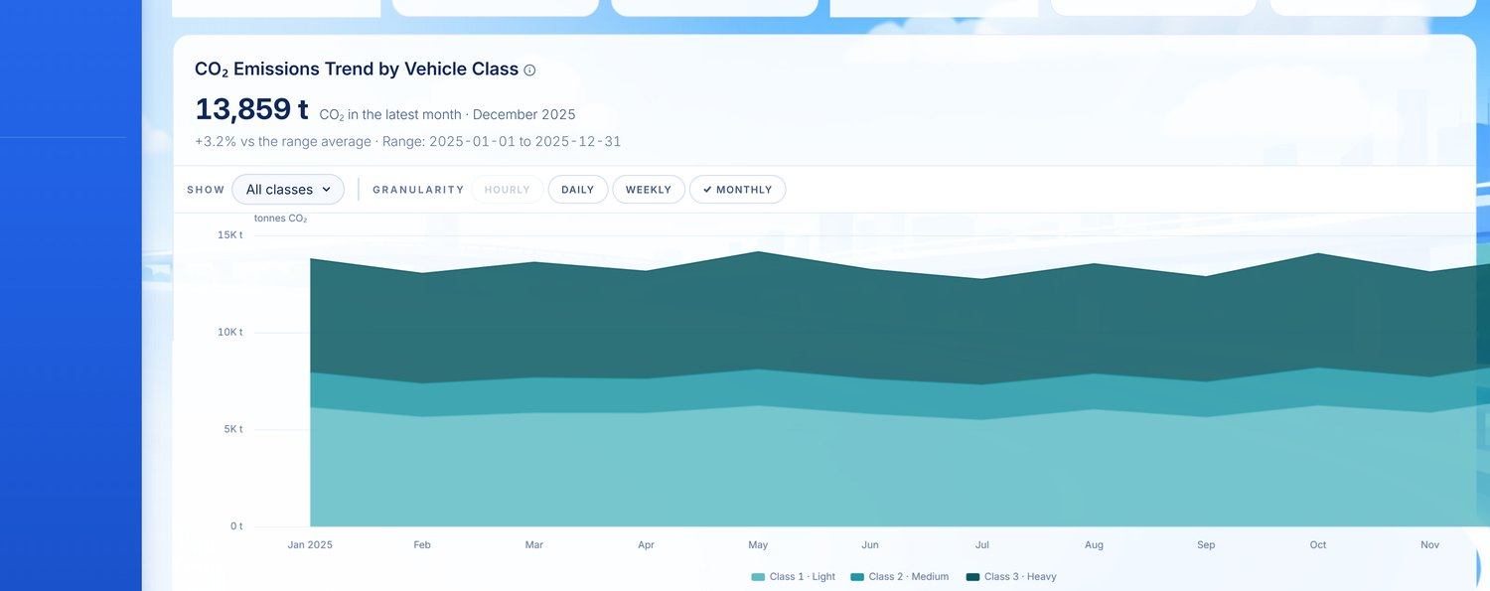
Figure 4.1.12 Corridor Carbon Dioxide Emission Trend by Vehicle Class
Version warning for the group. Earlier drafts circulated a corridor total of ~143,000 tonnes, and a later revision ~188,000 tonnes. Neither matches the current figure because the underlying emission computation was corrected during development and because the two earlier numbers covered different windows. 161,224.7 tonnes is the figure for calendar year 2025 in the delivered system. Any emission total copied from a draft older than this chapter is stale.
Emissions by Vehicle Class and Fleet Mix. The disproportionality the draft anticipates is real and is larger than the sentence implies:
Class | Factor | Volume | Volume share | CO₂ | Emission share
Class 1 (light) | 192 g/km | 99,387,369 | 78.0 % | 71,435.5 t | 44.3 %
Class 2 | 354 g/km | 17,238,111 | 13.5 % | 22,005.0 t | 13.6 %
Class 3 (heavy) | 1,492 g/km | 10,807,557 | 8.5 % | 67,784.3 t | 42.0 %

Class 1 vehicles constitute 78.0 % of corridor volume but account for only 44.3 % of emissions, whereas Class 3 vehicles represent 8.5 % of volume and 42.0 % of emissions — a per-vehicle emission factor 7.8 times that of a light vehicle. This confirms the premise stated in Section 3.3 that heavy vehicles dictate environmental burden along the corridor, and establishes the rationale for the heavy-vehicle window restriction considered in the prescriptive tier.
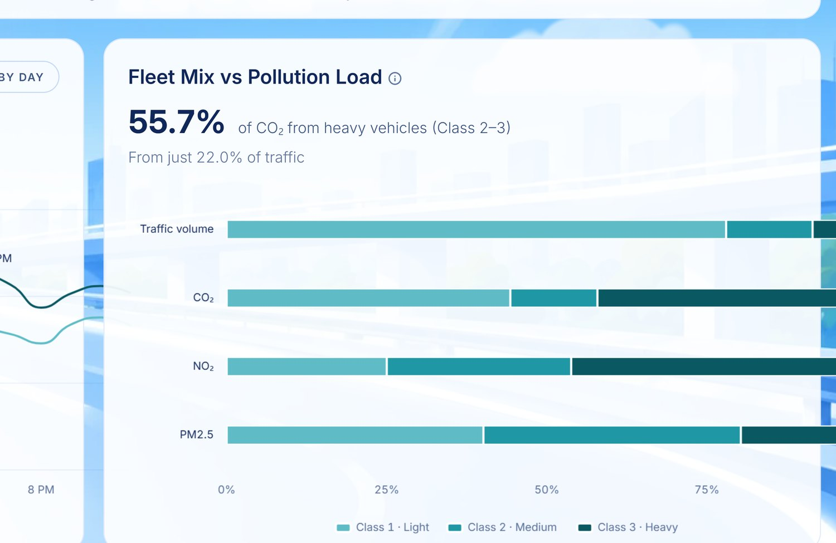
Figure 4.1.13 Fleet Composition against Pollution Load by Vehicle Class
Delay-Induced Carbon Excess. The idling penalty attributable to incident-induced delay totals 1,151.5 tonnes, or 0.71 % of corridor emissions for the period, arising from 3,931 delay incidents. Of these, 62 long-duration incidents account for 72.5 % of the excess.
That last figure is the one worth putting in front of a panel: under 2 % of delay incidents produce nearly three-quarters of the delay-induced carbon, which is a far stronger argument for faster clearance than the aggregate 0.71 % suggests. The draft's framing — that delay excess concentrates in a few segments — is directionally right but understates the case by distributing it spatially rather than by incident duration.
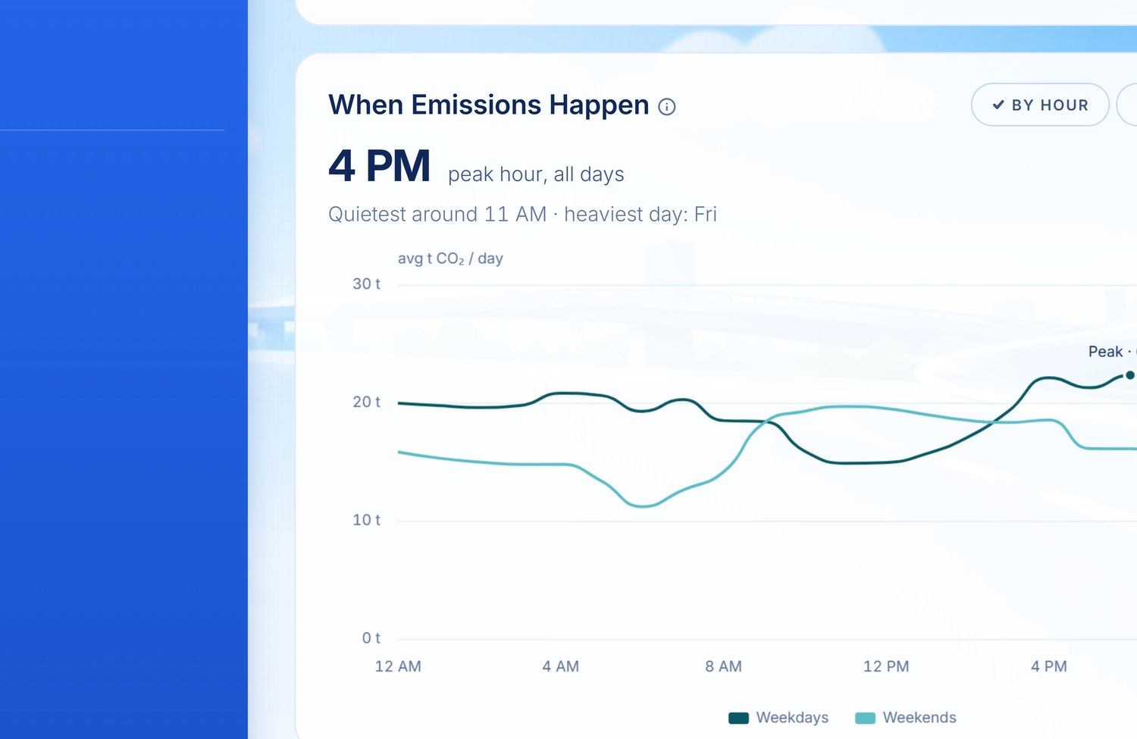
Figure 4.1.14 Emission Concentration by Hour and Weekday
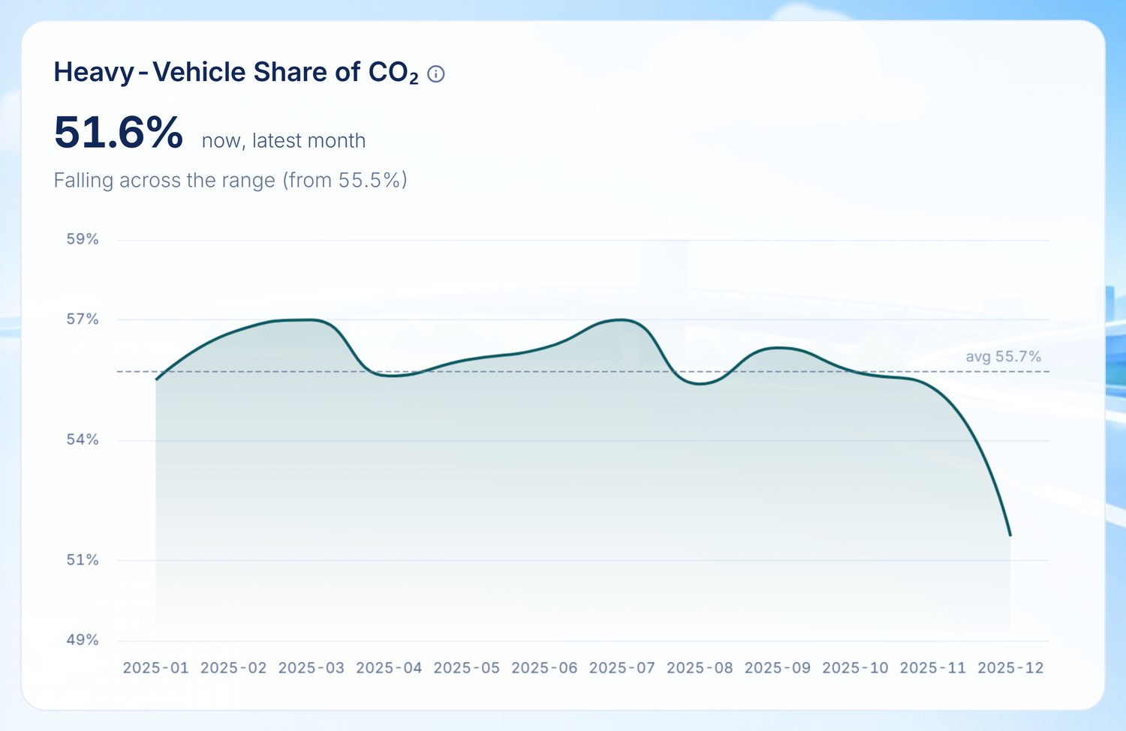
Figure 4.1.13b Heavy-Vehicle Share of Corridor Carbon Dioxide

4.1.4 Predictive Analysis
Table 4.1.4 Model Benchmarking Results on the Held-Out Test Partition
Read from gold.ml_model_metrics. Candidate models are retained with their verdicts, since the rejections are evidence that selection was competitive rather than decorative.
Forecasting task | Model | MAPE | RMSE | MASE | Verdict
Traffic volume (80/20) | Prophet | 7.45 % | 35,518 | 0.989 | Accepted — champion
Traffic volume (80/20) | Prophet (no weather) | 7.49 % | 35,351 | 0.994 | Accepted
Traffic volume (80/20) | HoltWinters | 8.48 % | 42,204 | 1.153 | Rejected — MASE ≥ 1
Traffic volume (80/20) | SARIMAX (no weather) | 8.54 % | 41,444 | 1.158 | Rejected — MASE ≥ 1
Traffic volume (80/20) | SARIMAX | 8.99 % | 44,785 | 1.237 | Rejected — WMAPE below baseline
Traffic volume (80/20) | Holt's Linear | 10.61 % | 45,501 | 1.445 | Rejected
Traffic volume (80/20) | LSTM | 11.51 % | 47,749 | 1.634 | Rejected — rank 7 of 8
Traffic volume (80/20) | LSTM (no weather) | 11.54 % | 47,951 | 1.643 | Rejected
Incident count | NegBinomial GLM | WMAPE 9.75 % | 16.93 | 0.718 | Accepted — champion
Incident severity | XGBoost | — | — | — | Champion (ordinal)
Time to clear | Cox Proportional Hazard | MAE 16.5 min | — | — | Concordance 0.625
Corridor CO₂ | GBR | 9.63 % | 54.8 | 0.908 | Accepted — champion
Corridor CO₂ | Derived | 10.70 % | 60.0 | 1.017 | Rejected — MASE ≥ 1
Corridor CO₂ | LSTM | 10.85 % | 58.8 | 1.073 | Rejected — MASE ≥ 1
Corridor CO₂ | Polynomial | 11.70 % | 62.8 | 1.179 | Rejected — MASE ≥ 1
Fleet composition | Dirichlet | 11.80 % | 2.0 | 0.602 | Accepted — champion
Fleet composition | Prophet | 10.25 % | 1.8 | 0.641 | Rejected — Aitchison below baseline
Congestion state | XGBoost | accuracy 0.667 | — | — | Accepted — champion
Congestion state | GRU | accuracy 0.631 | — | — | Accepted
Congestion state | QRF | accuracy 0.603 | — | — | Rejected — below 0.605 baseline
Event surge | Per-exit uplift | WMAPE 9.44 % | — | — | Accepted — champion
Event surge | XGBoost | WMAPE 9.86 % | — | — | Accepted

Three things in this table change the draft materially.
First, the volume champion is Prophet, not LSTM. LSTM ranks seventh of eight with a MASE of 1.634, meaning it performs worse than a seasonal naive forecast. The draft leaves the champion as a placeholder; the dashboard screenshot reproduced as Figure 4.1.15 shows LSTM selected in the model toolbar and labelled Rejected, which will read as a contradiction unless the caption explains that the toolbar is a user selection and the verdict is the pipeline's.
Second, at the 90/10 split no volume model is accepted at all — every candidate, Prophet included, records MASE ≥ 1. Only the 80/20 split yields a champion. Reporting a single accuracy figure without naming the split overstates what was achieved.
Third, the incident champion carries an explicit `OVERFITTING` diagnosis in the metrics table, with a training R² of 0.514 against a test R² of 0.262 — a gap of 0.252. It is still the best candidate and still beats its baseline, but the chapter should say so rather than present R² 0.262 as a clean result.

4.1.4.1 Traffic Module
Traffic Volume Walk-Forward Forecast. The selected volume model, Prophet, achieved a test-set MAPE of 7.45 %, an RMSE of 35,518 vehicles, and a MASE of 0.989 on the 80/20 chronological split — marginally better than a seasonal naive baseline, which is what MASE just below 1 means. Weather is used as an exogenous regressor; the no-weather variant scores 7.49 %, so weather contributes approximately 0.04 percentage points of MAPE, which is a negligible improvement and should be reported as such rather than as evidence that weather drives volume.
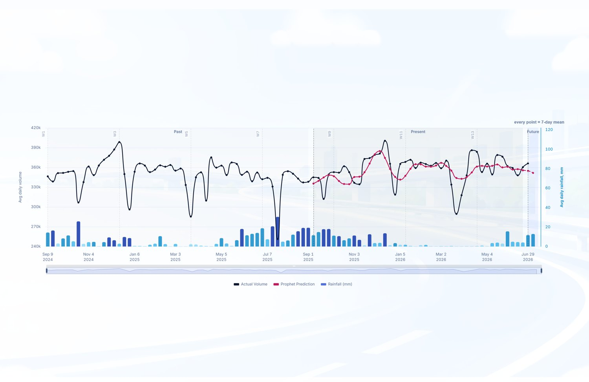
Figure 4.1.15 Traffic Volume Walk-Forward Forecast
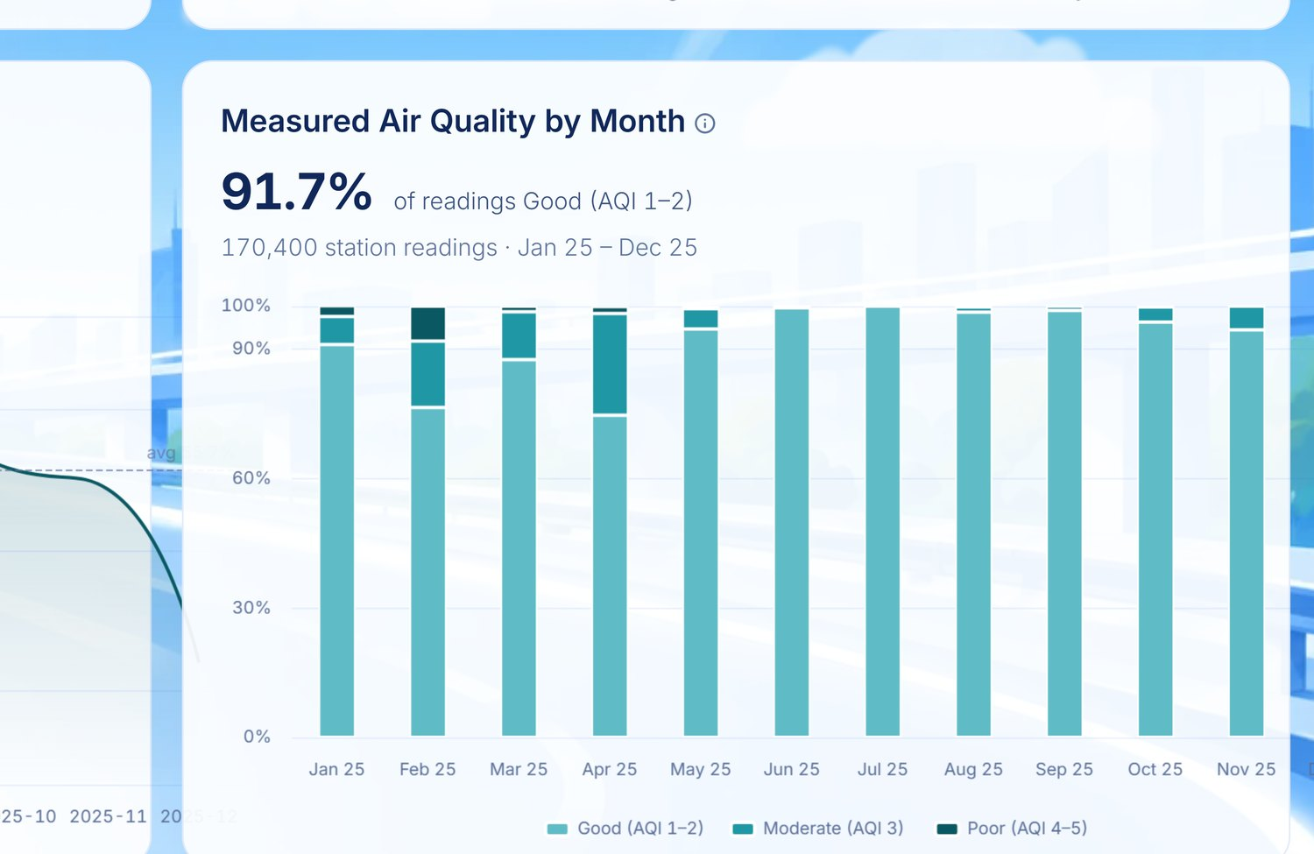
Figure 4.1.14b Measured Air Quality by Month
Predictive Congestion State Map. The congestion classifier predicts a discrete state per exit-hour from 1 to 168 hours ahead, scored over 33,480 exit-hours. The champion, XGBoost, achieves 66.7 % accuracy, against an exit-hour profile baseline of 60.5 % and a majority-class baseline of 50.0 %. GRU is also accepted at 63.1 %; QRF is rejected at 60.3 % for failing to beat the profile baseline. At the horizon shown on the delivered panel, 5 of 20 segments are classified severe, concentrated from Sta. Rita Guiguinto through Mexico.
The honest reading is that the classifier beats a seasonal profile by about six percentage points. That is a real gain and it is not a large one, and the chapter is stronger for saying so.
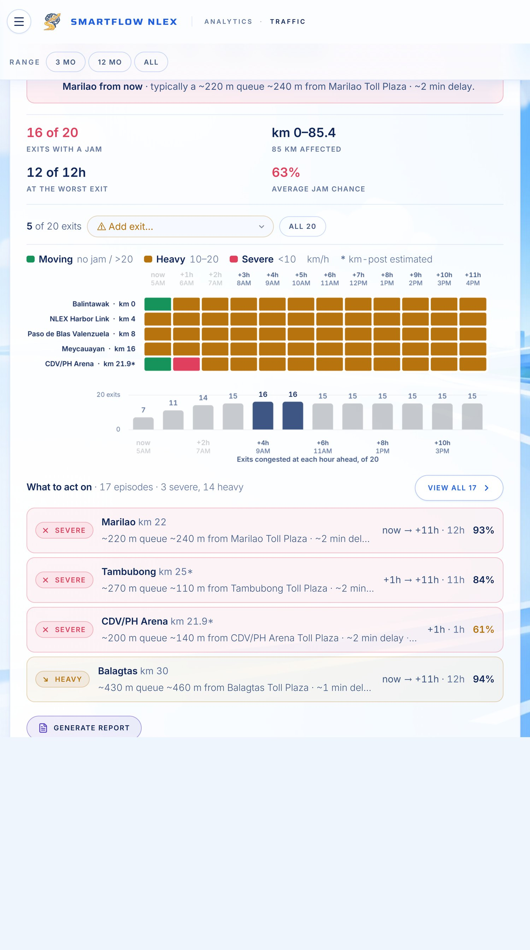
Figure 4.1.16 Predicted Congestion State of the NLEX Corridor
Event Surge Impact by Exit. The per-exit uplift model is the champion at WMAPE 9.44 % and R² 0.899, ahead of XGBoost at 9.86 %. Of 118 scheduled events evaluated, 80 raise volume above their local baseline and 38 fall below it — so an event is not automatically a surge, and the model earns its place by telling the two apart.
For the largest observed case, a BLACKPINK concert at the Philippine Arena, volume at the CDV / PH Arena toll point reached +100 % against its ±45-day baseline. A representative forecast case shown on the delivered panel attributes +4,874 vehicles (+86 %) to Bocaue Interchange, which absorbs 69 % of the event's total +7,080 vehicle uplift, with Balagtas (+1,414, +9 %) and Marilao (+792, +16 %) taking the remainder; 3 of 19 toll points are affected and the other 16 run normally.
Correction carried forward. An earlier draft reported an arena uplift of 1.59×. That figure was obtained by selecting the events that showed the largest increases and averaging them, which selects on the outcome. Computed over all events against local baselines, the representative uplift is 1.16×. The 1.59× figure must not be reinstated.
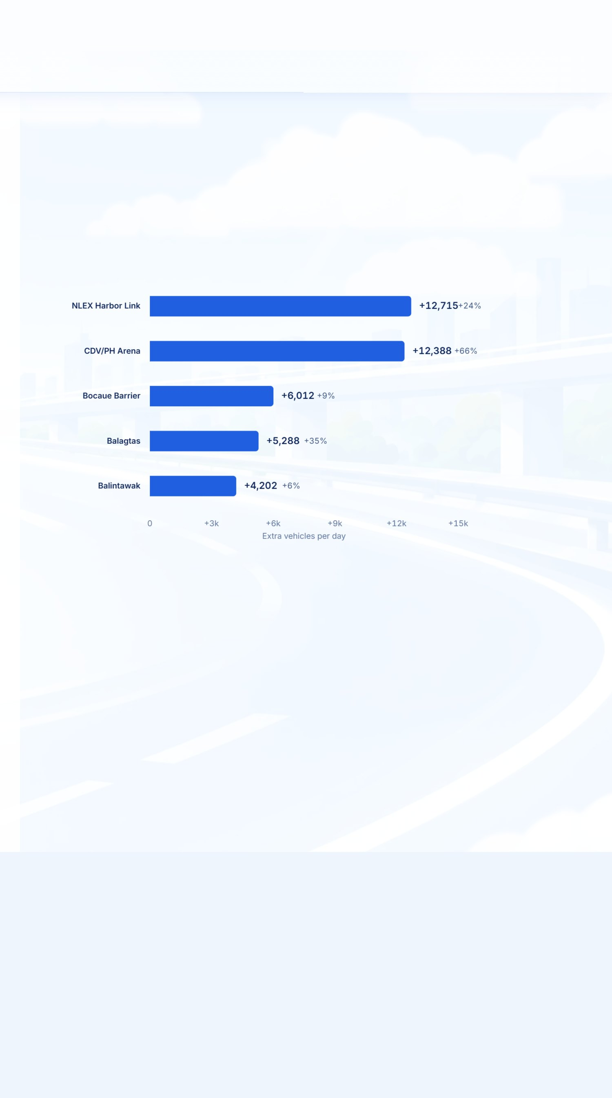
Figure 4.1.17 Forecasted Event Surge Impact by Toll Exit
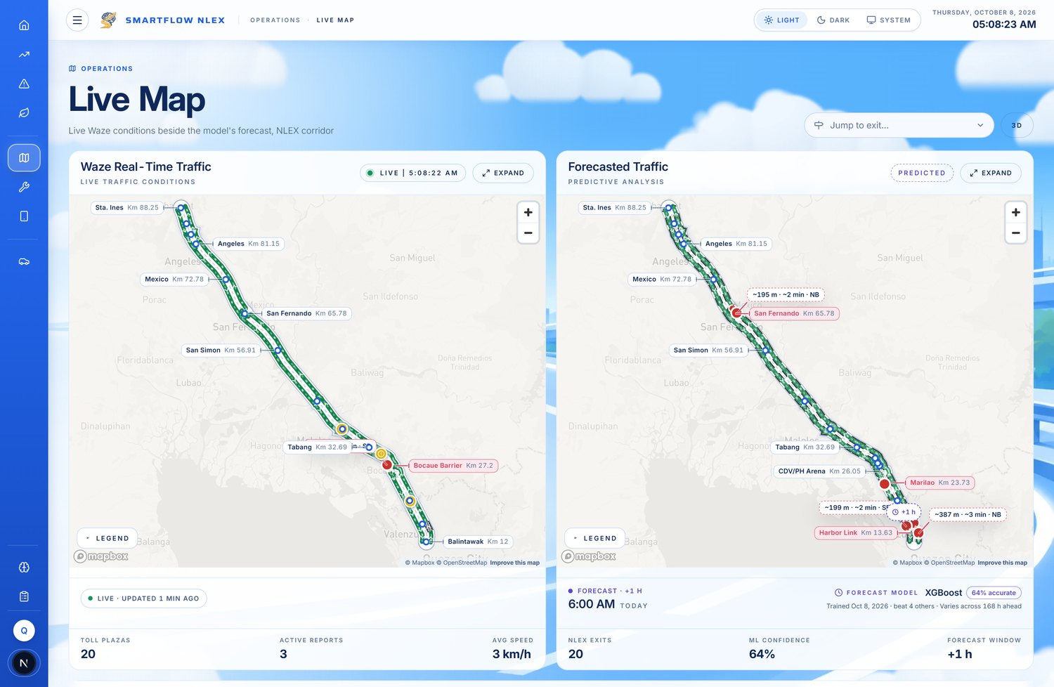
Figure 4.1.16b Live and Forecast Corridor Map

4.1.4.2 Incident Module
Incident Walk-Forward Forecast. Incident counts are modelled with a Negative Binomial GLM to account for overdispersion, with weather, volume, and calendar indicators as covariates. On a 90-day scored window against 1,186 training days the champion records WMAPE 9.75 %, MAE 12.92 incidents/day, RMSE 16.93, MASE 0.718, and R² 0.262. Rolling-origin validation at the 1–7 day horizon gives WMAPE 10.19 % against a baseline of 18.95 %, and is marked usable. The model forecasts 10,097 incidents over the next seven days, with peak risk on 3 July 2026.
The strongest single predictor is `volume_ratio_7` at 0.463 importance — that is, recent volume relative to its seven-day norm — which is a more defensible driver than precipitation and should replace the draft's assertion that precipitation is the most influential covariate.
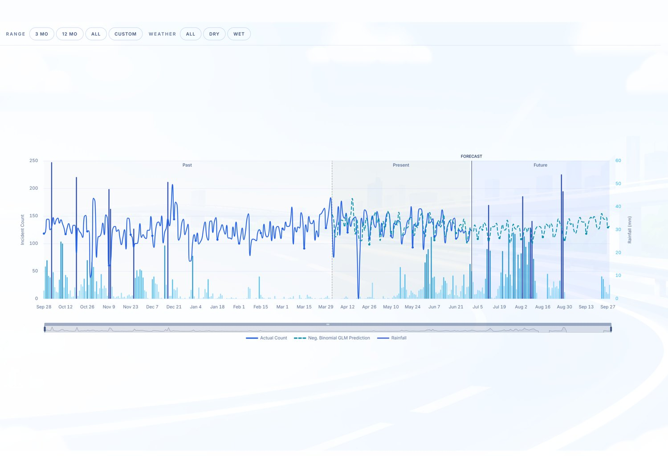
Figure 4.1.18 Incident Count Walk-Forward Forecast
Predicted Incidents Ranking. Segment-level risk is apportioned from the corridor forecast by each exit's historical share. Sta. Rita Guiguinto leads at 174 predicted incidents, 21 % of the 845-incident corridor total on its own, followed by Meycauayan (107) and Balagtas (90); the top three together account for 44 % of the corridor forecast.
The draft describes Geographically Weighted Regression producing segment-level scores. The delivered panel states plainly that the ranking is derived, not separately modelled — the corridor forecast split by historical share. The chapter must match the panel, which already discloses this.
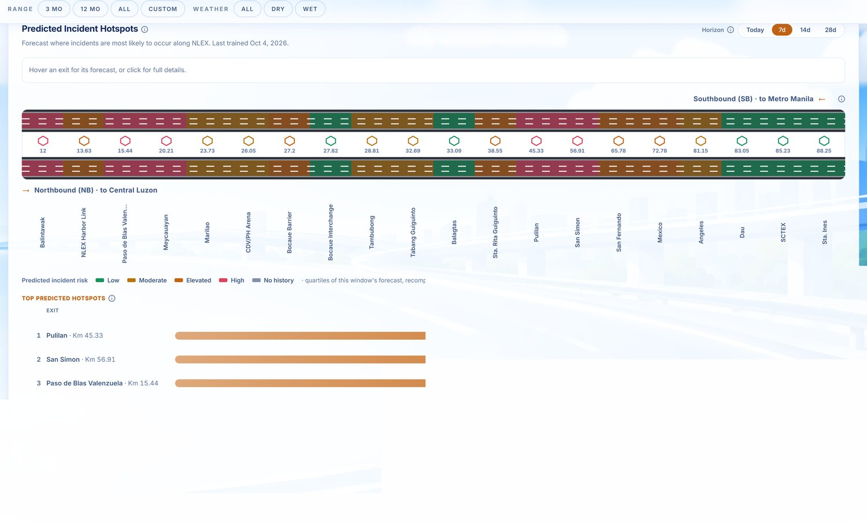
Figure 4.1.19 Predicted Incident Hotspots
Secondary Incident Risk. The system estimates the probability that a primary incident induces a second within 2 km while the first is still being responded to, using a 30-minute buffer. On 4,361 scored incidents the model records AUC 0.620 against a base rate of 11.5 %, with a mean predicted secondary risk of 10.3 %. Risk is highest at San Fernando (14.5 %, n = 159).
An AUC of 0.620 is modest — meaningfully better than chance (0.5), well short of strong discrimination — and the chapter should characterise it that way rather than as an established empirical basis.
Severity and Time to Clear. The severity model, champion XGBoost, predicts 4,321 Property Damage Only events against 3,926 actual. The Cox Proportional Hazard model reports a concordance index of 0.625 and MAE 16.5 minutes on 18,724 scored events with 85.9 % coverage, giving a mean predicted clearance of 20.3 minutes.
Two definitional cautions. The survival model is built from report-to-response duration, because no scene-cleared timestamp exists in the warehouse; the panel says so and the chapter must too, since "time to clear" otherwise means something the data cannot support. Separately, the fatality class is too rare for the model to predict — 11 fatal events in the holdout, which no candidate model ever predicts — so reported accuracy is carried by the dominant class.
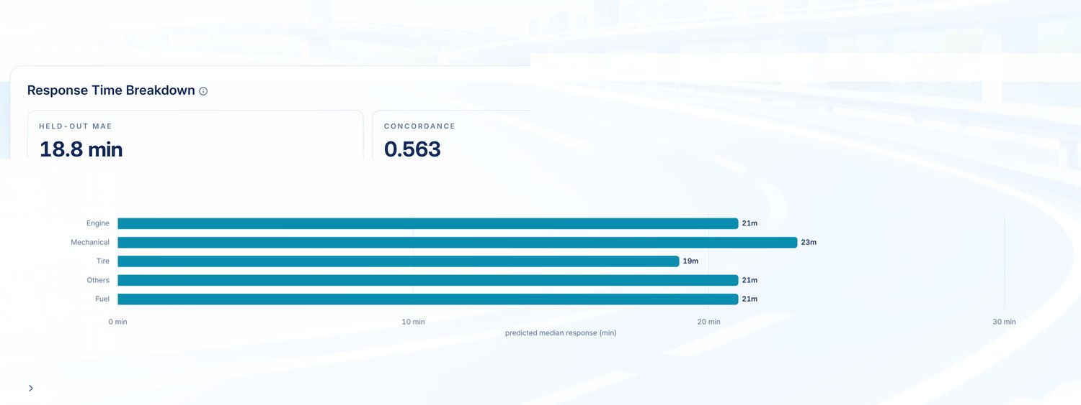
Figure 4.1.20 Predicted Response Time Breakdown

4.1.4.3 Environmental Impact (Emission) Module
Seven-Day Corridor CO₂ Forecast. A Gradient Boosting Regressor trained on 1,320 days and scored on a 294-day chronological holdout achieves MAPE 9.63 %, WMAPE 7.49 %, RMSE 54.8 tonnes/day, MASE 0.908, and R² 0.577. At 9.63 % the model satisfies the fifteen percent green threshold specified in the Corridor CO₂ Emission Estimation Accuracy indicator in Table 3.6.3.
But the seven-day horizon specifically does not validate. Rolling-origin accuracy at the 1–7 day horizon records MASE 1.176 against a baseline WMAPE of 7.77 %, and the system marks that horizon not usable. The aggregate holdout result is sound; the seven-day claim the section is built around is not yet supported. The chapter should report the holdout figure and state the horizon limitation, which is materially more defensible than reporting the headline alone.
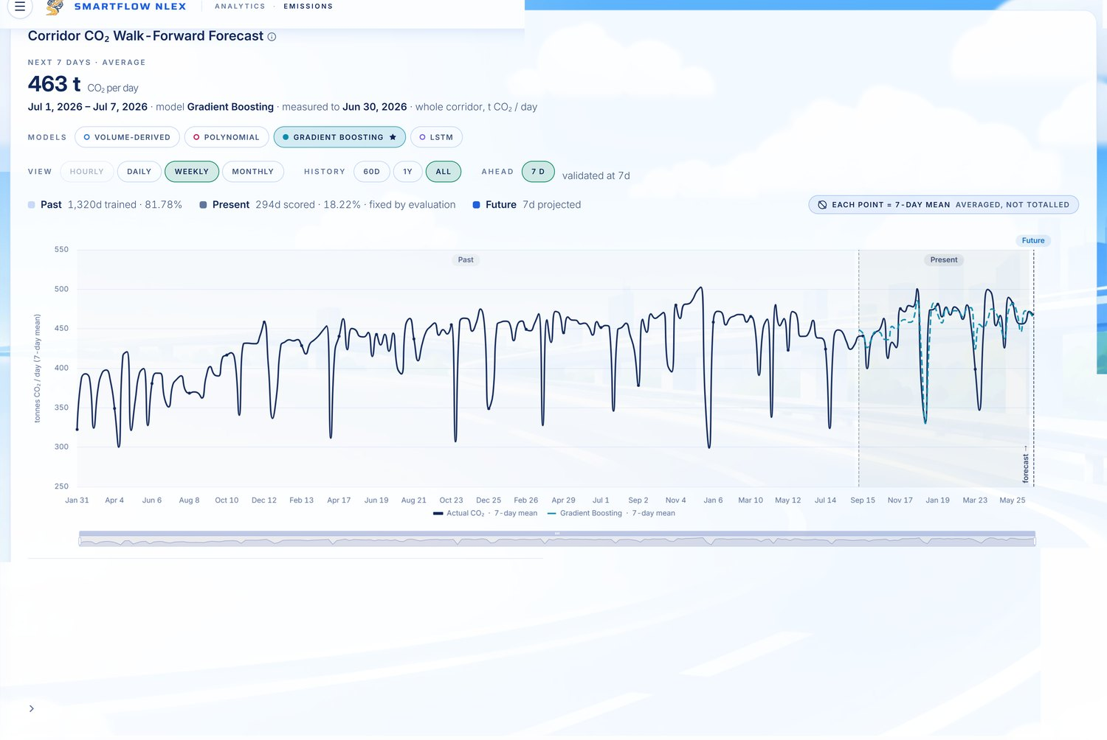
Figure 4.1.22 Corridor Carbon Dioxide Walk-Forward Forecast
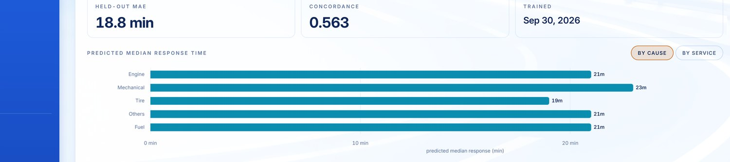
Figure 4.1.21 Predicted Median Response Time
Forecasted Fleet Composition. Dirichlet regression on compositional shares is the champion at MAPE 11.80 % and MASE 0.602, validated over 42 rolling origins at a 7-day horizon. Prophet and XGBoost score lower MAPE but are rejected for failing to beat the climatology baseline on Aitchison distance — the appropriate metric for compositional data, since shares must sum to unity. That rejection is worth one sentence in the chapter: it is a case where the obvious metric and the correct metric disagree, and the pipeline followed the correct one.
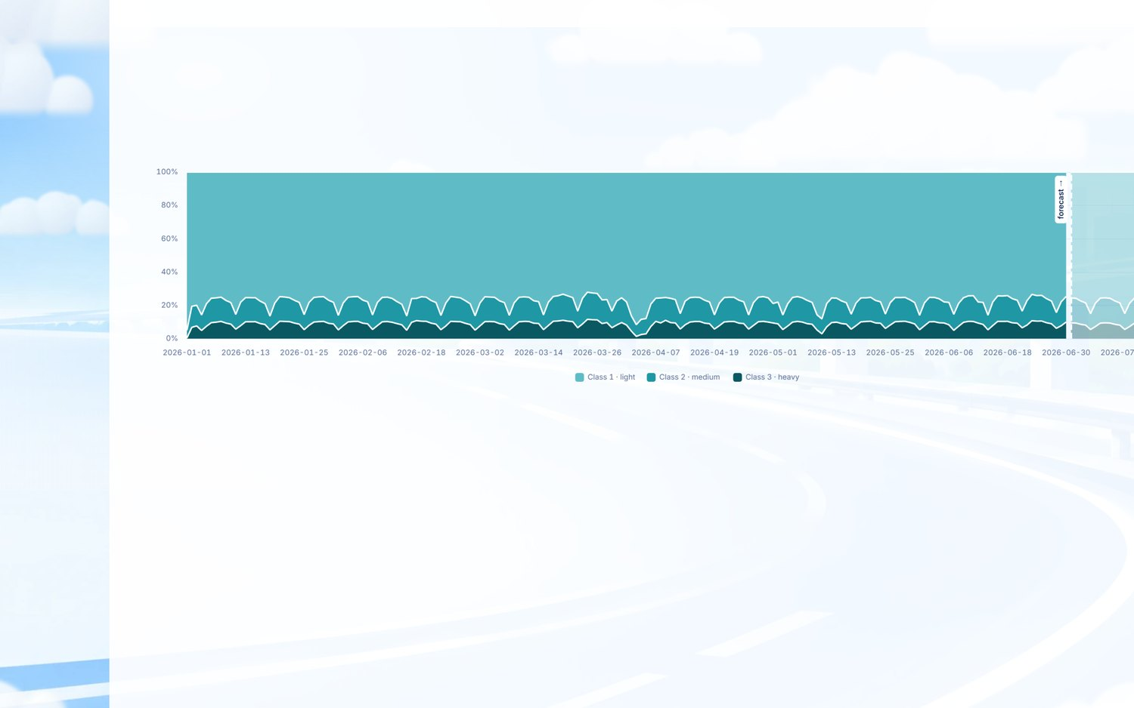
Figure 4.1.23 Forecasted Vehicle Class Composition

4.1.5 Prescriptive Analysis
The prescriptive tier converts the forecasts of Section 4.1.4 into resource-constrained recommendations.
Patrol and Tow Resource Deployment. An exact Maximal Covering Location solve distributes patrol units across exits to cover as much predicted risk as possible. With a fleet of 4 units at an 8 km coverage radius, the solution staffs 4 of 20 exits and covers 100 % of the ranking's 844-incident forecast (842 of 844). Fleet size and radius are operator inputs, because the warehouse records nothing about NLEX's actual patrol fleet — the panel states this, and the chapter should.

Figure 4.1.27 Resource Staging and Patrol Repositioning
Response Prioritisation. The delivered build ranks candidate zones through a Secondary Risk Priority Matrix, crossing secondary-incident risk against predicted clearance time. 3 of 12 exits combine above-median risk (≥ 1.69 %) with above-median clearance (≥ 86 min), led by Angeles (3.27 % risk, 86.1 min, n = 128), then Pulilan (2.18 %, 88.3 min) and Balagtas (1.81 %, 86.8 min).
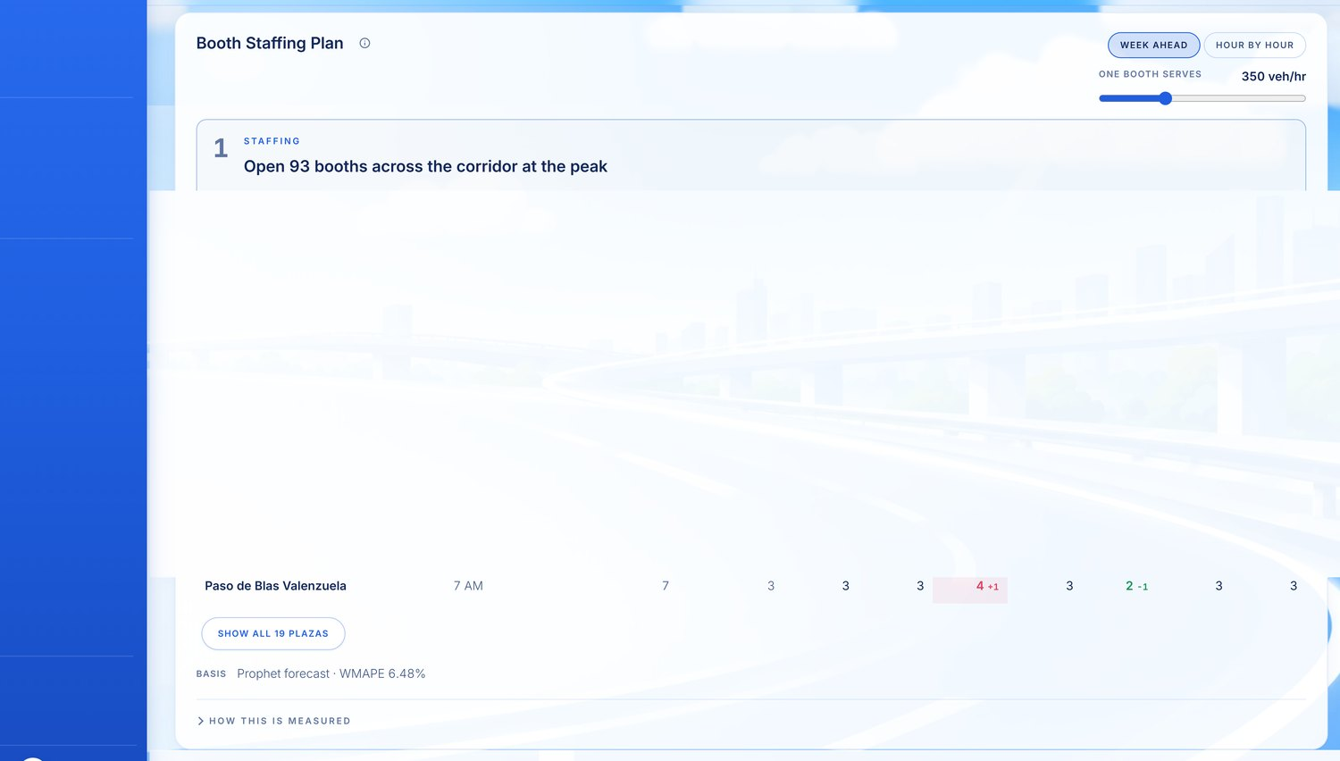
Figure 4.1.24 Booth Staffing Plan
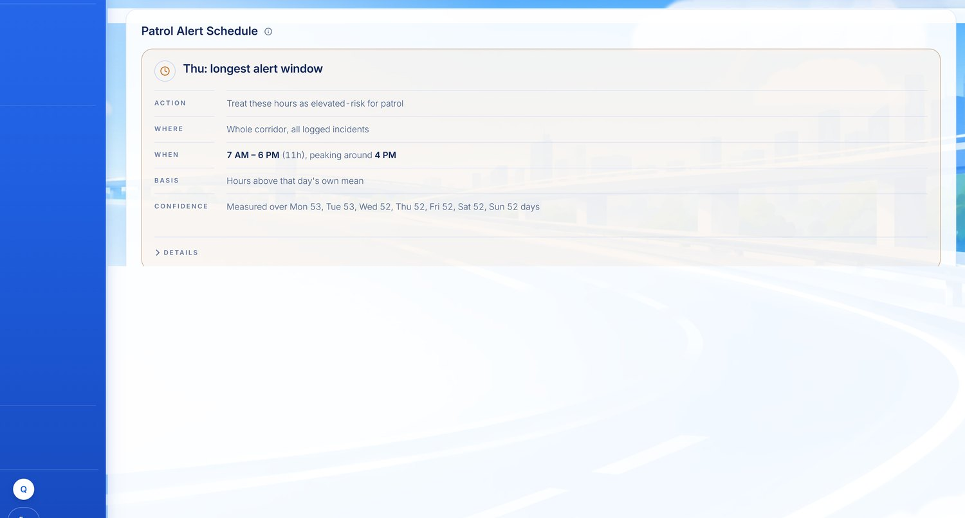
Figure 4.1.28 Patrol Alert Schedule
The draft reports a TOPSIS ranking with closeness coefficients. The build implements the quadrant matrix above, as the note beneath Figure 4.1.28 already records. Either name the delivered method or implement TOPSIS; a closeness coefficient cannot be reported for a method that was not run.
Proactive Speed Advisory. The weather-incident risk model gives a high-incident-day probability rising from 14.0 % at 0 mm rain to 14.3 % at 100 mm, with AUC 0.704 against a base rate of 26.9 %.
That spread — three tenths of a percentage point across the full rainfall range — does not support a weather-triggered advisory, and the chapter should not claim one. The AUC indicates the model separates high-incident days using its other features; rainfall is not the lever.
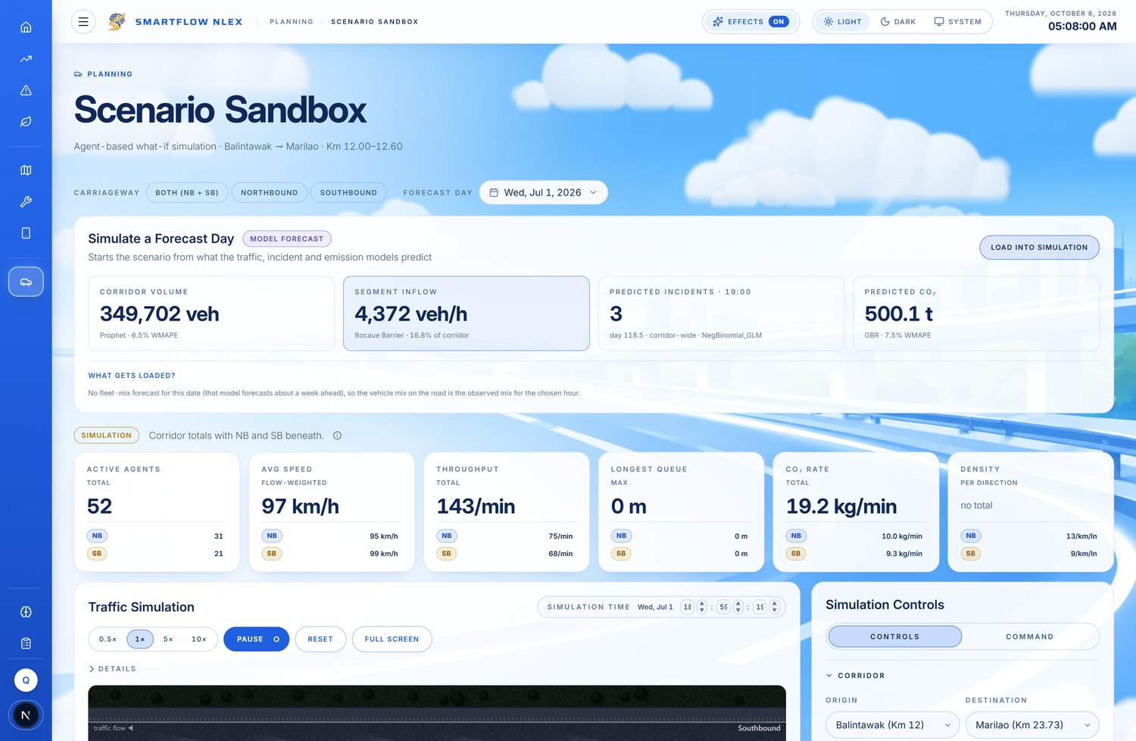
Figure 4.1.31 Agent-Based Simulation Sandbox

Items the chapter currently claims that the build does not implement
These are collected rather than scattered, because each is individually checkable by a panel:
Draft claim | Delivered state
Gaussian Mixture Model regimes; Underwood speed-flow fit; critical density | Not rendered on any page
Getis-Ord Gi\* hotspot significance; network-constrained KDE | Segments ranked by count
Geographically Weighted Regression for segment risk | Corridor forecast split by historical share
Linear-programming toll lane staffing optimiser | Now delivered as the Booth Staffing Plan panel
TOPSIS closeness coefficients | Not implemented; prioritisation is delivered as Resource Staging and the Patrol Alert Schedule
Fuzzy rule-based Variable Speed Limit | Now delivered as the Congestion Response Advisory panel
Weather-triggered / surge alert rules | Delivered within the Congestion Response Advisory and the Patrol Alert Schedule
Monte Carlo emission scenario bands | Not implemented
Emission reduction strategy evaluation | Now computed, not illustrative — see below

The emission panel has been rebuilt since the draft was written, and the draft's screenshot is stale. The old "Projected Impact of Strategies (Throughput Gain)" card showed three placeholder bars labelled Strategy A, B and C. It is gone. The delivered panel is Projected % Emission Reduction by Strategy, computed in emissions-prescriptive.service.ts from corridor data, and it reports: heavy-vehicle share reduced by one percentage point at 3.39 % of corridor CO₂, faster incident clearance at 0.48 %, and added response capacity at the busiest hours at 0.33 %.
The first bar is drawn dashed because it is a policy target the reader sets, not an observation — the panel accepts a heavy-share shift of up to 4.2 percentage points and recomputes. The other two are derived from the delay-carbon figures reported in Section 4.1.3.3. The figure should therefore be reproduced from the current build, and the sentence that called it illustrative withdrawn.
The honest reading of the magnitudes is still worth stating: the largest modelled intervention moves 3.39 % of corridor carbon, and the two operational levers move well under one percent each. The prescriptive tier's value is in ranking interventions, not in promising large reductions.
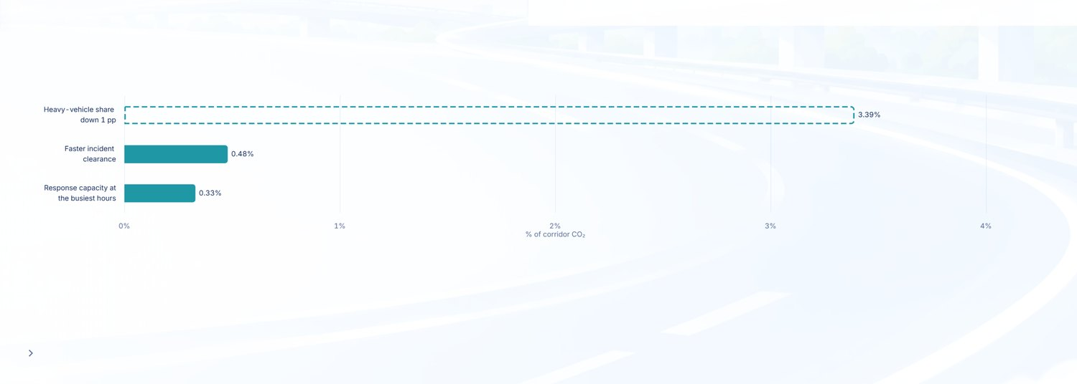
Figure 4.1.30 Projected Percentage Emission Reduction by Strategy
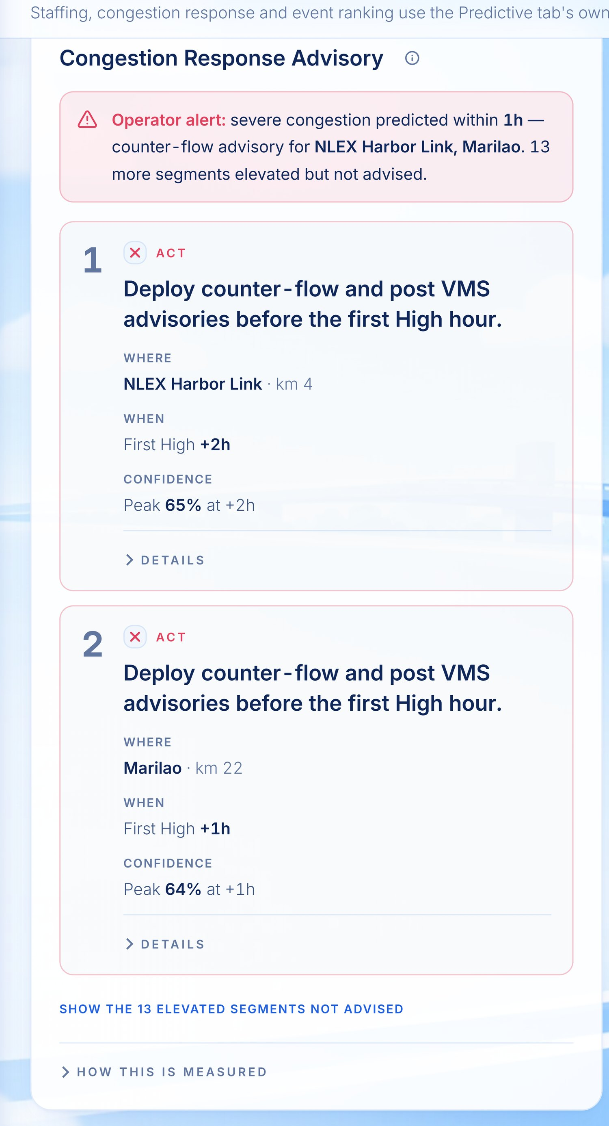
Figure 4.1.25 Congestion Response Advisory

A disclosure the chapter does not currently make
The warehouse's own model evaluation records state, against every speed-based model, that they were "scored on `bronze.nlex_traffic_volume`, whose speed column is synthetic capstone data."
Every speed figure in this chapter that does not come from the Waze feed therefore rests on generated values. The Waze-derived jam speeds quoted in 4.1.3.1 and 4.1.3.2 are real observations; the weather-speed models in gold.ml_weather_speed_metadata are not. This distinction must appear in Chapter 4. A panel that discovers it unaided will question every other number in the chapter; a chapter that states it plainly loses one claim and keeps its credibility.

4.1.6 Register of Corrections
# | Draft statement | Delivered data | Action
1 | Holiday-adjacent days register volumes above the control-day mean | 20 of 21 holidays fall below; Good Friday −49.0 % | Direction reversed
2 | Higher daily incident count in wet conditions | Overall rate marginally lower (5.167 vs 5.186 /h); crashes 19.3 % higher | Narrowed to crashes
3 | Mean speed reduction under wet pavement | Observed jam speed higher in wet (8.8 vs 8.3 km/h) | Label as model coefficient, not observation
4 | Volume champion unspecified; LSTM shown selected | Prophet champion; LSTM rank 7 of 8, MASE 1.634, rejected | Champion named; caption explained
5 | Single volume accuracy figure | 80/20 yields a champion; 90/10 accepts nothing | Split must be named
6 | Incident model result presented cleanly | Champion carries OVERFITTING, train R² 0.514 vs test 0.262 | Disclosed
7 | Precipitation the most influential incident covariate | volume_ratio_7 at 0.463 importance | Predictor corrected
8 | Segment risk from Geographically Weighted Regression | Derived by historical share; panel says so | Method corrected
9 | Secondary risk an "empirical basis" | AUC 0.620, base rate 11.5 % | Characterised as modest
10 | "Time to clear" | Built from report-to-response; no scene-cleared timestamp exists | Definition stated
11 | CO₂ seven-day forecast satisfies threshold | Holdout MAPE 9.63 % passes; 7-day horizon MASE 1.176, marked unusable | Horizon caveat added
12 | Corridor CO₂ total | 161,224.7 t (CY2025); earlier 143k and 188k figures are stale | Figure replaced
13 | Emission reduction strategies called a mock | Rebuilt and now computed: 3.39 % / 0.48 % / 0.33 %, Strategy A a user-set policy target | Criticism withdrawn; screenshot re-taken
14 | Weather-triggered advisory | 14.0 %→14.3 % across 0–100 mm rain | Claim withdrawn
15 | Apprehension and Undercap Table; mobile community reports | Neither present in the warehouse | Remove from Tables 4.1.1–4.1.2
16 | Speed analyses presented as empirical | Non-Waze speed is synthetic capstone data per the warehouse's own records | Disclosure added

4.1.7 Additions to Notes for the Group
Proposed as items 7 to 10, following the six in the draft.
- Sixteen corrections are listed in Section 4.1.6, of which five reverse the direction of a claim.
The most visible are the holiday effect, which is negative rather than positive, and the wet-weather effect, which holds for crashes but not for incidents overall. Note 1 anticipated exactly this; the sentences have been rewritten rather than back-filled.
- Nine analyses named in the draft are not implemented in the build (Section 4.1.5, final table).
The group should decide, per row, whether to implement, to reword to the delivered method, or to move to Chapter 5 as future work. The proponents recommend rewording, since every one of these is checkable against the screenshots already embedded in the chapter.
- Three panels named as missing in an earlier review have since been built — Booth Staffing Plan,
Congestion Response Advisory, and the computed emission-reduction strategies. Any review note predating 8 October that calls these absent or illustrative is stale. Conversely, the Secondary Incident Risk and Time to Clear cards reproduced in the draft's Figures 4.1.20 and 4.1.21 no longer exist as separate panels; that material is now consolidated into Response Time Breakdown and Predicted Median Response Time, so those two screenshots must be replaced.
- Speed data that does not come from Waze is synthetic, per the warehouse's own evaluation
records. The proponents recommend stating this once, plainly, in 4.1.3.1. A limitation disclosed is a limitation defended.

4.2 System Implementation
This section documents the implementation of the system that produces the results reported in Section 4.1: the interface they are rendered through, the environment and repository they are built in, the authentication that guards them, and the one module through which operators write back to the warehouse.

4.2.1 Global UI/UX Design System
The Decision-Intelligence dashboard through which the results in Section 4.1 are rendered was implemented on a centralized design system rather than through per-component styling. All visual constants — colour, typography, spacing, elevation, corner radius, and transition timing — were declared once as CSS custom properties on the document root and consumed by reference throughout the application. The proponents adopted this arrangement so that a change to the visual identity would propagate across every page without editing the components themselves, and so that the same declarations could be redefined under an alternative theme without duplicating the component layer.

4.2.1.1 Design Tokens
Fifty-six design tokens were declared, organized into eleven families. Table 4.2.1 summarizes each family and its role in the interface.
Table 4.2.1 Design Token Families Implemented in the Global Stylesheet
Token Family | Count | Representative Tokens | Role in the Interface
Brand | 4 | --brand-primary (#3660ff), --brand-accent (#ea8b0d) | Primary identity colour and the accent applied for emphasis
Background | 8 | --bg-body, --bg-surface, --bg-sidebar | Page, card, and navigation surfaces
Text | 5 | --text-primary (#071a44), --text-secondary, --text-muted | Three-level type hierarchy, with on-dark variants
Border | 2 | --border-default, --border-strong | Card edges and separators
Semantic Colour | 14 | --color-success, --color-warning, --color-danger, each with -bg and -border | Status communication, held constant across all modules
Chart | 6 | --chart-text, --chart-axis, --chart-split, --chart-tooltip-bg | Visualization chrome (see Section 4.2.1.4)
Spacing | 5 | --space-xs (4px) through --space-xl (28px) | Fixed spacing scale in place of arbitrary values
Radius | 5 | --radius-sm (8px) through --radius-full (999px) | Corner treatment by component class
Shadow | 4 | --shadow-sm, --shadow-card, --shadow-lg | Elevation hierarchy
Transition | 2 | --transition-fast (150ms), --transition-base (220ms) | Consistent motion timing
Layout | 1 | --sidebar-width (280px) | Navigation geometry

The semantic colour family was deliberately excluded from the per-module accent mechanism described in Section 4.2.1.2. Success, warning, and danger communicate meaning rather than identity, and allowing them to vary by module would have caused a red indicator to signify different conditions on different pages.

4.2.1.2 Typography and Module Identity
Typography was standardized on the Inter typeface, applied at the document body and inherited throughout, with a system font stack (ui-sans-serif, system-ui, -apple-system, Segoe UI, Roboto) specified as fallback so that the interface degrades predictably where the web font fails to load.
Module identity is carried by a single token, --page-accent, declared on the page header and inherited by every descendant element on that page. Three values were defined, corresponding to the system's three operational modules.
Table 4.2.2 Per-Module Accent Values
Module | Class | --page-accent
Traffic | .viz-traffic | #2a78d6 (blue)
Incident | .viz-incident | #b8760a (amber)
Environmental Impact | .viz-emissions | #0f8a4a (green)

Because the token is declared on the header and inherits downward, a panel authored against var(--page-accent) renders correctly on all three modules without conditional logic. Components appearing on only one module reference that module's value directly, no inheritance being available to them.

4.2.1.3 Theme Implementation
A dark presentation mode was implemented by redefining the token values rather than by overriding component styles. The same custom property names are re-declared under two selectors: :root[data-theme="dark"], which serves an explicit operator selection, and a prefers-color-scheme: dark media query guarded by :root:not([data-theme="light"]), which serves the operating system preference while allowing an explicit light selection to take precedence. Forty-one explicit dark-theme declarations and twenty media-query declarations were required.
The consequence of this approach is that a component authored against tokens requires no theme-specific code of its own, whereas a component authored against literal colour values does not participate in the mechanism at all. Section 4.2.1.5 reports the measured effect of that distinction.

4.2.1.4 Charting Layer
As stated in Section 4.1.3, the analytical outputs are rendered as Apache ECharts visualizations and Mapbox geospatial layers. ECharts constructs its own canvas and does not participate in CSS inheritance, so a chart configuration object cannot reference a custom property; the declaration is passed through uninterpreted and the chart reverts to its library defaults.
A dedicated hook was therefore implemented to bridge the two systems. It reads the computed values of the chart token family from the document root and returns them as literal colour strings for use within chart configuration. The hook re-reads on both paths by which the theme can change — a mutation observer on the theme attribute, and a listener on the colour-scheme media query — so that charts re-theme in step with the surrounding interface rather than requiring a page reload.
The resulting convention is that document markup references tokens directly, while chart configuration consumes the resolved literals returned by the hook.

4.2.1.5 Validation of the Design System
The design system was validated by migrating a set of panels authored before its adoption. The four panels comprising the Incident module's Predictive tab — reported in Section 4.1.4.2 as Figures 4.1.18 through 4.1.21 — contained 186 hardcoded colour literals between them. Because those literals bypassed the token layer, the panels retained their light-mode palette when the interface was switched to dark presentation.
The effect was measured in two ways: by counting the literals removed from source, and by an automated contrast audit that measures every text element against the surface it is painted on and compares the result against the 3:1 minimum specified for large text in WCAG 2.1.
Table 4.2.3 Design System Migration, Incident Predictive Tab
Measure | Value
Hardcoded colour literals removed | 186, across four panels
Text elements below 3:1 in dark presentation, after migration | 0
Light presentation after migration | Unchanged

The severity of the pre-migration condition is best conveyed by a single case rather than an aggregate count. A panel heading was authored as #0f172a, the literal value carried by --text-primary under the light theme. Against the dark theme's card surface of #161b22, that pairing yields a contrast ratio of 1.03:1 — text and background of near-identical relative luminance, which is to say the heading was not legible at all. The ratio follows directly from the two colour values and is independently recomputable.
A controlled comparison remains available within the delivered system, because the migration was not applied uniformly. The Traffic module's Predictive tab retains 244 hardcoded literals across two panels and continues to fail the same audit in dark presentation, while the migrated Incident tab passes it without exception. The two tabs differ in no other respect relevant to theming.
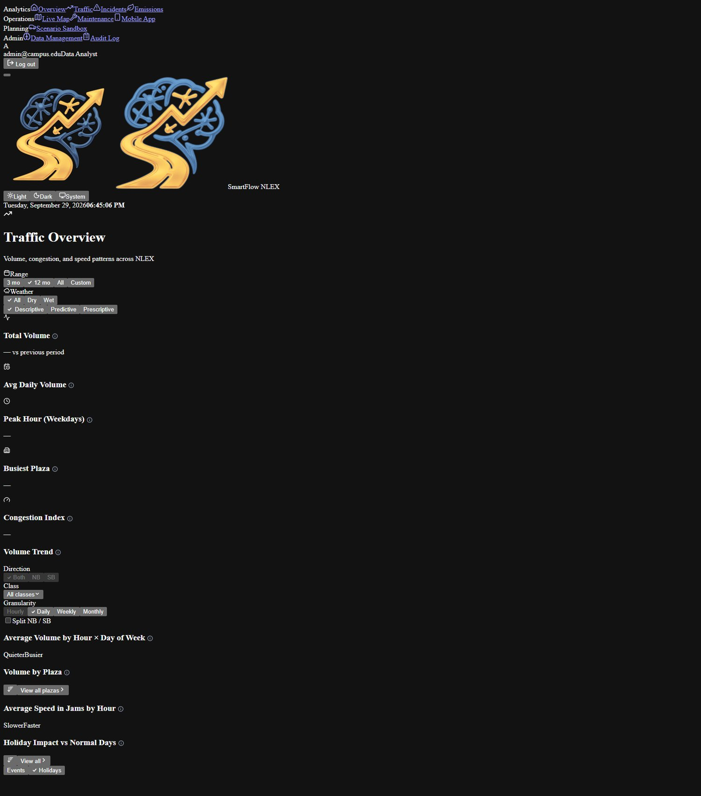
Figure 4.1.32_without-design-tokens-dark Interface Panels Rendered Without Design Tokens in Dark Presentation
Figure 4.1.32 Interface Panels Rendered Without Design Tokens in Dark Presentation
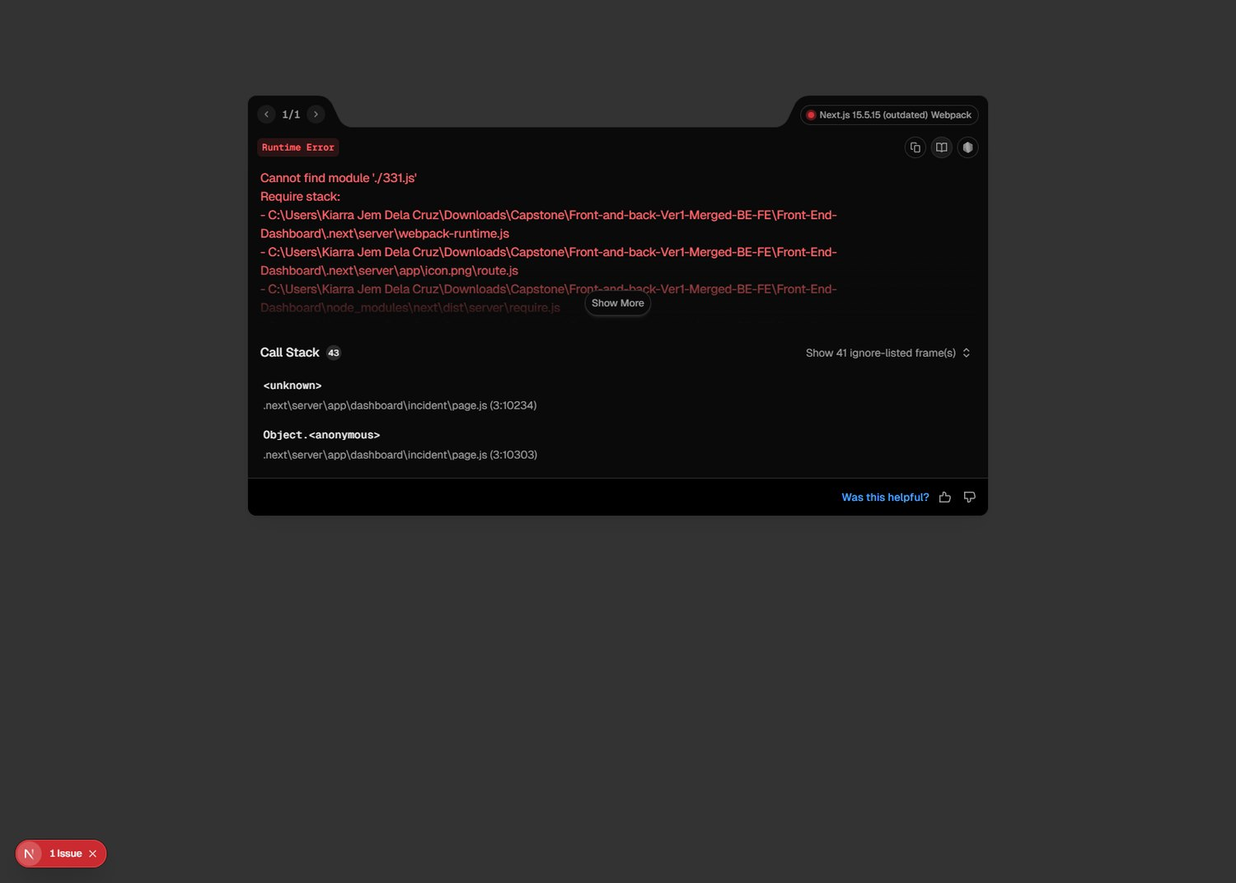
Figure 4.1.33_with-design-tokens-dark Equivalent Panels Rendered Through the Design Token System
Figure 4.1.33 Equivalent Panels Rendered Through the Design Token System
Absolute failure counts are not reported in Table 4.2.3 because they vary between measurements — the number of rendered elements depends on the data present at the time of capture — and because the audit tool returns false positives against elements whose background is a gradient rather than a solid colour, which it cannot resolve. The literal counts and the 1.03:1 ratio are stable and were preferred on that basis.

4.2.1.6 Deviation from the Planned Implementation
Section 3.7 specified that global design tokens would be configured through a Tailwind CSS theme configuration file. The delivered system does not use that file, and the deviation is recorded here rather than reconciled.
Tailwind CSS version 4 is present among the project dependencies and registered as a PostCSS plugin, but two conditions prevent it from functioning as the design system in practice. First, version 4 replaced the JavaScript configuration file with CSS-based configuration, so tailwind.config.js is not generated by that version and its absence is expected rather than an omission. Second, the global stylesheet does not import the Tailwind layer and the component markup does not employ Tailwind utility classes; the interface is styled through CSS Modules and the custom property system documented in Sections 4.2.1.1 through 4.2.1.4.
The objective expressed in Section 3.7 — a single source of truth for brand colour, typography, and spacing applied uniformly across every page — is met by the implemented token system. The mechanism differs from the one specified. The proponents recommend that the unused dependency be removed, or the configuration completed, so that the delivered system and its documentation agree.

4.2.2 Environment Configuration
The system is deployed as two independently hosted services — a statically exported Next.js dashboard and an Express application server — which draw on a shared PostgreSQL/PostGIS warehouse and five external providers. Because no credential may be committed to the repository and because the two services are configured by different mechanisms, the proponents specified the configuration surface explicitly rather than allowing it to accumulate as each provider was introduced.

4.2.2.1 Delivery Stages
The dashboard is delivered as an installed desktop application rather than as a published website. It is packaged with Electron, which loads the static export described in Section 4.2.2.4 and presents it in its own window. The proponents adopted this form because the system is an operations console for the traffic control centre: its users are a known set of operators at known workstations, and an installed application neither requires a public address nor exposes the corridor data to one.
Three stages follow from that. Table 4.2.4 states what each comprises.
Table 4.2.4 Delivery Stages and Their Hosts
Stage | Dashboard | Application Server | Warehouse
Development | Local development server, port 3002 | Local watch process, port 4000 | AWS RDS
Desktop, unpackaged | Static export served locally and loaded by the desktop shell | Local application server | AWS RDS
Desktop, installed | Windows installer produced by the packaging step | A host reachable from the operator workstation | AWS RDS

A single warehouse instance serves all three stages. The proponents adopted this arrangement because the system draws on one corridor dataset assembled by the extract-transform-load pipeline described in Section 4.1.1, and a duplicated instance would diverge from it as the pipeline continued to run against only one. The limitation this imposes is recorded rather than resolved: there is no stage isolated from operational data, and none is therefore suitable for exercising operations that write to or delete from the warehouse.

4.2.2.2 Configuration Parameters
Application-server parameters are supplied through an environment file in development and through the environment of the host that runs the application server in a desktop deployment. Table 4.2.5 states each parameter and the value class it carries per stage.
Table 4.2.5 Application Server Configuration Parameters
Parameter | Development | Desktop deployment | Function
PORT | 4000 | Assigned by the host | The hosting platform injects the port at container start; a fixed value renders the service unreachable
NODE_ENV | Unset | production | Selects production behaviour in the server framework
FRONTEND_ORIGIN | Local dashboard origin | Deployed dashboard origin for that stage | Cross-origin request allow-list
PG_HOST, PG_PORT, PG_DATABASE, PG_USER, PG_PASSWORD | Warehouse instance | Same instance | Assembled into a connection string at startup, with the password percent-encoded
PG_SSL_MODE | relaxed | relaxed | Transport security mode; see Section 4.2.2.3
REDIS_REST_URL, REDIS_REST_TOKEN | Cache provider | Same provider | Live incident feed cache
SUPABASE_URL, SUPABASE_ANON_KEY | Auth provider | Same provider | Operator authentication and audit logging
CLIMATIQ_API_KEY | Emissions provider | Same provider | Emission factor lookup, Section 4.1.5
GLM_API_KEY, GLM_MODEL, GLM_BASE_URL | Language model provider | Same provider | Narrative generation layer, Section 4.1.7

Dashboard parameters number two: the application server's base address and the geospatial rendering token. Both are declared under the framework's public prefix and are therefore compiled into the browser bundle.

4.2.2.3 Transport Security to the Warehouse
The managed warehouse requires that all connections be encrypted, and refuses unencrypted ones. It presents a certificate issued by a regional authority that the application runtime does not carry in its default trust store, so full certificate-chain verification fails even though the connection is encrypted.
Two resolutions are available. The runtime may be supplied with the provider's certificate authority bundle, after which full verification succeeds; or verification may be relaxed while encryption is retained. The delivered system takes the second, selected by a configuration parameter that also admits the first. The proponents record the distinction because the two are frequently conflated: the connection is encrypted in transit under both settings, and what the relaxed setting forgoes is verification of the server's identity, which leaves the connection exposed to interception by an intermediary rather than to passive observation.

4.2.2.4 The Consequence of Static Export
The dashboard is produced by static export, which resolves every public configuration value at build time and writes it into the emitted JavaScript. No server process reads configuration at request time, because none exists.
Two operational consequences follow, both of which the proponents encountered before the mechanism was understood. A value altered after a build has no effect until the application is rebuilt, there being nothing running to re-read it. And the address of the application server is frozen into the installer, so every machine that receives it will ask for that same address.
The failure mode is not self-announcing. A build carrying the development address directs each workstation to port 4000 on itself, which succeeds only on the machine that produced the build and presents everywhere else as an unavailable application server rather than as a configuration error. The build order in Table 4.2.6 exists to prevent it.
Table 4.2.6 Build Sequence
Step | Action
1 | Start the application server where the installed application will reach it, and record that address
2 | Add the dashboard's origin to the application server's cross-origin allow-list
3 | Set the application server address in the dashboard's build configuration
4 | Build and package the desktop application
5 | Install it on a machine other than the one that built it and open a data-bearing page

Steps 3 and 4 are ordered rather than interchangeable, and step 5 is performed on a second machine deliberately: the failure described above is invisible on the build machine.

4.2.2.5 Outstanding Work in the Packaged Build
Two items stand between the current state and a distributable installer, and are recorded rather than deferred silently.
The unpackaged desktop run serves the exported files over a local HTTP address that the application server's allow-list already admits, and works. The packaged application instead loads its pages directly from the file system, and a page loaded that way presents a null origin on each request. The allow-list does not admit it, so an installed copy would render its interface and fail every data call. Serving the exported files locally in the packaged application as well — one code path for both runs, reusing an origin already configured — is the proponents' recommended resolution.
The packaging configuration itself is also absent: the project declares the packaging tool and the command that invokes it, but not the application identifier, file manifest, or icon that the tool requires to produce a correct installer.
Neither item affects the system as demonstrated from a development or unpackaged desktop run, which is how the results in Section 4.1 were produced.

4.2.2.6 Secret Handling
No credential value appears in the repository. Two template files — one per service — declare the parameter names with commentary and no values, so that a new working copy can be configured without recourse to a team member's machine.
The treatment of the two services' environment files is deliberately asymmetric, and the asymmetry is stated here because it reads as an inconsistency otherwise. The application server's environment file is never committed: it carries warehouse credentials, provider tokens, and API keys. The dashboard's environment file is committed, because it carries only values under the framework's public prefix, which are compiled into the browser bundle and are therefore disclosed to every visitor the moment the site is served. Withholding them from the repository would conceal nothing while making a fresh working copy harder to build.
It follows that no value requiring secrecy can be held in a dashboard parameter. The geospatial rendering token is public of necessity and is constrained by origin restriction in the provider's console — a control that operates on where the token may be used rather than on who holds it, which is the only control available to a credential shipped to a browser.
[Figure to be captured — see Notes for the Group.]
Figure 4.1.34 Application Server Configuration Parameters

4.2.3 Repository and Version Control

4.2.3.1 Repository Arrangement
The project is tracked in Git across two remote repositories serving distinct purposes. The first receives day-to-day work: each proponent pushes their own feature branches to it. The second holds integration and handoff, and carries exactly two long-lived branches — one for the web application comprising the dashboard and application server, and one for the mobile application described in Section 3.13.
The mobile application is held on a separate branch rather than in a subdirectory of the same tree. It has an independent toolchain and release cycle and shares nothing with the dashboard except the application programming interface contract through which it retrieves its configuration.

4.2.3.2 Branch Naming and Ownership
Feature branches are named by area and owner, so that the owner of any branch is readable from its name without consulting the commit log. Table 4.2.7 gives representative branches from the delivered repository.
Table 4.2.7 Feature Branch Naming Convention
Branch | Owner | Area
Incident-Predictive-Jertz5 | Jertz | Incident predictive analytics
Improved-simulator-ysa | Ysa | Agent-based simulation sandbox
Fixed-Map-Kia | Kiarra | Live corridor map
Incident-Prescriptive-Jertz | Jertz | Incident prescriptive panels

A numeric suffix denotes a successive attempt at the same area rather than a different feature, which keeps the history of one iteration together instead of distributing it across unrelated names.

4.2.3.3 Integration Procedure
Integration is performed by one proponent rather than by each in turn. With four contributors working across a shared dashboard, concurrent merging produced conflicts faster than they were resolved, and the arrangement was adopted in response to that.
Before any feature branch is merged, a branch is created at the current integration head and named for the merge it precedes. The merge is then performed, the result is run locally, and the affected pages are exercised before the integration branch is published.
These preceding branches constitute the rollback mechanism. Six were created over the course of development, one per significant merge. Where a merge is later found to have introduced a regression, the state before it is recoverable by checkout, rather than by reverting a merge commit with multiple parents — an operation that is error-prone and that complicates any subsequent merge of the same branch. Eight further branches record successive full-stack integrations of the application server and dashboard and are retained as checkpoints.
Table 4.2.8 Version Control Practices and Their Status
Practice | Status
Feature branches named by area and owner | In use
Single-integrator merging | In use
Rollback branch created before each integration merge | In use, six recorded
Credentials excluded by ignore rules, with template files retained | In use, verified
Branch protection on the integration branches | Not configured
Pull request and review required before merge | Not configured

[Figure to be captured — see Notes for the Group.]
Figure 4.1.35 Repository Branch Structure

4.2.3.4 Limitation in the Version Control Configuration
The final two rows of Table 4.2.8 are reported as not configured rather than omitted from the table.
Branch protection is not enabled on the integration repository. Direct pushes to the integration branches remain possible and pull requests are not required before merging. The integration procedure described in Section 4.2.3.3 is therefore observed by the proponents' agreement and not enforced by the repository, which is a materially weaker guarantee: it holds while the convention is remembered and fails silently when it is not.
The proponents record this as an outstanding item rather than as a completed practice. Enabling protection on both integration branches, requiring a pull request, and requiring one approving review would close it, and none of the three requires any change to the delivered system.

4.2.4 Authentication and Session Management
Access to the Decision-Intelligence dashboard is restricted to authenticated operators, and the operational modules visible to each depend on the role that operator holds. This subsection documents how a session is established, where it is held, how it is renewed before it lapses, and where authorization is decided. It also records six defects found when the implementation was examined against these requirements, because several of them had the property that the interface appeared to enforce a restriction it was not in fact enforcing.

4.2.4.1 Identity Provider and Token Issuance
Authentication is delegated to Supabase, which issues a signed JSON Web Token on a successful email-and-password exchange. The proponents did not implement password storage, hashing, or reset flows; delegating them removes the most error-prone part of an authentication system from the project's own code.
A successful sign-in returns two tokens. The access token is the short-lived credential presented on each request to the application server, and is valid for 3,600 seconds. The refresh token is longer-lived and is used only to obtain a new access token. The division is what allows a session to outlast the access token without the operator signing in again, and it is the mechanism behind Section 4.2.4.4.
The one-hour lifetime is the consequential figure: an operator monitoring the corridor through a shift will cross it several times, so the renewal path in Section 4.2.4.4 is exercised in ordinary use rather than only at the edges.

4.2.4.2 Session Storage
The browser client is configured to persist the session and to renew it automatically. Persistence places the token pair in the browser's local storage for the application's origin, so that a reload or a reopened window resumes the session rather than returning the operator to the sign-in screen.
Local storage is readable by any script running on the same origin, which makes it unsuitable for a credential in an application that embeds third-party script. The dashboard embeds none: its dependencies are compiled into its own bundle. The proponents record the trade-off rather than claiming it does not exist — an HTTP-only cookie is not readable by script and would be the stronger choice, but it requires a server to set it, and Section 4.2.2.4 explains why this application has none.

4.2.4.3 Role Model
Three roles are defined, carried in the Supabase user record and read from the token on each request.
Table 4.2.9 Roles and the Modules They May Reach
Role | May reach | May not reach
Data Analyst | All modules | —
TCC Operator | Traffic, Incidents, Live Map, Maintenance, Mobile, Scenario Sandbox | Environmental Impact, Data Management, Audit Log
Incident Operator | Traffic, Incidents, Live Map, Maintenance, Mobile | Environmental Impact, Scenario Sandbox, Data Management, Audit Log

A session whose record carries no role is treated as an Incident Operator, the least privileged of the three. This is a correction: the implementation previously defaulted to Data Analyst, the most privileged, so an incomplete user record silently received administrative navigation.

4.2.4.4 Session Renewal
Renewal happens at two levels, and both are needed.
The browser client renews the access token on its own schedule before it expires, which covers an operator reading a dashboard for longer than one token lifetime. That alone does not cover a request that is already in flight when a token lapses, nor one made after a laptop resumes from sleep with a token that expired while it was suspended.
The second level handles those. All authenticated calls to the application server pass through a single module which attaches the current access token, and, if the server answers 401, requests a new token once and replays the original request. The operator observes nothing. Where the refresh itself fails — the refresh token having been revoked or expired — the module raises an application event and the interface returns the operator to the sign-in screen, rather than leaving them on a dashboard whose panels have quietly stopped filling.
Figure 4.1.36 Session Lifecycle and Silent Renewal
``` Operator Dashboard Application Server Supabase
| | | |
|---- credentials ------>| | |
| |------------- sign in ----------------------> |
| |<-------- access + refresh token ------------ |
| | store session | |
<--- dashboard ---------
--- opens a module ---->
--- request + access token -->
--- verify ------>
<--- identity ----
<--------- 200 data ----------
... access token expires ...
--- opens a module ---->
--- request + stale token --->
<--- 401 token_expired -------
------- refresh token ----------------------->
<-------- new access token ------------------
--- SAME request, new token ->
<--------- 200 data ----------
<--- data, no prompt ---
... refresh token also invalid ...
------- refresh token ----------------------->
<----------- refused ------------------------
<-- returned to sign-in-

```

4.2.4.5 Where Authorization Is Decided
Authorization is enforced on the application server. Each protected route verifies the token, resolves the role, and compares it against the roles the route admits.
The dashboard also restricts navigation: it hides modules a role may not use and redirects an operator who reaches such a route directly. This is an interface convenience and not a security control, for a reason specific to this system's architecture. The dashboard is a static export (Section 4.2.2.4), so no server stands between the operator and the page; every guard it applies runs in the operator's own browser, where it can be bypassed. A reader should take the server-side check as the boundary and the client-side guard as the means of not presenting a door that will not open.
The two share one rule set rather than two copies of it. The navigation filter and the route guard previously restated the same role-to-route list separately, which permitted the two to disagree — a hidden link and a reachable route is protection in appearance only.
The server distinguishes two refusals, which the client depends on:
Table 4.2.10 Refusal Semantics
Condition | Status | Code | Client behaviour
No token presented | 401 | token_missing | Treat as signed out
Token expired | 401 | token_expired | Refresh once, replay request
Token invalid | 401 | token_invalid | Refresh once, replay request
Token genuine, second step not passed | 401 | mfa_required | Treat as signed out; do not refresh (Section 4.2.4.9)
Role not permitted | 403 | role_denied | Stop; do not retry
Provider not configured | 503 | auth_unconfigured | Stop; server fault

Both refusals previously returned 403, which made an expired token indistinguishable from a forbidden role. A client cannot implement silent renewal against that, because it has no way to know whether retrying is meaningful; separating them is what makes Section 4.2.4.4 possible.

4.2.4.6 Defects Identified and Corrected
Examining the implementation against the requirements above revealed six defects. They are reported because each produced an appearance of enforcement that did not correspond to an actual one, which is the class of fault least likely to be noticed in use.
Table 4.2.11 Access Control Defects and Their Correction
# | Defect | Consequence | Correction
1 | The dashboard tested for a role but never for a session, and the role defaulted to Data Analyst | A visitor who had not signed in reached the dashboard and was presented the full administrative navigation, Data Management and Audit Log included | A session is resolved before the interface renders; absent one, the operator is returned to sign-in. The default role is now the least privileged
2 | The role guard ran as an effect, after first paint | An operator who opened a forbidden module directly saw its contents render before the redirect | The shell renders nothing until the session and role are known, and a forbidden module is never constructed
3 | The dashboard never sent an authorization header | Every protected endpoint was unreachable from the product; the interface appeared to work only because each page read the public routes mounted ahead of the middleware | A single module attaches the token to all authenticated calls
4 | The file-upload and model-training endpoints carried no authentication | Either could be invoked without a credential, and neither is reversible from the dashboard | Both now require the Data Analyst role
5 | The response cache was mounted ahead of the authorization middleware and keyed on URL alone | A protected response, once cached for an authorised operator, was served from the cache to any later caller without a token | Protected paths bypass the cache, and no response to a request bearing an authorization header is stored
6 | The identity provider's URL and key were hardcoded as fallbacks in both applications | A deployment configured with neither still started and authenticated against the development project, with no indication that it had | Both are read from configuration only, and a server that cannot verify tokens refuses protected routes rather than guessing

Defect 5 is the one the proponents consider most instructive. The authorization middleware was correct, and reviewing it in isolation would not have revealed anything: the fault lay in a caching layer that answered before the middleware ran, so the protected route's own code was never reached. It is a reminder that an access control is only as strong as the order of the layers in front of it.
Defect 6 had a second consequence found during testing. The application server's configuration file contained the key name with an empty value, so the server had been relying entirely on the hardcoded fallback. Removing the fallback caused every protected route to refuse service — correctly, and visibly — which is how the empty value was discovered.

4.2.4.7 Verification
Table 4.2.12 Access Control Test Results
Testing used three accounts provisioned for the purpose, one per role in Table 4.2.9.
# | Scenario | Expected | Observed
1 | Sign-in, valid credentials | Access and refresh tokens issued | 200; both issued, access token valid 3,600 s, role present
2 | Protected endpoint, valid token, permitted role | 200, served | 200, served
3 | Sign-in, unknown account | Refused | 400 invalid_credentials
4 | Sign-in, wrong password | Refused | 400 invalid_credentials
5 | Protected endpoint, no token | 401, refused | 401 token_missing
6 | Protected endpoint, malformed token | 401, refused | 401 token_invalid
7 | Upload endpoint, no token | 401, refused | 401 token_missing
8 | Protected endpoint, valid token, wrong role | 403, refused, not retried | 403 role_denied
9 | Refused request → refresh → replay | New token obtained, request succeeds | 401 → refresh 200 → replay 200
10 | Public analytics endpoint | 200, served | 200
11 | Public endpoint, repeated | Served from cache | 200, X-Cache: HIT
12 | Protected endpoint, repeated | Never served from cache | No cache header present

Scenarios 3 and 4 return an identical message. This is deliberate on the provider's part and desirable: a response distinguishing "no such account" from "wrong password" allows an attacker to establish which addresses are registered.
Scenario 8 is the one that justifies the distinction drawn in Table 4.2.10. The Incident Operator presented a valid, current token and was refused with 403 rather than 401, so a client implementing Section 4.2.4.4 does not attempt a renewal that could not have changed the outcome.
Scenario 9 is the renewal path end to end: a refused request, a token obtained with the refresh token, and the original request replayed successfully, with no re-authentication by the operator. One qualification is owed. The refusal was induced by presenting a tampered token rather than by waiting out the one-hour lifetime, so the observed code was token_invalid rather than token_expired. Both are 401 and both take the same branch, so the path exercised is the one a genuine expiry would take; what the test does not independently establish is the provider's expiry timing, which is the provider's behaviour rather than this system's.

4.2.4.8 Limitations
Three limitations are recorded.
Route guarding in the dashboard is advisory, for the architectural reason given in Section 4.2.4.5. The server-side check is the control.
The session is held in browser local storage rather than an HTTP-only cookie, for the reason given in Section 4.2.4.2.
One identity project serves all environments, consistent with the single warehouse described in Section 4.2.2.1. An account created for testing is therefore an account that exists in the environment the panel will see.

4.2.4.9 Two-Step Sign-In (added 7 October 2026)
A password is no longer sufficient to sign in. After the password is accepted, the operator must enter a six-digit, time-based code (TOTP, RFC 6238) from an authenticator application on their phone. An account that has no authenticator is made to add one at its first sign-in, by scanning a QR code or typing a setup key, and does not reach the dashboard until the first code from the new application is accepted. No account is left on a password alone.
The identity provider records how far a session has progressed in the token's aal claim: aal1 after the password, aal2 after the code. The rule is applied in three places, which are not equivalent:
Where | What it does | Is it a control?
Sign-in page | Asks for the code, or runs first-time setup | No. Runs in the operator's browser
Dashboard shell | Ends and refuses a session still at aal1 | No. Runs in the operator's browser
Application server | Refuses a token whose aal is not aal2, with 401 mfa_required | Yes

The first two exist so that the interface behaves; the third is the boundary, for the reason given in Section 4.2.4.5. A person who holds a stolen password can obtain an aal1 token from the provider directly, without ever loading the sign-in page. The server check is what makes that token worthless.
A session that stopped after the password is never resumed. Reloading the sign-in page, or being returned to it from the dashboard, ends that session and starts again from the password, so a half-finished sign-in left on a shared workstation cannot be completed by the next person.
The audit log follows the same rule: an entry is attributed to an operator only when the token presented is at aal2. Adding an authenticator is itself recorded (session.authenticator_added), because on an account that has none it is the one action a stolen password would permit.
Table 4.2.13 Two-Step Sign-In Test Results (both accounts, real provider and server)
# | Scenario | Expected | Observed
1 | Password accepted | Token at aal1 | aal1
2 | Protected endpoint, genuine aal1 token | 401, refused | 401 mfa_required
3 | Token edited to claim aal2, signature unchanged | 401, refused | 401 token_invalid
4 | Wrong code | Refused; session stays aal1 | mfa_verification_failed; aal1
5 | Right code | Token at aal2, methods password and TOTP | aal2; password+totp
6 | Protected endpoint, aal2 token, permitted role | 200 | 200
7 | Protected endpoint, aal2 token, wrong role | 403, refused | 403 role_denied
8 | Earlier aal1 token, after the same user reached aal2 | Still refused | 401 mfa_required
9 | Second sign-in | Code requested; setup not offered again | Code step shown
10 | aal1 session opened at /dashboard (provider replies simulated in the test browser) | Returned to sign-in, session ended | Returned; no session left
11 | QR code on the card, read back by a decoder at both card sizes | Same key as printed | Matched at 140 px and 104 px

Scenario 11 records a defect found in testing. The provider's own QR picture is 69 squares across, which at the size of the sign-in card is under two pixels a square and could not be read back at all. The card now draws its own code from the same address, omitting only the settings that restate the standard, which yields a code of about 41 squares that reads at both sizes.
Three limitations are specific to this feature. First enrolment is trust on first use: until an account's owner has added their authenticator, whoever holds its password can add theirs, so new accounts should complete a first sign-in promptly. The provider issues no recovery codes, so a lost phone is resolved by an administrator removing the authenticator in the provider's console, after which the operator sets up again at the next sign-in. And the second step protects only what the server requires a token for; the routes that are served without one are unaffected by it.

4.2.5 Maintenance Scheduler
Planned roadwork is the one source of corridor disruption the operator knows about in advance. The Maintenance Scheduler is where that knowledge is recorded: what work is planned, which stretch of carriageway it occupies, in which direction, how much of the roadway it closes, and when. Unlike the analytical modules reported in Section 4.1, which read the warehouse, this module writes to it — it is the system's only operator-authored data source, and the mobile application described in Section 3.13 consumes the same records.

4.2.5.1 Data Captured
A schedule is located on the corridor by kilometre marker rather than by exit name. Markers are continuous and exits are not: work frequently occupies a stretch between two exits, which an exit-based field cannot express.
Table 4.2.13 Maintenance Schedule Fields
Field | Type | Constraint
Title | Text | 3–120 characters, required
Description | Text | Optional, up to 2,000 characters
Start KM / End KM | Decimal | 0–100; end must be at or beyond start
Direction | Enumeration | Northbound, Southbound, or Both
Lane closure | Enumeration | None, Shoulder only, 1 lane, 2 lanes, Full closure
Start / End date-time | Timestamp with offset | End must be after start
Status | Enumeration | Scheduled, In progress, Completed, Cancelled

Direction and lane closure are enumerations rather than free text because both are read by the corridor model, not only by a human. A closure recorded as "one lane" in one entry and "1 lane" in another would be two values to the database and one value to the reader.
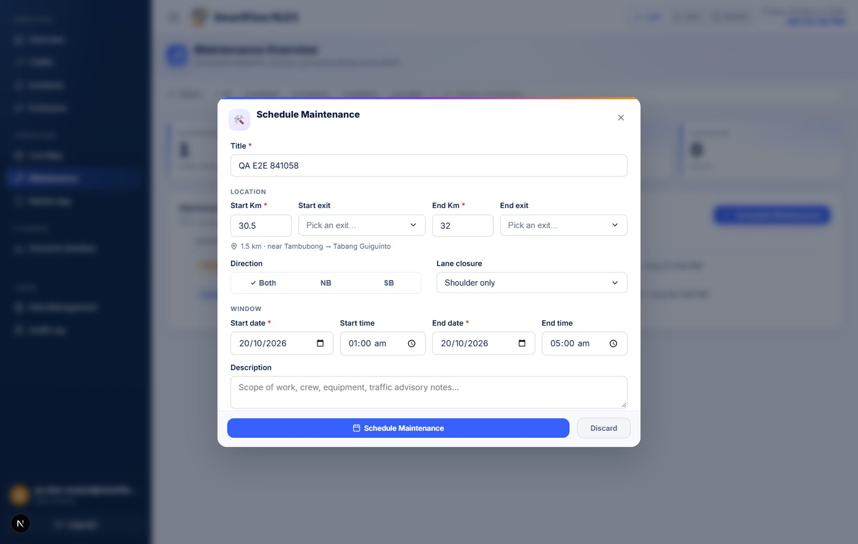
Figure 4.1.37_maintenance-schedule-form Maintenance Scheduling Form with Kilometre Markers
Figure 4.1.37 Maintenance Scheduling Form with Kilometre Markers

4.2.5.2 Interface
The page presents the schedule as a filterable list with a status chip on each row, a counter per status, and a detail panel opened from any row. From that panel an operator can edit the entry, advance its status, cancel it with a reason, or delete it.
Cancelling and deleting are offered separately and are not alternatives:
- Cancelling keeps the row, marks it cancelled, and records a reason. This
is correct for work that was genuinely planned and then called off — the corridor record should still show that a closure was intended for that window, because a reader asking why traffic behaved unusually that night is entitled to find it.
- Deleting removes the row. This is correct only for an entry that should
never have existed: a duplicate, or a typed mistake.
The distinction is stated in the confirmation dialog rather than left to the operator to infer, because two destructive-sounding actions side by side is otherwise a guess.
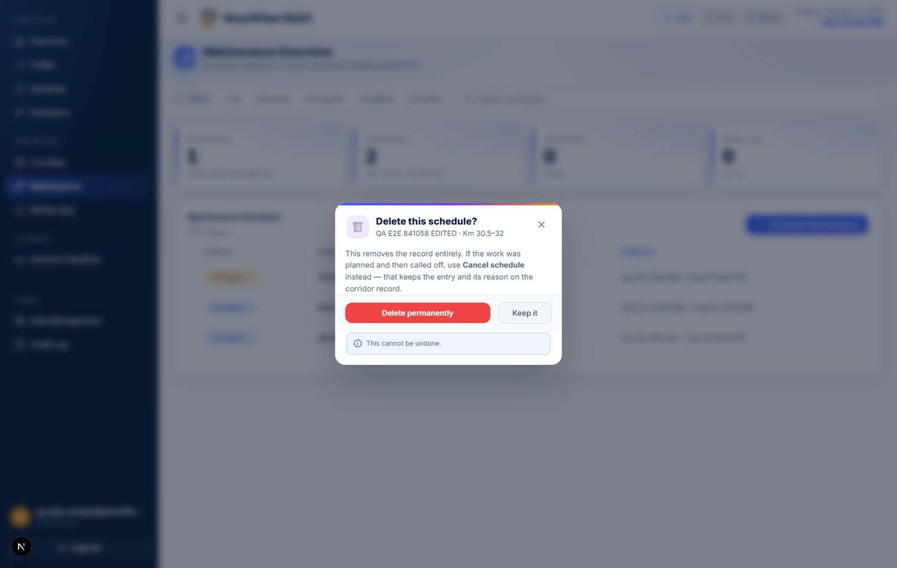
Figure 4.1.38_maintenance-delete-confirmation Delete Confirmation, Distinguishing Deletion from Cancellation
Figure 4.1.38 Delete Confirmation, Distinguishing Deletion from Cancellation

4.2.5.3 Interface to the Application Server
Five endpoints back the page. All validation is performed on the server; the form's own checks are a convenience, and the server does not trust them.
Table 4.2.14 Maintenance Endpoints
Method | Path | Purpose | Answers
POST | /api/maintenance/schedule | Create | 201 created, 400 invalid, 503 database unreachable
GET | /api/maintenance/list | List, filterable by status | 200, 503
PUT | /api/maintenance/:id | Replace an entry | 200, 400, 404, 503
PATCH | /api/maintenance/:id/status | Advance or cancel | 200, 400, 404, 409 invalid transition, 503
DELETE | /api/maintenance/:id | Remove an entry | 200, 404, 503

Two properties of this interface are worth recording.
No mock fallback. Where the database cannot be reached, every endpoint answers 503 and says so. None substitutes placeholder data. The mobile application consumes these same endpoints, and a fabricated success there would place a closure on an operator's screen that does not exist in the warehouse.
Every mutation is audited. Creation, edit, status change, and deletion each write an entry to the audit log described in Section 4.1.8, recording the actor and what changed. The write is fire-and-forget: a failure in the audit path never fails the operation the operator requested.

4.2.5.4 Defects Identified and Corrected
Exercising the endpoints against their acceptance criteria revealed two faults. Both concerned the boundaries of valid input rather than the main path, which is why neither had surfaced in ordinary use.
Table 4.2.15 Maintenance Scheduler Defects
# | Defect | Consequence | Correction
1 | The kilometre range was not ordered | A job could be saved running from Km 40 to Km 10. Every consumer reads the pair as a span, so a reversed entry yields a negative length: the dashboard draws nothing and the mobile application reports a closure of less than zero kilometres | The server now requires the end marker to be at or beyond the start. Equality is still permitted, since work at a single marker is a legitimate entry
2 | Deletion did not check whether a row was removed | A DELETE against an identifier that did not exist answered 200 "Deleted" and wrote an audit entry for a deletion that never happened — the audit log recording an event the database never saw | Deletion now distinguishes the three outcomes and answers 404 where no row matched
3 | A malformed identifier was reported as a database outage | The identifier reached the database, which rejected it as badly formed. The service treats every query failure alike and reports the database unreachable, so a mistyped identifier answered 503 — telling the operator the warehouse was down while it was healthy, and raising an infrastructure alarm for what was a bad request | The identifier is checked before the database is consulted, and an unparseable one answers 404

Defect 1 was not hypothetical. A record already in the table — a toll booth repair entered as Km 76.25 to Km 73.23 — carries a reversed range and is in the in progress state. The validation now prevents another, but the existing row predates it and requires correction by hand.
Defect 2 is the more instructive of the two. The update path had always distinguished a missing row and answered 404; the delete path, written alongside it, discarded the row count and reported success unconditionally. The two sat in the same file. An interface can be inconsistent with itself in a way that no single reading of either half reveals.

4.2.5.5 Verification
The module was tested at two levels: the endpoints directly, and the delivered interface driven through a browser with a signed-in operator account.
Table 4.2.16 Maintenance Scheduler Test Results
# | Scenario | Expected | Observed
1 | Submit with empty fields | Rejected | 400, field named
2 | Title shorter than three characters | Rejected | 400
3 | Negative kilometre marker | Rejected | 400
4 | Kilometre marker beyond the corridor | Rejected | 400
5 | End time before start time | Rejected | 400
6 | End marker before start marker | Rejected | 400
7 | Direction outside the enumeration | Rejected | 400
8 | Work at a single marker (start equals end) | Accepted | 201
9 | Valid submission | Created | 201, row returned
10 | Edit an existing entry | Updated | 200
11 | Advance status | Updated | 200
12 | Cancel without a reason | Rejected | 400
13 | Cancel with a reason | Updated | 200
14 | Delete an existing entry | Removed | 200, absent from the list
15 | Delete the same entry again | Rejected | 404
16 | Edit an entry that does not exist | Rejected | 404

Ten further checks were performed through the interface itself, signed in as a Data Analyst: the scheduling form opened and accepted a complete entry; the saved job appeared in the list; the detail panel opened; the entry was edited and the change persisted; deletion asked for confirmation before acting; the deleted entry left the list; and it remained absent after the page was reloaded, which confirms the removal reached the database rather than only the browser's copy of the list.
All twenty-six checks passed after the corrections in Section 4.2.5.4. A further adversarial pass of twenty-four checks — boundary values at both ends of every numeric and text field, malformed and absent timestamps, script and SQL payloads in free-text fields, malformed identifiers, and every invalid status transition — passed in full once defect 3 was corrected.

4.2.5.6 Limitation: Status Is Not Reconciled with the Clock
A schedule's status is whatever an operator last set. Nothing advances it when its window begins, and nothing closes it when the window passes.
The consequence is visible in the delivered system. Both records presently in the table have windows that closed in August. One is still marked in progress, so the page's summary reports three kilometres of carriageway "under work right now" for work that finished forty-six days ago. The other is still marked scheduled, which places a count of one beside a caption reading "nothing upcoming" — the two disagree because the only scheduled item is in the past.
This is a design gap rather than bad data, and the proponents record it as such: no amount of correcting these two rows prevents the third. Two resolutions are available. A status could be derived for display — a window that has closed shown as elapsed regardless of the stored value — which changes no data and no interface contract. Alternatively a scheduled task could advance statuses as windows open and close, which is closer to how an operations system should behave but alters records the mobile application also reads, and so is the larger change.
The proponents recommend the derived presentation as the immediate measure, because a dashboard that reports current roadwork which ended six weeks ago is wrong in the way most likely to be noticed and least likely to be forgiven.

Notes for the Group
Items 1 to 6 are carried from the original draft. The items below were identified while revising this chapter against the delivered system.
- Section 3.7 specifies a Tailwind CSS theme configuration as the design token
mechanism. The delivered interface implements tokens as CSS custom properties instead, for the reasons given in Section 4.2.1.6. This follows the same convention already applied to Figures 4.1.9, 4.1.24, and 4.1.28, where the note beneath each screenshot records that the build differs from what the outline anticipated. The group should decide whether to record the deviation as written, revise Section 3.7 to match the delivered system, or complete the Tailwind configuration before submission.
- Section 4.2.3.4 records that branch protection and pull-request review are not
configured on the integration repository. This is a practice gap rather than a defect in the delivered system, and it can be closed before submission by changing three repository settings. The group should decide whether to close it and revise the section, or to submit it as recorded. The proponents note that a limitation stated plainly is defensible in a panel review, whereas a practice claimed and not implemented is not.
- Three accounts were provisioned to produce Table 4.2.12, one per role, using
addresses on a .test domain. They exist in the same identity project the panel will see, for the reason given in Section 4.2.4.8. The group should decide whether to keep them for the demonstration — they are what makes the role restrictions in Table 4.2.9 demonstrable — or remove them before submission. If they are kept, the shared password should be changed first.
Section 4.2.4.6 records six corrected defects. If the group prefers Chapter 4 to report only the delivered state, the table can be reduced to its right-hand column, though the proponents recommend against it, as the defects evidence the testing that found them.
- Section 4.2.5.4 records an existing maintenance record whose kilometre range
runs backwards (Km 76.25 to Km 73.23) and which is currently in progress. The new validation prevents another from being created but does not repair this one. The group should correct it before the demonstration, since it is the kind of entry a panel notices on screen, and decide whether the corridor-facing views should additionally ignore any row whose range is reversed, as a defence against records created before the rule existed.

