*Step*  1:🡪Sign-In To GitHub.

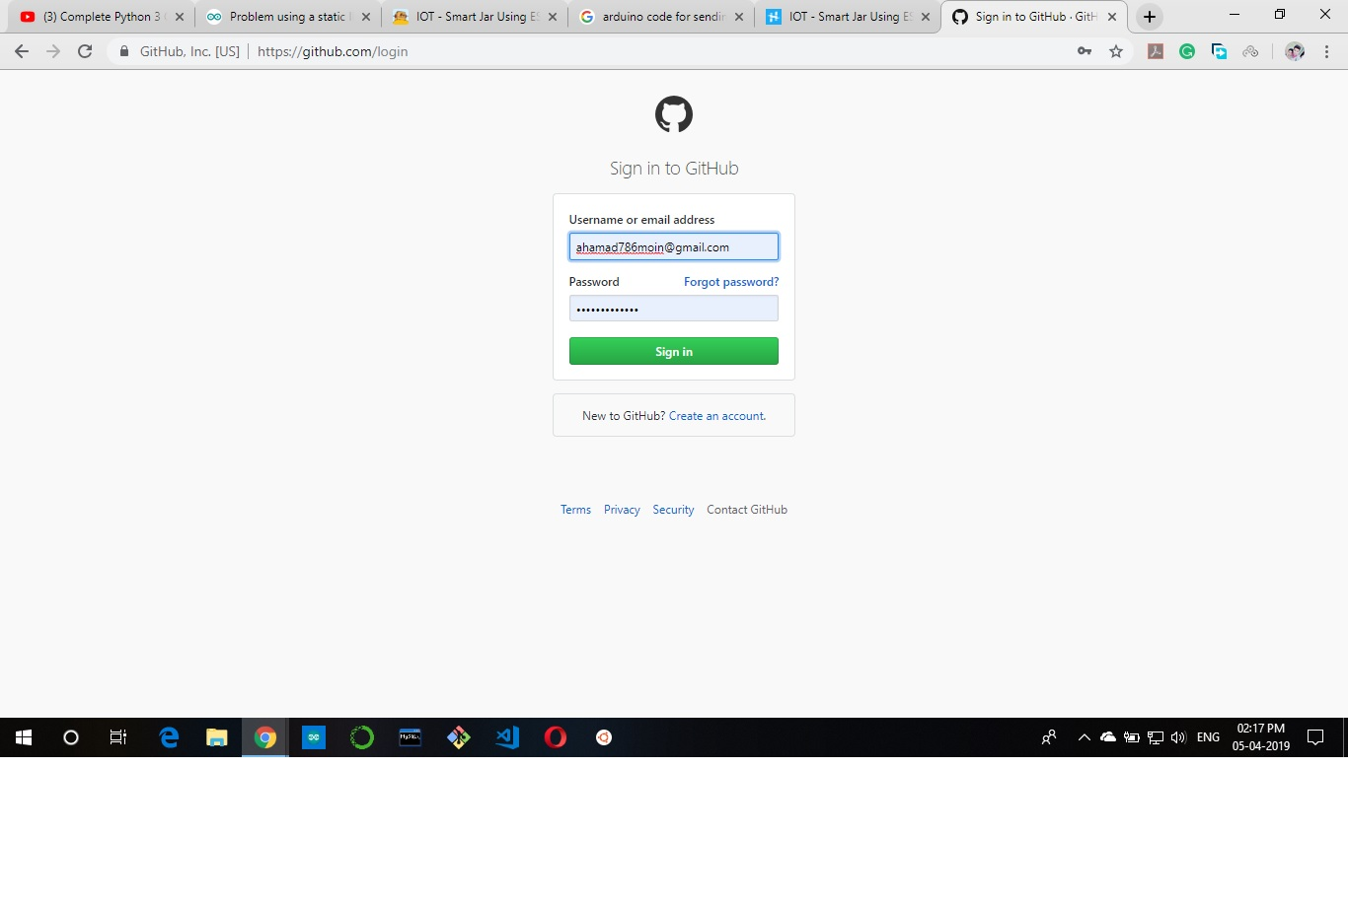

*Step*  2:🡪Now Click On “New”.

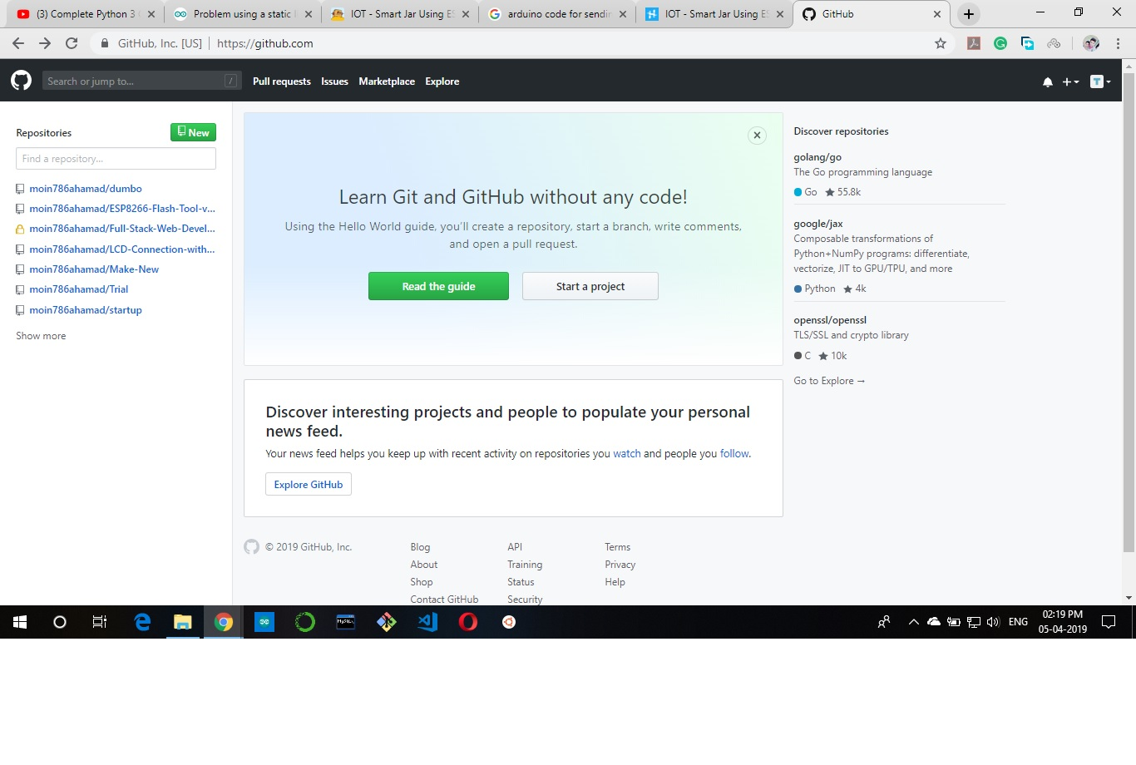

*Step*  3:🡪Give A Repository Name.

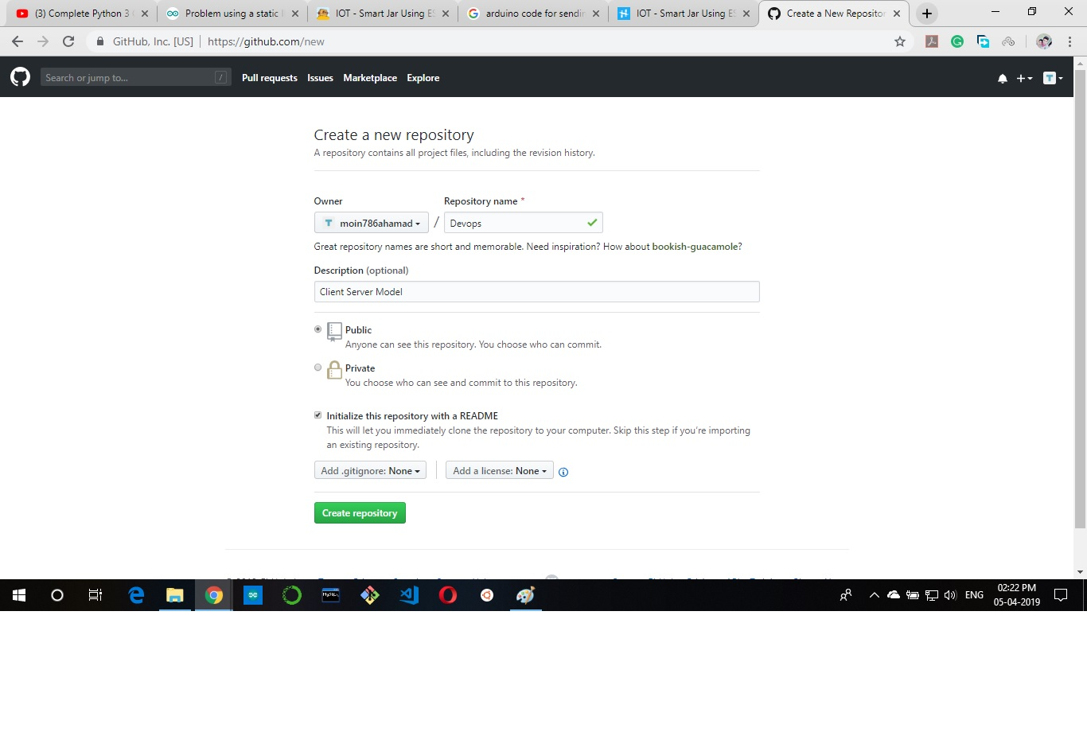

*Step*  4:🡪Now Click On “Create Repository”.

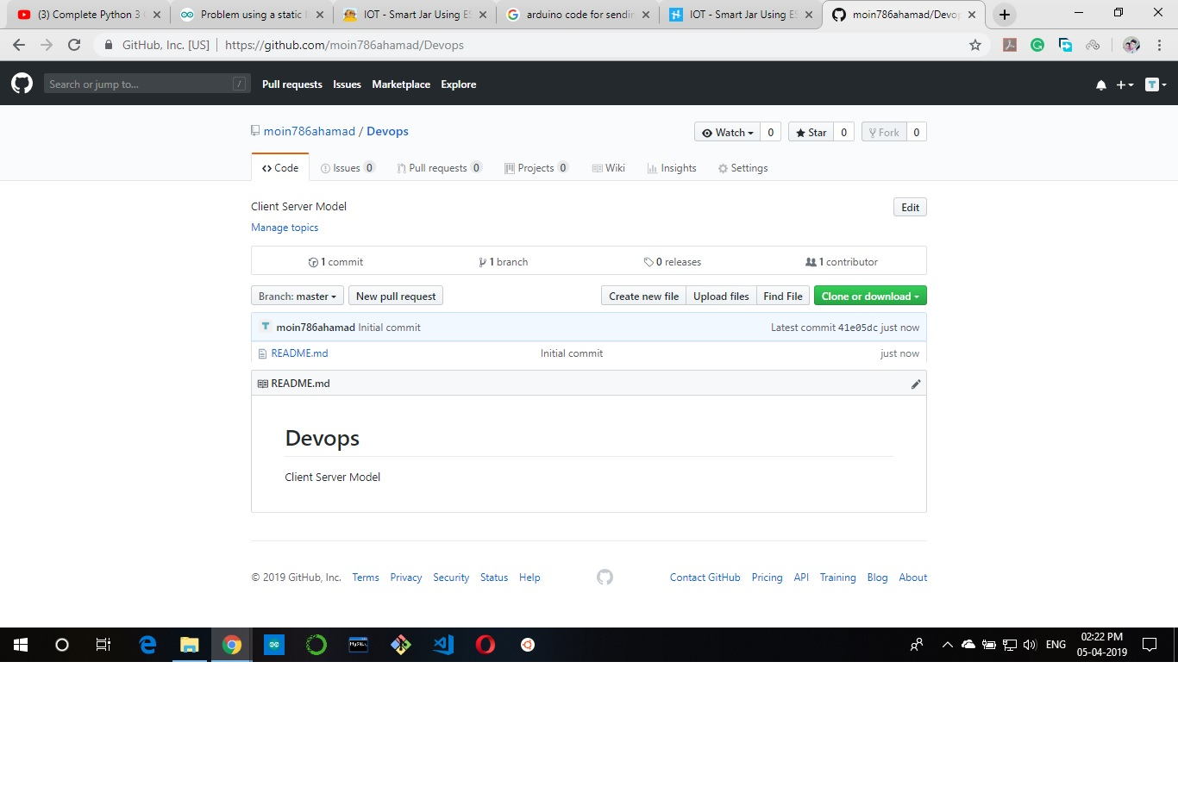

*Step*  5:🡪Now Click On “Clone or Download”.

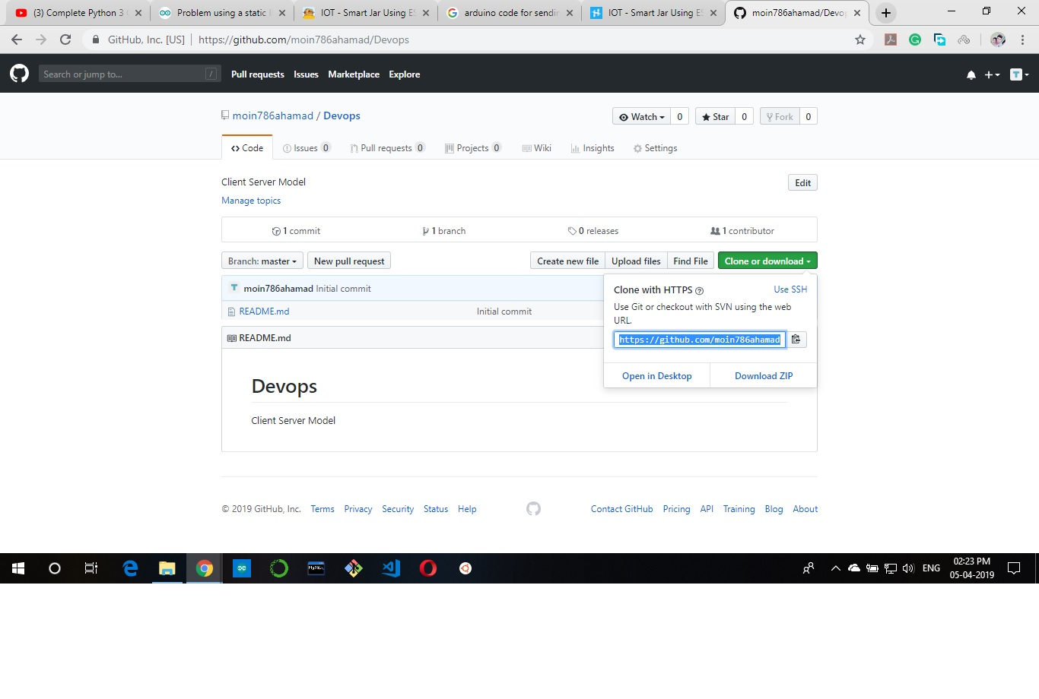

*Step*  6:🡪Now Open GitBash And Clone Your Repository on your Local Machine.

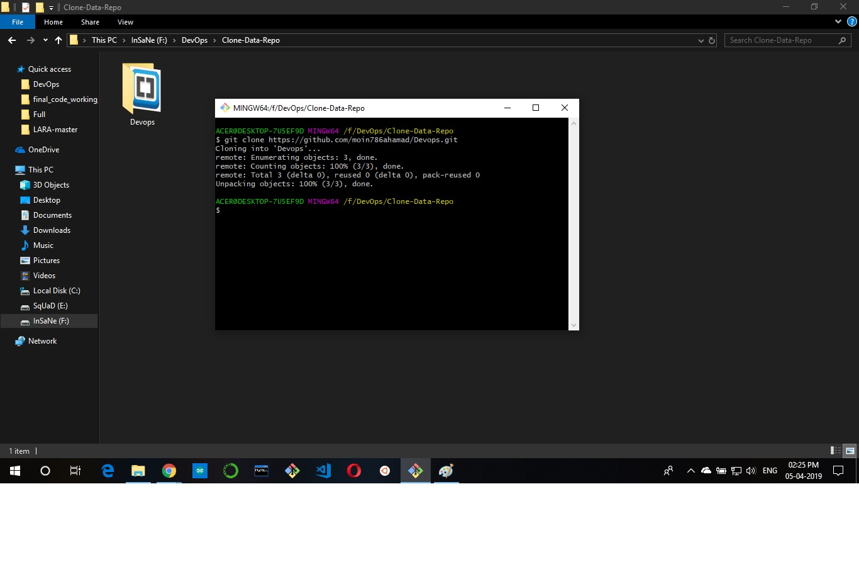

*Step*  7:🡪Now Go To Your Cloned Directory.

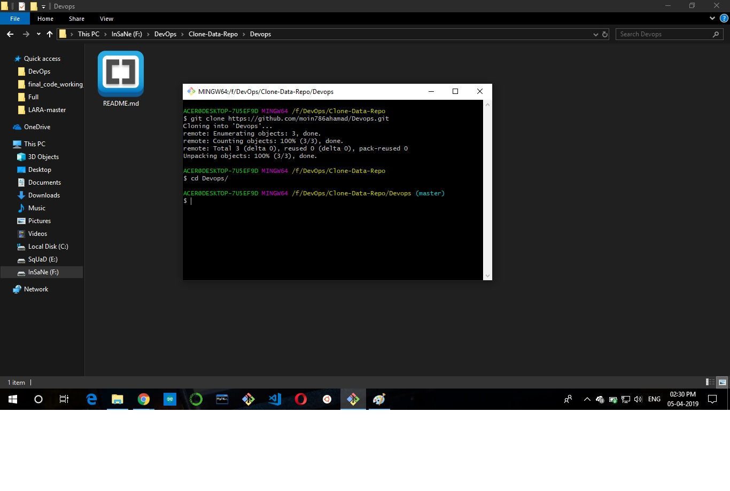

*Step*  8:🡪Now Create a Client.java File which will Act as a Client and Receive Message From Server End.

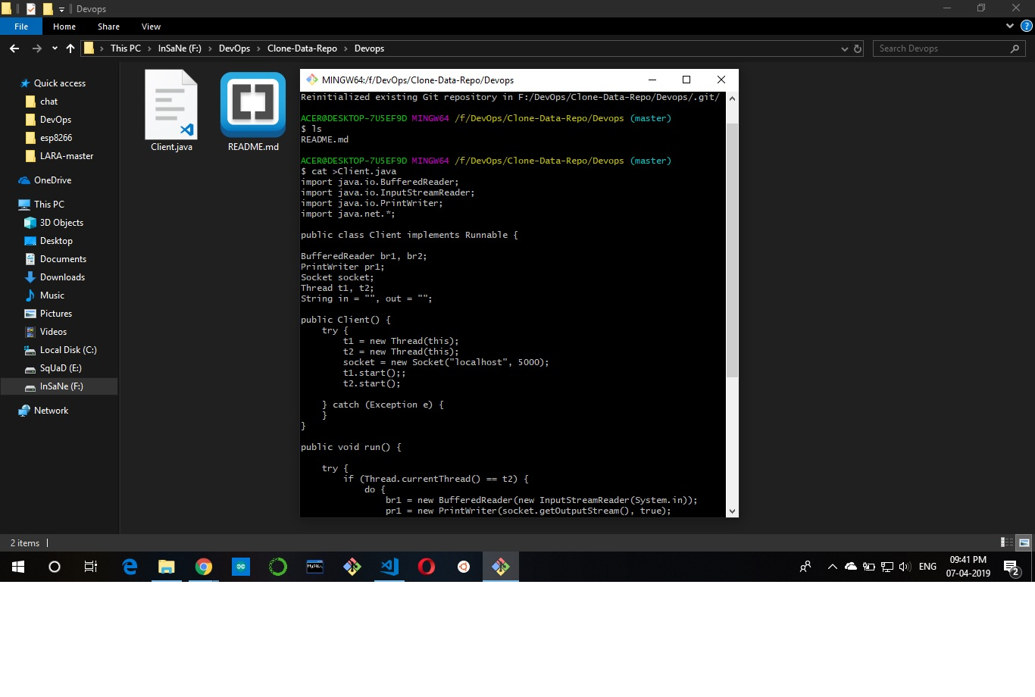

*Step*  9:🡪Now Create a Server.java File Which will connect to It’s Client to Establish A connection Between Them.

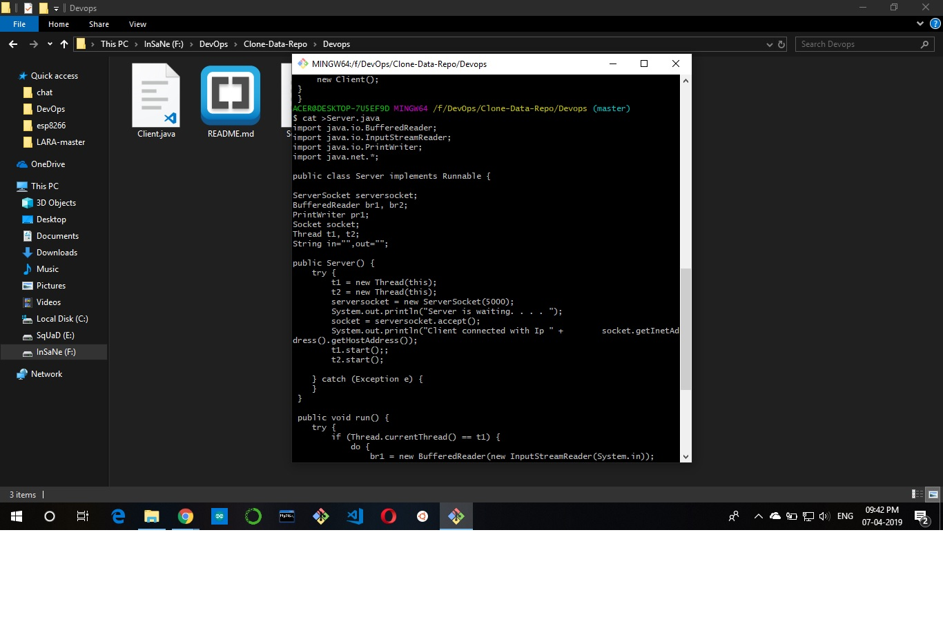

*Step*  10:🡪 Now Test Your Client-Server Model.

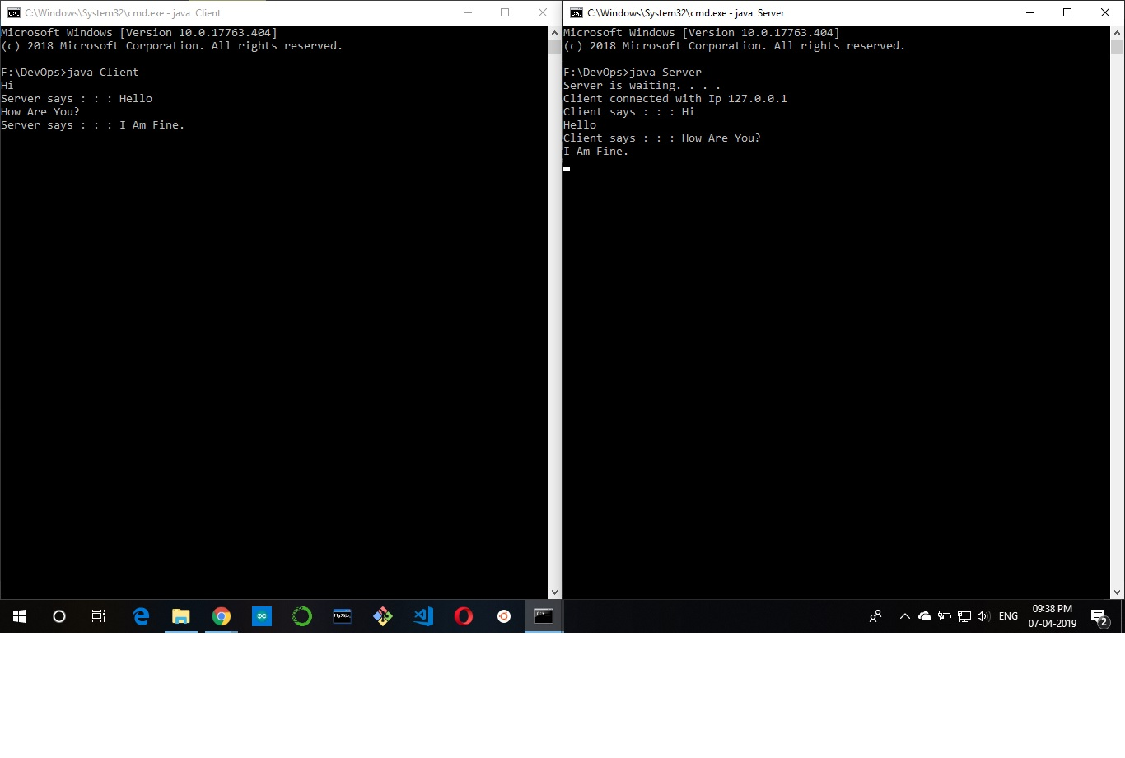

*Step*  11:🡪 Now Append All the Changes To Your Github Repo Using “git add .” command.

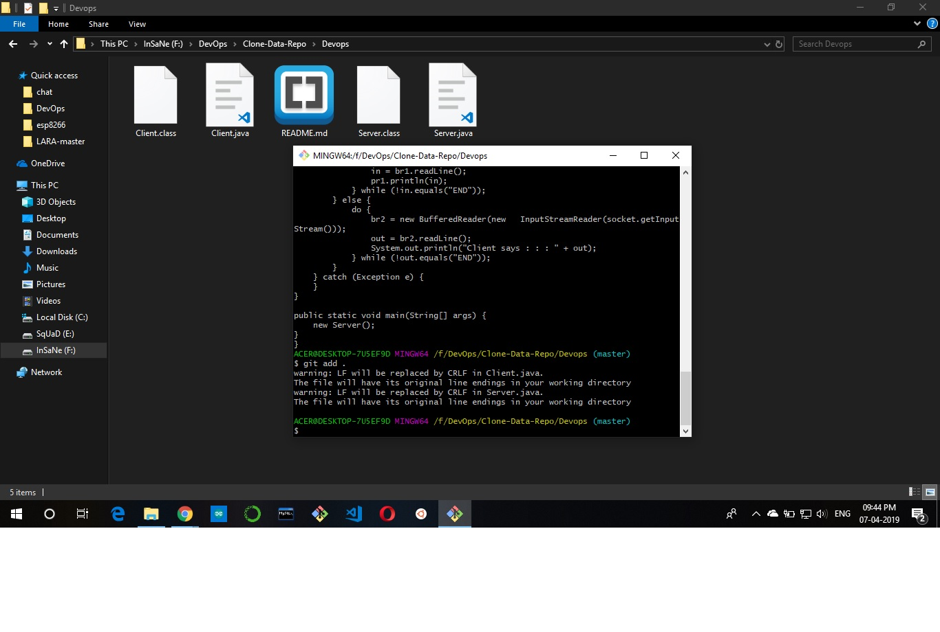

*Step*  12:🡪Now Commit The Changes “git commit -m “Message””command.

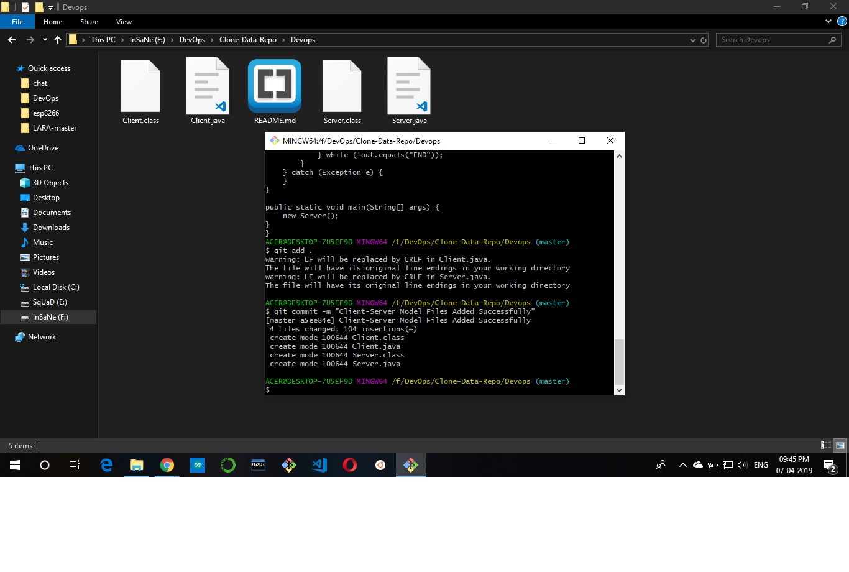

*Step*  13:🡪Now Push Your Files To The Master Branch “git push origin master”.

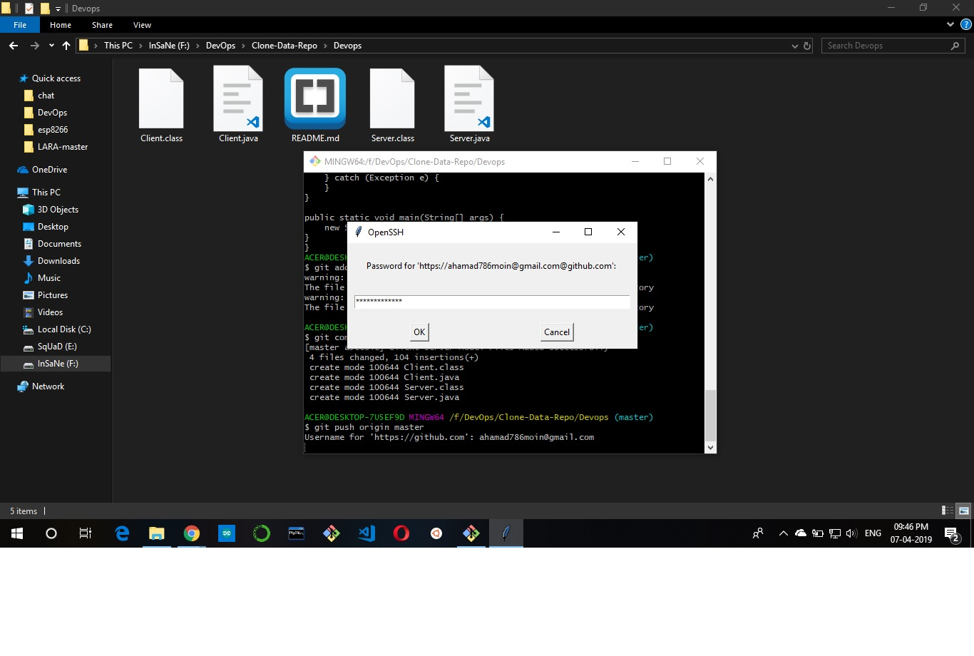

*Step*  14:🡪Now check The Logs “git log” which will show All Your Change Logs Made by You.

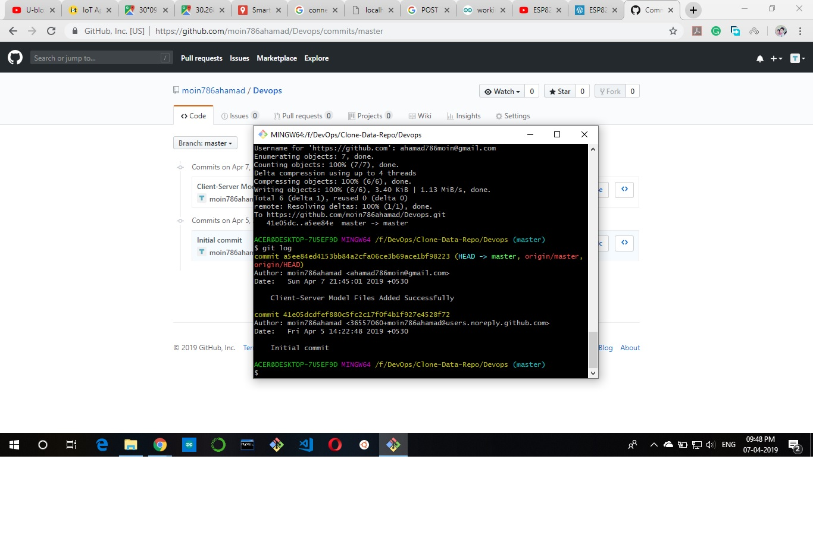

*Step*  15:🡪Access Your logs Using GUI.

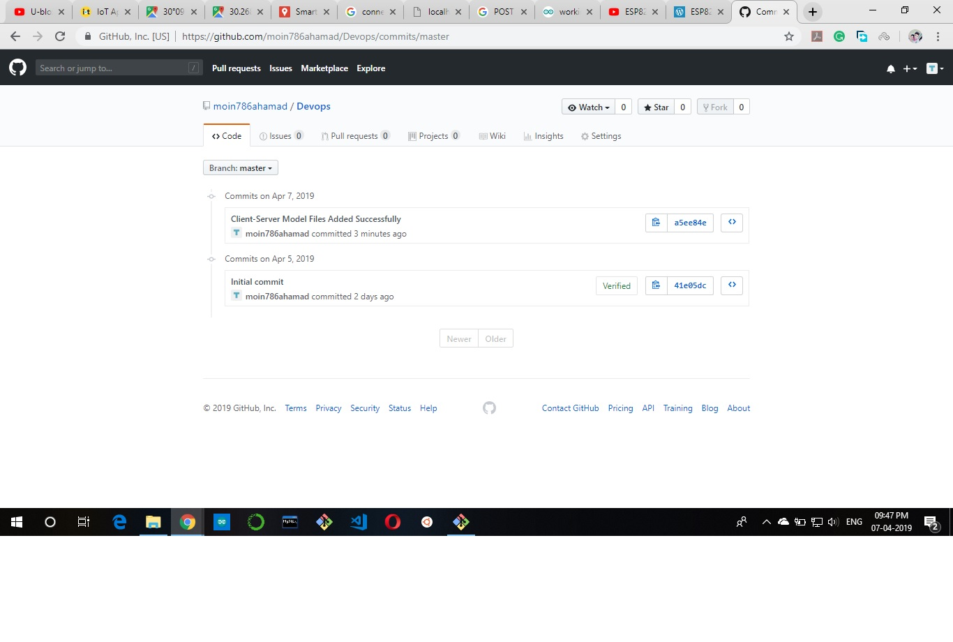

*Step*  16:🡪Check Your Central Repository.

