Welcome to our twitter plant project and our first instructable. We hope you like it and try to make your own twittera plant. If you need our help and experience we will be happy to help you.

First of all we introduce ourselves, we are a group of three students of ‘Creative Electronics’, a BEng Electronic Engineering 4th year module at the University of Malaga, School of Telecommunication (<http://etsit.uma.es/>).

Our project was born of our desire to do something fun using electronics, in addition we had read about the BotaniCalls[1] project so we decided to make our plant smart.

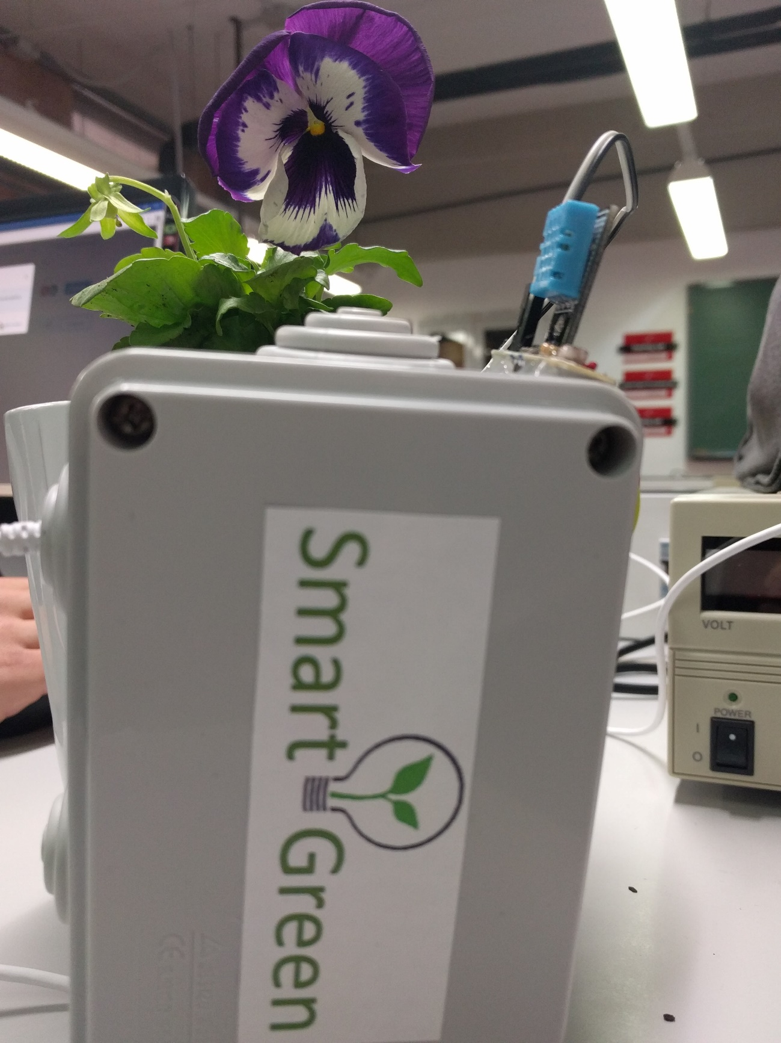

1. https://www.botanicalls.com/