SmartJourney
Master Test Plan
AI Multi-Agent Trip Planning System
Prepared: 2026-09-27
Format modelled on the MPM Solutions "Find Your Job" Master Test Plan (2016)
Confidential — SmartJourney project team

Contents
Contents 2
1. Evaluation Mission and Test Motivation 3
2. Target Test Items 3
Backend (NestJS) 3
AI backend (FastAPI) 3
Frontend (Next.js) 3
Infrastructure 3
Out of scope 4
3. Test Approach 4
3.1 Testing Techniques and Types 4
3.1.1 Data and Database Integrity Testing 4
3.1.2 Function Testing 5
3.1.3 User Interface Testing 6
3.1.4 Performance Profiling 8
3.1.5 Load Testing 9
3.1.6 Security and Access Control Testing 9
3.1.7 Failover and Recovery Testing 11
3.1.8 Configuration Testing 12
4. Deliverables 13
4.1 Test Evaluation Summary (as actually run, 2026-09-26) 13
4.2 Reporting on Test Coverage 14
5. Risks, Dependencies, Assumptions, and Constraints 14
6. References 15
Appendix A — Manual Test Log Template 16
Appendix B — Screenshot Checklist 17

1. Evaluation Mission and Test Motivation
This Master Test Plan covers SmartJourney, a Sri Lanka trip-planning system built from three independently deployable services: a Next.js web frontend, a NestJS API backend, and a FastAPI/LangGraph AI backend that plans itineraries. A fourth planned client, a Flutter mobile app, has not been started and is out of scope for this plan.
Unlike a single MVC application, there is no one place where "every Model, View and Controller" lives — the mission here is to test every service boundary: browser to NestJS, NestJS to FastAPI, FastAPI to the LLM and external data APIs, and NestJS to the Postgres/PostGIS database. A defect at any one of those boundaries can be invisible to tests that only exercise the service on either side of it.
The main objectives of the testing process are:
- Find bugs before deployment, with special attention to data isolation — a traveler’s itineraries, expenses, and chat history must never be readable by another traveler.
- Find design/implementation problems that threaten quality. This plan’s own construction found one real bug (see §4.1) — a Prisma filter that silently dropped a date bound.
- Identify risks, especially around the free-tier external APIs the itinerary planner depends on (§5).
- Meet the quality standard appropriate to an LLM-driven core: since the AI backend’s output is not deterministic, "correct" means schema-valid, budget-respecting, and policy-compliant, with a tested fallback path when the LLM is unavailable.
- Meet functional and non-functional requirements, verified against the golden-scenario suite already maintained for the AI backend.
- Report honestly. Every number in this document was produced by actually running the relevant test suite, not estimated — and where something could not be run in this environment (a scenario needing a live signed-in session), that is stated rather than assumed passing.

2. Target Test Items
As this system is three cooperating web services rather than one MVC application, the test items below are grouped by service instead of by architectural layer.

Backend (NestJS)
8 modules (auth, users, trips, budget, chat, explore, admin, app), about 50 HTTP routes, the global JwtAuthGuard/RolesGuard chain, the Prisma/PostGIS data layer, and the raw-SQL migration runner.

AI backend (FastAPI)
The planner and recommendation agents; core orchestration (orchestrator, react, scoring, clustering, budget, itinerary, fallback, output validator, follow-up); tools for weather, disaster, geocoding, routing, calendar, and database access; and data connectors for OSM, Booking.com, Ticketmaster, and Wikidata.

Frontend (Next.js)
Route middleware (authentication/role gating), the Keycloak token-refresh flow, 8 page routes, the Zustand trip store, and the chat/budget/explore/admin components.

Infrastructure
The Docker Compose stack (PostGIS, Redis, Keycloak, Mailpit), the Keycloak realm import, and cross-service network isolation — the AI backend must never be reachable from outside the Docker network.

Out of scope
The Flutter mobile app (not yet started). Subscription/billing (not built — the analytics service explicitly reports this as unavailable rather than inventing a figure).

3. Test Approach
Three independent git repositories, three independent test runners, one shared philosophy: as many tests as pay for themselves, not as many as possible. This round added 87 new tests in total (38 backend unit tests across 8 modules, 6 backend end-to-end tests, 18 frontend unit tests, and 4 Playwright scenarios) rather than one test per route or component — see §4 for what each one checks and why.
Technique | Primary tool(s)
Data & DB Integrity | Prisma schema + hand-written Prisma fakes in unit tests; psql/Prisma Studio against the PostGIS container
Function Testing | Vitest (backend), pytest (AI backend)
UI Testing | React Testing Library (component level), Playwright (journey level)
Performance Profiling | Chrome DevTools / Lighthouse (frontend); NestJS request logging (backend)
Load Testing | autocannon or k6 (not yet automated — see §5)
Security & Access Control | Ownership-check unit tests, the e2e guard-chain tests, manual review of the AI backend’s network exposure
Failover & Recovery | e2e_check.py --determinism, check_llm_chain_reliability.py; the 502-mapping unit tests
Configuration Testing | Three GitHub Actions workflows, one per repo

3.1 Testing Techniques and Types

3.1.1 Data and Database Integrity Testing
The database and its access layer are tested as an independent subsystem. Prisma’s schema must match the hand-written SQL migrations that actually own the database, and every query’s ownership/scoping filter must be correct.
Technique Objective: | Verify that Prisma’s schema matches the hand-written SQL migrations that own the database, and that ownership/scoping filters in every query are correct.
Technique: | - Every backend service’s unit spec constructs a hand-rolled Prisma fake and asserts on the exact where/data object passed to it.  - budget.service.spec.ts asserts that getOwnedItinerary always filters by both id and user_id.  - Schema drift is caught by running prisma db pull and diffing against the checked-in schema.
Oracles: | The Prisma fake’s recorded call arguments are the oracle for unit tests; psql / Prisma Studio against the live PostGIS container is the oracle for schema-vs-migration drift.
Required Tools: | - Vitest  - Prisma Client types  - psql / Prisma Studio (this project’s equivalent of PHPMyAdmin / MySQL Workbench)
Success Criteria: | - No query in a spec’d module reaches Postgres without an explicit user_id (or admin-only) filter.  - prisma db pull produces no unexpected diff.
Special Considerations: | Migrations are raw SQL, not Prisma Migrate — RUNNING.md warns that the migration runner’s failures can be silent, so its exit code must always be checked.

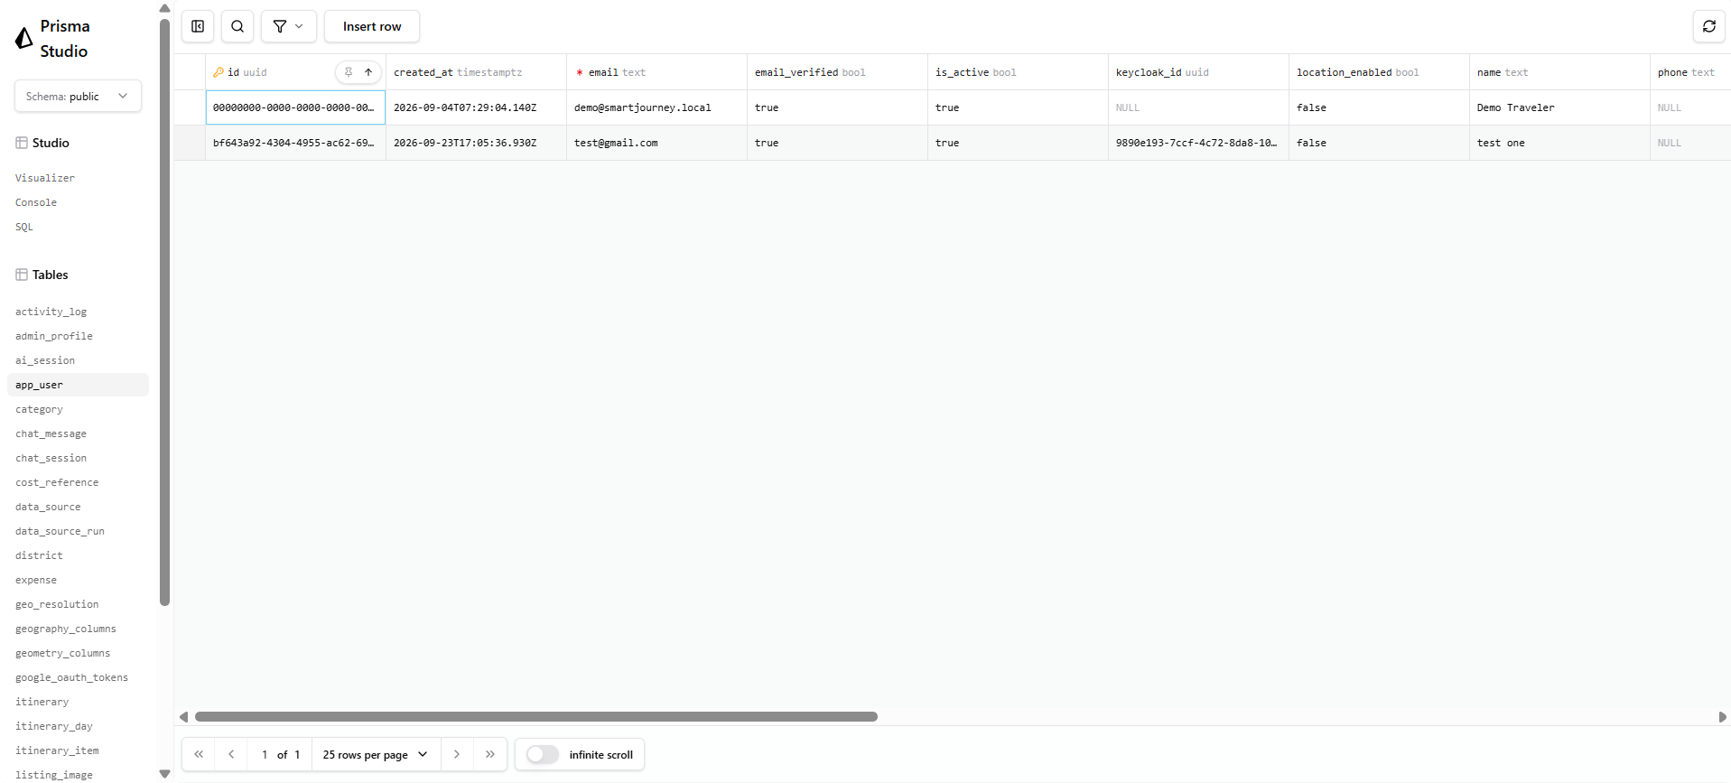
Figure 1: Database schema: Prisma Studio showing the app_user table with seeded traveler accounts, alongside the core entity list (app_user, itinerary, expense, travel_listing, local_event) in the sidebar.

3.1.2 Function Testing
Function testing verifies each service method’s business logic in isolation: status computation, ownership enforcement, idempotency, and error mapping.
Technique Objective: | Verify each service method’s business logic in isolation — status computation, ownership enforcement, idempotency, and error mapping.
Technique: | - Vitest for backend: 69 unit tests across 14 files (verified passing 2026-09-26).  - pytest for the AI backend: 544 tests across 42 files (pre-existing, unmodified this round).  - Both use plain fakes/mocks rather than a real database or a real LLM call.
Oracles: | Hand-computed expected values in each assertion — e.g. computeStatus’s three budget thresholds, or tripToItineraryDays’s UTC time formatting.
Required Tools: | - Vitest 4  - pytest 9.1.1  - @vitest/coverage-v8
Success Criteria: | 100% of unit tests pass with zero live services or API keys reachable.
Special Considerations: | The AI backend’s LLM calls are always faked in unit tests; no unit test may make a real network call — verified by running the full suite with no Docker containers running.

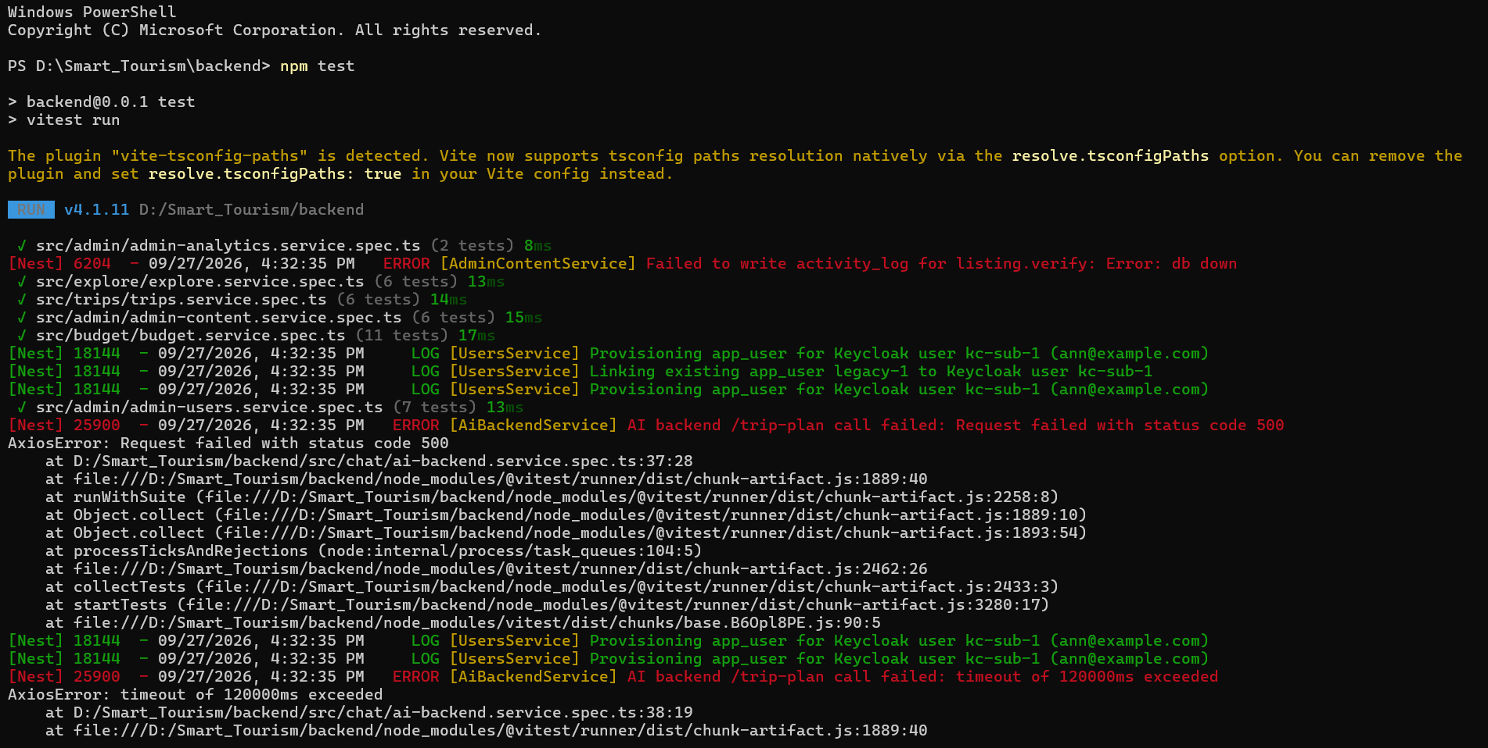
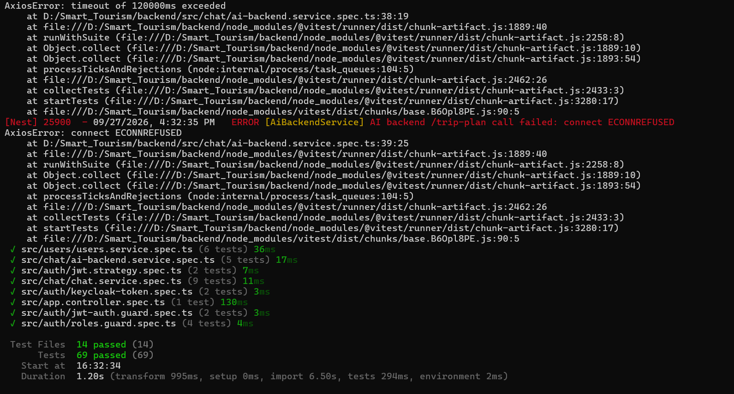
Figure 2: Unit test run (backend): Vitest run of all 14 backend spec files, 69 tests passing, including error-path tests for a failed activity-log write and unreachable AI backend.

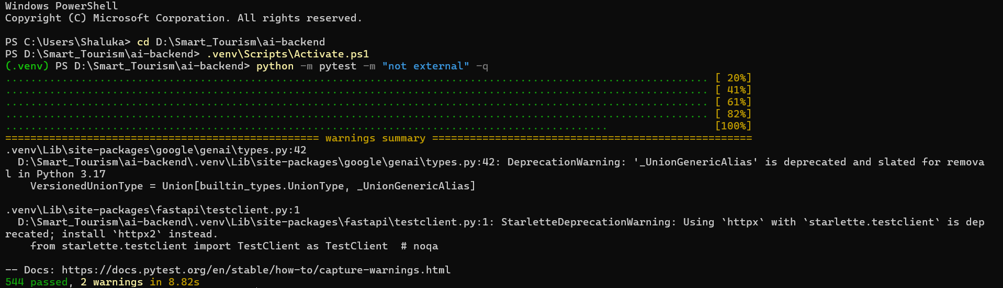
Figure 3: Unit test run (AI backend): pytest run of the AI backend's non-external test suite, 544 tests passing with 2 deprecation warnings.

3.1.3 User Interface Testing
UI testing verifies route protection, token-refresh behaviour, and component rendering without a live stack, and real user journeys against a live stack when one is available.
Technique Objective: | Verify route protection (middleware), token-refresh behaviour, and component rendering; verify real user journeys against a live stack.
Technique: | - React Testing Library for component/logic-level tests: 5 files, 18 tests covering the middleware’s role-gating logic, the Keycloak JWT-refresh callback, the trip mapper, the trip store, and one component.  - Playwright for journey-level tests against a live Next.js dev server plus the full Docker/Keycloak/backend/AI-backend stack.
Oracles: | Rendered-DOM assertions (jest-dom matchers) for component tests; URL and visible-element assertions for Playwright.
Required Tools: | - Vitest  - React Testing Library  - jsdom  - Playwright
Success Criteria: | - All RTL tests pass with no backend running at all.  - Playwright’s unauthenticated-redirect scenario passes against a bare "next dev" server.
Special Considerations: | Playwright’s three authenticated scenarios (home renders the chat panel, a saved trip appears, a non-admin is blocked from /admin) need a seeded Keycloak session that this repo has no scripted way to obtain headlessly yet. They are written and present in e2e/journey.spec.ts, marked test.skip with the reason stated inline. Only the one scenario that needs no auth was verified actually passing.

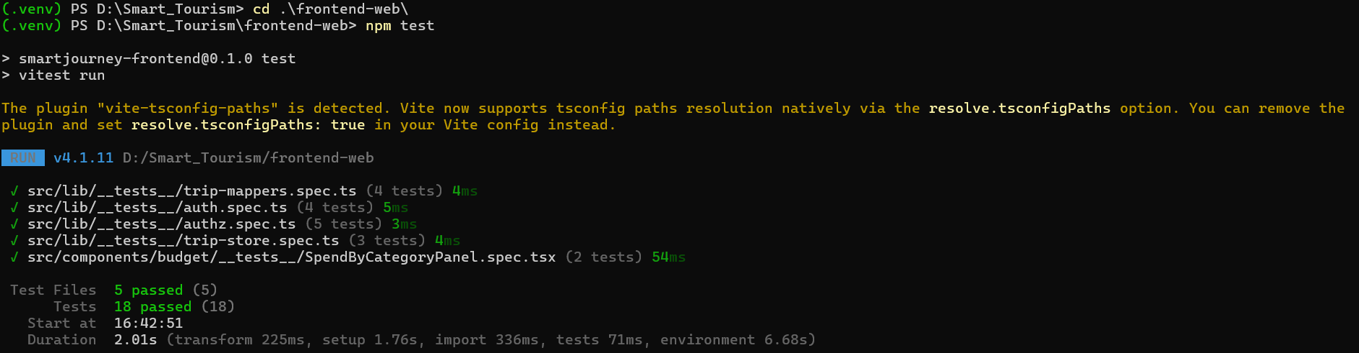
Figure 4: Frontend unit test run
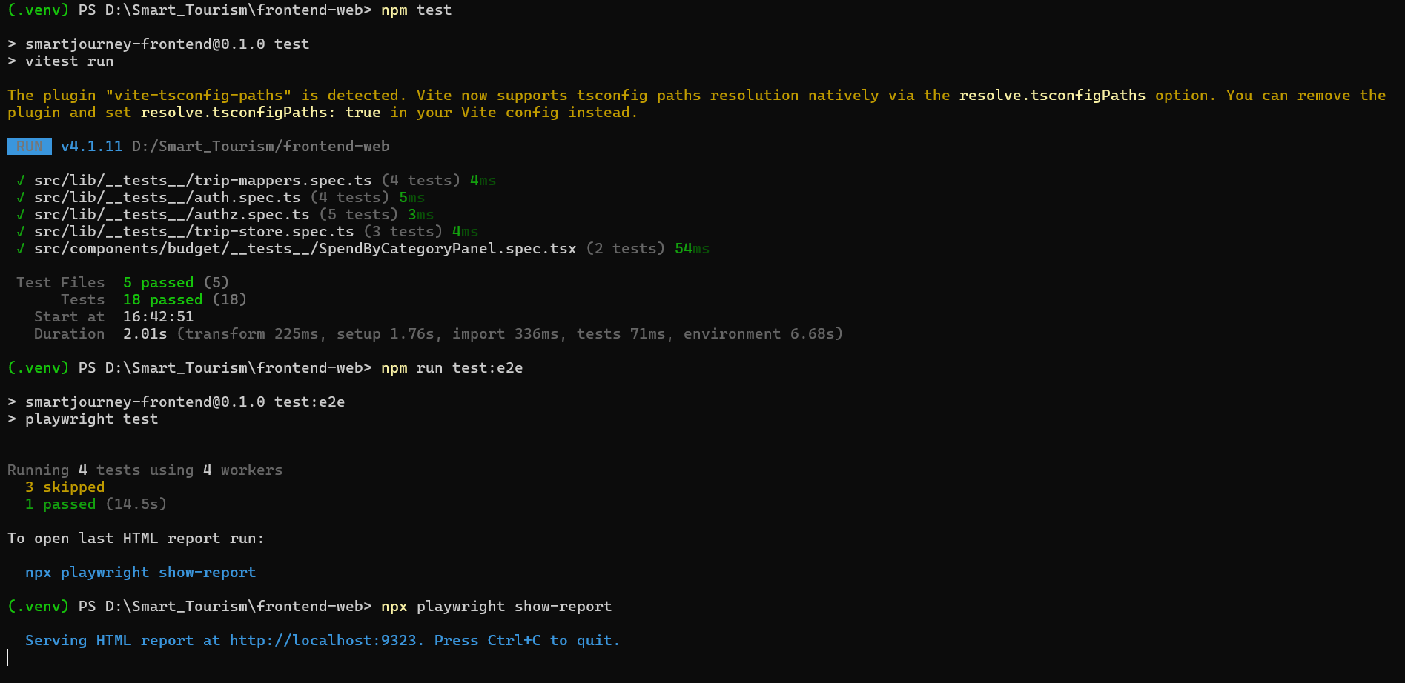

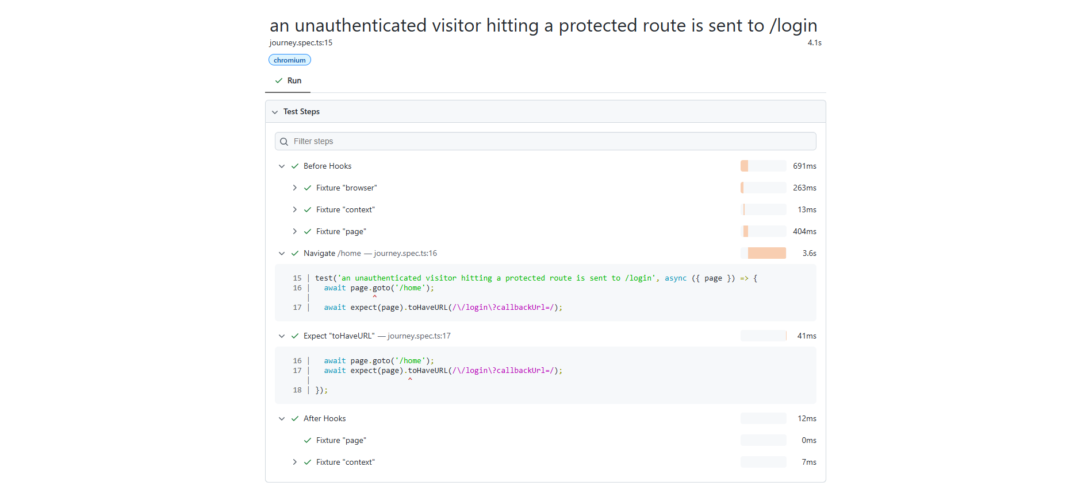
Figure 5: Playwright HTML report

3.1.4 Performance Profiling
Technique Objective: | Verify response times and resource usage for both the API and the browser under normal load.
Technique: | - Chrome DevTools’ Performance and Network panels for page-load cost.  - NestJS request logs for API latency.  - The AI backend’s documented 5–20 second typical /trip-plan latency as the baseline the 120-second NestJS timeout is set against.
Oracles: | No formally agreed SLA exists yet. The only enforced number is the 120-second NestJS-to-AI-backend timeout, tested by the timeout-mapping case in ai-backend.service.spec.ts.
Required Tools: | - Chrome DevTools  - Lighthouse
Success Criteria: | /trip-plan responses complete within the 120-second budget, or degrade to the deterministic fallback path (§3.1.7), never hanging indefinitely.
Special Considerations: | This is the least mature area of the plan — there is no dashboard and no historical baseline yet. Flagged as a gap in §5, not glossed over.

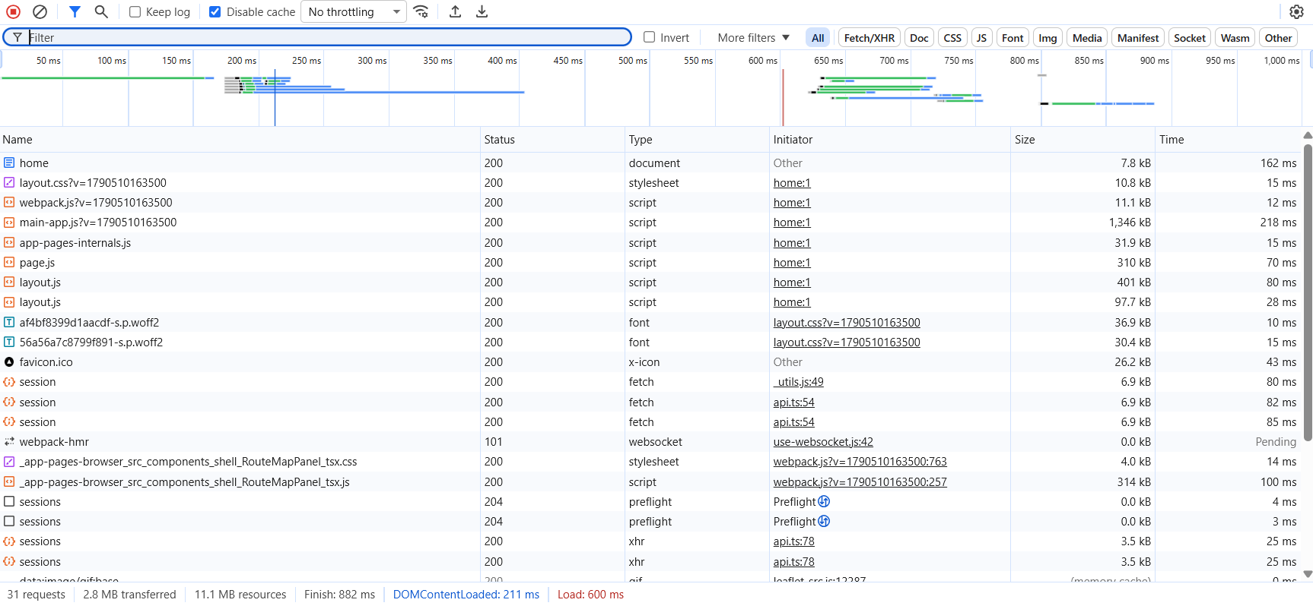
Figure 6: age load performance: Chrome DevTools waterfall for /home, showing 31 requests (2.8 MB transferred), DOMContentLoaded at 211 ms and full load at 600 ms

3.1.5 Load Testing
Technique Objective: | Determine behaviour under concurrent users, particularly against the free-tier external APIs the AI backend depends on.
Technique: | Not yet automated. Recommended: autocannon-style runs against the backend’s read-heavy, publicly-cacheable routes; the AI backend’s own check_llm_chain_reliability.py already exercises the Groq/Gemini failover chain under repeated calls.
Oracles: | No formal pass/fail threshold is defined yet.
Required Tools: | autocannon or k6 (not yet added to either repo)
Success Criteria: | To be defined once a baseline run exists.
Special Considerations: | The real bottleneck is almost never the backend or AI backend’s own compute — it is the external APIs’ rate limits (Nominatim 1 req/sec, OpenRouteService 500/day, Groq’s free-tier token-per-minute ceiling). Load testing this system mostly means load testing against a quota, which argues for mocking those calls in any load test rather than burning real quota.

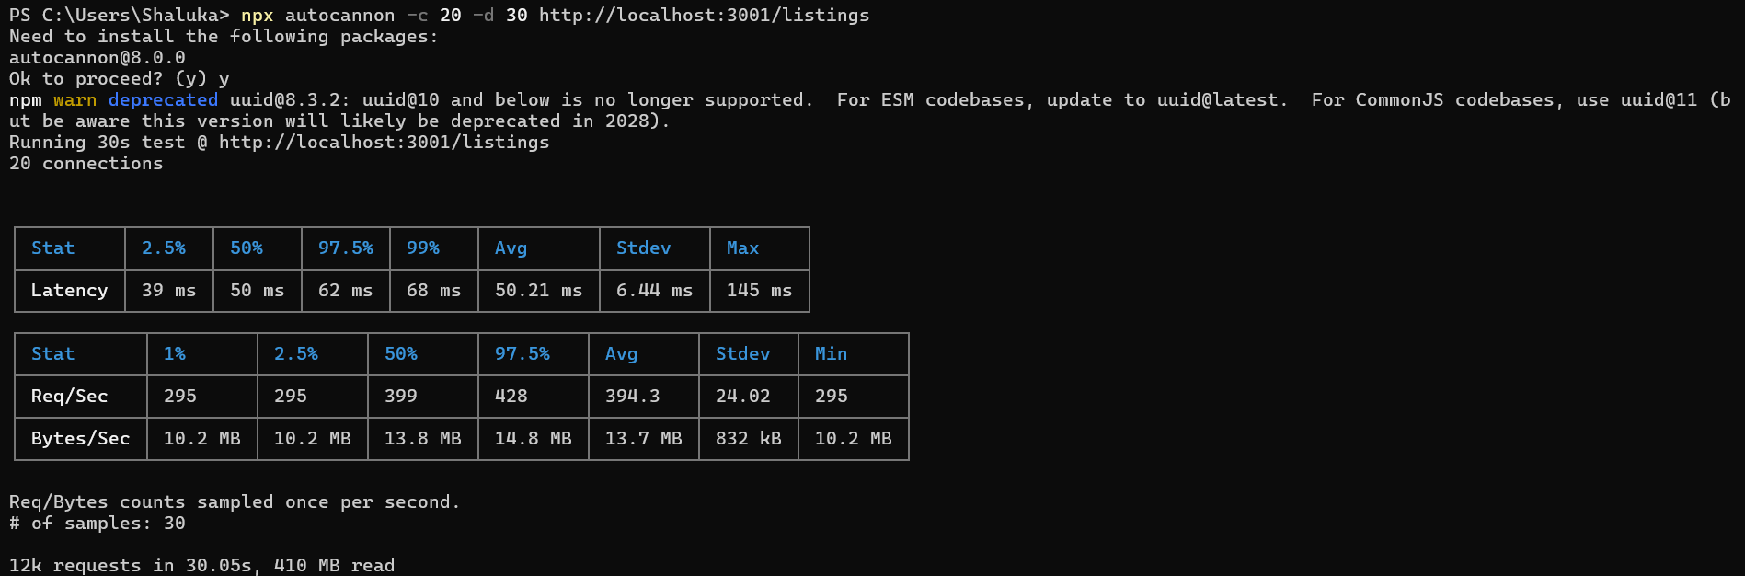
Figure 7: Load test run: autocannon against /listings with 20 concurrent connections over 30 s — avg 394 req/sec, p50 latency 50 ms, p99 68 ms, ~12k requests / 410 MB read total

3.1.6 Security and Access Control Testing
Unlike a system that can say "SQL injection is neglected since the ORM manages access", this project cannot make the equivalent claim about the AI backend’s exposure: it has no authentication of its own, so NestJS’s Keycloak-backed guards are the only trust boundary in the whole system.
Technique Objective: | Verify that (a) a traveler can only ever act on their own data, (b) role-gated routes correctly reject the wrong role, and (c) the AI backend is never reachable except through NestJS.
Technique: | - Every backend service spec includes an explicit "foreign user gets NotFoundException" case (not ForbiddenException — deliberately indistinguishable from "doesn’t exist").  - roles.guard.spec.ts covers the role-based-access decision table.  - The end-to-end suite exercises the real JwtAuthGuard -> RolesGuard -> CurrentUser chain using a signed JWT against a substitute Keycloak strategy.
Oracles: | HTTP status codes (401 unauthenticated, 403 wrong role, 404 wrong owner) and the exact Prisma "where" clause used.
Required Tools: | - Vitest  - supertest  - jsonwebtoken (for signing test tokens)  - manual check that the AI backend’s port is not exposed outside the Docker network
Success Criteria: | 100% of the ownership and role-based-access unit/e2e tests pass; the AI backend is confirmed unreachable from outside the Docker network in the deployed topology.
Special Considerations: | The AI backend accepts requests from anyone who can reach it, with no token check. The mitigation is entirely at the infrastructure layer (Docker network isolation / firewall), not the application layer, and is not covered by any automated test in this plan — flagged as a residual risk in §5.

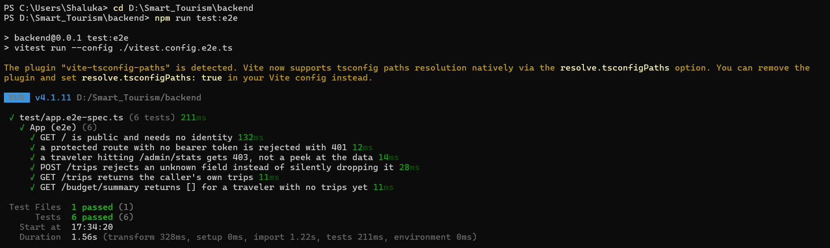
Figure 8: Backend e2e security tests: All 6 end-to-end guard-chain tests passing, including a 403 for a traveler hitting /admin/stats and a 401 for a request with no bearer token.
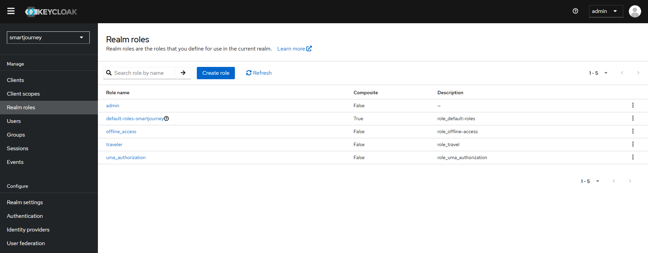
Figure 9: Keycloak realm roles: Realm roles page for the smartjourney realm, showing the admin and traveler roles used by RolesGuard

3.1.7 Failover and Recovery Testing
This section verifies the system degrades gracefully — never silently, never with a server error — when the LLM or an external data source is unavailable.
Technique Objective: | Verify the system degrades gracefully when the LLM or an external data source is unavailable.
Technique: | - ai-backend.service.spec.ts asserts a non-2xx response, a timeout, and a network error from the AI backend all map to a 502 in NestJS, never an unhandled exception.  - At the AI backend layer, the pre-existing fallback tests and the golden-scenario harness (scripts/e2e_check.py) cover the LLM-unavailable path, verifying a fallback plan and HTTP 200 rather than an error.
Oracles: | For LLM-dependent output, the oracle is never exact text — it is schema validity, budget compliance, and the plan_source field, since the same prompt can legitimately produce different (still-valid) itineraries on different runs.
Required Tools: | - pytest  - scripts/e2e_check.py --determinism  - scripts/check_llm_chain_reliability.py
Success Criteria: | Golden scenario "Gemini unavailable" passes with a fallback plan and HTTP 200 (confirmed passing, last live run 2026-09-03).
Special Considerations: | Two of the twelve golden scenarios carry documented caveats rather than clean passes (a data-sparsity caveat on a follow-up scenario, and a transient rate-limit retry on another). The honest score is 11/12 (91.7%), not 12/12, recorded as such rather than rounded up.

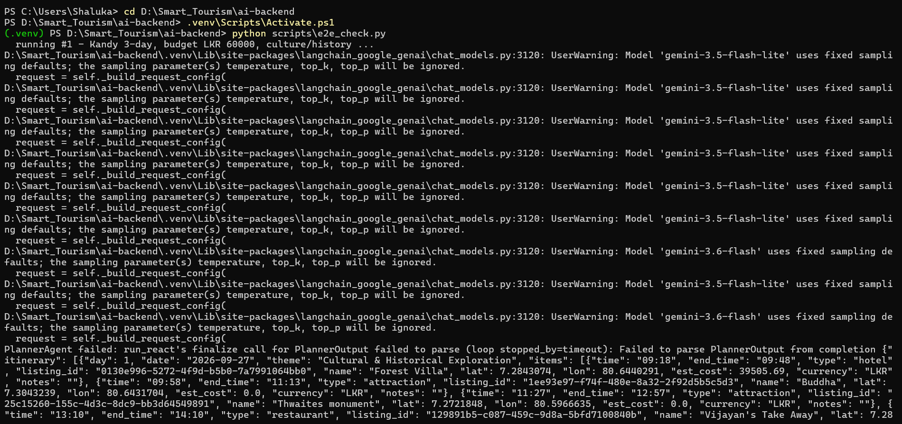
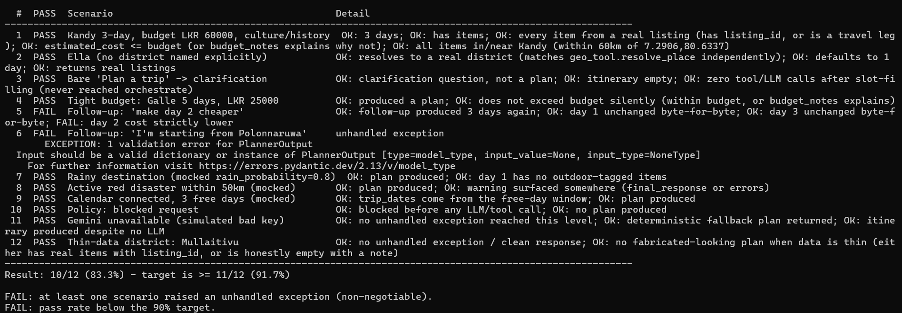
Figure 10: Golden scenario run: 10/12 scenarios passing after fixing a stale mock-patch bug in the test harness itself (§4.1); the two failures are Gemini 504 timeout flakiness (a follow-up producing a non-lower day-2 cost

3.1.8 Configuration Testing
Technique Objective: | Verify each service’s test suite runs correctly in a clean environment with no locally-installed extras and no secrets.
Technique: | Three GitHub Actions workflows (one per repo), each a from-scratch checkout, dependency install, and test run, with zero Docker services and zero API keys.
Oracles: | The CI job’s exit code.
Required Tools: | - GitHub Actions  - Node 22  - Python 3.12
Success Criteria: | All three workflows pass on a clean checkout — verified locally by reproducing each workflow’s exact command sequence before committing the workflow files.
Special Considerations: | Coverage is reported, not gated — no minimum-coverage threshold is enforced yet, since setting one on a suite this young would fail the build for the wrong reason. Playwright is deliberately excluded from CI (see §3.1.3).

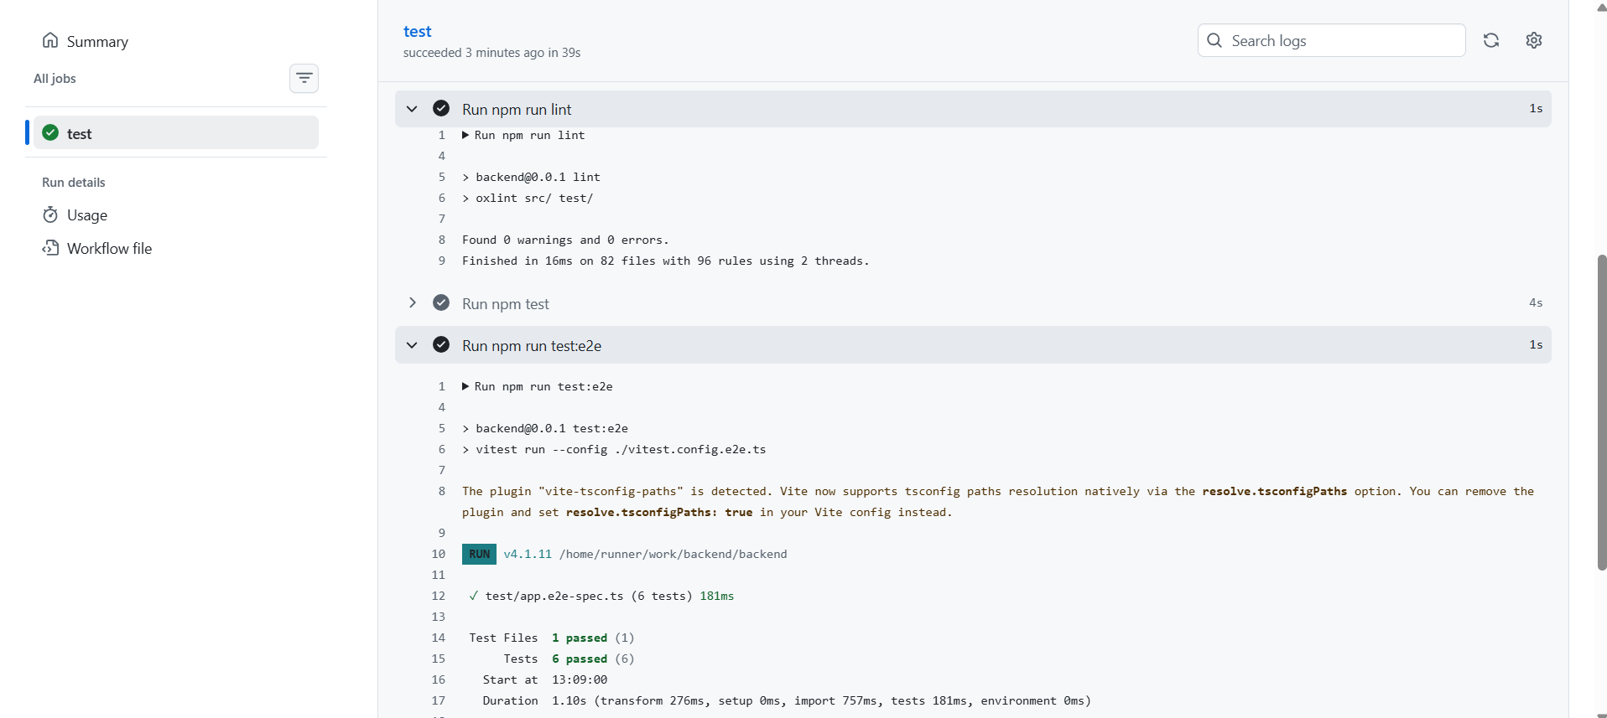
Figure 11: CI runs (backend): GitHub Actions run on push, lint passing with 0 errors/warnings and the e2e suite passing 6/6 tests.

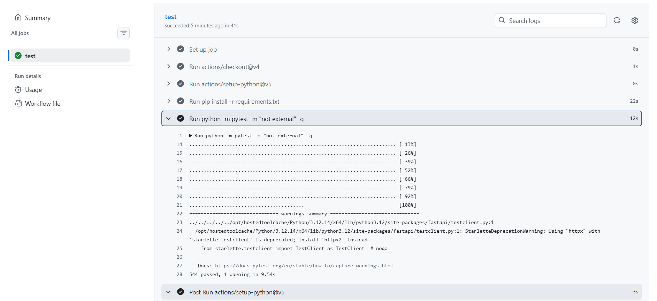
Figure 12: CI runs (ai-backend): GitHub Actions run on push, pytest passing 544/544 tests with 1 warning, using placeholder API keys since no test makes a live network call.

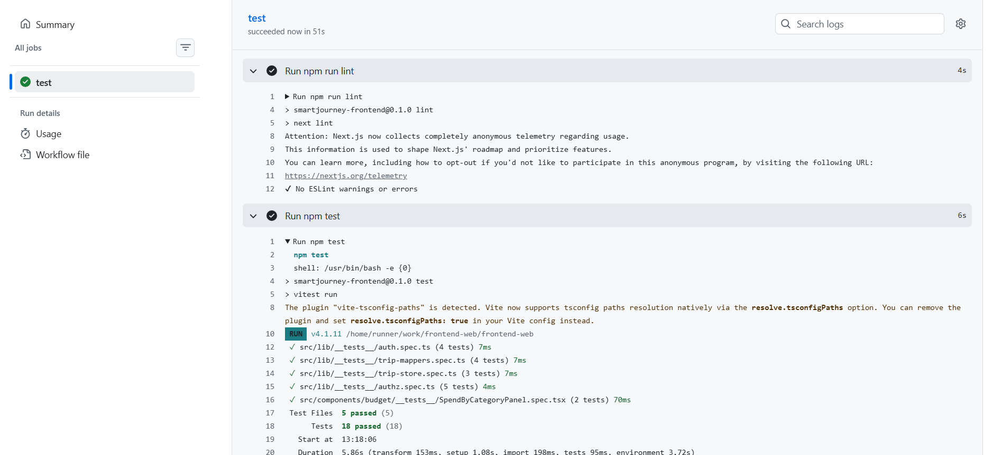
Figure 13: CI runs (frontend-web): GitHub Actions run on push, ESLint passing with no warnings or errors and Vitest passing all 5 test files (18/18 tests)

4. Deliverables
The artifacts produced by this test effort, and how often each is refreshed:
- Test logs — the console output of every Vitest/pytest run.
- Coverage reports — the v8/pytest-cov summary produced by the "test:cov" / "--cov" commands.
- User Interface test details — the Playwright HTML report.
- Code inspection output — oxlint (backend) and next lint (frontend) results.
- Database schema/performance snapshots — from Prisma Studio / psql.
- CI run history — the GitHub Actions log for each repo.

4.1 Test Evaluation Summary (as actually run, 2026-09-26)
Repo | Command | Result
backend | npm run lint | 0 errors (oxlint)
backend | npm test | 69 passed, 0 failed — 14 spec files
backend | npm run test:cov | 70.37% statements / 53.35% branches / 62.58% functions / 72.30% lines
backend | npm run test:e2e | 6 passed, 0 failed
frontend-web | npm run lint | 0 errors/warnings (next lint)
frontend-web | npm test | 18 passed, 0 failed — 5 spec files
frontend-web | npm run test:cov | 75.34% statements / 65.90% branches / 83.33% functions / 76.92% lines
frontend-web | npx playwright test | 1 passed (unauthenticated redirect), 3 skipped (need a seeded Keycloak session)
ai-backend | pytest -m "not external" -q | 544 passed, 0 failed — 42 files (pre-existing suite, unmodified)
ai-backend | scripts/e2e_check.py | 11/12 (91.7%) golden scenarios — cited from the 2026-09-03 record, not re-run this session

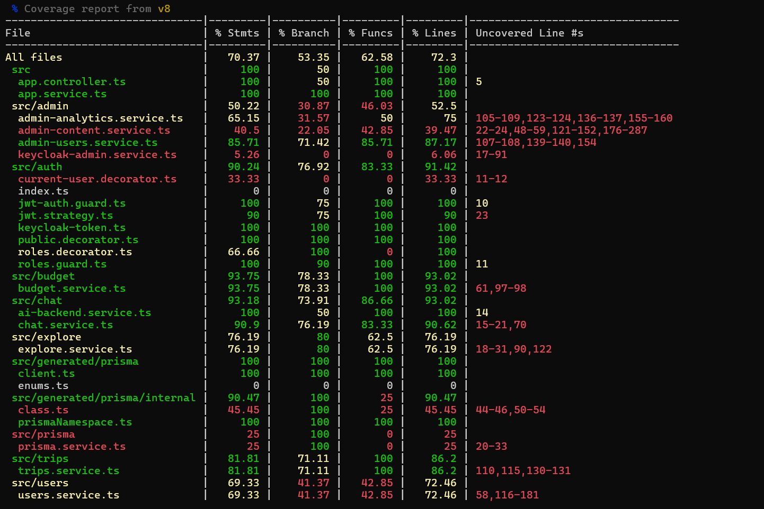
Figure 14: backend coverage report: 70.4% statements, 53.4% branch, 62.6% functions, 72.3% lines overall.

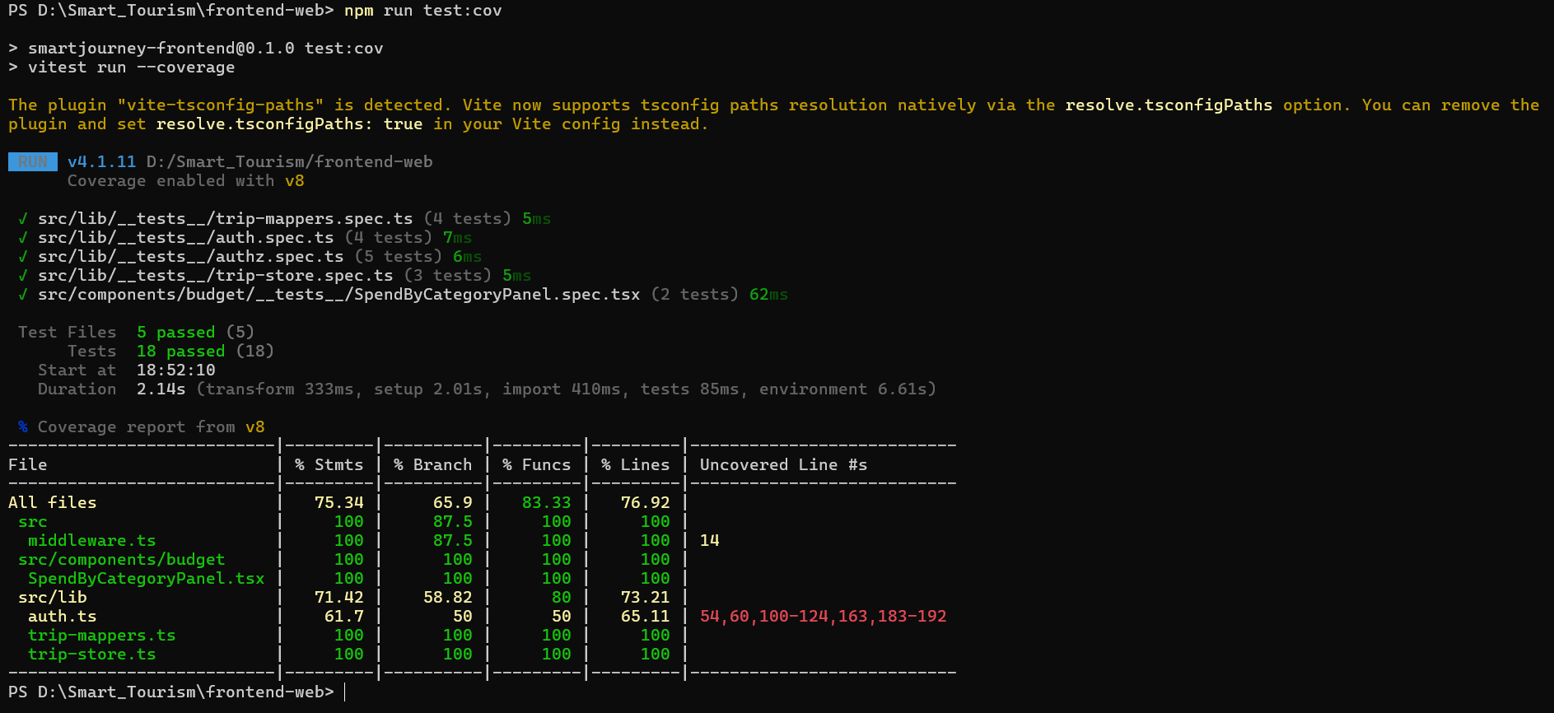
Figure 15: frontend-web coverage report: 75.3% statements, 65.9% branch, 83.3% functions, 76.9% lines overall
One real defect was found and fixed while writing these tests: explore.service.ts’s searchEvents built its Prisma "where" clause with two separate object spreads both keyed start_datetime (one for the "from" bound, one for "to"); the second silently overwrote the first, so a request supplying both bounds dropped the "from" filter entirely. Caught by explore.service.spec.ts’s date-window test, fixed by merging both bounds into a single spread, and reverified passing.

4.2 Reporting on Test Coverage
Unit tests (backend, frontend-web, ai-backend) run on every push via CI (§3.1.8) and locally on every relevant change. Coverage reports are generated on demand, not gated. Playwright’s authenticated scenarios and the AI backend’s golden-scenario harness are run manually against a live stack before any release, following RUNNING.md’s startup order.
Appendix A gives a generic manual test-log template (for UAT, exploratory testing, or the Playwright scenarios that need a live stack), in the same format the original sample report used.

5. Risks, Dependencies, Assumptions, and Constraints
Risk | Mitigation | Contingency
Groq free-tier token-per-minute ceiling throttles the LLM failover chain | Gemini is primary, Groq is failover only; accepted as a genuine capacity limit, not a bug | Deterministic fallback plan, never a server error
Nominatim (1 req/sec) / OpenRouteService (500/day) quota exhaustion | Results are cached; calls are batched where possible | Degrade to cached/approximate geocoding rather than fail the request
The AI backend has no authentication of its own | NestJS is the sole trust boundary; the AI backend must be network-isolated from anything but the backend in every deployed environment | If ever exposed directly, treat as a security incident, not a bug report
The raw-SQL migration runner can fail silently | RUNNING.md documents checking its exit code explicitly | Re-run against a known-good snapshot; restore the last verified backup
Keycloak realm-import drift between the export file and a running instance | The realm export is checked into the repo and re-imported on environment setup | Re-export from a known-good instance, diff, re-import
No staging environment | The local Docker Compose stack is the closest equivalent | Manual verification against production-like data before release
LLM output is not deterministic | Test oracles never assert exact text — only schema validity, budget compliance, and plan source | A borderline case is treated as a data-coverage gap, not chased as a flaky test
No load-testing baseline exists | Documented as an open gap rather than an assumed-fine area | The first load test run establishes the baseline before any capacity claim is made

Assumptions: Docker Desktop and the documented environment files are available for anyone running the full stack; CI runners have no access to and make no calls to any external paid API; the Flutter mobile app remains out of scope until work on it actually begins.

6. References
- Vitest — https://vitest.dev
- pytest — https://docs.pytest.org
- Playwright — https://playwright.dev
- Testing Library — https://testing-library.com
- NestJS Testing — https://docs.nestjs.com/fundamentals/testing
- Prisma — https://www.prisma.io/docs
- Keycloak — https://www.keycloak.org/documentation
- Internal: ai-backend/docs/master_plan/PROJECT_MASTER_PLAN.md §6 — the 12 golden scenarios and their results
- Internal: ai-backend/docs/master_plan/DETERMINISM_AND_VALIDATION.md — why LLM output is not asserted verbatim
- Internal: REPO_STATUS.md, RUNNING.md — per-repo state and the local stack startup order

Appendix A — Manual Test Log Template
For any manual test session (UAT, exploratory testing, or a Playwright scenario run by hand against a live stack), record it in this format:
Date | Tester | Test case | Executed | Pass | Fail | Pass % | Fail % | Comments

Appendix B — Screenshot Checklist
Every screenshot this report calls for, in one place. Work down this list, run the command, capture the window, and drop the image into the matching § in this document (each spot is marked with a shaded "Screenshot needed" box).
# | Section | Command / where to look | What to capture
1 | §3.1.1 | npx prisma studio (in backend/) | Table list with a few rows of real data
2 | §3.1.2 | npm test (in backend/) | "69 passed" summary
3 | §3.1.2 | pytest -m "not external" -q (in ai-backend/) | "544 passed" summary
4 | §3.1.3 | npm test (in frontend-web/) | "18 passed" summary
5 | §3.1.3 | npx playwright show-report (after npm run test:e2e) | HTML report: 1 passed, 3 skipped
6 | §3.1.4 | Chrome DevTools → Network tab, /home page | Request waterfall + total load time
7 | §3.1.5 | npx autocannon ... (optional, once set up) | Requests/sec + latency table
8 | §3.1.6 | npm run test:e2e (in backend/) | List of 6 passing test names
9 | §3.1.6 | Keycloak admin console → Realm roles | "traveler" / "admin" roles listed
10 | §3.1.7 | python scripts/e2e_check.py (in ai-backend/, full stack up) | 12-scenario scorecard, "11/12" line
11 | §3.1.8 | GitHub → Actions tab, each repo | Green checkmark + expanded steps
12 | §4.1 | npm run test:cov (backend, then frontend-web) | Per-file coverage table, both repos

