**Task 1**: To create two API for logging in and signing up a customer for Smart Munim Ji.

Creating in a spring starter project with spring security.

Libraries imported while creatin project:

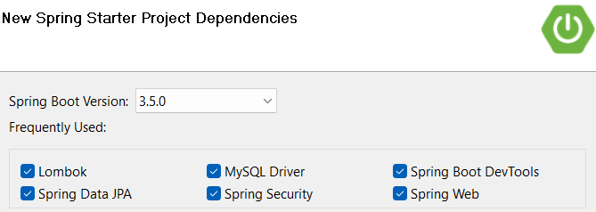

Must add these dependencies manually in pom.xml:

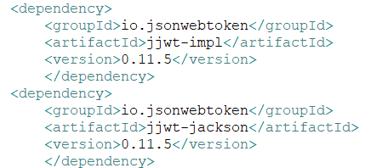

Created a modular project structure:

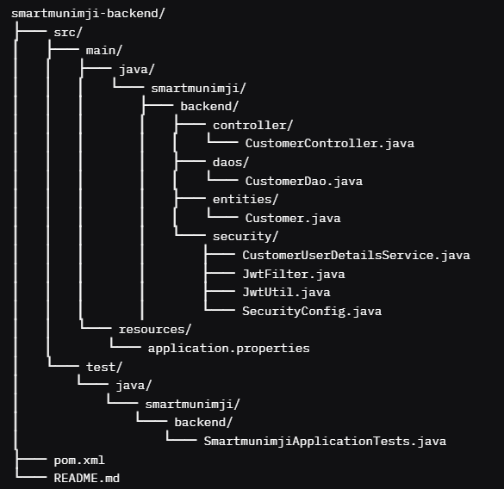

Customer api:

**POST**: <http://localhost:8080/sm/register>

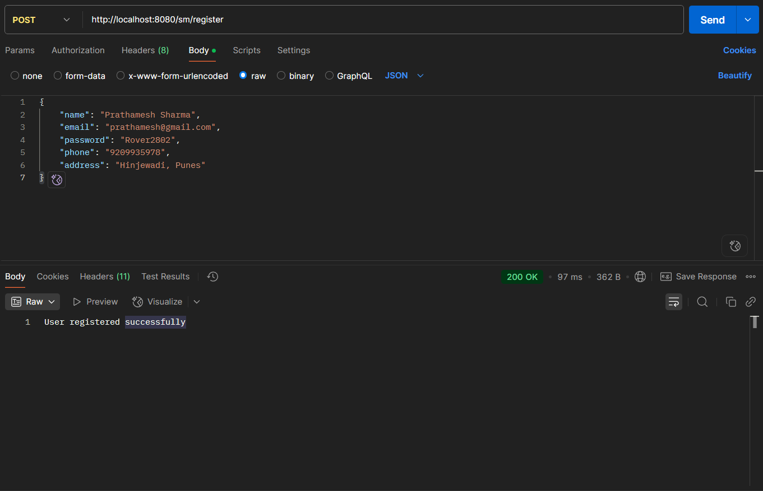

**POST:** <http://localhost:8080/sm/authenticate>

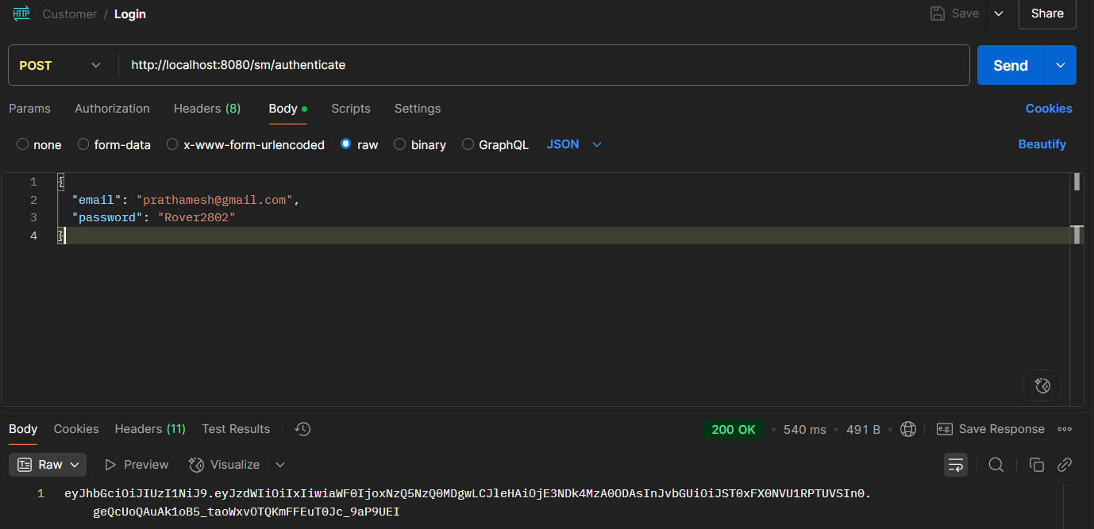

**GET:** <http://localhost:8080/sm/cust/profile>

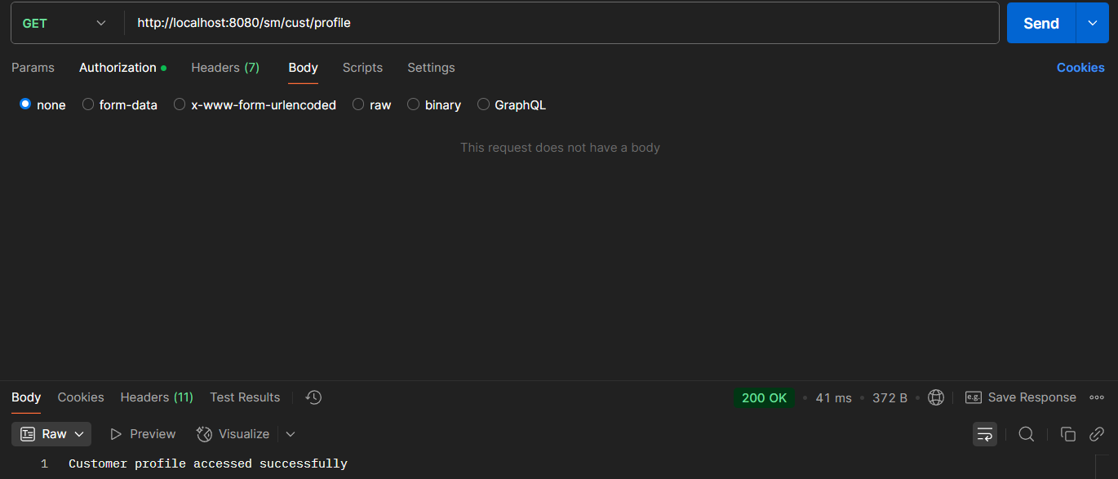

**PUT:** <http://localhost:8080/sm/update-profile>

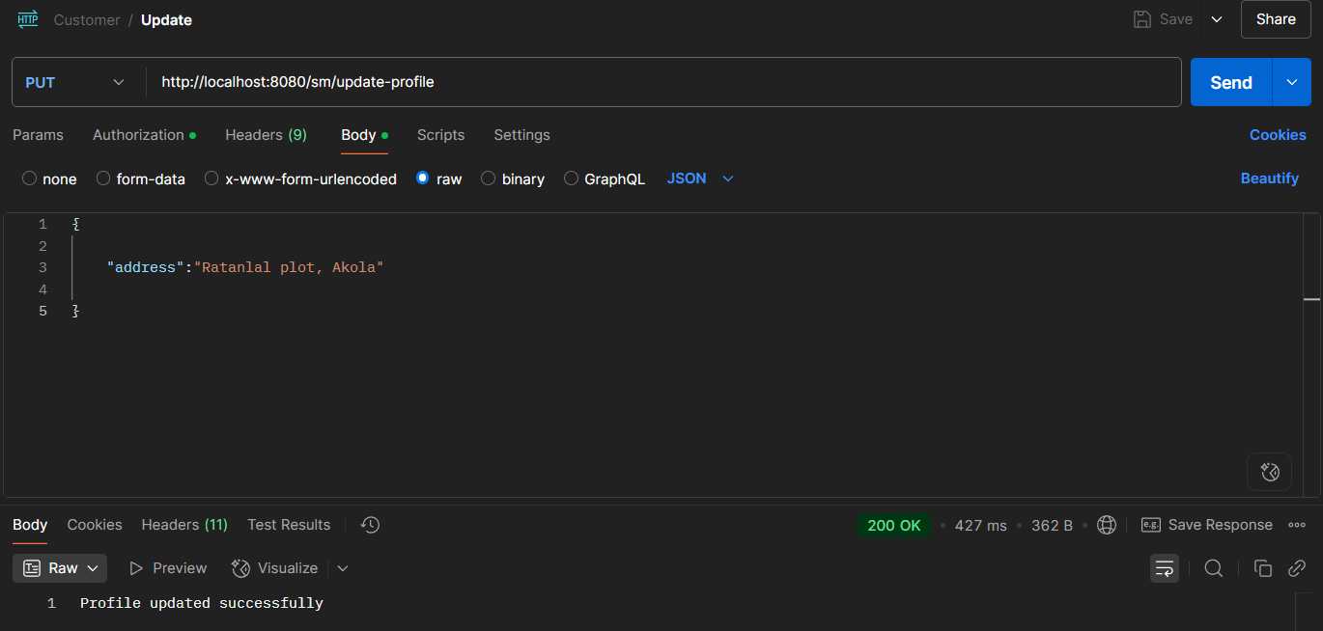

**POST:**  <http://localhost:8080/sm/admin/register>

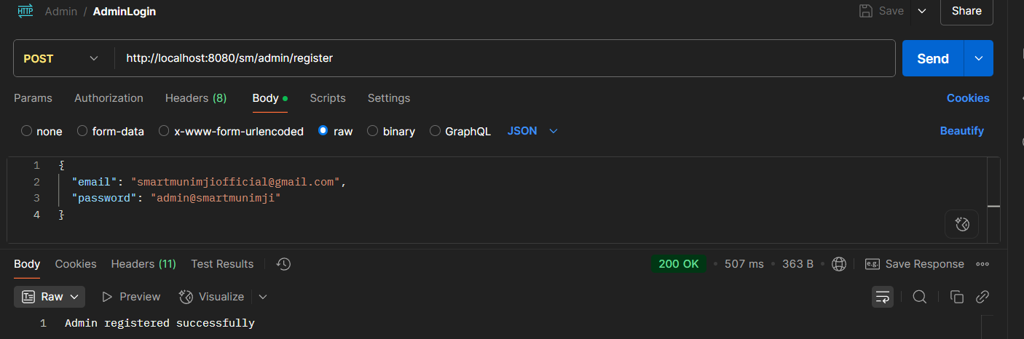

**POST:** <http://localhost:8080/sm/admin/authenticate>

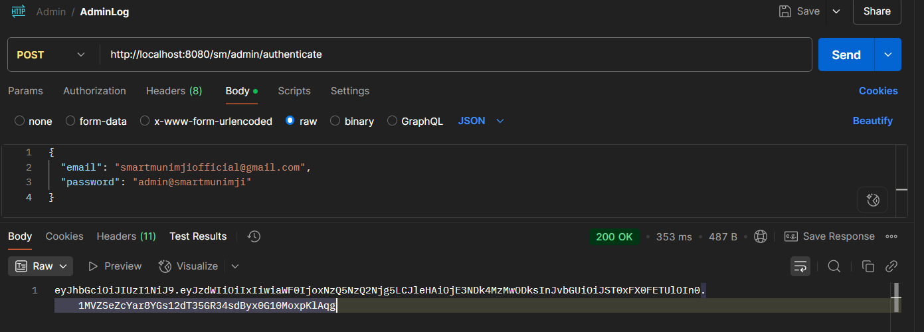

**POST:** <http://localhost:8080/sm/seller/register>

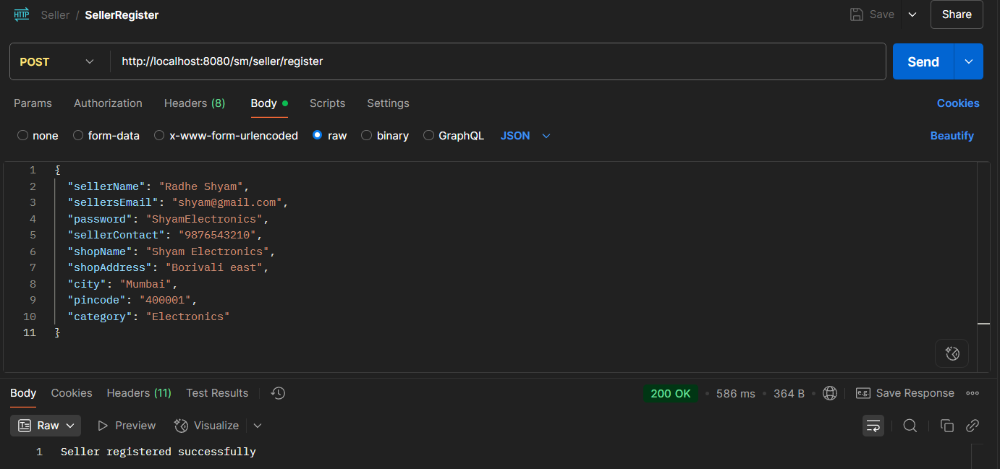

**POST:** <http://localhost:8080/sm/seller/authenticate>