Campus Partnership Proposal
  - Help capable students present the right evidence for each role
A generic resume can hide a strong candidate. SmartNShine helps students align their application with the job description, understand their match score and show the work behind their claims.
Prepared for institute leadership and the Training and Placement Office
3 November 2026

The challenge One resume for every opportunity
Students may apply to several companies using the same resume, even when the roles require different skills and experience. Their strongest relevant projects can remain buried, while the wording does not make the connection to the job description clear. A capable student can therefore present an application that understates their suitability. This can contribute to missed shortlisting opportunities, alongside other hiring factors.

The missing evidence Projects that recruiters cannot see
A short project description rarely shows the full work. Without a portfolio, working links or a clear presentation, recruiters may have little opportunity to explore what a student built, how it works or the creativity behind it. Students need a way to connect resume claims with visible project evidence.

How SmartNShine helps
Understand the fit. Compare a resume with a target job description and receive an indicative match score out of 100, relevant skills, missing keywords and improvement suggestions.
Improve the application. Use the feedback to highlight genuine experience relevant to that role, refine selected sections and export a tailored resume. Scores guide revision; they are not a recruiter score or a guarantee of shortlisting.
Show the capability. Publish a portfolio with project descriptions, live demos, repository links and professional links where available. Together, the resume and portfolio help students explain both their suitability and the work they can demonstrate.

Bring this support to the campus
The annual programme combines student tools with a dedicated TPO dashboard for activation, preparation activity and participation reporting. Plans are INR 149, INR 199 and INR 249 per student per year, excluding applicable taxes. Campus Plus at INR 199 is the recommended starting plan for an initial cohort of 300 to 400 students.

How students benefit
  - From a first resume to a role specific application
Students can work at their own pace and return to the same workspace as their projects, experience and target roles change. Annual AI allowances remain available across the subscription year, with flexibility for placement season.
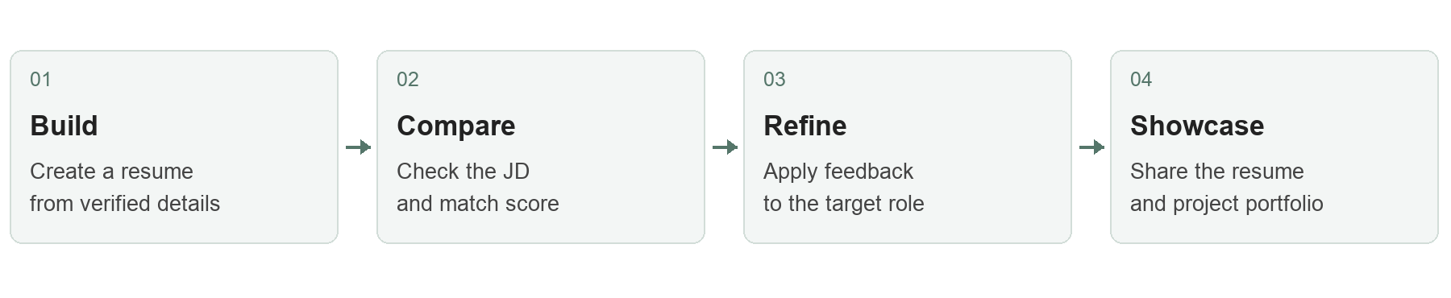

Build a clear and accurate resume
Students create a resume or import an existing PDF or DOCX, review their details and select an available template. Manual editing lets them organise education, projects, experience and achievements. AI section rewrites offer wording suggestions for the student to review and accept.
Student output: an editable resume and a PDF version ready to share.

Use a match score to guide targeted improvements
A student compares a resume version with a target job description and receives an indicative match score out of 100. The report explains relevant skills, missing keywords, strengths and suggested improvements. Students use this feedback to revise their application and can run another analysis to review the revised version. Each analysis uses the annual allowance.
Student output: a match score, actionable feedback and a role specific resume.

Present projects through a portfolio
Each student can create one hosted portfolio using the available themes. Project descriptions, live demos, repository links and professional links, where available, help a reviewer explore the work behind the resume and the approach and creativity of the student. Students review public information before publishing.
Student output: a personal portfolio link that complements the resume.

Support that continues throughout the year
Manual editing, template selection and core PDF export remain available during the subscription term. AI features use the selected annual allowance. Students who need more AI usage can request a separately priced upgrade or credit package.
AI analysis supports preparation and coaching. It does not certify a resume, predict a recruiter decision or guarantee placement.

A dedicated dashboard for the TPO
  - Understand adoption and guide the next action
The institute dashboard is included in every campus plan. Authorised staff will have a view restricted to their assigned institute cohort, so they can understand how students are using the programme and plan focused support.
Dashboard area | What the institute can review
Activation and participation | Purchased, assigned and activated seats; unique active students over 7 or 30 days.
Resume preparation | Students with saved resumes and students who have exported a PDF.
Portfolio adoption | Draft and published portfolios within the campus cohort.
Follow up reports | CSV activity summaries and filtered student lists for TPO led follow up.

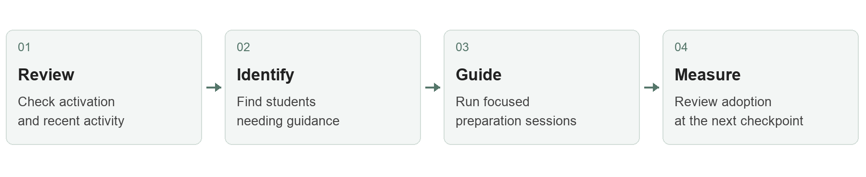

Turn participation data into focused support
Before a preparation session, the TPO can identify students who have not activated their accounts or started a resume. Before a placement drive, staff can review resume and portfolio preparation activity and invite students to guidance sessions. A later checkpoint shows whether participation and preparation activity have increased.

Use consistent and understandable metrics
An activated student has completed first access to the assigned seat. An active student has performed a recorded product action during the selected period. Dashboard views will show their latest refresh time. Usage indicators describe participation; they are not measures of hiring probability.

Keep institute access appropriately scoped
Summary analytics are the default. Individual resume content and identifiable exports will follow the permissions and student notice agreed with the institute. Campus data separation will be checked during acceptance.
The campus dashboard and institute permissions form part of the proposed rollout and will be demonstrated and accepted before wider student activation.

Annual plans and institute investment
  - One annual subscription with flexible usage across 12 months
All plans include existing resume templates and portfolio themes, manual editing, core PDF export, one hosted portfolio per student and the proposed TPO dashboard. AI allowances are assigned per student for the full year.
Annual entitlement | Essential | Plus | Advanced
Price per student | INR 149 | INR 199 | INR 249
JD analyses | 36 | 72 | 120
AI section rewrites | 72 | 144 | 240
Resume imports | 12 | 12 | 12
Average JD analyses per month | 3 | 6 | 10
Average rewrites per month | 6 | 12 | 20

Monthly figures are averages only. There is no monthly reset: students may concentrate their annual allowance around placement drives.

Choose the level of support
Essential supports occasional JD checks and writing assistance. Plus supports regular preparation through the academic year and is our recommended starting plan. Advanced gives students more scope to tailor applications across a larger number of opportunities.

Annual campus pricing
Paid student seats | Essential | Plus | Advanced
300 | INR 44,700 | INR 59,700 | INR 74,700
350 | INR 52,150 | INR 69,650 | INR 87,150
400 | INR 59,600 | INR 79,600 | INR 99,600

Prices exclude applicable taxes and assume at least 300 paid seats. The final order records the selected plan, paid seat count, activation date and any separately agreed work. Inactivity does not reduce the contracted seat count.

Simple allowance definitions
One JD analysis compares one resume version with one job description. One AI rewrite improves one selected section. One import processes one uploaded resume. Manual edits and template changes do not consume AI allowances. Unused allowances expire at the end of the subscription year.
Additional credits and upgrades require an agreed price and approval. Interviews, voice features, custom domains and bespoke integrations are outside these plans.

Implementation and annual operation
  - A staged launch with clear responsibilities

1 Confirm the campus scope
The institute selects its plan, confirms student seats and nominates a TPO coordinator. Together we agree roster fields, staff permissions, the activation date and support arrangements. Only the information needed to assign and group seats should be included in the roster.

2 Configure and demonstrate
SmartNShine configures campus access, allowances and dashboard views. A small nominated group tests the student journey. The TPO reviews roster accuracy, reporting and campus data separation. The campus deliverables are demonstrated and accepted before wider activation.

3 Activate and orient the cohort
Following acceptance and the agreed payment arrangements, students receive access for the contracted 12 month period. A launch orientation explains resume and portfolio workflows, JD analysis, annual allowances, portfolio visibility and the support route.

4 Review adoption through the year
The TPO reviews participation at agreed checkpoints and around placement drives. Students retain core editing access if they exhaust AI allowances during the term. Any additional AI package is separately approved. Rollout dates and support response expectations are confirmed in the final agreement.

5 Review and renew
Before expiry, the institute and SmartNShine review activation, recent activity, resume exports and published portfolios. Renewal pricing, seat numbers and allowances are agreed for the following year. Portfolio hosting after expiry is not included unless separately agreed.

Service and information handling
The final agreement records billing and payment timing, support hours, file and input limits, export and traffic limits, data retention and deletion, cancellation terms and approved staff access. Public portfolios are published by student choice. Custom development is separately scoped and priced.

Proposed next step
Confirm the preferred plan and initial cohort size, nominate a TPO coordinator and schedule a student workflow and dashboard demonstration. For a cohort of 300 students, the recommended Campus Plus plan is INR 59,700 for 12 months, excluding applicable taxes.

