**Remote Key Inject Deployment**

1. Change to project root directory.
2. Execute command: mvn clean package
3. Change to target directory, there has a file named "RemoteKeyInjectServer.jar".
4. Mkdir running
5. The file list under running directory:

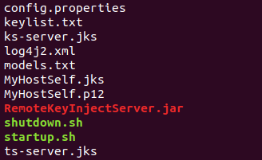

The locations:

|  |  |
| --- | --- |
| config.properties | ./config.properties |
| keylist.txt | ./keylist.txt |
| ks-server.jks | ./ks-server.jks |
| ts-server.jks | ./ts-server.jks |
| models.txt | ./models.txt |
| MyHostSelf.jks | ./MyHostSelf.jks |
| MyHostSelf.p12 | ./MyHostSelf.p12 |
| log4j2.xml | ./src/main/resources/log4j2.xml |
| shutdown.sh | ./docs/shutdown.sh |
| startup.sh | ./docs/startup.sh |
| remoteKeyInjectServer.jar | ./target/RemoteKeyInjectServer.jar |

1. Zip the running directory and transfer to where you want
2. Start service: ./startup.sh
3. Stop service: ./shutdown.sh