1. background research
2. summary of your application

**Motivation:**

With the rapid development of mobile networks, it’s very common to bring a smart phone. But when we want to view today’s class schedule or venue, we still need to open HKU page using any browser on the smart phone. The operation is so cumbersome that we want to replace it with a smart, convenient app.

**Framework Design:**

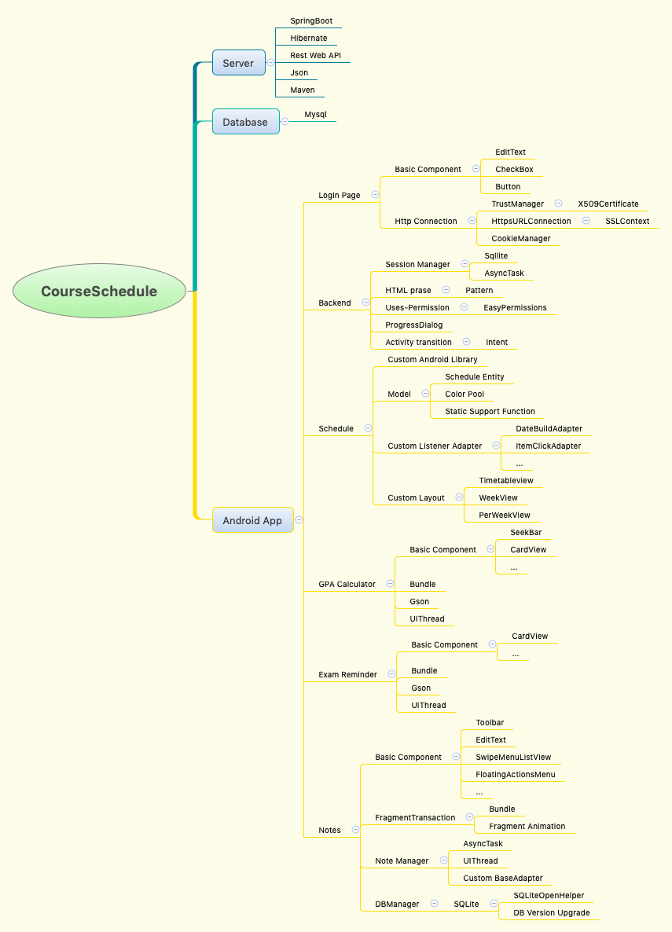

**Features:**

1. Login with HKU Portal UID and PIN.

Different student get login in the system, view their own courses or use other features. User data is independent.

1. Personal course schedule.

Query personal courses here in a time table sort by time. You can get the whole semester courses information including Holiday and Reading Week information. Click the course item to get further information. Because data is saved in from remote server，you will not miss any courses.

1. Add reminder to calendar.

You can add a course reminder to calendar by long click the course item. Of course, you need to permit the app reading/writing your calendar.

1. Calculate personal GPA.

You can use this feature to transform score into GPA by drag the seek bar control.

1. Check personal exam time.

You can check out your exam information, including dater, venue, note. The remain days count will give you a precise time to make preparation.

1. Add/Modify/Delete personal notes.

You can manage your notes here. Taking notes at any time may keep you from missing any deadline.

3、Contributions