MSc App

1、Basic framework :

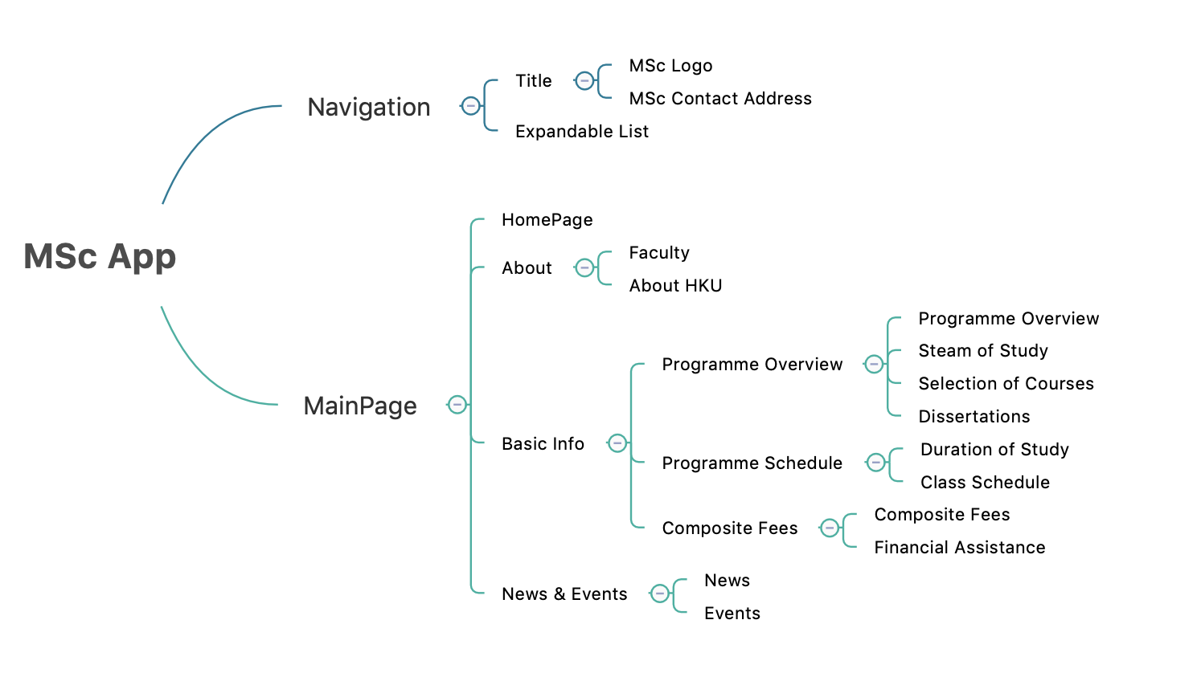

2、Main functions :

a) MainActivity.java

The app starts with this activity and set content view to activity_main.xml.

**private void** initNavigationView():

Initialize the menu data in expandableListView and populate the expandable list. Set adapter, setOnGroupClickListener and setOnChildClickListener here.

**private void** switchFragment(Fragment targetFragment):

Use FragmentManager and FragmentTransaction to switch different fragment.

**public void** goBackView()、goForwardView():

Provide an interface to child fragments call to switch views.

b) ExpandableListAdapter.java

This is customized list adapter extend BaseExpandableListAdapter, we define different function to get child view or group view data here, like :

**public long** getChildId(**int** groupPosition, **int** childPosition)

**public** View getChildView(**int** groupPosition, **final int** childPosition,  
 **boolean** isLastChild, View convertView, ViewGroup parent)

**public int** getChildrenCount(**int** groupPosition)

**public** MenuModel getGroup(**int** groupPosition)

so on.

c) FragmentHome.java

This is the fragment of homepage implements AppbarLayout.

**private void** initToolbar(View view) & initAppBarLayout(View view):

Bind the toggle icon animation with drawer, add drawer listener. And set appbar offsetChangedListener to change alphaScale according to offset height.

**private void** initConvenientBanner(View view):

Use ConvenientBanner and LocalImageHolderView to complete the custom rotation effect with pictures.

**private void** initTextViewClick(View view):

Set textView click listener to change fragment view.

d) LocalImageHolderView.java

A custom HolderView implements Holder.

e) FragmentAbout.java, FragmentFaculty…FragmentSchedule.java

Different child fragment function, including setting the corresponding view, setting toolbar click listener on icon and initializing view pager with different layout xml files

f) LoadingView.java

A custom loading effect chart and some functions to set its visibility.

g) FragmentNews.java, FragmentEvents.java

**private void** initNewThread():

Start new thread and use Jsoup to get information from website. Then parse HTML doc into required elements and generate different Card View.

getActivity().runOnUiThread(**new** Runnable() {}):

Update the application UI by using runOnUiThread(), This will magically cause the Runnable code to get executed on the Main Thread.

3、Project structure :  
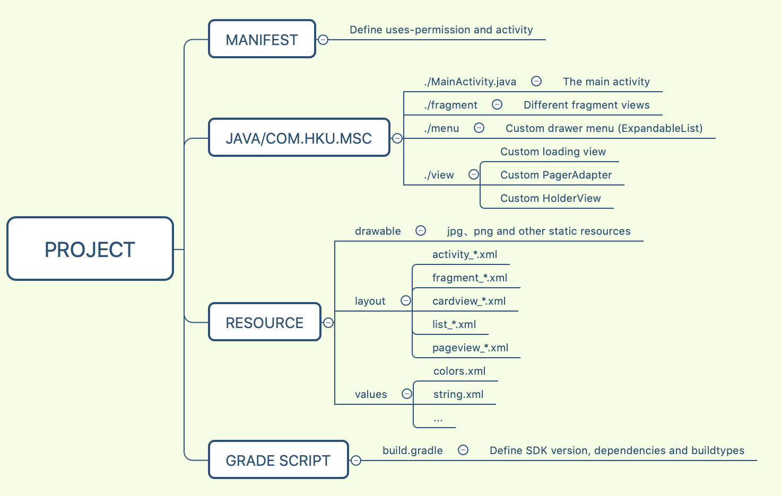

4、Compilation and Execution process

截图