

Component Technical Documentation
SmartPot-API-Java (Legacy Stack A)
Legacy Spring Boot Core API and MQTT Bridge
REST with JWT, MQTT broker bridge, physical and virtual crops, AI automation agent, notification channels, security, configuration, and operations of the legacy Stack A API.
DOCUMENT / DOCUMENTO VERSION / VERSIÓN TEAM / EQUIPO PROJECT / PROYECTO
SmartPot-API-Java Documentation 1.1 · October 2026 SmartPotTech smartpot.app

WARNING / ATENCIÓN
Legacy Component (Stack A): This service has been superseded in production by the canonical Go API (`SmartPot-API`). This document preserves the historical architecture and implementation details of the original Spring Boot 4.1 and Java 21 service.

DOCUMENT

Document Summary

FIELD | VALUE
Project | SmartPot · smartpot.app
Component | SmartPot-API
Version | 1.1 · octubre 2026
Scope | API domains, physical and virtual crops, telemetry and command flow, security, configuration, testing, and operations
Platform Documentation | Technical Documentation, Project Journey, Software Lifecycle, and Global Diagrams
Maintenance | Generated from docs/ in this repository via .github/docs/tools; updated with every component change

CONTENTS · CONTENIDO

Contents / Contenido
1. Purpose
2. Component Architecture
3. Physical and Virtual Crops
4. Telemetry Ingestion to Command Execution
5. Request Security & Authorization Pipeline
6. API and MQTT Contracts
7. Configuration & Environment
8. Automated Testing Suite
9. Deployment and Production Operations

PART I
Component Overview

SECTION 01

Purpose

In Plain Terms
The API serves as the primary gateway of SmartPot. The PWA communicates via HTTPS; crop devices communicate via MQTT through the broker. The API stores telemetry readings, queries the AI assistant for agronomic health evaluations, dispatches actuation commands, provisions per-crop MQTT credentials, and delivers alerts through the PWA and Telegram. All user interactions route through this layer, scoped strictly to authenticated tenant accounts.

RESPONSIBILITY | MECHANISM
Accounts & Auth | Registration, JWT login, email password recovery, user profile, and cascaded account deletion
Crops | Physical or virtual (immutable once created), 6 species profiles, 4 system forms, live weather location, and automatic mode
Devices | Per-crop MQTT tenant account with 192-bit AES-256-GCM encrypted credentials; Mosquitto dynamic provisioning
Telemetry | MQTT telemetry validated against physical sensor bounds, historical series, digest recap, and CSV export
Commands | Actuators operated as switches (409 Conflict if redundant or pending), QoS 1 commands, device ACK, expiration ticker, and bulk orders
AI Assistant | Evaluation with SmartPot-AI-Python, automation reactive agent, and real-crop telemetry pipeline for continuous learning
Simulation | Virtual crop parameters and internal proxy to SmartPot-DataGenerator-Python
Alerts | PWA and Telegram alerts, pluggable notification channels, per-crop subscriptions, daily digests, and shared collaborator chats

SECTION 02

Component Architecture
Each domain follows a layered architecture (controller, service, repository, mapper, and model). Domains interact via service interfaces and internal Spring ApplicationEvents (ReadingRecordedEvent, CropDeletedEvent, DeviceKeyRotatedEvent, NotificationCreatedEvent), isolating domain concerns.

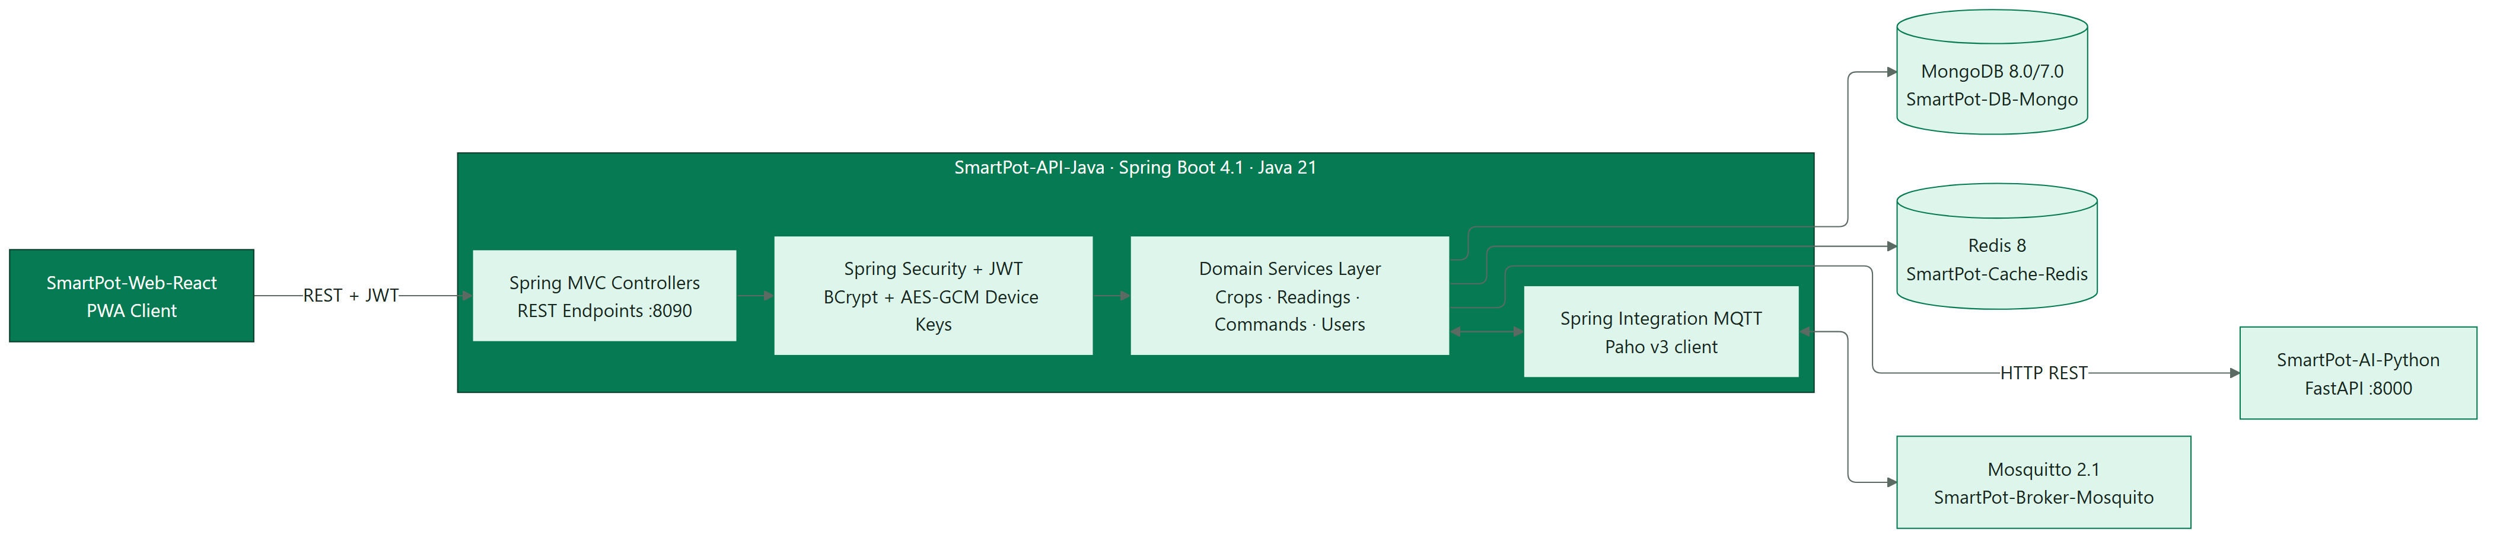
Figure / Figura 1 · SmartPot-API Internal Architecture

PACKAGE | DESCRIPTION
security, users | Security filters, JWT authentication, rate limiting, AES-GCM encryption, user management
crops | Crop domain, immutable kind, system form, automatic mode, and device credentials
readings | Telemetry ingest, physical boundary validation, historical series, CSV export
actuators, commands | Crop actuators state machine and command lifecycle management
mqtt | Paho MQTT client, v1 topic routing, telemetry decoder, dynamic broker security provisioning
ai | AI client, periodic evaluation, reactive automation agent, and LearningFeed queue
overview | Fleet overview: aggregates, $dateTrunc time-series metrics, and crop comparator
notifications, channels | Alert routing and external channels (NotificationChannel, Telegram Bot)
virtualdevices | Virtual crop simulation proxy, reconciliation loops, and legacy backfill
cache, mail, health, config | Redis cache with in-memory fallback, JavaMail, /health endpoint, Spring configuration

SECTION 03

Physical and Virtual Crops
When creating a crop, its origin type is selected once and remains immutable. Both physical and virtual crops have dedicated credentials on the MQTT broker; they differ in who publishes telemetry.

POLICY | PHYSICAL (REAL) | VIRTUAL
Telemetry Publisher | Physical ESP32 or simulated in Wokwi | SmartPot-DataGenerator
Credentials | Displayed once and rotatable | Internal: API provisions simulator over docker network
Initial Actuators | Water pump, UV light, ventilation fan | All six supported actuators
Dedicated Endpoints | /device and /device/key | /virtual-device (PUT updates, DELETE pauses)
Continuous Learning | Telemetry trains ML models | Excluded from continuous learning dataset
Tenant Quota | Max 20 crops per account | Up to 5 virtual crops per account

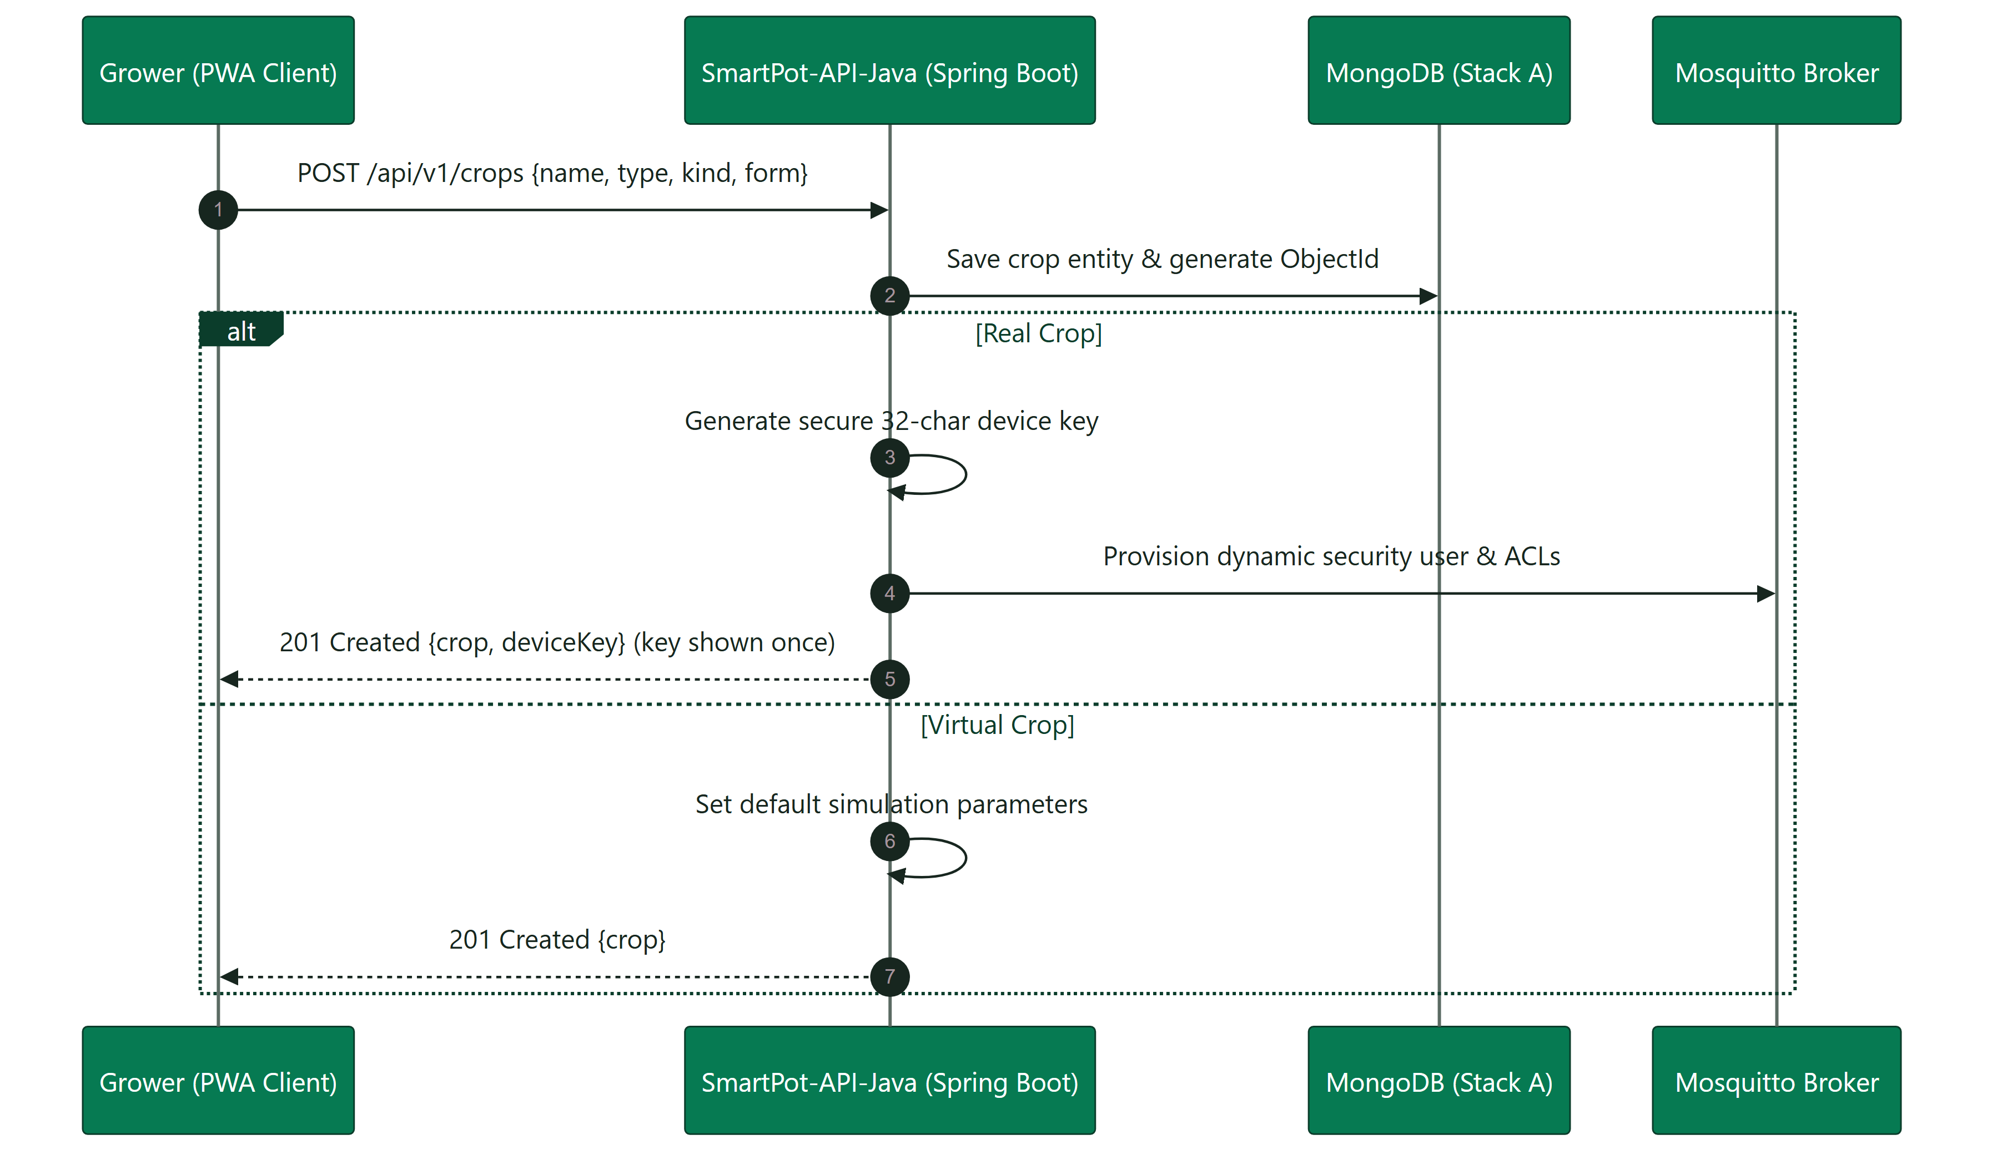
Figure / Figura 2 · Crop Creation Flow (Physical vs. Virtual)
The system form (POT, NFT, TOWER, RAFT) configures visual rendering in the PWA and can be edited anytime. Legacy crops created prior to explicit typing are normalized on startup via CropKindBackfill.

PART II
System Operations & Contracts

SECTION 04

Telemetry Ingestion to Command Execution
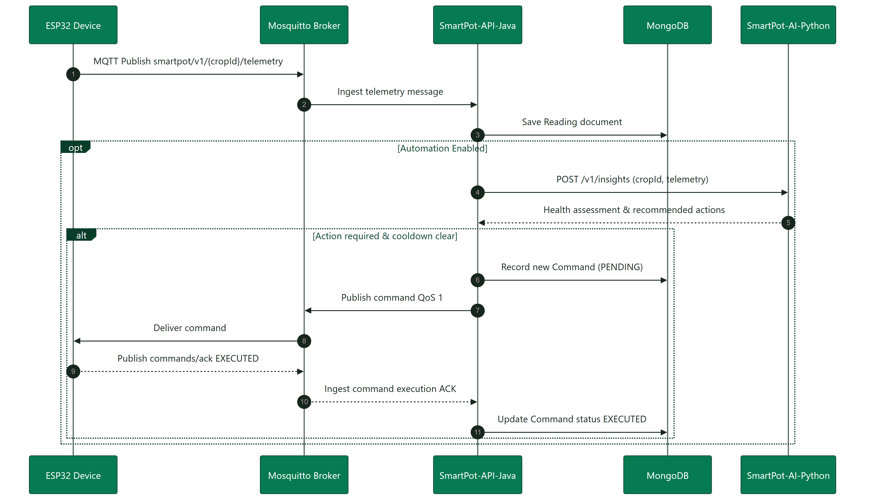
Figure / Figura 3 · Telemetry to Command Lifecycle

POLICY | VALUE
Crop Telemetry Rate Limit | 1 reading per 5 seconds max; bursts discarded
Sensor Validation | Every metric within physical sensor bounds; invalid samples discarded
AI Evaluation Cadence | Max once per 30s in automatic mode, 5min in manual mode
Agent Actuator Cooldown | 10 minutes per actuator
Command Expiration | 2 minutes without ACK → EXPIRED status and alert
Learning Ingest Batch | Flushed every 60s, up to 1,000 readings per batch; 20,000 capacity

SECTION 05

Request Security & Authorization Pipeline
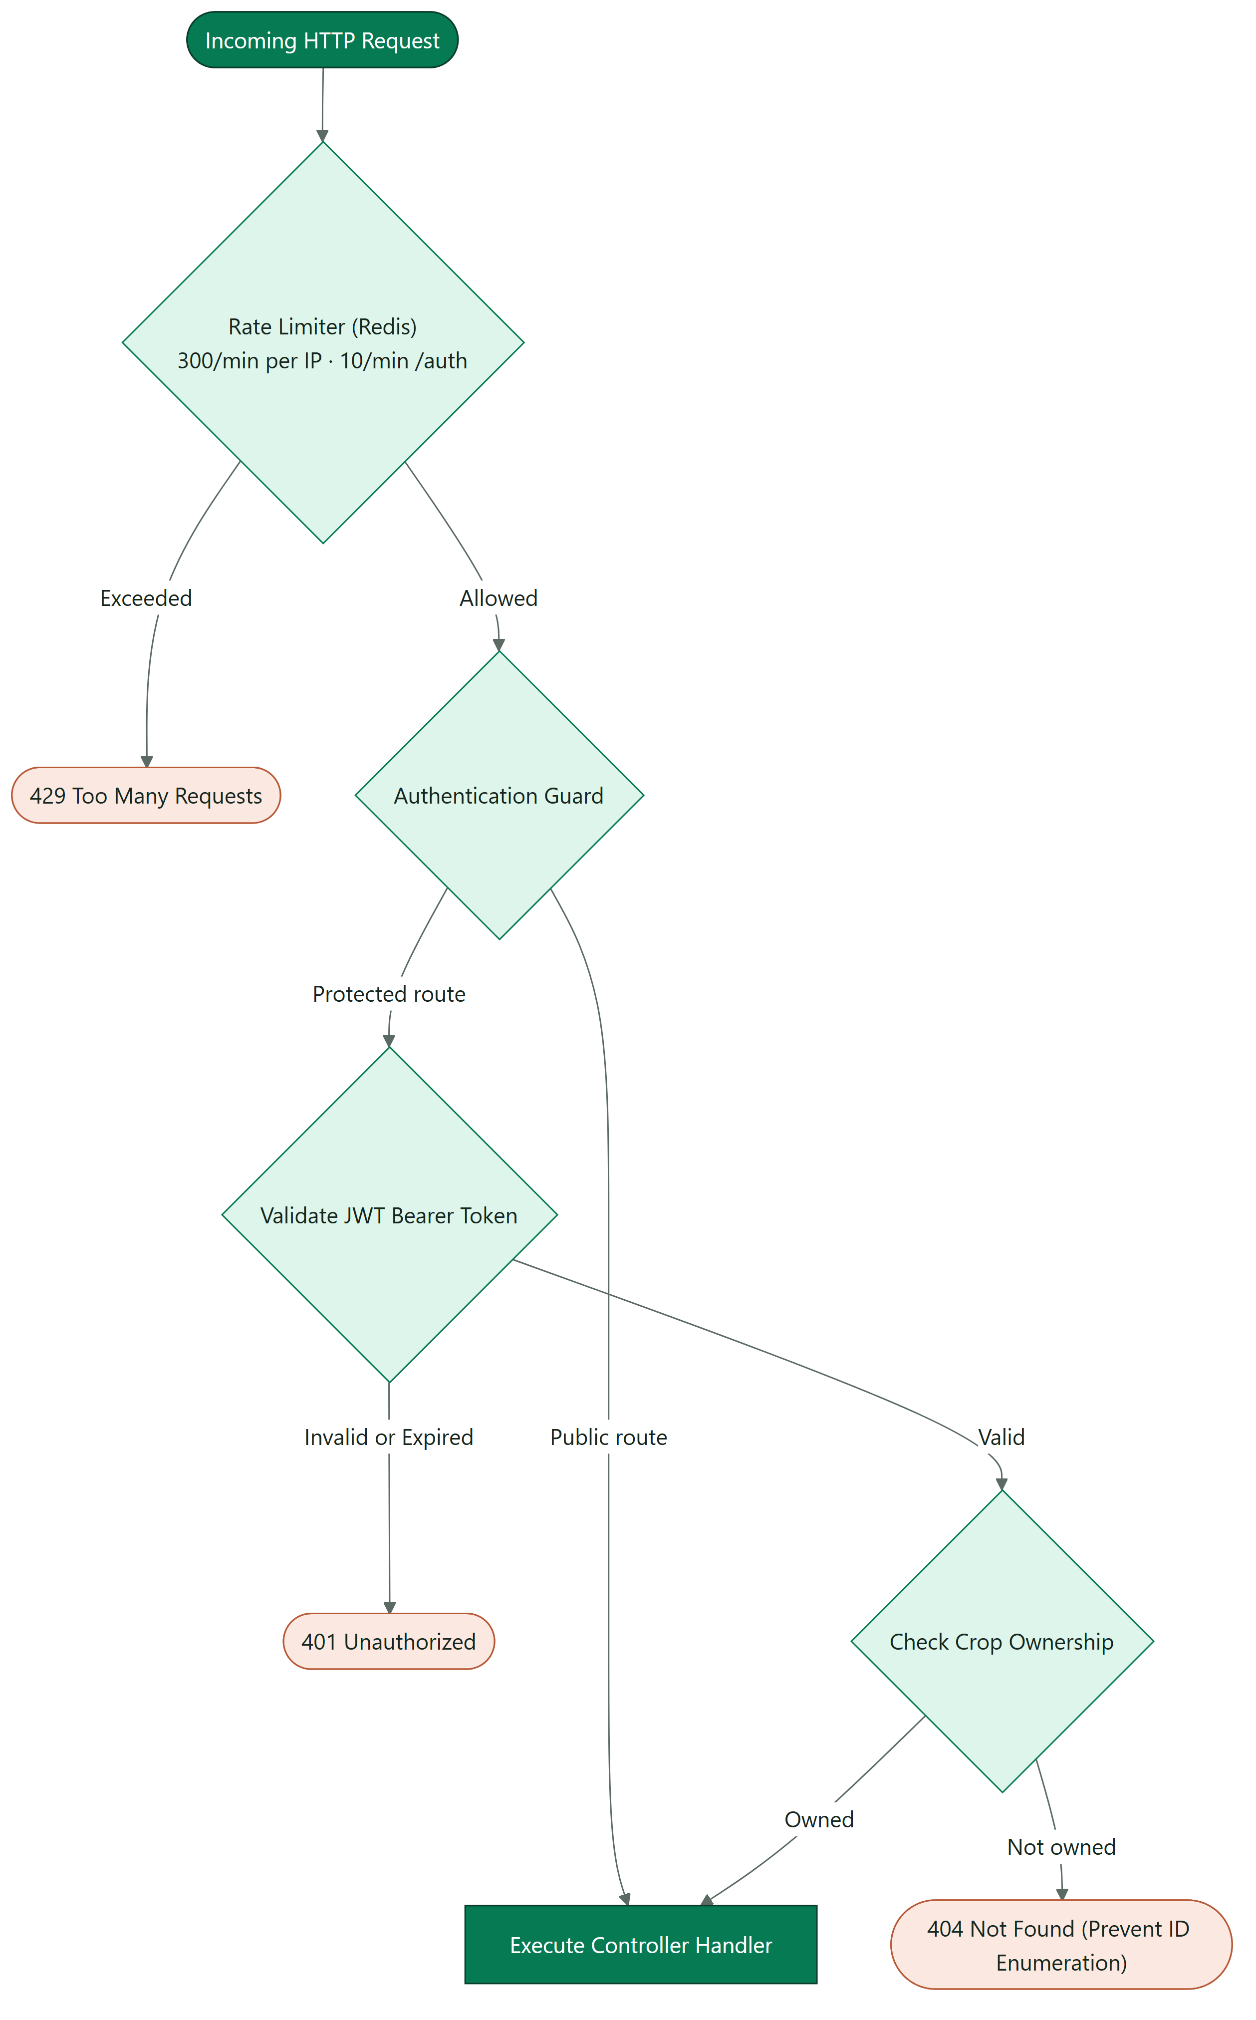
Figure / Figura 4 · Request Security Validation Pipeline

SECURITY CONTROL | IMPLEMENTATION DETAILS
Passwords | 8 chars to 72 bytes max (upper, lower, digits); BCrypt cost factor 12
Password Recovery | Returns 202 Accepted on non-existent email; 30-min token stored as SHA-256
Device Credentials | 24 cryptographically random bytes, encrypted with AES-256-GCM via SMARTPOT_AES_KEY
Internal Services | AI engine and data generator queried with bearer service token over docker network
Telegram Bot Integration | Webhook with constant-time token comparison; single-use 10-minute linking codes

SECTION 06

API and MQTT Contracts
Interactive OpenAPI documentation is hosted at /docs with raw JSON schema at /v3/api-docs. The repository README details REST endpoints, while the Platform Technical Documentation details the MQTT v1 protocol.

ROUTE GROUP | ENDPOINTS
Public | /health, /api/v1/auth/*, /api/v1/crop-profiles
Crops | /api/v1/crops, /crops/{id}, /crops/automation, /crops/{id}/device, /crops/{id}/weather
Crop Telemetry | /readings, /actuators, /commands, /insights, /virtual-device, /channels
Account & Fleet | /api/v1/users/me, /notifications, /channels, /overview, /commands, /ai/learning

PART III
Operations & Verification

SECTION 07

Configuration & Environment
The API loads .env on startup; all supported variables are declared in .env.example.

CONFIG CATEGORY | ENVIRONMENT VARIABLES
Server | PORT, LOG_LEVEL, WEB_BASE_URL, PUBLIC_API_URL, CORS_ALLOWED_ORIGINS, API_DOCS_ENABLED
Secrets | SMARTPOT_JWT_SECRET (32 caracteres o más), SMARTPOT_AES_KEY (AES-256 en Base64), JWT_EXPIRATION
Data Stores | MONGODB_URI, REDIS_HOST, REDIS_PORT, REDIS_PASSWORD
Mail Service | MAIL_ENABLED, MAIL_HOST, MAIL_PORT, MAIL_USERNAME, MAIL_PASSWORD, MAIL_FROM
MQTT | MQTT_ENABLED, MQTT_BROKER_URI, MQTT_ADMIN_USERNAME, MQTT_ADMIN_PASSWORD, MQTT_PUBLIC_*, MQTT_WEBSOCKET_URL
AI Engine | AI_ENABLED, AI_BASE_URL, SMARTPOT_AI_TOKEN, AI_EVALUATION_INTERVAL, AI_AUTOMATION_COOLDOWN, AI_LEARNING_*
Telegram | TELEGRAM_BOT_TOKEN, TELEGRAM_BOT_USERNAME, TELEGRAM_MODE (polling o webhook), TELEGRAM_WEBHOOK_SECRET
Simulator | SIMULATOR_ENABLED, SIMULATOR_BASE_URL, SIMULATOR_TOKEN (sin él no se crean cultivos virtuales)

AES KEY PERSISTENCE
If SMARTPOT_AES_KEY is lost or modified, stored MQTT device credentials cannot be decrypted: growers must rotate credentials for all physical crops.

SECTION 08

Automated Testing Suite
./mvnw verify executes 147 automated unit and integration tests via JUnit 5 and Mockito: cryptography, JWT validation, password constraints, MQTT v1 routing and telemetry parsing, broker provisioning, actuator switches, crop immutable typing, weather integrations, per-crop notifications, reactive agent logic, continuous learning ingest, Telegram bot webhooks, simulation proxy, legacy backfill, Redis cache fallbacks, and security filters. The centralized E2E suite in .github/docker/demo/test.py validates 46 end-to-end assertions.
SECTION 09

Deployment and Production Operations

OPERATIONAL TASK | PROCEDURE
Health Check | GET /health → database, broker, cache, AI engine, and simulator (503 on database outage)
Log Inspection | docker logs -f smartpot-api
Container Image | ghcr.io/smartpottech/smartpot-api: multi-stage build, non-root user 1000, read-only rootfs with /tmp tmpfs, and Docker HEALTHCHECK
CI/CD Pipeline | Every commit to main executes CI workflows, builds and signs container images on GHCR
Key Rotation | Device tab in PWA or POST /api/v1/crops/{id}/device/key (physical crops only)

