

Component Technical Documentation
SmartPot-IoT-Python
Real Crop Firmware Engine
MicroPython firmware for ESP32 hardware and Wokwi simulation: sensor acquisition, LCD status interface, PWM actuator control, and MQTT v1 contract with TLS encryption.
DOCUMENT / DOCUMENTO VERSION / VERSIÓN TEAM / EQUIPO PROJECT / PROYECTO
SmartPot-IoT-Python Documentation 2.0 · November 2026 SmartPotTech smartpot.app

NOTE / NOTA
Language / Idioma: ---

Document Sheet

FIELD | VALUE
Project | SmartPot · smartpot.app
Component | SmartPot-IoT-Python
Version | 2.0 · November 2026
Scope | Circuit, firmware modules, main loop, commands, telemetry and capabilities, secure connection, configuration, and tests
Platform Documentation | Technical documentation, project journey, software lifecycle, and global diagrams
Maintenance | Generated from docs/ in this repository using .github/docs/tools; updated with each component change

CONTENTS · CONTENIDO

Contents / Contenido
1. Purpose
2. Component Architecture
3. Main Loop
4. Commands
5. Telemetry, Capabilities and Command Validation
6. Secure Connection
7. Configuration
8. Tests
9. Getting Started

PART I
The Component

1. Purpose

In Plain Terms
SmartPot-IoT-Python is the program running on the device of a real crop: an ESP32 with its sensors, actuators, and LCD display. It measures, displays, publishes readings to the SmartPot broker, and executes incoming commands while acknowledging each one. It makes no autonomous agronomic decisions—the API and the platform AI decide. The same firmware runs on a physical board or in Wokwi, and in both cases the crop is real to the platform; virtual crops, by contrast, are simulated by SmartPot-DataGenerator.

2. Component Architecture
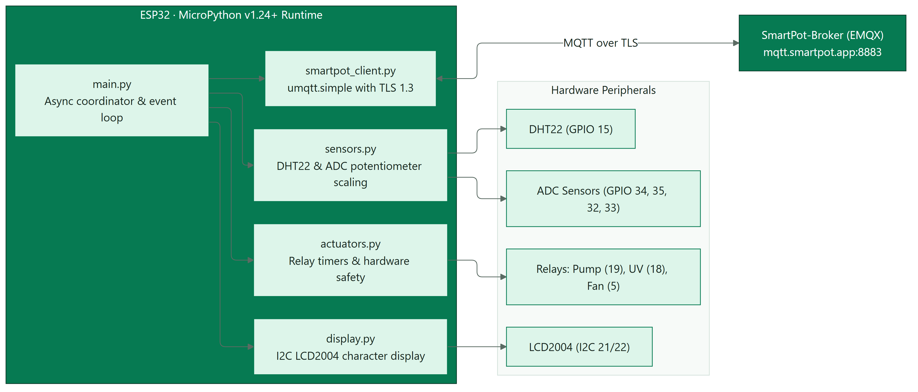
Figure / Figura 1 · SmartPot-IoT-Python por dentro

COMPONENT | ESP32 PIN | REPORTED SCALE
DHT22 (air temperature and humidity) | GPIO 15 | °C and %
Light sensor (potentiometer in Wokwi) | GPIO 34 | 0–2000 lux
pH sensor | GPIO 35 | 0–14
TDS sensor | GPIO 32 | 0–3000 ppm
Substrate moisture | GPIO 33 | 0–100 %
Water pump | GPIO 19 | WATER_PUMP
UV light | GPIO 18 | UV_LIGHT
Fan | GPIO 5 | FAN
20×4 I2C LCD | SCL 16 · SDA 17 | —

PART II
Operation

3. Main Loop
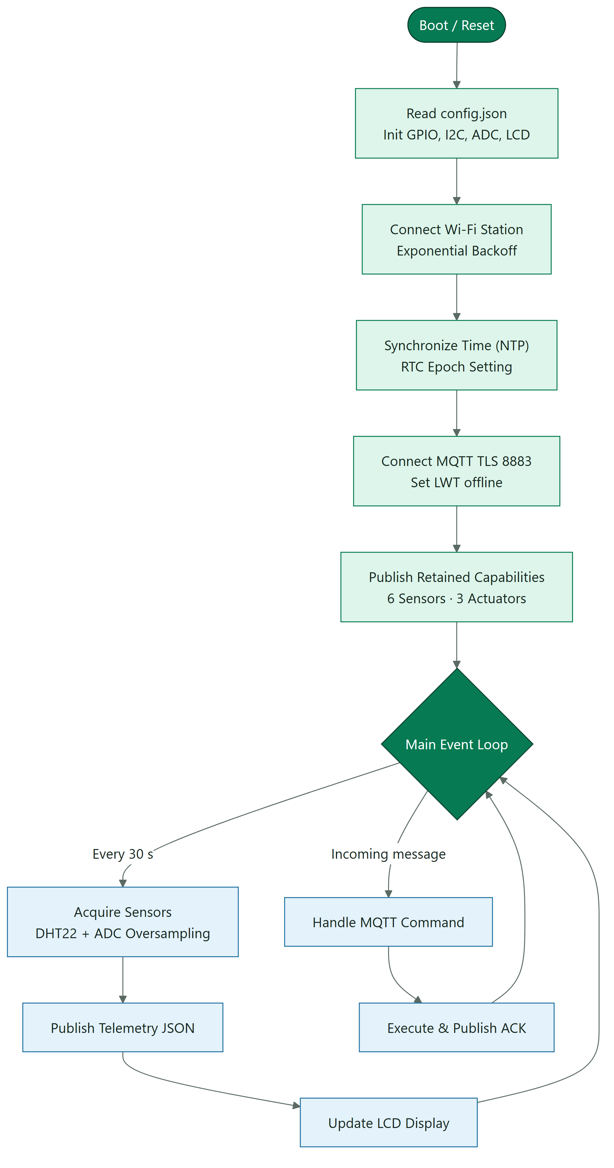
Figure / Figura 2 · Ciclo principal del firmware

4. Commands
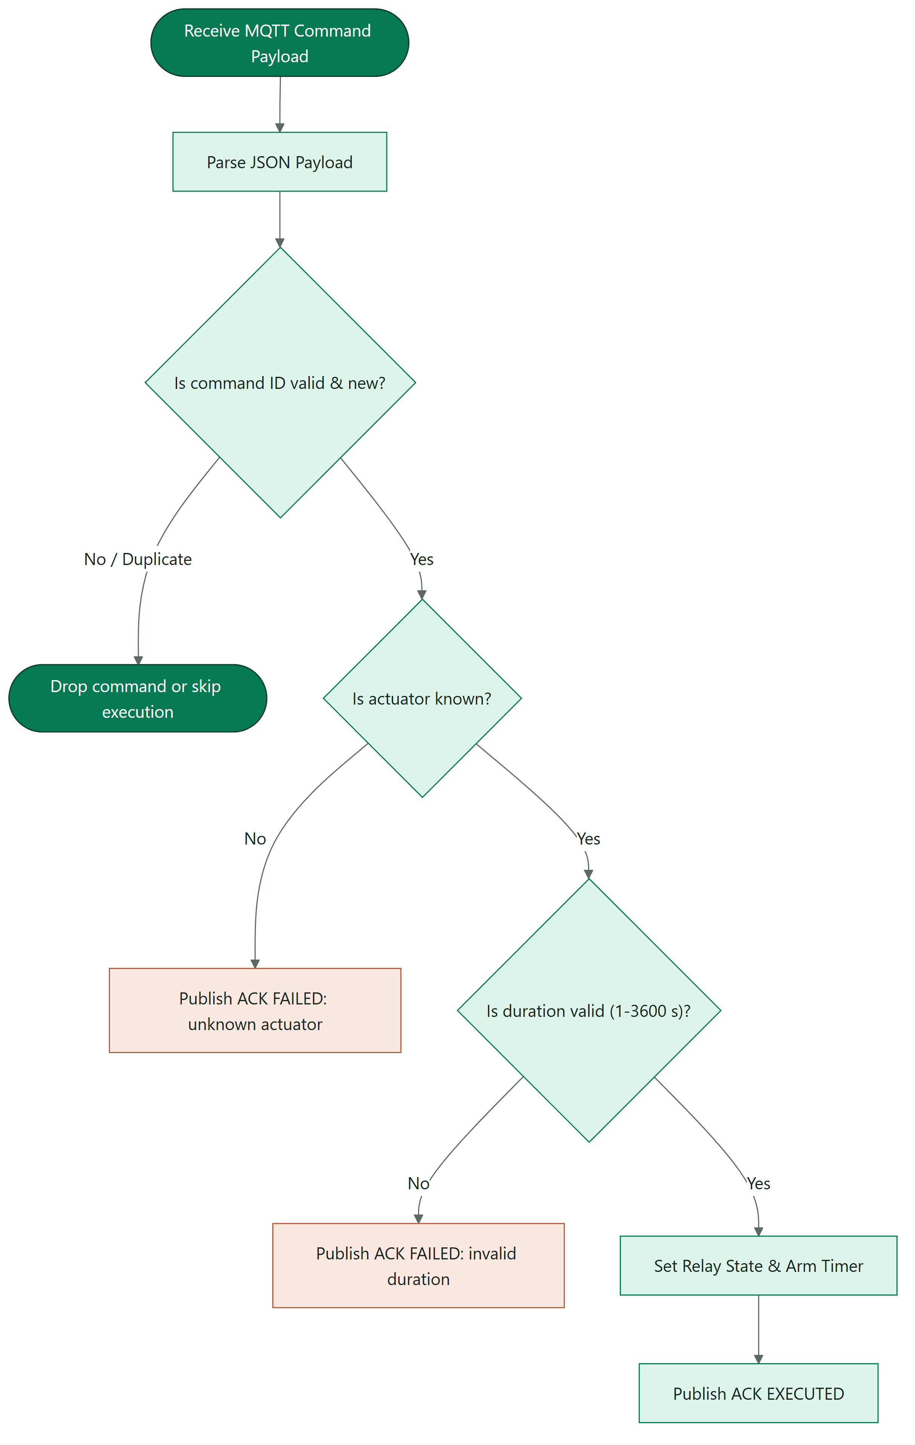
Figure / Figura 3 · Cómo atiende una orden

5. Telemetry, Capabilities and Command Validation
- Telemetry: JSON v1 with six fields (temperature, humidity, brightness, ph, tds, soilMoisture). brightness and tds are integers; ph keeps two decimals and the rest one. Missing sensors are omitted, never sent as null.
- Capabilities: after status=online and before subscribing to commands, the client publishes a retained QoS 1 message on .../capabilities. It uses schema 1, declares firmware smartpot-iot-python/2.0.0, hardware esp32-devkit-c-v4, telemetry json-v1 only, six sensors (no atmosphere) and three actuators (WATER_PUMP, UV_LIGHT, FAN). The payload stays under 2 KB; a publish failure does not block the command subscription.
- Command ids: parse_command requires id to be a non-empty string; null, booleans, numbers, lists and objects are rejected. actuator and action must be non-empty strings, and durationSeconds must be a non-negative integer or absent.
- Deduplication: ActuatorBank keeps the last 16 ids with their ACK. A QoS 1 redelivery repeats the stored ACK without toggling the pin; success and failure results are both cached.

6. Secure Connection

PARAMETER | VALUE
Broker | mqtt.smartpot.app:8883, MQTT over TLS 1.2 or newer
Certificate | Signed by SmartPot's internal CA; verified by the firmware using the public CA embedded in config.json under BROKER["CA_CRT"]
Username & Key | Crop ID and device key, shown once by the PWA upon creating the real crop or rotating the key
Client ID | smartpot-<cropId>
Status | Retained online upon connecting and offline as Last Will

WOKWI
Keep your copy of the project private: anyone who sees config.json can publish as your crop. If leaked, generate a new key from the Device tab.

PART III
Configuration & Testing

7. Configuration
The PWA generates config.json in its connection guide, containing the WiFi network (yours or Wokwi-GUEST), the crop's SMARTPOT block, and the BROKER block with the broker CA. config.json is untracked; config.example.json is the template, and the Rust firmware reads the same file when it is built.

KEY | PURPOSE
WIFI.ssid, WIFI.password | Network the ESP32 connects to
SMARTPOT.crop_id, device_key | MQTT credentials for the real crop
SMARTPOT.host, port, tls | Broker host, port, and TLS toggle
BROKER.CA_CRT | SmartPot public CA in PEM format used by the firmware to verify the broker certificate
SMARTPOT.interval_seconds | Seconds between readings (30 by default)

8. Tests
uv run ruff check . and uv run pytest: a 135-test CPython suite with simulated MicroPython modules covering the MQTT contract, integer telemetry, capabilities, strict command ids, 16-id deduplication and ACKs (with durations in seconds, minutes, or hours), timed actuator shutoff, sensor scaling, broker verification with the template CA, and TLS fallback for older MicroPython versions.

9. Getting Started

ENVIRONMENT | STEPS
Physical board | Wire the circuit, flash MicroPython 1.22.0 (1.23+ also works), copy fs/ with mpremote, add your config.json (includes the CA), and power on
Wokwi in browser | Open the project, create config.json with the guide's block, and run; the Wokwi-GUEST network has Internet access
Local Wokwi | uv sync, copy your config.json into fs/, run uv run python tools/build_flash.py (MicroPython 1.22.0 with fs/ in its LittleFS), and start the simulation: it boots straight into main.py

<a id="español"></a>

