**1.INTRODUCTION**

**1.1.OVERVIEW**

The segmentation, detection, and extraction of infected tumor area from magnetic resonance (MR) images are a primary concern but a tedious and time taking task performed by radiologists or clinical experts, and their accuracy depends on their experience only. So, the use of computer aided technology becomes very necessary to overcome these limitations. In this project, to improve the performance and reduce the complexity involves in the brain tumor detection process, we have used deep learning method of classification.The experimental results of proposed technique have been evaluated and validated for performance and quality analysis on magnetic resonance brain images, based on accuracy,

**1.2.PURPOSE**

Medical image segmentation for detection of brain tumor from the magnetic resonance (MR) images or from other medical imaging modalities is a very important process for deciding right therapy at the right time. Many techniques have been proposed for classification of brain tumors in MR images, most notably, fuzzy clustering means (FCM), support vector machine (SVM), artificial neural network (ANN), knowledge-based techniques, and expectation-maximization (EM) algorithm technique which are some of the popular techniques used for region based segmentation and so to extract the important information from the medical imaging modalities.

The main purpose of this project was to build a convolutional neural network(CNN) model that would classify if the subject has a tumor or not based on MRI scan. I used accuracy as a metric to justify the model performance which can be defined as:

Accuracy=Number of correctly predicted images/Total number of tested images×100%

**2.LITERATURE SURVEY**

**2.1.EXISTING PROBLEM**

A brain tumor occurs when abnormal cells form within the brain. There are two main types of tumors: cancerous (malignant) tumors and benign tumors. Cancerous tumors can be divided into primary tumors, which start within the brain, and secondary tumors, which have spread from elsewhere, known as brain metastasis tumors. All types of brain tumors may produce symptoms that vary depending on the part of the brain involved. These symptoms may include headaches, seizures, problems with vision, vomiting and mental changes. The headache is classically worse in the morning and goes away with vomiting. Other symptoms may include difficulty walking, speaking or with sensations. As the disease progresses, unconsciousness may occur.

To detect infected tumor tissues from medical imaging modalities, segmentation is employed. Segmentation is a necessary and important step in image analysis; it is a process of separating an image into different regions or blocks sharing common and identical properties, such as color, texture, contrast, brightness, boundaries, and gray level. Brain tumor segmentation involves the process of separating the tumor tissues such as edema and dead cells from normal brain tissues and solid tumors, with the help of MR images or other imaging modalities.

**2.2.PROPOSED SOLUTION**

In this project, different magnetic resonance imaging (MRI) sequence images are employed for diagnosis, and classify the brain images into normal or deceased using a convolutional neural network. The detection of a brain tumor at an early stage is a key issue for providing improved treatment. Once a brain tumor is clinically suspected, radiological evaluation is required to determine its location, its size, and impact on the surrounding areas. On the basis of this information the best therapy, surgery, radiation, or chemotherapy, is decided. It is evident that the chances of survival of a tumor-infected patient can be increased significantly if the tumor is detected accurately in its early stage . As a result, the study of brain tumors using imaging modalities has gained importance in the radiology department.

The image data that was used for this problem is [Brain MRI Images for Brain Tumor Detection](https://www.kaggle.com/navoneel/brain-mri-images-for-brain-tumor-detection). It consists of MRI scans of two classes:

* NO - no tumor, encoded as 0
* YES - tumor, encoded as 1

**3.THEORETICAL ANALYSIS**

**3.1.BLOCK DIAGRAM**

The block diagram of brain tumor classification based on convolution neural network is shown in fig.1. The CNN based brain tumor classification is divided into two phases such as training and testing phases. The number of images is divided into different categories by using label names such as tumor and non-tumor brain image…etc. In the training phase, preprocessing, feature extraction and classification with Loss function is performed to make a prediction model. Initially, label the training image set. In the preprocessing image resizing is applied to change size of the image.

Finally, the convolution neural network is used for automatic brain tumor classification.The loss function is calculated by using gradient descent algorithm. The raw image pixel is mapping with class scores by using a score function. The quality of a particular set of parameters is measured by loss function. It is based on how well the induced scores approved with the ground truth labels in the training data. The loss function calculation is very important to improve the accuracy. If the loss function is high, when the accuracy is low. Similarly, the accuracy is high, when the loss function is low. The gradient value is calculated for the loss function to compute gradient descent algorithm. Repeatedly evaluate the gradient value to compute the gradient of loss function.

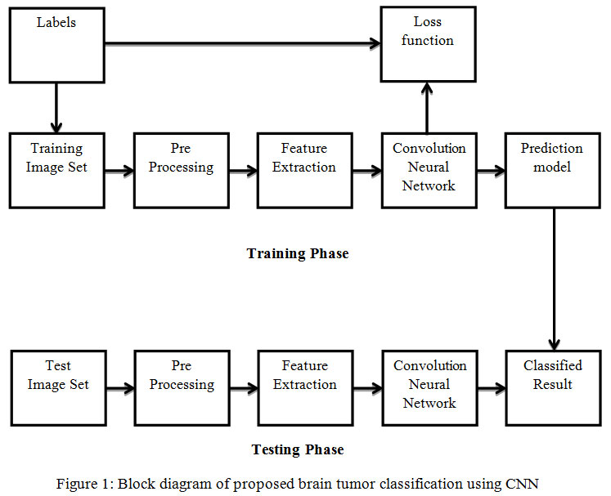

**3.2.HARDWARE/SOFTWARE DESIGN**

Start with the convolution filter in first layer in the neural network to extract features. Then we apply max pooling to get some well defined features from the image. Then we flatten the image using the flatten layer. A hidden layer is then added with RELU activation function where the output dimension is 128. The final layer or the output layer has one node with sigmoid activation function.The CNN network has four sections input and convolution sections. The input layer processes the input image in order to produce the designed image patches. The convolution section process the designed image patches, in which multilayer convolutional filters operates and output feature maps. Further, the fully connected layer that groups all feature maps. The classification section estimates a prediction score to classify the every image voxel and provides a segmentation map.

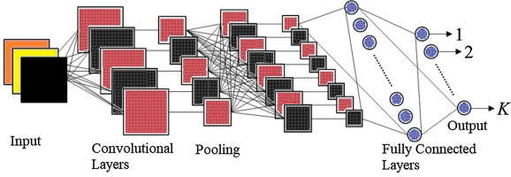

**4.EXPERIMENTAL INVESTIGATIONS**

In this work, efficient automatic brain tumor detection is performed by using convolution neural network. Simulation is performed by using python language. The accuracy is calculated and compared with the all other state of arts methods. The training accuracy, validation accuracy and validation loss are calculated to find the efficiency of proposed brain tumor classification scheme. In the existing technique, the Support Vector Machine (SVM) based classification is performed for brain tumor detection. It needs feature extraction output. Based on feature value, the classification output is generated and accuracy is calculated. The computation time is high and accuracy is low in SVM based tumor and non-tumor detection.

In the proposed CNN based classification doesn’t require feature extraction steps separately. The feature value is taken from CNN itself. Hence the complexity and computation time is low and accuracy is high. Finally, the classification results as Tumor brain or non-tumor brain based on the probability score value. The normal brain image has the lowest probability score. Tumor brain has highest probability score value, when compared to normal and tumor brain.

**5.FLOWCHART**

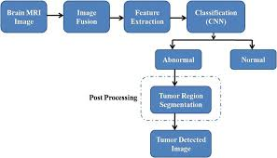

**6.RESULT**

The main goal of this project is to design efficient automatic brain tumor classification with high accuracy, performance and low complexity. In the conventional brain tumor classification is performed by using Fuzzy C Means (FCM) based segmentation, texture and shape feature extraction and SVM and DNN based classification are carried out. The complexity is low. But the computation time is high meanwhile accuracy is low. Further to improve the accuracy and to reduce the computation time, a convolution neural network based classification is introduced in the proposed scheme. Also the classification results are given as tumor or normal brain images. CNN is one of the deep learning methods, which contains sequences of feed forward layers. Also python language is used for implementation.

The model has an accuracy above 80%.So the developed system efficiently detects and extracts the tumor from the input MRI image of Brain Cancer affected patients. The MRI images of patients affected by Brain Cancer are used during Recognition/Testing phase.

**7.ADVANTAGES & DISADVANTAGES**

In this system a classification of brain tumour image is implemented using CNN architecture. The algorithm relates both local and global features, because it helps to perform the segmentation accurately. The training and testing speed is increased by using max pooling, max out and drop out complement the learning process. The speed is increased by reducing the features in the fully connected layer. Reducing of parameters also causes the reduction of overfitting. The result shows that the implemented method helps in detection of enhancing tumour as well as specifying tumour to the actual tumour region only.

Deep learning methods and models use a large amount of data for semantic segmentation of brain tumors, and it is a challenging task to acquire sufficient data for the training of models. The labeling of medical images requires domain knowledge expertise. Sharing the medical data of patients to a centralized location results in privacy, legal, data-ownership and technical challenges at the international level.Another major disadvantage of CNN is that the training period is long and there are problems with being able to stick to a single solution during training.Extreme learning machine (ELM) is a method of classification that has been used in studies for recent years, and which has been proposed to overcome some of the disadvantages of the backpropagation algorithm.

**8.APPLICATIONS**

Brain Tumor segmentation is one of the most crucial and arduous tasks in the terrain of medical image processing as a human-assisted manual classification can result in inaccurate prediction and diagnosis. Moreover, it is an aggravating task when there is a large amount of data present to be assisted. Brain tumors have high diversity in appearance and there is a similarity between tumor and normal tissues and thus the extraction of tumor regions from images becomes unyielding.the segmentation of brain tumour plays an important role in diagnostic procedures. The accurate segmentation helps in clinical diagnostic, but also helps to increase the lifetime of the patient.

**9.CONCLUSION**

This project was a combination of CNN model classification problem (to predict whether the subject has a brain tumor or not & Computer Vision problem (to automate the process of brain cropping from MRI scans). Finally, the Gradient descent based loss function is applied to achieve high accuracy. The training accuracy, validation accuracy and validation loss are calculated. The training accuracy is 87.5%. Similarly, the validation accuracy is high and validation loss is very low.. However, it could be increased by larger number of train images or through model hyperparameters tuning or we can use transfer learning with Imagenet.

**10.FUTURE SCOPE**

The scalability in healthcare services, that includes the patient prioritization process and patient analysis, is a challenging task . The demand for health care services is increasing gradually as the number of patients increases due to a rise in the population. The priority of healthcare services is based on the emergency status of patients. The identification of innovative research contributions for the provision of effective and efficient health care systems is an important and challenging task.

Various studies are conducted in bioinformatics to improve the prioritization process and provide a solution for the scalability problems in health care services

This section introduces the relevant literature that explores the dilemma of the growing number of elderly patients who need timely and effective telemedicine services. An increase in the number of patients is expected to occur in the context of an ageing population and disasters phenomena. There are a number of problems in health care services but the aging population is considered to be the greatest problem.

Prediction of brain tumors and the chances of survival for patients are open challenges for the researchers. MRIs opens ways of research in the field of brain tumors such as prediction, classification and segmentation analysis.

**11.BIBILIOGRAPHY**

1. Mohsen H et al. Classification using Deep Learning Neural Networks for Brain Tumors. *Future Computing and Informatics.* 2017:1-4.
2. Bauer S. et al. Multi scale Modeling for Image Analysis of Brain Tumor Studies. *IEEE Transactions on Biomedical Engineering.* 2012;59:1.  
    [CrossRef](https://doi.org/10.1109/TBME.2011.2163406)
3. Islam A. et al. Multi-fractal Texture Estimation for Detection and Segmentation of Brain Tumors. *IEEE.*

**APPENDIX**

1. **SOURCE CODE**

from __future__ import division,print_function

import os

import sys

import glob

import numpy as np

import tensorflow as tf

from tensorflow.keras.preprocessing import image

from tensorflow.keras.models import load_model

#from tensorflow.python.keras.backend import set_session

from tensorflow.keras import backend as K

from tensorflow.python.framework import ops

#ops.reset_default_graph()

from tensorflow.python.keras.backend import set_session

sess = tf.Session()

global graph

graph=tf.compat.v1.get_default_graph()

#tf.executing_eagerly()

from flask import Flask,request,url_for,render_template

from werkzeug.utils import secure_filename

from gevent.pywsgi import WSGIServer

app=Flask(__name__)

set_session(sess)

model=load_model("cnn.h5")

print("Model uploaded..Check localhost")

@app.route('/',methods=['GET'])

def index():

return render_template('base.html')

@app.route('/predict', methods=['GET','POST'])

def upload():

if request.method == 'POST':

f=request.files['image']

basepath=os.path.dirname(__file__)

print("current path",basepath)

file_path=os.path.join(basepath,'uploads',secure_filename(f.filename))

f.save(file_path)

img=image.load_img(file_path,target_size=(64,64))

x=image.img_to_array(img)

x=np.expand_dims(x,axis=0)

with graph.as_default():

preds=model.predict_classes(x)

index=["Normal","Tumor"]

text="prediction:"+index[preds[0]]

print(text)

return text

if __name__=='__main__':

app.run(debug=True)