**SUMMER INTERNSHIP PROJECT REPORT**

**ON INTELLIGENT CUSTOMER HELP DESK WITH SMART DOCUMENT UNDERSTANDING**

**BY**

**B.LAKSHMAN**

**SBID:SB20200044850**

**EMAIL:lakshman12b@gmail.com**

|  |  |  |
| --- | --- | --- |
|  |  |  |

**ACKNOWLEDGEMENT**

Successful completion of any task is unimaginable without appreciating the people associated with it. So, after the completion of this Project, I would like to express my regards to all the persons who contribute with their helping hands, whether in a direct or indirect way. With a deep sense of gratitude, I wish to express my sincere thanks to the MENTORS of **SMARTINTERNZ** for their assistance and constant source of encouragement and for their exampolary guidance, monitoring and constant encouragement throughout the course of this project.

INTRODUCTION

In this project a chatbot is created which offers a complete and easy way to answer different sets of questions asked by the customers. With the help of Watson discovery channel it can also answer some typical questions about the operation of a device because we have feeds the owners manual to the watson discovery channel. The benefits of this kind of chatbot is that it is superior than the typical chatbot which can answers simple questions like store location and hours. The chatbot is upgraded with the help of watson discovery collection which is build using smart document understanding.

It's main objective is

* • To solve customer's queries as early as possible to save the time of the customer.
* • We will use the IBM cloud function that allows watson assistant to post queries to Watson discovery.
* • The goal is to set up a remote connection between the customer and the company.

*By this chatbot anyone can have their problem solved by posting queries to chatbot via being at home or without calling an employee.*

Overview

The typical customer care chatbot can answer simple questions, such as store locations and hours, directions, and maybe even making appointments. When a question falls outside of the scope of the pre-determined question set, the option is typically to tell the customer the question isn’t valid or offer to speak to a real person.

In this project, a chatbot is created which offers a complete and easy way to answer different sets of questions asked by the customers. With the help of Watson discovery channel it can also answer some typical questions about the operation of a device because we have feeds the owners manual to the watson discovery channel.

To take it a step further, the project shall use the Smart Document Understanding feature of Watson Discovery to train it on what text in the owners manual is important and what is not. This will improve the answers returned from the queries.

Purpose

To solve customer's queries as early as possible to save the time of the customer.

We will use the IBM cloud function that allows watson assistant to post queries to Watson discovery.

The goal is to set up a remote connection between the customer and the company.

LITERATURE SURVEY

The literature review method is an examination of information on specific subject. It is reviewing what is known and not what is assumed. It aims to create the final, precise representation of the knowledge and research-based theory available topic

Existing problems

The typical customer care chatbot can answer simple questions, such as store locations and hours, directions, and maybe even making appointments. When a question falls outside of the scope of the pre-determined question set, the option is typically to tell the customer the question isn’t valid or offer to speak to a real person.

Proposed solution

So, the solution is that, If the customer question is about the operation of a device, the application shall pass the question onto Watson Discovery Service, which has been pre-loaded with the device’s owners manual. So now, instead of “Would you like to speak to a customer representative?” we can return relevant sections of the owners manual to help solve our customers’ problems.

THEORITICAL ANALYSIS

Conversations play an important role in everyday life. Conversation can be general which are used to generate fun or they can be used to solve queries. For any conversation in general at least two people are required. Conversation can also occur between a computer and a human. Such conversations can be achieved through chatbots.

What is a Chatbot?

Chatbot is made up of two words “Chat” representing conversation and “Bot” representing a robot. Hence a chatbot is enabling conversations with a robot.

• Generally speaking a bot is any software that performs an automated task, however, we are interested in the class of bots that live online in chat platforms or on social media called chatbots.

• In this context, there are many possible definitions and some confusion about what a bot is. This is partly because there are so many varied use cases for bots and these influence what people perceive a chatbot to be. .

BLOCK DIAGRAM



SOFTWARE DESIGNING

The software which are required to build the chatbot are:

1. IBM watson services

2. IBM Assistant

3. IBM cloud

4. Github

5. Node red

6. User interface

FLOWCHART



1. The document is annotated using Watson Discovery Smart Document Understanding.

2. The user interacts with the back-end server via the app UI. The front-end app UI is a chatbot that engages the user in a conversation.

3. Dialog between the user and back-end server is coordinated using a Watson Assistant dialog skill.

4. If the user asks a product operation question, a search query is passed to a predefined IBM Cloud Functions action.

5. The IBM Cloud Functions action will query the Watson Discovery Service and return the results.

RESULTS

• We have Created a Chatbot which is able to answer queries.

• The model created i.e. a chatbot would be able to identify any operational question posted by the user and using IBM Watson discovery will redirect the user to the section of the owner's manual where the answer to the question lies.

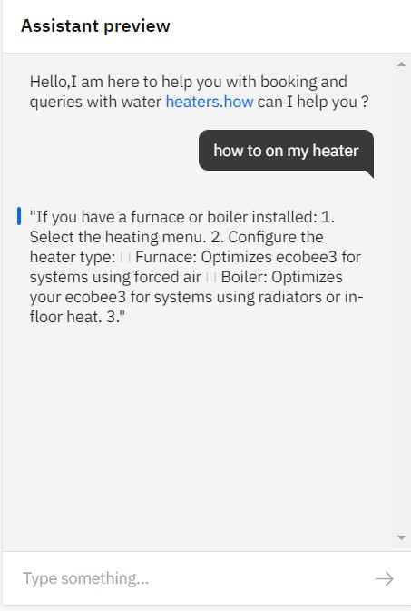

ADVANTAGES

Chatbots have been on the rise since a couple of years and have already faced a wide adoption. They are bringing a new way for businesses to communicate with the world and most importantly with their customers by the help of exploding popularity of messaging apps, the accelerated development of all kinds of sensors and wearables and of course with the rise of emerging technologies and Artificial Intelligence (AI).

• Keeping Up with the Trends: Being Present on Messaging Platforms

• Improved Customer Service.

• Always-Available Customer Support

• Proactive Customer Interaction

• Increased Customer Engagement

DISADVANTAGES

This definition however often leads to two potential misconceptions.

1. The biggest misconception that arises is that a chatbot is a bot that converses with a human in the way that another human would converse with a human. Software or even a robot (the digital part of the robot is of course software) that communicates with a human in natural language is not difficult to imagine. Science fiction is full of examples. While this may be the end goal, this is simply not possible using the current technology.

2. The second misconception is that a chatbot communicates using only text or voice. Actually chatbots allow users to interact with them via graphical interfaces or graphical widgets, and the trend is in this direction. Many chat platforms including WeChat, Facebook Messenger and Kik allow web views on which developers can create a completely customized graphical interfaces.

APPLICATIONS

A Chatbot is a program that can have a conversation with a person using rules and Artificial Intelligence (AI) in a way that mimics human-like conversations and interactions. Chatbots have become popular in the past few years as businesses discover innovative ways to put them to use. Having a Chatbot today has numerous benefits for businesses – they make life easier for customers, are available 24/7, save time (no more long waits to talk to a service rep) and they are easy to use. .

*Order Food:* Various fast food giants like KFC and Pizza Hut have invested in Chatbots that enable customers to place their orders through conversations. Taco Bell went a step further to improve the conversational experience by giving their Chatbot named TacoBot some personality.

*Book Flights:* Icelandair’s chatbot gives their customers the ability to search for and book flights in a text-based conversational manner. Instead of drop-down menus, customers enter the information themselves.

*Health Care:* Chatbots have also made their way into health care by easing the burden on medical professionals by facilitating faster medical diagnosis, answering health-related questions, booking appointments and lots more. A Chatbot like Super Izzy can track menstrual cycles, dates and fertile windows.

CONCLUSION

There is more to building chatbots and conversational UI than just plugging tools, services, and data together. It takes practice and a deeper understanding of underlying concepts to get the design right and build bots that give users a great experience. The user should be able to get the job done by having a conversation with the bot without having to think too much and with a smile on their face.

FUTURE SCOPE

Chatbots are hot software in the enterprise, but to maintain longevity and relevance, developers need to take a look at the barriers to entry, interface options and NLP issues.

From gauging purchase intent to answering questions about IT issues, chatbots are on track to play a major role in the contemporary enterprise. Chatbots are fully functioning, semi-autonomous systems that can assist customer service experiences and response time.

The clearest use of chatbots right now is in customer service and online ordering, where it can automate customer issues or complete orders without human interaction.

• Adding Natural Language Processing in the Bot to understand the User Statements.

• Adding Sentiment Analysis to predict User Sentiment during the Chat.

• Use Voice Recognition with Bot.

APPENDIX

1.) <https://github.com/SmartPracticeschool/Intelligent-Customer-Help-Desk-with-Smart-Document-Understanding---SB44850>

2.) <http://www.iotgyan.com/learning-resource/build-chatbot-using-watson-assistant-tool>

3.) <http://www.iotgyan.com/learning-resource/integration-of-watson-assistant-to-node-red>

4.) <https://developer.ibm.com/patterns/enhance-customer-help-desk-with-smart-document-understanding/>