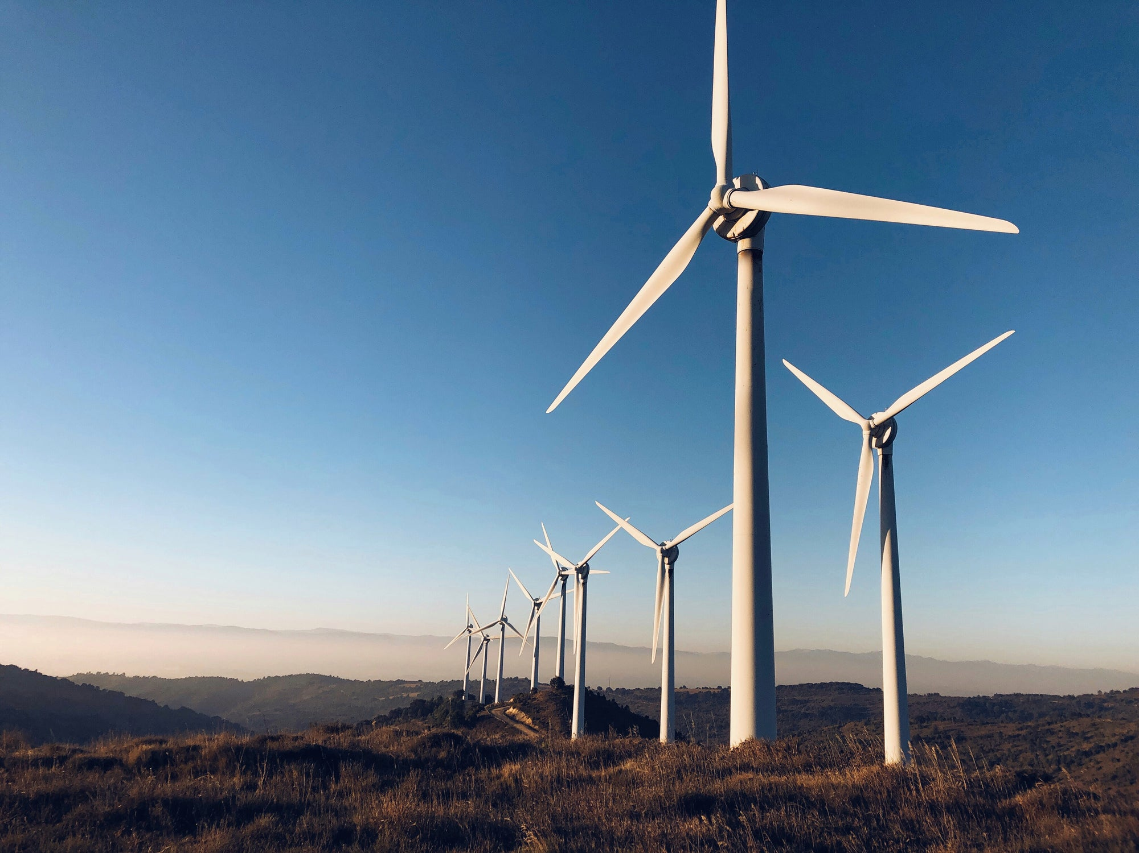Wind Farm Power Output Predictor

**Developed By: ProConspiracy**

**Project ID: SPS_PRO_745**

**Team ProConspiracy**

Swapnil Nema

Uday Rajoriya

# Introduction

## Overview

Wind energy plays an increasing role in the supply of energy world-wide. The energy output of a wind farm is highly dependent on the wind conditions present at its site. If the output can be predicted more accurately, energy suppliers can coordinate the collaborative production of different energy sources more efficiently to avoid costly overproduction.

## Purpose

Our aim is to map weather data to energy production. We wish to show that even data that is publicly available for weather stations close to wind farms can be used to give a good prediction of the energy output. Furthermore, we examine the impact of different weather conditions on the energy output of wind farms. We are particularly, interested in the correlation of different components that characterize various weather conditions.

# Literature Survey

## Exisiting Problem

Wind energy plays an increasing role in the supply of energy world wide. The energy output of a wind farm is highly dependent on the weather conditions present at its site.

The existing problem is costly overproduction, which comes in due to the operation of a power plant in non-feasible weather conditions without knowing the expected output.

## Proposed Solution

Our solution is an application that has an ML model trained from real-life data, that can predict the output energy based on the weather conditions on the site area. This prediction will help the power plant operators to operate plant whenever it will be feasible.

# Theoretical Analysis

## Block Diagram

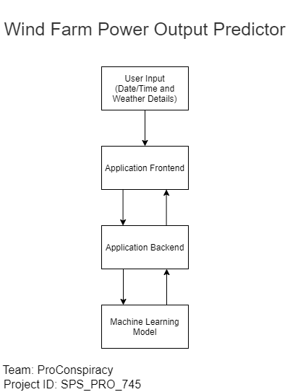

## Software Designing

Wind Farm Power Output Predictor is a simple application, which has a trained ML model at the backend, which predicts the output that the plant would generate, if operational under the values of various wind/weather parameters, as entered by the user.

This application/solution is complete developed as well as hosted on the IBM Cloud Platform.

The development process began with the team analysing the problem statement. After we made sure that the entire team was on the same page, now we had to chose our approach towards the development.

Out of the various tools available for our disposal, wo chose the AutoAI for creating our Machine Learning model. It saved a lot of our time, as we didn’t had to write anything from scratch. All we had to do was create a Machine Learning service, and the AutoAI service. And the next step was just to feed in the dataset to AutoAI.

After AutoAI generated a suitable model, now we had to connect this model to a user-friendly frontend. So, for that we used Node-RED. Now with Node-RED’s versatility and ease of use, creation of frontend went through without any troubles.

Once the frontend was also completed, we connected both our model and our frontend from Node-RED itself.

# Application Screenshot

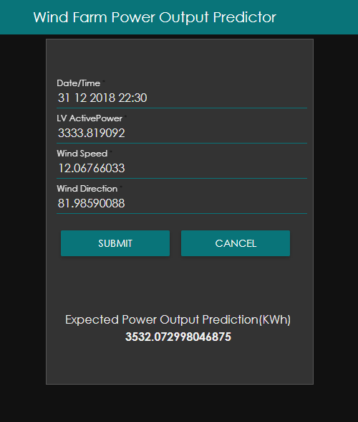

This is the solution/application. User will fill all the fields with data, then will hit the Submit button. This will generate/display a predicted output of energy as shown at the bottom of the image.

# Flowchart

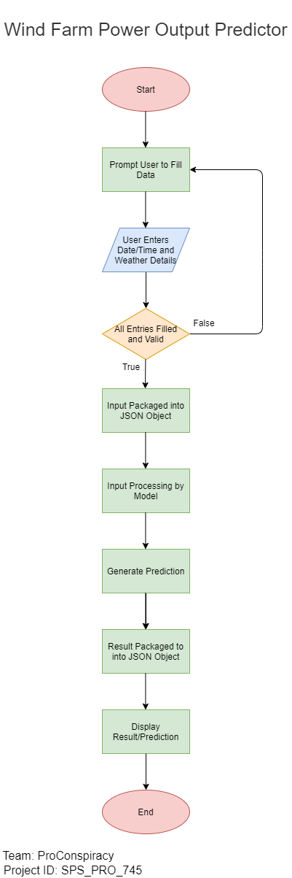

# Result

The solution predicts the power output of a Wind Powerplant which can reduce the wastage problems at the power plant as well as increase it’s efficiency.

# Advantages and Disadvantages

## Advantage(s)

1. This solution can predict the power output of a power plant, which can help the plant be more economically feasible, since the over-production costs will be reduced.
2. Since, the solution will make power generation from wind energy power plants more feasible, it can replace a significant part of other non-environment friendly ways of power production and hence making the environment significantly cleaner.

## Disadvantage(s)

The predicted output may not be completely accurate at times, since the solution uses an ML model which was trained using previous data of previous conditions.

# Conclusion

Wind Farm Power Output Predictor, is an application that has an ML model trained with wind/weather and power output dataset, that predicts the power output at a particular time and weather conditions.

This solution/application was required to prevent the costly over-production that happens when a wind energy power plant stays operational in non-feasible weather conditions, by predicting the power output by which the plant can decide if the output would be worth it or not.

# Bibliography

## Predicting the Energy Output of Wind Farms Based on Weather Data: Important Variables and their Correlation

*Author(s):* Katya Vladislavleva, Tobias Friedrich, Frank Neumann, Markus Wagner

*Link:* <https://hpi.de/friedrich/docs/paper/RE1.pdf>

## Wind Turbine Scada Dataset

*Author(s):* Berk Erisen

*Link:* <https://www.kaggle.com/berkerisen/wind-turbine-scada-dataset>

# Appendix

## The solution/application

*Link:* <https://node-red-qlgrg.eu-gb.mybluemix.net/ui>

## The source including the Dataset, NodeRED Flow, Presentation and, Demonstration Video

*Link:* <https://github.com/SmartPracticeschool/SBSPS-Challenge-1100-Wind-Farm-Power-Output-Predictor>