IBM HACK CHALLENGE2020

AI Recruiter

INTRODUNCTION:

* Overview:

Software Bot enabled with Artificial Intelligence on a website, which screens the candidate application, shortlists for interview and identify his skills & personality traits through conversation. If traits matches for specified job role (In our case Data Analyst), qualify candidate for human interview.

* Purpose:

To create AI Recruiter to help recruiter to recruit right candidate matching their expectations.

LITERATURE SURVEY:

* Existing problem:

52% of talent acquisition leaders say that the most difficult part of their job is to shortlist the right candidate and 3% of candidates never hear back from a company after one touchpoint. On the flip side, it’s a challenge for employers to communicate well with all their candidates. For high volume recruiting, this would require communicating with thousands of candidates, in addition to a recruiter’s normal screening functions and other duties. Artificial Intelligence enabled software bots can definitely provide a solution for this problem.

* Proposed solution

1.Candidate applies on company website using std application form, which is screened by AI. If found matching the requirement, chatbot schedules an interview (this is first level shortlisting).

* Criteria for First Level Shortlisting

This file contains the skills that are required for Data Analyst job role.

* This file should be given by the company, that includes what techonologies should the applicant knows already. this file can change from one job role to another job role .

This file is required for first level of shortlisting.

2.In the interview chat bot asks certain questions (e.g. tell me about yourself, your strengths/weaknesses, your most challenging project, how do you spend weekends etc) which helps understand personality insights, using IBM Watson Personality Insights.

3.This personality insights is mapped to the expectations and this becomes second level shortlisting

* From the above and alot more resources I have understood all the models IBM watson Persoality Insights uses to make a profile then I study what are the traits that should be there in a good Data Analyst and then make this file.
* This file will be used In secod level of shortlisting.

THEORITICAL ANALYSIS:

Hardware / Software designing:

Here we are using IBM tools in software designing and For the UI Development we are using Django framework

FLOWCHART:

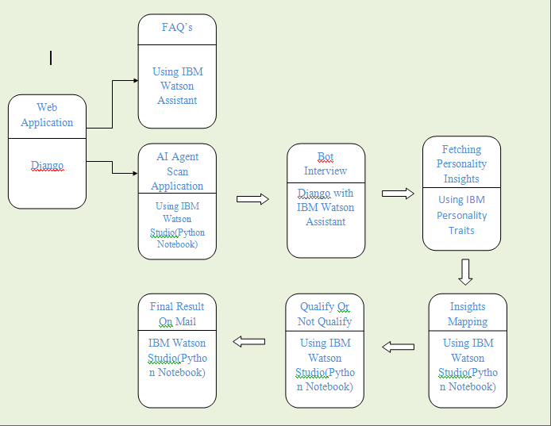

RESULT:

The result of the project is at the time of recruitment process Perfect candidate for that particular job will be get selected by AI Recruiter And Employer will get the perfect candidate for there company .

ADVANTAGES & DISADVANTAGES:

As we know if there is solution for some problem they have there own Advantages and Disadvantages

Advantages:

* The main advantage in this AI recruiter ,the company saves Man Hours in searching for the right application of candidate.
* Employer get right candidate for there job in less time.
* Communication gets better with candidate as he gets selected.

Disadvantages:

* You cant meet the candidate till he gets selected.
* The information he gives is correct or not

CONCLUSION:

Software Bot enabled with Artificial Intelligence on a website, which screens the candidate application, shortlists for interview and identify his skills & personality traits through conversation. If traits matches for specified job role (In our case Data Analyst), qualify candidate for human interview

FUTURE SCOPE:

Future Scope of this project will after shortlisting the right candidate for the job ,the AI recruiter will also take technical interview of the candidate ,So that the Company will get the right perfect candidate for there job.

BIBILOGRAPHY:

For this project we have created this file for Data Analyst job role . we have refered to these links:

<https://rmsresults.com/2012/04/23/13-traits-of-a-good-data-analyst-market-research-careers/>

<https://cloud.ibm.com/docs/personality-insights?topic=personality-insights-numeric>

For Django framework :

<https://www.djangoproject.com/>