**SMART INDIA HACKATHON-2020**

**TOPIC:**

**Bus Ticket Booking System During COVID-19 Lockdown**

**SUBMITTED BY:**

AKASH V

YAKESH KUMAR N

GANESH J

**INDEX**

|  |
| --- |
|  |

* INTRODUCTION

1.1 Overview

1.2 Purpose

* STATEMENT OF PROBLEM
* EXPERIMENTAL INVESTIGATIONS
* DATABASE DESIGN

4.1. List of Entities

4.2. List of attributes

* METHODOLOGY
* RECOMMENDATION
* APPLICATION
* SUMMARY
* FUTURE SCOPE
* CONCLUSION
* BIBILOGRAPHY

**1. INTRODUCTION**

**1.1 Overview**

Online Bus Ticket Reservation System is a Web based application that workswithin a centralized network. This project presents a review on the web application program “Bus Ticket Booking System During COVID-19 Lockdown” as should be used in a bus transportation system, a facility which is used to reserve seats, and different types of route enquiries used on securing quick reservations. It maintains all customer details, bus details, reservation details. Traveling is a large growing business across all countries.

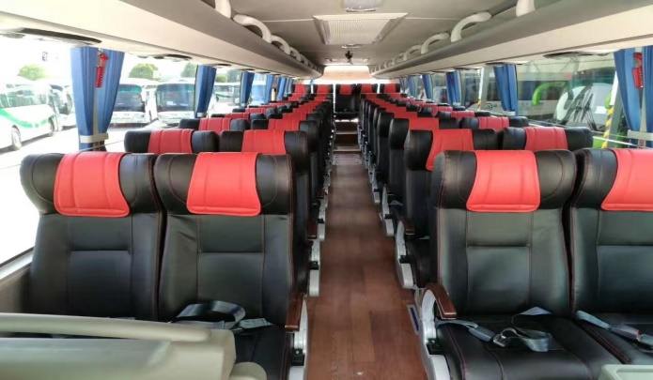

Bus reservation system deals with maintenance of records of details of each passenger. It also includes maintenance of information like schedule and details of each bus. We observed the working of the Bus reservation system and after going through it, we get to know that there are many operations, which they have to do manually. It takes a lot of time and causing many errors while data entry. Due to this, sometimes a lot of problems occur and they were facing many disputes with customers. To solve the above problem, and further maintaining records of passenger details, seat availability, price per seat, we are offering this proposal of computerized reservation system. COVID-19 has rapidly spread in the world and social distancing or stay-at-home measures have been adopted by many countries. So that it is important to take some safety measures in transportation.

**1.2 Purpose**

The design of this online system will be beneficial to the company.

Currently, staff at the bus ticket counter is using an manual system to sell tickets at the counter and customers who are unable to buy bus ticket online at this moment would have to go to the counter to a buy bus ticket. Sometimes, customers’ needs to queue up a long queue to buy bus ticket. So that the social distance will not be maintained properly. However, Bus Ticket Booking System During COVID-19 enables the customer to buy bus ticket, make payment, and ask for information online easily. Furthermore, staff can sell bus ticket using Bus Ticket Reservation System after checking the bus ticket availability for the customer and print the bus ticket to the customer.

**2. STATEMENT OF PROBLEM**

COVID-19 has rapidly spread in the world and social distancing or stay-at-home measures have been adopted by many countries. So that it is important to take some safety measures in transportation.



Currently, the type of system being used at the counter is an internal system which is manually used in selling the bus tickets. The problems are that customers have to go to the counter to buy bus ticket; customers will also have to queue up for a long time in order to buy a bus ticket.

**3. EXPERIMENTAL INVESTIGATIONS**

This project aims at building an application to automate the manual procedures of reserving a bus ticket for journey. The customers can select seats by themselves. Providing a web-based bus ticket reservation function where a customer can buy bus ticket through the online system without a need to queue up at the counter to purchase a bus ticket. To achieve this, we will be using node-red service to build a web UI. By this automated reservation system there will be no need of waiting in queue. So it is one of the safety measures against COVID-19.

**4. DATABASE DESIGN**

**4.1 List of Entities**

* Bus Details
* Passenger Details
* Reservation
* Confirmation

**4.2 List of attributes**

4.2.1. Bus Details:

* Bus ID
* Fare
* Date and Timing

4.2.2. Passenger Details:

* Name
* Age
* Gender
* Mobile number
* E-mail
* Number of seats

4.2.3. Reservation:

* Seat
* Date

4.2.4. Confirmation:

* Confirmation of Booking.

**5. METHODOLOGY**

This project will be achieved using Node-red platform and collecting the data from the user and storing it in the Db2 database service. In Node-red platform we will use form node, function node, template node, inject node, debug node, text node, button node, cloudant node, http request node, etc… To build this project and storing data in database service.

**6. RECOMMENDATION**

Research and development are continuous processes; this is the same in computer and software development. Since in many transportation company the operation are still carried out manually. The system can contribute more on those bus representatives handling the account if it can generate reports by trip so that they will no longer go to a certain module to check the reservation and its details. Also, it will be more beneficial to both clients and bus representatives if clients can create an account just like in airlines websites. With that, the system can record the modifications made, could also be integrated into the system in order to enhance user friendliness and interactions.

**7. APPLICATION**

* Advanced Traveler Information System
* Advanced Vehicle Control system
* Advanced Public Transportation System
* Advanced Rural Transportation Systems

**8. SUMMARY**

In 1974, American airlines were the first to use an automated booking system, which was still almost manual. Technology grew, and a computer reservation system was developed. In this present era, online booking or reservation system has improved the operations of various sectors of a nation’s economy deploying this system. Online Bus Ticket Reservation System being a web based system that ensures that the company would be able to transform most of the processes carried out manually into automated and easy to use operations in the organization especially in the area of transportation.

**9. FUTURE SCOPE**

* Faster processing of information as compared to the current system with high accuracy and reliability.
* Automatic and error free report generation as per the specified format with ease.
* Automatic calculation and generation of correct and precise Bills thus reducing much of the workload on the accounting staff and the errors arising due to manual calculations.
* With a fully automated solution, lesser staff, better space utilization and peaceful work environment, the company is bound to experience high turnover.

**10. CONCLUSION**

It can be observed that computer applications are very important in every field of human endeavor. Here all the information about customer that made reservation can be gotten just by clicking a button with this new system, some of the difficulties encountered with the manual system are overcome. It will also reduce the workload of the staff, reduce the time used for making reservation at the bus terminal and also increase efficiency. This project, as a whole, will give a new way in bus reservations and ticketing processes. The automation and management of seats and reservations will be done online. This also lessens the use of papers like in the traditional way of ticketing. By this automated reservation system there will be no need of waiting in queue. So it is one of the safety measures against COVID-19.

**11. BIBILOGRAPHY**

* https://www.youtube.com/watch?v=BlXZUdaQcTA&t=101s
* <https://www.youtube.com/watch?v=iEadmCNb_hE&feature=youtu.be>
* <https://www.angleritech.com/case_studies/online-bus-booking-system/>
* <https://www.youtube.com/watch?v=NCSzqhNR-lk&feature=youtu.be>
* <https://www.youtube.com/watch?v=_SJEG5sMQJA>
* <https://www.youtube.com/watch?v=Al90oiU4dhg>
* <http://khartoumspace.uofk.edu/bitstream/handle/123456789/25757/Online%20Bus%20Reseevation%20System_%20MAALIM%20ALSHAZALY%20124101.pdf?sequence=1&isAllowed=y>