**REPORT**

**1)INTRODUCTION**

**Overview:**

A twitter sentiment analysis was done based on English tweets as well as Devnagri script classifying them into four particular emotions (sad, happy, relief, anxiety) along with a general classification of percentages of positive and negative tweets.

We observed the sentiments over a while from April to July 15 and currently, live tweets are scrapped for analysis to understand what trends are associated over time. We also have a word cloud that shows words with the highest frequencies and analyses are done to show the emotions associated with them.

A search bar is added to particularly search a word and then you can analyse the sentiments associated with that particular word. A map of India shows colours based on the dominating emotion (average) on a particular day in a particular city. The usability of the dashboard is extremely friendly with options to view the graphs in bar, line or pie chart and to switch between dark and semi-dark (light) mode.

The machine learning model is manually trained along with Watson tone analyser and a deep convolutional neural network was used for model training the model.

We have also included a list of important events i.e announcements made by the respective governments to understand the trend change and see reactions after the announcements were made.

**Purpose:**

  Twitter sentiment analysis for lockdown extension can have benefits for regime organizations as well as various businesses.  Sentiment analysis is done based on tweets collected over a while and a dashboard is created for the same having the following attributes and purpose.

* **Word cloud**: A word cloud is created of Important topics along with a graph that analyses the sentiments of important topics.
* **Important Event**: Sentiment analyses of the general public is done based on the regime (government) announcements throughout the lockdown period.
* **Customizable Dashboard**: The companies can tweak the dashboard according to their needs and hence it's an adaptable UI, allowing companies to focus on their needs and even understand competitors. A search bar is provided for the same where the companies can type a specific word related to their product and graphs will be generated according to the sentiments analysis related to that word.
* **Live tweets**: To understand the current and ongoing trends
* **Map of India**: Sentiment analysis is based on particular cities to understand the overall sentiments specific to geolocations.

**2)LITERATURE SURVEY:**

**Existing Problem:**

The existing sentiment analysis are incapable of understanding sarcasm and also can't correctly identify specific emotions. Many Tweets are hence marked neutral and hence it becomes difficult to get accuracy and data is skewed by a huge difference.

Live tweets aren't fetched properly and hence the graphs associated are not accurate. Emotions based on geographical locations are averaged out thus leading to biased results.

The cloud words are not customizable and stop words aren't removed properly and hence the majority of the cloud words are prepositions etc.

Importing and updating hude data sets becomes a task and hence live tweets are affected and the data becomes skewed by a huge margin.

As India is the focused country devnagri scripts might be added to neutral as the characters maybe unrecognised

**Proposed Solution:**

Using IBM cloud for deployment solves the problem of updating the live tweets by implementing cronjob.

The emotions of a particular city or state is shown based on the graphs and which emotion dominates (i.e higher in percentage)

We have also included the important announcements made by the government so that they can understand reactions of the general public to those announcements by looking at graphs in bar, line or pie format created by chart.js

Companies can have a huge benefit from these important announcements as they can understand when to push their products into markets etc by looking at the dates and overall sentiments provided by the graphs.

There is a search bar to search for particular terms and a customizable word cloud is then developed based on the search term hence companies can tweak the dashboard according to their needs and then look at the sentiment analysis provided by the graphs of those particular words.

Devnagri Script has been included and hence sentiment analysis is not skewed by a great margin.

**THEORETICAL ANALYSIS:**

**Block Diagram:**

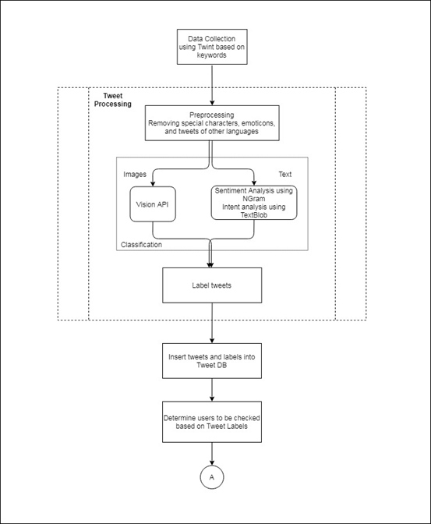

**Hardware/software design**

The software design was made in Adobe XD

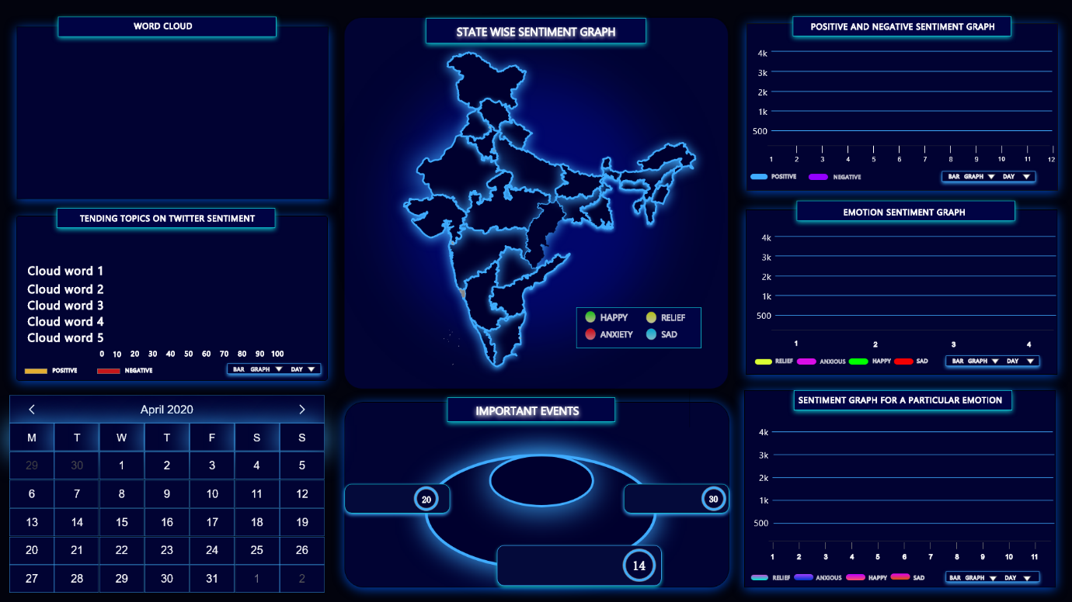

**EXPERIMENTAL INVESTIGATION:**

The data was manually trained along with watson tone analyser on approx 10k tweets and after training the model the accuracy of the model was found to be  83.09%  .

The filters were applied such as particular dates were selected and the graphs changed accordingly.

Clicking on the government announcement also made the necessary changes in graphs for that particular day.

Searching for a particular word customized the word cloud according to the word and also showed the sentiments associated with it.

We could do word search for limited brands as the data was limited. We also observed that the number of tweets for a particular day in july has decreased as people maybe aren't using the hashtags much. But even with this limited amount of data our model is proving highly accurate results.

Live tweets are updated at the end of the day using cronjob i.e everyday at a particular time live tweets are fetched from that particular day and graphs are made using chart.js accordingly.

**FLOWCHART:**

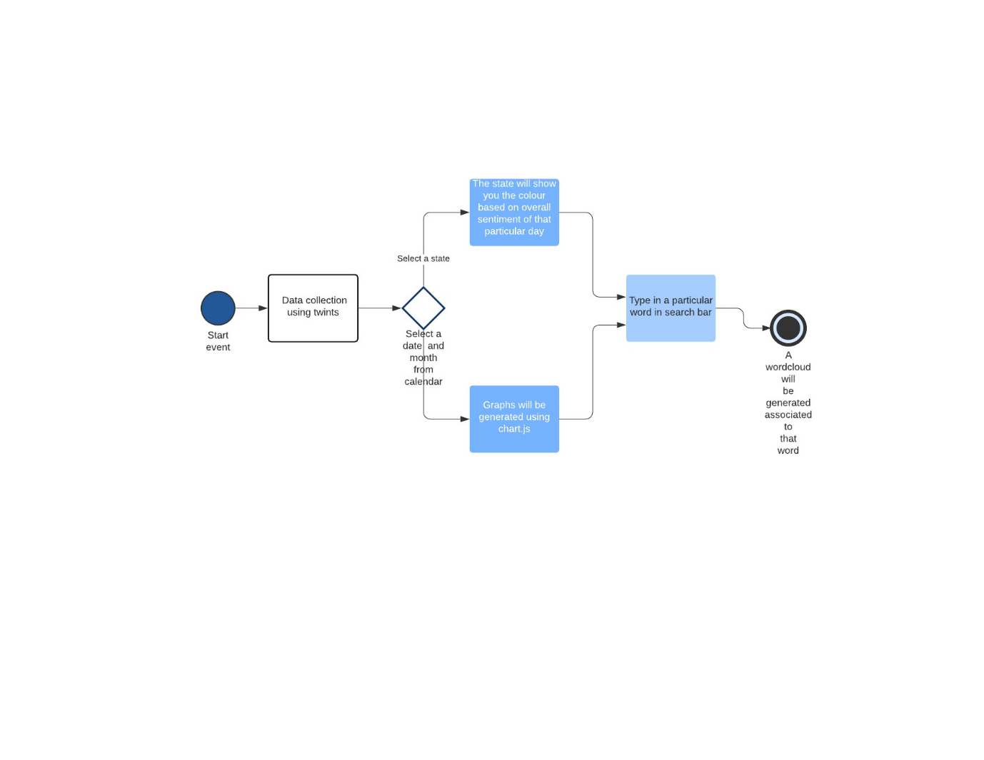

**RESULT:**

In the results we can see the accuracy of the model is 83.09 which is a fair model. The live tweets are updated at the end of the day, the timings for collecting and updating the live tweets can be changed accordingly. As devnagri script was included the number of tweets that were neutral significantly reduced and they were classified according to the emotions. The map clearly reflected the dominating emotion on a particular day in a state. The word cloud customized according to the word typed in the search bar and even showed the sentiment analyses associated with that word. On clicking on the important announcements made by the government on a particular day the graphs updated accordingly and we could observe the sentiments associated with it.

**ADVANTAGES AND DISADVANTAGES**

**Advantages:**

* Customizable according to a company's needs, the company can see the sentiments attatched to their products along with their competitors
* List of important government announcements and sentiments.
* Devnagri script is included while classifying tweets, multilevel classification.
* Colour of state changes according to the dominating emotion in a particular state at the end of the day
* Live tweets are collected and updated and real time sentiments are shown

**Disadvantages:**

* Limited space in IBM cloud and hence a large set of data cannot be uploaded in lite version
* Word cloud takes 3 seconds to load.

**APPLICATIONS:**

Twitter sentiment analysis for lockdown extension can have benefits for regime organizations as well as various businesses.  The government can understand and make obligatory changes or give assurance with their proposed solutions for quandaries concerning people with the help of our listings of their announcements on our dashboard and sentiments of general public associated with it.

Our dashboard is customizable according to the company's needs i.e the company can tweak the dashboard and search for terms based on their products to understand the sentiments of people regarding it. The companies can then draw a conclusion to strategise how to sell their products based on the sentiments analysed on the past data and understand the trend. The main takeaway is that companies can even analyse their competitors and see whether their product is in sync with the general emotions of the public. The word cloud will show words related to the input word typed in the search bar and hence the companies can even identify the issues related to their products, helping them to pinpoint the problem.

In the field of finance and general public, live tweets is the best feature as company's/ investors can see the government announcements made and then accordingly take a call based on reactions associated with it. The investors can also search for a brand and see how people are generally reacting to their products and what are the sentiments associated with it.

 Including devnagri script has allowed us to even look at government announcements made in that script and emotions associated with it.

**CONCLUSION:**

A dashboard was made for twitter sentiment analysis that included various sentiment graphs. A customizable word cloud was available based on the input word, with the freedom to search for brand names etc. The map reflected colours and the graphs are available in pie, bar and line charts. Important government announcements showed the sentiments associated with it.

**FUTURE SCOPE:**

In the future our dashboard can create trend lines and inturn draw conclusions and suggest what should a company do in the future based on past emotion analysis.

The stock companies can ask to be notified about certain companies they select and emotions of people associated with those brands.

The important events and announcements will automatically get scraped and updated along with twitter links or news links for the same.

**BIBILOGRAPHY:**

<https://www.aclweb.org/anthology/S13-2063.pdf>

<https://www.ncbi.nlm.nih.gov/pmc/articles/PMC7152888/>

**APPENDIX:**

Uploaded on Github