**RISK-FREE TRANSIT SYSTEM**

**A PROJECT REPORT**

**SUBMITTED BY**

**M.VARSHAA**

**G.K.SHREE**

**G.KARISHMA**

**Bachelor of Electronics and Communication**



**Saranathan College of Engineering,**

**Trichy**

**Table of content**

|  |  |
| --- | --- |
| **CHAPTER** | **TITLE** |
| 1. | INTRODUCTION |
|  | 1.1  OVERVIEW |
|  | 1.2 PURPOSE |
| 2. | LITERATURESURVEY |
|  | 2.1 EXISTING PROBLEM |
|  | 2.2PROPOSED SOLUTION |
| 3. | THEORETICAL ANALYSIS |
|  | 3.1 BLOCK DIAGRAM |
|  | 3.2SOFTWARE |
| 4. | RESULT |
| 5. | ADVANTAGE |
| 6. | APPLICATION |
| 7. | CONCLUSION |
| 8. | FUTURE SCOPE |
| 9. | BIBILOGRAPHY |
|  | 10.1APPENDIX |
|  | 10.2SOURCE CODE |

**1. INTRODUCTION**

**1.1 OVERVIEW :**

**To overcome the issue of covid-19 while traveling in the public transport,we have developed an app for conductor.**

**This app enables the user to permit the safe people by detecting their temperature.**

**Tickets can be booked via the app and**

**upi payment is available.**

**To maintain the social distancing, time schedule for the public transport has been displayed.**

**1.2 PURPOSE :**

**Proper utilization of public transportation while efficiently maintaining social distancing, by following certain guidelines, is very crucial at this hour, to stay protected.**

**As the old normalcy is not attainable anytime soon, we have devised a logical approach to new normalcy involving integration of various independent services, to make way for safe transportation.**

**This approach involves creation of a platform / Solution  for the bus operators to facilitate temperature check for the onboarding passengers, UPI Payment Gateway, bus time schedule monitor and social distance check for the passengers in the bus.**

**2. LITERATURE SURVEY**

**2.1 EXISTING PROBLEM :**

**"Intelligent post-lock down public transportation management system"**

**Post-Lockdown, it will be risky to allow the public transportation without proper mechanism to maintain the social distancing, especially the frequency of buses, trains and metros shall be managed properly to utilize the capacity with social distancing criteria. The transport authorities must integrate together to maintain the system properly.**

**2.2 PROPOSED SOLUTION :**

**Covid-19 pandemic has toppled the world, impacting lives of millions and brought in unforeseen challenges. As part of the preventive measures, unprecedented changes to the global transportation system have been introduced.**

**Amidst the uncertainty, social distancing is believed to be the key to flatten the curve of this deadly pandemic. In times of the chaos, with the perspective of social distancing in mind, we propose a practical solution to enable a risk free transit system.**

**3. THEORITICAL ANALYSIS**

**3.1 BLOCK DIAGRAM :**

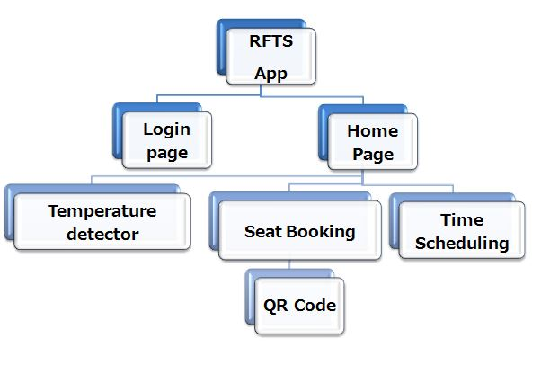

**3.2 SOFTWARE DESINGING :**

**The design of the app was done by using kodular and node-red platform.**

**4.RESULT**

**As the result we have developed an app,"RISK FREE TRANSIT SYSTEM " which ensures public safety.**

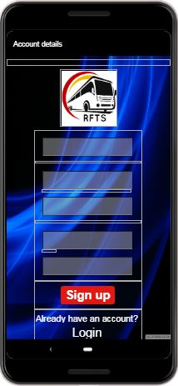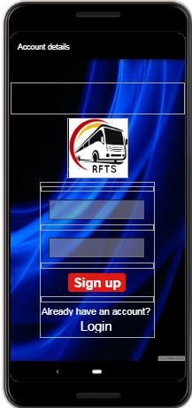

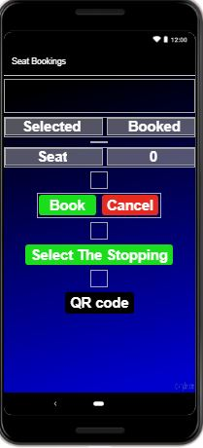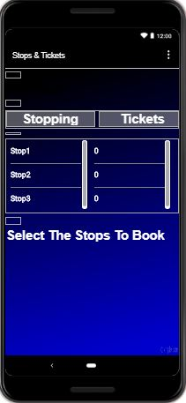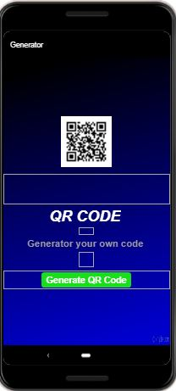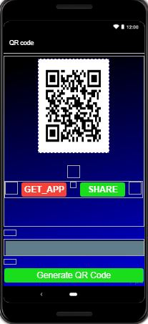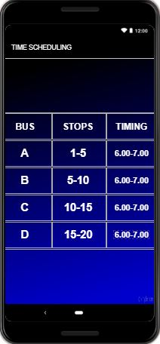

**5. ADVANTAGES & DISADVANTAGES**

**6.1 ADVANTAGES :**

* **Simpler development at lower cost**
* **Easy payment options**
* **Social distance is maintained**
* **User friendly**

**6. APPLICATIONS**

**♦** **The new normalcy let the conductor to foresee the time scheduling which allows only 60% of people into the bus.**

**♦** **Contactless transaction will be held so that the risk of exchanging cash can be avoided**

**7. CONCLUSION**

* **The coronavirus disease continues to spread across the world following a trajectory that is difficult to predict.**
* **In the public transport community, each of us has a different role to play to prevent the spread, and keep essential services running**
* **We have designed an app so that the public people and conductor can overcome this tragedy.**

**8. FUTURE SCOPE :**

**➢ Statistics Page can be added which enable Ticket Collector, Driver and other authorities to view the data of Social Distancing maintenance ratio along with the number of people travelled**

**9. BIBILOGRAPHY :**

**APPENDIX :**

**A.SOURCE CODE**

**This is the node-red flow for login.**

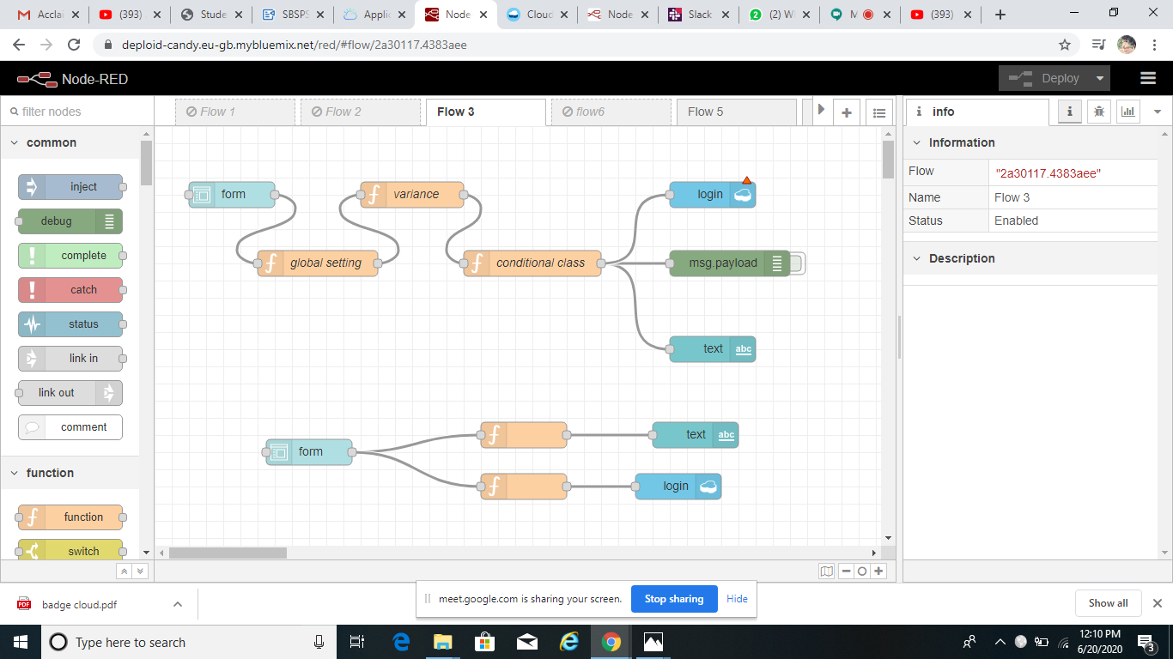

**This is the node-red flow for login.**

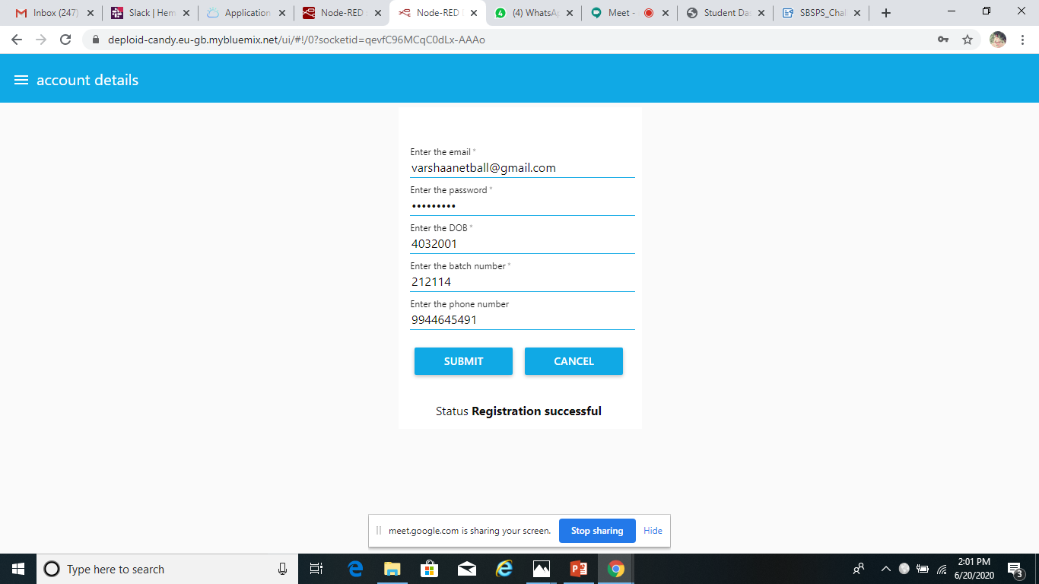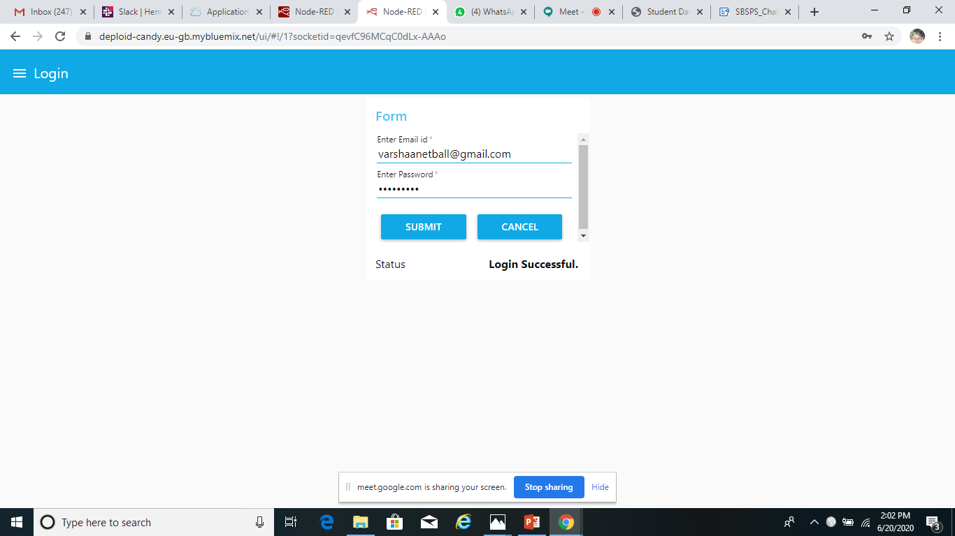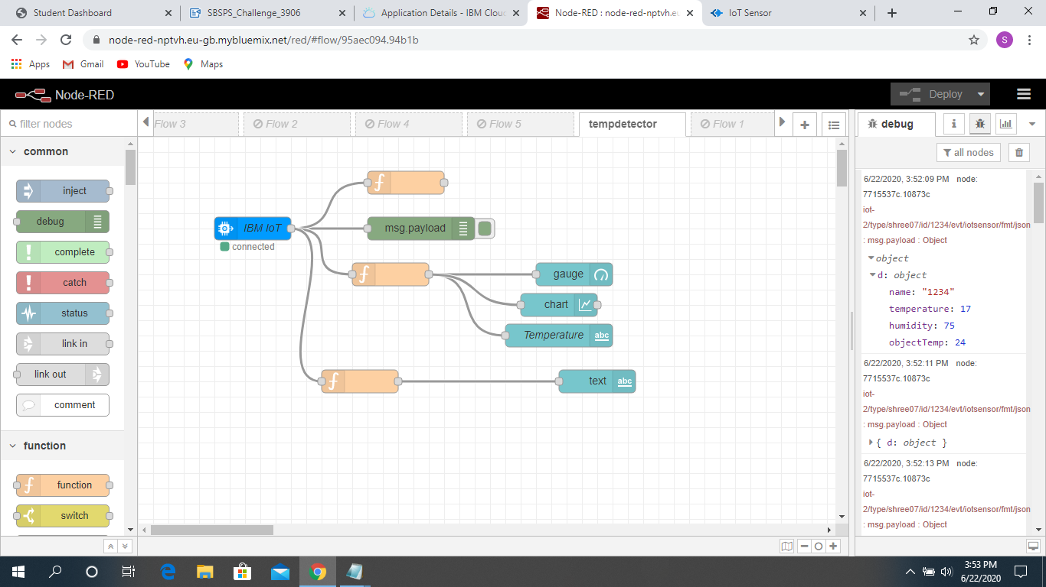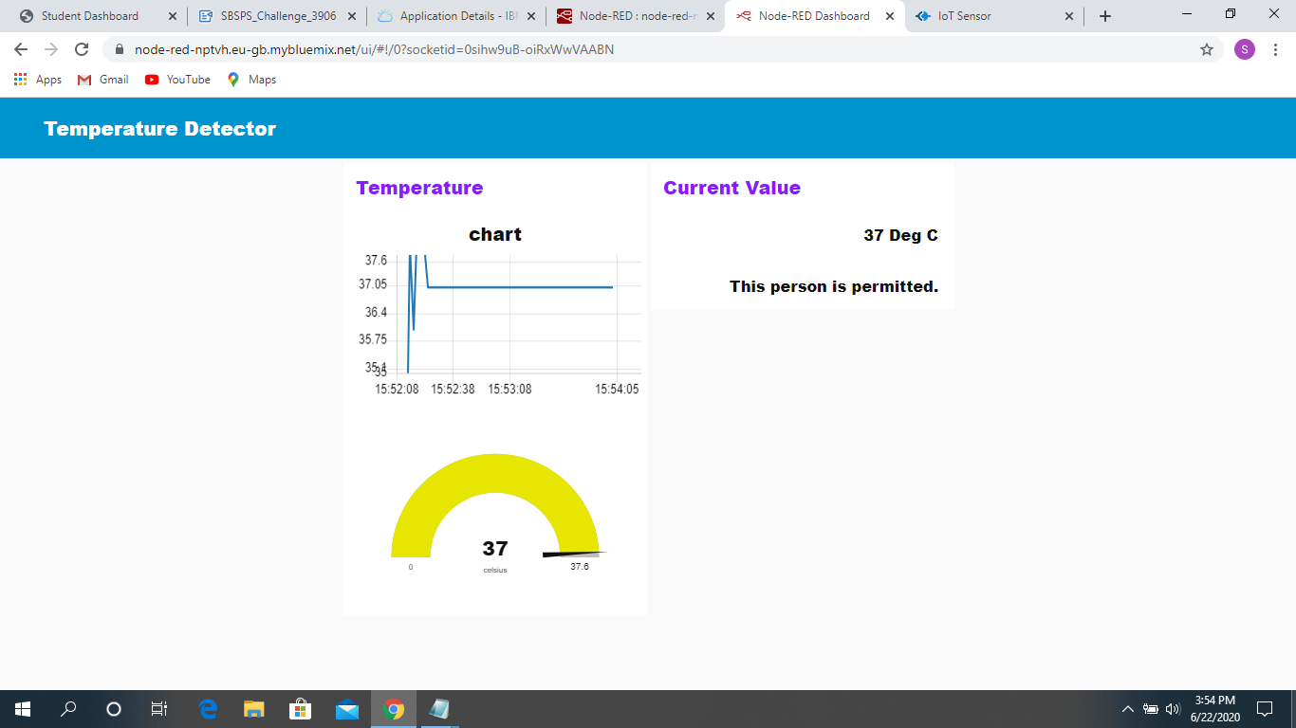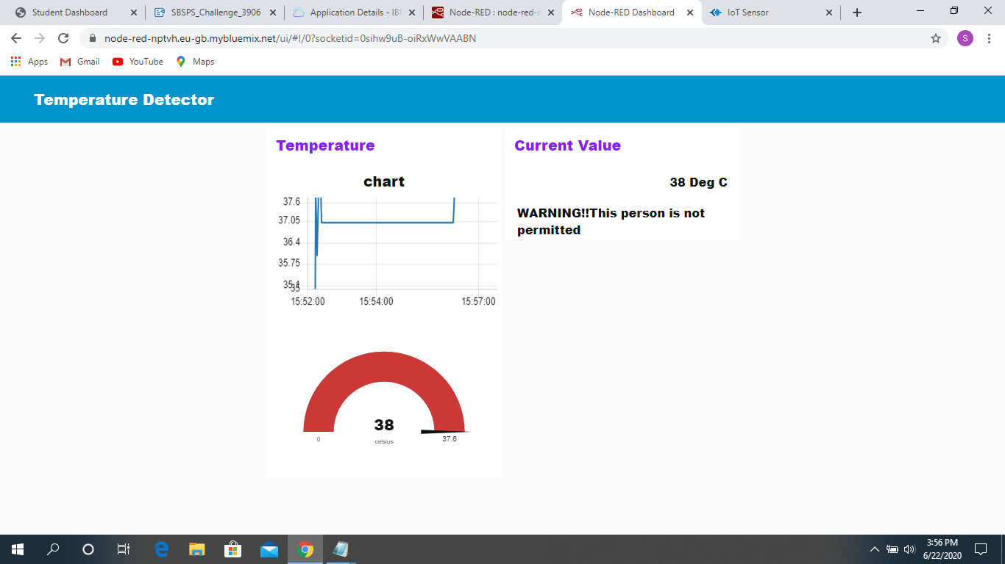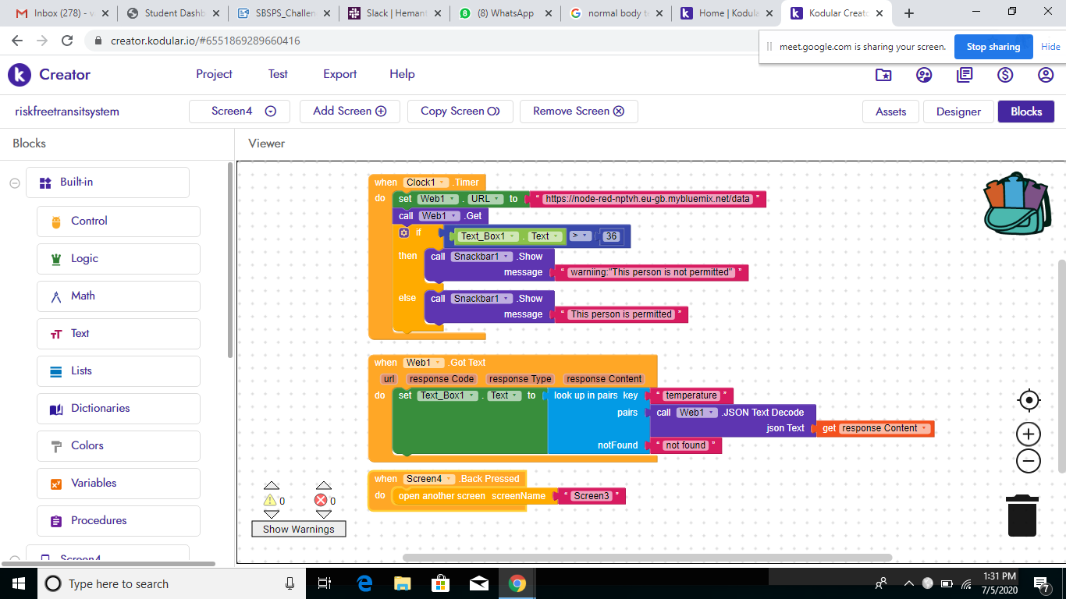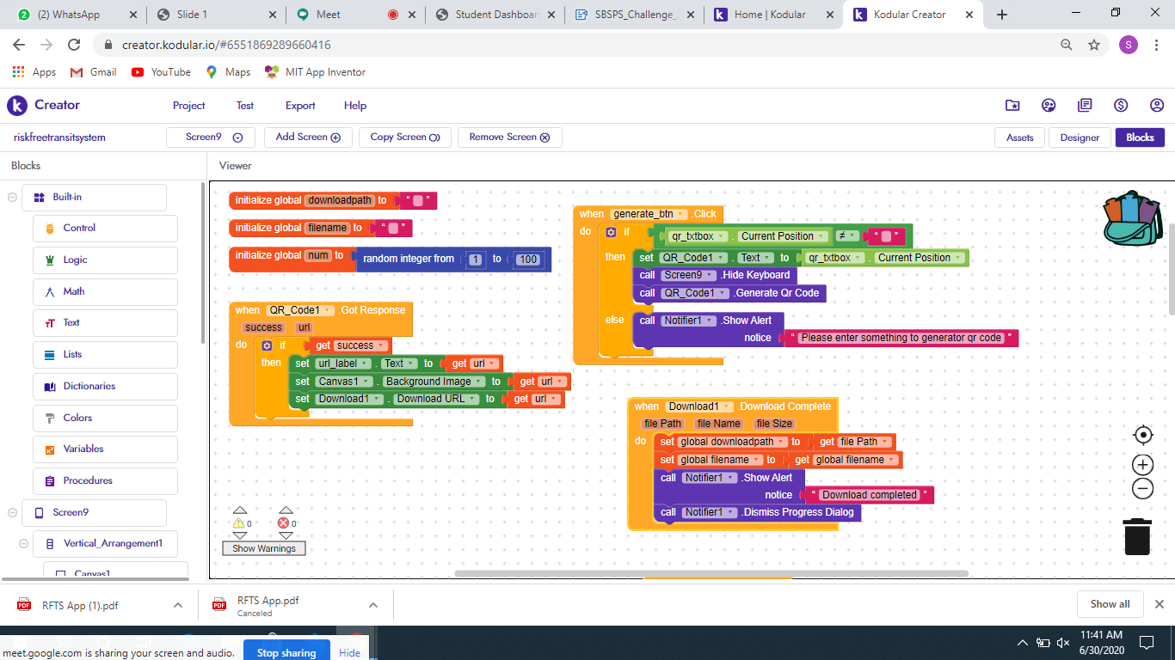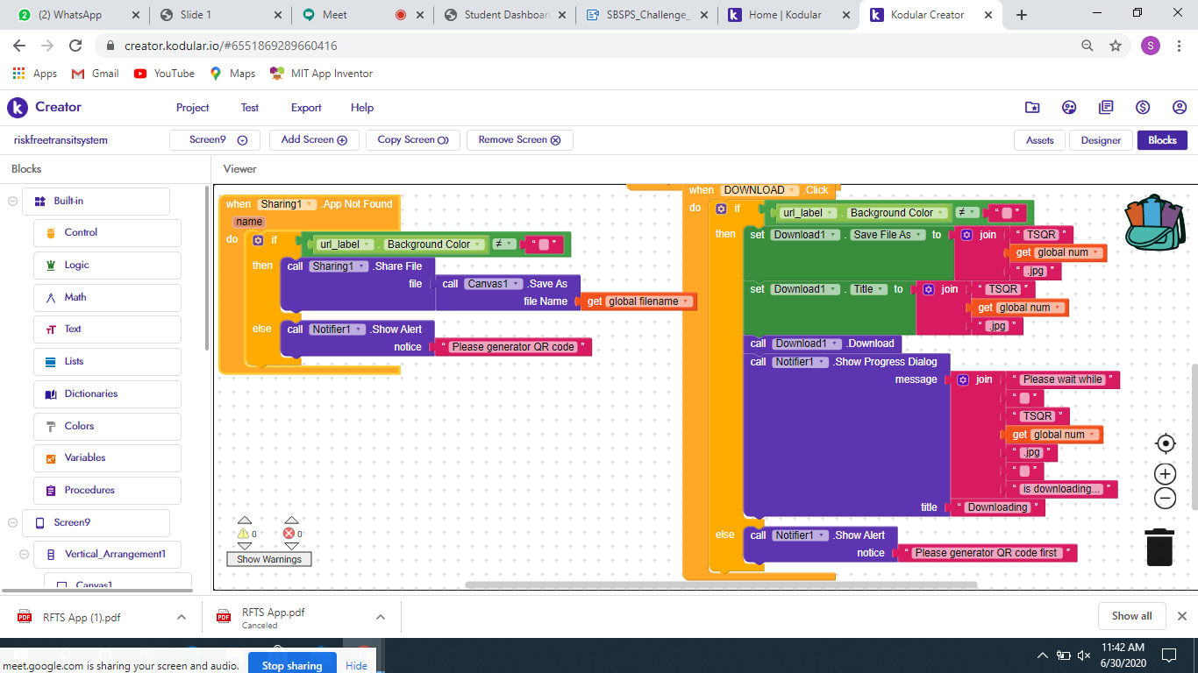

  This flow is for temperature detector.

  Backend In The Kodular For Temperature Detector

  Backend in the kodular for upi payment gateway