**AI-RECRUITER (AN AI-DRIVEN CHATBOT FOR RECRUITERS)**

**1. INTRODUCTION**

   1.1 Overview

      1.2 Purpose

**2.   LITERATURE SURVEY**

2.1 Existing problem

       2.2 Proposed solution

**3. THEORITICAL ANALYSIS**

3.1 Block diagram

       3.2 Hardware / Software designing

**4. EXPERIMENTAL INVESTIGATIONS**

**5. FLOWCHART**

**6. RESULT**

**7. ADVANTAGES & DISADVANTAGES**

**8. APPLICATIONS**

**9. CONCLUSION**

**10. FUTURE SCOPE**

**11. BIBILOGRAPHY**

**APPENDIX**

       A. Source code

1.  INTRODUCTION

1.1 Overview

AI recruiting chatbot helps the HR team by sourcing passive candidates, and screening candidates that come in via the careers page or sourcing activities. Their solution learns over time which profiles are a good fit for a given role which results in better and better matches.  Overall, this is designed to save the TA team time, and allow them to focus on more strategic initiatives.

It is found that bot engages 40% more career site visitors than just asking candidates to apply, and that candidates who’ve engaged with the bot are 100-200% more likely to be hired. The chatbot is tightly integrated into a leading candidate relationship management (CRM) offering. An HR Chatbot is one major category within AI recruiting software that allows job seekers and employees to communicate via a conversational UI via SMS, website, and other messaging applications like WhatsApp.

1.2 Purpose

                       This Chatbot is designed to convert more career site traffic into applications in the ATS by answering candidate's most pressing questions, or navigating them through the application. The platform allows for meaningful exchanges without the need for HR leaders to take time out of their day. Chatbot will begin to understand which metrics it should be looking for based on the data it collects and rank candidates accordingly.

2. LITERATURE SURVEY

2.1 Existing Problem

           52% of talent acquisition leaders say that the most difficult part of their job is to shortlist the right candidate and 3% of candidates never hear back from a company after one touchpoint. On the flip side, it’s a challenge for employers to communicate well with all their candidates. For high volume recruiting, this would require communicating with thousands of candidates, in addition to a recruiter’s normal screening functions and other duties. Artificial Intelligence enabled software bots can definitely provide a solution for this problem.

* AI is too dependent on keywords and phrases to look for the desirability of a candidate. Those who are familiar with AI’s functionality, know how to outsmart the technology by using specific words and appearing themselves look fit for the roles they aren't.
* AI is a relatively new concept. A lot of advancements and upgradations are required to fix the loopholes that this technology encounters from time-to-time. AI experiences a lot of technical errors apart from poor speech comprehension.
* Due to a lack of legislation on the issues around AI and the risk of data, many organizations are apprehensive of using the technology. AI’s potential to collect data and human inadequacy in dealing with the consequences of AI errors are other disadvantages of AI in recruitment.

2.2 Proposed Solution

The platform allows for meaningful exchanges without the need for HR leaders to take time out of their day. Chatbot will begin to understand which metrics it should be looking for based on the data it collects and rank candidates accordingly.

* Collect information from candidates such as their resume and contact information
* Ask screening questions about candidates’ experience, knowledge, and skills
* Rank candidates on metrics such as qualifications, engagement, recent activity
* Answer FAQs about the job and the application process
* Schedule an interview with a human recruiter
* Keep track of employee’s records, past history, achievements
* Helps in retrenchment process suggesting HR which employee to sack out
* Carry out referrals for candidates
* Candidate friendly environment suggesting and helping candidate to apply for the job
* Also have the feature of **“retrenchment”** that also helps the hr. management team to carry out retrenchment keeping the employee’s past records, achievement and history.
* The recruiting chatbot that allows you to **add videos right into the conversation.**
* Have glossed over above are the **non-recruiting jobs like onboarding, answering employee questions, new hire check ins, employee engagement, and internal mobility.**  The best HR chatbots are extremely powerful, and only getting better
* Chatbots enabling employees to make **referrals through their interface** - and will actually ping company’s employees with reminders about open roles, and how much the bounty is for each.

3. THEORITICAL ANALYSIS

3.1 Block diagram

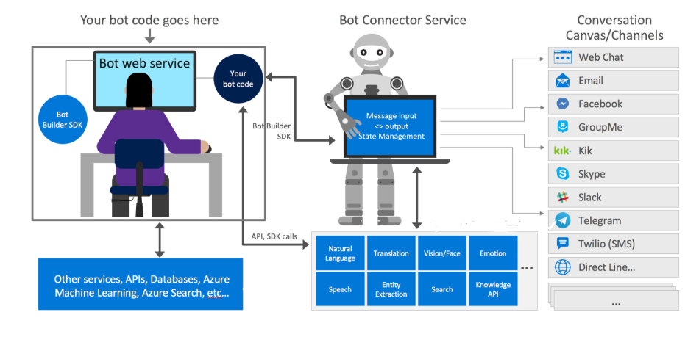

Workflow

3.2 Hardware/Software Designing

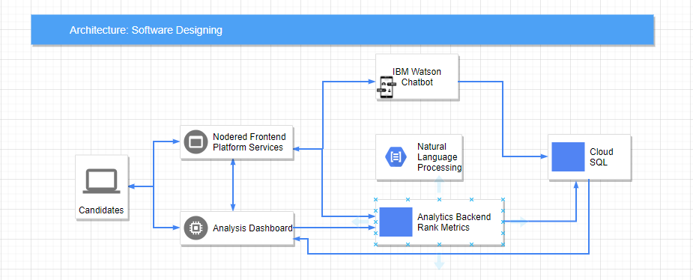

4. Experimental Investigations

* In the backdrop of the chatbot we have used **Deep Learning algorithms.** Initially **NLP for text analysis** for extracting information from the candidates.
* Machine learning to understand the nuances of syntax and semantics, and respond to candidates in a human-like way. By **learning from each conversation,** chatbots get smarter and better at responding to candidates over time.
* Further if the candidates upload resume then it also does **image processing using CNN** and **extract certain keywords from the resume** which helps in screening the candidates as per the required skills of the desired job.
* For better communication, it helps candidate to upload videos for high value conversation and helps companies to improve their talent acquisition metrics.
* Here an **Analysis Dashboard** has been prepared where all the related information of the candidates is stored **creating a rank metrics**.
* Using **IBM Watson,** chatbot has been created and **visual recognition model** has been used for the better extraction of candidate's information.

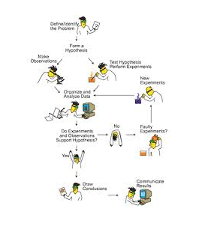

5. Flowchart

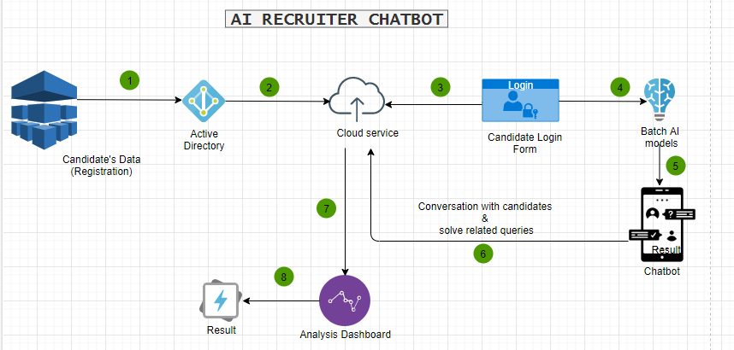

6. Result

A Analysis dashboard in business is a tool used to manage all the business information from a single point of access. It helps the chatbot to manage the details of the candidates applying for a suitable job and considering tracking KPIs and utilizes business intelligence to help companies make data-driven decisions.

Analysis Dashboard is maintained at the backdrop of the webpage where the rank metrics is created i.e., containing brief various attributes such as qualification, grades, skills, project accomplished, experience tenure, soft skills and related things. this rank is then filled by keyword extraction of their resumes/cv.

At the end from the rank metrics top n that is number of required candidates for the job are selected for the further round.

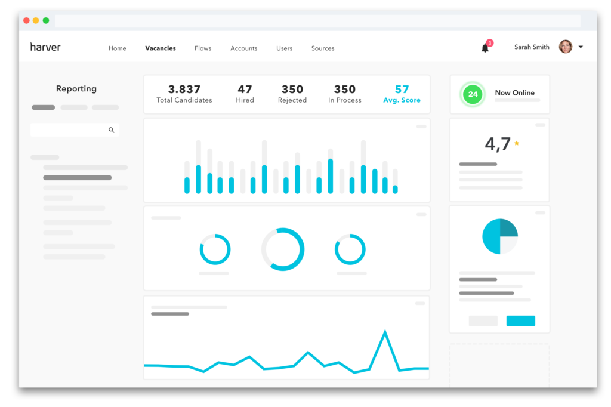

(just a prototype demonstrating analysis dashboard)

7. Advantages & Disadvantages

An AI can appear in many forms, integrated in a number of industries, offering services and assistance to us in many ways to streamline our businesses and optimize our lives.AI is disrupting a lot of industries and business sectors, and recruitment is no exception. It’s safe to say that any form of automation is going to optimize any given process and deploying AI solutions into your existing recruitment funnel is no exception to this rule!

Advantages:

* **Reduce human biasness**: Humans tend to be biased in some ways. Whether they realized it or not, some recruiters may make hiring decisions based on gender, ethnicity, age, looks and so on. An AI on the other hand, can be programmed to focus only on important factors such as candidates’ personality, skills, experience and qualifications.
* **Saves time, money and increase in efficiency**: One of the main challenges for HR recruiters is to identify the best talent out of the many applications they receive each day. AI can help to eliminate these manual tasks as they are programmed to obtain maximum efficiency in terms of time, costs and quality. Once the process of selecting candidates are fully automated, more data can then be gathered and efficiently assessed.
* **Improve candidate experience and engagement**: HR recruiters are often inundated with tasks that take up most of their time, hence many face difficulties in maintaining good response time with their candidates, resulting in poor candidate experience and engagement. By introducing chatbots and virtual assistants, candidates will experience better interaction and response time, keeping them engaged and posted throughout the whole recruitment process.

Disadvantages:

* **Too much dependency on certain keywords**:

AI depends very much on certain keywords to scan through their pile of candidates. This can become a loophole for candidates who are familiar with how the system in AI is programmed, where they may include certain keywords that have the potential to trick the system and camouflage them as good fits for various positions, even though they are not.

* **Lacks nuance of human judgement**: If a company is looking to diversify its workforce, using an AI in its hiring process may not be the best option. There are candidates out there who have atypical work experience but may still be the best fit for the position based on his or her personality, personal interests, character and work ethics. These are factors that require human judgement. Using an AI in this sense can greatly reduce the diversity in a workforce.
* **Chatbots can’t evaluate human qualities**:  Unlike human recruiters, chatbots can’t accurately gauge things like personality traits, culture match and work ethic —all factors that are important when assessing whether a candidate is the right match for the company and role.

8. Applications

* In the HR department
* Within the organization

9. Conclusion

This chatbot as for now mainly focuses on recruiting candidates masking the task of the hr. easy. From the rank metrics it selected the top n candidates send the list of candidate’s names for the further round. Besides recruitment it also creates a friendly environment for the candidates, talking to them, resolving their quires and related issues.

10. Future scope

* Personal AI Assistant of HR
* Served as middleman in building relationship and implement important task between two companies.
* NLU for making the chatbot capable of **understanding** even the **unstructured input**.
* NLG comes into a picture while the chatbot tries to generate a response to the query and the next scope is multilinguistic responses.
* Building the **employee Analysis Dashboard** maintaining the record and accomplishments of the employees, can be further used as a sorting criteria to select employee for **retrenchment** process.
* Track chatbot performance: Continually evaluate what’s working and what’s not to gauge the success of the chatbot and help tune the system. Consider tracking KPIs like:
* **Chat engagement:** The number of candidates who’ve exchanged messages with your chatbot.
* **Bot messages:** The length of conversations between candidates and your chatbot.
* **Rate of confusion:** How many times your chatbot gets confused by unexpected messages.
* **Quality of applicants:** The number of candidates recommended by your chatbot that are actually worth interviewing or hiring.
* **Conversion rate:** The percentage of people visiting your company’s career site that convert into your applicant tracking system (ATS).
* Integrations with calendar and video software like Outlook, Office 365, Google Calendar, and Zoom

11. Bibliography

* <https://ideal.com/recruitment-chatbot/>
* <https://chatbotsmagazine.com/how-to-develop-a-chatbot-from-scratch-62bed1adab8c>
* <https://idaas.iam.ibm.com/>
* <https://www.textrecruit.com/ari/>
* <https://www.indeed.com/hire/c/info/pros-and-cons-of-recruiting-chatbots>

Appendix

Source Code:

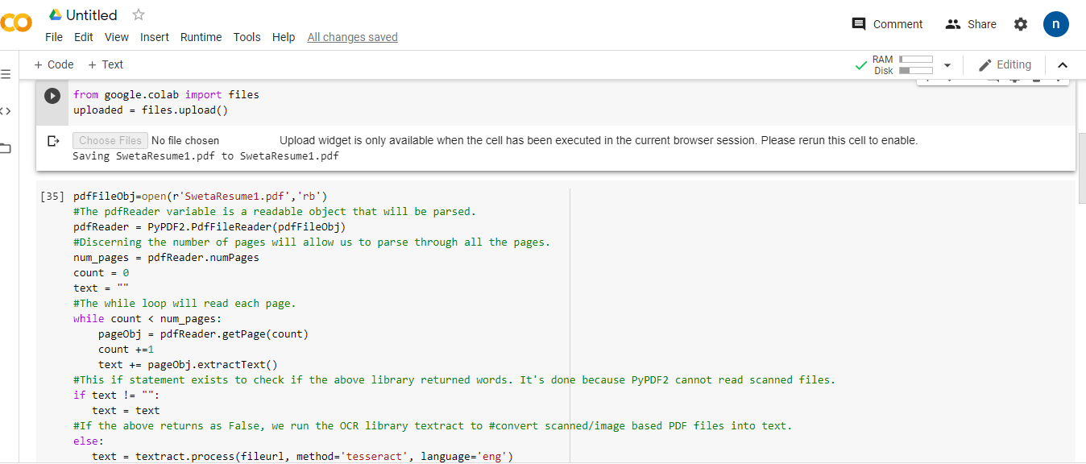

**Code showing the extraction of keywords from the uploaded cv.**

**#!pip install PyPDF2**

**#!pip install textract**

**import PyPDF2**

**import textract**

**from nltk.tokenize import word_tokenize**

**from nltk.corpus import stopwords**

**import nltk**

**nltk.download('punkt')**

**nltk.download('stopwords')**

**from google.colab import files**

**uploaded = files.upload()**

**pdfFileObj=open(r'SwetaResume1.pdf','rb')**

**#The pdfReader variable is a readable object that will be parsed.**

**pdfReader = PyPDF2.PdfFileReader(pdfFileObj)**

**#Discerning the number of pages will allow us to parse through all the pages.**

**num_pages = pdfReader.numPages**

**count = 0**

**text = ""**

**#The while loop will read each page.**

**while count < num_pages:**

**pageObj = pdfReader.getPage(count)**

**count +=1**

**text += pageObj.extractText()**

**#This if statement exists to check if the above library returned words. It's done because PyPDF2 cannot read scanned files.**

**if text != "":**

**text = text**

**#If the above returns as False, we run the OCR library textract to #convert scanned/image based PDF files into text.**

**else:**

**text = textract.process(fileurl, method='tesseract', language='eng')**

**#Now we have a text variable that contains all the text derived from our PDF file. Type print(text) to see what it contains. It likely contains a lot of spaces, possibly junk such as '\n,' etc.**

**#Now, we will clean our text variable and return it as a list of keywords.**

**tokens = word_tokenize(text)**

**#We'll create a new list that contains punctuation we wish to clean.**

**punctuations = ['(',')',';',':','[',']',',']**

**#We initialize the stopwords variable, which is a list of words like "The," "I," "and," etc. that don't hold much value as keywords.**

**stop_words = stopwords.words('english')**

**#We create a list comprehension that only returns a list of words that are NOT IN stop_words and NOT IN punctuations.**

**keywords = [word for word in tokens if not word in stop_words and not word in punctuations]**

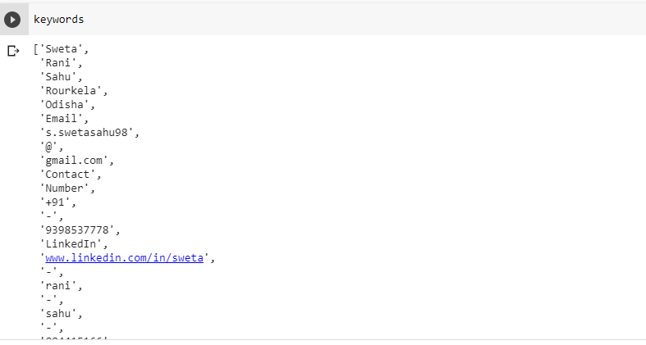

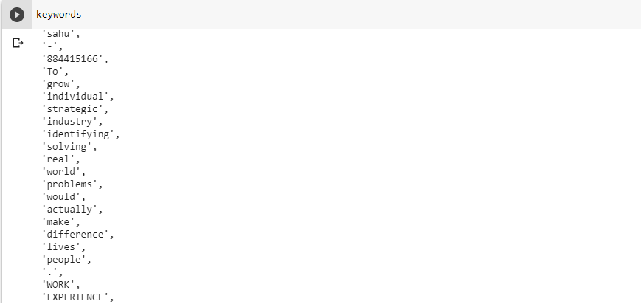

[**source code**](https://colab.research.google.com/drive/1gR8jVGwJirHTF8uff10t69xRy5I_h2sX?usp=sharing) **(link to the code for extracting keywords from the cv)**