1. INTRODUCTION
1.1 OVERVIEW
COVID 19 is an infectious disease cause by the most recently discovered Corona virus. Its most common symptoms are fever, tiredness and dry cough. Its outbreak began in Wuhan, China and now it’s a pandemic affecting many countries globally. It can spread from person to person through small droplets from mouth or nose. If any person breaths in these droplets, then they will be affected by this virus. So WHO prefers everyone to wear a mask and to wash their hands properly and also to maintain social distancing. We need proper monitoring system to make sure that the guidelines are followed by the citizens properly. Since no vaccines or drugs have been found yet, precaution is the only way out.

1.2 PURPOSE
Its very crucial for us to maintain social distancing to reduce the spread of the virus. A small careless action can lead to danger. The most important guideline provided by the government and the health department is to use masks while going out. Wearing mask can prevent us from catching the disease and also prevents us being a carrier. So it necessary to ensure that people wear masks while using public transport. The purpose of this app is to ensure that people are wearing masks while going out.

2. LITERATURE SURVEY
2.1 Existing Problem
During this great pandemic, we cannot act as both carriers or covid-19 patients. The only way to avoid the spreading of the virus is to maintain social distancing and to wear a mask. Mask can protect us from both spreading and catching the virus. In public transportations, the authorities cannot make sure if the passengers are following the guidelines such as social distancing and wearing mask. Even if any one of the passenger isn’t doing so, then it will lead to huge community spread and the situation will be out of hands. So, in-order to avoid community spread, we need to make sure if everyone is wearing masks and a proper system is to be implemented to check that from time to time. Also we need to make sure that the number of passengers in a public transportation system doesn’t exceed beyond a limit.

2.2 Proposed solution
An intelligent app is introduced to schedule the timing and transportation avoiding over occupancy of public transportation ,buses ,railway stations.
According to the situation we must understand the need for safety for the people which would help in not spreading the disease to one another. Here social distancing comes to aid. Each bus should only carry limited number of people .What we aim to accomplish is relavent safety mesures to not transmit disease. The main motives for this app are:
1. preventing contact of people within the public transport
2. social distancing and limiting the pasenger in the public transport

How are we going to achieve this :

1. This app allows us to interlink various smart bus services to book our respective seats in the bus/train as our convenience.
2. Limits the seat availability to the satisfy the safety standards.
3. Makes sure if the passengers are wearing a mask.
4. Allows us to correctly select a time slot as per our convenience .
5. Prebooking can help clear confusion and attain the cheapest rate .
6. The location of the bus/train can be tracked at any point of time so we can get to the bus stop/railway station at the correct time .
7. This app is directly linked to our Aadhaar.
8. The money transfer can be done using google pay to the bus service providers.
9. T ensure proper safety measure each individual should show his aadhar barcode which will be scanned with the barcode scanner to validate his presence in the public transport.
10. This will give you a ticket corresponding to your journey.
11. One-by-one entry to the bus/train boggie.
12. For entry to the railway station, the passenger has to get his Aadhar barcode scanned in order to make sure that he has pre booked his ticket.
13. Each traveller is allowed to have 2 people with him in the railway platform to ensure no crowding happens in the platform (pre-stated in the app while booking).
14. A similar system can be placed in the buses so that the date regarding the number of travelers in the bus, and whether they keeping the social distancing norms will be sent to the associated authority so that they can strictly monitor the vehicles.

How does this app work :
1.While installing this application the user must visit a nearby Akshaya to get access to the application updating the aadhar card details and verifying it.
2. Once this is done they can choose the destination and their current location .
3. Next we chose our expected time we need to reach the destination .
4. Then the app checks the sear availability of bus or train to reach the destination at approximately the required time of the passengers.
5. The user can pay for the travel online but maximum 24 hours before travel .
6. Each public transport will be equipped 1-4 seats for urgent travelers same way as the tatkal book and pay for the seat maximum by 1 hour before the bus reaches your current location.
7. This ensures the fact that any cancelled seats can also be used.

3. THEORITICAL ANALYSIS
3.1 Block Diagram
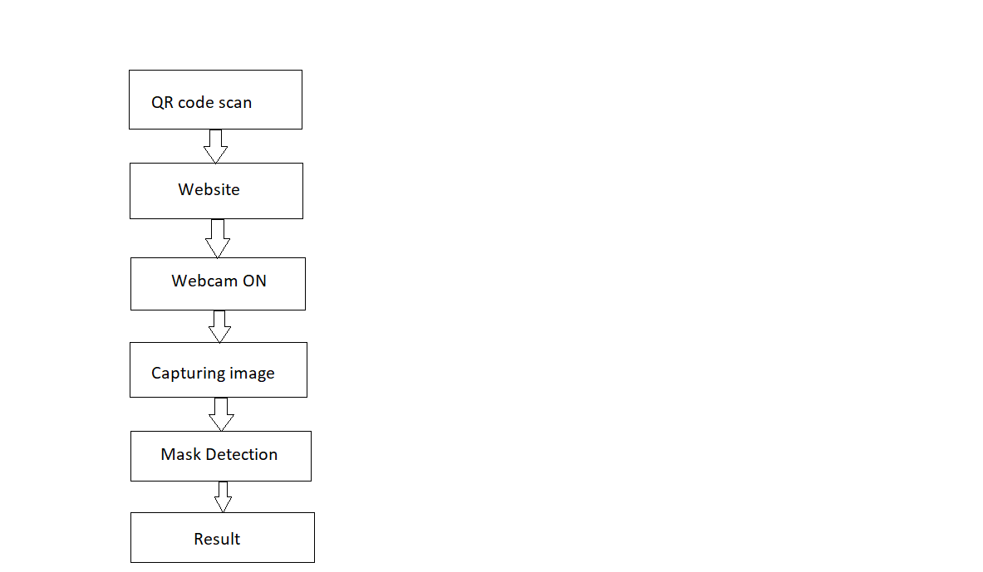

4. FLOWCHART
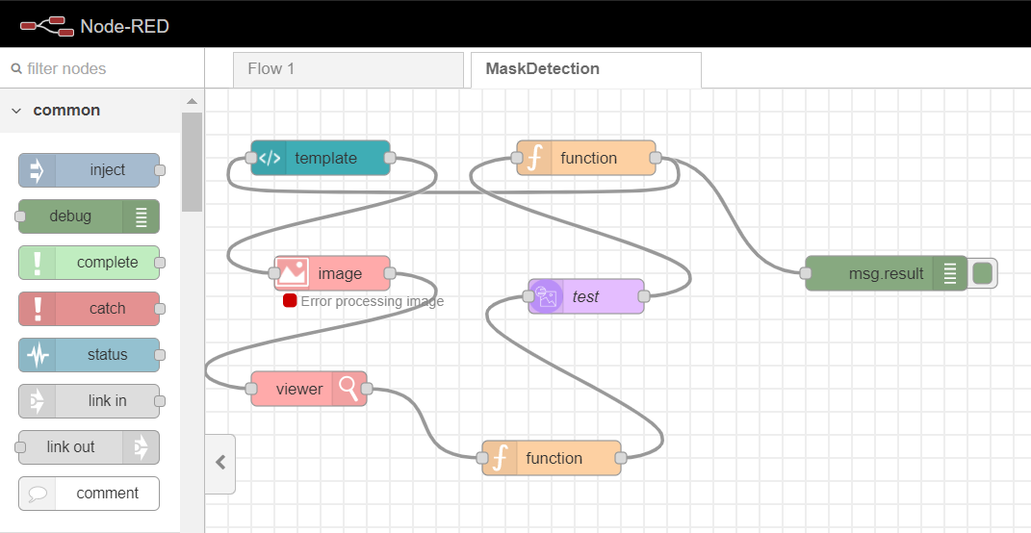

5. RESULT

The app worked as mentioned. It showed “can not book the ticket” comment when the user was not wearing mask. The app was able to book the ticket when the user was wearing his mask.

6. ADVANTAGES AND DISADVANTAGES

Advantages
1. Less physical contact between people
2. No crowd
3. Less spread of the pandemic
4. Easy transaction
5. Faster and efficient transportation
6. Neat and clean transportation
7. It's a very convenient method since everyone uses smartphones these days

Disadvantage
1. The setup of the app is a bit tedious
2. Lots of people and not enough space to accommodate everyone
3. Travel cost is more than before
4. Old people may find it difficult to use the app

7. APPLICATIONS
This app ensures social distancing and use of masks. So helping prevent spreading .

8.CONCLUSION

So concluding what we have here is an intelligent app to schedule the timing and transportation avoiding over occupancy of public transportation buss railway station. According to the situation our motive here is preventing contact of people within the public transportation and achieving social distancing by limiting the passenger in the public transport which is successfully accomplished and provide a safe and efficient method of transportation and to eliminate the spread of virus. Also it makes sure whether the person is wearing a mask or not.

9. FUTURE SCOPE

As the era of technology is rising we will make the app much simple since most phone have fingerprint locks we can use it to verify access to the app at the time of setup. Each person's travel log shall be saved into a server if by any means they are infected their travel map details will be readily available only to people will high clearance. We also plan to reduce the travel cost for regular customers by providing offers we are planning to include large scale booking of bus for specific events or works. Along with that , we can also set a count of the maximum number of people allowed to use the particular public transport at a time. So if this count is reached , no one can book a ticket. This will also ensure social distancing.

10. APPENDIX

- https://www.transformative-mobility.org/news/the-covid-19-outbreak-and-implications-to-public-transport-some-observations

- https://www.teriin.org/article/effects-covid-19-transportation-demand

- https://www.uitp.org/public-transport-and-covid-19

